|  |  |  |
| --- | --- | --- |
| MSSV | TÊN | LỚP |
| 1653005 | VŨ TƯỜNG BÁCH | 16CLC1 |

MÔN HỌC PHÁT TRIỂN ỨNG DỤNG WEB NÂNG CAO

ĐÁNH GIÁ

- Use React router to add two url /map and /stats to switch between Map and Stats component as two attachments below: 2 points. (HOÀN THÀNH )

- When navigate to /map display and ensure features implemented in BTCN04 working correctly: 2 points. (HOÀN THÀNH )

- When navigate to /stats display two line charts about COVID-19 statistics of Vietnam and the World from Dec 08'19 to the current date: 4 points. ( HOÀN THÀNH )

- Upload your project to public host: 1 points. ( HOÀN THÀNH )

- Use git to track and mange your mid-term working, capture your commit history as proof: 1 points ( HOÀN THÀNH )

THAM KHẢO:

<https://www.npmjs.com/package/react-compound-slider>

<https://reacttraining.com/react-router/web/guides/quick-start?fbclid=IwAR2ehZz3zDU4GIrA6OTBdZE6jEG9XB1ooXjDoMN0Do4mwsgTctH9KbFDCo8>

ĐIỂM TỰ ĐÁNH GIÁ : 10

My public host : <https://1653005.github.io/CovidMidterm/>

Use Git:

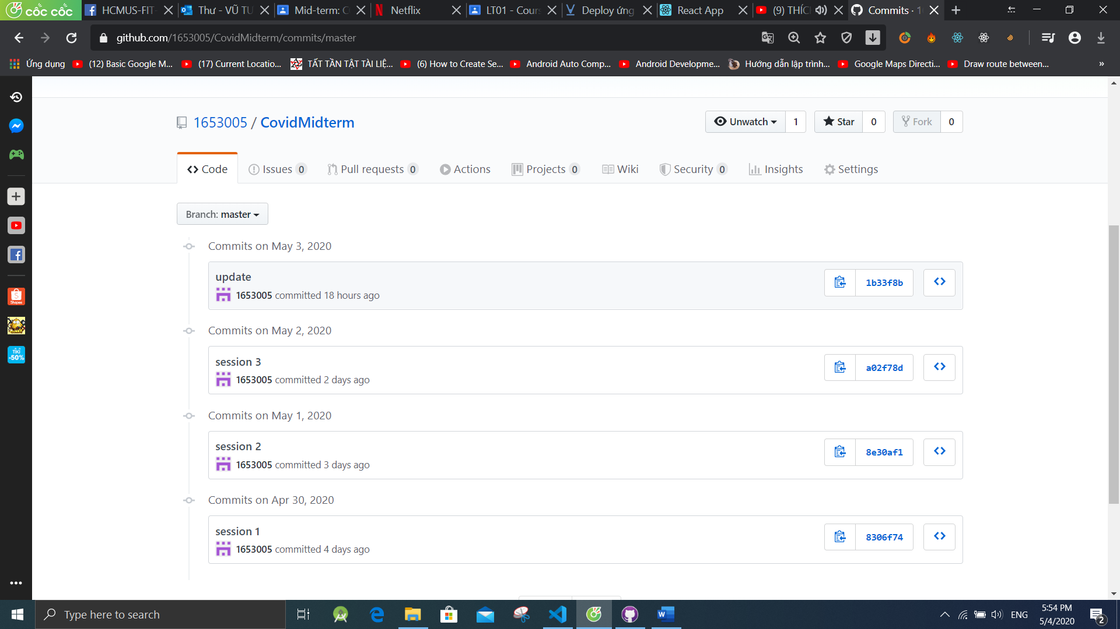

Em cảm ơn thầy đã cho em kiến thức môn học này