HOMEWORK 3

1. Bài 1

* Code:

#Họ và tên: Trần Thị Thúy  
#MSSV: N20DCCN154  
  
import numpy as np  
import matplotlib.pyplot as plt  
from matplotlib.colors import NoNorm  
  
  
def read_file(file_name, size):  
 try:  
 with open(file_name, 'rb') as file:  
 data = np.fromfile(file, dtype=np.uint8, count=size*size)  
 except FileNotFoundError:  
 print(f"\nLoi: Khong the mo file {file_name}!")  
 return None  
 return data  
  
  
def plot_a(data1, data2):  
 plt.figure(figsize=(12, 6))  
 plt.subplot(1, 2, 1)  
 plt.imshow(data1, cmap='gray', norm=NoNorm())  
 plt.title('Original image')  
  
 plt.subplot(1, 2, 2)  
 plt.imshow(data2, cmap='gray', norm=NoNorm())  
 plt.title('Thresholding Result')  
 plt.axis('image')  
  
  
def plot_b(data, file_name):  
 plt.figure(figsize=(6, 6))  
 plt.subplot(1, 1, 1)  
 plt.imshow(data, cmap='gray', norm=NoNorm())  
 plt.axis('image')  
 plt.title('Cau b', fontsize =12)  
 plt.savefig(file_name, format='eps')  
 plt.savefig(file_name[:-4]+'.pdf', format='pdf')  
  
  
def main():  
 #CAU A  
 xsize = 256  
 thresh = 95  
  
 file_name = 'Mammogram_256bin.sec'  
 x_original = read_file(file_name, xsize)  
 if x_original is None:  
 return  
 x_original = x_original.reshape(xsize, xsize)  
  
 x = 255 * (x_original >= thresh)  
 plot_a(x_original, x)  
  
 #CAU B  
 y = np.zeros((xsize, xsize), dtype=np.uint8)  
 for row in range(xsize):  
 for col in range(xsize):  
 if x[row, col] == 255:  
 y[row, col] = 0  
 else:  
 if((col > 0 and x[row, col-1] == 255) or  
 (col <xsize - 1 and x[row, col + 1] == 255) or  
 (row > 0 and x[row-1, col] == 255) or  
 (row < xsize -1 and x[row + 1, col] == 255)):  
 y[row, col] = 255  
 else:  
 y[row, col] = 0  
 plot_b(y, 'Approximate Contour Image Generation')  
 plt.show()  
  
  
if __name__ == "__main__":  
 main()

* Kết quả câu a:

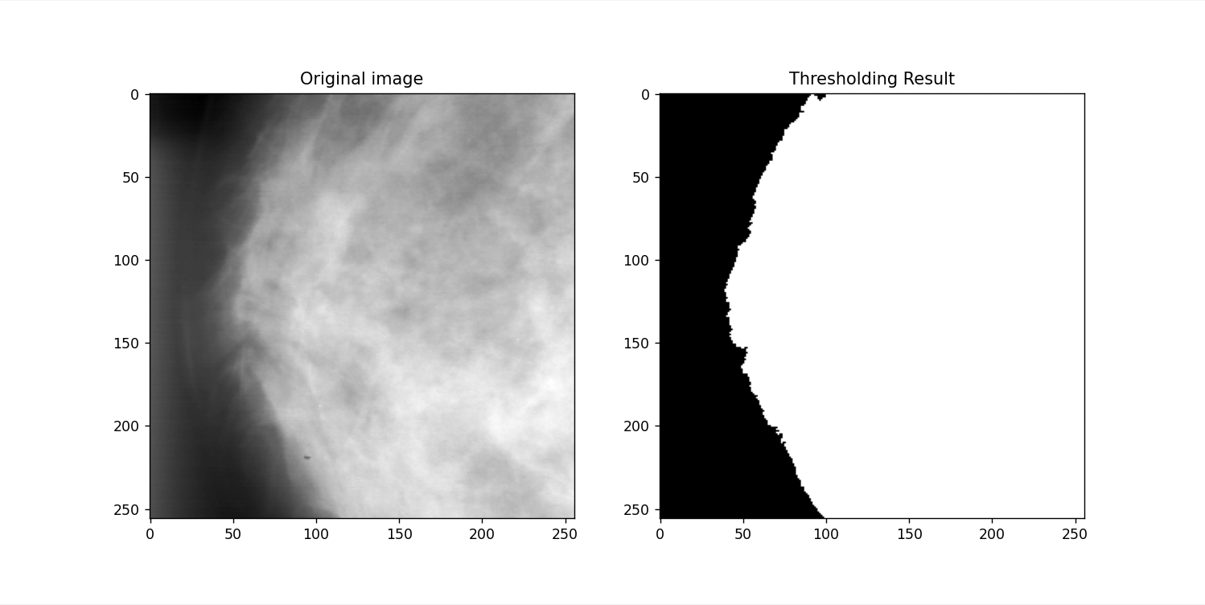

* Kết quả câu b:

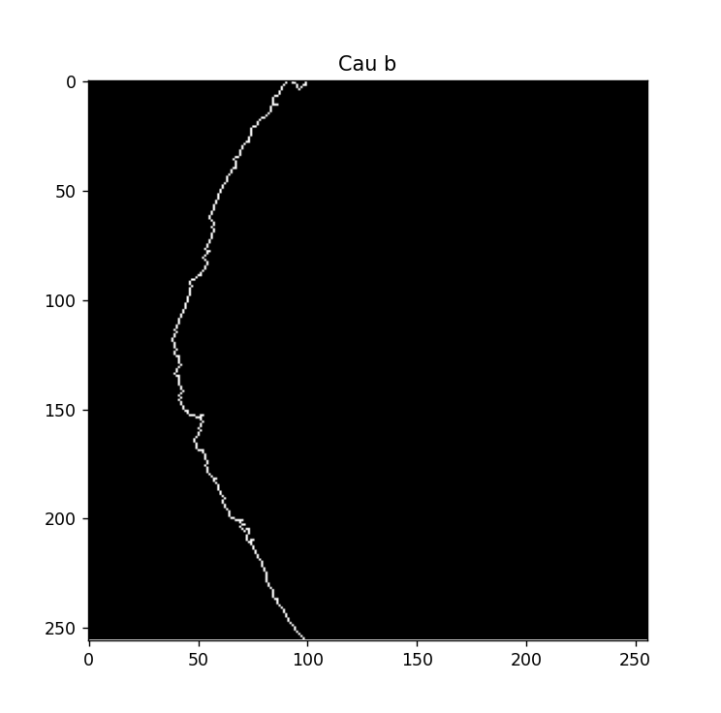

* Câu c: Một mã chuỗi có thể được dùng để biểu diễn đường viền chính trong hình ảnh đường viền hay không? Tại sao hoặc tại sao không?

Trả lời: Mã chuỗi không thể được sử dụng để biểu diễn đường viền chính bởi vì thuật toán tạo đường viền chỉ mang tính xấp xỉ.

1. Bài 2

* Code:

#Họ và tên: Trần Thị Thúy  
#MSSV: N20DCCN154  
  
import numpy as np  
import matplotlib.pyplot as plt  
  
  
def read_file(file_name, xsize):  
 try:  
 with open(file_name, 'rb') as file:  
 data = np.fromfile(file, dtype=np.uint8, count=xsize * xsize)  
 if data.size != xsize * xsize:  
 raise Exception(f"Doc file {file_name} that bai")  
 return data.reshape(256, 256)  
 except FileNotFoundError:  
 raise Exception(f'Khong the mo file {file_name}')  
  
  
def stretch(a):  
 min_val = np.min(a)  
 max_val = np.max(a)  
 x = 255.0 / (max_val - min_val)  
 stretched = np.round((a - min_val) * x)  
 return stretched.astype(np.uint8)  
  
  
def plot2(data1, data2, data3, data4):  
 plt.figure(figsize=(10, 8))  
 plt.subplot(2, 2, 1)  
 plt.imshow(data1, cmap='gray', vmin=0, vmax=255)  
 plt.title('Original image')  
  
 plt.subplot(2, 2, 2)  
 plt.imshow(data2, cmap='gray')  
 plt.title('Full-scale stretch')  
  
 plt.subplot(2, 2, 3)  
 plt.bar(range(256), data3)  
 plt.title('Histogram image')  
  
 plt.subplot(2, 2, 4)  
 plt.bar(range(256), data4)  
 plt.title('New histogram image')  
 plt.show()  
  
  
def main():  
 xsize = 256  
 x = read_file('ladybin.sec', xsize)  
 histogram_x = np.histogram(x, bins= np.arange(257), range=(0, 256))[0]  
 y = stretch(x)  
 histogram_y = np.histogram(y, bins= np.arange(257), range=(0, 256))[0]  
 plot2(x, y, histogram_x, histogram_y)  
  
  
if __name__ == '__main__':  
 main()

* Kết quả:

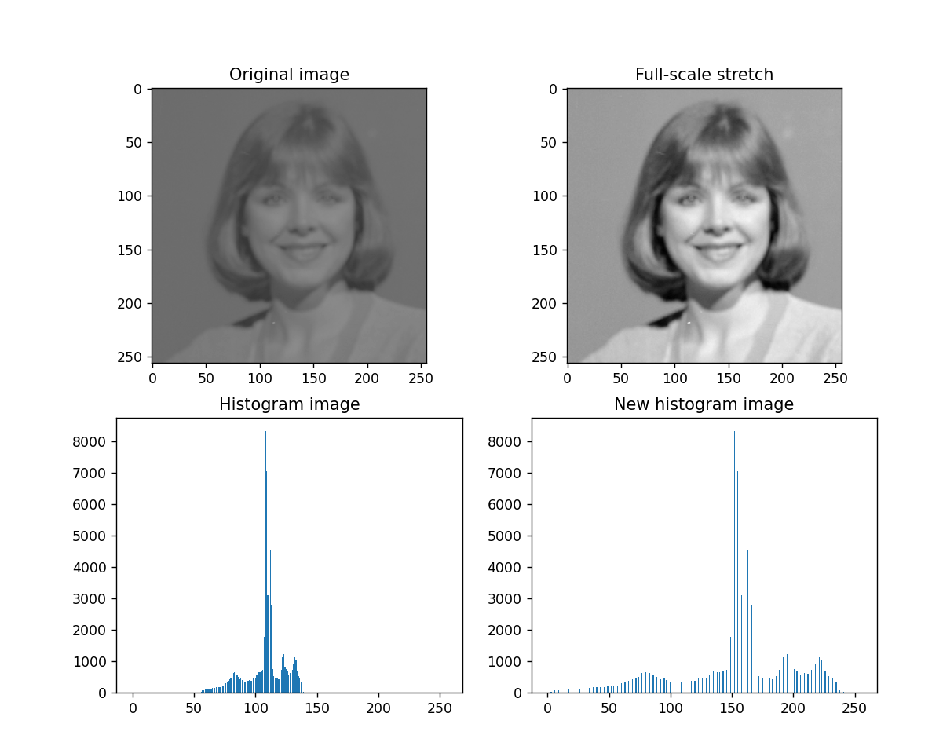

1. Bài 3

* Code:

#Họ và tên: Trần Thị Thúy  
#MSSV: N20DCCN154  
  
import numpy as np  
import matplotlib.pyplot as plt  
  
  
def read_file(file_name, size):  
 try:  
 with open(file_name, 'rb') as file:  
 data = np.fromfile(file, dtype=np.uint8, count=size*size)  
 except FileNotFoundError:  
 print(f"\nLoi: Khong the mo file {file_name}!")  
 return None  
 return data  
  
  
def plot2(data1, data2, data3):  
 plt.figure(figsize=(10, 8))  
 plt.subplot(2, 2, 1)  
 plt.imshow(data1, cmap='gray')  
 plt.title('Original image')  
  
 plt.subplot(2, 2, 2)  
 plt.imshow(data2, cmap='gray', vmin=0, vmax=255)  
 plt.title('J1 image')  
  
 plt.subplot(2, 2, 4)  
 plt.imshow(data3, cmap='gray', vmin=0, vmax=255)  
 plt.title('J2 image')  
  
 plt.show()  
  
  
#Hàm tính toán đo lường M2  
def compute_match_measure(image, template):  
 J1 = np.zeros_like(image, dtype=int)  
 TemplRowso2, TemplColso2 = template.shape[0]//2, template.shape[1]//2  
  
 for row in range(TemplRowso2, image.shape[0] - TemplRowso2):  
 for col in range(TemplColso2, image.shape[1] - TemplColso2):  
 window_set = image[row - TemplRowso2:row + TemplRowso2 + 1, col - TemplColso2:col + TemplColso2 + 1]  
 J1[row, col] = np.sum(window_set == template)  
   
 return J1  
  
def bult_templ():  
 TemplRows = 47  
 TemplCols = 15  
 TemplRowso2 = TemplRows // 2  
 TemplColso2 = TemplCols // 2  
 Templ = np.zeros((TemplRows, TemplCols), dtype=np.uint8)  
  
 for row in range(10):  
 for col in range(TemplCols):  
 Templ[row, col] = 0  
  
 for row in range(10, 16):  
 for col in range(TemplCols):  
 Templ[row, col] = 255  
  
 for row in range(17, 37):  
 for col in range(6):  
 Templ[row, col] = 0  
 for col in range(6, 10):  
 Templ[row, col] = 255  
 for col in range(10, TemplCols):  
 Templ[row, col] = 0  
  
 for row in range(38, TemplRows):  
 for col in range(TemplCols):  
 Templ[row, col] = 0  
  
 return Templ  
  
  
def stretch(a):  
 min_val = np.min(a)  
 max_val = np.max(a)  
 x = 255.0 / (max_val - min_val)  
 stretched = np.round((a - min_val) * x)  
 return stretched.astype(np.uint8)  
  
  
def main():  
 xsize = 256  
 file_name = 'actontBinbin.sec'  
 x = read_file(file_name, xsize)  
 if x is None:  
 return  
 x = x.reshape(xsize, xsize)  
 Templ = bult_templ()  
  
 J1 = compute_match_measure(x, Templ)  
 J1 = stretch(J1)  
  
 count = np.sort(J1.ravel())[::-1]  
 threshold = count[1]  
 J2 = 255 * (J1 >= threshold)  
 plot2(x, J1, J2)  
  
  
if __name__ == '__main__':  
 main()

* Kết quả:

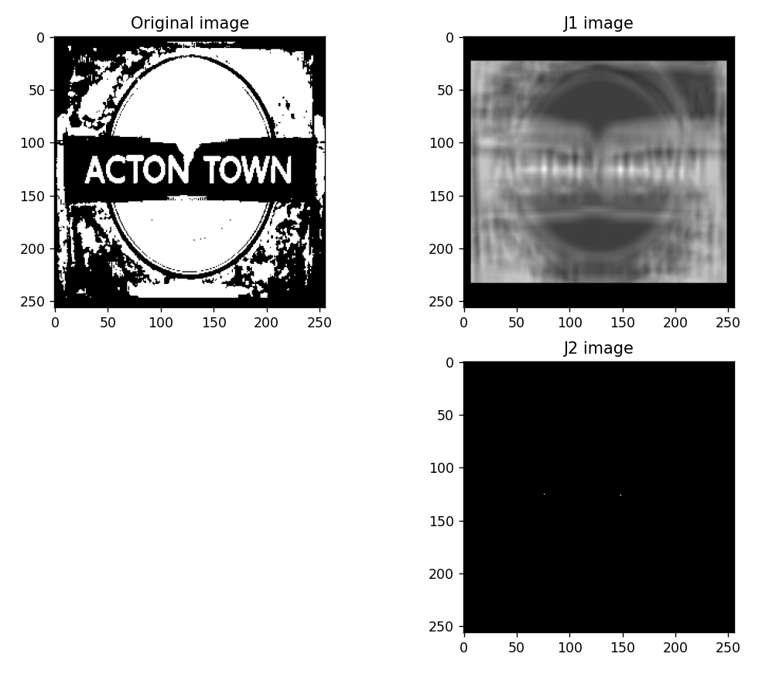

1. Câu 4

* Code:

#Họ và tên: Trần Thị Thúy  
#MSSV: N20DCCN154  
  
import numpy as np  
import matplotlib.pyplot as plt  
  
  
def read_file(file_name, size):  
 try:  
 with open(file_name, 'rb') as file:  
 data = np.fromfile(file, dtype=np.uint8, count=size*size)  
 except FileNotFoundError:  
 print(f"\nLoi: Khong the mo file {file_name}!")  
 return None  
 return data  
  
  
def plot2(data1, data2, data3, data4):  
 plt.figure(figsize=(10, 8))  
 plt.subplot(2, 2, 1)  
 plt.imshow(data1, cmap='gray', vmin=0, vmax=255)  
 plt.title('Original image')  
  
 plt.subplot(2, 2, 2)  
 plt.bar(np.arange(256), data2)  
 plt.title('Original Histogram')  
 plt.axis([0, 256, 0, 2500])  
 plt.xticks(np.arange(0, 256, 16))  
 plt.yticks(np.arange(0, 2500, 250))  
  
 plt.subplot(2, 2, 3)  
 plt.imshow(data3, cmap='gray', vmin=0, vmax=255)  
 plt.title('Histogram Equalized Image')  
  
 plt.subplot(2, 2, 4)  
 plt.bar(np.arange(256), data4)  
 plt.title('Equalized Histogram')  
 plt.axis([0, 256, 0, 2500])  
 plt.xticks(np.arange(0, 256, 16))  
 plt.yticks(np.arange(0, 2500, 250))  
  
 plt.show()  
  
def stretch(a):  
 min_val = np.min(a)  
 max_val = np.max(a)  
 x = 255.0 / (max_val - min_val)  
 stretched = np.round((a - min_val) * x)  
 return stretched.astype(np.uint8)  
  
  
def hist_equalization(image):  
 hist = np.histogram(image, bins=256, range=(0, 256))[0]  
 num_pixels = image.size  
 x = hist/num_pixels  
  
 y = np.cumsum(x)  
 J = y[image]  
  
 K = stretch(J)  
 return K  
  
  
def main():  
 xsize = 256  
 file_name = 'johnnybin.sec'  
 x = read_file(file_name, xsize)  
 if x is None:  
 return  
 x = x.reshape(xsize, xsize)  
  
 hist_x = np.histogram(x, bins=256, range=(0, 256))[0]  
  
 y = hist_equalization(x)  
 hist_y = np.histogram(y, bins=256, range=(0, 256))[0]  
  
 plot2(x, hist_x, y, hist_y)  
  
  
if __name__ == '__main__':  
 main()

* Kết quả:

