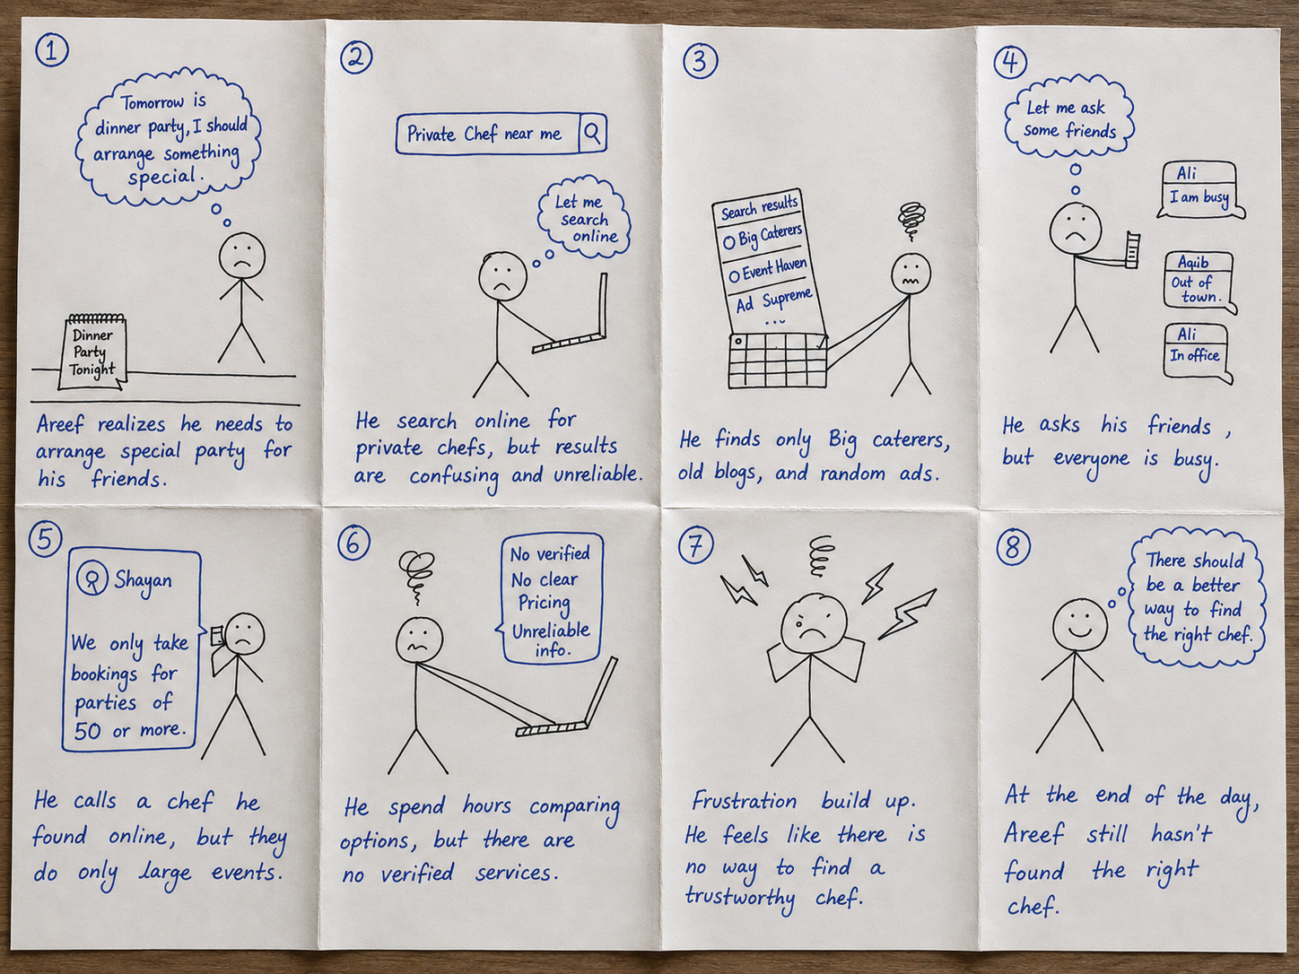

8 - Up storyboard -- Chef Finder (Problem Scenario) - By Areef

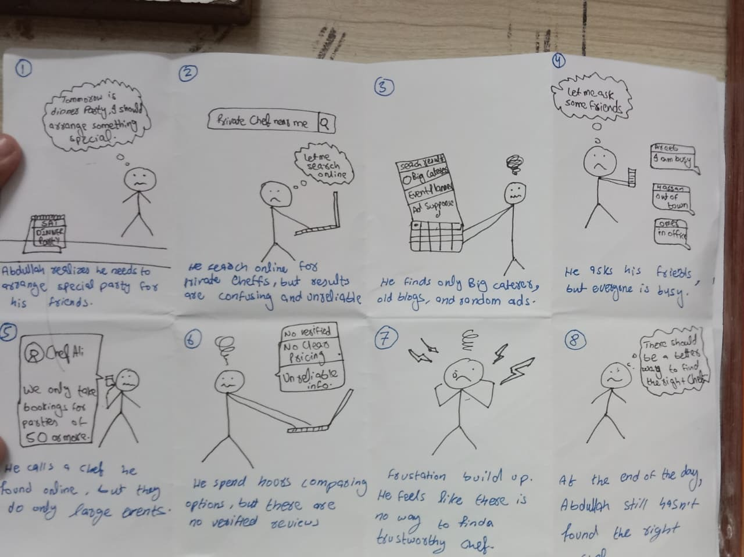
8 - Up storyboard -- Chef Finder (Problem Scenario) - By Abdullah

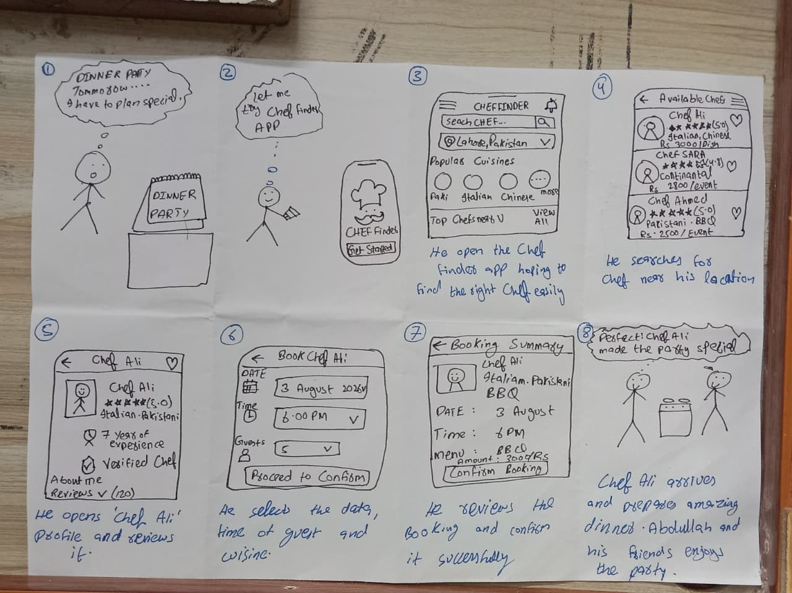

8 - Up storyboard -- Chef Finder (Final Solution Flow)

