HCI Quiz 3 Submission
Student Name: Abdullah Maqbool
Roll Number: L1F23BSSE0391
Course: Human-Computer Interaction (HCI)
System Assigned: Hospital Appointment System
Task Assigned: Cancelling a booked appointment with a doctor

Part (a): GUI Design and Wireframe Sketch
To design an effective interface for cancelling a doctor's appointment, we prioritize Recognition over Recall (by showing active bookings instead of requiring users to remember or type booking IDs) and Error Prevention (via confirmation dialogue constraints).
Below are the two sequential screen layouts designed for this task:

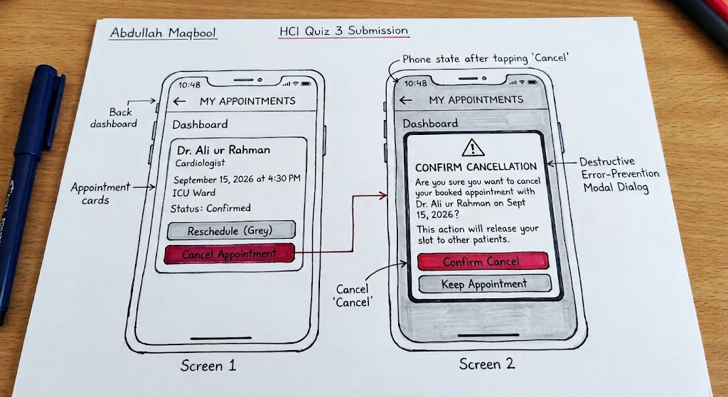

Part (b): How will the user know what goal to achieve when they see the GUI?
This phase corresponds to the Gulf of Execution (bridging the gap from the user's psychological goal to the physical system execution) and the Articulation/Performance stages of the Abowd & Beale Interaction Model.
- Context-Driven Title (System Presentation): The bold, prominent header "MY APPOINTMENTS" immediately aligns with the user's high-level mental goal (assessing their schedule).
- Skeuomorphic Status Representation: Displaying the doctor’s explicit details ("Dr. Ali ur Rahman", "Sept 15 at 4:30 PM") provides immediate knowledge in the world. The user is not required to perform cognitive operations or retrieve details from their memory (Recall), which dramatically lowers short-term memory load.
- Semantic Action Mapping: The action buttons use explicit natural language ("Cancel Appointment" and "Reschedule") rather than system jargon or ambiguous icons. This direct semantic mapping tells the user exactly which button corresponds to their internal desire of removing the booked appointment.

Part (c): How will the user notice the correct action?
This phase corresponds to the Gulf of Evaluation (how easily the user interprets the state of the system after interacting) and the Observation stage of the Abowd & Beale Framework.
- Pre-Attentive Visual Hierarchy: The "Cancel Appointment" button is designed using high-intensity Crimson Red, while secondary actions ("Reschedule") use neutral Grey. Red serves as a pre-attentive feature (hue/color contrast) that is processed instantly by the user's low-level visual system before conscious cognitive processing begins. This immediately draws the user's eyes to the primary action path.
- Explicit Action Confirmation (Error Prevention): On tapping "Cancel", a modal dialog box locks focus (Constraint) and asks for confirmation. By using distinct button labels ("Confirm Cancel" in red and "Keep Appointment" in grey), we prevent accidental slips (the "rm *" Unix problem).
- Visible System Feedback: Once "Confirm Cancel" is selected, the system immediately displays a success message toast: "Appointment cancelled successfully. A confirmation message has been sent to your registered phone." This immediate visual and alphanumeric feedback bridges the Gulf of Evaluation, informing the user that the system's core state has successfully updated to reflect their goal.

