**VISVESVARAYA TECHNOLOGICAL UNIVERSITY**

**Jnana Sangama, Belagavi-590018**



**Mini Project Report**

on

**“GST-Billing Application”**

submitted in partial fulfillment of the requirement for the award of degree

**BACHELOR OF ENGINEERING**

in

**COMPUTER SCIENCE & ENGINEERING**

**for the academic year**

**2021-2022**

**submitted by**

**Mr. Jayatheertha S G 1AR19CS018**

**Mr. Vishwas Gowda H V 1AR19CS061**

**Under the guidance of**

Mr. Ramesh Babu N

Associate Professor,

Dept. of CSE

AIEMS

**BENGALURU**

**2021-22**

**DEPARTMENT OF COMPUTER SCIENCE AND ENGINEERING**

**B.V.V. Sangha’s**

**AMRUTA INSTITUTE OF ENGINEERING & MANAGEMENT SCIENCES**

**Bidadi, Bengaluru-562109, Karnataka**



**Department of Computer Science & Engineering**

AIEMS

**BENGALURU**

**CERTIFICATE**

This is to certify that the mini project report entitled **“GST-Billing Application**” is a bonafide work carried out by

**Mr. Jayatheertha S G [1AR19CS018],**

**Mr. Vishwas Gowda H V [1AR19CS061]**

in partial fulfilment of award of **Bachelor of Engineering** in **Computer Science & Engineering** of the Visvesvaraya Technological University, Belagavi, during the academic year 2021-2022. It is certified that all corrections/suggestions indicated for Internal Assessment have been incorporated. The mini project has been approved as it satisfies the academic requirements in respect to MAD Lab(18CSMP68) associated with the degree mentioned.

…………………………… …....………………………

Signature of Guide Signature of HOD

**Mr. Ramesh Babu N Dr. M S Patel**

Associate Professor, Professor & Head,

Dept. of CSE Dept. of CSE

AIEMS AIEMS

**External**

**Examiner Name Signature**

1. **__________________________ __________________________**
2. **__________________________ __________________________**

**ACKNOWLEDGEMENT**

The satisfaction and euphoria that accompany the successful completion of any task would be incomplete without the mention of the people who made it possible, whose constant guidance and encouragement crowned my effort with success.

We are grateful to our institution, **B.V.V Sangha’s Amruta Institute of Engineering & Management Sciences (AIEMS),** with its ideals and inspirations for having provided us with the facilities, which has made this, project a success.

We earnestly thank **Dr. Santosh M Muranal, Principal, AIEMS,** for facilitating academic excellence in the college and providing us with the congenial environment to work in, that helped us in completing this project.

We wish to extend our profound thanks to **Dr. M S Patel, Professor & Head, Department of Computer Science & Engineering, AIEMS,** for giving us the consent to carry out this project.

We would like to express our sincere thanks to our guide **Mr Ramesh Babu N, Associate Professor, Department of Computer Science & Engineering, AIEMS,** for his immense help during the project and also for his valuable suggestions on the project report preparations, which helped us in the successful completion of the project.

We would like to thank all the faculties of **Computer Science & Engineering Department**, for their valuable advice and support.

We would like to express our sincere thanks to our parents and friends for their support.

**Mr. JAYATHEERTHA S G Mr. VISHWAS GOWDA H V**

**[1AR19CS018] [1AR19CS061]**

i

**DECLARATION**

We, **Mr. JAYATHEERTHA S G [1AR19CS018]** and **Mr. VISHWAS GOWDA H V [1AR19CS061]** students of VI semester B.E, Department of Computer Science & Engineering, AMRUTA INSTITUTE OF ENGINEERING AND MANAGEMENT SCIENCES, Bengaluru, declare that mini project work entitled “**GST- Billing Application**” has been carried out by us and submitted in partial fulfillment of the course requirements for the award of degree in Bachelor of Engineering in Computer Science & Engineering of Visvesvaraya Technological University, Belgavi during the academic year 2021-2022. The matter embodied in this report has not been submitted to any other university or institution for the award of any degree.

Place:

Date:

**Mr. JAYATHEERTHA S G Mr. VISHWAS GOWDA H V**

**[1AR19CS018] [1AR19CS061]**

ii

**ABSTRACT**

GST is characterized as the bigger backhanded expense structure intended to help and upgrade the financial development of a country. It would enthusiasm to comprehend why this proposed GST administration may hamper the development and advancement of the nation.

In this project I have developed an application software to manage the bill submission process in shop or organization. Manually it’s very difficult to calculate different types of items with different GST value. This process is very difficult and time consuming. That’ s why I tried to develop a system which can calculate GST value of each and every product. This application is developed to manage the bill submission process in shop or organization. Using this system shop employee can generate bill with GST calculations for customer for his purchase and also print its bill copy for customer. The main purpose of this inventory maintenance and billing using GST system project is developing a system that automate the bill save.

iii

**TABLE OF CONTENTS**

|  |  |  |
| --- | --- | --- |
|  | Acknowledgement | i |
| Declaration | ii |
| Abstract | iii |
| Table of Contents | iv |
| List of Figures | v |
| List of Tables | vi |
| **Chapter 1**  1.1  1.2 | **INTRODUCTION**  Introduction to Android  Problem Statement/ Aim | 1  5 |
| 1.3 | Scope | 5 |
| 1.4 | Project Description | 5 |
| **Chapter 2**  2.1  2.2  2.3 | **HARDWARE AND SOFTWARE REQUIREMENTS**  Functional Requirements  Non-Functional Requirements  Hardware Requirements | 6  6  7 |
| 2.4 | Software Requirements | 7 |
| **Chapter 3**  3.1 | **DESIGN**  System Design | 8 |
| 3.2 | Flow Chart | 9 |
| 3.3  3.4 | Use Case Diagram  User Interface | 10  10 |
| **Chapter 4**  4.1  4.2  4.3 | **IMPLEMENATION**  Platform  Language  Code Snippets | 11  11  12 |
| **Chapter 5**  5.1 | **RESULT AND DISCUSSION**  Screen Shots | 25 |
| **Chapter 6** | **CONCLUSION AND FUTURE ENHANCEMENTS** | 30 |
|  | **BIBLIOGRAPHY** | 31 |

**List of Figures**

|  |  |  |
| --- | --- | --- |
| **Figure no.** | **Title** | **Page no.** |
| 1.1 | Advantages of Android | 2 |
| 3.1 | System Design | 8 |
| 3.2 | Flow Chart | 9 |
| 3.3 | Use case Diagram | 10 |
| 3.4 | User Interface | 10 |
| 5.1 | GST billing application logo | 25 |
| 5.2 | Enter customer details | 26 |
| 5.3 | Set Password | 27 |
| 5.4 | Customer purchase details | 28 |
| 5.5 | Mark as paid | 29 |

v

**CHAPTER 1**

**INTRODUCTION**

* 1. **Introduction to Android**

Android is an operating system and programming platform developed by Google for mobile phones and other mobile devices, such as tablets. It can run on many different devices from many different manufacturers. Android includes a software development kit ( SDK) that helps you write original code and assemble software modules to create apps for Android users. Android also provides a marketplace to distribute apps. Altogether, Android represents an ecosystem for mobile apps.

Android is an open source and Linux-based Operating System for mobile devices such as smartphones and tablet computers. Android was developed by the Open Handset Alliance, led by Google, and other companies.

Android offers a unified approach to application development for mobile devices which means developers need only develop for Android, and their applications should be able to run on different devices powered by Android.

The first beta version of the Android Software Development Kit (SDK) was released by Google in 2007 where as the first commercial version, Android 1.0, was released in September 2008.

improving the user interface, both in terms of functionality and performance. On June 27, 2012, at the Google I/O conference, Google announced the next Android version,

4.1 Jelly Bean. Jelly Bean is an incremental update, with the primary aim of

The source code for Android is available under free and open-source software licenses. Google publishes most of the code under the Apache License version 2.0 and the rest, Linux kernel changes, under the GNU General Public License version 2.

* + 1. **Android Development**

The Android operating systemis the largest installed base among various mobile platforms across the globe. Hundreds of millions of mobile devices are powered by Android in more than 190 countries of the world. It conquered around 75**%** of the global market share by the end of 2020, and this trend is growing bigger every other day

Google sponsored the project at initial stages and in the year 2005, it acquired the whole company. In September 2008, the first Android-powered device launched in the market. Android dominates the mobile OS industry because of the long list of features it provides.

It’s user-friendly, has huge community support, provides a greater extent of customization, and a large number of companies build Android-compatible smart phones. As a result, the market observes a sharp increase in the demand for developing Android mobile applications, and with that companies need smart developers with the right skill set. At first, the purpose of Android was thought of as a mobile operating system. However, with the advancement of code libraries and its popularity among developers of the divergent domain, Android becomes an absolute set of software for all devices like tablets, wear able, set-top boxes, smart TVs, notebooks, etc.

* + 1. **Why Android?**

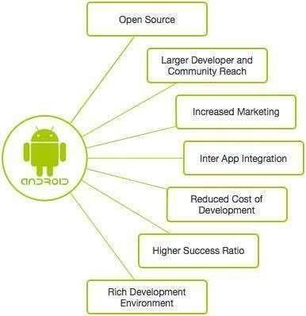

**Figure 1.1: Advantages of Android**

CG (Computer graphics) started with the display of data on hardcopy plotters and cathode ray tube screens soon after the introduction of computer themselves.

* + 1. **Android Applications**

Android applications are usually developed in the Java language using the Android Software Development Kit.

Once developed, Android applications can be packaged easily and sold out either through a store such as Google Play, Slide ME, Opera Mobile Store, Mobango, F- droid and the Amazon App store.

Android powers hundreds of millions of mobile devices in more than 190 countries around the world. It's the largest installed base of any mobile platform and growing fast. Every day more than 1 million new Android devices are activated worldwide.

This tutorial has been written with an aim to teach you how to develop and package Android application. We will start from environment setup for Android application programming and then drill down to look into various aspects of Android applications.

* + 1. **Android Features**

Android is a powerful open-source operating system which provides a lot of great features, those are

* + - * It’s open-source and we can customize the OS based on our requirements.
      * It supports connectivity for GSM, CDMA, WIFI, NFC, Bluetooth, etc. for telephony or data transfer.
      * By using WIFI technology we can pair with other devices using apps.
      * It has a wide range of media supports like AVI, MPEG4, etc. to play or record a variety of audio/video and having a different image format like JPEG, PNG, GIF, MP3, etc. to perform playback or recording using camera and microphone
      * It has an integrated open-source Web Kit layout-based web browser to support HTML5, CSS3
      * It supports a multi-tasking.
      * It will give a chance to reuse the application components and the replacement of native applications.
      * It has support for 2D/3D Graphics
    1. **The challenges of Android app development.**

While the Android platform provides rich functionality for app development, there are still a number of challenges you need to address, such as:

* Building for a multi-screen world
* Getting performance right
* Keeping your code and your users more secure
* Making sure your app is compatible with older platform versions
  + 1. **Applications**

Applications is the top layer of android architecture. The pre-installed applications like home, contacts, camera, gallery etc. And third-party applications downloaded from the play store, like chat applications, games etc. will be installed on this layer only. It runs within the android runtime with the help of the classes and services provided by the application framework.

* 1. **Problem Statement / Aim**

In today’s society, it’s very hard to be competitive without using cutting edge technology available in market. After years of business, the data was grown much. It is becoming a challenge for a person to manage that data in an effective way.

To be more productive in order processing, we need a solution which can facilitate their current process with the use of technology and software. With increased number of orders, it becomes difficult for salesperson to manage orders in effective and efficient manner.

It is very hard to go through all paper work and back tracking orders. If there is any complain or review of any orders, it takes large amount of effort and time to back track and fix the problem. These results in loss of resource.

* 1. **Scope**

It is used to define and understand the current method of implementation, such as a system, a product etc. From this analysis, it is not uncommon to discover there is actually nothing wrong with the current system or product other than some misunderstandings regarding it overlaps it needs some simple modifications regarding it or perhaps it needs some simple modifications as opposed to a major service.

Currently in most of our shops or market does not use computers for performing their daily tasks. There is a limited number or shop that uses Microsoft office products, such as MS word and MS excel for performing their daily inventory tasks. Most of them do not even have the information that computers can make a great difference in the way they are doing their t asks when they are programmed to do so. In the existing system all transactions, dealing of products, purchasing of products were done manually which time consuming. Reports are prepared manually when needed. Maintaining of reports are very difficult task and it is very difficult to know the status of the submitted bill calculation with GST.

* 1. **Project Description**

GST is applied to all the goods and services. GST is divided into four distinct tax rates,

5%, 12%, 18% and 28%. This GST Billing can be used by different types of users, such as customers, manufacturers, and wholesalers. In this primarily Users should register by giving business name, address and set the Password. To calculate the GST the user should give the customer’s name and phone then items, Quantity and GST percentage. We have options such

as mark as paid, calls, delete, add more items etc.

**CHAPTER 2**

**HARDWARE AND SOFTWARE REQUIREMENTS**

In the development of any software applications, we require same particular system configuration of software and hardware components. This configuration helps in achieving the proper execution.

The various requirements that are essential for this project are specified over here. These requirements have to be fulfilled for successful of the project. The purpose scope along with hardware and software requirements helps for proper execution.

* 1. **Functional Requirements**

In software engineering and system engineering, a functional requirement defines functions of a system. Billing system is the process by which a business bills and invoices customers. Billing systems often include payment software that automates the process of collecting payments, sending out recurring invoices, expense tracking, and invoice tracking.

* 1. **Non-Functional Requirements**

In systems engineering and requirements engineering, a non-functional requirement is a requirement that specifies criteria that can be used to judge the operation of a system, rather than specific behaviour’s. They are contrasted with functional requirements that define specific behaviour or functions.

* The user must get a great experience while calculating GST.
* Manual calculations are more time consuming.
* The application must be strong to withstand the large numbers on the system so that it does not crash or stop, and the system response must be fast and download user data quickly.
* The app must be accessible for all user segments.
* It saves time and reduces the chances of manual errors while computing the cost of goods and services.

**2.3 Software Requirements**

A software requirements description of a software system to be developed. This document enlists enough and necessary requirements that are required for the project development.

* + - Android development tool (ADT)
    - Android studio (2021.2.1 Windows 64-bit)
    - XML
    - Java development tool kit (JDK)
    - Software development kit (SDK )
  1. **Hardware Requirements**

The project works with any IBM PC compatible with Intel or AMD processor.

* Processor: Intel Pentium 41.50 Giga HZ
* Memory: 512MB to 1GB
* Operating System: windows 9/10/11
* RAM: 4/8GB

**CHAPTER 3**

**DESIGN**

The proposed system is intended to provide the facility of automating the inventory tasks such as item management and customer billing with a GST for the shop or market. This project is designed with a goal to making the existing system more informative, reliable, fast and easier.

* 1. **System Design**

System design is the process of defining elements of a system like modules, architecture, components and their interfaces and data for a system based on the specified requirements. it is the process of defining , developing and designing systems which satisfies the specific needs and requirements of a business



no yes

Add customer

Discard

yes

Add Item

Menu

no

Discard

**Figure 3.1: System Design**

* 1. **Flow Chart**

A flow chart is a diagrammatic representation of an algorithm, a step-by-step approach to solving a task. The flowchart shows the steps as boxes of various kinds and their order by converting the boxes with an arrow.

Start

Business details



Add Item

Save to

paid

Add more

items

Delete

Call

Mark as

paid

Add Customer

Stop

**Figure 3.2: Flow chart**

**3.3 Use Case Diagram**

Use case diagram is a graphical representation of users possible interactions with a system. A use case diagram shows various use case and different types of users the systems have and will have accomplished by other circles and ellipses. The actors are often shown as stick figures.

Users

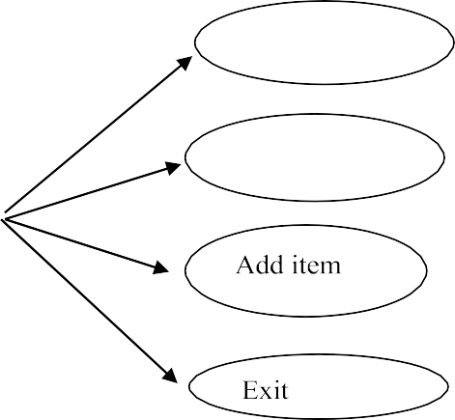

Business details

Add customers

**Figure 3.3: Use Case Diagram**

**3.4 User Interface**

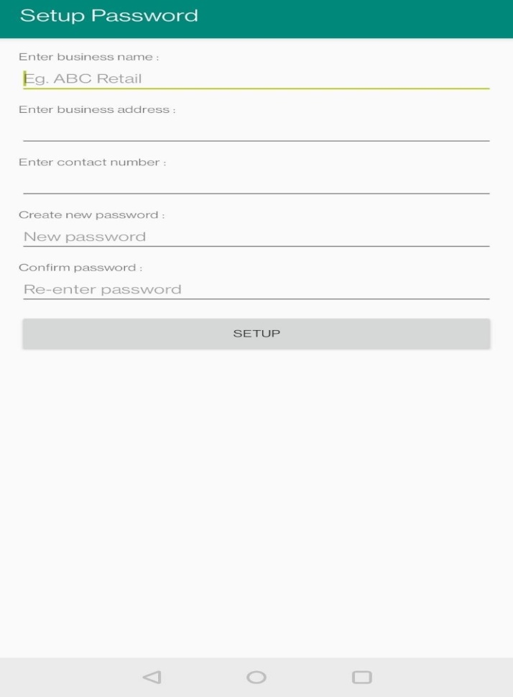

**Figure 3.4: Set Password**

Here, admin or authority of the sales organization can add his business name, address, contact number and password credentials. When setup is clicked, records are stored into database.

**CHAPTER 4**

**IMPLEMENTION**

Project implementation is the segment wherein visions and plans come to be a reality. This is the logical conclusion, after evaluating, deciding, visioning, planning, applying for finances, and finding the monetary resources of a challenge. The implementation degree of the project cycle is in many approaches the most critical, as it’s miles in the course of this stage that planned advantages are delivered. All different stages within the cycle are therefore essentially supportive of this implementation stage. A task has to be implemented successfully while the allocation of undertaking obligations to the assignment team in the organization.

* 1. **Platform**

Windows 10 is a computer operating system by Microsoft as part of its Microsoft Windows family of operating systems. It was known as Threshold when it was being developed and announced at a press event on 30 September 2014. It came out for PC son 29 July 2015. Beginning on that day, Windows 10 was available as a free upgrade for users running Windows 7and Windows 8.1 for one year.

Windows 10 is designed to provide a common, "universal" user interface for various systems. These include desktop, laptop, and all-in-one PCs, tablet computers, smart phones, and embedded systems such as the Xbox game console. This allows Microsoft to integrate each type of platform with greater ease.

Microsoft releases updates every half a year, an example of the software as a service principle. Each release has a four-digit build number the first two digits referring to the year of release, and the other two digits referring to the month of release (eg: "1903" refers to a build released in March 2019).

* 1. **Language**

Java is a high-level, class-based, object-oriented programming language that is designed to have as few implementation dependencies as possible. It is a general- purpose programming language intended to let application developers write once, run anywhere meaning that compiled Java code can run on all platforms that support Java without the need for recompilation. Java applications are typically compiled to byte code that can run on any Java virtual.

* 1. **CODE SNIPPETS**

In implementation we implement code for GST-E-BILLING Android Application. Here we are using 15 activities to build our apk. Each activity contains one xml and one java file. Here are some files

1. BillsActivity.java
2. NewBillActivity.java

**BillsActivity.java**

Here we created a new project using an empty activity as our starting point, once that’s ready head over to codes. Here we have used linear layout as a layout. In this activity We can add the new customer details and we can see the paid and unpaid bills.

package com.gstbilling;

import android.Manifest; import android.content.Intent;

import android.content.SharedPreferences; import android.content.pm.PackageManager; import android.database.Cursor;

import android.graphics.Color; import android.os.Build; import android.os.Bundle; import android.os.StrictMode;

import android.preference.PreferenceManager;

import android.support.design.widget.FloatingActionButton; import android.support.v4.app.ActivityCompat;

import android.support.v4.app.LoaderManager; import android.support.v4.content.CursorLoader; import android.support.v4.content.Loader;

import android.support.v7.app.AppCompatActivity; import android.support.v7.widget.LinearLayoutManager; import android.support.v7.widget.RecyclerView;

import android.support.v7.widget.Toolbar; import android.view.View;

import android.view.Menu; import android.view.MenuItem;

importcom.taneja.ajay.gstbillig.data.GSTBillingContract;

public class BillsActivity extends AppCompatActivity implements

LoaderManager.LoaderCallbacks<Cursor>, BillAdapter.BillItemClickListener {

Private RecyclerViewunpaid RecyclerView; private BillAdapter adapter;

private String billListStatus; private int billDividerColor; private String billSortOrder;

private static final int BILL_LOADER_ID = 100;

@Override

protected void onCreate(Bundle savedInstanceState) { super.onCreate(savedInstanceState); setContentView(R.layout.activity_bills);

Toolbar toolbar = (Toolbar) findViewById(R.id.toolbar); setSupportActionBar(toolbar);

if(savedInstanceState != null){ billListStatus=savedInstanceState.getString(GSTBillingContract.GSTBillingEntry.PRIMARY_ COLUMN_ STATUS);

}else {

billListStatus = GSTBillingContract.BILL_STATUS_UNPAID;

}

StrictMode.VmPolicy.Builder builder = new StrictMode.VmPolicy.Builder(); StrictMode.setVmPolicy(builder.build());

isStoragePermissionGranted(); switch (billListStatus){

case GSTBillingContract.BILL_STATUS_PAID: getSupportActionBar().setTitle(R.string.paid_bills_title); billDividerColor = Color.GREEN; billSortOrde="DESC";

break;

}

case GSTBillingContract.BILL_STATUS_UNPAID: getSupportActionBar().setTitle(R.string.unpaid_bills_title); billDividerColor = Color.RED;

billSortOrder = " ASC"; break;

FloatingActionButton fab = (FloatingActionButton) findViewById(R.id.fab_unpaid); fab.setOnClickListener(new View.OnClickListener() {

@Override

public void onClick(View view) {

startActivity(new Intent(BillsActivity.this, NewBillCustomerActivity.class));

}

});

checkPasswordSetup();

unpaidRecyclerView = (RecyclerView) findViewById(R.id.unpaid_recycler_view);

unpaidRecyclerView.setLayoutManager(new LinearLayoutManager(this));

unpaidRecyclerView.setHasFixedSize(true);

adapter = new BillAdapter(this, this, billDividerColor); unpaidRecyclerView.setAdapter(adapter); getSupportLoaderManager().initLoader(BILL_LOADER_ID, null, this);

}

private void checkPasswordSetup() {

SharedPreferences prefs = PreferenceManager.getDefaultSharedPreferences(this); if(prefs.getString(SetupPasswordActivity.SETUP_PASSWORD_KEY, null) == null){ Intentintent=newIntent(this,SetupPasswordActivity.class);

startActivity(intent); finish();

}

}

public boolean isStoragePermissionGranted(){ if(Build.VERSION.SDK_INT >= 23){ if(checkSelfPermission(Manifest.permission.WRITE_EXTERNAL_STORAGE)== PackageManager.PERMISSION_GRANTED){

return true;

}else{

ActivityCompat.requestPermissions(this, new String[]{Manifest.permission.WRITE_EXTERNAL_STORAGE}, 1); return false;

}

}else{ return true;

}

}

@Override

public boolean onCreateOptionsMenu(Menu menu) {

// Inflate the menu; this adds items to the action bar if it is present. getMenuInflater().inflate(R.menu.menu_bills_list, menu);

if(billListStatus.equals(GSTBillingContract.BILL_STATUS_PAID)){ menu.findItem(R.id.action_swap_bills_list).setTitle(R.string.action_show_unpaid_bills);

}

return true;

}

@Override

public boolean onOptionsItemSelected(MenuItem item) {

// Handle action bar item clicks here. The action bar will

// automatically handle clicks on the Home/Up button, so long

// as you specify a parent activity in AndroidManifest.xml. int id = item.getItemId(); if(id == R.id.action_swap_bills_list){

switch (billListStatus){

case GSTBillingContract.BILL_STATUS_UNPAID: billListStatus = GSTBillingContract.BILL_STATUS_PAID; item.setTitle(getString(R.string.action_show_unpaid_bills)); getSupportActionBar().setTitle(getString(R.string.paid_bills_title)); billDividerColor = Color.GREEN;

billSortOrder = " DESC"; break;

case GSTBillingContract.BILL_STATUS_PAID:

billListStatus = GSTBillingContract.BILL_STATUS_UNPAID; item.setTitle(getString(R.string.action_show_paid_bills)); getSupportActionBar().setTitle(getString(R.string.unpaid_bills_title)); billDividerColor = Color.RED;

billSortOrder = " ASC"; break;

}

getSupportLoaderManager().restartLoader(BILL_LOADER_ID, null, this);

}

return super.onOptionsItemSelected(item);

}

@Override

public Loader<Cursor> onCreateLoader(int id, Bundle args) { switch (id) case BILL_LOADER_ID: return new CursorLoader(

this, GSTBillingContract.GSTBillingEntry.CONTENT_URI, null, GSTBillingContract.GSTBillingEntry.PRIMARY_COLUMN_STATUS + "='" + billListStatus

+ "'",null,

GSTBillingContract.GSTBillingEntry._ID + billSortOrder

);

default:

throw new RuntimeException("Loader not implemented: " + id);

}

}

@Override

public void onLoadFinished(Loader<Cursor> loader, Cursor data) { adapter.swapCursor(data,

billDividerColor);

}

@Override

public void onLoaderReset(Loader<Cursor> loader) { adapter.swapCursor(null, Color.RED);

}

@Override

public void onBillItemClick(String clickedBillId,String customerName,String

phoneNumber) {

Intent detailIntent = new Intent(this, DetailActivity.class);

detailIntent.putExtra(GSTBillingContract.GSTBillingEntry._ID, clickedBillId); detailIntent.putExtra(GSTBillingContract.GSTBillingEntry.PRIMARY_COLUMN_STATU S, billListStatus); detailIntent.putExtra(GSTBillingContract.GSTBillingEntry.PRIMARY_COLUMN_NAME, customerName); detailIntent.putExtra(GSTBillingContract.GSTBillingEntry.PRIMARY_COLUMN_PHONE

_NUMBER, phoneNumber); startActivity(detailIntent);

}

@Override

protected void onSaveInstanceState(Bundle outState) { outState.putString(GSTBillingContract.GSTBillingEntry.PRIMARY_COLUMN_STATUS, billListStatus);

super.onSaveInstanceState(outState);

}

}

**NewBillActivity.java**

Here we created a new project using an empty activity as our starting point, once that’s ready head over to codes. Here we have used linear layout as a layout. In this activity We can add the item, selling price, quantity and tax percentage.

package com.gstbilling;

import android.content.ContentValues; import android.content.Intent;

import android.net.Uri;

import android.support.v7.app.AppCompatActivity; import android.os.Bundle;

import android.view.Menu; import android.view.MenuItem; import android.view.View;

import android.widget.AdapterView; import android.widget.ArrayAdapter; import android.widget.Button; import android.widget.EditText; import android.widget.Spinner; import android.widget.Toast;

import com.taneja.ajay.gstbilling.data.GSTBillingContract.GSTBillingCustomerEntry; import com.taneja.ajay.gstbilling.data.GSTBillingContract.GSTBillingEntry;

import com.taneja.ajay.gstbilling.data.GSTBillingContract; import java.text.SimpleDateFormat; import java.util.ArrayList; import java.util.Date; import java.util.List;

public class NewBillActivity extends AppCompatActivity { public static boolean addingMoreItems = false;

private Spinner taxSlabSpinner; private EditText itemDescription; private EditText finalPriceEt; private EditText quantityEt;

private Button finishBtn;

private int taxSlab; List<ContentValues> cvList; @Override

protected void onCreate(Bundle savedInstanceState) { super.onCreate(savedInstanceState); setContentView(R.layout.activity_new_bill);

taxSlabSpinner = (Spinner) findViewById(R.id.tax_slab_spinner); setupTaxSpinner();

itemDescription = (EditText) findViewById(R.id.new_item_value); finalPriceEt = (EditText) findViewById(R.id.new_final_price_value); quantityEt = (EditText) findViewById(R.id.new_quantity_value); finishBtn = (Button) findViewById(R.id.finish_btn); finishBtn.setEnabled(false); if(getIntent().hasExtra(DetailActivity.EDITING_ITEM)){ getSupportActionBar().setTitle(R.string.action_edit_bill_item_label); findViewById(R.id.add_to_bill_btn).setVisibility(View.GONE); finishBtn.setVisibility(View.GONE);

final Intent editIntent = getIntent();

final int idValue = editIntent.getIntExtra(GSTBillingCustomerEntry._ID, 0); String itemDescriptionValue=

editIntent.getStringExtra(GSTBillingCustomerEntry.SECONDARY_COLUMN_ITEM_DES

CRIPTION);

float finalPriceValue = editIntent.getFloatExtra(GSTBillingCustomerEntry.SECONDARY_COLUMN_FINAL_PRI CE, 0f);

int quantityValue = editIntent.getIntExtra(GSTBillingCustomerEntry.SECONDARY_COLUMN_QUANTITY, 0); itemDescription.setText(itemDescriptionValue); finalPriceEt.setText(String.valueOf((int) finalPriceValue));

quantityEt.setText(String.valueOf(quantityValue));

Button doneEditingBtn = (Button) findViewById(R.id.done_edit_item_btn);

doneEditingBtn.setVisibility(View.VISIBLE); doneEditingBtn.setOnClickListener(new

View.OnClickListener() { @Override

public void onClick(View v) { if(itemDescription.getText().toString().length() == 0){ itemDescription.setText("NA");

}

if(finalPriceEt.getText().toString().length() == 0){ finalPriceEt.requestFocus(); Toast.makeText(NewBillActivity.this,

getString(R.string.enter_final_price_error), Toast.LENGTH_SHORT).show(); return;

}

if(quantityEt.getText().toString().length() == 0){ quantityEt.setText("1");

}

ContentValues cv = new ContentValues(); cv.put(GSTBillingCustomerEntry.SECONDARY_COLUMN_ITEM_DESCRIPTION, itemDescription.getText().toString()); cv.put(GSTBillingCustomerEntry.SECONDARY_COLUMN_FINAL_PRICE, Integer.parseInt(finalPriceEt.getText().toString()));

cv.put(GSTBillingCustomerEntry.SECONDARY_COLUMN_QUANTITY,

Integer.parseInt(quantityEt.getText().toString())); cv.put(GSTBillingCustomerEntry.SECONDARY_COLUMN_TAX_SLAB,taxSlab); getContentResolver().update( GSTBillingEntry.CONTENT_URI.buildUpon().appendPath(editIntent.getStringExtra(Detail Activity.EDITING_ITEM)).appendPath(String.valueOf(idValue)).build(),

cv, null, null

);

ContentValues contentValues = new ContentValues();

contentValues.put(GSTBillingContract.GSTBillingEntry.PRIMARY_COLUMN_STATUS, GSTBillingContract.BILL_STATUS_UNPAID);

getContentResolver().update( GSTBillingContract.GSTBillingEntry.CONTENT_URI.buildUpon().appendPath(editIntent.get StringExtra(DetailActivity.EDITING_ITEM)).build(),contentValues,

GSTBillingContract.GSTBillingEntry._ID+"="+editIntent.getStringExtra(DetailActivity.EDIT ING_ITEM),null);

DetailActivity.changeBillStatus(); finish();

}

});

}else{

cvList = new ArrayList<>();

}

}

private void setupTaxSpinner() { ArrayAdapter<CharSequence>adapter=ArrayAdapter.createFromResource(this, R.array.tax_slab_list_array,

android.R.layout.simple_spinner_item); adapter.setDropDownViewResource(android.R.layout.simple_spinner_dropdown_item); taxSlabSpinner.setAdapter(adapter);

taxSlabSpinner.setOnItemSelectedListener(new AdapterView.OnItemSelectedListener()

{

@Override

public void onItemSelected(AdapterView<?> parent, View view, int position, long id)

{

switch (position){ case 0: taxSlab = 28; break;

case 1:

taxSlab = 18; break; case 2:

taxSlab = 12; break; case 3:

taxSlab = 5; break;

}

}

@Override

public void onNothingSelected(AdapterView<?> parent) { taxSlab = 28;

}

});

}

public void addToBill(View view){ if(itemDescription.getText().toString().length() == 0){ itemDescription.setText("NA");

}

if(finalPriceEt.getText().toString().length() == 0){ finalPriceEt.requestFocus(); Toast.makeText(this, getString(R.string.enter_final_price_error), Toast.LENGTH_SHORT).show();

return;

}

if(quantityEt.getText().toString().length() == 0){ quantityEt.setText("1");

}

ContentValues cv = new ContentValues(); cv.put(GSTBillingCustomerEntry.SECONDARY_COLUMN_ITEM_DESCRIPTION, itemDescription.getText().toString()); cv.put(GSTBillingCustomerEntry.SECONDARY_COLUMN_FINAL_PRICE, Integer.parseInt(finalPriceEt.getText().toString())); cv.put(GSTBillingCustomerEntry.SECONDARY_COLUMN_QUANTITY, Integer.parseInt(quantityEt.getText().toString())); cv.put(GSTBillingCustomerEntry.SECONDARY_COLUMN_TAX_SLAB, taxSlab); cvList.add(cv);

Toast.makeText(this,getString(R.string.item_added_success), Toast.LENGTH_SHORT).show();

itemDescription.setText(""); finalPriceEt.setText(""); quantityEt.setText(""); finishBtn.setEnabled(true);

itemDescription.requestFocus();

}

public void finishAddingItems(View view){

// Check if any item is added in Selling price EditText before finishing the bill

if(finalPriceEt.getText().toString().length() != 0){

Toast.makeText(this, getString(R.string.add_item_to_bill_error), Toast.LENGTH_SHORT).show();

return;

}

if(!getIntent().hasExtra(DetailActivity.ADDING_MORE_ITEMS)){

// Inserting customer details in primary table Intent intent = getIntent(); String customerName =

intent.getStringExtra(NewBillCustomerActivity.ADD_CUSTOMER_NAME_KEY); String phoneNumber =

intent.getStringExtra(NewBillCustomerActivity.ADD_CUSTOMER_PHONE_KEY); String billDate = new SimpleDateFormat("dd-MM-yyyy").format(new Date()); String billStatus = GSTBillingContract.BILL_STATUS_UNPAID;

ContentValues contentValues = new ContentValues(); contentValues.put(GSTBillingEntry.PRIMARY_COLUMN_NAME, customerName); contentValues.put(GSTBillingEntry.PRIMARY_COLUMN_PHONE_NUMBER, phoneNumber); contentValues.put(GSTBillingEntry.PRIMARY_COLUMN_DATE, billDate); contentValues.put(GSTBillingEntry.PRIMARY_COLUMN_STATUS, billStatus);

Uri idUri = getContentResolver().insert(GSTBillingEntry.CONTENT_URI, contentValues);

// Inserting item details in secondary table String id = idUri.getLastPathSegment(); getContentResolver().bulkInsert(GSTBillingContract.GSTBillingEntry.CONTENT_URI.buil dUpon().appendPath(id).build(),

cvList.toArray(new ContentValues[cvList.size()]));

// Opening detail activity

Intent detailIntent = new Intent(this, DetailActivity.class); detailIntent.putExtra(GSTBillingEntry._ID, id); detailIntent.putExtra(GSTBillingEntry.PRIMARY_COLUMN_NAME, customerName); detailIntent.putExtra(GSTBillingEntry.PRIMARY_COLUMN_PHONE_NUMBER, phoneNumber); detailIntent.putExtra(GSTBillingEntry.PRIMARY_COLUMN_STATUS, GSTBillingContract.BILL_STATUS_UNPAID);

startActivity(detailIntent); finish();

}else { addingMoreItems = true;

String id = getIntent().getStringExtra(GSTBillingEntry._ID); getContentResolver().bulkInsert(GSTBillingContract.GSTBillingEntry.CONTENT_URI.buil

dUpon().appendPath(id).build(),

cvList.toArray(new ContentValues[cvList.size()])); ContentValues contentValues = new ContentValues();

contentValues.put(GSTBillingContract.GSTBillingEntry.PRIMARY_COLUMN_STATUS, GSTBillingContract.BILL_STATUS_UNPAID);

getContentResolver().update( GSTBillingContract.GSTBillingEntry.CONTENT_URI.buildUpon().appendPath(String.valu eOf(id)).build(),

contentValues, GSTBillingContract.GSTBillingEntry._ID + "=" + id, null

);

DetailActivity.changeBillStatus(); finish();

}

}

@Override

public boolean onCreateOptionsMenu(Menu menu) { getMenuInflater().inflate(R.menu.menu_bill, menu); return true;

}

@Override

public boolean onOptionsItemSelected(MenuItem item) { int id = item.getItemId(); if(id == R.id.action_discard){ finish();

}

return super.onOptionsItemSelected(item);

}

}

**CHAPTER 5**

**RESULT AND DISCUSSION**

**5.1 Snapshots**

Snapshots is nothing but informal photograph taken quickly, typically with a small handheld camera. In other words defined as an informal photograph that is taken quickly a quick view or a small amount of information that tells you a little about what someone or something is like The complete working of the GST Billing Application have been picturized. And the outcomes are depicted using snapshots. These snapshots sequentially describe all the phases included in the code.



**Figure 5.1: GST billing Application Logo**

The fig shows the application logo which shows when the run is succeeded and the application is installed into the android virtual device. When the user clicks on application icon, application is started.

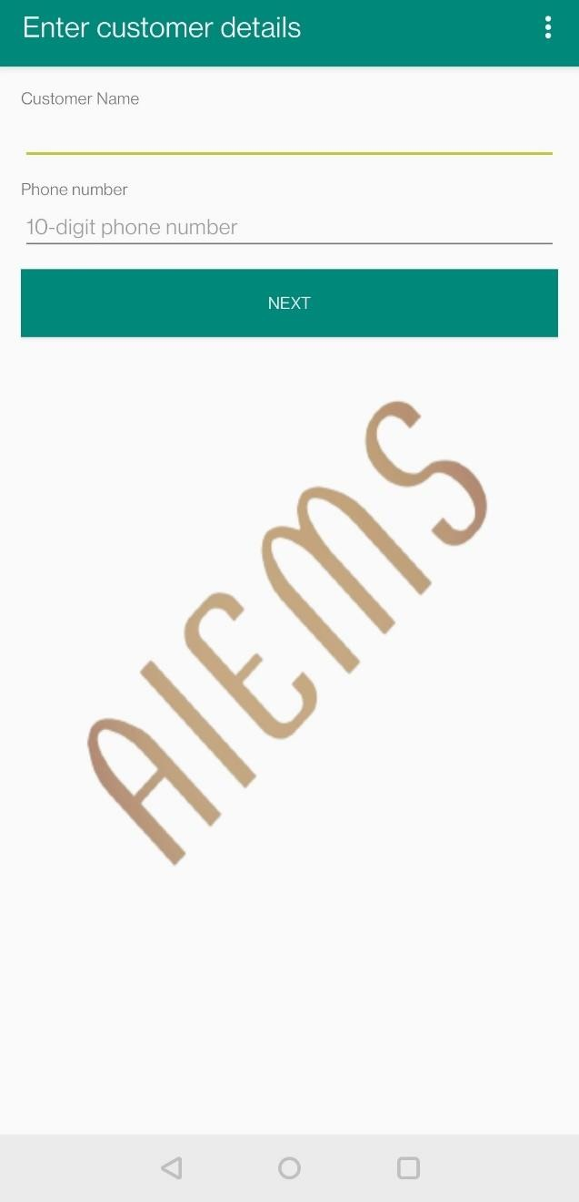

**Figure 5.2: Enter Customer Details**

This is the intro layout window or screen which is displayed when the application is started. Here the user has to enter customer details like name and contact details.

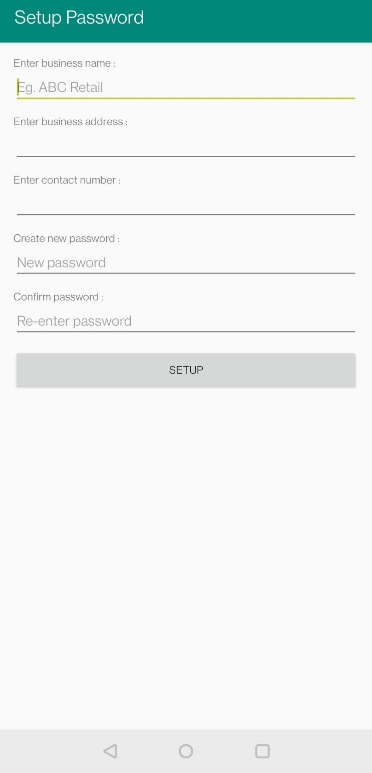

**Figure 5.3: Set Password**

Here, admin or authority of the sales organization can add his business name, address, contact number and password credentials. When setup is clicked, records are stored into database.

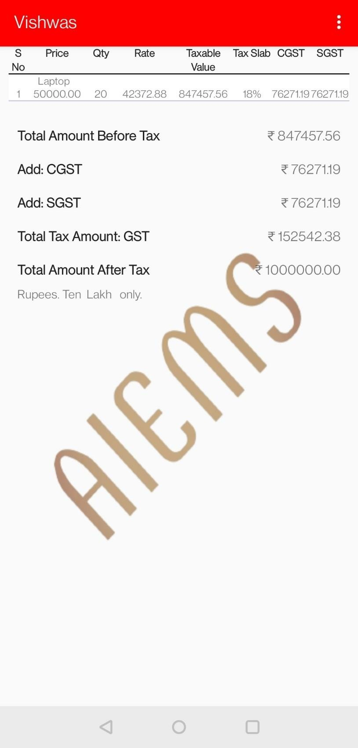

**Figure 5.4: Customer purchase details**

The price details like MRP, tax amount, CGST, SGST, GST are allotted to the customer as per his purchases. And total price amount is calculated and are displayed at the bottom of the layout.

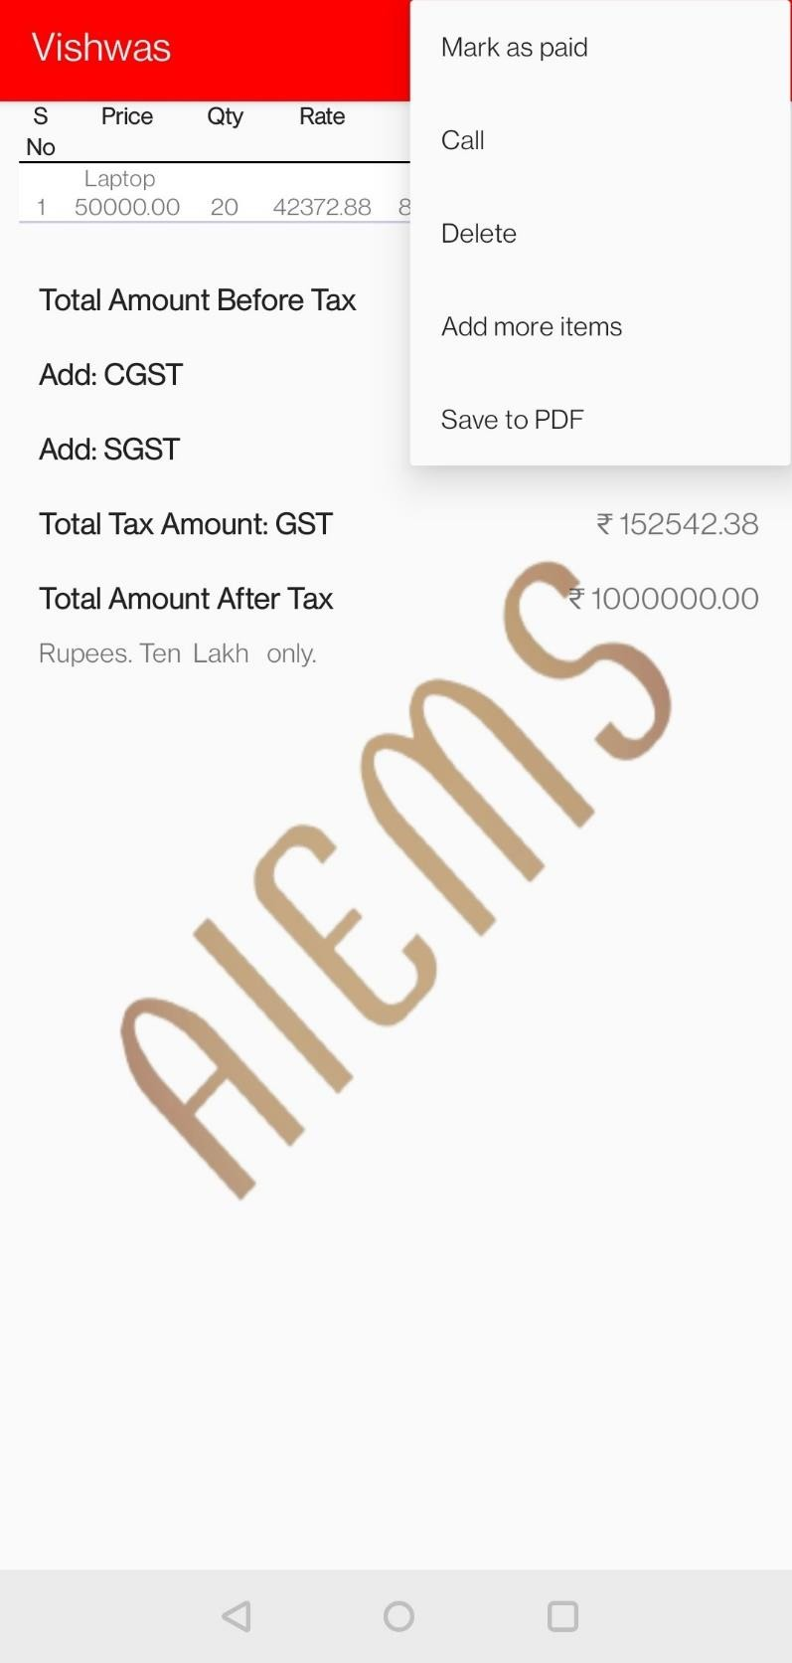

**Figure 5.5: Mark as paid**

When the customer agrees to purchase the product in respective sales organization, admin can mark that payment has done by clicking the three menu button and ‘Mark as paid’ button.

**CHAPTER 6**

**CONCLUSION AND FUTURE ENHANCEMENTS**

In this system we implement the automatic GST report generation software for purchase and sales. We develop a system which calculates the GST reports and also generate excel sheets of the reports which needs to submit to the government. To do manual calculation is a difficult task so we design a system which will reduce the manual work as well as save the time and generate reports efficiently. It is designed to replace an existing manual record system for reducing time taken for calculations and for storing data. The system is strong to handle daily operations where the database is cleared over certain time. This will reduce manual work, calculations and will also provide periodic reports any time.

The future system can be designed with more filter facilities such as supplier wise GST Billing. Integrate Bank transaction details with the application. Managing Credit and Debit details like mini accounts. The application will be enhanced into mobile application. GST Wise Report will be displayed in the form of chart layout. Auditor can view the company GST bill details in their mobile application itself.

**BIBLIOGRAPHY**

1. Google Developer Training, "Android Developer Fundamentals Course – Concept Reference”, Google Developer Training Team, 2017. https://[www.gitbook.com/book/googledeveloper-](http://www.gitbook.com/book/googledeveloper-) training/android-developer-fundamentals-course-concepts/details.
2. Erik Hellman, “Android Programming – Pushing the Limits”.
3. Dawn Griffiths and David Griffiths, “Head First Android Development”.
4. J F DiMarzio, “Beginning Android Programming with Android Studio”.
5. Anubhav Pradhan, Anil V Deshpande, “Composing Mobile Apps” using Android.
   * https://projectworlds.in/android-gst-billing-project-with-source-code/
   * [https://projectworlds.in](https://projectworlds.in/)
   * ht[tps://www.w3schools.com](http://www.w3schools.com/)
   * ht[tps://www.javatpoint.com/android-tutorial](http://www.javatpoint.com/android-tutorial)
   * ht[tps://www.ge](http://www.geeksforgeeks.org/android-app-development-fundamentals-for-beginners)e[ksforgeeks.org/android-app-development-fundamentals-for-beginners](http://www.geeksforgeeks.org/android-app-development-fundamentals-for-beginners)
   * [www.script-tutorials.com](http://www.script-tutorials.com/)