Buzzer

The buzzer is an audio device used to play the alarm. In the system the busser is connected to the pin 7 of the Arduino.

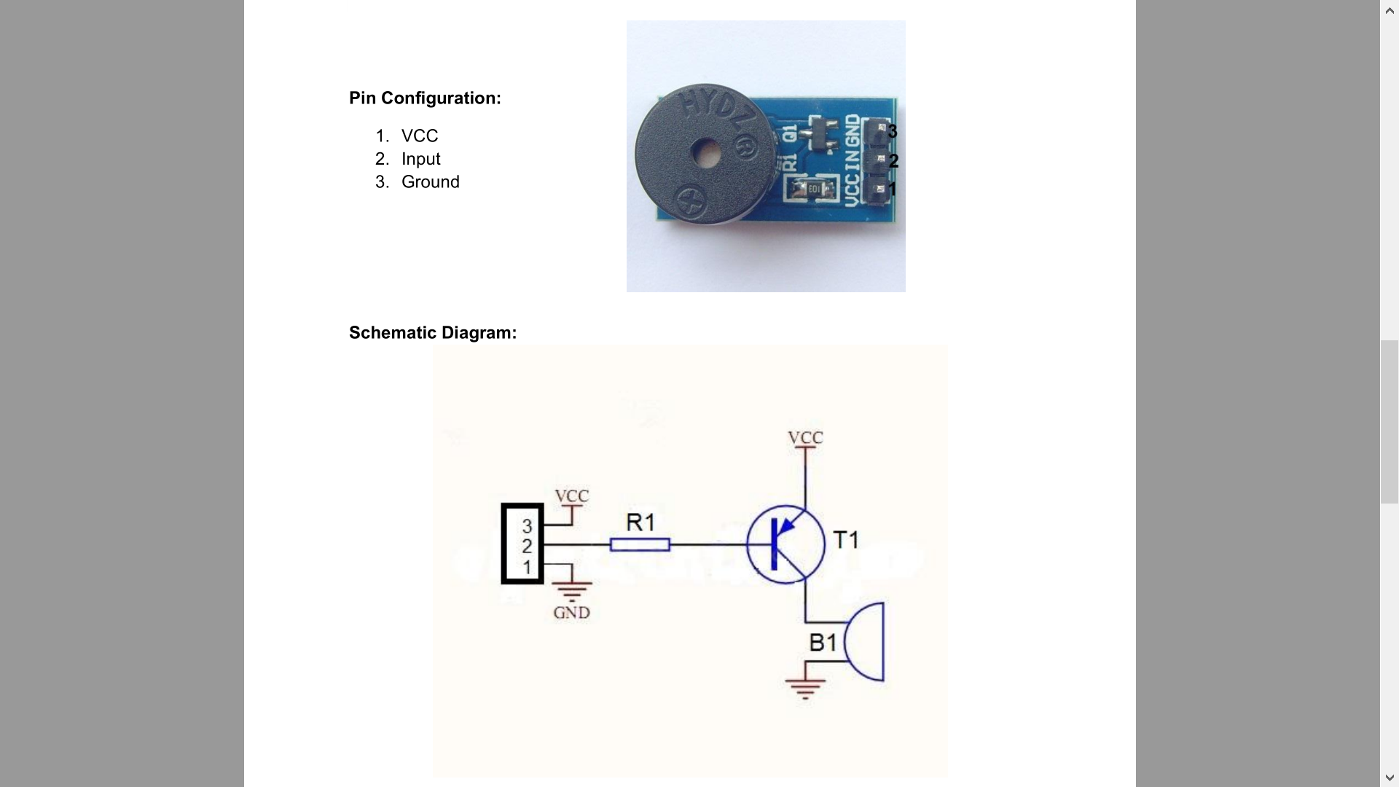

In order to write melodies, the pitches.h file has been included. Its macros define different notes and different durations.

Playing is performed by the playMelody() method. It is called by the checkAlarm() method executed in the loop, only if the current state is RING.

void playMelody() {

 static long notePause = 0, betweenPause = 0;

 static bool isPlaying = false, isWaiting = false;

 int noteDuration,pauseBetweenNotes,actualPause,curr;

  if (!isPlaying){

       noteDuration = 1000 / noteDurations[currentNote];  //length of the note

       pauseBetweenNotes = noteDuration * 1.30;         //calculating an adequate pause prior the next note

       actualPause = pauseBetweenNotes - noteDuration;

       curr = melody[currentNote];

   if (curr != PAUSE)

     tone(BUZZER, melody[currentNote], noteDuration);      // playing the note on the buzzer pin

   notePause = millis();

   isPlaying = true;

 }

 if (notePause + noteDuration > millis())

     return;

 noTone(BUZZER);

 digitalWrite(BUZZER, HIGH);

 if (!isWaiting) {

   betweenPause = millis();

   isWaiting = true;

 }

 if (betweenPause + actualPause > millis())

     return;

 currentNote = (++currentNote) % MELODY_LENGTH;    //change index to the next note (the melody will replay using modulo math)

 isPlaying = false;

 isWaiting = false;

}

This method uses two global arrays: melody[] contains the notes to be played, while noteDurations[] contains the duration of each note. These arrays must me of the same size, since each note must have its duration. This method executes one note per time, tracked by the currentNote variable. Therefore, it must be called several times in order to play a complete melody. After retrieving the current note to execute and its duration, if this note is not a PAUSE, it is played. Following every note there is a short pause, realized by the variables isPlaying and isWaiting. Next the currentNote value is increased by one. Thanks to the modulo function, after the last note the first one will start again.

In order to regulate the sound intensity, the system is equipped with a potentiometer.

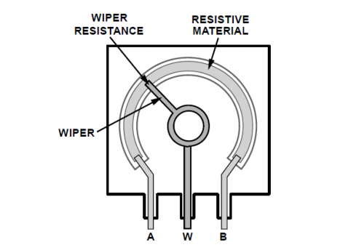

It is a variable resistor. By rotating the knob, it is possible to increase or decrease electric voltage. In this way the sound played by the buzzer will be louder or lower.