Final state machine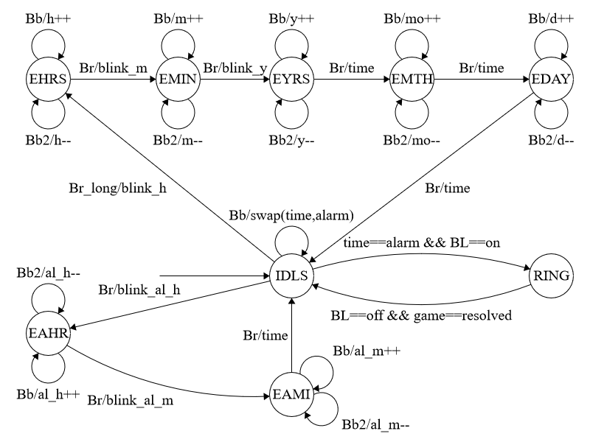

The final state machine above describes the behaviour of the system.

The possible states are:

* IDLS: idle state
* EAHR: editing alarm hours
* EAMI: editing alarm minutes
* RING: the buzzer is ringing
* EHRS: editing current time hours
* EMIN: editing current time minutes
* EYRS: editing date year
* EMTH: editing month
* EDAY: editing day

At the beginning, the default state is IDLS (idle). In this state the 7-segment displays the current time, and the colon between hours and minutes blinks. Pressing the first black button, the display view will switch to alarm. In this view the colon does not blink.

Starting from the IDLS state, after pressing the red button the system switches on EAHR state: edit alarm hours. A press on the first black button increases alarm hours, a press on the second black button decreases it and a press on the red button switches to the EAMI state, to edit alarm minutes. As before, it is possible to increase and decrease values by pressing black buttons. Another press on the red button and the system goes back to IDLS state.

Another transition from IDLS state is possible by pressing for a long time the red button: it makes the state switches to EHRS (editing hours). By pressing the first black button is possible to increase hours, while the second black button will decrease it. At this point, a short press on the red button and is possible to edit minutes (EMIN), with the same method: first black button to increase, second to decrease by one.  
In these states the display shows the time modified blinking respectively hours and minutes. From the EMIN state, pressing on the red button switches the system to the editing date mode: first EYRS to modify current year, then EMTH to modify current month, then EDAY to modify current day. In each of these states, a press on the first black button increases value by one, while a press on the second black button decreases it. While editing date, the 7-segments displays current time, while the date is shown on the Nokia display, without blinking.  
After editing date, it is possible to go back to IDLS state with another press on the red button.

Last transition occurs during alarm: when alarm and current time are the same, and the alarm switch is ON, the system commutes to RING state, where the buzzer starts playing. In order to go back to idle, the alarm switch must be turned OFF and the game must be resolved.