Interrupts

An interrupt is a signal that can interrupt the normal execution flow to take care of an immediate event. Arduino Leonardo allows for as many as 5 interrupt pins. Interrupts can be triggered on 4 different situations:

* When the pin is LOW
* Whenever the pin changes value
* When the pin goes from LOW to HIGH
* When the pin goes from HIGH to LOW

Additionally, timed interrupts can be set. Arduino Leonardo

Pin 2

sei();                    // Enable global interrupts  
EIMSK |= (1 << 1);     // Enable external interrupt INT1

EICRA |= (1 << 2);    // Trigger INT1 on change

EICRA |= (1<<ISC31) | (1<<ISC21) | ((1<<ISC11)|(1<<ISC10)) | (1<<ISC00)

ISR(EXT_INT1_vect)

ICR1 = 15625 /timer limit

TCCR1B |= (1<<CS12) | (1<<WGM13) //100 -> 256 scaling and wgm13-> ICR1 is limit

TIMSK1 |= 1 timer overflow

ISR(TIMER1_OVF_vect)

Pin 11 input no pullup

Value = PINB & (1<<7) // read value

Pin 2 pullup

PORTD |= (1<<1) //set pullup

Value = PIND & (1<<1)

I2c

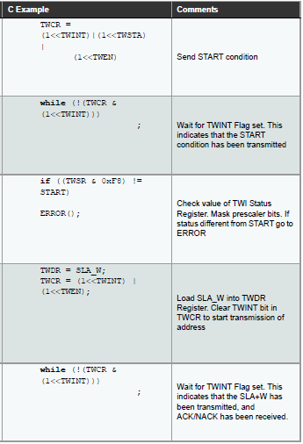

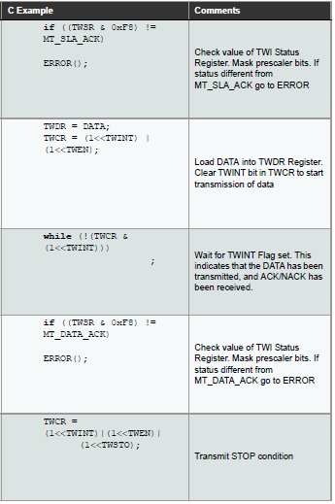

Spi

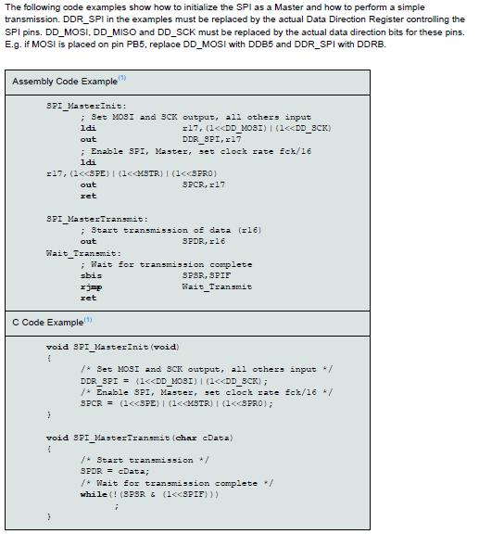

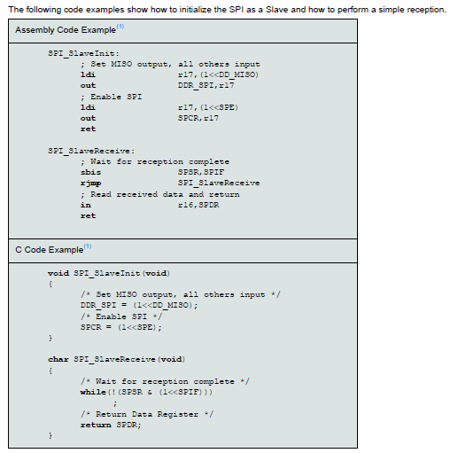

PWM

void NewTone(uint8_t pin, unsigned long frequency, unsigned long length) {

uint8_t prescaler = _BV(CS10); // Try using prescaler 1 first.

unsigned long top = F_CPU / frequency / 4 - 1; // Calculate the top.

if (top > 65535) { // If not in the range for prescaler 1, use prescaler 256 (61 Hz and lower @ 16 MHz).

prescaler = _BV(CS12); // Set the 256 prescaler bit.

top = top / 256 - 1; // Calculate the top using prescaler 256.

}

if (length > 0) _nt_time = millis() + length; else _nt_time = 0xFFFFFFFF; // Set when the note should end, or play "forever".

if (_pinMask == 0) {

_pinMask = digitalPinToBitMask(pin); // Get the port register bitmask for the pin.

_pinOutput = portOutputRegister(digitalPinToPort(pin)); // Get the output port register for the pin.

uint8_t *_pinMode = (uint8_t *) portModeRegister(digitalPinToPort(pin)); // Get the port mode register for the pin.

*_pinMode |= _pinMask; // Set the pin to Output mode.

}

ICR1 = top; // Set the top.

if (TCNT1 > top) TCNT1 = top; // Counter over the top, put within range.

TCCR1B = _BV(WGM13) | prescaler; // Set PWM, phase and frequency corrected (ICR1) and prescaler.

TCCR1A = _BV(COM1B0);

TIMSK1 |= _BV(OCIE1A); // Activate the timer interrupt.

}

Analog read

int ADCsingleREAD(uint8_t adctouse)

{

    int ADCval;

    ADMUX = adctouse;        // use #1 ADC 9 -> pin 12

    ADMUX |= (1 << REFS0);   // use AVcc as the reference

    ADMUX &= ~(1 << ADLAR); // clear for 10 bit resolution

// 128 prescale for 8Mhz

ADCSRA |= (1 << ADPS2) | (1 << ADPS1) | (1 << ADPS0);

    ADCSRA |= (1 << ADEN);    // Enable the ADC

    ADCSRA |= (1 << ADSC);    // Start the ADC conversion

    while(ADCSRA & (1 << ADSC)); // waits for the ADC to finish

    ADCval = ADCL;

    ADCval = (ADCH << 8) + ADCval; // ADCH is read so ADC can be updated again

    return ADCval;

}

Tone

<https://github.com/arduino/ArduinoCore-avr/blob/master/cores/arduino/Tone.cpp>