Matteo Belenchia, Marcin Massalski

Politechnika Łódzka, international faculty of engineering  ul. Żeromskiego 116, Łódź

Admin panel component

Contents

Purpose and range 3

Requirements 3

Functional requirements 3

Non-Functional requirements 4

Use case diagram 5

Component Diagram 6

Class Diagram 6

Use case implementation 7

Join chat 7

Read chat 8

Send message 11

Delete message 12

Leave chat 13

Set max players 14

Set minimum bet 15

Close Game session 17

See running Games 18

See connected Players 19

Edit Player 20

Ban Player 21

Refresh stats 23

Show game specific stats 23

Show today’s stats 24

Show player stats 25

Show total stats 26

Show history 27

Activity diagrams 27

Delete Message 27

Send Message 28

Show Player statistics 28

State transition diagrams 28

AdminPanel Class 28

Chat Class 29

DataViewer Class 29

Timing Diagram 29

Package Diagram 30

Composite structure diagrams 31

Chat Class 31

DataViewer Class 31

Interaction Overview Diagram 32

Conclusions 32

User guide 32

# Purpose and range

The Admin Panel component is designed to work as part of the Online Casino system, the purpose of which is the development of a web application that provides the basic functionalities of a Casino, such as playing slots, BlackJack and Roulette, withdraw and deposit money, chat with other Players and more.

The purpose of the Admin Panel component is to provide the administration and monitorization of Players and visualization of the relevant data and information present in the system, both as runtime data and database data. The component offers various administration tool such as banning Players, closing Games, limiting the number of connected Players, setting a minimum bet requirement and more, as described in the requirements section and use case diagram. At the same time, the list of logged Players and currently running games is also visualized. There also is a great deal of variety in the kind of data that can be visualized, that spans Player personal statistics to Game specific statistics to global total or daily statistics of the system as a whole. Statistics can also be visualized day by day.

Additionally, we decided to develop also a Chat, which does not belong to the Admin Panel component, but is in fact part of the User Management component. To simplify things, the Chat doesn’t use the Database Management component and does all its work internally to its own package, which is fully developed by us.

The range of the component is limited by its strong dependencies on User Management and Game Management components. All operations of the Admin Panel need to use the interfaces provided by the aforementioned components, and thus by itself the component is merely visualizing received data or formatting input data to be used in the appropriate interface, and dealing with the communication between the front-end GUI and the back-end Server.

# Requirements

## Functional requirements

The server management component shall:

1. Let the admins ban a player until a certain time in the future.
2. Allow the admin to close game sessions
3. Allow the admin to change any attribute of any user
4. Allow the admin to change the minimum allowed bet
5. Allow the admin to set the maximum number of concurrently connected users
6. Show connected users and admin(s)
7. Show currently running game sessions
8. Show, for each game type:
   1. House losses and gains total
   2. Average and minimum bet
   3. Number of game sessions
   4. Profitability
9. Show today’s :
   1. Aggregated house losses and gains
   2. House losses and gains per game type
   3. Number of game sessions
   4. Profitability
10. Show total:
    1. Aggregated house losses and gains
    2. Number of game sessions
    3. Profitability
11. Show player’s :
    1. Anagraphic data
    2. Total losses, gains and current balance
12. Show all daily stats (history) in the last month
13. Refresh the shown data periodically without any user input
14. Allow joining and leaving the chat
15. Read latest messages in the global chat
16. Let admins and users alike send messages in the global chat
17. Let users delete their own messages as long as they are shown in the chat
18. Let admins delete any message as long as they are shown in the chat

## Non-Functional requirements

The server management component shall:

1. Let players be banned with a zero duration
2. Not allow a less than 1 minimum bet
3. Not allow to edit a Player into having an already used username
4. Not allow to edit a Player into having an already used email
5. Not allow a less than 1 maximum number of connected Players
6. Refresh shown statistics once every 5 minutes
7. Assign an ID to each chat message for identification and selection
8. Set the chat message timestamp as the server's local time upon receipt
9. Limit the number of messages shown on the chat
10. Highlight admin messages in the chat
11. Delegate the DB access for the editing of the users' data, kicking players, setting server capacity, query Player statistics and visualize connected Playersto the User Management Component by using the appropriate interface
12. Delegate the DB access for closing games, setting the minimum bet and querying statistics to the Game Management Component by using the appropriate interface
13. Have a user-friendly graphical user interface

# Use case diagram

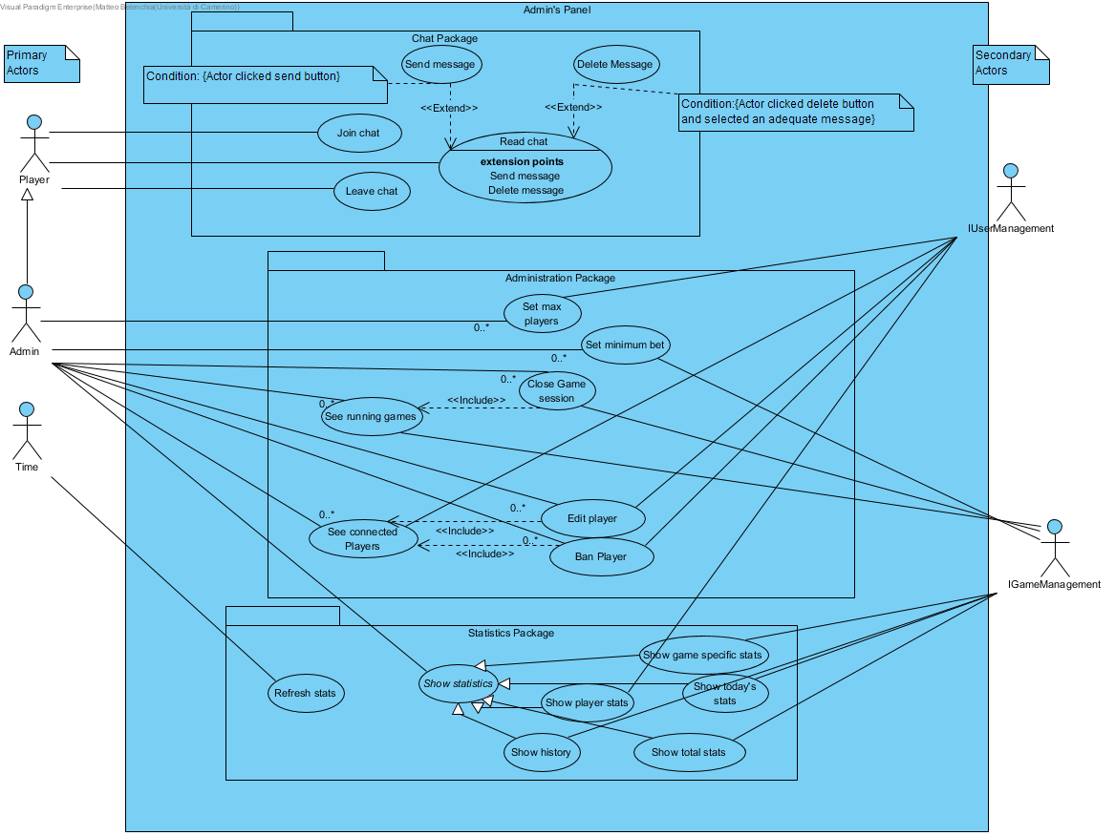

# Component Diagram

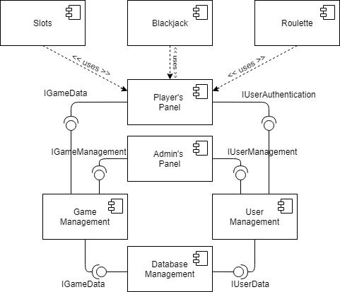

# Class Diagram

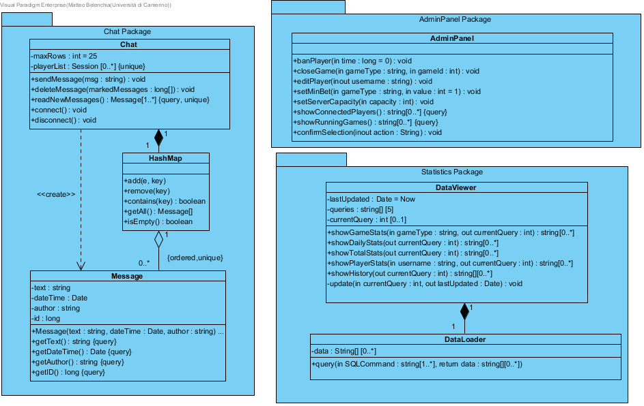

# Use case implementation

## Join chat

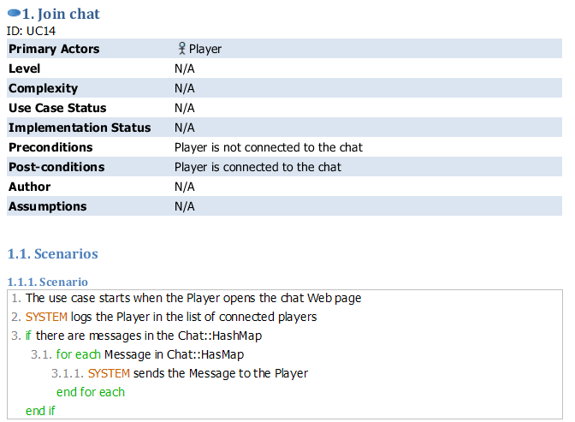

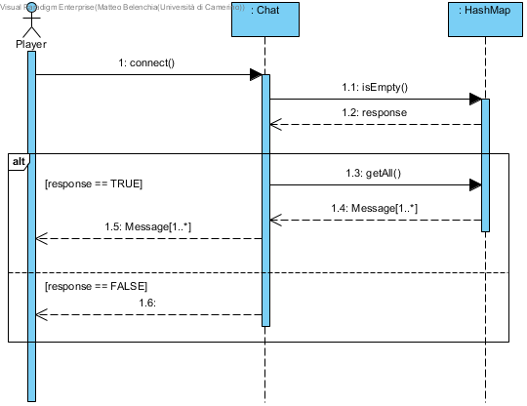

## Read chat

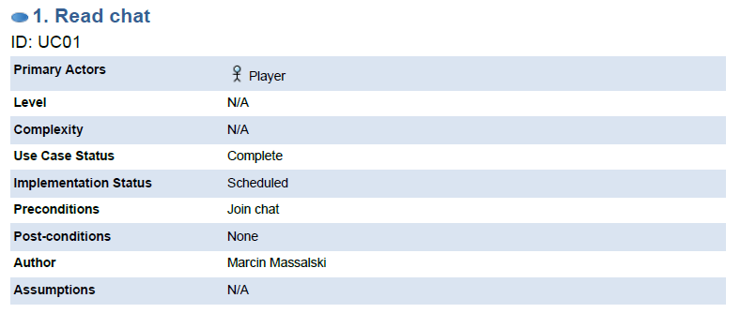

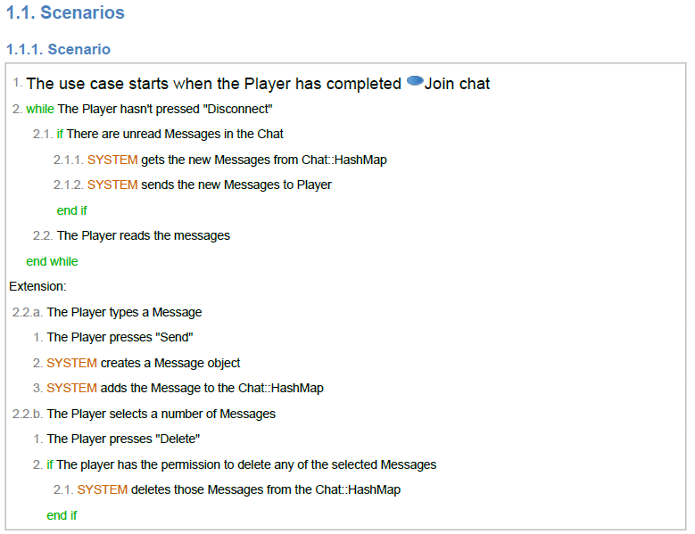

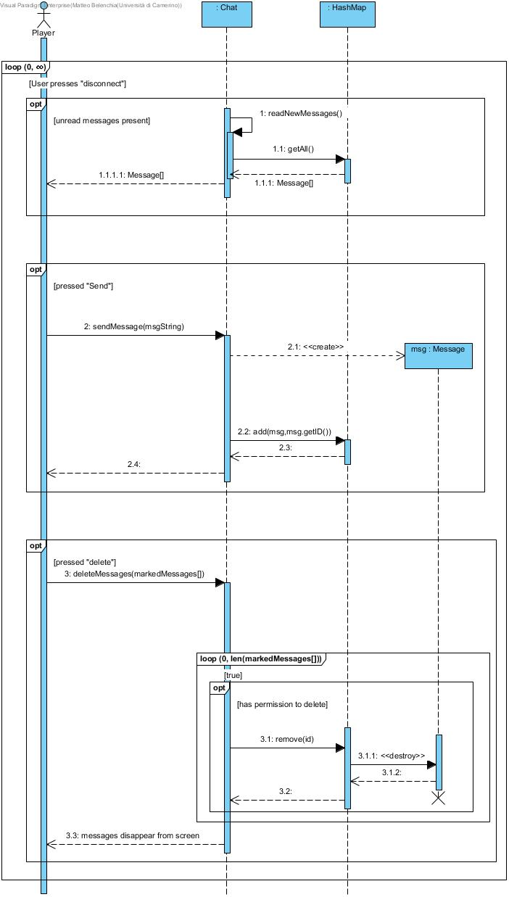

## Send message

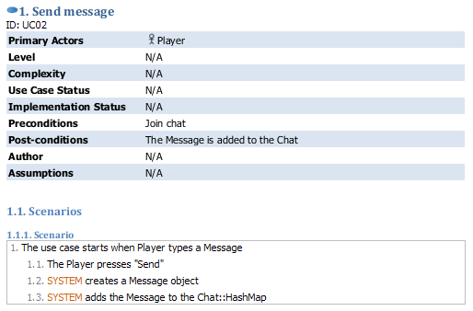

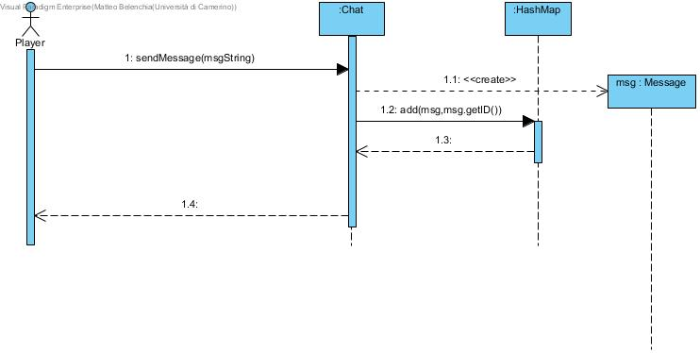

## Delete message

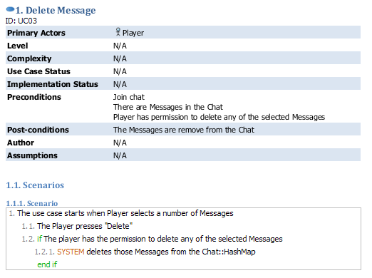

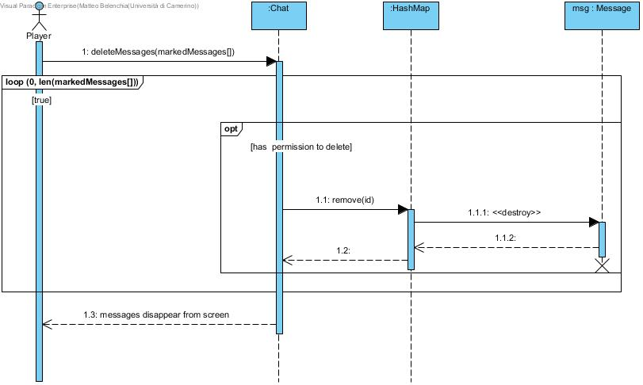

## Leave chat

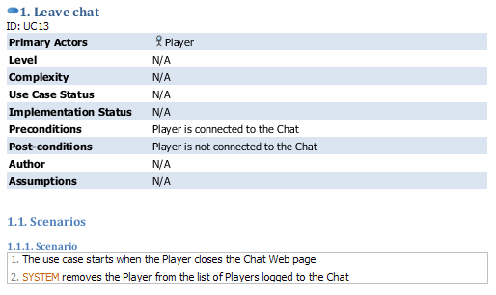

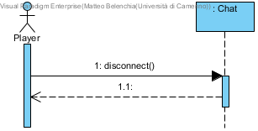

## Set max players

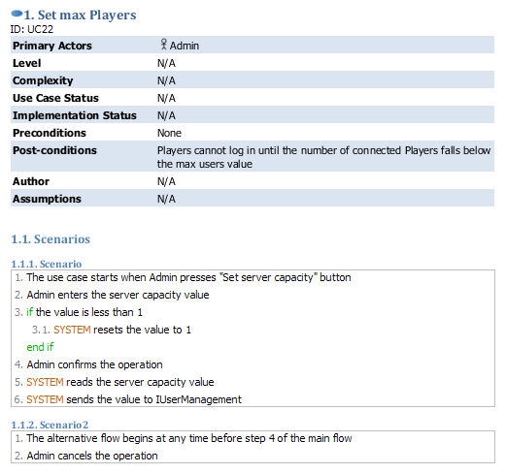

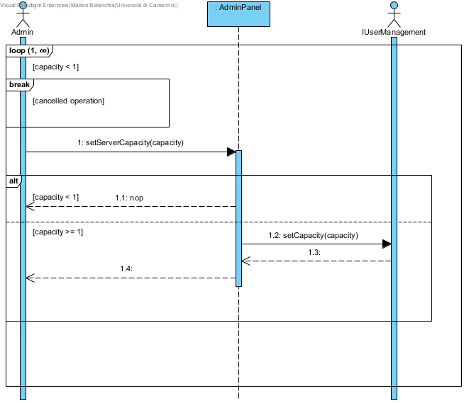

## Set minimum bet

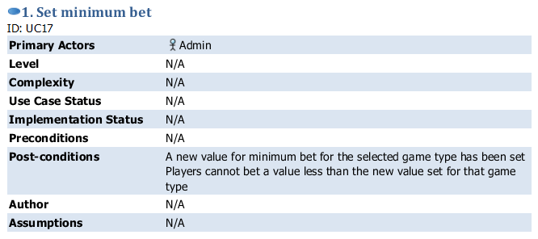

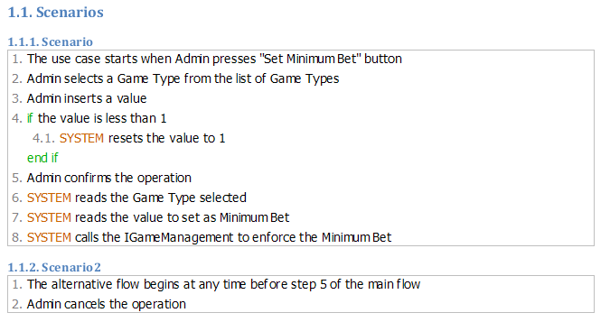

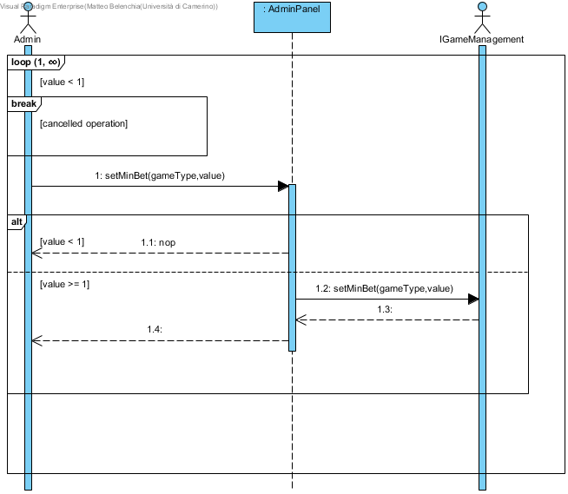

## Close Game session

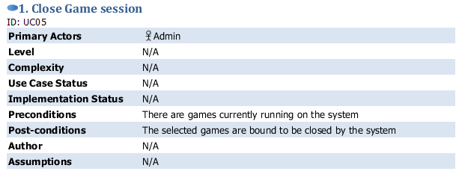

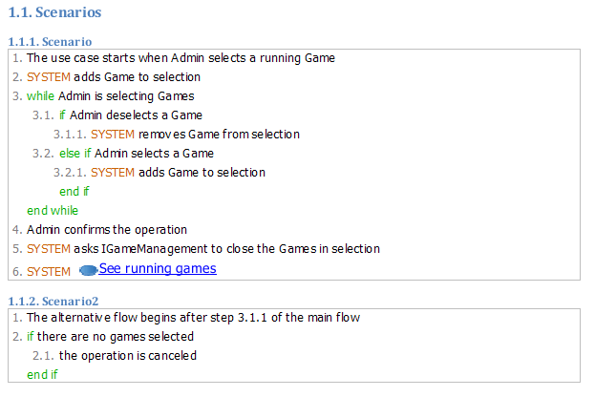

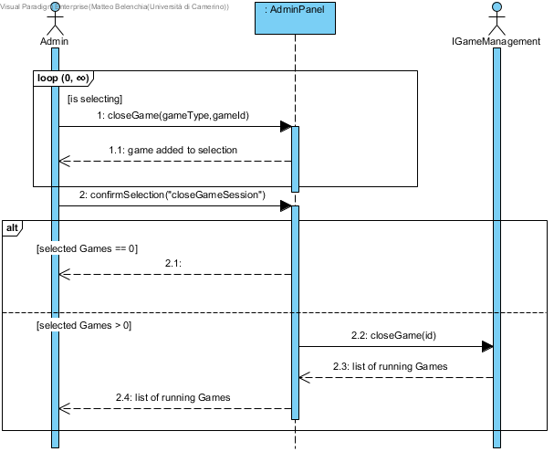

## See running Games

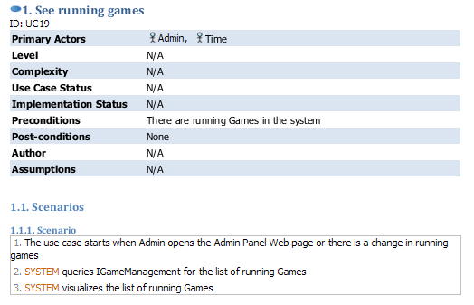

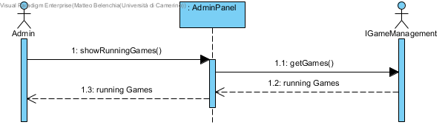

## See connected Players

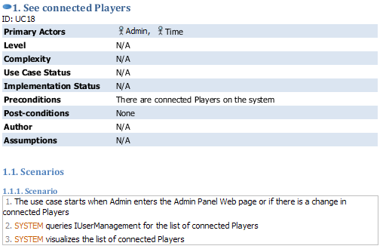

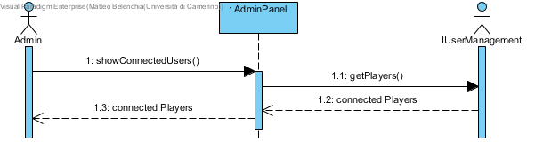

## Edit Player

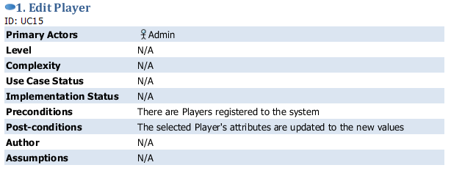

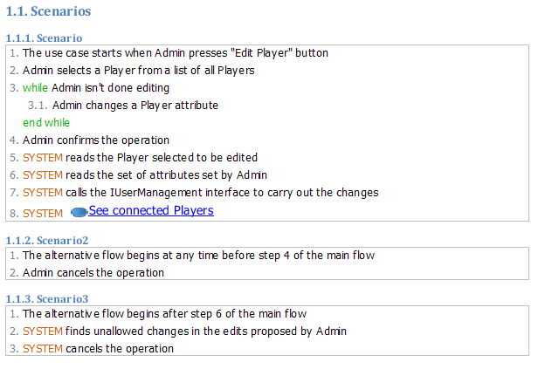

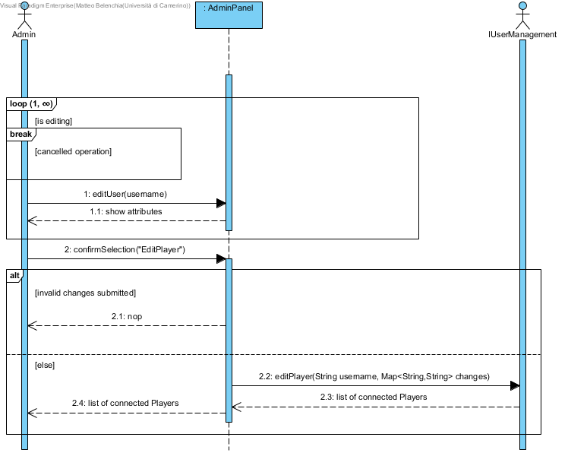

## Ban Player

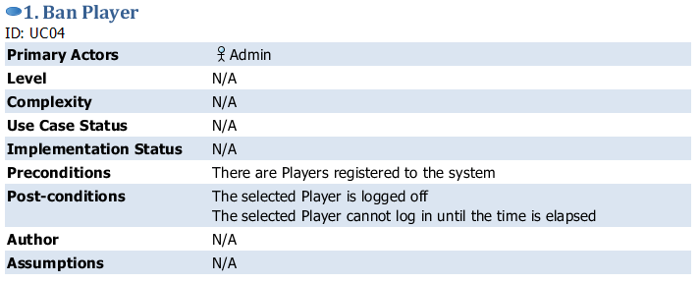

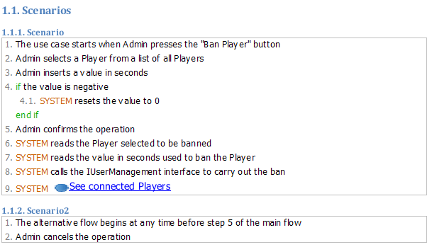

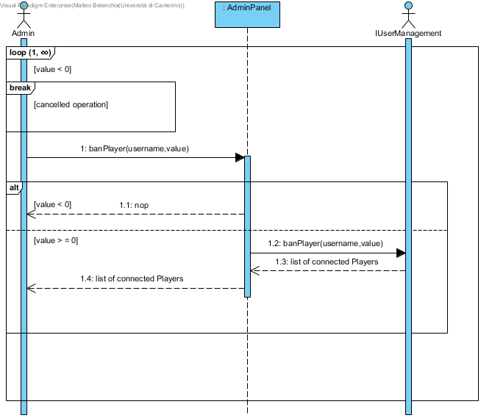

## Refresh stats

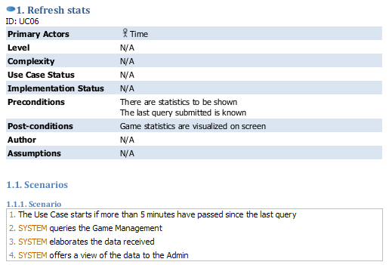

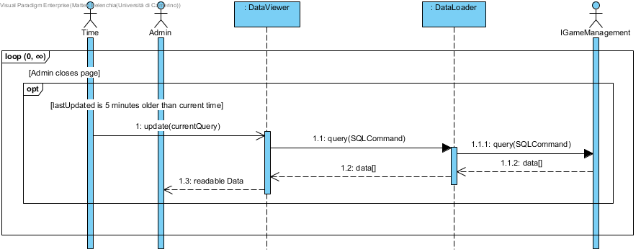

## Show game specific stats

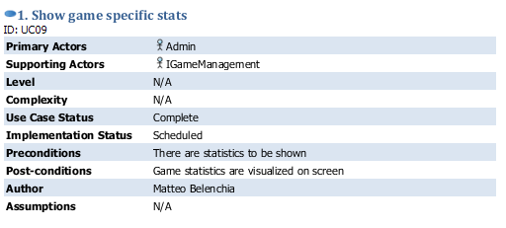

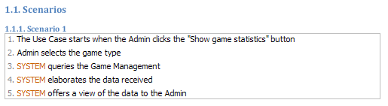

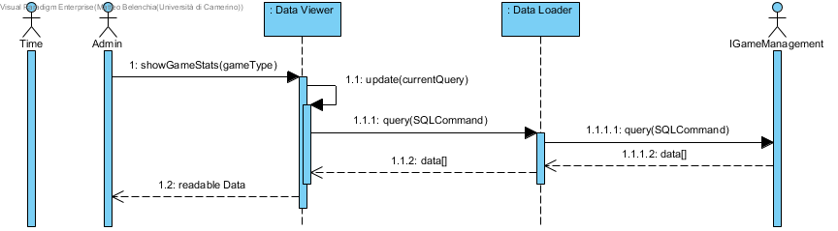

## Show today’s stats

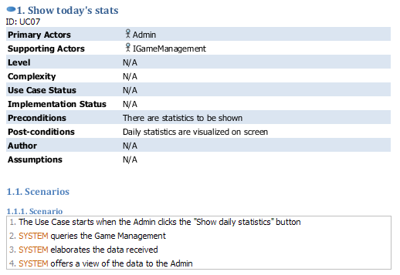

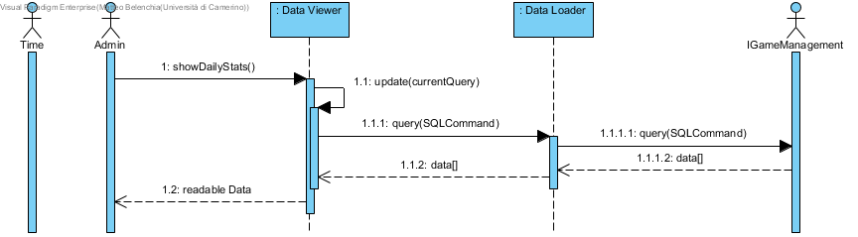

## Show player stats

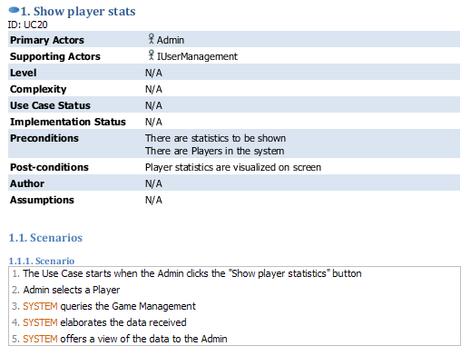

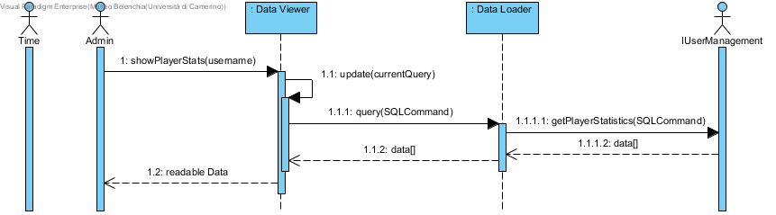

## Show total stats

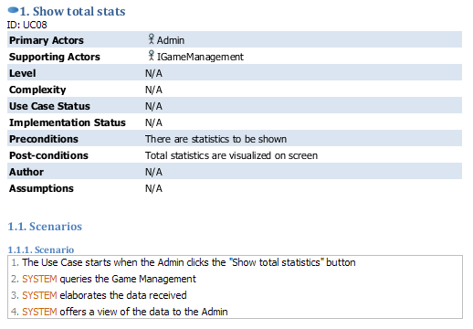

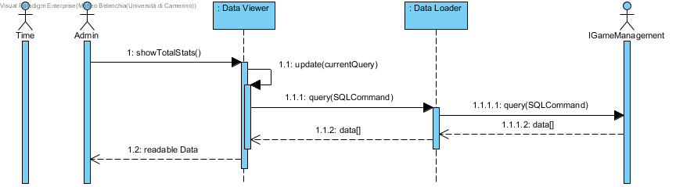

## Show history

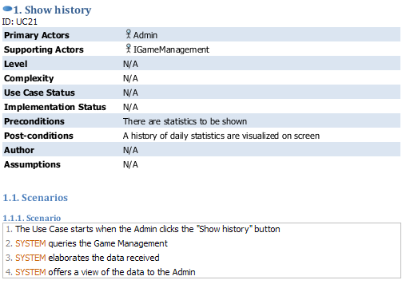

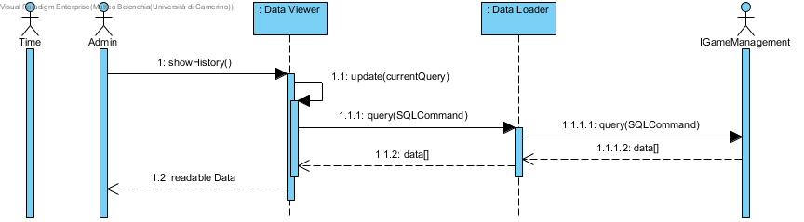

# Activity diagrams

## Delete Message

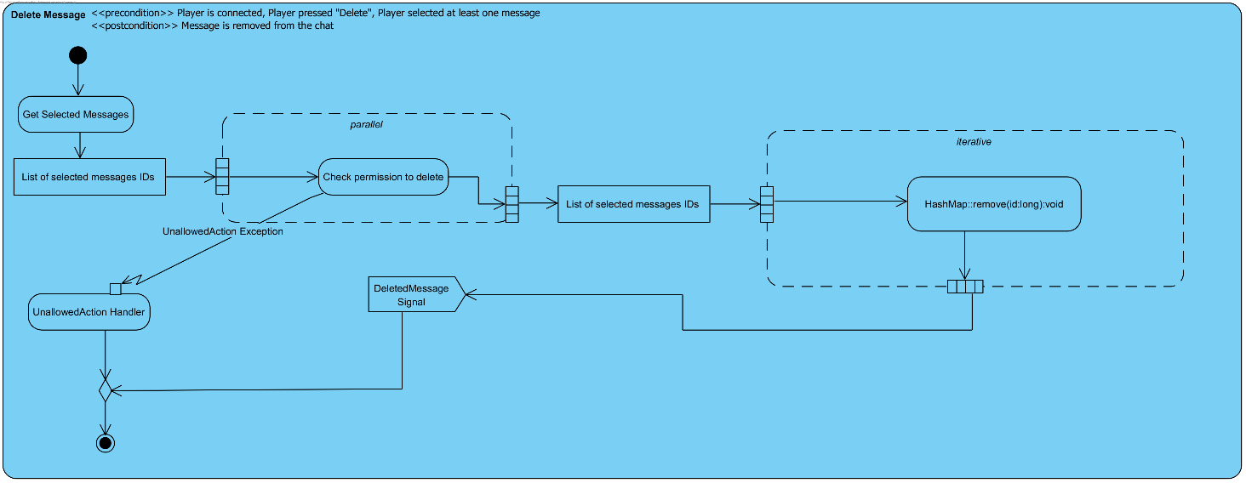

## Send Message

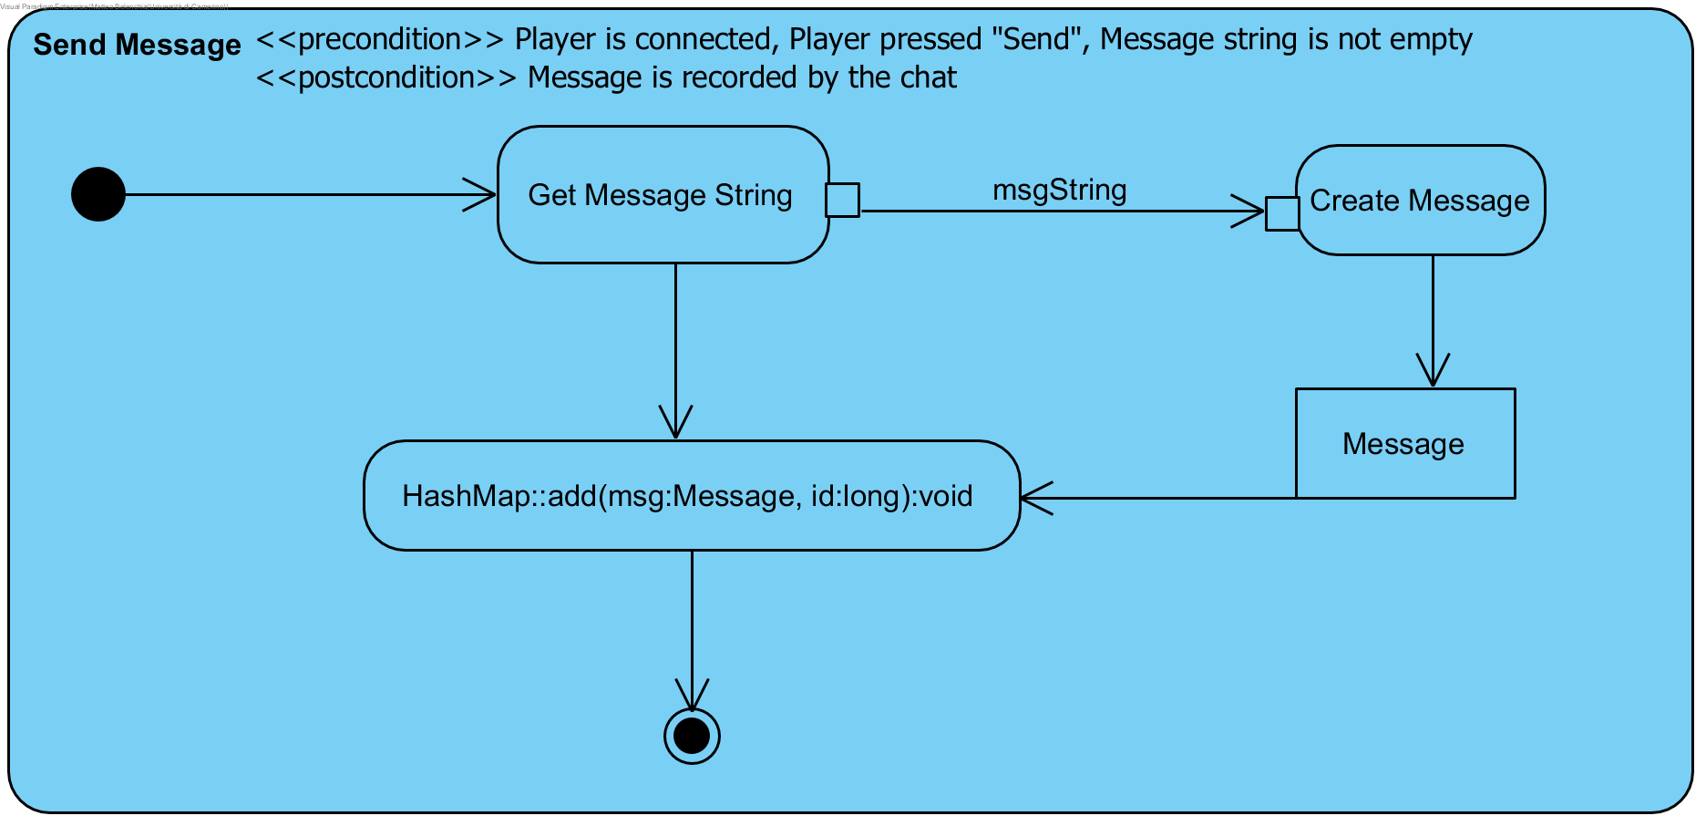

## Show Player statistics

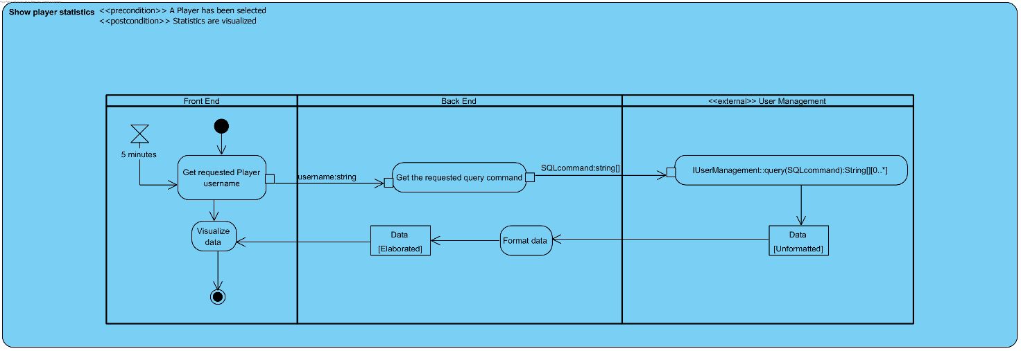

# State transition diagrams

## AdminPanel Class

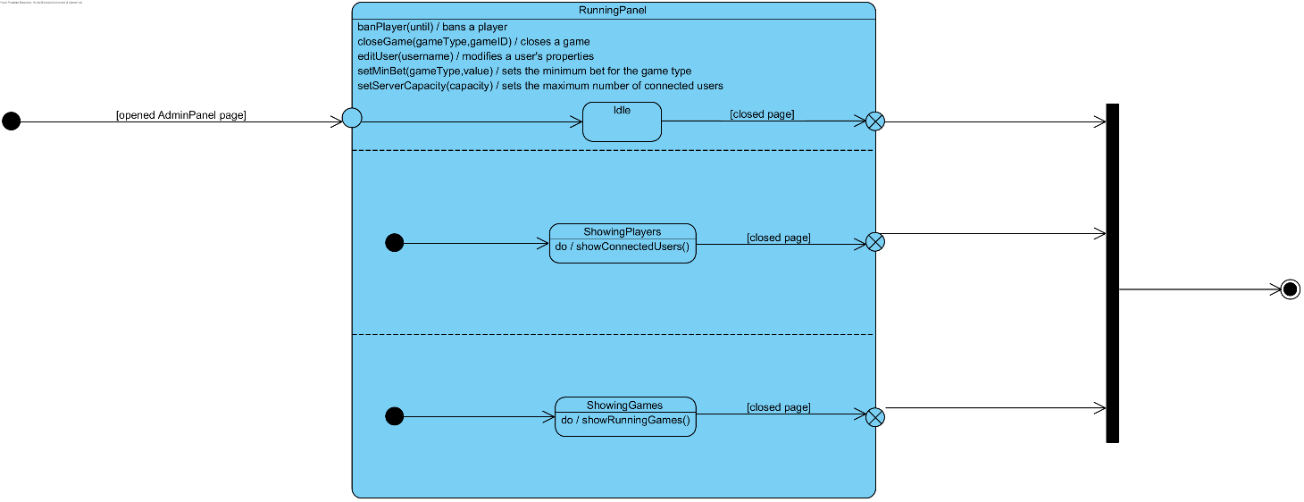

## Chat Class

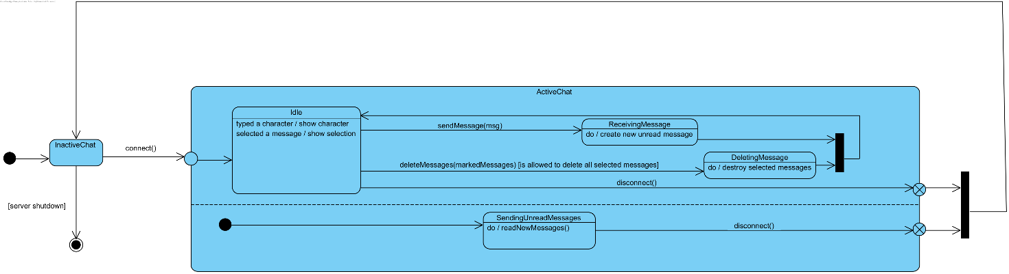

DataViewer Class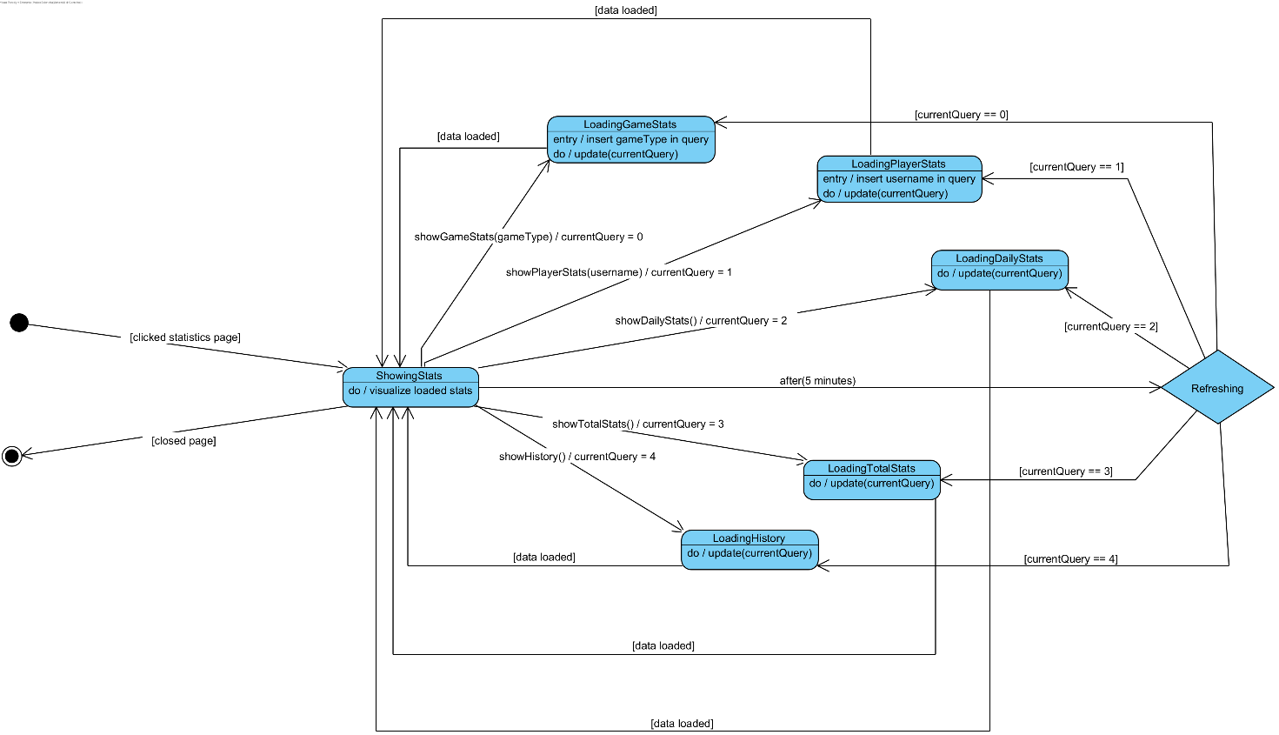

# Timing Diagram

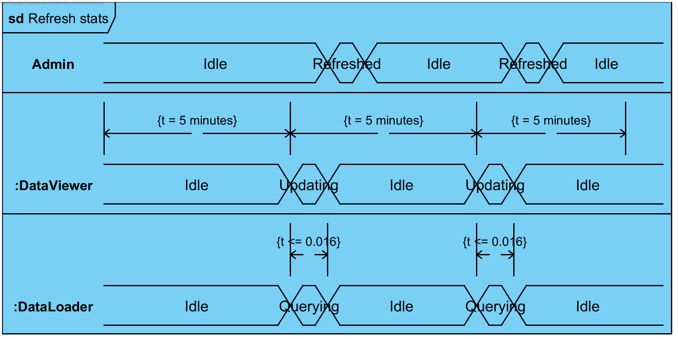

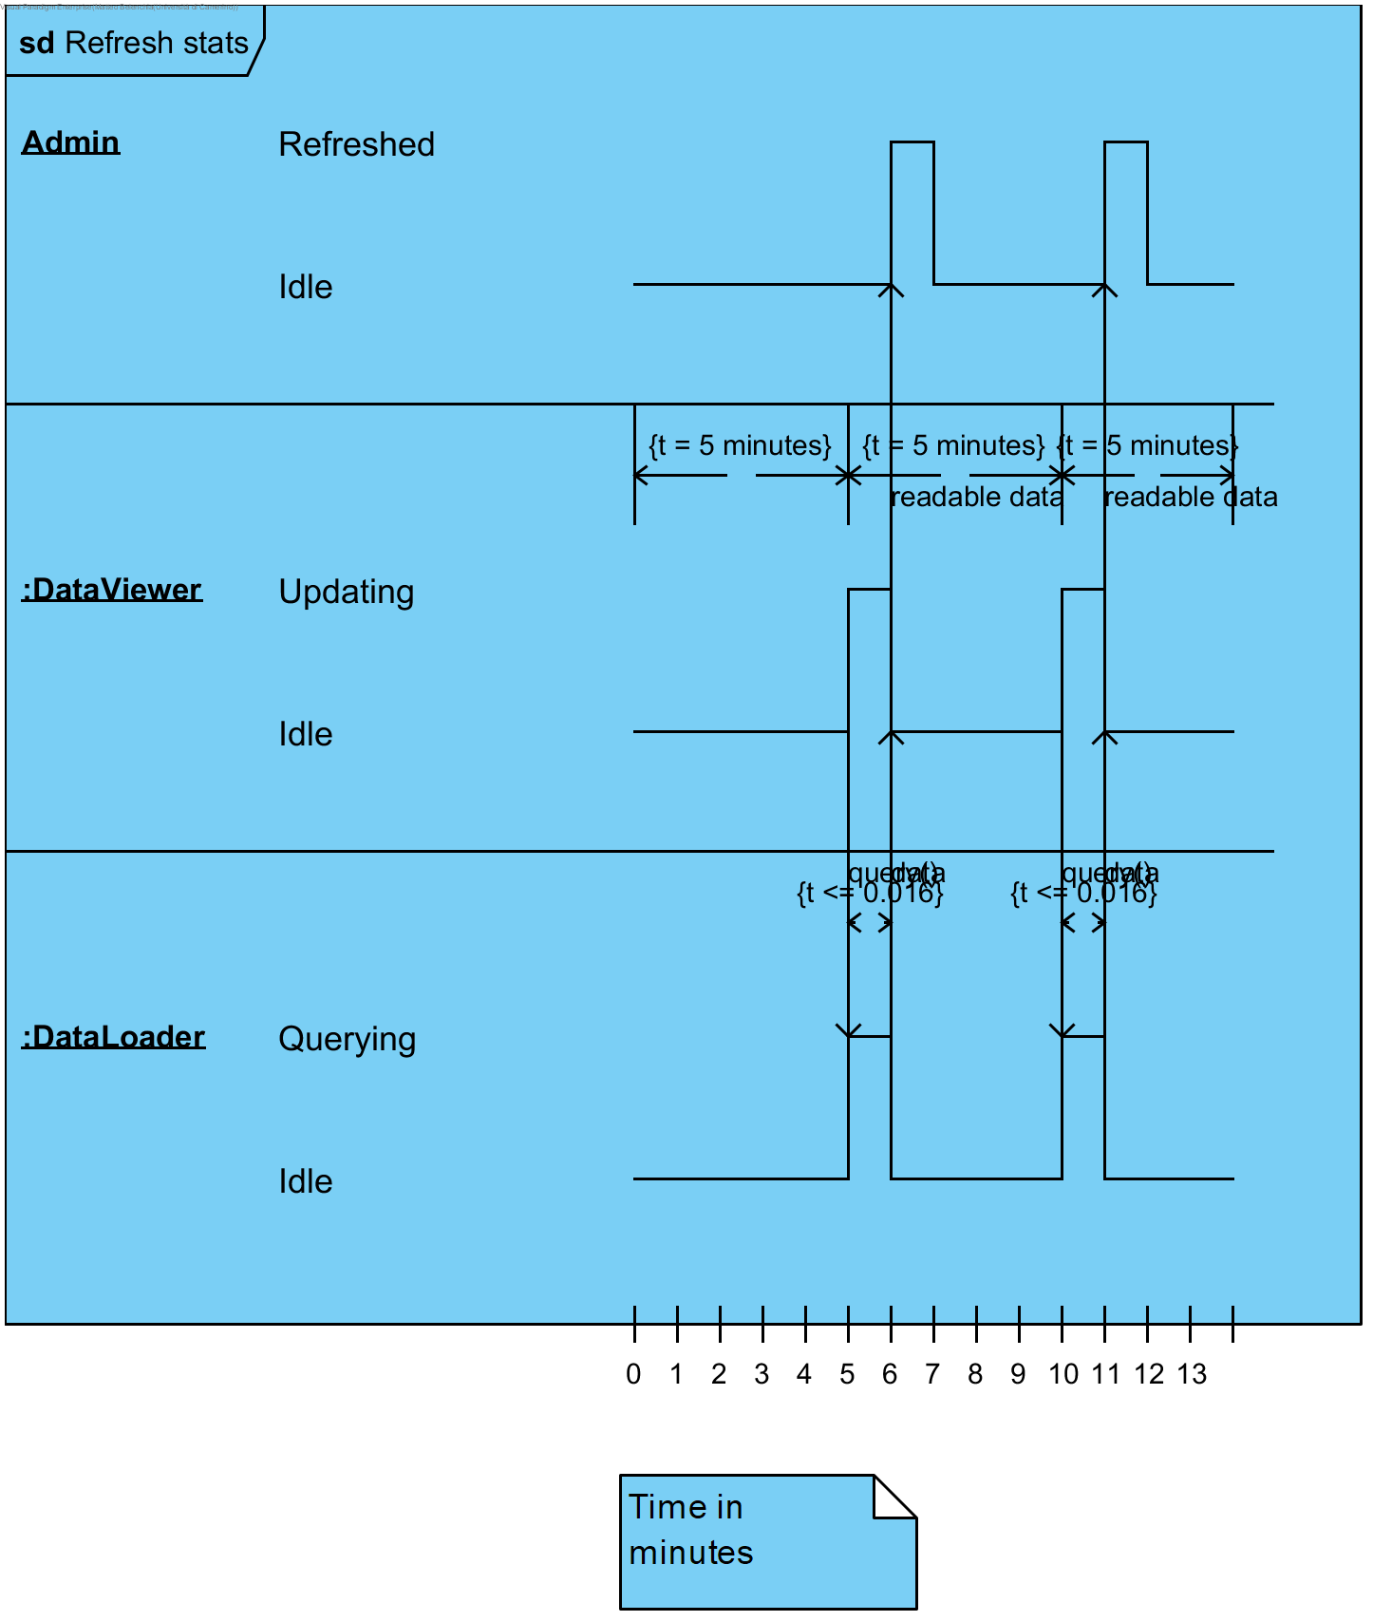

# Package Diagram

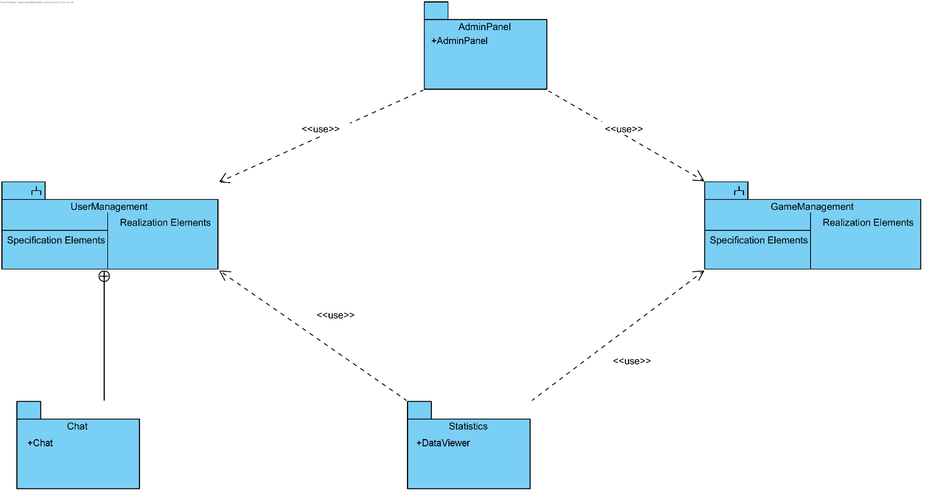

# Composite structure diagrams

## Chat Class

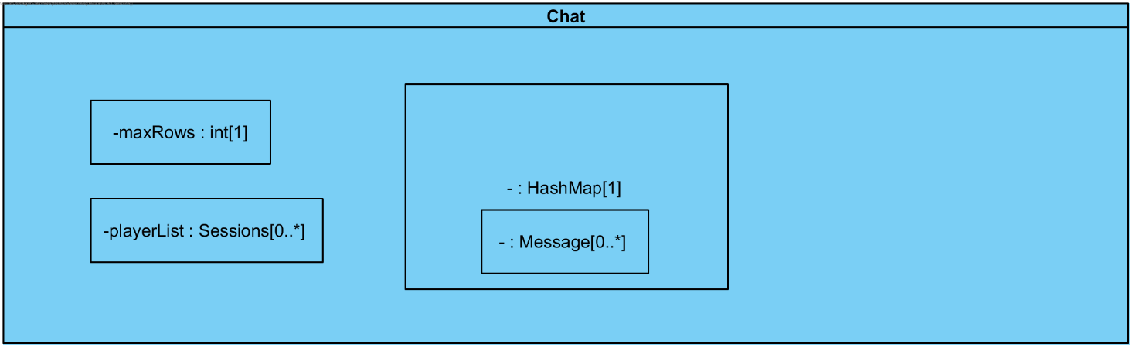

## DataViewer Class

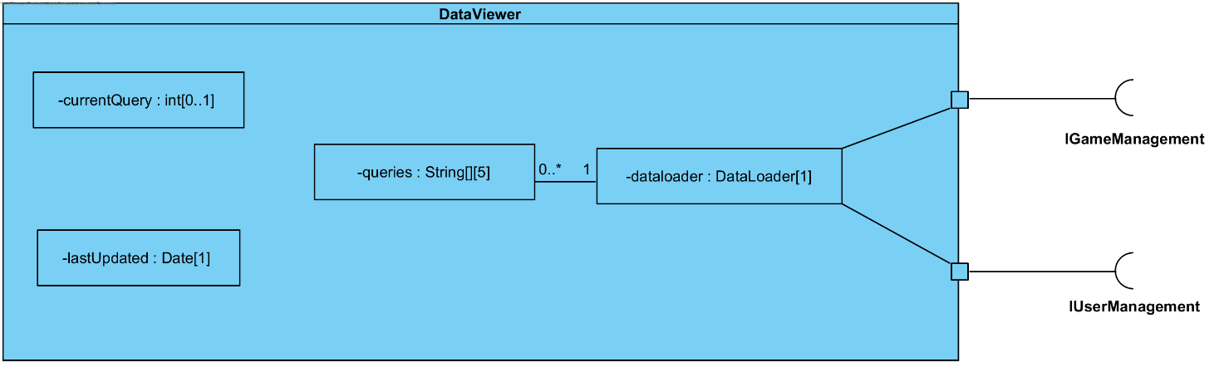

# Interaction Overview Diagram

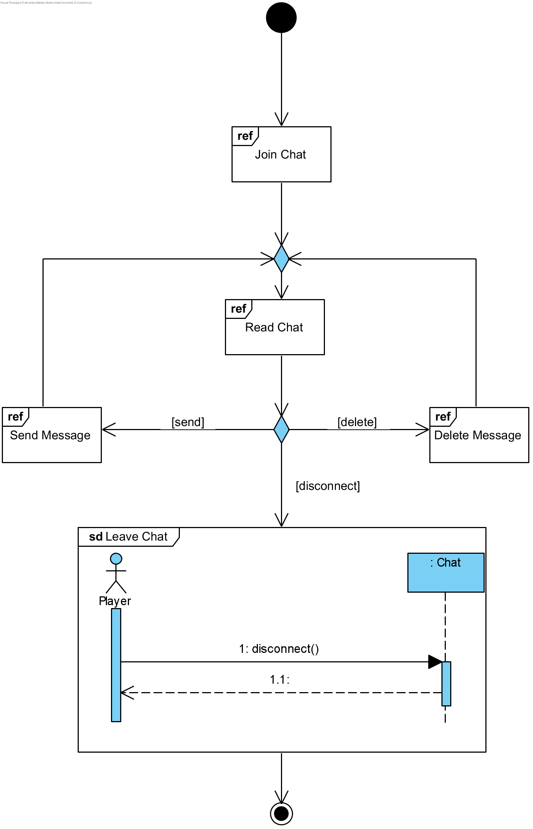

# Conclusions

# User guide