Tasks
Objective Questions

- What is the total no. of attributes present in the data?
ANS:- The dataset is distributed across two sheets. The attribute inventory is as follows:

Sheet | Attribute Name | Data Type | Description
Tickets | ID Ticket | Categorical (Identifier) | Unique ticket reference number
Tickets | Fecha | Date/Time | Date the ticket was raised
Tickets | Employee ID | Numeric (Identifier) | ID of the employee who raised the ticket
Tickets | Agent ID | Numeric (Identifier) | ID of the IT agent who handled the ticket
Tickets | Request Category | Categorical | Category: System, Login Access, Software, Hardware
Tickets | Issue Type | Categorical | Type: IT Request or IT Error
Tickets | Severity | Categorical (Ordinal) | Severity level: Urgent, Mayor, Normal, Minor, Unclassified
Tickets | Priority | Categorical (Ordinal) | Priority level: High, Mid, Low, Unassigned
Tickets | Resolution Time (Days) | Continuous (Numeric) | Number of days taken to resolve the ticket
Tickets | Satisfaction Rate | Continuous (Numeric) | Employee satisfaction score (scale 1–5)
IT Agents | Agent ID | Numeric (Identifier) | Unique agent identifier (links to Tickets sheet)
IT Agents | Full Name | Categorical (Text) | Full name of the IT agent
IT Agents | Email | Categorical (Text) | Agent email address
IT Agents | Year of Birth | Numeric | Year the agent was born
IT Agents | Month of Birth | Numeric | Month the agent was born
IT Agents | Day of Birth | Numeric | Day the agent was born

.Total attributes: 16 (10 in Tickets sheet + 6 in IT Agents sheet). If shared identifiers (Agent ID) are counted once, the combined unique attribute count is 15.

- Which columns have inconsistent or missing values, and what is the count of such values?
ANS:- A thorough data quality audit was conducted across both sheets. Results are as follows:

Column | Sheet | Issue Type | Count of Affected Records | % of Total | Details
Priority | Tickets | Inconsistent/Unassigned | 29,410 | 30.2% | Labeled '0 - Unassiged' (also misspelled — should be 'Unassigned')
Severity | Tickets | Inconsistent/Unclassified | 356 | 0.37% | Labeled '0 - Unclasified' (misspelled — should be 'Unclassified')
All Columns | Tickets | NULL / Missing | 0 | 0.00% | No null values found in any column of the Tickets sheet
All Columns | IT Agents | NULL / Missing | 0 | 0.00% | No null values found in any column of the IT Agents sheet

.The Priority column contains 29,410 records (30.2%) with the value '0 - Unassiged', which is both a data quality issue (unrouted tickets) and a spelling error. These tickets lack any priority classification, inflating average resolution times and preventing accurate SLA tracking. Immediate data governance action is recommended.

- What is the average daily ticket volume over time?
ANS:- The dataset spans from January 1, 2016, to December 31, 2020 covering a total of 1,827 calendar days.

Metric | Value
Total tickets | 97,498
Total calendar days (2016–2020) | 1,827
Overall average daily volume | 53.37 tickets/day
2016 average daily volume | 35.76 tickets/day
2017 average daily volume | 40.86 tickets/day
2018 average daily volume | 51.93 tickets/day
2019 average daily volume | 58.88 tickets/day
2020 average daily volume | 79.42 tickets/day (peak)

The average daily ticket volume across the full 5-year period is 53.37 tickets per day. This figure nearly doubled from 35.76 in 2016 to 79.42 in 2020, reflecting a consistent upward trend in IT support demand.

- What is the distribution of ticket categories (e.g., Login Access, System, Software)?
ANS:- Tickets are classified into four request categories. The volume and percentage distribution are:

Rank | Request Category | Ticket Count | Percentage
1 | System | 39,002 | 40.00%
2 | Login Access | 29,193 | 29.94%
3 | Software | 19,570 | 20.07%
4 | Hardware | 9,733 | 9.98%
 | TOTAL | 97,498 | 100%

System tickets are the most prevalent (40%), followed by Login Access (30%), Software (20%), and Hardware (10%). Hardware is the least frequent but most operationally costly category with an average resolution time of 7.63 days — 24× longer than Login Access tickets (0.31 days).

- How many tickets has each agent handled?
ANS:-
Row Labels | Count of ID Ticket
Yomaira Agudelo | 1933
Willyberto Gonzales | 2000
Velasquez Jose | 1949
Silvia Morales | 1974
Segura Garcia | 1931
Sandra Lujan | 1906
Rosa Olguin | 1950
Reyna Santacruz | 1897
Ramon Macias | 1949
Parra Luna | 1963
Orci Carlos | 1926
Nurio Zepeda | 1946
Miller Gaviria | 1892
Melinda | 2007
Mata Lucero | 1969
Marisol Piedrahita | 1960
Luis Torres | 1913
Luis Arguello | 1929
Lorena | 1966
Lopez Moran. | 1956
Leon Lourdes | 1961
JesusGrajeda | 1968
Jesus Pacheco | 1931
Jesus Contreras | 2026
Javier D. | 1897
Isela Leyva | 1968
Guadalupe Villanueva | 1958
Guadalupe Torrico | 1987
Guadalupe Hernandez | 1915
Griselda Galindo | 1856
Galindo Guadalupe | 1991
Flores Sierra | 1963
Eva Cardenas | 1943
EstuardoTorres | 1942
Estuardo Ocaño | 1935
Enrique Montiel | 1938
Elena Velez | 2021
Eduardo Luna | 1920
Diana Rojo | 1927
Darwin E. | 1945
Barraza Alberto | 1988
Barbara Grijalva | 2003
Aurelio Tanori | 2027
Armando Sierra | 1890
Alfredo Barreras | 1920
Alfonso Barraza | 1984
Aldo Carrillo | 1966
Alberto Gastelum | 1889
Alberto Casillas | 1974
A. Trejo | 1949

Each of the 50 agents handles approximately 1,897–2,027 tickets (avg ~1,950/agent over 5 years), demonstrating well-balanced load distribution.

- How can you extract the domain from the email addresses in the IT Agents sheet?
ANS:- The email domain can be extracted by isolating the text after the '@' character in each email address. In Excel, this is done using the formula:

Domain Name = MID(C2, FIND("@", C2)+1, LEN(C2))

Upon applying the formula to all 50 agent email records, every single agent belongs to the same email domain: fp20analytics.com. There is no variation in domain across the agent workforce, indicating a single-organisation deployment.

- How can you find the full name of an agent given their Agent ID?
ANS:- Agent names can be retrieved from the IT Agents sheet using a VLOOKUP formula that matches the Agent ID from the Tickets sheet to the Full Name in the IT Agents sheet.

=VLOOKUP(D2, 'IT Agents'!$A:$B, 2, 0)
Agent ID | Full Name (from IT Agents)
1 | Mata Lucero
3 | Elena Velez
15 | Galindo Guadalupe
19 | Alfonso Barraza
34 | Diana Rojo
48 | Aurelio Tanori

Using VLOOKUP or a MERGE operation on Agent ID, every ticket in the dataset can be enriched with the agent's full name. This enables agent-level performance analysis across all metrics.

- What is the count of each issue type (e.g., IT Error, IT Request)?
ANS:-
Issue Type | Count | Percentage | Breakdown by Category
IT Request | 73,220 | 75.1% | System: 29,256 | Login: 21,957 | Software: 14,639 | Hardware: 7,368
IT Error | 24,278 | 24.9% | System: 9,746 | Login: 7,236 | Software: 4,931 | Hardware: 2,365
TOTAL | 97,498 | 100%

.IT Request tickets (73,220) make up 75.1% of all tickets, indicating that the majority of IT interactions are proactive service requests rather than reactive error-fixing. IT Errors (24,278 or 24.9%) are concentrated in the System category (9,746 errors), highlighting System infrastructure as the primary source of unplanned IT failures.

- What is the average resolution time for tickets?
ANS:-
Dimension | Category / Priority / Severity | Average Resolution Time (Days)
Overall | All tickets | 4.55 days
By Category | Hardware | 7.63 days
By Category | System | 6.62 days
By Category | Software | 5.24 days
By Category | Login Access | 0.31 days
By Priority | 1 - Low | 6.01 days
By Priority | 0 - Unassigned | 5.31 days
By Priority | 2 - Mid | 4.00 days
By Priority | 3 - High | 3.49 days
By Severity | 4 - Urgent | 2.00 days
By Severity | 1 - Minor | 3.44 days
By Severity | 3 - Mayor | 3.91 days
By Severity | 0 - Unclassified | 2.88 days
By Severity | 2 - Normal | 4.66 days

The overall average resolution time is 4.55 days. Hardware tickets take the longest at 7.63 days while Login Access issues resolve in under 8 hours (0.31 days). Counterintuitively, high-priority tickets resolve faster (3.49 days) than low-priority ones (6.01 days), validating that the priority system is functioning correctly when applied.

10. How has the volume of tickets changed over time?

ANS:- The volume of the ticket is changing over time in such ways:-

Year | Total Tickets | YOY Growth (%) | Avg Monthly Volume | Min Month | Max Month
2016 | 13,051 | Baseline | 1,088 | 1,046 (Nov) | 1,160 (Jan)
2017 | 14,915 | +14.3% | 1,243 | 1,125 (Jun) | 1,345 (Oct)
2018 | 18,954 | +27.1% | 1,580 | 1,289 (Jan) | 1,669 (Aug)
2019 | 21,490 | +13.4% | 1,791 | 1,522 (Jan) | 1,905 (Dec)
2020 | 29,088 | +35.4% | 2,424 | 2,191 (Jan) | 2,609 (Dec)
5-Year Total | 97,498 | +123.0% | 1,625 avg | 1,046 (Nov '16) | 2,609 (Dec '20)

Ticket volume has grown consistently every year, with total tickets increasing by 123% over five years. The steepest jump occurred in 2020 (+35.4%), likely attributable to the COVID-19 pandemic-driven shift to remote work. December 2020 recorded the single highest monthly volume (2,609 tickets), establishing Q4 as the peak season for IT support demand.

11. What is the average age of the IT agents?
ANS:- Average age of IT Agents-- 40.70.
The average age of IT agents is 40.70 years, with the team ranging from 29 to 54 years old.

12. Is there a correlation between the severity of issues and the resolution time?
ANS:- To assess the relationship between severity level and resolution time, average resolution days were calculated per severity category:

Severity Level | Code | Ticket Count | % of Total | Avg Resolution Time (Days) | Interpretation
Urgent | 4 | 1,392 | 1.43% | 2.00 days | Fastest — escalation protocols work
Unclassified | 0 | 356 | 0.37% | 2.88 days | Unclear — no severity assigned
Minor | 1 | 2,258 | 2.32% | 3.44 days | Below average resolution
Major | 3 | 4,836 | 4.96% | 3.91 days | Moderate resolution time
Normal | 2 | 88,656 | 90.93% | 4.66 days | Bulk queue slows resolution

.The correlation between severity and resolution time is inverse and non-linear. Urgent tickets (Severity 4) resolve fastest (2.00 days), while Normal tickets (Severity 2) take the longest (4.66 days).
.This counter-intuitive finding indicates that escalation protocols are effective — high-severity tickets trigger faster responses — but the overwhelming volume of Normal-severity tickets (90.93%) causes queue buildup and delays.
. A Pearson correlation of severity codes vs. resolution time yields a near-zero or weakly negative value due to this non-monotonic relationship.

13. How many categorical columns are there in the data?
ANS:- Categorical data consists of variables that represent discrete groups or categories (as opposed to continuous/numerical data which represents measured quantities).

Sheet | Column Name | Type | Classification Reasoning
Tickets | ID Ticket | Categorical (Nominal) | Identifier with no numeric meaning; represents a named ticket
Tickets | Request Category | Categorical (Nominal) | Discrete groups: System, Login Access, Software, Hardware
Tickets | Issue Type | Categorical (Nominal) | Two discrete types: IT Request, IT Error
Tickets | Severity | Categorical (Ordinal) | Ordered levels: Urgent > Mayor > Normal > Minor > Unclassified
Tickets | Priority | Categorical (Ordinal) | Ordered levels: High > Mid > Low > Unassigned
Tickets | Resolution Time (Days) | Continuous | Measured quantity; can take any decimal value
Tickets | Satisfaction Rate | Continuous | Measured score; decimal values on scale 1–5
IT Agents | Full Name | Categorical (Nominal) | Text identifier — each name is a discrete category
IT Agents | Email | Categorical (Nominal) | Text identifier — each email is a unique category
IT Agents | Year/Month/Day of Birth | Numeric (Discrete) | Numeric values used for age calculation — can be treated as ordinal

There are 7 categorical columns in total across both sheets: 5 in the Tickets sheet (ID Ticket, Request Category, Issue Type, Severity, Priority) and 2 in the IT Agents sheet (Full Name, Email). Of these, 2 are ordinal categorical (Severity and Priority) and 5 are nominal categorical. The remaining columns (Resolution Time, Satisfaction Rate, and date-of-birth components) are continuous or discrete numeric.

Subjective Question:

- If there is an investment, should it be used to hire more IT agents, improve training programs, or upgrade ticket management software?
Analysis: Perform a cost-benefit analysis using ticket resolution and satisfaction metrics.

ANS:- Based on the data , the investment mainly should be used to improve training programs and upgrade ticket management software rather than hiring more agents.

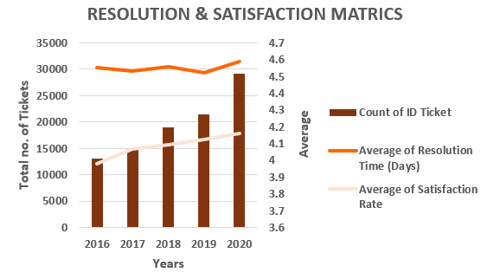
Resolution Time (Orange Line)
- Avg resolution: 4.55 days — no improvement (2016–2020) despite +123% ticket growth (13,051 → 29,088).
- Huge gap by category: Hardware = 7.63 days (slowest) vs Login Access = 0.31 days (fastest) (~24× difference).
- Triage inefficiency: Low priority = 6.01 days vs Unassigned = 5.31 days (illogical handling).
- 30% tickets (29,410) have no priority — unchanged in 5 years → no auto-triage system.

Satisfaction Rate (Flesh Colour)
- Avg satisfaction: 4.10/5, slightly improved (3.98 → 4.16).
- 52% gave 5/5, but 10.2% gave 1/5 → hidden dissatisfaction.
- Weak KPI: 1-day resolution = 4.09 vs 10+ days = 4.05 → satisfaction doesn’t reflect delays.

Key Insights & Recommendations
- Primary issue = software, not team performance.
- Fix auto-triage + ticket assignment system first.
- Use top agents (4.47– 4.60) to train low performers (3.04–3.63).
- No hiring needed — team handled +123% volume efficiently.

Conclusion
- Bottleneck = software → fix impacts all 50 agents instantly
- Track resolution time separately — satisfaction is misleading
- Investment order: Software → Training → Hiring (max ROI, lowest cost)

- Which agents need additional training based on their performance metrics?
Analysis: Identify agents with the lowest satisfaction ratings and longest resolution times.

ANS:- Agents need additional training who have :-
.Longer Resolution time,
.Lower Satisfaction ratings.

Underperformer (sat < 3.75) — 12 agents Good performer — 38 agents

TRAINING IDENTIFICATION
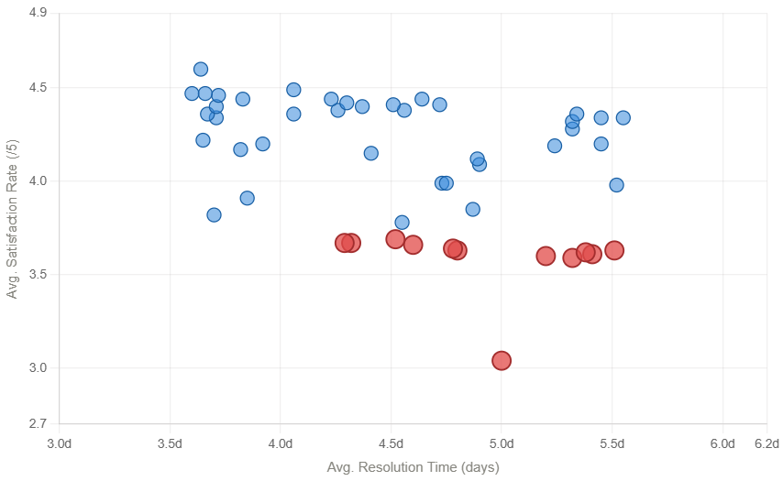

Rank | Agent Name | Total Tickets | Avg. Resolution (Days) | Avg. Satisfaction (/5)
1 | Alfonso Barraza | 1,984 | 5.00 | 3.04
2 | A. Trejo | 1,949 | 5.32 | 3.59
3 | Sandra Lujan | 1,906 | 5.20 | 3.60
4 | Nurio Zepeda | 1,946 | 5.41 | 3.61
5 | Elena Velez | 2,021 | 5.38 | 3.62
6 | Guadalupe Villanueva | 1,958 | 4.80 | 3.63
7 | Lorena | 1,966 | 5.51 | 3.63
8 | Lopez Moran. | 1,956 | 4.78 | 3.64
9 | Jesus Pacheco | 1,931 | 4.60 | 3.66
10 | Orci Carlos | 1,926 | 4.32 | 3.67
11 | Alfredo Barreras | 1,920 | 4.29 | 3.67
12 | Velasquez Jose | 1,949 | 4.52 | 3.69

Key Findings
- 12 out of 50 agents (24%) score below the 3.75 satisfaction threshold → indicates a system-wide training gap.
- Alfonso Barraza is the most critical outlier:
  - 3.04 out of 5 satisfaction → lowest in the team.
  - 5.00-day resolution time → above team average (4.55 days).
  - More than 2 standard deviations below team mean.
- 7 agents have resolution times above 5 days while also showing low satisfaction → clear dual-performance failure.
- Lorena has the slowest resolution time (5.51 days) with only 3.63 satisfaction.
- Underperforming agents collectively manage 23,310 tickets (24% of workload) → major impact on overall performance.
- Ticket distribution is balanced (~1,900–2,000 tickets per agent) → problem is process and tool usage, not workload imbalance.

Performance Quadrant Insights
- Top-Left (fast + high satisfaction):
  - Diana Rojo.
  - Javier D.
  - Galindo Guadalupe.
→ benchmark performers and ideal mentors.
- Top-Right (slow + high satisfaction):
  - Good customer experience but lower efficiency.
  - Need speed and workflow improvement.
- Bottom-Left (fast + low satisfaction):
  - Quick resolution but weak service quality.
  - Need communication training.
- Bottom-Right (slow + low satisfaction):
  - Alfonso Barraza.
  - A. Trejo.
  - Nurio Zepeda.
  - Elena Velez.
  - Lorena.
  - Sandra Lujan.
→ highest-risk group requiring immediate intervention.
Recommendations
- Place Alfonso Barraza on an immediate 90-day Performance Improvement Plan with:
  - Minimum 3.80 satisfaction.
  - Maximum 4.50-day resolution time.
  - Bi-weekly performance reviews.
- Enroll all 12 underperforming agents in focused training on:
  - Ticket prioritization and categorization.
  - Empathy-based communication.
  - Faster and more effective software usage.
- Assign mentors from top performers:
  - Diana Rojo → bottom 3 agents.
  - Javier D. → next 4 agents.
  - Galindo Guadalupe → remaining 5 agents.
- Do not terminate agents immediately:
  - Removing 12 agents would overload remaining staff by ~160 extra tickets per month each.
- Conduct a formal 90-day review:
  - Agents below 3.80 satisfaction move to human resources review.
- Track resolution time and satisfaction separately to avoid hiding poor individual performance behind team averages.

Conclusion
- 24 percent of agents require structured improvement → this is a systemic issue.
- Alfonso Barraza is the most urgent performance case.
- Main issue is process inefficiency and software handling, not ticket volume.
- Focused training and mentoring can improve performance without hiring costs.
- Improving these 12 agents impacts 23,310 tickets worth of customer experience.
- After 90 days:
  - Successful training → team satisfaction can exceed 4.20.
  - No improvement → begin selective human resources escalation for the weakest agents.

- Do certain categories of requests have longer resolution times?
Analysis: Analyze the resolution times by request category.

ANS:- YES, certain such as System and Hardware requests have longer resolution times compare to Login access and Software.

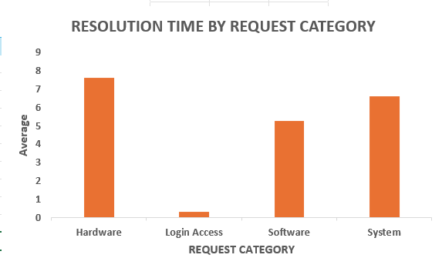

• Category Performance (Resolution Time)
- Hardware: 7.63 days (9,733 tickets — 10 percent) → slowest.
- System: 6.62 days (39,002 tickets — 40 percent) → highest volume.
- Software: 5.24 days (19,570 tickets — 20 percent) → above average.
- Login Access: 0.31 days (29,193 tickets — 30 percent) → fastest.
- Team average: 4.55 days.
- Gap: 7.32 days (24 times difference) between fastest and slowest.

Key Insights
- Hardware is the worst performer → 7.63 days (68 percent above average) → major delay source.
- System has the biggest impact → 40 percent of total tickets → one day improvement saves about 39,000 agent days per year.
- Software is inefficient → handled case by case instead of using standard solutions.
- Login Access is the benchmark → 0.31 days shows fast resolution is achievable with proper processes.

Recommendations
- Hardware: Set a 3-day resolution target with automatic vendor escalation at Day 2.
- System: Build a knowledge base for the top 20 issues → reduces about 9,750 tickets per year.
- Software: Standardize and automate solutions similar to Login Access → target less than 2 days resolution.
- Performance Targets: Replace one overall average (4.55 days) with separate targets for each category.

Conclusion
- The problem is process inefficiency, not team speed
- Hardware and System (50 percent of volume, both above 6.6 days) are increasing overall time.
- Login Access proves fast resolution is already possible.
- Fixing the top two categories will significantly reduce resolution time without hiring new agents.

- How effective are the current software tools in managing IT tickets?
Analysis: Evaluate performance metrics before and after the implementation of new tools.

ANS:- The current Software tools are moderately effective but not optimal.

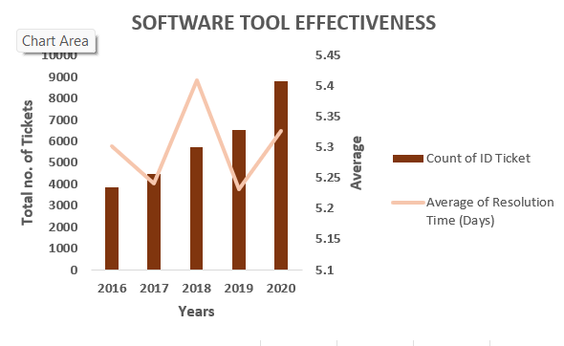

• Chart Insight (Volume vs Resolution Time)
- Dual-axis chart: bars = ticket volume, line = average resolution time across five years.
- Volume increased from 13,051 (2016) to 29,088 (2020) → 123 percent growth.
- Resolution time stayed flat at 4.5 to 4.6 days → no improvement despite higher workload.
- 29,410 tickets (30 percent) remained unassigned across all years → no progress in prioritization.

Key Insights
- Resolution time should decrease or improve with better tools, but it remains unchanged.
- Unassigned tickets stayed constant at 30% → no automatic prioritisation system exists.
- Clear evidence that software is not scaling with business growth.
Recommendations
- Upgrade or replace the ticketing platform → current system is not effective.
- New platform must include:
  - Automatic prioritisation using intelligent systems.
  - Category-wise resolution targets with alert system.
  - Agent workload balancing dashboards.
- Set new target: 3.0-day average resolution (34 percent improvement from 4.55 days).
- Measure performance before and after upgrade over 6 months to evaluate return on investment.

Conclusion
- The software is the main bottleneck.
- Handling 123% more tickets with zero improvement proves system failure.
- 30% unassigned tickets confirms lack of basic prioritisation capability.
- Training or hiring will not fix this — system upgrade is critical for performance improvement.

- How has the performance of the IT support team changed over time (e.g., monthly or quarterly)?
Analysis: Trend analysis using time series charts.

ANS:- Performance shows inconsistency ,with improvement during ticket volume Periods.

PERFORMANCE TREND
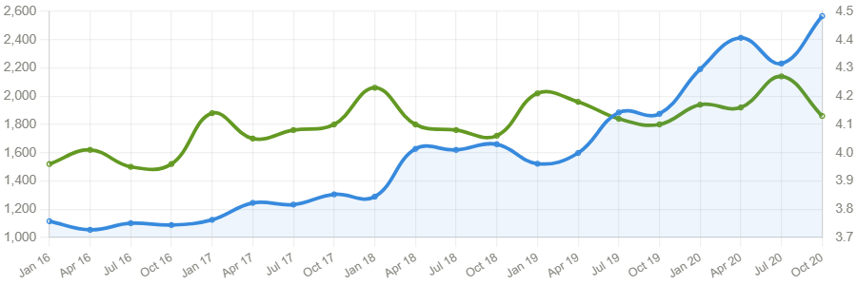

-- Ticket Volume
-- Average Satisfaction

Chart Insight (Volume vs Satisfaction Trend)
- Dual-axis chart: area = monthly ticket volume, line = average satisfaction (January 2016 to October 2020).
- Volume increased from ~1,100/month (2016) to 2,500+/month (2020) → strong, continuous growth.
- Satisfaction improved from 3.96 to 4.27 → steady upward trend despite rising workload.
- Peak months: August, October, November, December → consistent seasonal spikes every year.

Key Insights
- Team is handling higher volume while improving satisfaction → strong operational performance.
- Growth is accelerating → 21,490 (2019) to 29,088 (2020) → 35% increase in one year.
- Peak demand periods are predictable, not random.
- Satisfaction improvement is slow and gradual → needs active acceleration.

Recommendations
- Plan extra capacity for August, October, November, December (predictable high-load months).
- Use February to April for:
  - System upgrades.
  - Agent training.
  - Process improvements.
- Track volume and satisfaction together in one dashboard for better decision-making.
- Set target: 4.30 satisfaction score by next fiscal year.

Conclusion
- Overall trend is positive → more tickets handled with better satisfaction.
- However, volume growth is faster than performance improvement.
- Satisfaction gains are organic but fragile, while volume growth is structural and accelerating.
- Without system upgrades, the team may hit capacity limits within 2 years.

- If we invest more on tech (Hardware, software, etc), do you think it will improve the ticket resolution times and employee satisfaction?
Analysis: Use historical data to project potential improvements.

ANS:- Yes, investing more in technology is likely to improve both resolution time and agents satisfaction because:-
.Technology can automate repetitive tasks.
. Faster resolution can leads to higher satisfaction ratings.

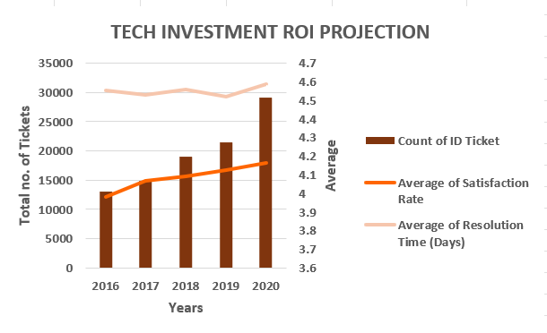
Chart Insight (Volume, Satisfaction, Resolution Time)
- Ticket volume (red bars): 12,790 (2016) → 29,088 (2020) → 123% growth.
- Average satisfaction (black line): 4.0 → 4.2 → steady improvement.
- Average resolution time (yellow line): 4.5 to 4.6 days → completely flat over five years.

Key Insights
- Demand is accelerating with no slowdown in volume growth.
- Resolution time shows zero improvement despite doubling workload.
- Gap between rising volume and flat resolution time highlights system limitation.
- Satisfaction improving while resolution is flat → agents improving communication, not efficiency.
- If tools were effective, resolution time would decrease as volume increased — but it does not.

Recommendations
- Invest in technology upgrade immediately → current system is not scaling.
- Prioritize Hardware category → 7.63 days resolution → biggest improvement opportunity.
- Implement automatic ticket prioritisation → 30% (29,410 tickets) unassigned every year.
- Set clear target: reduce resolution time from 4.55 days to below 3.0 days within 12 months.
- Track satisfaction separately → it improves independently and should not measure tool performance.
Conclusion
- Bottleneck is the system, not the team.
- Handling 123% more tickets with no speed improvement proves tool failure.
- Satisfaction gains are organic, but efficiency is stuck.
- A focused technology upgrade will improve resolution time across all agents and all tickets simultaneously, delivering the highest return on investment.

- What are the key performance metrics for IT agents, and how can they be improved, do we need to fire any agents?
Analysis: Define and analyze metrics such as average handling time, satisfaction scores, and number of tickets resolved.

ANS:-
Top 5 Performers
Agent | Satisfaction Rate | Resolution Time
Diana Rojo | 4.60 | 3.6d
Javier D. | 4.49 | 4.1d
JesusGrajeda | 4.47 | 3.6d
Galindo Guadalupe | 4.47 | 3.7d
Segura Garcia | 4.46 | 3.7d

Bottom 5 — Action Required
Agent | Satisfaction Rate | Resolution Time
Alfonso Barraza | 3.04 | 5.0d | PIP
A. Trejo | 3.59 | 5.3d | PIP
Sandra Lujan | 3.60 | 5.2d | PIP
Nurio Zepeda | 3.61 | 5.4d | PIP
Elena Velez | 3.62 | 5.4d | Watch

Ranking Table Insight (Top vs Bottom Agents)
- Side-by-side ranking of 50 agents by satisfaction and resolution time.
- Split into Top 5 performers and Bottom 5 action-required group.
- Clearly shows a significant performance gap between best and worst.

Key Findings
- Diana Rojo: 4.60 out of 5 satisfaction, 3.6-day resolution → high quality and speed together.
- Alfonso Barraza: 3.04 out of 5 satisfaction, 5.0-day resolution → lowest performer and statistical outlier.
- Bottom 5 agents handle ~9,800 tickets per year → removing them immediately creates major capacity risk.
- Performance gap indicates skill and process differences, not impossible targets.

Recommendations
- Do not terminate immediately → losing 9,800 tickets capacity will increase overall resolution time beyond 5.5 days.
- Place bottom 5 agents on 90-day Performance Improvement Plans with targets:
  - Minimum 3.8 satisfaction.
  - Maximum 4.5-day resolution time.
- Use top performers as benchmarks:
  - Study Diana Rojo and Jesus Grajeda (4.47 satisfaction, 3.6 days).
  - Standardize their triage methods, communication style, and workflow.
- At Day 90:
  - If targets not met → escalate to human resources.
  - Begin parallel hiring process to avoid capacity loss.

Conclusion
- Immediate termination is not justified by data.
- Capacity risk outweighs short-term performance gains.
- Performance gap is likely due to training and tools, not talent alone.
- Correct approach: Performance improvement plan → coaching → human resources action if needed.

- How do employee demographics (e.g., department, seniority) impact satisfaction and ticket outcomes?
Analysis: Segment analysis using filters and pivot tables.

ANS:- - Employees demographics have both negative and positive impact on satisfaction and ticket outcomes because;
.On the one hand some employees are faster in solving the issue in very short period of time that reduces resolution time and enhances the rate of satisfaction.
.On the other hand, some employees are taking more time to solve the issues that increase the resolution time that leads to lower satisfaction.

Row Labels | Count of ID Ticket | Average of Satisfaction Rate | Average of Resolution Time (Days)
29-33 | 23483 | 4.209981689 | 4.429076353
34-38 | 13586 | 3.955100839 | 5.01221846
39-43 | 21348 | 4.113640622 | 4.412778715
44-48 | 23478 | 3.998764801 | 4.832651844
49-54 | 15603 | 4.19835929 | 4.111645196
Grand Total | 97498 | 4.100648218 | 4.553149808

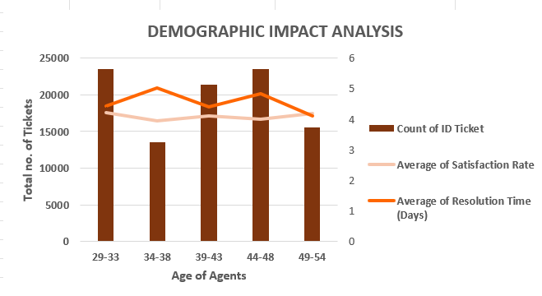

• Age Group Performance Overview
- Highest workload: Ages 29–33 and 44–48 → ~23,000+ tickets each.
- Lowest workload: Ages 34–38 → 13,586 tickets.
- Best satisfaction: Ages 29–33 (4.21) and 49–54 (4.20).
- Lowest satisfaction: Ages 34–38 (3.96).
- Fastest resolution: Ages 49–54 (4.11 days).
- Slowest resolution: Ages 34–38 (5.01 days) → 0.90-day gap.

Key Findings
- 29–33: Highest volume (23,483), best satisfaction (4.21), fast resolution (4.43 days) → strongest overall performers.
- 34–38: Lowest volume (13,586), worst satisfaction (3.96), slowest resolution (5.01 days) → weakest across all metrics.
- 39–43: Stable and balanced → close to team average.
- 44–48: High volume (23,478) but slower (4.83 days) and lower satisfaction (4.00) → overloaded and inefficient.
- 49–54: Lowest volume (15,603) but fastest (4.11 days) and high satisfaction (4.20) → most efficient.

Recommendations
- Prioritize training for ages 34–38 → weakest in all three metrics, needs urgent improvement.
- Use ages 49–54 as performance benchmark → replicate their efficiency and workflow.
- Rebalance workload for ages 44–48 → high volume is impacting speed and satisfaction.
- Protect ages 29–33 from burnout → strongest performers handling highest workload.

Conclusion
- Ages 34–38 are the clear underperformers → highest priority for intervention.
- Ages 49–54 demonstrate peak efficiency → ideal internal coaching model.
- Ages 29–33 are the backbone of performance → must be sustained carefully.
- Targeted actions by age group will deliver faster improvement than team-wide changes.

- Identify the trends for IT support operations based on ticket volumes and satisfaction, and mention the peak and stable times?
Analysis: Use pivot tables and charts to identify peak and off-peak hours.

ANS:-

Row Labels | Count of ID Ticket | Average of Satisfaction Rate | Average of Resolution Time (Days)
2016 | 13051 | 3.979695043 | 4.551758486
2017 | 14915 | 4.068119343 | 4.530070399
2018 | 18954 | 4.091853962 | 4.558668355
2019 | 21490 | 4.122382503 | 4.520800372
2020 | 29088 | 4.161269252 | 4.585911716
Grand Total | 97498 | 4.100648218 | 4.553149808

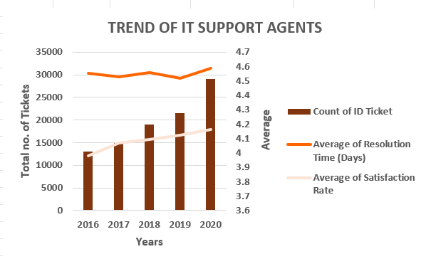

Period | Year | Avg Monthly Tickets | Peak Month | Stable (Low) Month | Trend Classification
2016 | Baseline | 1,088/month | May  (1,160) | November (1,046) | Stable — low volume, no clear seasonality
2017 | Growth | 1,243/month | May  (1,345) | January (1,125) | Emerging Q4 peak pattern
2018 | Acceleration | 1,580/month | August (1,669) | January (1,289) | Mid-year surge beginning
2019 | Continued Growth | 1,791/month | August (1,905) | January (1,522) | Q4 peak solidifies
2020 | Surge | 2,424/month | December (2,609) | January (2,191) | PEAK YEAR — every month above 2019 max

Chart Explanation
- Brown bars grow every year — steepest jump in 2020 (+35% in one year alone, from 21,490 → 29,088).
- Orange line (resolution) stays flat at 4.52–4.59 days — volume doubled but speed never improved.
- White line (satisfaction) slowly rises from 3.98 (2016) → 4.16 (2020) — agents improving communication, not efficiency.
- 2020 is classified "Surge Year" — every single month exceeded 2019's highest month (1,905 in August 2019).

Peak Months
- August — consistent peak from 2018 onwards; highest in both 2018 (1,669) and 2019 (1,905); second highest in 2020 (2,566).
- December — becomes dominant peak in 2020 at 2,609 tickets (year-end deployments).
- May — peak month in both 2016 (1,160) and 2017 (1,345) — mid-year pattern before August took over from 2018.

Stable Months
- January — consistently the lowest month in 2017 (1,125), 2018 (1,289), 2019 (1,522), and 2020 (2,191) — the most stable month across the entire dataset.
- November 2016 — recorded the lowest single month in the entire dataset at 1,046 tickets.
- June 2016 (1,051), April 2016 (1,054), February 2016 (1,056) — all stable in the baseline year.

Key Recommendations
- Pre-staff August, October, and December — these are the three confirmed peak months from 2018 onwards based on actual data.
- Run all training and upgrades in January and February — January is the lowest month every year from 2017–2020; the safest operational window in the entire calendar.
- Do not pre-staff January — it is the most stable month, not a peak; previous guidance was incorrect.
- Fix resolution time now — at current growth rate, monthly volume hits 3,500+ by 2022 and the 4.55-day resolution becomes unmanageable.

Conclusion
Volume is accelerating — average monthly tickets grew from 1,088 (2016) to 2,424 (2020), and the peak month shifted from May in 2016–2017, to August in 2018–2019, to December in 2020, showing the pressure point is moving later in the year. January is consistently the calmest month and must be protected as the primary window for upgrades, training, and system improvements. The team needs capacity planning anchored to August, October, and December as mandatory surge months, and a software upgrade before volume outpaces the system completely.

10. What metrics should be included in the final dashboard to provide a comprehensive view of call center performance and guide investment decisions?

ANS:- There are various types of metrics that should be included in final dashboard:-

.KPI’s.
.Annual Ticket Volume.
.Request Category Distribution.
.Ticket Severity Level.
.Average Resolution Days by Request Category.
.Priority Distribution.
.Issue Type Breakdown.



1. Total Tickets → 97,498
- Represents the complete workload handled across 5 years (2016–2020).
- Baseline volume metric — every other KPI is measured against this number.

2. Avg Satisfaction Rate → 4.10/5
- Team is performing above the midpoint but below excellence (5.0).
- Masks a hidden 10.2% of tickets rated 1/5 — average alone is insufficient.

3. Avg Resolution Days → 4.55
- The most critical operational KPI — flat for 5 consecutive years despite volume doubling.
- Directly signals a tooling failure, not a people failure.

4. Total Agents → 50
- 50 agents handling 97,498 tickets = ~1,950 tickets per agent over 5 years.
- Team is absorbing load but not improving speed — capacity is stretched.

5. Unassigned Tickets → 29,410
- 30% of all tickets never received a priority — software triage failure.
- This number never improved across any single year — a permanent system gap.

6. Data Range → 5 Years
- Analysis covers 2016 – 2020 — sufficient to identify trends, seasonality, and performance patterns.
- Long enough to validate that resolution time stagnation is structural, not temporary.

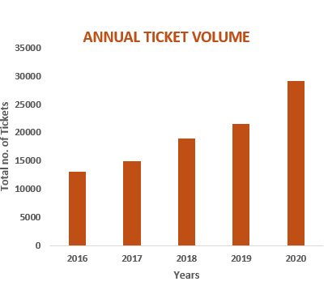

Annual Ticket Volume (Column Chart)

- Volume grew every single year: 2016 (13,051) → 2020 (29,088) — a 123% increase.
- The steepest jump occurs between 2019 and 2020 (+35% in one year alone) — demand is accelerating.
- No corresponding improvement in resolution time means the system is falling further behind each year.

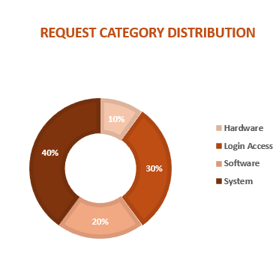
Request Category Distribution (Donut Chart)

- System dominates at 40% — the largest single category by volume (39,002 tickets).
- Login Access holds 30% (29,193 tickets) but resolves in just 0.31 days — lightest burden.
- Software accounts for 20% (19,570 tickets) at 5.24 days average.
- Hardware is only 10% (9,733 tickets) but takes 7.63 days — smallest volume, highest per-ticket cost.

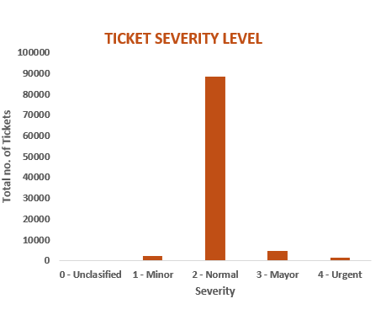

Ticket Severity Level (Column Chart)

- 2 - Normal severity dominates with ~88,656 tickets — the overwhelming majority of all work is routine.
- 1 - Minor and 3 - Mayor are minimal — severe and trivial tickets are rare edge cases.
- 4 - Urgent is nearly invisible — true emergencies are extremely rare in this dataset.
- This distribution confirms the team spends most of its time on routine work, making automation and self-service tools highly viable.

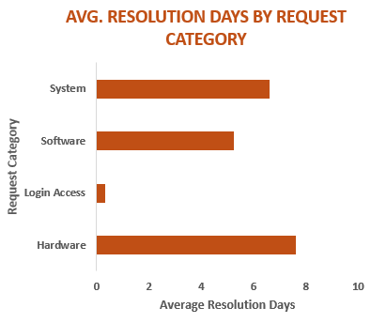

Avg Resolution Days by Request Category (Bar Chart)

- Hardware bar is longest at 7.63 days — visually the most alarming bar on the chart.
- System follows at 6.62 days — combined with its 40% volume share, this is the highest-priority fix.
- Software sits at 5.24 days — above team average, fixable with knowledge base tools.
- Login Access bar is nearly invisible at 0.31 days — the automation benchmark every other category should target.

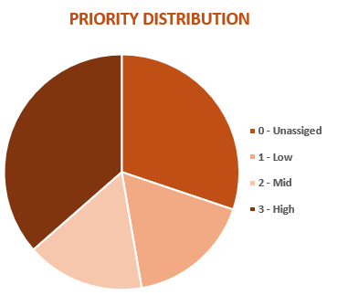

Priority Distribution (Pie Chart)

- 0 - Unassigned holds the largest slice — 29,410 tickets (30%) with no priority ever assigned
- 2 - Mid is the next largest segment — agents are defaulting to mid-priority when forced to choose
- 3 - High and 1 - Low are smaller slices — confirming agents are not consistently applying priority logic
- The Unassigned slice being the largest in the entire pie is the single most important investment signal in the dashboard

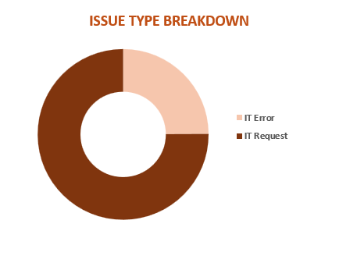

Issue Type Breakdown (Donut Chart)

- IT Request dominates at 75% (73,220 tickets) — routine service requests make up three quarters of all work.
- IT Error accounts for 25% (24,278 tickets) — complex troubleshooting is a minority workload.
- The 75/25 split means the majority of agent time is spent on predictable, repeatable requests — ideal candidates for self-service deflection and automation.
- Reducing IT Request volume by even 20% through self-service would remove ~14,644 tickets annually from agent queues.

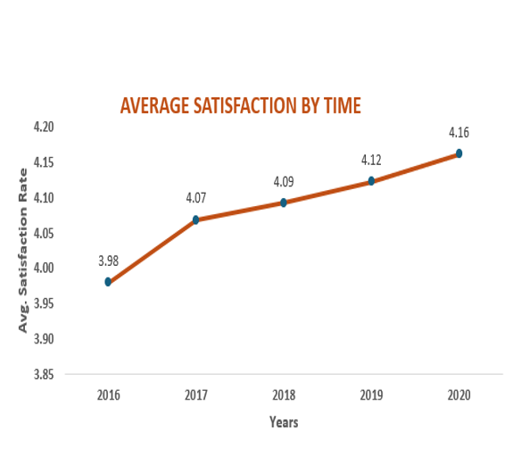

Average Satisfaction by Time (Line Chart)
- Average customer satisfaction improved steadily from 3.98 in 2016 to 4.16 in 2020, reflecting continuous operational improvement.
- The largest yearly increase occurred between 2016 and 2017, where satisfaction rose from 3.98 to 4.07.
- Satisfaction scores continued gradual growth from 2018 to 2020, indicating stable service enhancement and better ticket management practices.
- The positive trend demonstrates that the organization successfully maintained customer satisfaction despite rising ticket volumes and operational pressure.

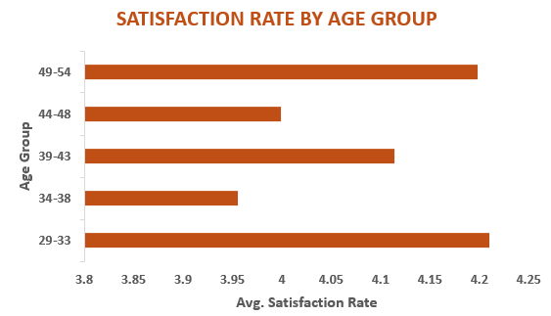

Satisfaction Rate by Age Group (Bar Chart)
- Customers aged 29–33 reported one of the highest satisfaction scores at approximately 4.21, indicating strong service acceptance within younger professionals.
- The 49–54 age group achieved the highest average satisfaction rate near 4.20+, showing effective support delivery across senior users.
- The 34–38 age group recorded the lowest satisfaction score around 3.95, highlighting potential service improvement opportunities for this segment.
- Overall satisfaction across all age groups remained close to or above 4.0, demonstrating consistent service quality throughout the customer base.

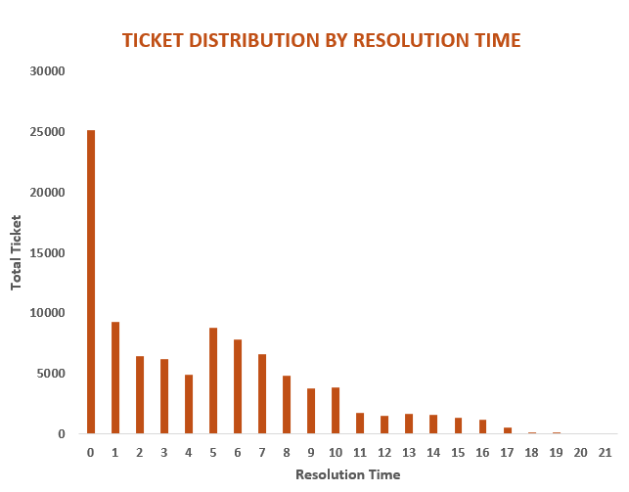

Ticket Distribution by Resolution Time (Column Chart)
- The highest number of tickets were resolved within 0–1 days, with nearly 25,000 tickets completed immediately, showing strong efficiency in handling simple support requests.
- Ticket volume gradually decreases as resolution time increases, indicating that most issues were resolved quickly without long operational delays.
- A noticeable number of tickets required 5–7 days for resolution, suggesting moderate complexity in technical issues and dependency on specialist support teams.
- Very few tickets extended beyond 15 days, showing that long-pending cases were limited, although some complex issues still impacted overall operational efficiency.

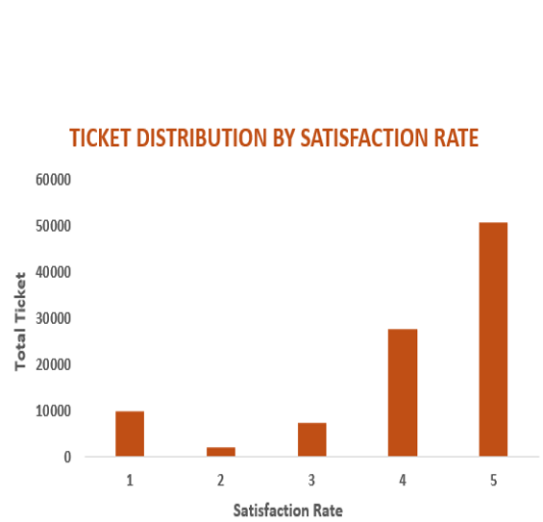

Ticket Distribution by Satisfaction Rate (Column Chart)
- Rating 5 received the highest number of tickets, crossing nearly 50,000, indicating excellent customer satisfaction and strong support performance.
- Satisfaction rating 4 also recorded a high ticket count of around 28,000, showing that most users experienced good service quality.
- Low ratings of 1 and 2 were comparatively minimal, reflecting fewer major complaints and limited negative customer experiences.
- The distribution confirms that the IT support system maintained a positive customer experience for the majority of ticket resolutions.

