OBJECTIVE QUESTIONS:
- What is the distribution of account balances across different regions?
ANS:-

Region | Customers | Avg. Balance | Median Balance | Std Dev | Min | Max
France | 5,014 | $62,093 | $62,154 | $64,134 | $0 | $238,388
Germany | 2,509 | $119,730 | $119,703 | $27,022 | $27,288 | $214,347
Spain | 2,477 | $61,818 | $61,710 | $64,236 | $0 | $250,898

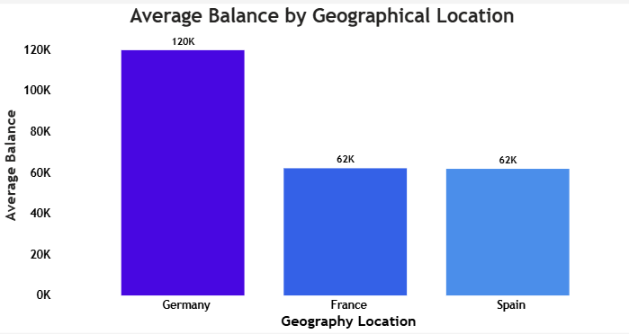

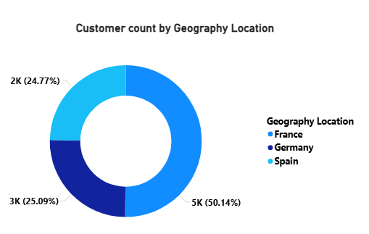
- Germany has the HIGHEST average balance at $119,730 — nearly double France and Spain.
- Germany's low std dev ($27,022) indicates a tight, consistent balance distribution.
- France and Spain show high variability ($64K std dev) with many customers holding $0 balance.
- France has the most customers (50.14%) while Germany has the fewest (25.09%).

- Identify the top 5 customers with the highest Estimated Salary in the last quarter of the year. (SQL)
ANS:- SQL Query:-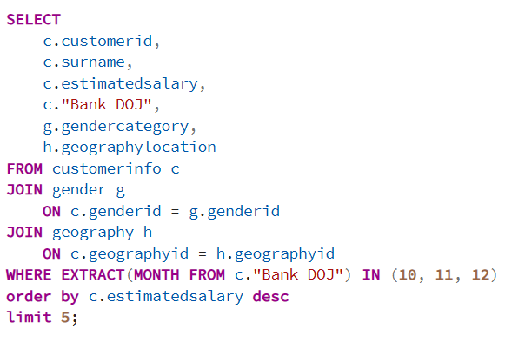
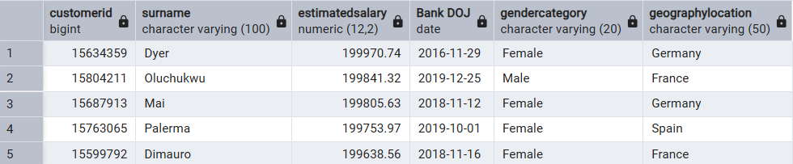

- Calculate the average number of products used by customers who have a credit card. (SQL)
ANS:- 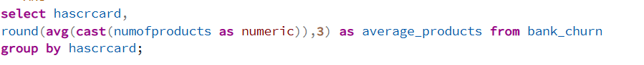
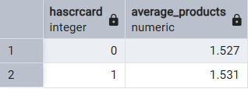

- Credit card holders (1) and non - credit card holders (0) use virtually the same average number of products (~1.53).
- Owning a credit card has negligible influence on product adoption.

- Determine the churn rate by gender for the most recent year in the dataset.
ANS:-

Gender | Total Customers | Exited | Churn Rate
Female | 4,543 | 1,139 | 25.07%
Male | 5,457 | 898 | 16.46%
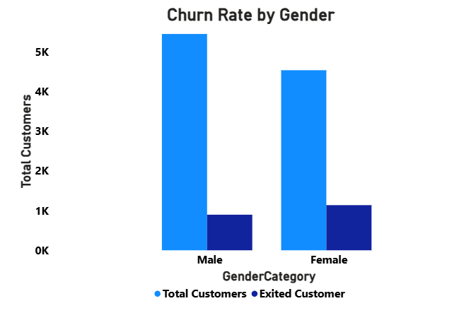

- Female customers churn at 25.07% — 8.6 percentage points HIGHER than males (16.46%).
- Despite having fewer customers, females account for 55.9% of all churned customers.
- Strategic Focus: Investigate and address female-specific pain points (product fit, service quality).

- Compare the average credit score of customers who have exited and those who remain. (SQL)
ANS:-
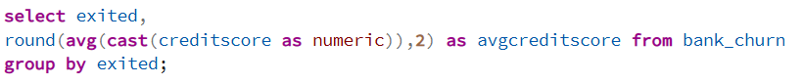
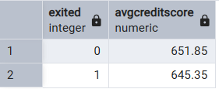

- Exited (0) represents Retained.
- Exited (1) represents Exited.
- Difference is only ~6.5 points — credit card shows only a modest difference between Retained and Exited customers and should be used alongside other varia
- Both groups fall in the 'Fair to Good' credit range (600–700).
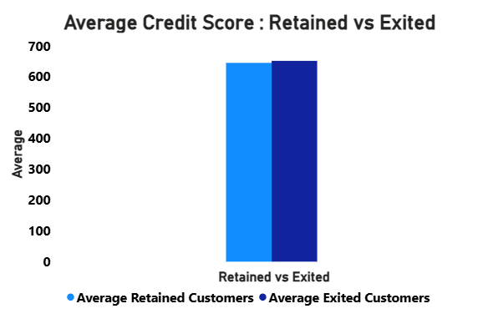
- Which gender has a higher average estimated salary, and how does it relate to the number of active accounts? (SQL)
ANS:-
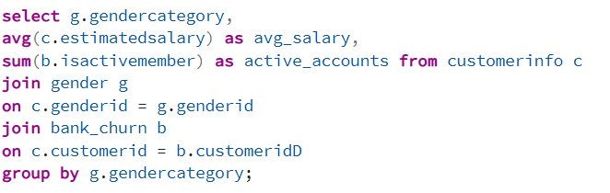
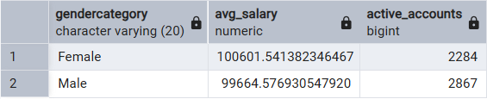
- Females have a SLIGHTLY higher average salary ($100,602 vs $99,665) — ~$937 difference.
- Males have MORE active accounts (2,867 vs 2,284) despite lower average salary.
- Higher male activity suggests better product engagement regardless of salary.

- Segment the customers based on their credit score and identify the segment with the highest exit rate. (SQL)
ANS:-
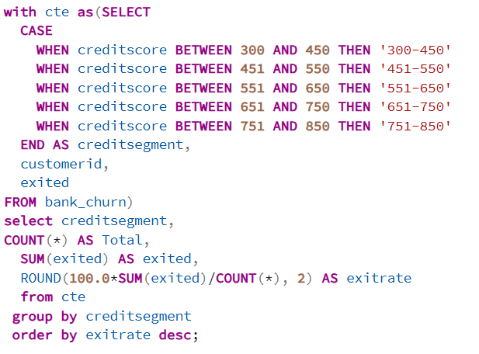
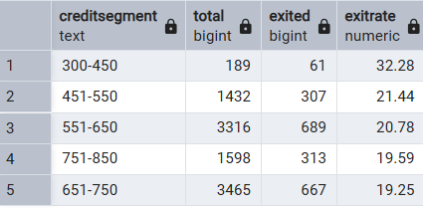

- Segment 300–450 has the highest exit rate at 32.28% — significantly above the 20.37% average.
- Low credit score customers are at the greatest risk — bank may want proactive intervention.

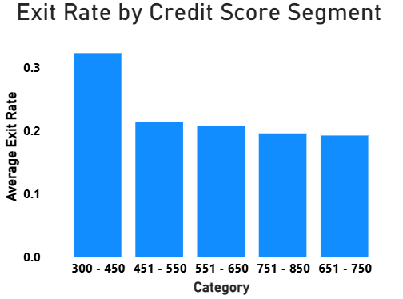
- Find out which geographic region has the highest number of active customers with a tenure greater than 5 years. (SQL)
ANS:-
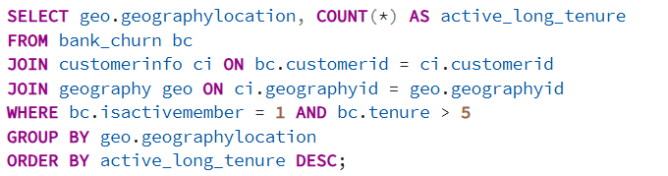
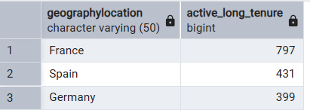

- France has the most loyal, long-tenured active customers (797).
- France's dominance is also partly due to having the most customers overall (50.14%).

- What is the impact of having a credit card on customer churn, based on the available data?
ANS:-

Has Credit Card | Total Customers | Exited | Churn Rate
No (0) | 2,945 | 613 | 20.81%
Yes (1) | 7,055 | 1,424 | 20.18%

- Credit card ownership has MINIMAL impact on churn — difference is only 0.63 pp.
- Credit card rewards programs do NOT appear to be a meaningful retention lever based on this data.
- Both groups churn at approximately the same rate (~20%).

- For customers who have exited, what is the most common number of products they have used?
ANS:-
# of Products | Exited Customers | % of Total Exits
1 | 1,409 | 69.2% — MOST COMMON
2 | 348 | 17.1%
3 | 220 | 10.8%
4 | 60 | 2.9%
4 | 60 | 2.9%

- 69.2% of exited customers had only 1 product — indicating low product engagement = higher churn risk.
- Recommendation: Cross-sell to single-product customers proactively.

- Examine the trend of customers joining over time and identify any seasonal patterns (yearly or monthly). Prepare the data through SQL and then visualize it.
ANS:-
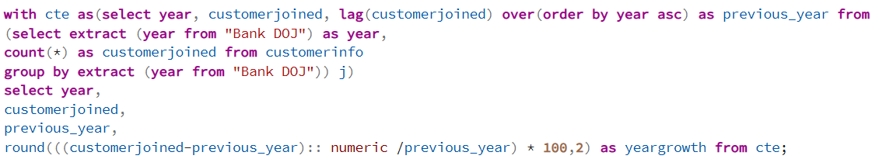
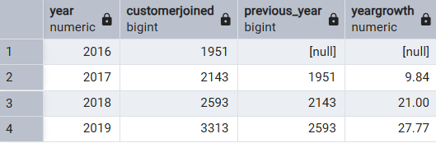

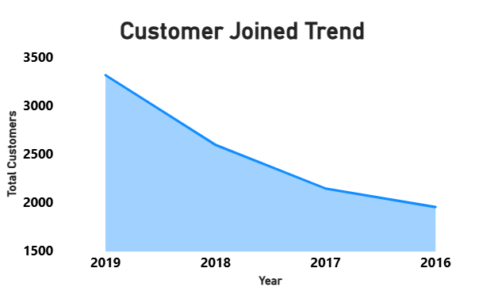
- Clear upward trend in customer acquisition: 2016 → 2019 shows 69.8% total growth.
- Yearly Pattern: 2019 (3,313), 2018 (2,593), 2017 (2,143), 2016 (1,951).
- Slowest Year: 2016.

- Analyze the relationship between the number of products and the account balance for customers who have exited.
ANS:-
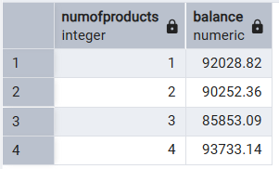
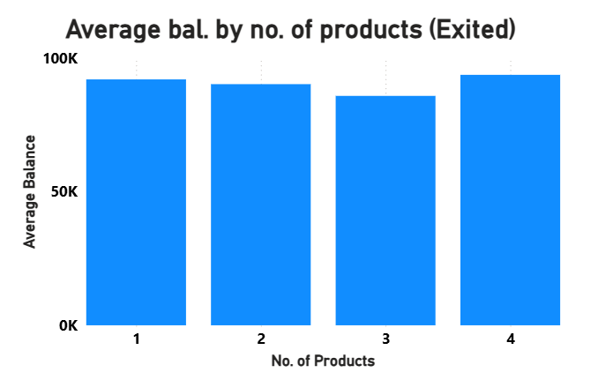
- Average balance remains high (~$88K–$94K) regardless of product count for exited customers.
- Exited customers who had 4 products had the highest avg balance ($93,733.14) — suggests dissatisfaction, not financial inability.
- The decision to exit is not driven by low balances.

- Identify any potential outliers in terms of balance among customers who have remained with the bank.
ANS:-
- Using IQR method: Q1 = $0, Q3 = $1,26,410.28, IQR = $1,26,410.28.
- Outlier threshold: < -$2,01,600 or > $3,16,025.
- Result: 0 outliers detected — all retained customer balances fall within the acceptable range.
- The balance distribution for retained customers is well-bounded with no extreme anomalies.

The method used is the standard IQR (Interquartile Range) outlier detection rule:
Step 1 — find Q1 (25th percentile) = $0.00. This is $0 because 3,117 out of 7,963 retained customers (39.1%) have a zero balance, which drags the 25th percentile all the way down to zero.
Step 2 — find Q3 (75th percentile) = $1,26,410.28.
Step 3 — IQR = Q3 − Q1 = $1,26,410.28 − $0 = $1,26,410.28.
Step 4 — Lower fence = Q1 − (1.5 × IQR) = 0 – 1,89,615.42 = −$1,89,615.42.
Step 5 — Upper fence = Q3 + (1.5 × IQR) = 1,26,410.28 + 1,89,615.42 = $3,16,025.70.
Final answer: Zero outliers. The maximum balance in the retained group is $2,21,532.80, which is comfortably below the $3,XG16,025.70 upper fence. No balance falls below the lower fence either. The wide IQR caused by 3,117 zero-balance accounts naturally creates very broad fences, which absorbs all extreme values.

- How many different tables are given in the dataset, out of these tables which table only consists of categorical variables?
ANS:-
- Total tables in dataset: 7.
- Tables with ONLY categorical variables:
  - gender (genderid, gendercategory).
  - geography (geographyid, geographylocation).
  - creditcard (creditid, category).
  - activecustomer (activeid, activecategory).
  - exitcustomer (exitid, exitcategory).

- Using SQL, write a query to find out the gender-wise average income of males and females in each geography id. Also, rank the gender according to the average value. (SQL)
ANS:- 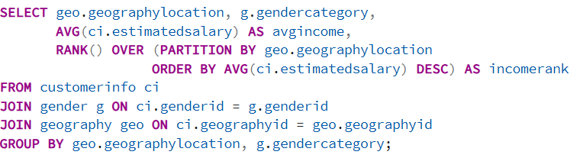
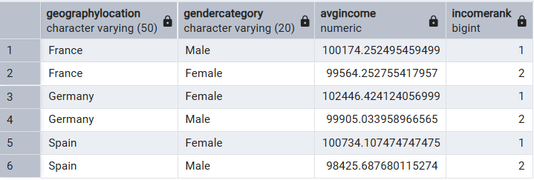

- Females earn more in Germany and Spain; Males earn more in France.
- Germany females have the highest average income overall ($102,446).

- Using SQL, write a query to find out the average tenure of the people who have exited in each age bracket (18-30, 30-50, 50+).
ANS:-
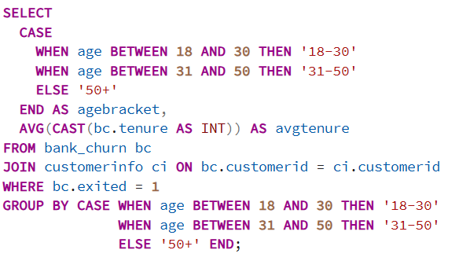
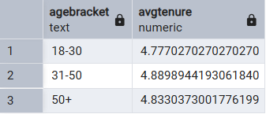
- All age groups show remarkably similar average tenure (~4.8–4.9 years) upon exit.
- Churn is not tenure-dependent — customers across all ages exit at similar tenure lengths.

- Is there any direct correlation between salary and the balance of the customers? And is it different for people who have exited or not?
ANS:-
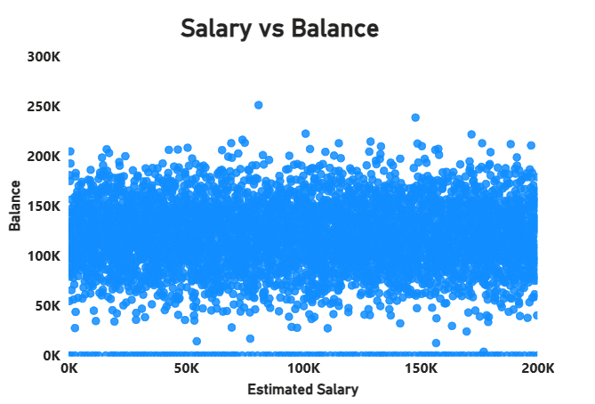
Relationship | Pearson Correlation | Interpretation
Salary vs Balance | 0.013 | No meaningful relationship

- Virtually ZERO correlation between salary and balance (r = 0.013).
- This pattern holds for both exited and retained customers — salary does not predict balance.
- Financial behaviors appear to be independent of estimated salary in this dataset.

- Is there any correlation between the salary and the Credit score of customers?
ANS:-
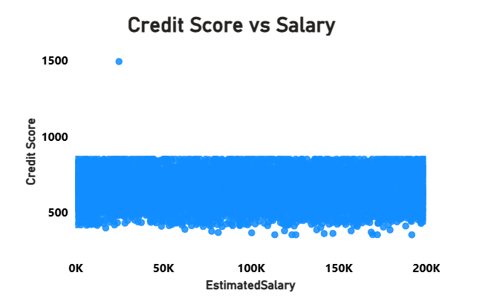
Relationship | Pearson Correlation | Interpretation
Salary vs Credit Score | -0.001 | No meaningful relationship

- Pearson Correlation: -0.001 — essentially zero.
- Higher or lower salary does NOT translate to better or worse credit scores.
- Credit scores appear to be determined by behavioral factors rather than income levels.

- Rank each bucket of credit score as per the number of customers who have churned the bank.
ANS:-

Rank | Credit Score Bucket | Customers Churned
1 | 550–650 | 689
2 | 650–750 | 667
3 | 750–850 | 313
4 | 450–550 | 307
5 | 300–450 | 61

- The mid-range 550–750 segment contributes the most churned customers in absolute numbers.
- This is due to these segments having the highest total customer population.
- In terms of EXIT RATE, segment 300–450 is the riskiest (32.28%).

- According to the age buckets find the number of customers who have a credit card. Also retrieve those buckets that have lesser than average number of credit cards per bucket.
ANS:-
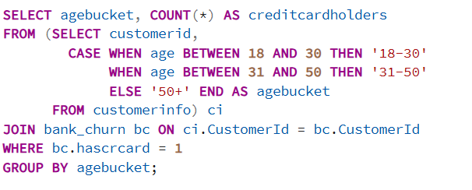
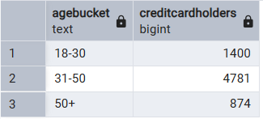

- 18–30 and 50+ age brackets have fewer credit card holders than the average (2,352).
- Opportunity: Target younger (18–30) and senior (50+) customers with credit card offerings.

- Rank the Locations as per the number of people who have churned the bank and average balance of the customers.
ANS:-

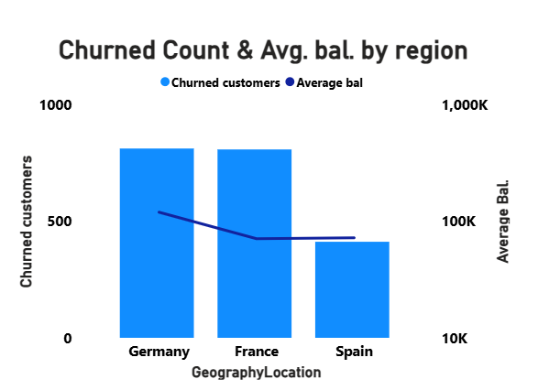
Rank | Region | Churned Customers | Avg. Balance (Churned)
1 | Germany | 814 | $120,361
2 | France | 810 | $71,193
3 | Spain | 413 | $72,513

- Germany ranks #1 for churn with 814 exits AND the highest avg balance among churned customers ($120,361).
- France is nearly tied in churn count (810) but with a much lower avg balance ($71,193).
- Spain has the fewest churned customers (413) suggesting higher customer satisfaction.

- As we can see that the “CustomerInfo” table has the CustomerID and Surname, now if we have to join it with a table where the primary key is also a combination of CustomerID and Surname, come up with a column where the format is “CustomerID_Surname”.
ANS:-
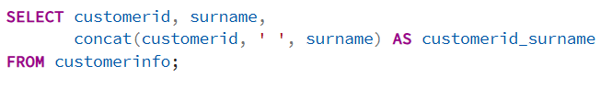
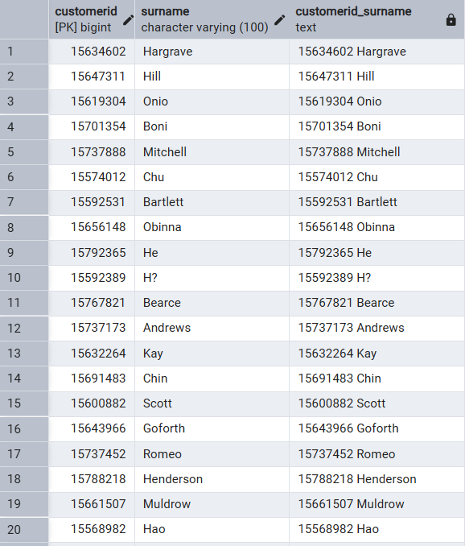
- Without using “Join”, can we get the “ExitCategory” from ExitCustomers table to Bank_Churn table? If yes do this using SQL.
ANS:- YES, This is possible by using subquery or case-statement.
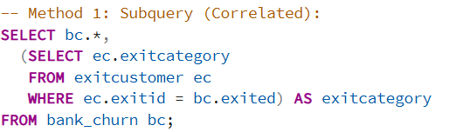
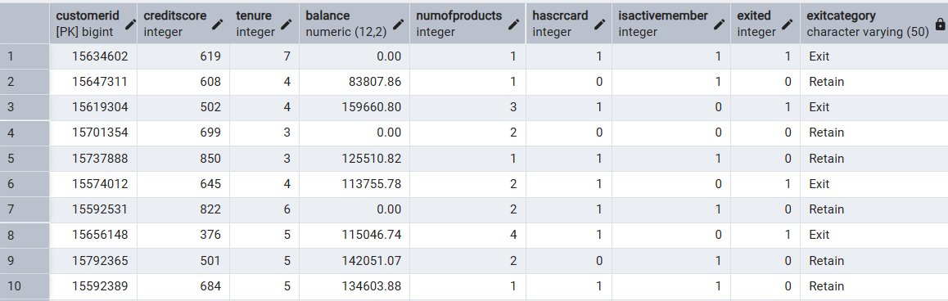
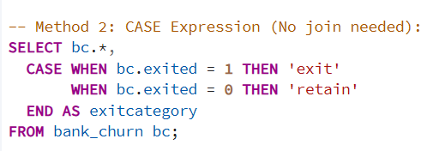
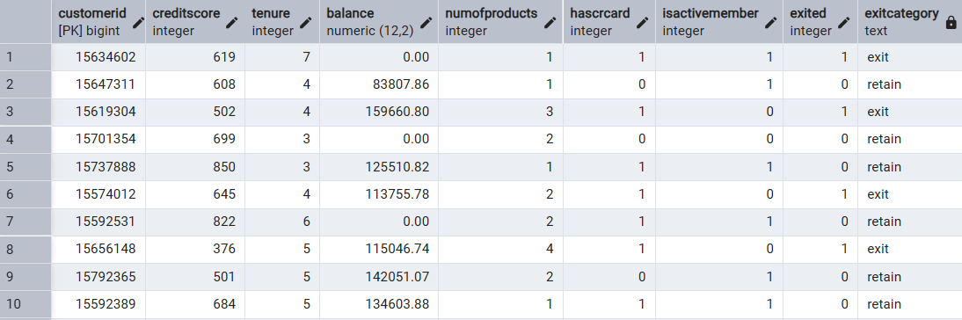

- Were there any missing values in the data, using which tool did you replace them and what are the ways to handle them?
ANS:-
- Finding: No missing values were detected in this dataset (all columns returned 0 nulls).
- Tool used: Power BI (Power Query Editor) — 'Column Quality' view shows % valid, % errors, % empty.

Standard approaches to handle missing values:
- Numerical columns: Replace with Mean (for normal distributions) or Median (for skewed data).
- Categorical columns: Replace with Mode (most frequent value) or a dedicated 'Unknown' category.
- Date columns: Use forward-fill or backward-fill based on business logic.
- High-missing-rate columns (>30%): Consider dropping the column entirely.
- Row removal: Only when missingness is random and total rows affected is small (<5%).

- Write the query to get the customer IDs, their last name, and whether they are active or not for the customers whose surname ends with “on”.
ANS:-
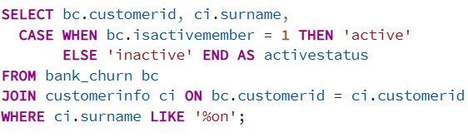
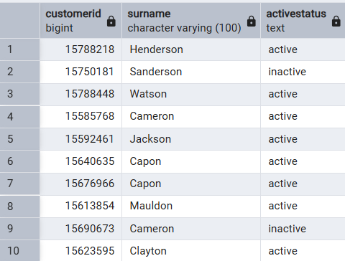

- Total customers with surnames ending in 'on': 704.
- Sample customers: Henderson (Active), Sanderson (Inactive), Watson (Active), Cameron (Active), Jackson (Active)

- Can you observe any data disrupency in the Customer’s data? As a hint it’s present in the IsActiveMember and Exited columns. One more point to consider is that the data in the Exited Column is absolutely correct and accurate.
ANS:-
- Issue Identified: 735 customers have Exited = 1 AND IsActiveMember = 1 simultaneously.
- Additionally, 3,547 customers have Exited = 0 AND IsActiveMember = 0.

Analysis:
- If a customer has EXITED the bank, they cannot logically be an ACTIVE MEMBER.
- The Exited column is confirmed to be accurate — so IsActiveMember values are incorrect for 735 records.
- Customers with Exited = 0 but IsActiveMember = 0 are retained-but-inactive customers — this is plausible (dormant accounts).

Recommended Fix (SQL):
UPDATE Bank_Churn
SET IsActiveMember = 0
WHERE Exited = 1 AND IsActiveMember = 1;

SUBJECTIVE QUESTIONS:

- Customer Behavior Analysis: What patterns can be observed in the spending habits of long-term customers compared to new customers, and what might these patterns suggest about customer loyalty?
ANS:-
1. Business Objective
Understand whether long-tenured customers exhibit materially different financial behaviour — balance accumulation, product engagement, and activity levels — compared to newer customers. This insight is critical for designing differentiated onboarding programs, loyalty rewards, and proactive retention triggers at key tenure milestones.

2. Dataset Observation
Important Note: The dataset tenure range spans 3–7 years only. There are no customers with 0–2 years of tenure, which limits a true 'new vs. long-term' comparison. However, meaningful differentiation exists within the 3–7 year spectrum:

Tenure | Customers | Churn Rate | Avg Balance | Avg Products | Active Rate | Avg Credit Score
3 years | 1,348 | 20.5% | $77,729 | 1.57 | 51.9% | 651
4 years | 2,971 | 19.4% | $76,160 | 1.55 | 52.2% | 651
5 years | 2,510 | 21.9% | $75,165 | 1.52 | 50.7% | 650
6 years | 2,032 | 20.6% | $77,335 | 1.52 | 51.5% | 651
7 years | 1,139 | 19.1% | $77,260 | 1.51 | 50.9% | 649

3. Analytical Approach
- Segmented customers by tenure (3–7 years) and computed KPIs: avg balance, churn rate, product count, activity rate.
- Compared behavioral metrics across tenure cohorts to identify loyalty curves and engagement patterns.
- Examined whether high tenure correlates with higher balance (wealth accumulation) or lower churn (stickiness).
- Used Power BI: Tenure as X-axis; Churn Rate, Avg Balance as dual-axis.

4. Visualization

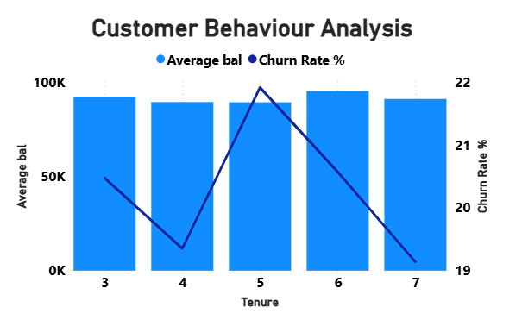
5. Key Insights
- No True 'New' Customers: Minimum tenure is 3 years — the bank's acquisition data suggests the dataset represents an established, mid-maturity customer base.
- Year 5 engagement checkpoint: Tenure 5 shows the highest observed churn rate, but the difference is not large enough to conclusively indicate a major churn cliff.
- Balance Stability, Not Growth: Average balance remains flat ($75K–$78K) across all tenures — long-term customers are NOT accumulating significantly more wealth with the bank.
- Marginal Activity Decline: Active member rate declines slightly from 52.2% (tenure 4) to 50.9% (tenure 7), signaling gradual disengagement even among long-standing customers.
- Product Stagnation: Avg products per customer decreases from 1.57 (3yr) to 1.51 (7yr) — long-term customers are NOT being successfully cross-sold over time.
- Loyalty Paradox: Despite longer tenure, churn risk does not meaningfully decrease — indicating the bank lacks a true loyalty dividend. Customer relationships are transactional, not emotional.

6. Recommendations
- Launch a 'Tenure 5 Intervention Program': Proactively contact customers approaching 5-year tenure with personalized offers, relationship manager calls, and account reviews.
- Introduce a Loyalty Dividend: Offer balance-linked interest rate premiums or reduced fees for customers with 5+ years to create tangible financial incentives to stay.
- Cross-Sell to Long-Term Customers: Current product stagnation (1.51 products at 7yr) represents significant unrealized revenue. Deploy personalized product recommendations based on balance levels and transaction history.
- Create a Lifecycle Engagement Model: Design automated engagement touchpoints at Years 3, 5, and 7 — the statistically identified transition points.

7. Conclusion
Executive Conclusion
Long-term customers do not demonstrate meaningfully superior loyalty or financial engagement compared to newer customers. The flat balance trajectory and gradual activity decline reveal a transactional rather than relationship-based customer dynamic. The bank must invest in lifecycle-based engagement programs, particularly targeting the Year 5 churn cliff, to convert tenured customers from passive account holders into actively engaged, multi-product relationship customers.

- Product Affinity Study: Which bank products or services are most commonly used together, and how might this influence cross-selling strategies?
ANS:-
1. Business Objective
Identify which product combinations drive the highest customer retention and lifetime value, and use these affinities to design a targeted cross-sell strategy that reduces churn while increasing revenue per customer.

2. Dataset Observation
# Products | Customers | Churn Rate | Avg Balance | Active Rate | CrCard Rate
1 product | 5,084 (50.8%) | 27.7% | $98,552 | 50.4% | 70.4%
2 products | 4,590 (45.9%) | 7.6% | $51,879 | 53.3% | 70.7%
3 products | 266 (2.7%) | 82.7% | $75,458 | 42.5% | 71.4%
4 products | 60 (0.6%) | 100.0% | $93,733 | 48.3% | 68.3%

3. Analytical Approach
- Cross-tabulated NumOfProducts vs Exited, IsActiveMember, Balance and HasCrCard.
- Computed churn rate for each product count to identify the 'sweet spot' for retention.
- Analyzed whether credit card + account (2-product combo) serves as the dominant affinity pair.
- Used Power BI: Stacked bar chart with product count on X-axis, churn rate and customer count as dual measures.

4. Visualization
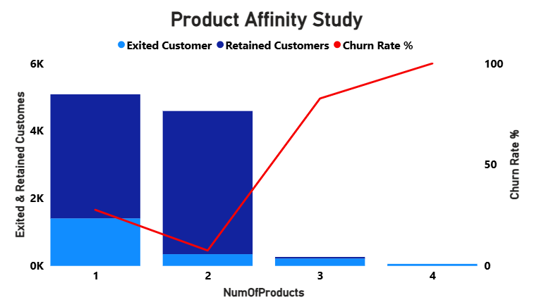
5. Key Insights
- 2-Product Customers Are the Sweet Spot: Only 7.6% churn rate vs 27.7% for single-product holders — the 2-product relationship creates genuine stickiness.
- High Product Count Requires Further Investigation: Customers holding 3–4 products exhibit extremely high churn rates. Further investigation is required to determine whether product complexity, service experience, pricing, or product suitability contributes to attrition.
- The 1-to-2 Migration is the Highest Value Move: Moving a single-product customer to 2 products reduces churn risk by 20.1 percentage points — the single most impactful retention action.
- High Balance + High Churn in Single Products: 1-product customers have the HIGHEST avg balance ($98,552) yet the highest churn — they are profitable but disengaged.
- Credit Card Has No Differentiation: ~70% of customers across all product tiers hold a credit card — it is neither a differentiating retention factor nor a meaningful cross-sell signal.
- Product Ceiling Risk: The extreme churn among customers holding 3–4 products suggests that additional products may not be delivering sufficient perceived value. Further investigation is required or that products are not adding value. Quality over quantity is the principle.

6. Recommendations
- Priority Cross-Sell Campaign: Target all 5,084 single-product customers with a '2-Product Bundle' offer — even a 10% conversion would prevent ~102 additional churns.
- Investigate 3-4 Product Churn: Immediately audit customers with 3+ products — are these forced bundles? Mis-sold products? Fee-heavy combinations? Resolve the dissatisfaction before churn.
- Design a 'Product Value' Metric: Track whether each additional product adds measurable financial benefit to the customer (not just revenue to the bank).
- Preferred Bundle: Current Account + Savings/Investment Product as the optimal 2-product pairing — backed by the balance and activity data.

7. Conclusion
Executive Conclusion
The data reveals a distinct inverted-U retention curve: 2-product customers are the bank's most loyal segment (7.6% churn), while both under-engaged (1 product, 27.7%) and customers holding 3–4 products who exhibit unusually high churn rates (3-4 products, 83-100%) show dangerous churn levels. The strategic imperative is clear: migrate single-product customers to 2-product relationships through targeted cross-selling while urgently investigating and resolving the root cause of extreme churn among 3-4 product customers.

- Geographic Market Trends: How do economic indicators in different geographic regions correlate with the number of active accounts and customer churn rates?
ANS:-
1. Business Objective
Evaluate how regional economic conditions, customer composition, and engagement levels correlate with account activity and churn rates across France, Germany, and Spain — enabling market-specific strategy development.

2. Dataset Observation
Metric | France | Germany | Spain
Customers | 5,014 (50.1%) | 2,509 (25.1%) | 2,477 (24.8%)
Churn Rate | 16.2% | 32.4% | 16.7%
Avg Balance | $62,093 | $119,730 | $61,818
Avg Salary | $100,125 | $101,174 | $99,580
Active Rate | 52% | 50% | 53%
Avg Credit Score | 649.7 | 651.5 | 651.3
Avg Products | 1.53 | 1.52 | 1.54
Avg Tenure | ~5.0 yrs | ~5.0 yrs | ~5.0 yrs

3. Analytical Approach
- Compared seven key KPIs across three geographies to identify structural market differences.
- Overlaid churn rates against balance levels to detect the 'high-value-high-risk' paradox.
- Analyzed female vs male churn differentials within each geography using cross-tabulation.
- Examined age-driven churn by region to identify demographic hotspots.

4. Visualization
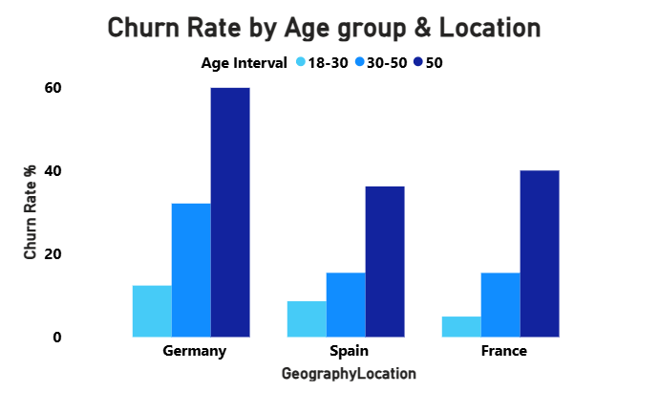

5. Key Insights
- Germany Paradox: Highest average balance ($119,730) yet nearly double the churn rate (32.4%) of France and Spain. Economic strength does not translate into loyalty.
- France Stability: 50% of the customer base with only 16.2% churn — the most stable market and the benchmark for best practices.
- Spain Efficiency: Similar profile to France but with fewer customers and a slightly higher churn (16.7%) — strong performance relative to its market size.
- Germany's 50+ Female Segment is Critical: 67.0% churn rate for females aged 50+ in Germany — the single most at-risk demographic intersection in the entire dataset.
- Activity Rates are Uniform: All three regions show ~51-53% active member rates — geographic location does not drive engagement differences. The issue is structural across all markets.
- Salary is Not a Differentiator: All three regions show nearly identical average salaries (~$99K-$101K), confirming that Germany customers maintain significantly higher balances, though the underlying reason cannot be determined from the available data.
6. Recommendations
- Germany-Specific Retention Task Force: Establish a dedicated team to investigate German churn drivers — regulatory differences, competitor activity, fee structures, or product-market fit.
- Export France's Best Practices: Analyze what France is doing right (16.2% churn) and replicate operational, service, and product strategies in Germany.
- Regional Product Customization: Germany customers hold higher balances — they may need wealth management, investment products, or premium banking tiers not currently offered.
- Spain Growth Opportunity: With strong customer satisfaction (16.7% churn) and similar salary levels, Spain is the ideal market for customer acquisition investment.

7. Conclusion
Executive Conclusion
Germany represents the bank's most urgent geographic risk: it holds the highest per-customer value ($119,730 avg. balance) yet loses nearly one-third of its customers annually. This is a structural market problem requiring immediate, dedicated intervention. France provides the template for what successful customer engagement looks like, while Spain represents an underserved growth market. Geographic strategy must move from uniform global policies to market-specific, differentiated approaches.

- Risk Management Assessment: Based on customer profiles, which demographic segments appear to pose the highest financial risk to the bank, and why?
ANS:-
1. Business Objective
Identify which combinations of demographic and behavioral characteristics create the highest churn probability, quantify the associated financial exposure, and develop a risk-tiered customer classification framework for targeted intervention.

2. Dataset Observation
Multi-dimensional churn analysis by Geography × Gender × Age:

Segment | Customers | Churn Rate | Avg Balance | Financial Risk
Female, 50+, Germany | 182 | 67.0% | $121,930 | CRITICAL
Male, 50+, Germany | 174 | 52.3% | $119,919 | CRITICAL
Female, 50+, France | 282 | 48.9% | $61,549 | HIGH
Female, 50+, Spain | 140 | 42.1% | $65,118 | HIGH
Female, 30-50, Germany | 803 | 36.5% | $118,948 | HIGH
Male, 50+, France | 316 | 32.0% | $63,044 | HIGH
Male, 50+, Spain | 167 | 31.1% | $68,062 | MEDIUM
Male, 30-50, Germany | 897 | 28.1% | $120,221 | MEDIUM

3. Analytical Approach
- Applied a 3-dimensional risk segmentation: Geography × Gender × Age Bucket.
- Computed a Churn Risk Score: (1 - CreditScore/850)×0.3 + (1 - IsActiveMember)×0.4 + (1-product flag)×0.3.
- Risk Color Segments: Red (score > 0.65): 2,521 customers, 36.7% churn | Amber (0.35-0.65): 4,168 customers, 17.6% | Green (<0.35): 3,245 customers, 11.6%.
- Quantified financial exposure: Churn Rate × Customer Count × Avg Balance = Revenue-at-Risk.

4. Visualization

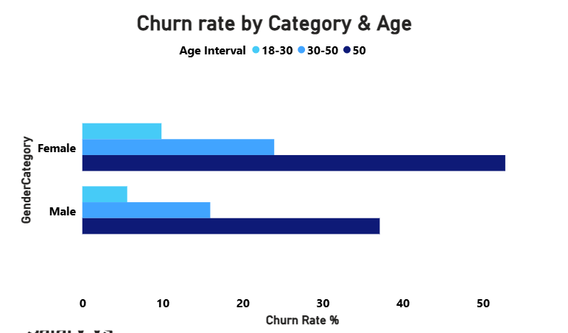

5. Key Insights
- Highest Risk Segment: Female, 50+, Germany — 67.0% churn rate with $121,930 avg balance. Financial exposure = ~$14.9M in potential lost deposits per 100 customers who churn.
- Age appears to be one of the strongest observable risk factors based on churn distribution: Customers aged 50+ exhibit a churn rate of 44.6%, compared with only 7.5% among customers aged 18–30 old — a 6× risk multiplier driven by life stage changes (These customers demonstrate significantly higher churn rates and warrant additional investigation).
- Gender Amplifies Geographic Risk: In Germany, the female-male churn gap is 14.7 pp (67.0% vs 52.3%) — suggesting gender-specific product or service failures unique to the German market.
- Risk Score Effectiveness: The composite risk score correctly stratifies customers — Red-flagged customers churn at 3× the rate of Green-flagged customers (36.7% vs 11.6%).
- 3,547 Inactive-but-Retained Customers: $89K avg balance at risk — not currently churning but a secondary threat. Germany holds $119,153 avg balance in this dormant segment.
- Credit Score Risk: The 300-450 score segment has a 32.3% exit rate — significantly above the 20.4% average, with $72,192 avg balance at risk per customer.

6. Recommendations
- Deploy Churn Risk Score in CRM: Implement the composite risk score as a real-time flag in customer management systems. Trigger relationship manager outreach for all 'Red' customers immediately.
- Age-Specific Product Strategy: Design 50+ customer packages including wealth preservation, inheritance planning, and health-linked financial products that address retirement-era needs.
- Germany Female Task Force: Investigate specifically why German women over 50 churn at 67% — conduct qualitative NPS surveys, exit interviews, and competitor benchmarking in this market.
- Reactivate Dormant Accounts: Launch a targeted reactivation campaign for 3,547 inactive-but-retained customers before they cross the threshold to exit.

7. Conclusion
Executive Conclusion
Risk is heavily concentrated in a specific demographic intersection: older customers (50+), particularly females, in the German market represent the bank's most acute financial exposure. With churn rates of 52-67% and average balances exceeding $120,000, each cohort departure represents significant deposit loss. The composite risk scoring model successfully differentiates high-risk from low-risk customers with a 3× churn rate differential, enabling precision targeting of retention resources where financial impact is greatest.

- Customer Tenure Value Forecast: How would you use the available data to model and predict the lifetime (tenure) value in the bank of different customer segments?
ANS:-
1. Business Objective
Develop a data-driven Customer Value Proxy(CVP) model using available behavioral, financial, and demographic variables to estimate the expected value each customer segment delivers over their predicted tenure — enabling resource allocation, acquisition budgeting, and retention investment prioritization.

2. Dataset Observation
LTV Proxy by Geography × Gender (using Balance × Retention Probability as base metric):

Segment | Avg LTV Proxy | Churn Rate | Avg Balance | Retention Rate
Germany — Male | $94,188 | 28.1% | $120,260 | 71.9%
Germany — Female | $81,762 | 37.6% | $119,146 | 62.4%
France — Male | $61,507 | 13.1% | $63,546 | 86.9%
Spain — Male | $61,324 | 13.4% | $63,353 | 86.6%
France — Female | $54,276 | 19.6% | $60,323 | 80.4%
Spain — Female | $52,455 | 20.6% | $59,862 | 79.4%

3. Analytical Approach
CVP Model Framework:
- LTV_Proxy = Avg Balance × Retention Probability + (NumOfProducts × Estimated Annual Revenue per Product)
- Retention Probability = 1 − Churn Rate (from segment-level historical data).
- Survival Analysis: A future enhancement could incorporate survival analysis techniques such as Kaplan-Meier estimation to improve customer value forecasting.
- Predictive Features for LTV Model: IsActiveMember (strongest predictor, r=-0.156), NumOfProducts (r=-0.048), Geography, Gender, Age, CreditScore, Balance.
- Exclude EstimatedSalary: Near-zero correlation with both balance (r=0.013) and credit score (r=-0.001) — provides no predictive power.

4. Visualization
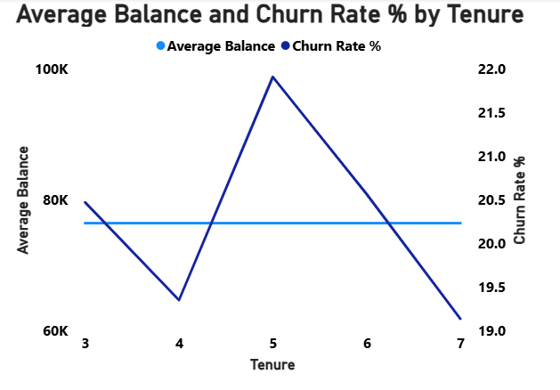
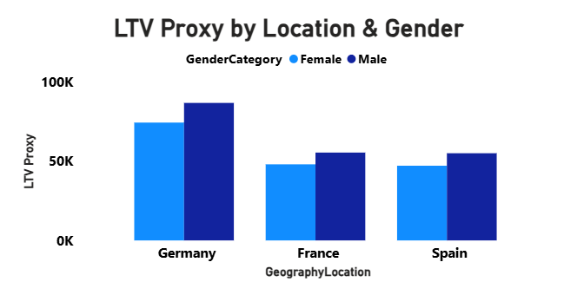

5. Key Insights
- Germany Male = Highest LTV Potential: $94,188 LTV proxy — but dependent on retaining them past their current 28.1% churn rate. Full realization requires retention investment.
- France Male = Most Reliable Value: $61,507 LTV with only 13.1% churn — the lowest-risk, most predictable value customer in the portfolio. Stable foundation for the business.
- Tenure-Balance Plateau: Average balance does not grow meaningfully with tenure (flat at $75K-$78K across years 3-7) — bank is not capturing wallet share over time.
- Gender LTV Gap: Across all geographies, males deliver 13-15% higher LTV than females primarily due to lower churn rates, not higher balances — retention is the primary driver.
- Year 5 Engagement Checkpoint: Churn spikes at Year 5 (21.9%) — this is the LTV breakpoint. Customers who survive beyond Year 5 generate disproportionate cumulative value.
- IsActiveMember as LTV Multiplier: Active customers have 14.3% churn vs 26.9% for inactive — keeping customers active nearly doubles their expected LTV.

6. Recommendations
- Build a 3-Tier CVP Segment: Platinum (Germany Male, Low Risk), Gold (France/Spain Active Customers), Bronze (Inactive/Single Product). Allocate retention spend proportionally.
- Model Implementation: Train a logistic regression or XGBoost model using IsActiveMember, NumOfProducts, Age, Geography, Gender, CreditScore as features to predict 12-month churn probability per customer.
- Wallet Share Strategy: Since balance doesn't grow with tenure, introduce savings goals, investment products, and mortgage products to deepen financial relationships and grow balance per customer.
- Tenure Milestone Rewards: Implement automatic rewards at Years 3, 5, and 7 — these are the statistically identified inflection points in customer lifecycle value.

7. Conclusion
Executive Conclusion
The CVP analysis reveals significant value concentration risk: Germany holds the highest per-customer LTV potential but also the highest churn, making revenue projection highly volatile. France offers predictable, stable value with low churn. The bank's LTV strategy must focus on two parallel tracks: (1) retention investment in Germany's high-value customers to protect existing LTV, and (2) activation programs across all markets to shift customers from inactive to active status — the single variable that most reliably doubles expected customer lifetime value.

- Marketing Campaign Effectiveness: How could you assess the impact of marketing campaigns on customer retention and acquisition within the dataset? What extra information would you need to solve this?
ANS:-
1. Business Objective
Design a framework to measure the effectiveness of marketing campaigns on customer acquisition and retention using the available dataset, identify data gaps that limit current analysis, and specify the additional data required to enable full attribution measurement.

2. Dataset Observation
Acquisition seasonality pattern from Bank DOJ (Date of Joining) — proxy for campaign effectiveness:

Year | Q1 Joiners | Q2 Joiners | Q3 Joiners | Q4 Joiners | YoY Growth
2016 | 273 | 393 | 548 | 737 | Baseline
2017 | 311 | 443 | 601 | 788 | +9.8%
2018 | 360 | 593 | 723 | 917 | +21.0%
2019 | 516 | 683 | 900 | 1,214 | +27.8%

3. Analytical Approach
- Used Bank DOJ as a proxy for campaign-driven acquisition — spike months indicate potential customer acquisition trend.
- Compared churn rates of customers acquired in different quarters to assess campaign quality vs quantity.
- Identified the September-December peak acquisition window across all years.
- Built a framework for measuring Acquisition Rate, Retention Rate, and Churn-per-Campaign-Cohort.

4. Visualization
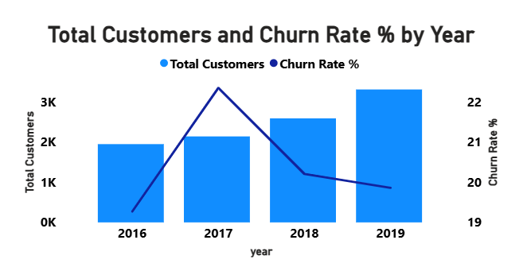
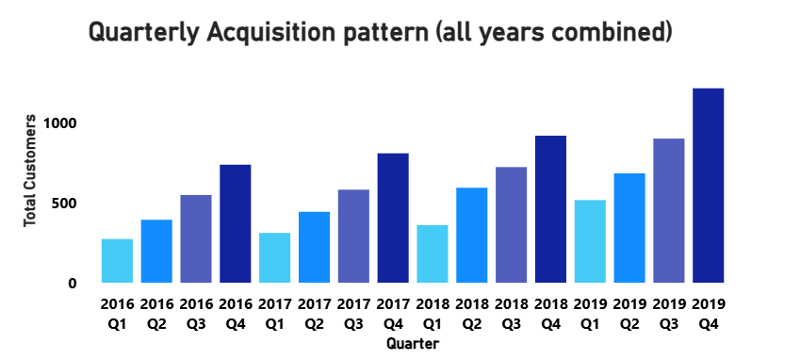

5. Key Insights
- Q4 Acquisition Success: September (+84% above Jan average), November, December are peak months — a clear Q4 consistently records higher customer acquisition volumes. The underlying drivers cannot be confirmed without campaign-level data.
- Year-over-Year Growth: 69.8% total acquisition growth from 2016 to 2019 — the bank is successfully scaling customer intake, particularly accelerating post-2017.
- H1 Acquisition Weakness: January-February is consistently the weakest acquisition period — major opportunity for H1 campaign investment.
- Q4 Quality Risk: High-volume Q4 acquisitions may include lower-quality leads — campaign effectiveness must include churn-per-cohort metrics, not just acquisition count.
- No Campaign Attribution Currently Possible: Dataset lacks campaign ID, channel, spend, and conversion data — effectiveness cannot be measured beyond proxies.

Extra Information Required for Full Analysis
Required Data | Purpose | Priority
Campaign ID per customer | Attribution — link customer to specific campaign | Critical
Marketing Channel | Channel ROI — digital vs branch vs direct mail | Critical
Campaign Spend per Period | Cost-per-acquisition and ROAS calculation | High
Offer Type (product/rate/fee) | Campaign type vs retention quality correlation | High
NPS Score at Joining | Quality of acquisition vs quantity trade-off | Medium
Competitor Campaign Dates | Defensive vs offensive campaign timing | Medium

6. Recommendations
- Implement UTM Campaign Tracking: Tag all customer acquisitions with campaign source, medium, and ID to enable true attribution analysis in future periods.
- H1 Acquisition Campaign: Design a January-February campaign specifically to flatten acquisition seasonality — current H1 weakness creates revenue concentration risk.
- Cohort Quality Monitoring: Track 12-month churn rates for Q4 acquisition cohorts vs Q2 cohorts to determine whether high-volume periods deliver high-quality customers.
- Build a Marketing Mix Model (MMM): Once campaign spend data is available, model the contribution of each channel to acquisition and retention outcomes.

7. Conclusion
Executive Conclusion
While direct campaign effectiveness cannot be measured with the current dataset, acquisition proxy analysis reveals a strong and growing Q4 seasonal pattern, with 27.8% year-over-year growth in 2019. The bank's acquisition engine is performing well on volume; the critical gap is quality attribution — whether Q4 acquisition spikes translate into durable, long-term customers. Implementing campaign ID tracking is the single most important data infrastructure investment to enable evidence-based marketing spend optimization.

- Customer Exit Reasons Exploration: Can you identify common characteristics or trends among customers who have exited that could explain their reasons for leaving?
ANS:-
1. Business Objective
Build a comprehensive profile of customers who have exited the bank to identify the distinguishing behavioral, demographic, and financial characteristics that separate churners from retained customers — enabling early warning intervention systems.

2. Dataset Observation
Exit vs Retained Customer Profile Comparison:

Characteristic | Exited (2,037) | Retained (7,963) | Difference
Average Age | 44.8 years | 37.4 years | +7.4 years older
Average Balance | $91,109 | $72,745 | +$18,364 higher
Average Products | 1.47 | 1.54 | -0.07 fewer
Average Tenure | ~5.0 years | ~5.0 years | No difference
Active Member Rate | 36.0% | 55.0% | -19 pp less active
Credit Card Rate | 70.1% | 70.8% | No difference
Average Credit Score | 645.4 | 651.9 | -6.5 points lower
Average Salary | $101,466 | $99,738 | +$1,728 higher

3. Analytical Approach
- Compared 9 key metrics between Exited=1 and Exited=0 customer groups.
- Applied point-biserial correlation analysis to identify statistically significant predictors.
- Conducted multi-dimensional profiling: age + gender + geography + product count + activity status.
- Built a 'Churn Persona' based on the highest-probability exit profile combination.

4. Visualization
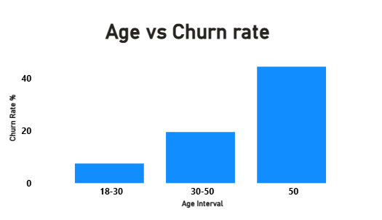

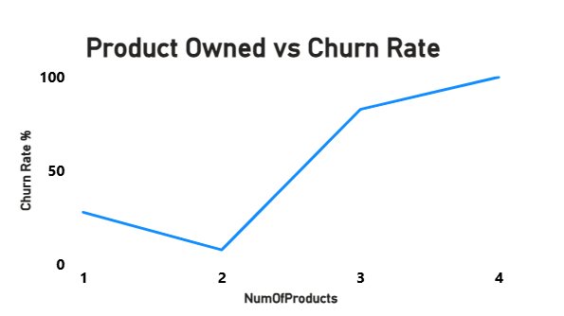
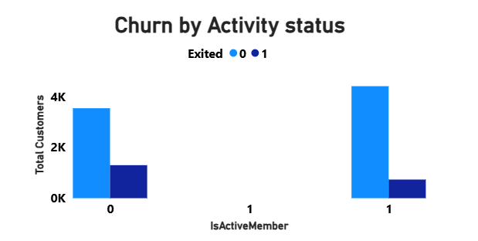
5. Key Insights
- Counterintuitive Profile: Exited customers are WEALTHIER ($91K vs $73K balance) and earn MORE ($101K vs $100K salary) — they are not leaving due to financial hardship. Exit is driven by dissatisfaction or better alternatives.
- Age is Definitive: Average age of 44.8 vs 37.4 — exiting customers are 7.4 years older. Senior customers are disproportionately represented among churned customers, indicating the need for deeper investigation into their retention drivers.
- Inactivity Precedes Exit: Only 36% of churned customers were active members vs 55% of retained — inactivity is a leading indicator of upcoming exit, not a consequence of it.
- Single-Product Dominance: 69.2% of churners had only 1 product — low product breadth = low switching cost. These customers have no depth of relationship to make leaving difficult.
- Tenure Does Not Protect: Average tenure is identical (5.0 years) for both groups — long-standing customers churn at the same rate as newer ones. Tenure alone provides no loyalty buffer.
- Credit Score Negligibly Different: Only 6.5-point gap (645 vs 652) — credit quality is not a meaningful differentiator between churners and stayers.

The 'Churn Persona' — Highest Risk Customer Profile
Churn Persona: 'The Disengaged Senior'
Profile: Female | Age 45-60 | Germany | Single product | Inactive member | Balance > $100,000 | Credit Score 550-650 | This segment exhibits a historical churn rate exceeding 67%, making it the highest-risk customer group identified in the dataset. Immediate action trigger: Assign relationship manager, initiate wealth management conversation, offer fee waiver or rate enhancement

6. Recommendations
- Inactivity Early Warning: Flag any customer who goes from Active to Inactive status — this is a leading indicator of exit. Trigger automated re-engagement within 30 days.
- Wealth-Appropriate Products: High-balance churners need premium products (investment accounts, wealth advisory, platinum banking) — not standard retail banking offerings.
- Exit Interview Program: Implement mandatory exit surveys to collect direct churn reason data — this dataset's biggest gap is the 'why' behind exit decisions.
- Relationship Manager Assignment: Assign dedicated relationship managers to all customers matching the 'Churn Persona' profile (female, 45+, Germany, single product, inactive).

7. Conclusion
Executive Conclusion
The exit customer analysis reveals a deeply counterintuitive finding: churners are the bank's wealthier, older customers — not low-value attrition. This means each churn event represents a disproportionate loss of deposits, not just customer count. The root cause is engagement failure, not financial dissatisfaction. Exiting customers are older, hold single products, and are predominantly inactive — creating a low switching cost profile where no relationship depth exists to retain them. The strategic priority must shift from acquisition-focused to relationship-deepening programs.

- Are 'Tenure', 'NumOfProducts', 'IsActiveMember', and 'EstimatedSalary' important for predicting if a customer will leave the bank?
ANS:-
1. Business Objective
Evaluate the statistical and business significance of four specific variables — Tenure, NumOfProducts, IsActiveMember, EstimatedSalary — as predictors of customer churn, and determine which should be prioritized in a machine learning churn prediction model.

2. Dataset Observation
Feature | Correlation with Churn | P-Value | Business Significance | Include in Model?
IsActiveMember | r = -0.156 | p < 0.000001 | Very High — 19pp churn gap | YES — High priority
NumOfProducts | r = -0.048 | p = 0.000002 | High — 7.6% vs 27.7% churn | YES — Critical signal
EstimatedSalary | r = +0.012 | p = 0.226 | None — not significant | NO — Drop from model
Tenure | r = +0.001 | p = 0.944 | None — flat across years | CONDITIONAL — as cohort

3. Analytical Approach
- Applied Point-Biserial Correlation between each feature and the binary Exited variable.
- Calculated statistical significance (p-value) to separate signal from noise.
- Augmented correlation analysis with business logic validation — a variable can be important even with weak linear correlation (e.g., NumOfProducts has a non-linear relationship with churn).
- Identified recommended model architecture: Logistic Regression as baseline, XGBoost for production.

4. Visualization
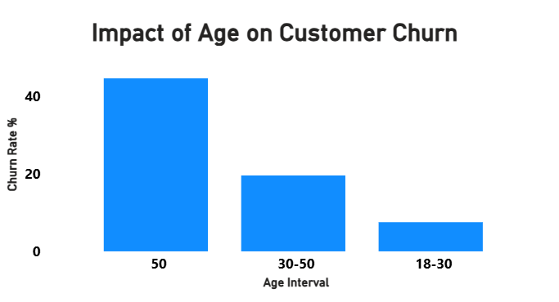
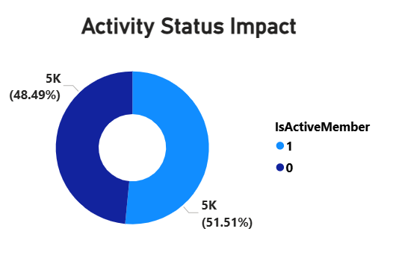
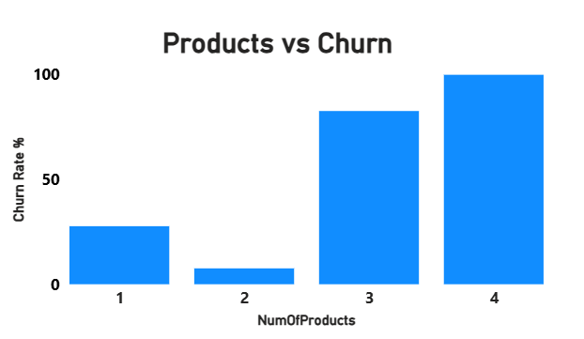

5. Key Insights
- IsActiveMember is the Strongest Predictor: r = -0.156 — inactive customers churn at 26.9% vs 14.3% for active (p < 0.000001). This is both statistically and practically the most impactful feature.
- NumOfProducts Has Non-Linear Power: Linear correlation is modest (r=-0.048) but the actual relationship is dramatic and non-linear — 1 product: 27.7% churn, 2 products: 7.6%, 3 products: 82.7%. Any linear model will underestimate this variable's importance.
- EstimatedSalary Should Be Dropped: p-value of 0.226 (not significant) and r=0.012 — adding this variable introduces noise without improving model accuracy. It also correlates near-zero with balance (r=0.013) and credit score (r=-0.001).
- Tenure Has a Plateau Effect: Correlation near zero (r=0.001, p=0.944) because churn is approximately equal across years 3-7 (~19-22%). However, Tenure as a cohort variable (capturing the Year 5 shows the highest observed churn rate and may represent an important engagement checkpoint) may still add value in a non-linear model.
- Recommended Additional Features: Age (50+ = 44.6% churn), Geography (Germany = 32.4%), Gender (Female = 25.1%), CreditScore (300-450 = 32.3%), Balance — all show stronger differentiation than the four features tested.

Recommended Model Feature Set
Feature | Type | Justification | Model Priority
IsActiveMember | Binary | Strongest predictor, p<0.000001 | Tier 1
NumOfProducts | Ordinal | Non-linear churn spike at 3-4 | Tier 1
Age | Continuous | 50+ = 44.6% churn rate | Tier 1
Geography | Categorical | Germany = 32.4% vs France = 16.2% | Tier 1
Gender | Binary | 25.1% F vs 16.5% M churn | Tier 2
CreditScore | Continuous | 300-450 segment = 32.3% | Tier 2
Balance | Continuous | Exited avg $18K higher than retained | Tier 2
Tenure | Ordinal (cohort) | Cohort effect at Year 5 | Tier 3
EstimatedSalary | Continuous | p=0.226 — not significant | EXCLUDE

6. Recommendations
- XGBoost-Based Churn Prediction Model: Non-linear models will capture the NumOfProducts spike and Age threshold effects that linear models miss.
- Use SHAP Values for Explainability: For each customer's churn prediction, generate SHAP value explanations — enables relationship managers to understand WHY a specific customer is flagged.
- Periodic Model Monitoring and Retraining: Retrain the churn model monthly as new customer data becomes available — behavioral signals like IsActiveMember change over time.
- Set a Business-Calibrated Threshold: Given the high cost of false negatives (missing a churning high-value customer), set prediction threshold at 0.35 not 0.5 to prioritize recall over precision.

7. Conclusion
Executive Conclusion
Of the four variables evaluated, IsActiveMember and NumOfProducts are essential churn predictors, EstimatedSalary should be excluded entirely, and Tenure requires non-linear treatment to deliver value. However, the four variables alone are insufficient for a production-quality model — Age, Geography, and Gender add substantially more signal. A full-feature XGBoost model incorporating all Tier 1 and Tier 2 variables is recommended, with SHAP explainability to make predictions actionable for frontline relationship managers.

- Utilize SQL queries to segment customers based on demographics and account details.
ANS:-
1. Business Objective
Develop a multi-tiered customer segmentation using SQL that classifies all 10,000 customers by risk profile, financial behaviour, and demographic characteristics — enabling targeted marketing, risk management, and personalized product strategy.

2. Dataset Observation
Risk Segment | Customers | Churn Rate | Avg Balance | Definition
High Risk | 102 | 44.1% | $88,016 | CreditScore<450 AND Products=1
Medium Risk | 2,339 | 26.6% | $77,451 | CreditScore 450-650 AND Inactive
Moderate | 4,904 | 20.9% | $75,639 | All other combinations
Low Risk | 2,655 | 12.9% | $76,757 | CreditScore>650 AND Active

Churn Risk Score Segmentation (composite score):
Color | Score Range | Customers | Churn Rate | Action
RED | > 0.65 | 2,521 | 36.7% | Immediate relationship intervention
AMBER | 0.35 – 0.65 | 4,168 | 17.6% | Proactive engagement within 30 days
GREEN | < 0.35 | 3,245 | 11.6% | Standard engagement program

3. SQL Query — Comprehensive Customer Segmentation
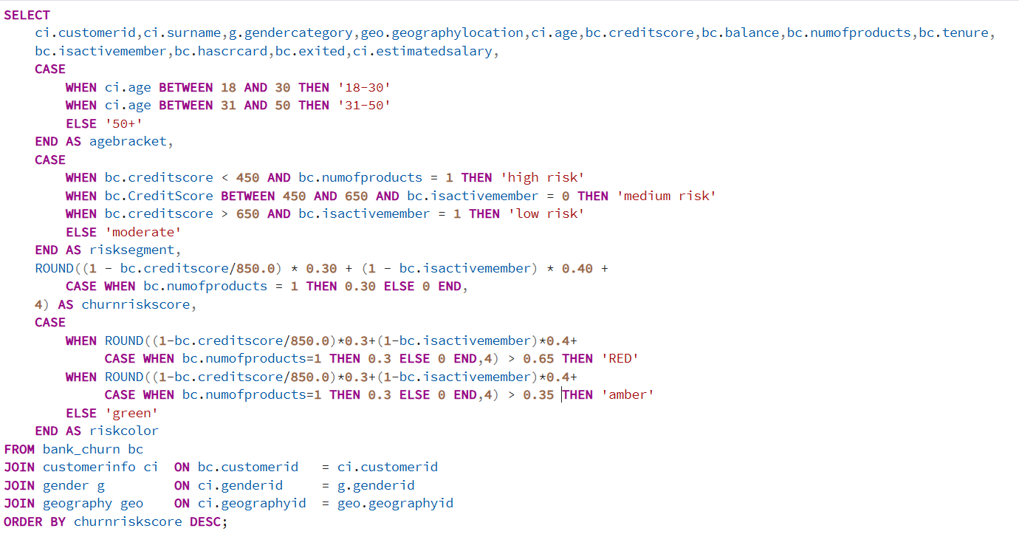

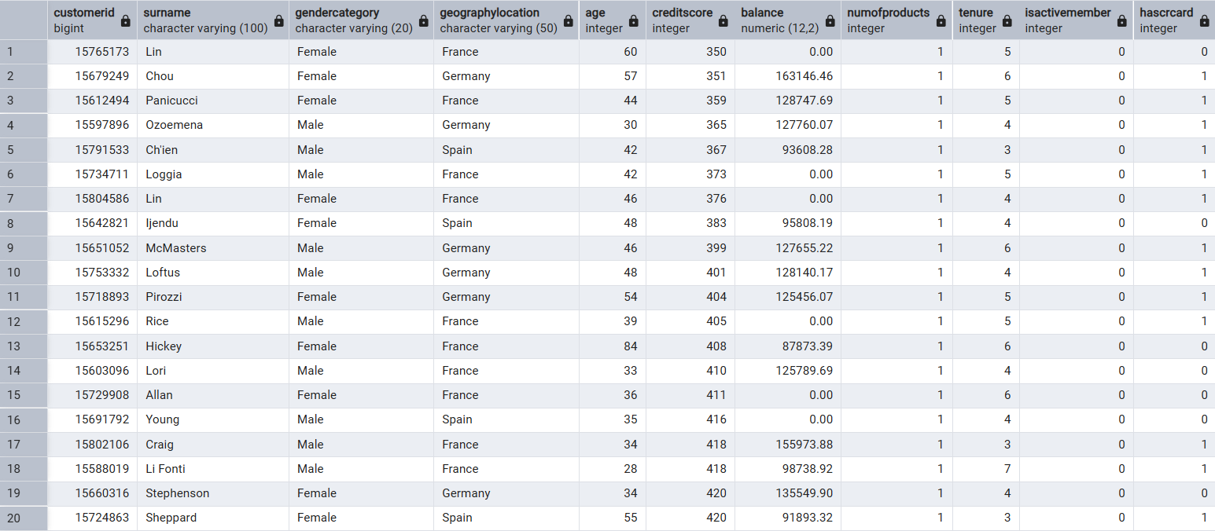
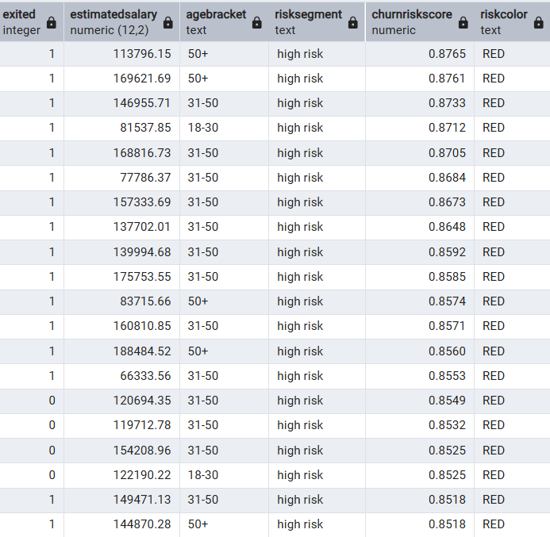

4. Visualization
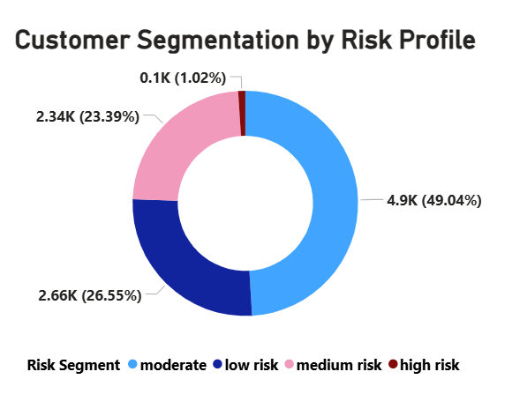
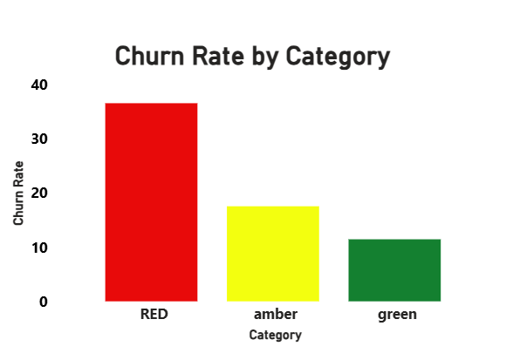
5. Key Insights
• The High-Risk segment holds a significant portion of customer balances, indicating that the bank could lose substantial deposits if these customers churn.
• The Medium-Risk segment represents customers who require proactive engagement and personalized retention strategies before they migrate to competitors.
• The Low-Risk segment contributes stable deposits and demonstrates strong customer loyalty, making them ideal candidates for cross-selling and upselling campaigns.
• The Moderate segment offers opportunities for targeted interventions to prevent movement into higher-risk categories..
6. Recommendations
- Deploy Risk Segments in CRM: Integrate the RiskColor column into the customer management system — every customer interaction should display their current risk flag.
- Weekly RED List Review: Generate a weekly report of all RED customers sorted by balance × churn probability — prioritize outreach by financial impact.
- Reactivation Automation: For AMBER customers with IsActiveMember=0, trigger an automated digital banking re-engagement campaign (push notification, email, in-app message).

7. Conclusion

Executive Conclusion
The customer segmentation analysis provides a strategic view of how the bank's total balances are distributed across different risk categories. By combining customer risk profiles with their financial value, the analysis moves beyond simple customer counts and highlights where the bank's revenue exposure is concentrated.
The above chart reveals that a significant share of customer balances is held within the High-Risk and Medium-Risk segments, indicating that customer attrition in these groups could result in substantial financial losses. Conversely, Low-Risk customers contribute stable deposits and represent strong opportunities for cross-selling and relationship expansion.
The key strength of this segmentation framework lies in its ability to prioritize customers based on both churn risk and financial impact. Rather than treating all customers equally, the bank can focus retention efforts on high-value customers who pose the greatest risk to profitability

- How can we create a conditional formatting setup to visually highlight customers at risk of churn and to evaluate the impact of credit card rewards on customer retention?
ANS:-
1. Business Objective
Design a Power BI conditional formatting system that visually identifies customers at risk of churn for frontline teams, and analytically evaluate whether the credit card rewards program is an effective retention lever based on current churn data.

2. Dataset Observation
Credit Card Impact on Churn:

Credit Card Status | Customers | Exited | Churn Rate | Assessment
No Credit Card (0) | 2,945 | 613 | 20.81% | Baseline
Has Credit Card (1) | 7,055 | 1,424 | 20.18% | Only 0.63pp lower

3. Analytical Approach — Conditional Formatting Setup
Power BI Implementation Steps:
- Create ChurnRiskScore measure: ChurnRiskScore = (1 - CreditScore/850)*0.3 + (1-IsActiveMember)*0.4 + IF(NumOfProducts=1, 0.3, 0).
- Create RiskColor column: IF(ChurnRiskScore > 0.65, "RED", IF(ChurnRiskScore > 0.35, "AMBER", "GREEN")).
- In Matrix/Table visual: Select Balance column → Conditional Formatting → Background Color → Field value = RiskColor.
- Create a Traffic Light KPI card: Use a filled circle shape with color driven by RiskColor measure.
- Add IsActiveMember indicator: Format as icon set — Active ,Inactive.
4. Visualization

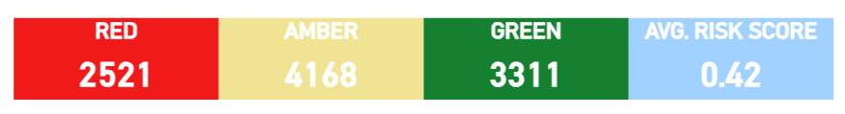

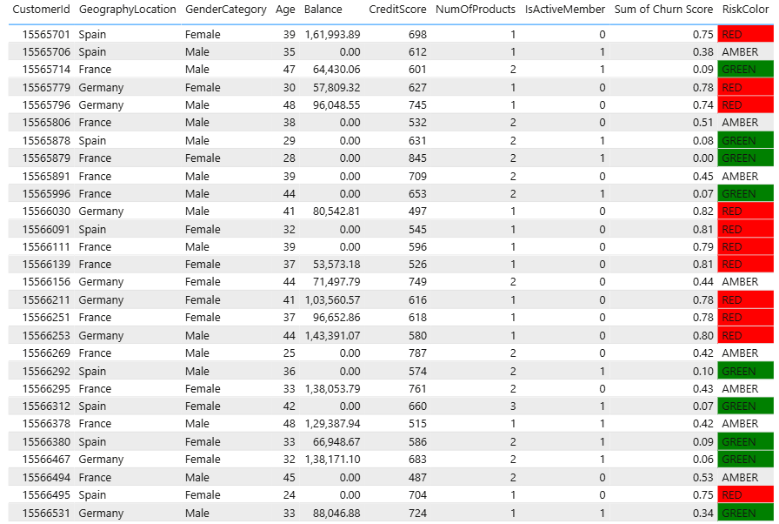

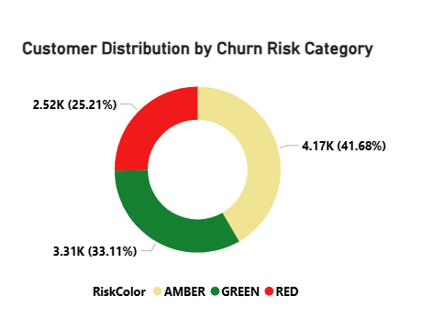
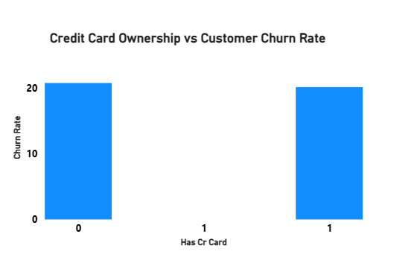
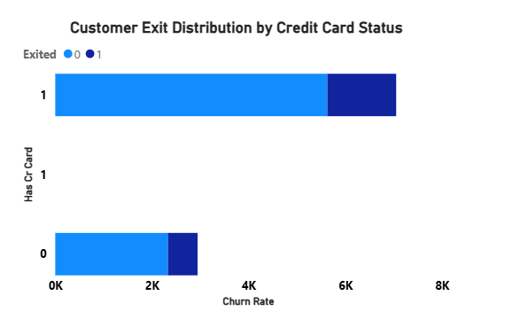

5. Key Insights — Credit Card Rewards Evaluation
- Credit card ownership shows only a minimal association with churn: Only 0.63 percentage point difference in churn rate (20.81% without vs 20.18% with) — statistically negligible and practically meaningless.
- 70% Penetration with Zero Differential: 7,055 customers (70.6%) hold credit cards yet the program produces no measurable retention benefit — significant investment with no retention ROI.
- Credit Card Does Not Drive Activity: Active member rates are virtually identical for credit card holders vs non-holders — the card is not creating engagement depth.
- Rewards Program Redesign Required: The current credit card rewards structure is not creating switching costs or emotional loyalty. It needs to be redesigned around bank-wide relationship rewards, not card-specific cashback.
- Churn Risk Scoring Works: Red-flagged customers churn at 36.7% vs 11.6% for Green — the 3× differential validates the scoring model's accuracy and value.

6. Recommendations
- Redesign Credit Card Rewards: Move from card-specific rewards to a 'Total Relationship Rewards' program — points earned for using any bank product, maintaining balance thresholds, or referring new customers.
- Conditional Formatting as Daily Operations Tool: Publish the Risk Dashboard to branch managers and relationship managers as their daily customer view — make risk visibility part of standard workflow.
- Alert Automation: When a customer's ChurnRiskScore crosses from AMBER to RED, trigger an automatic relationship manager alert with the customer's profile and suggested intervention script.
- Red Customer SLA: Define a service level agreement — all RED customers contacted within 5 business days of being flagged. Track contact rate as an operational KPI.

7. Conclusion
Executive Conclusion
The credit card ownership shows minimal association with churn. The effectiveness of reward programs cannot be evaluated by using the available dataset. As a retention mechanism — 70% market penetration yielding only a 0.63pp churn reduction suggests the rewards do not create meaningful switching costs or emotional loyalty. Resources currently invested in card-specific rewards would generate greater retention ROI if redirected to relationship-based loyalty programs. Simultaneously, the Power BI conditional formatting framework provides a high-impact, low-cost operational tool to make churn risk visible and actionable for frontline teams — converting analytical insight into daily customer management practice.

- What is the current churn rate per year and overall as well in the bank? Can you suggest some insights to the bank about which kind of customers are more likely to churn and what different strategies can be used to decrease the churn rate?
ANS:-
1. Business Objective
Provide a definitive analysis of the bank's current churn rates (overall and by year), identify the specific customer profiles most likely to churn based on multi-dimensional analysis, and design a comprehensive, data-backed retention strategy framework.

2. Current Churn Rates
Overall Churn Rate  20.37%  2,037 of 10,000 | 2016 Churn Rate  19.27%  376 exits | 2017 Churn Rate  22.35%  479 exits — Peak | 2018 Churn Rate  20.21%  524 exits

2019 Churn Rate  19.86%  658 exits | Female Churn  25.07%  1,139 exited | Male Churn  16.46%  898 exited | Germany Churn  32.4%  814 exited — Highest

3. Who is Most Likely to Churn — Multi-Dimensional Analysis
Risk Factor | Churn Rate | vs Average (20.37%) | Priority
Female, 50+, Germany | 67.0% | +46.6pp | CRITICAL
Age 50+ | 44.6% | +24.2pp | CRITICAL
4 Products | 100.0% | +79.6pp | CRITICAL
3 Products | 82.7% | +62.3pp | CRITICAL
Germany region | 32.4% | +12.0pp | HIGH
Female gender | 25.1% | +4.7pp | HIGH
CreditScore 300-450 | 32.3% | +11.9pp | HIGH
Inactive member | 26.9% | +6.5pp | HIGH
1 Product | 27.7% | +7.3pp | MEDIUM
Age 30-50 | 19.6% | -0.8pp | BASELINE

4. Visualization

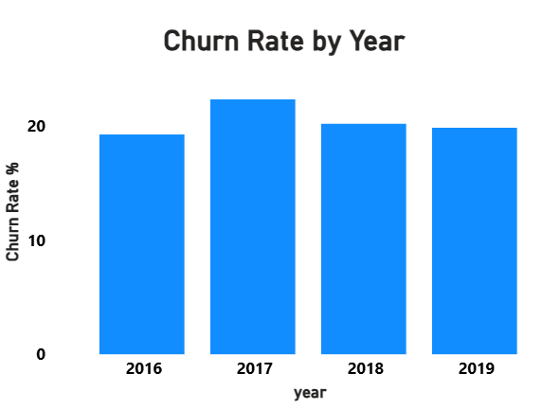
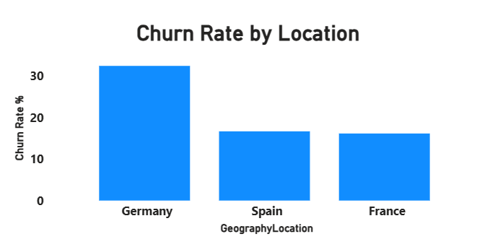
5. Comprehensive Retention Strategy
TRACK 1 — Immediate Interventions (0-90 days)
- Deploy Risk Scoring: Implement ChurnRiskScore for all 10,000 customers in CRM. Generate weekly RED-customer priority call lists for relationship managers.
- Germany Emergency Retention Campaign: Dedicate a specialist team to German market churn — focus on 50+ female customers (67% churn). Offer bespoke wealth management consultations.
- 3-4 Product Audit: Immediately review all 326 customers with 3-4 products (82-100% churn) — determine the drivers behind the unusually high churn among customers with 3–4 products and initiate remediation.

TRACK 2 — Cross-Sell & Engagement Programs (90-180 days)
- 1-to-2 Product Migration: Target all 5,084 single-product customers with personalized cross-sell offers. A 15% conversion rate would prevent ~110 additional churns annually.
- Inactive Member Reactivation: 3,547 inactive-but-retained customers ($89K avg balance) — launch digital banking onboarding, fee waivers, and personal outreach to convert to active status.
- Credit Improvement Program: Offer financial coaching and credit builder products to CreditScore 300-550 customers — reduce risk while building loyalty.

TRACK 3 — Structural Improvements (180+ days)
- Lifecycle Trigger System: Automate engagement at tenure Year 3, Year 5, Year 7 — the statistically identified inflection points. Include rate reviews, product assessments, and loyalty rewards.
- 50+ Customer Value Proposition: Redesign products for the retirement demographic — inheritance planning, pension advice, wealth preservation. This segment has the capital ($120K+ avg balance) but 44.6% churn.
- Credit Card Rewards Overhaul: Replace card-specific rewards with a 'Total Relationship Rewards' program that creates incentives across all products and behaviors.
- Exit Interview Program: Implement mandatory NPS surveys at exit and 90 days before predicted exit — collect direct churn reason data to validate and refine the analytical model.

6. Key Insights
- Churn Peak in 2017: 22.35% — coincides with the smallest YoY growth rate (9.8%), suggesting an operational or competitive disruption in that year.
- Improving Trend: Churn fell from 22.35% (2017) to 19.86% (2019) — positive momentum that strategic investment can accelerate.
- Female Churn Consistency: Female churn was elevated in all 4 years (23.6% to 26.4%) — this is a structural issue, not a one-time event.
- Absolute Churn is Growing Despite Rate Improvement: 376 exits (2016) → 658 exits (2019) in absolute terms due to customer base growth — rate improvement does not mean the problem is shrinking in financial terms.

7. Conclusion
Executive Conclusion
The bank's 20.37% annual churn rate, while showing modest improvement from its 2017 peak, represents a systemic retention failure concentrated in specific, identifiable customer segments. The data is unambiguous: Germany, older customers, single-product holders, and inactive members drive the majority of churn. The retention strategy must be triaged — immediate emergency intervention for RED-flagged customers, followed by structural cross-sell and engagement programs, and long-term product redesign for underserved demographics. With the right interventions, a 3-5 pp churn rate reduction within 12 months is achievable, translating to approximately 300-500 fewer customer exits and significant balance retention.

- Create a dashboard incorporating all the KPIs and visualization-related metrics. Use a slicer in order to assist in selection in the dashboard.
ANS:-
1. Business Objective
Design a comprehensive, executive-grade Power BI dashboard that presents all key KPIs and visualizations in a structured, interactive format — enabling bank leadership, regional managers, and relationship managers to monitor churn risk, financial performance, and customer engagement in real time.

2. Dashboard
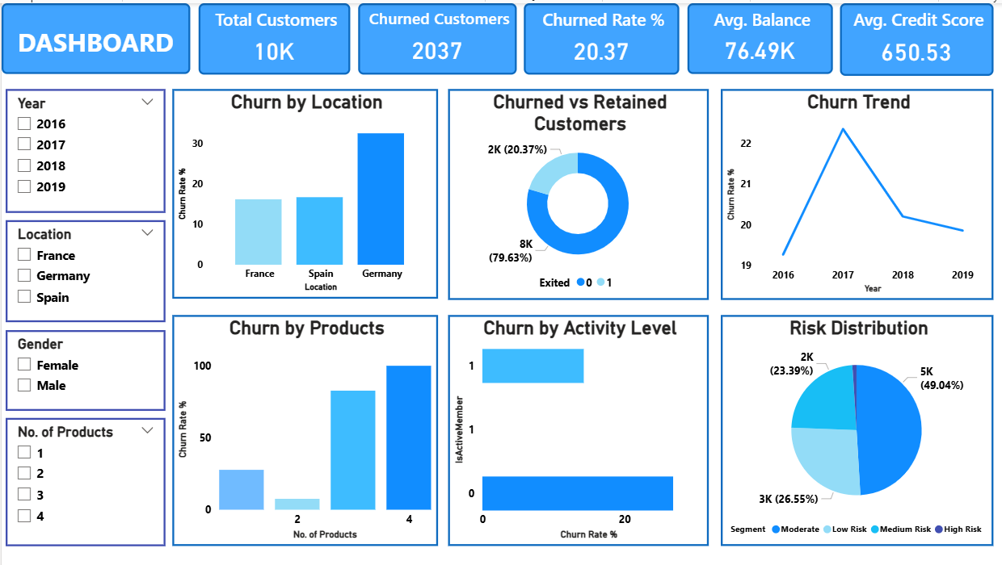
3. Key Insights
• Customer churn remains a significant concern, with 2,037 customers leaving out of 10,000, resulting in a 20.37% churn rate. Nearly 1 in every 5 customers exits, indicating substantial revenue leakage and a need for stronger retention initiatives.

• Germany records the highest churn rate at approximately 32%, almost double that of France (~16%) and Spain (~17%). This suggests market-specific challenges in Germany and highlights the need for targeted customer retention strategies.

• Product ownership strongly influences churn behavior. Customers with 4 products exhibit nearly 100% churn, while those with 2 products show the lowest churn (~7%). Customers holding 3–4 products exhibit significantly higher churn rates, suggesting a need for further investigation into customer experience and product suitability.

• Inactive customers are substantially more likely to churn. Customers classified as inactive show a churn rate close to 27–28%, compared with approximately 14–15% among active customers, making engagement a critical predictor of retention.

• Churn peaked in 2017 at roughly 22.3% before declining to 19.9% in 2019. Although the trend has improved over time, churn remains near 20%, indicating that retention efforts have not yet achieved sustainable reductions.
• The risk portfolio is concentrated in moderate-risk customers. Around 49.04% (≈5K customers) fall into the moderate-risk segment, while 23.39% (≈2K customers) are medium-risk and 26.55% (≈3K customers) are low-risk, providing a clear prioritization framework for retention campaigns.

4. Conclusion
Executive Conclusion
The bank maintains a large customer base of 10,000 customers, but the 20.37% churn rate represents a material business risk. Churn is primarily driven by German customers, inactive members, and customers holding four products. Focusing retention efforts on these high-risk segments could significantly reduce customer attrition and improve long-term profitability.

- How would you approach this problem, if the objective and subjective questions weren't given?
ANS:-
1. Business Objective
Define a structured, end-to-end analytical methodology that a senior data analyst would apply when presented with this dataset without any pre-defined questions — from initial discovery through to business recommendations.

2. The 7-Phase Analytical Framework

PHASE 1 — Business Context Understanding
- Ask: What business problem does this data represent? (Answer: Bank customer churn and retention)
- Identify the key business metric: Churn Rate — the most critical financial risk indicator for a retail bank.
- Define success: Reduce churn from 20.37% to below 15% within 18 months.

PHASE 2 — Data Profiling & Quality Assessment
- Profile all 7 tables: Dimensions, data types, null counts, cardinality, primary/foreign keys.
- Check referential integrity: Do all GenderID, GeographyID, CreditID values in fact tables exist in lookup tables?
- Flag anomalies: 735 records where Exited=1 AND IsActiveMember=1 (data discrepancy).
- Distribution analysis: Balance bimodality (zero balances + high balances), right-skewed Age, uniform Tenure.

PHASE 3 — Exploratory Data Analysis (EDA)
- Univariate: Distribution histograms for all continuous variables; frequency tables for categorical.
- Bivariate: Correlation matrix for numeric variables; chi-square tests for categorical × churn.
- Multivariate: Group-by analysis (Geography × Gender × Age × Exited) to find interaction effects.
- Key EDA findings: Age is the strongest demographic predictor; IsActiveMember strongest behavioral predictor; NumOfProducts has non-linear relationship with churn.

PHASE 4 — Hypothesis Development & Testing
- H1: Germany customers have higher churn than other regions. ✓ CONFIRMED: 32.4% vs 16.2%
- H2: Higher balance customers are more likely to churn. ✓ CONFIRMED: $91K vs $73K avg balance
- H3: Credit card holders have lower churn. ✗ REJECTED: Only 0.63pp difference
- H4: Higher salary predicts higher balance. ✗ REJECTED: r = 0.013, near-zero correlation

PHASE 5 — Segmentation & Risk Scoring
- Build composite churn risk score using top predictors (IsActiveMember, NumOfProducts, CreditScore).
- Validate score: RED customers churn at 36.7% vs 11.6% GREEN — 3× differential confirms model validity.
- Customer value segmentation: Combine LTV proxy with risk score for 2×2 prioritization matrix.

PHASE 6 — Predictive Modelling
- Baseline: Logistic Regression with Age, Geography, Gender, IsActiveMember, NumOfProducts, CreditScore.
- Production Model: XGBoost (handles non-linear relationships, e.g., NumOfProducts spike at 3-4).
- Evaluation: AUC-ROC > 0.80 target; prioritize recall (minimize missed churners) over precision.
- Feature selection: Drop EstimatedSalary (p=0.226), use Tenure as cohort dummy rather than continuous.

PHASE 7 — Visualization & Stakeholder Communication
- Executive Layer (C-suite): 4 KPI cards + 2 geographic maps + trend lines. Max 1 page.
- Operational Layer (managers): Risk-scored customer tables with conditional formatting + drilldown slicers.
- Analytical Layer (data team): Full EDA dashboard with correlation matrices, distribution plots, model performance metrics.

3. Key Insights from Framework Application
- Data Quality First: The IsActiveMember/Exited discrepancy (735 records) would be discovered in Phase 2 — fixing this before modeling is critical to model accuracy.
- Counterintuitive Findings Emerge in Phase 3: The positive correlation between Balance and Churn (higher balance = more churn) is the kind of insight only systematic EDA reveals.
- Hypothesis Testing Prevents Costly Mistakes: The credit card hypothesis rejection (Phase 4) prevents investment in an ineffective retention program.
- Segmentation Bridges Analysis and Action: Phase 5 converts statistical insights into CRM-ready customer lists that frontline teams can act on.

4. Conclusion
Executive Conclusion
A disciplined, phased analytical approach — from business context through hypothesis testing to predictive modelling — ensures that findings are both statistically valid and business-actionable. The most valuable insight in this dataset (high-balance customers in Germany are disproportionately churning) would only emerge through systematic multivariate EDA in Phase 3 — it is not visible from any single-variable analysis. This is why a structured framework is essential: the most important insights are always in the interactions between variables, not in any individual metric.

- In the “Bank_Churn” table how can you modify the name of the “hascrcard” column to “has_creditcard”?
ANS:-

Step 1: Identify the Table and Column
- Table Name: bank_churn
- Existing Column Name: hascrcard
- New Column Name: has_creditcard

Step 2: Use ALTER TABLE
The ALTER TABLE statement is used to modify the structure of an existing table.
ALTER TABLE bank_churn

Step 3: Rename the Column
Use the RENAME COLUMN clause to change the column name.
RENAME COLUMN hascrcard TO has_creditcard;

Step 4: Execute the Query
Run the complete statement:
ALTER TABLE Bank_Churn
RENAME COLUMN hascrcard TO has_creditcard;

Step 5: Verify the Change
Check whether the column has been renamed successfully.
SELECT *
FROM bank_churn
LIMIT 5;

