
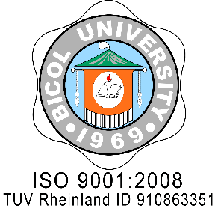
REPUBLIC OF THE PHILIPPINES
BICOL UNIVERSITY
LEGAL AFFAIRS OFFICE
Legazpi City
Email: op@bicol-u.edu.ph

ISO 9001: 2015
SOCOTEC SCP000722Q
MANILA OFFICE:
No. 4 Lopez St., M. H. del Pilar, Roosevelt Ave., Quezon City
 Telefax: (02) 921-1586

Legal Affairs Office

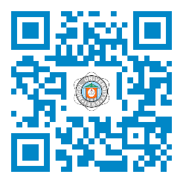

LETTERHEAD


A University for Humanity characterized by productive scholarship, transformative leadership,
collaborative service and distinctive character for sustainable societies.
This communication is aligned to

SDG No. ked221____16________dd

