**Part 1:**

1. **<title>小資族的北海道旅行</title>**

**<nav><h1><b>小資族的北海道旅行-規劃篇</b></h1></nav>**

1. **Carousel和div指令(5 pictures. 本次旅遊景點)**

<head>

<meta charset="UTF-8">

<title>小資族的北海道旅行</title>

<link rel="stylesheet" href="https://maxcdn.bootstrapcdn.com/bootstrap/3.3.7/css/bootstrap.min.css">

<script src="https://ajax.googleapis.com/ajax/libs/jquery/3.1.1/jquery.min.js"></script>

<script src="https://maxcdn.bootstrapcdn.com/bootstrap/3.3.7/js/bootstrap.min.js"></script>s

<nav><h1><b>小資族的北海道旅行-規劃篇</b></h1></nav>

<style>

.SAPPORO{font-size: 80px; color:red; Size:40}

.HAKODATE{font-size: 80px; color:red; font: 40}

.OTARU{font-size: 80px; color:red; Size:40}

.HURANO{font-size: 80px; color:red; Size:40}

.ASAHIKAWA{font-size: 80px; color:red; Size:40}

</style>

</head>

<body>

<div id="slideshow" class="carousel slide" data-ride="carousel">

<div class="carousel-inner" role="listbox">

<div class="item active"><img src="https://github.com/0980320975/3333/blob/master/SAPPORO.jpg" alt="SAPPORO" style="height: 500px; width: 110%;">

<div class="carousel-caption SAPPORO"><h1>札幌</h1><p></div>

</div>

<div class="item"><img src="https://github.com/0980320975/3333/blob/master/HAKODATE.jpg" alt="HAKODATE" style="max-height: 500px; width:110%;">

<div class="carousel-caption HAKODATE"><h1>函館</h1></div>

</div>

<div class="item"><img src="https://github.com/0980320975/3333/blob/master/OTARU.jpg " alt="OTARU" style="max-height: 500px; width: 100%">

<div class="carousel-caption OTARU"><h1>小樽</h1></div>

</div>

<div class="item"><img src="https://github.com/0980320975/3333/blob/master/HURANO.jpg" alt="HURANO" style="max-height: 500px; width:110%;">

<div class="carousel-caption HURANO"><h1>富良野</h1></div>

</div>

<div class="item"><img src="https://github.com/0980320975/3333/blob/master/ASAHIKAWA.jpg" alt="ASAHIKAWA" style="max-height: 500px; width: 100%">

<div class="carousel-caption ASAHIKAWA"><h1>旭川</h1></div>

</div>

</div>

<div class="control-btn">

<a href="#slideshow" class="left carousel-control" role="button" data-slide="prev">

<span class="glyphicon glyphicon-chevron-left" aria-hiddden="true"></span>

</a>

<a href="#slideshow" class="right carousel-control" role="button" data-slide="next">

<span class="glyphicon glyphicon-chevron-right" aria-hiddden="true"></span>

</a>

<a href="#slideshow" class="right carousel-control" role="button" data-slide="next">

<span class="glyphicon glyphicon-chevron-right" aria-hiddden="true"></span>

</a>

<a href="#slideshow" class="right carousel-control" role="button" data-slide="next">

<span class="glyphicon glyphicon-chevron-right" aria-hiddden="true"></span>

</a>

<a href="#slideshow" class="right carousel-control" role="button" data-slide="next">

<span class="glyphicon glyphicon-chevron-right" aria-hiddden="true"></span>

</a>

</div>

<ol class="carousel-indicators">

<li data-target="#slideshow" data-slide-to="0"></li>

<li data-target="#slideshow" data-slide-to="1"></li>

<li data-target="#slideshow" data-slide-to="2"></li>

<li data-target="#slideshow" data-slide-to="3"></li>

<li data-target="#slideshow" data-slide-to="4"></li>

</ol>

</div>

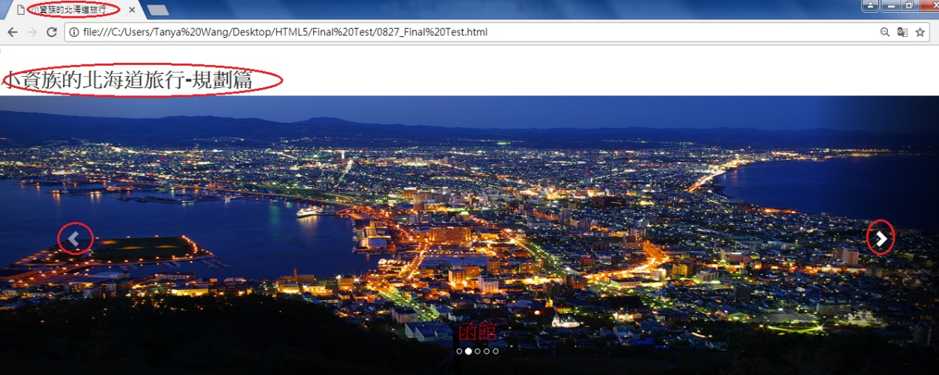

1. **去回程時程表**

<table border= solid black cellspacing="0" cellpadding="5">

<tr>

<td> CPE<->CTS</td>

<td>Date</td>

<td>Flight Time</td>

<td>Flight Company</td>

<td>Ticket Fee </td>

</tr>

<tr>

<tr>

<td>去程</td>

<td>9/9</td>

<td>12:00- 16:55</td>

<td rowspan="2">Scoot</td>

<td rowspan="2">NTD 8,000</td>

</tr>

<tr>

<td>去程</td>

<td>9/12</td>

<td>20:10- 23:10</td>

</tr>

</table>

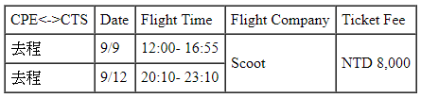

1. **nest Hotel飯店連結**

<a href="http://rsv.rurubu.travel/PhotoList.aspx?st=1529084&sk=B4&pc=B2CEHTL&rc=378&rv=40&dt=20170909&pn=2&aff=rurubu_t">**nest Hote**l </a>

1. **北海道地圖**

<a href="https://github.com/0980320975/3333/blob/master/HOKKAITO%20MAP.png">北海道地圖</a>

**Part 2:**

**學習困難:**

**需多練習. 並對於個別觀念做聯想. 並需下更功夫於基本功.**