5

Data Visualization

*Present 1-2: The title slide and the Learning Objectives slide. An overview of what we will achieve in this course*

Lesson Objectives:

By the end of this lesson, you will be able to:

* Create and customize line plots, bar plots, histograms, scatterplots, and box-and-whisker plots using the functional method
* Create a programmatic, descriptive title
* Describe the advantages of using the object-oriented method rather than the functional method in matplotlib
* Create a callable figure object containing a single axis or multiple axes
* Resize and save a figure object with numerous subplots

Introduction

*Present 3: Brief introduction to plotting*

Data visualizations are powerful tools allowing the user to digest large amounts of data very quickly. Plots come in a variety of shapes, sizes, and styles. In business, line plots and bar graphs are very common to display trends over time and compare metrics across groups, respectively. Statisticians, on the other hand, may be more interested in checking correlations between variables using a scatterplot or correlation heat map. They may also use histograms to check the distribution of a variable or boxplots to check for outliers. In politics, pie charts are widely used for comparing the total data between or among categories. Data visualizations can be very intricate and creative, being limited only by one’s imagination.

*Present 4: Introduction to Matplotlib*

The Python library Matplotlib is a well-documented, 2-dimensional plotting library which can be used to create a variety of powerful data visualizations and aims to “...make easy things easy and hard things possible” ([https://matplotlib.org/index.html](https://matplotlib.org/3.0.3/index.html)). On the Matplotlib home page are instructions for installation as well as the documentation. Additionally, Matplotlib provides a very comprehensive gallery of examples with the corresponding code.

For example, if we are wanting to create a bar chart and we want to see some of the examples that have already been completed we would begin by clicking on the *examples* link from the Matplotlib home page.

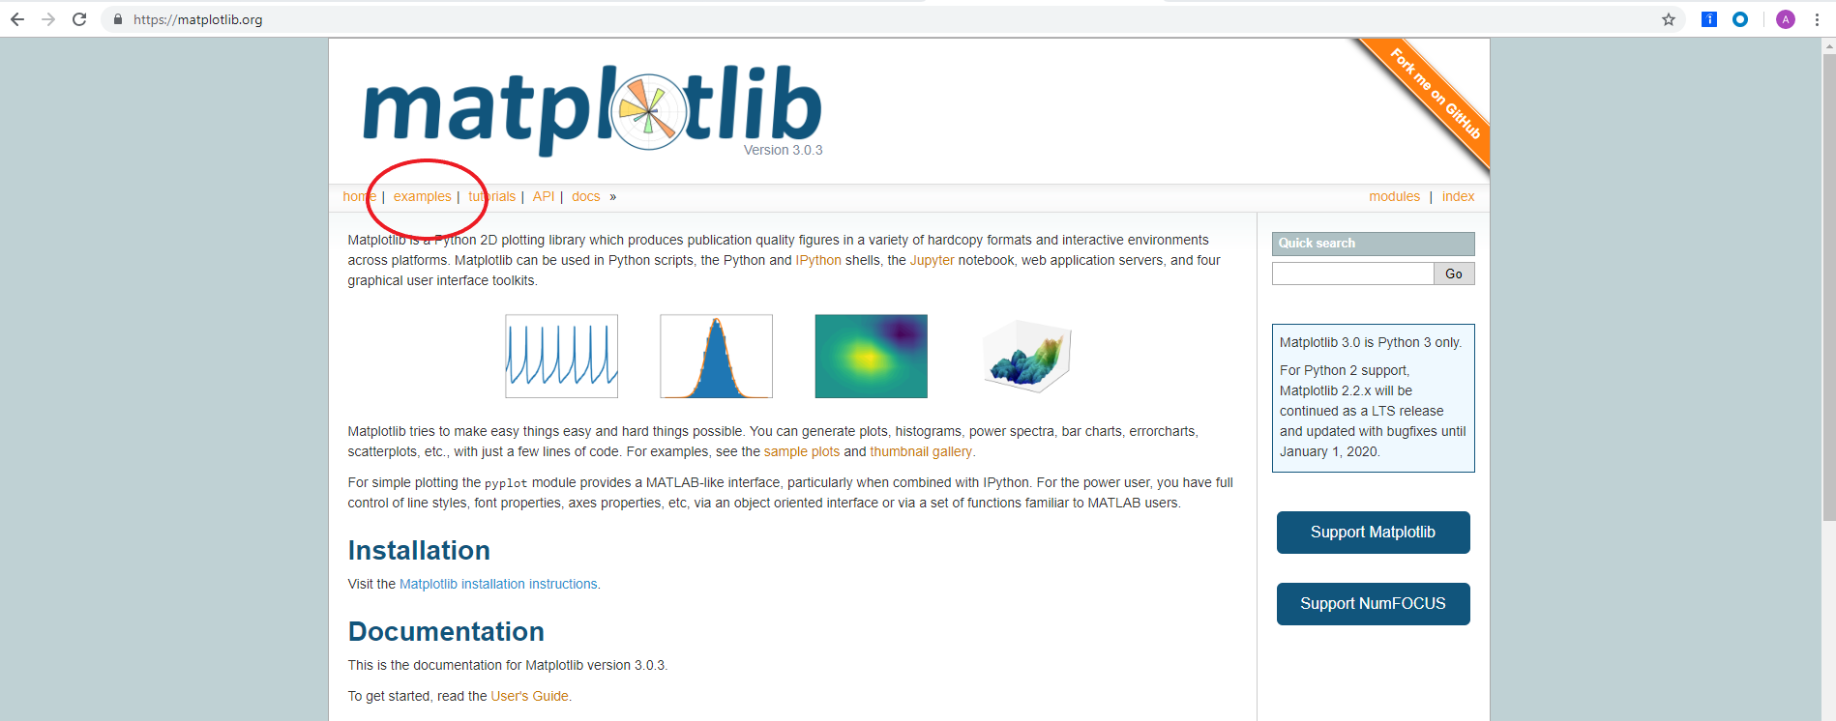

Figure 5.1. Matplotlib home page.

In the gallery, we can see hundreds of examples, but if we want to see an example of a horizontal bar chart, we can select the *Horizontal bar chart* example.

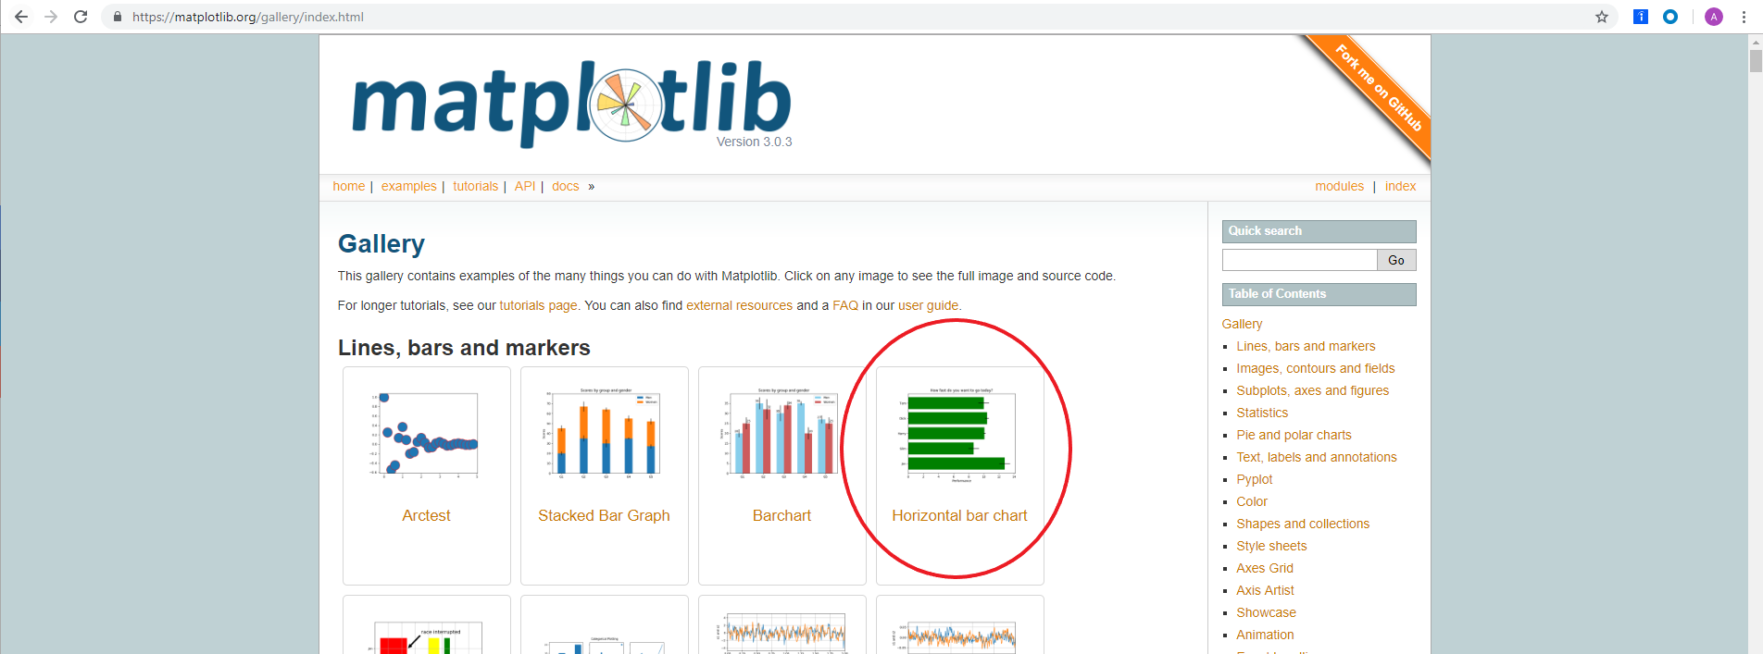

Figure 5.2. Matplotlib gallery.

This brings to a page displaying a picture of the chart as well as the code used to construct the plot which can be downloaded as a Python file or a Jupyter Notebook.

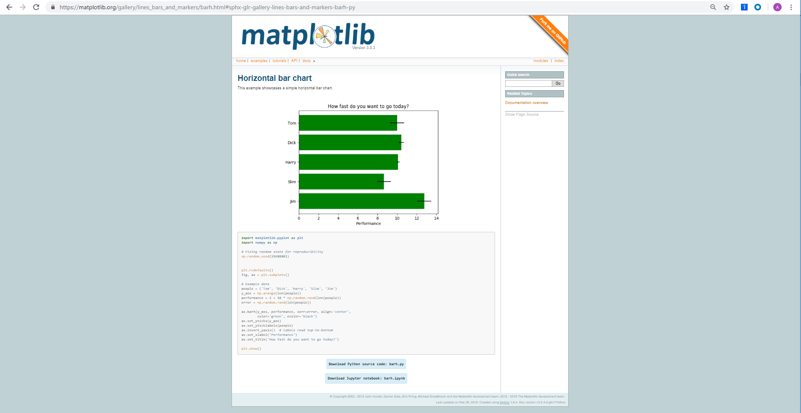

Figure 5.3. Matplotlib horizontal bar chart example.

*Present 5: Introduction to Matplotlib methods*

There are two methods in which plots are created using Matplotlib, the functional method and the object-oriented method.

In the functional method, 1 figure is created with 1 plot. The plots are created and customized by a collection of line-by-line functions. However, the functional method does not allow us to save the plot to our environment as an object; this is possible using the object-oriented method. In the object-oriented method we create a figure object and assign an axis or numerous axes for one plot or multiple subplots, respectively. We can then customize the axis or axes and call that single plot or set of multiple plots by calling the figure object.

In this Chapter, we will use the functional method to create and customize line plots, bar plots, histograms, scatterplots, and box-and-whisker plots. This will include 2 activities. In the first activity, we will create and customize a line plot to analyze the trend of Items Sold by Month. In the next activity we will create and customize a bar plot to display NBA titles by franchise. We will be introduced to programmatic titles that communicate to the reader what the plot is displaying and are able to adapt if the data changes. Using the object-oriented method, we will complete 2 exercises and 1 activity. The first exercise will include creating and customizing a single line plot on a callable figure object. The second exercise will demonstrate creating, referencing, and customizing multiple axes on a callable figure object. The third activity will include creating, referencing, and customizing multiple axes and plot types on a callable figure object. By the end of the chapter we will be experts in creating and customizing common plot types using matplotlib. We will also gain comfortability in navigating the matplotlib documentation so we can figure out how to make plots that are not covered in this chapter.

Functional Method

*Present 6: Functional Method*

Exercise 1: Line Plot

To learn matplotlib, we will begin with learning how to make a line plot and progress from there.

1. Create an array and save it as the object x. By first importing numpy, we are able to create an array of numbers ranging 0 to 10 in 20 evenly spaced values using x = np.linspace(0, 10, 20).

import numpy as np

x = np.linspace(0, 10, 20)

print(x)

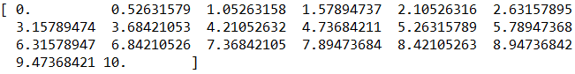

1. Create an array and save it as object y. The snippet of code below cubes the values of x and saves it to the array, y.

y = x**3

print(y)

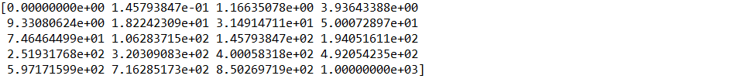

1. Create the plot using plt.plot(x, y) and print it to the console using plt.show().

import matplotlib.pyplot as plt

plt.plot(x, y)

plt.show()

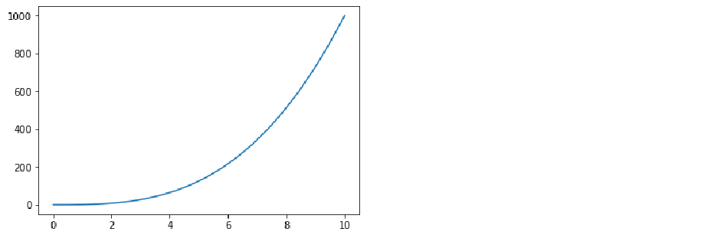

***Note***

Here, we have a plot which displays x on the x-axis and cubed values of x on the y-axis. Matplotlib makes it straightforward to add styling and labels to plots.

1. Add an x-axis label that reads ‘Linearly Spaced Numbers’ using plt.xlabel(‘Linearly Spaced Numbers’)

import matplotlib.pyplot as plt

plt.plot(x, y)

plt.xlabel('Linearly Spaced Numbers') # add x axis label

plt.show()

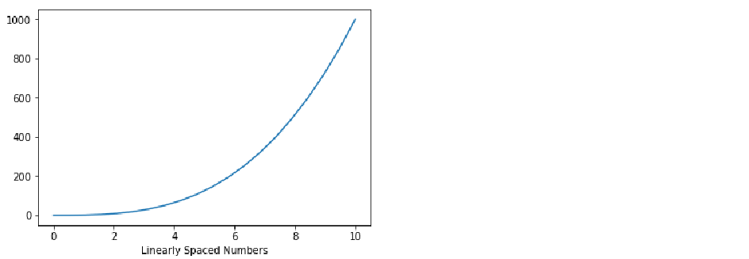

1. Add a y-axis label that reads ‘y Value’ using plt.ylabel(‘y Value’).

import matplotlib.pyplot as plt

plt.plot(x, y)

plt.xlabel('Linearly Spaced Numbers') # add x axis label

plt.ylabel('y Value') # add y axis label

plt.show()

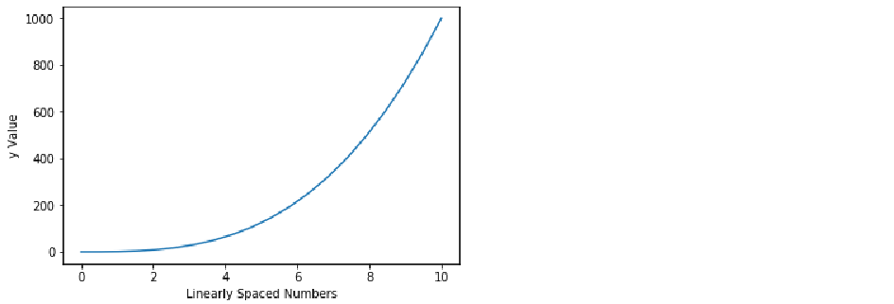

1. Add a title that reads ‘x by x cubed’ using plt.title(‘x by x Cubed’).

import matplotlib.pyplot as plt

plt.plot(x, y)

plt.xlabel('Linearly Spaced Numbers') # add x axis label

plt.ylabel('y Value') # add y axis label

plt.title('x by x Cubed') # add title

plt.show()

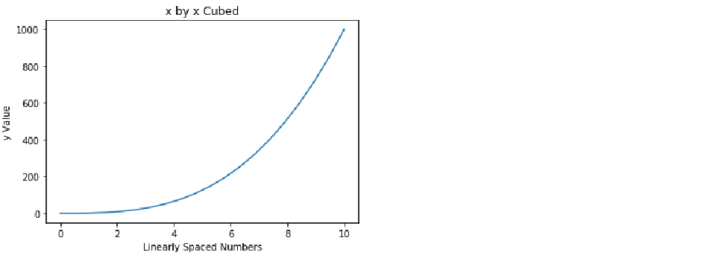

1. To change the line color specify a color argument in the plt.plot() function using plt.plot(x, y, ‘k’).

import matplotlib.pyplot as plt

plt.plot(x, y, 'k') # change color to black

plt.xlabel('Linearly Spaced Numbers') # add x axis label

plt.ylabel('y Value') # add y axis label

plt.title('x by x Cubed') # add title

plt.show()

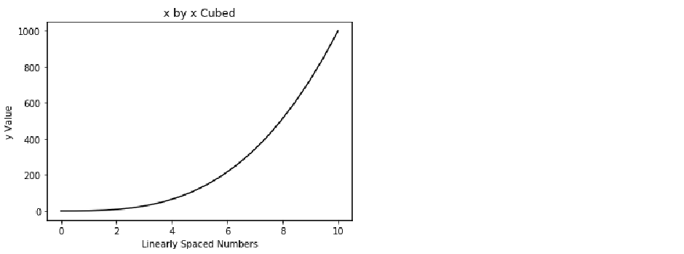

***Note***

We specified the color of the line to be black using the ‘k’ argument. For a full list of color arguments see <https://matplotlib.org/2.1.1/api/_as_gen/matplotlib.pyplot.plot.html>.

1. To make the line characters into a diamond use a character argument combined with the color character.

import matplotlib.pyplot as plt

plt.plot(x, y, 'Dk') # make markers into diamonds

plt.xlabel('Linearly Spaced Numbers') # add x axis label

plt.ylabel('y Value') # add y axis label

plt.title('x by x Cubed') # add title

plt.show()

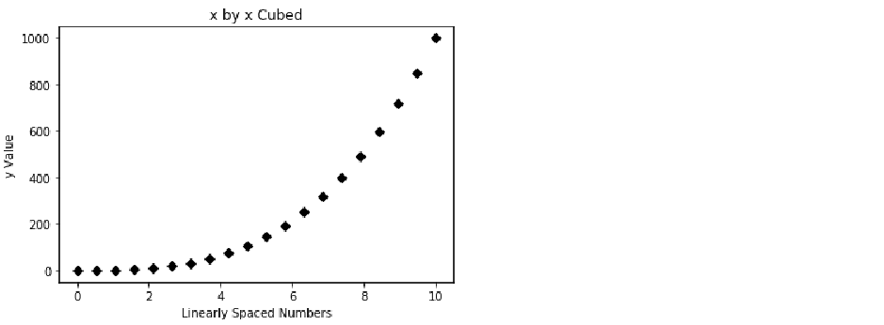

1. We lost the solid line, so we will connect the diamonds with a solid line by placing ‘-’ between ‘D’ and ‘k’ using ‘D-k’.

import matplotlib.pyplot as plt

plt.plot(x, y, 'D-k') # connect markers with a solid line

plt.xlabel('Linearly Spaced Numbers') # add x axis label

plt.ylabel('y Value') # add y axis label

plt.title('x by x Cubed') # add title

plt.show()

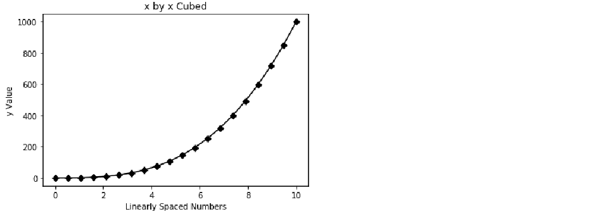

1. Increase the font size of the title using the fontsize argument in the plt.title() function.

import matplotlib.pyplot as plt

plt.plot(x, y, 'D-k') # connect markers with a solid line

plt.xlabel('Linearly Spaced Numbers') # add x axis label

plt.ylabel('y Value') # add y axis label

plt.title('x by x Cubed', fontsize=22) # increase font size

plt.show()

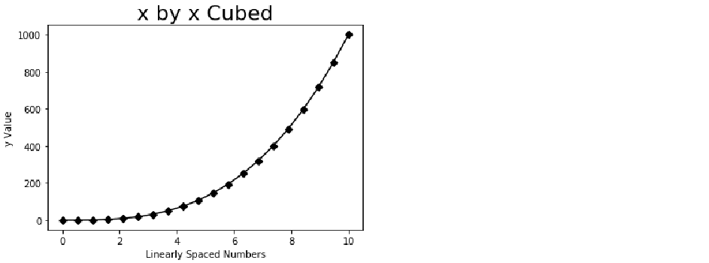

***Note***

The fontsize argument can be used in the xlabel() and xlabel() functions as well.

1. Add another line to the plot by simply specifying another plt.plot() function. For this exercise we will be displaying x-squared in another line. First, we must create another y object much as we did the first y object, but this time squaring x rather than cubing x.

y2 = x**2

print(y2)



1. Now, plot y2 in the same plot at y using plt.plot(x, y2).

import matplotlib.pyplot as plt

plt.plot(x, y, 'D-k') # connect markers with a solid line

plt.plot(x, y2) # add a line for y2

plt.xlabel('Linearly Spaced Numbers') # add x axis label

plt.ylabel('y Value') # add y axis label

plt.title('x by x Cubed', fontsize=22) # increase font size

plt.show()

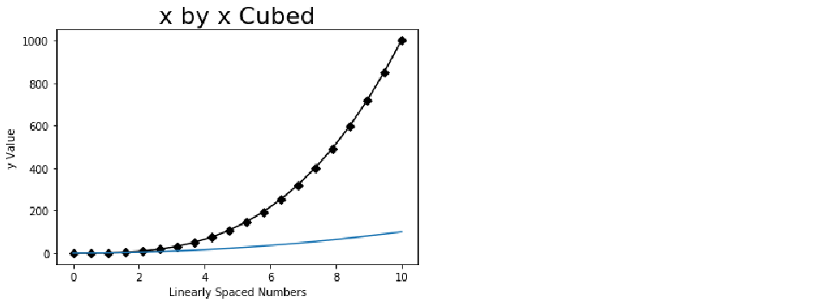

1. Change the color of y2 to dotted red line using plt.plot(x, y2, ‘--r’).

import matplotlib.pyplot as plt

plt.plot(x, y, 'D-k') # connect markers with a solid line

plt.plot(x, y2, '--r') # make y2 a red, dotted line

plt.xlabel('Linearly Spaced Numbers') # add x axis label

plt.ylabel('y Value') # add y axis label

plt.title('x by x Cubed', fontsize=22) # increase font size

plt.show()

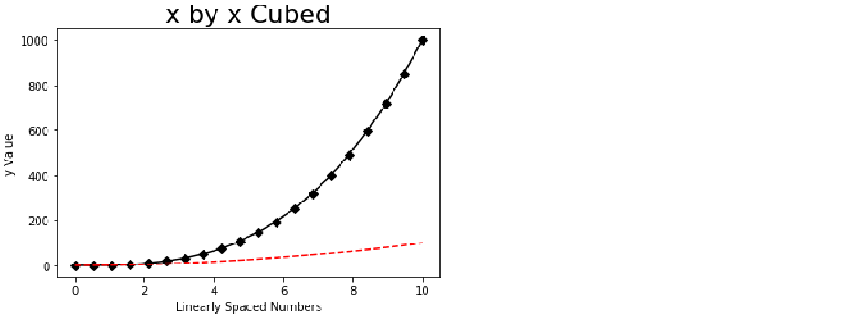

***Note***

At first glance, it is not intuitive as to what this plot is showing. We need to include a more descriptive title and a legend.

1. To create a legend we must first create labels for our lines using the label argument inside the plt.plot() functions. To label y as ‘x cubed’ use plt.plot(x, y, 'D-k', label='x cubed'). To label y2 as ‘x squared’ use plt.plot(x, y2, '--r', label='x squared'). Then, use plt.legend(loc=’upper left’) to specify the location for the legend.

***Note***

To view other arguments for legend locations see <https://matplotlib.org/api/_as_gen/matplotlib.pyplot.legend.html>.

import matplotlib.pyplot as plt

plt.plot(x, y, 'D-k', label='x cubed') # label as x cubed

plt.plot(x, y2, '--r', label='x squared') # label as x squared

plt.xlabel('Linearly Spaced Numbers') # add x axis label

plt.ylabel('y Value') # add y axis label

plt.title('x by x Cubed', fontsize=22) # increase font size

plt.legend(loc='upper left') # create a plot legend and place it in the upper left

plt.show()

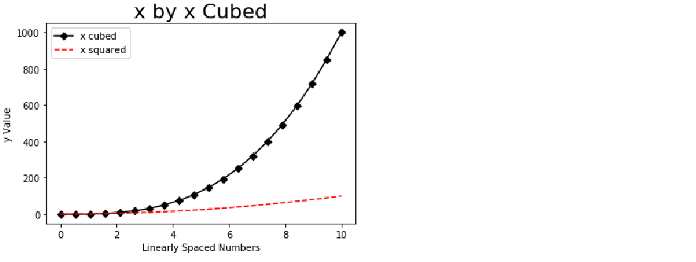

1. It is helpful to the reader if the plot can be summarized in the title. In this plot, I want to communicate to the reader that, as x increases, x cubed increases at a greater rate than x squared. Sometimes, titles may get a little longer than we want. To break a line into new lines we use ‘\n’ at the beginning of a new line within our string. Thus, using plt.title('As x increases, \nx Cubed (black) increases \nat a Greater Rate than \nx Squared (red)', fontsize=22), we can create the title displayed below.

import matplotlib.pyplot as plt

plt.plot(x, y, 'D-k', label='x cubed') # label as x cubed

plt.plot(x, y2, '--r', label='x squared') # label as x squared

plt.xlabel('Linearly Spaced Numbers') # add x axis label

plt.ylabel('y Value') # add y axis label

plt.title('As x increases, \nx Cubed (black) increases \nat a Greater Rate than \nx Squared (red)', fontsize=22) # make a multi-line title

plt.legend(loc='upper left') # create a plot legend and place it in the upper left

plt.show()

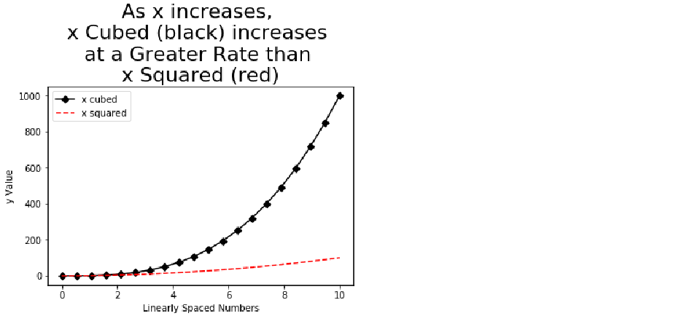

1. To change the dimensions of our plot we will need to add the function plt.figure(figsize=(10,5)) to the top of our plt functions. The figsize argument of 10 and 5 specify the width and height, respectively.

import matplotlib.pyplot as plt

plt.figure(figsize=(10,5)) # increase plot size

plt.plot(x, y, 'D-k', label='x cubed') # label as x cubed

plt.plot(x, y2, '--r', label='x squared') # label as x squared

plt.xlabel('Linearly Spaced Numbers') # add x axis label

plt.ylabel('y Value')

plt.title('As x increases, \nx Cubed (black) increases \nat a Greater Rate than \nx Squared (red)', fontsize=22) # make a multi-line title

plt.legend(loc='upper left') # create a plot legend and place it in the upper left

plt.show()

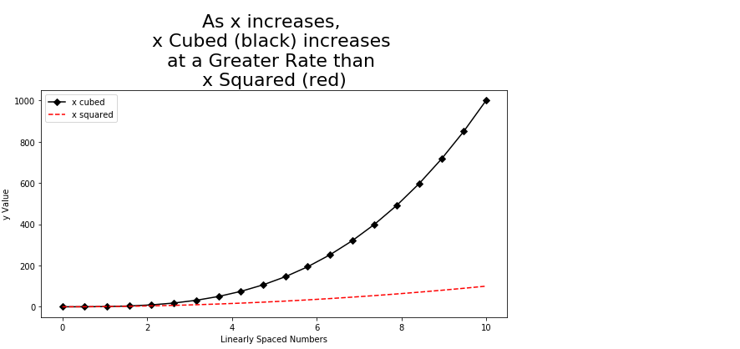

Activity 1: Line Plot

In this activity we will create a line plot to analyze month-to-month trends of Items Sold for months January through June. The trend will be positive, linear and will be represented using a dotted, blue line, with star markers (for styling see, <https://matplotlib.org/2.1.1/api/_as_gen/matplotlib.pyplot.plot.html>). The x-axis will be labeled ‘Month’ and the y-axis will be labeled ‘Items Sold.’ The title will say ‘Items Sold has been Increasing Linearly.’

1. Create a list of 6 strings for x containing months January through June.
2. Create a list of 6 values for y containing values for ‘Items Sold’ that starts at 1000 and increases by 200 in each value, so the final value is 2000.
3. Generate the described plot.

**Solution:**

1. To create a list of 6 strings for each month January through June and save it as x use x = ['January','February','March','April','May','June'].

x = ['January','February','March','April','May','June']

print(x)



1. To create a list of 6 values for ‘Items Sold’ that starts at 1000 and increases by 200 so the final value is 2000 and save it as y use y = [1000, 1200, 1400, 1600, 1800, 2000].

y = [1000, 1200, 1400, 1600, 1800, 2000]

print(y)



1. To plot y (‘Items Sold’) by x (‘Month’) with a dotted blue line and star markers use plt.plot(x, y, '*:b'). To set the x-axis to ‘Month’ use plt.xlabel('Month'). To set the y-axis to ‘Items Sold’ use plt.ylabel('Items Sold'). To set the title to ‘Items Sold has been Increasing Linearly’ use plt.title('Items Sold has been Increasing Linearly').

import matplotlib.pyplot as plt # import matplotlib

plt.plot(x, y, '*:b') # plot items sold (y) by month (x)

plt.xlabel('Month') # label x-axis

plt.ylabel('Items Sold') # label y-axis

plt.title('Items Sold has been Increasing Linearly') # add plot title

plt.show() # print plot

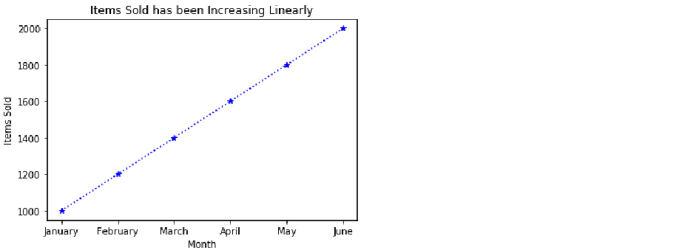

Exercise 2: Bar Plot

Now, that we have the basics of creating a line plot in matplotlib, we will explore how to create another very common type of plot, the bar plot. While line charts are most powerful when presenting trends, bar plots strive in displaying the differences between, or among, groups. Thus, in this example, we will be displaying Sales Revenue by Item type.

1. Create a list of item types and save it as x using x = ['Shirts', 'Pants','Shorts','Shoes'].

x = ['Shirts', 'Pants','Shorts','Shoes']

print(x)



1. Create a list of Sales Revenue and save it as y using y = [1000, 1200, 800, 1800].

y = [1000, 1200, 800, 1800]

print(y)



1. Create a bar plot using plt.bar(x, y) and print the plot using plt.show().

import matplotlib.pyplot as plt

plt.bar(x, y) # plot revenue by group

plt.show()

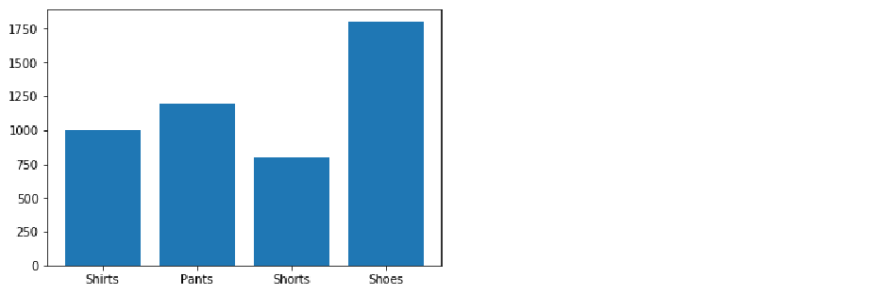

1. Add a title, an x label, and y label as we did in Exercise 1.

import matplotlib.pyplot as plt

plt.bar(x, y) # plot revenue by group

plt.xlabel('Item Type') # x-axis label

plt.ylabel('Sales Revenue ($)') # y-axis label

plt.title('Sales Revenue by Item Type')

plt.show() # print the plot

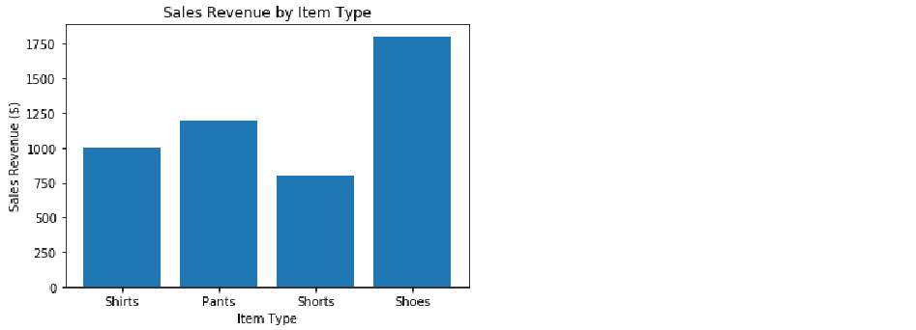

***Note***

While this title explains what the plot is displaying, it does not tell the reader what is going on in the plot. Next, we will go over how to make a programmatic title explaining to the reader what is happening in the plot.

1. We are going to create a title that will change to the data which is plotted. For this example, it will read “Shoes Produce the Most Sales Revenue.” First, we will find the index of the maximum value in y and save it as the object index_of_max_y using index_of_max_y = y.index(max(y)).

index_of_max_y = y.index(max(y))

print(index_of_max_y)



1. Save the item in list x with index equaling index_of_max_y to the object most_sold_item using most_sold_item = x[index_of_max_y].

most_sold_item = x[index_of_max_y]

print(most_sold_item)



1. Make the title programmatic using plt.title('{} Produce the Most Sales Revenue'.format(most_sold_item)). This code places the value for most_sold_item in place of {}.

import matplotlib.pyplot as plt

plt.bar(x, y) # plot revenue by group

plt.xlabel('Item Type') # x-axis label

plt.ylabel('Sales Revenue ($)') # y-axis label

plt.title('{} Produce the Most Sales Revenue'.format(most_sold_item)) # create programmatic title

plt.show() # print the plot

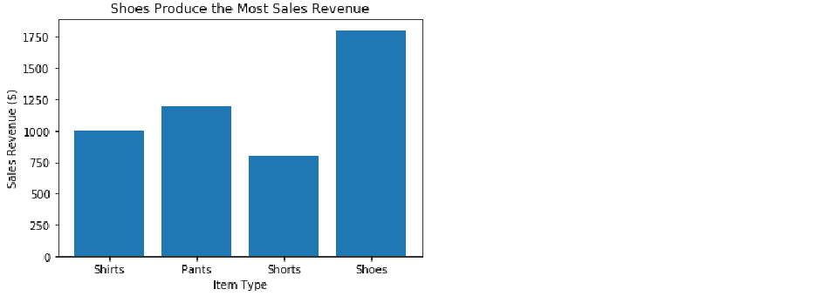

1. Turn the plot into a horizontal bar plot by preplacing plt.bar(x, y) with plt.barh(x, y).

import matplotlib.pyplot as plt

plt.barh(x, y) # turn the plot horizontal

plt.xlabel('Item Type') # x-axis label

plt.ylabel('Sales Revenue ($)') # y-axis label

plt.title('{} Produce the Most Sales Revenue'.format(most_sold_item)) # create programmatic title

plt.show() # print the plot

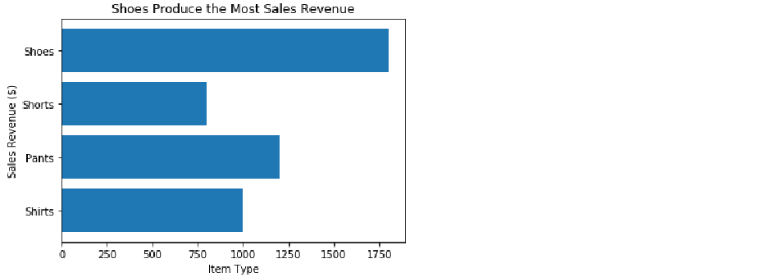

***Note***

Remember, when a bar plot is transformed from vertical to horizontal that the x and y axes need to be switched.

1. Switch x and y labels from plt.xlabel('Item Type') and plt.ylabel('Sales Revenue ($)'), respectively, to plt.xlabel('Sales Revenue ($)') and plt.ylabel('Item Type'), respectively.

import matplotlib.pyplot as plt

plt.barh(x, y) # turn the plot horizontal

plt.xlabel('Sales Revenue ($)') # x-axis label

plt.ylabel('Item Type') # y-axis label

plt.title('{} Produce the Most Sales Revenue'.format(most_sold_item)) # create programmatic title

plt.show() # print the plot

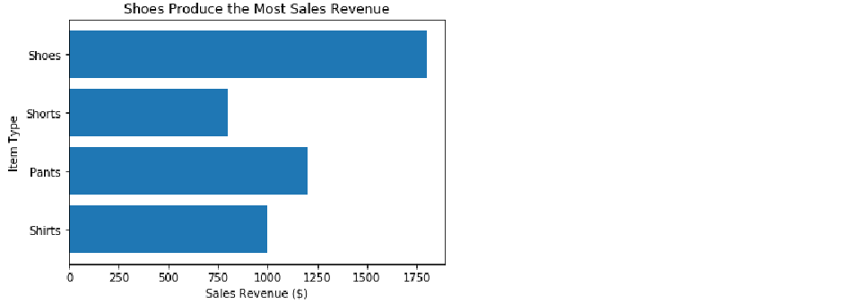

Activity 2: Bar Plot

In this activity, we will be creating a bar plot comparing the number of NBA championships among the 5 franchises with the most championships. The plot will be sorted so the franchise with the greatest number of championships is on the left and the franchise with the least is on the right. The bars will be red, the x-axis will be titled ‘NBA Franchises’, the y-axis will be titled ‘Number of Championships’, and the title will be programmatic explaining which franchise has the most titles and how many they have. Additionally, we will rotate the x tick labels 45 degrees so they do not overlap, and we will save our plot to the current directory.

1. Create a list of 5 strings for x containing the names of NBA franchises with the most titles.
2. Create a list of 5 values for y containing values for ‘Titles Won’ that corresponds with the strings in x.
3. Place x and y into a data frame with the column names ‘Team’ and ‘Titles’, respectively.
4. Sort the data frame descending by ‘Titles.’
5. Make a programmatic title and save it as title.
6. Generate the described plot.
7. Fix the cropping issue upon saving.

**Solution:**

1. Create a list of 5 strings for x containing the names of NBA franchises with the most titles using x = ['Boston Celtics','Los Angeles Lakers', 'Chicago Bulls', 'Golden State Warriors', 'San Antonio Spurs'].

x = ['Boston Celtics','Los Angeles Lakers', 'Chicago Bulls', 'Golden State Warriors', 'San Antonio Spurs']

print(x)



1. Create a list of 5 values for y containing values for ‘Titles Won’ that corresponds with the strings in x using y = [17, 16, 6, 6, 5].

y = [17, 16, 6, 6, 5]

print(y)



1. Place x and y into a data frame with the column names ‘Team’ and ‘Titles’, respectively by importing pandas using import pandas as pd. Once pandas has been imported, create the data frame using df = pd.DataFrame({'Team': x, 'Titles': y}).

import pandas as pd

df = pd.DataFrame({'Team': x,

'Titles': y})

1. Sort the data frame descending by ‘Titles’ and save it as df_sorted using df_sorted = df.sort_values(by=('Titles'), ascending=False).

df_sorted = df.sort_values(by=('Titles'), ascending=False)

***Note***

If we sort with ascending=True the plot will have the larger values to the right. Since we want the larger values on the left we will be using ascending=False.

1. Make a programmatic title and save it as title by first finding the team with the most titles and saving it as the object team_with_most_titles using team_with_most_titles = df_sorted['Team'][0]. Then, get the number of titles for the team with the most titles using most_titles = df_sorted['Titles'][0]. Then, with the format() function, create a string that reads 'The Boston Celtics have the most titles with 17' using title = 'The {} have the most titles with {}'.format(team_with_most_titles, most_titles).

***Note***

Since the data is sorted with the largest numbers at the top (I.e., descending) we can access the maximum values by referencing index 0.

team_with_most_titles = df_sorted['Team'][0] # get team with most titles

most_titles = df_sorted['Titles'][0] # get the number of max titles

title = 'The {} have the most titles with {}'.format(team_with_most_titles, most_titles) # create title

print(title)



1. To use a bar graph to plot the number of titles by team use plt.bar(df_sorted['Team'], df_sorted['Titles'], color='red').

import matplotlib.pyplot as plt # import matplotlib

plt.bar(df_sorted['Team'], df_sorted['Titles'], color='red')

Set the x-axis label to ‘Team’ using plt.xlabel('Team').

plt.xlabel('Team')

Set the y-axis label to ‘Number of Championships’ using plt.ylabel('Number of Championships').

plt.ylabel('Number of Championships')

Prevent the x tick labels from overlapping by rotating them 45 degrees using plt.xticks(rotation=45).

plt.xticks(rotation=45)

Set the title of the plot to the programmatic title object we created using plt.title(title).

plt.title(title)

Save the plot to our current working directory as ‘Titles_by_Team.jpeg’ using plt.savefig('Titles_by_Team.jpeg').

plt.savefig('Titles_by_Team.jpeg')

Print the plot using plt.show().

plt.show()

Altogether, this looks like:

import matplotlib.pyplot as plt # import matplotlib

plt.bar(df_sorted['Team'], df_sorted['Titles'], color='red') # plot titles by team and make bars red

plt.xlabel('Team') # create x label

plt.ylabel('Number of Championships') # create y label

plt.xticks(rotation=45) # rotate x tick labels 45 degrees

plt.title(title) # title

plt.savefig('Titles_by_Team.jpeg') # save figure to present working directory

plt.show() # print plot

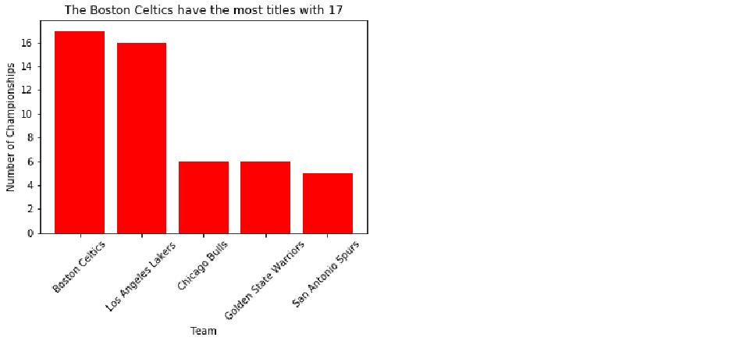

***Note***

When we print the plot to the console using plt.show() it appears as intended, however, when we open the file we created titled ‘Titles_by_Team.jpeg’ we see that it crops the x tick labels.

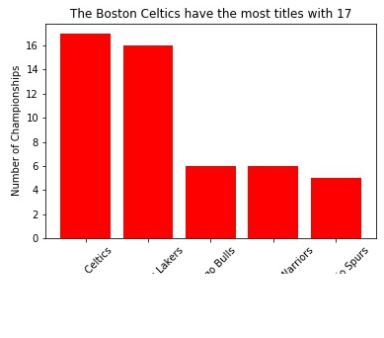

Figure 5.4. Saved figure with x tick labels cropped.

1. To fix the cropping issue use the argument bbox_inches=’Tight’ inside the plt.savefig() function using plt.savefig('Titles_by_Team.jpeg', bbox_inches='tight'). The code now looks like:

import matplotlib.pyplot as plt

plt.bar(df_sorted['Team'], df_sorted['Titles'], color='red')

plt.xlabel('Team')

plt.ylabel('Number of Championships')

plt.xticks(rotation=45)

plt.title(title)

plt.savefig('Titles_by_Team.jpeg', bbox_inches='tight') # fix the cropping issue

plt.show()

***Note***

Now, if we open the saved file ‘Titles_by_Team.jpeg’ from our working directory we see that the x tick labels are not cropped.

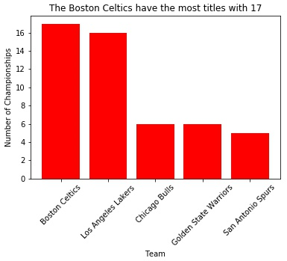

Figure 5.5. Saved figure with x tick labels fixed.

Exercise 3: Histogram

In statistics, it is essential to be aware of the distribution of continuous variables. To display the distribution we will use a histogram. Histograms display the frequency by the bin for a given array.

1. To demonstrate the creation of a histogram we must first generate an array of normally distributed values and save it as y. First, use import numpy as np. Then, using numpy’s random.normal function, use y = np.random.normal(loc=0, scale=0.1, size=100). This generates 100 normally distributed numbers with a mean of 0 and a standard deviation of 0.1.

import numpy as np

y = np.random.normal(loc=0, scale=0.1, size=100) # 100 numbers with mean of 0 and standard deviation of 0.1

print(y)

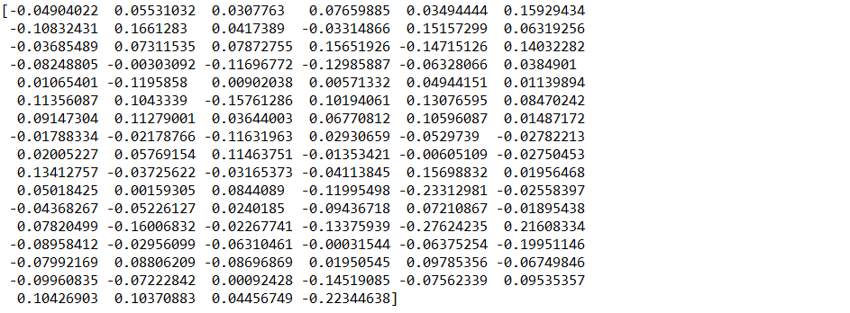

1. With matplotlib imported, create the histogram using plt.hist(y, bins=20). The ‘bins’ argument determines the extent of the histogram’s granularity. Thus, the range of y is divided into 20 evenly spaced buckets, or bins.

import matplotlib.pyplot as plt

plt.hist(y, bins=20)

plt.show()

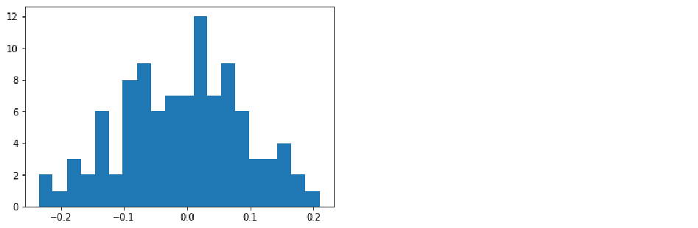

***Note***

Since we covered styling arguments in great detail in Exercises 2 and 3, we will skip this portion and go right into making the title tell us what we need to know.

When we are looking at a histogram, we are determining whether the distribution is normal. There is a separate test for normality termed the Shapiro-Wilk test. The null hypothesis for the Shapiro-Wilk test is that the data is normally distributed. Thus, a p-value < 0.05 indicates a non-normal distribution while a p-value > 0.05 indicates a normal distribution.

1. To return the W test statistic and the corresponding p-value from the Shapiro-Wilk test we must import the shapiro function using from scipy.stats import shapiro. The shapiro function returns a tuple containing two values. The first is the W statistic while the second is the p-value. Thus, we can use tuple unpacking to save the W statistic and the p-value into the objects shap_w and shap_p, respectively, using shap_w, shap_p = shapiro(y).

from scipy.stats import shapiro

shap_w, shap_p = shapiro(y)

print(shap_p)



***Note***

The p-value is > 0.05, so, according to the Shapiro-Wilk test, y is normally distributed. We will set up some logic to make this decision programmatic.

1. We will use an if-else statement that assigns the string 'Fail to reject the null hypothesis. Data is normally distributed' to the object normal_YN if shap_p > 0.05 and assigns the string 'Null hypothesis is rejected. Data is not normally distributed' is shap_p > 0.05.

if shap_p > 0.05:

normal_YN = 'Fail to reject the null hypothesis. Data is normally distributed.'

else:

normal_YN = 'Null hypothesis is rejected. Data is not normally distributed.'

print(normal_YN)



1. Assign normal_YN to our plot using plt.title(normal_YN).

import matplotlib.pyplot as plt

plt.hist(y, bins=20)

plt.xlabel('y Value')

plt.ylabel('Frequency')

plt.title(normal_YN) # programmatic plot title

plt.show()

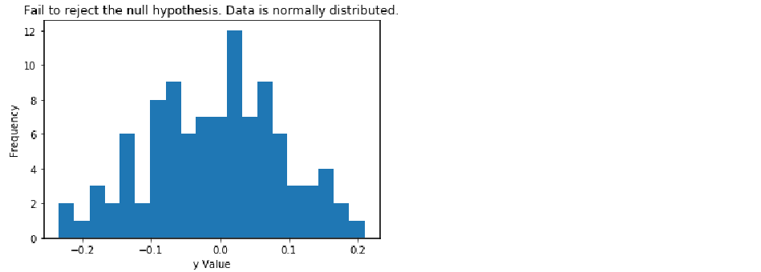

Exercise 4: Scatterplot

A common plot used for displaying a relationship between two continuous variables is the scatterplot. In this exercise, we will be creating a scatterplot of weight vs height. We will, again, create a title explaining the message for which the plot is portraying.

1. Generate a list of numbers representing height and save it as y using y = [5, 5.5, 5, 5.5, 6, 6.5, 6, 6.5, 7, 5.5, 5.25, 6, 5.25].

y = [5, 5.5, 5, 5.5, 6, 6.5, 6, 6.5, 7, 5.5, 5.25, 6, 5.25]

print(y)



1. Generate a list of numbers representing weight and save it as x using x = [100, 150, 110, 140, 140, 170, 168, 165, 180, 125, 115, 155, 135].

x = [100, 150, 110, 140, 140, 170, 168, 165, 180, 125, 115, 155, 135]

print(x)



1. Create a basic scatterplot with weight on the x-axis and height on the y-axis using plt.scatter(x, y).

import matplotlib.pyplot as plt

plt.scatter(x, y)

Label the x-axis ‘Weight’ and the y-axis ‘Height’.

import matplotlib.pyplot as plt

plt.scatter(x, y) # generate scatterplot

plt.xlabel('Weight') # label x-axis

plt.ylabel('Height') # label y-axis

plt.show() # print plot

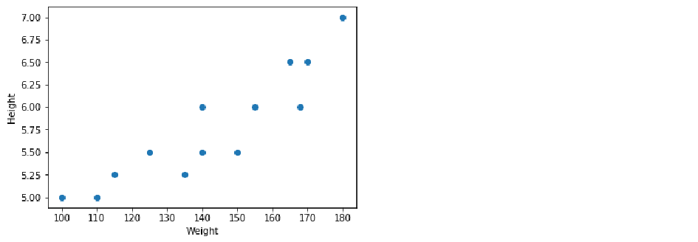

***Note***

We want our plot to tell us the strength of the relationship and the Pearson correlation coefficient, so we need to calculate this and set up some logic for our programmatic title.

1. Import the pearsonr function using from scipy.stats import pearsonr. The pearsonr function returns a tuple; the first value in the tuple correlation coefficient and the second is the p-value. We can unpack the tuple using correlation_coeff, p_value = pearsonr(x, y).

from scipy.stats import pearsonr

correlation_coeff, p_value = pearsonr(x, y)

print(correlation_coeff)



***Note***

Now that we have our correlation coefficient, we can set up some logic detailing the strength and direction of the relationship as well as the coefficient.

1. Set-up some logic to interpret the value of the correlation coefficient.

if correlation_coeff == 1.00:

title = 'There is a perfect positive linear relationship (r = {0:0.2f}).'.format(correlation_coeff)

elif correlation_coeff >= 0.8:

title = 'There is a very strong, positive linear relationship (r = {0:0.2f}).'.format(correlation_coeff)

elif correlation_coeff >= 0.6:

title = 'There is a strong, positive linear relationship (r = {0:0.2f}).'.format(correlation_coeff)

elif correlation_coeff >= 0.4:

title = 'There is a moderate, positive linear relationship (r = {0:0.2f}).'.format(correlation_coeff)

elif correlation_coeff >= 0.2:

title = 'There is a weak, positive linear relationship (r = {0:0.2f}).'.format(correlation_coeff)

elif correlation_coeff > 0:

title = 'There is a very weak, positive linear relationship (r = {0:0.2f}).'.format(correlation_coeff)

elif correlation_coeff == 0:

title = 'There is no linear relationship (r = {0:0.2f}).'.format(correlation_coeff)

elif correlation_coeff <= -0.8:

title = 'There is a very strong, negative linear relationship (r = {0:0.2f}).'.format(correlation_coeff)

elif correlation_coeff <= -0.6:

title = 'There is a strong, negative linear relationship (r = {0:0.2f}).'.format(correlation_coeff)

elif correlation_coeff <= -0.4:

title = 'There is a moderate, negative linear relationship (r = {0:0.2f}).'.format(correlation_coeff)

elif correlation_coeff <= -0.2:

title = 'There is a weak, negative linear relationship (r = {0:0.2f}).'.format(correlation_coeff)

else:

title = 'There is a very weak, negative linear relationship (r = {0:0.2f}).'.format(correlation_coeff)

print(title)



1. Now, we can use the object title as our title using plt.title(title).

Altogether, the code looks like:

import matplotlib.pyplot as plt

plt.scatter(x, y) # generate scatterplot

plt.xlabel('Weight') # label x-axis

plt.ylabel('Height') # label y-axis

plt.title(title) # set programmatic title

plt.show() # print plot

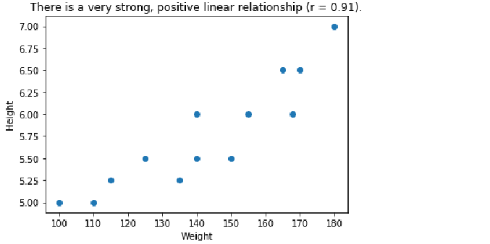

Exercise 5: Box-and-Whisker plot

The last plot we will cover is the Box-and-Whisker plot. This plot is used primarily to indicate skew of a distribution and to identify outliers. We will portray this information in our title.

1. Import numpy using import numpy as np. Generate an array of 100 normally distributed numbers with a mean of 0 and a standard deviation of 0.1 and save it as y using y = np.random.normal(loc=0, scale=0.1, size=100).

import numpy as np

y = np.random.normal(loc=0, scale=0.1, size=100) # 100 numbers with mean of 0 and standard deviation of 0.1

1. Import matplotlib using import matplotlib.pyplot as plt. Then, create the plot using plt.boxplot(y).

import matplotlib.pyplot as plt # import matplotlib

plt.boxplot(y) # create boxplot of y

plt.show() # print plot

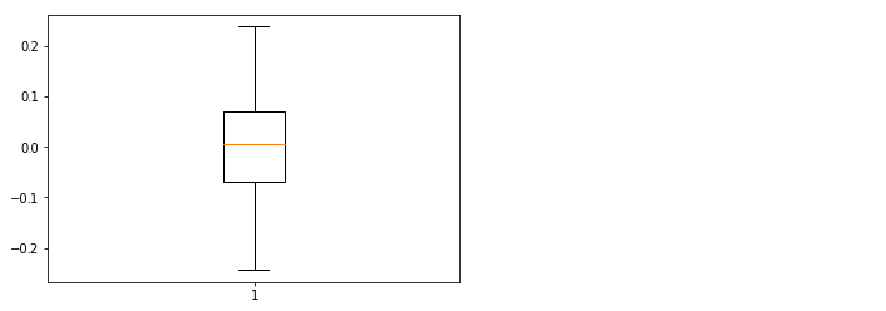

1. Calculate the p-value from the Shapiro-Wilk test by importing the shapiro function using from scipy.stats import shapiro. The, using tuple unpacking to save the Shapiro W and p-value from the shapiro function using shap_w, shap_p = shapiro(y).

from scipy.stats import shapiro

shap_w, shap_p = shapiro(y)

print(shap_p)



1. Import the zscore function using from scipy.stats import zscore. Then, use the function to convert y into z-scores using y_z_scores = zscore(y).

from scipy.stats import zscore

y_z_scores = zscore(y) # convert y into z scores

1. Iterate through the y_z_scores array to find how many outliers there are. Set the object total_outliers to 0 using total_outliers = 0. Then, iterating through every index of y_z_scores, check to see if the value is greater than or equal to 3. If the value is at least 3, increase the value for total_outliers by 1.

***Note***

Because the array, y, was generated to be normally distributed we can expect that there are no outliers in the data.

total_outliers = 0 # set value to zero

for i in range(len(y_z_scores)): # check every item in y

if abs(y_z_scores[i]) >= 3: # if the absolute value is at least 3

total_outliers += 1 # add 1 to total_outliers

print(total_outliers)



1. Set-up some logic for our programmatic title. Our title will tell us if the data is normally distributed as well as the number of outliers. If shap_p is greater than 0.05 then our data is normally distributed. If it is not greater than 0.05 then our data is not normally distributed. We can set this up and include the number of outliers by the logic below.

if shap_p > 0.05:

title = 'Normally distributed with {} outlier(s).'.format(total_outliers)

else:

title = 'Not normally distributed with {} outlier(s).'.format(total_outliers)

print(title)



1. Set our plot title as the programmatically named title using plt.title(title).

Altogether, the code looks like:

import matplotlib.pyplot as plt # import matplotlib

plt.boxplot(y) # generate boxplot

plt.title(title) # programmatic title

plt.show() # print plot

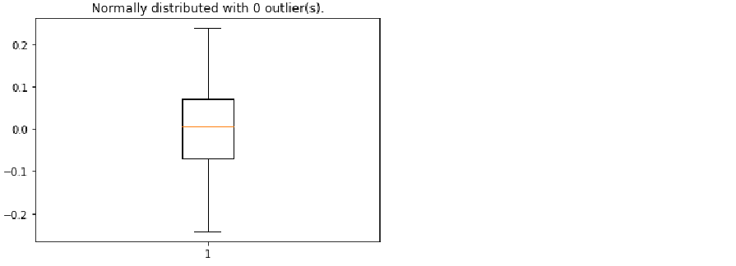

Object-Oriented Method Using Subplots

*Present 17-18: Introduction to the Object-Oriented method*

However, it is much more common to see the use of subplots in Matplotlib plots than to see the functional method. In the object-oriented method we create a figure object which acts as an empty canvas and then we add a set of axes, or subplots, to it. The figure object is callable and if called will return the figure to the console. We will demonstrate how this works by plotting the same x and y objects as we did in Exercise 1.

Exercise 6: Single Line Plot using Subplots

1. Save x as an array ranging from 0 to 10 in 20 linearly spaced steps using x = np.linspace(0, 10, 20). Then, save y as x cubed using y = x**3.

import numpy as np

x = np.linspace(0, 10, 20) # create x

y = x**3 # create y

1. Import matplotlib using import matplotlib.pyplot as plt. Use tuple unpacking to create a figure and a set of axes using fig, axes = plt.subplots().

import matplotlib.pyplot as plt # import dependencies

fig, axes = plt.subplots() # create figure and set of axes

plt.show() # print plot

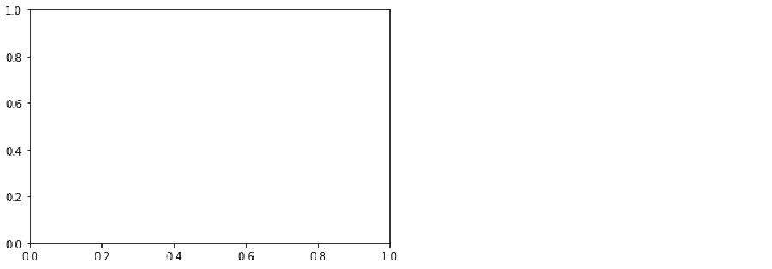

***Note***

By default, matplotlib creates a figure with one set of axes. To create multiple plots we will provide arguments inside the subplots() function.

1. If we now just run fig we can see the axes that were created.

Fig



1. To plot y by x (i.e., x squared), we use axes.plot(x, y) and show the plot using plt.show().

import matplotlib.pyplot as plt # import dependencies

fig, axes = plt.subplots() # create figure and set of axes

axes.plot(x, y) # generate line

plt.show() # print plot

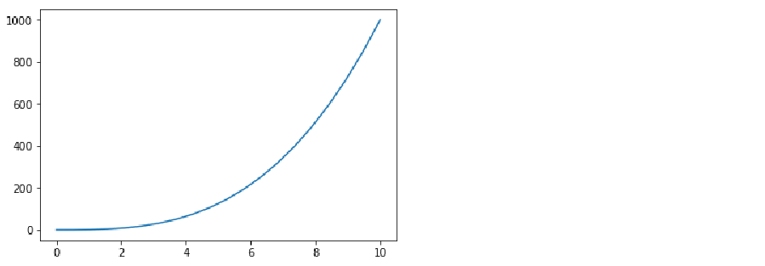

1. Style the plot much the same as in Exercise 1. First, change the line color and markers use the argument ‘D-k’ in the axes.plot() function.

axes.plot(x, y, 'D-k')

Set the x-axis label to ‘Linearly Spaced Numbers’ using axes.set_xlabel('Linearly Spaced Numbers').

axes.set_xlabel('Linearly Spaced Numbers')

To set the y-axis to ‘y Value’ use axes.set_ylabel('y Value').

axes.set_ylabel('y Value')

To set the title to ‘As x increases, y increases by x cubed’ use axes.set_title('As x increases, y increases by x cubed').

axes.set_title('As x increases, y increases by x cubed')

Altogether, the code looks like:

import matplotlib.pyplot as plt # import matplotlib

fig, axes = plt.subplots() # create figure and axes

axes.plot(x, y, 'D-k') # create black line with diamond markers

axes.set_xlabel('Linearly Spaced Numbers') # x label

axes.set_ylabel('y Value') # y label

axes.set_title('As x increases, y increases by x cubed') # set title

plt.show() # print plot

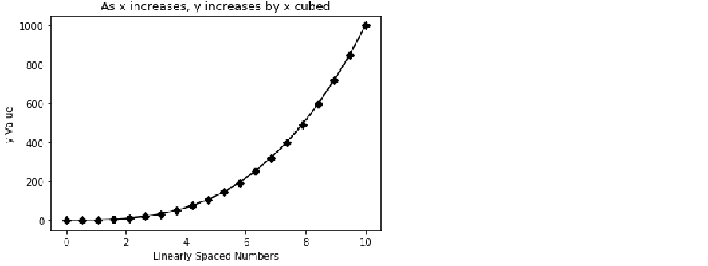

1. Call the fig object using fig

fig



***Note***

We created a plot very similar to the first plot in Exercise 1, but now it is a callable object. A further advantage of using the object-oriented approach is the ability to create multiple sublots on a single figure object.

*Discuss: What might be some advantages to having a callable figure object?*

Exercise 7: Multiple Line Plots Using Subplots

In this exercise, we will plot the same lines as in Exercise 1, but we will plot them on two subplots.

After, x, y, and y2 have been created (for more details, see Exercise 1):

import numpy as np

x = np.linspace(0, 10, 20) # create x

y = x**3 # create y

y2 = x**2 # create y2

1. Import matplotlib using import matplotlib.pyplot as plt. Create a figure with 2 axes (I.e., plots) that are side-by-side (I.e., 1 row with 2 columns) using fig, axes = plt.subplots(nrows=1, ncols=2).

import matplotlib.pyplot as plt

fig, axes = plt.subplots(nrows=1, ncols=2)

plt.show()

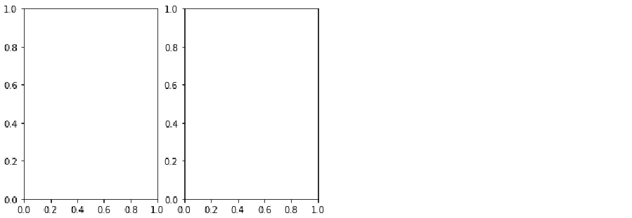

***Note***

To access the various axes we will treat the axes object as a list. The plot on the left is the first index of the axes object so we can reference it using axes[0]. The plot on the right is second index of the axes object so we reference it using axes[1] (see Figure 5.6).

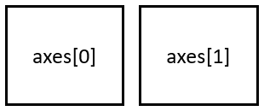

Figure 5.6. Axes index referencing in a figure object with 1 row and multiple columns.

If the figure contained one column of two axes (I.e., if there were two axes stacked on top of one another), the top plot would be index 0 while the bottom plot would be index 1 (see Figure 5.7).

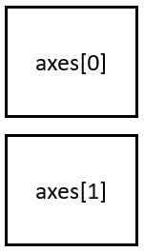

Figure 5.7. Axes index referencing in a figure object with multiple rows and 1 column.

However, if our figure contains multiple rows and multiple columns, we reference the plot using [row, column]. For example, if our figure object contains 4 subplots organized in 2 rows and 2 columns, we would index reference the top left plot using axes[0,0] and the bottom right plot using axes[1,1] (see Figure 5.8). This will become and extremely important concept to understand to complete activity 3.

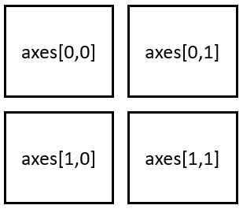

Figure 5.8. Axes index referencing in a figure object with multiple rows and multiple columns.

1. To access the plot on the left refer to it as axes[0]. To access the plot on the right refer to it as axes[1]. On the left axes, plot y by x using axes[0].plot(x, y).

import matplotlib.pyplot as plt

fig, axes = plt.subplots(nrows=1, ncols=2)

axes[0].plot(x, y) # plot x squared by y

plt.show() # print plot

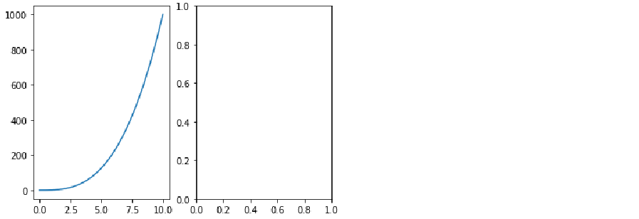

1. Style it the same way we did in Exercise 3 by adding a title, x label, and y label.

import matplotlib.pyplot as plt

fig, axes = plt.subplots(nrows=1, ncols=2)

axes[0].plot(x, y) # plot x squared by y

axes[0].set_xlabel('Linearly Spaced Numbers') # set x axis label

axes[0].set_ylabel('y Value') # set y axis label

plt.show() # print plot

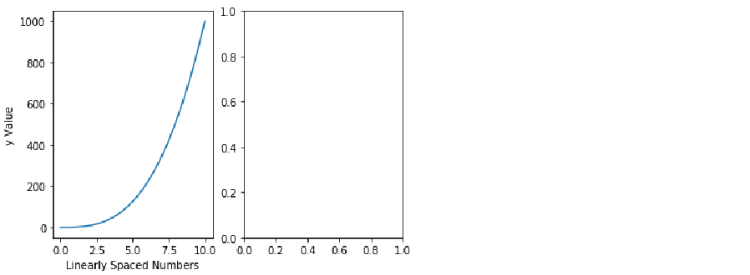

1. On the right axes, plot y by x using axes[1].plot(x, y2) and use the same styling as in step 5.

import matplotlib.pyplot as plt

fig, axes = plt.subplots(nrows=1, ncols=2)

axes[0].plot(x, y) # plot x-cubed by x

axes[0].set_title('x by x Cubed') # set title

axes[0].set_xlabel('Linearly Spaced Numbers') # set x axis label

axes[0].set_ylabel('y Value') # set y axis label

# plot on the right axes

axes[1].plot(x, y2) # plot x-squared by x

axes[1].set_title('x by x Squared') # set title

axes[1].set_xlabel('Linearly Spaced Numbers') # set x axis label

axes[1].set_ylabel('y Value') # set y axis label

plt.show()

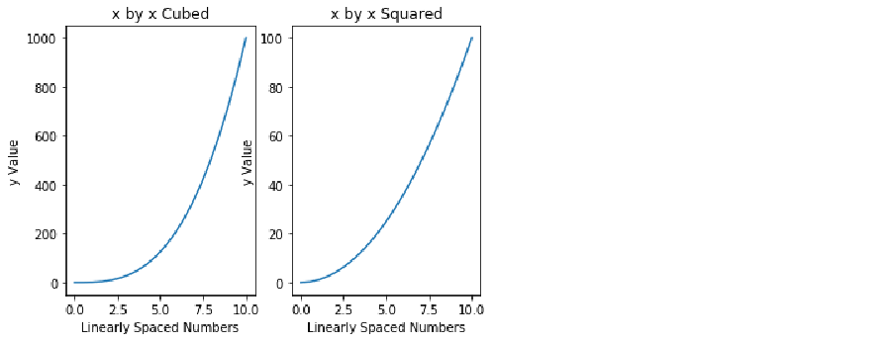

***Note***

We have successfully created two subplots. However, it looks like the y-axis of the plot on the right is overlapping onto the left plot.

1. Fix the overlapping of the plots using plt.tight_layout().

import matplotlib.pyplot as plt

fig, axes = plt.subplots(nrows=1, ncols=2)

axes[0].plot(x, y) # plot x-cubed by x

axes[0].set_title('x by x Cubed') # set title

axes[0].set_xlabel('Linearly Spaced Numbers') # set x axis label

axes[0].set_ylabel('y Value') # set y axis label

# plot on the right axes

axes[1].plot(x, y2) # plot x-squared by x

axes[1].set_title('x by x Squared') # set title

axes[1].set_xlabel('Linearly Spaced Numbers') # set x axis label

axes[1].set_ylabel('y Value') # set y axis label

plt.tight_layout() # prevent plot overlap

plt.show()

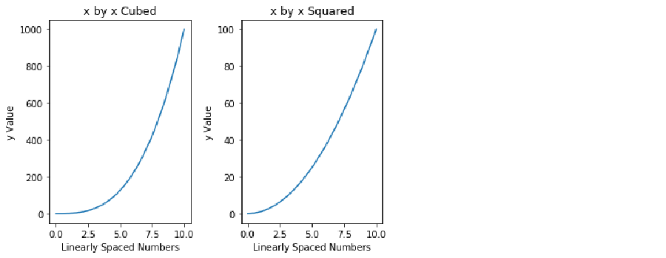

1. Call the fig object using fig.

fig



***Note***

Using the object-oriented approach, we are able to display both plots just by calling the fig object. We will get more practice doing this in Activity 3.

Activity 3: Multiple Plot Types using Subplots

In exercises 1-5 and activities 1-2, we learned to build, customize, and program line plots, bar plots, histograms, scatterplots, and box-and-whisker plots using the Functional method. In exercise 6, we were introduced to the Object-Oriented Method and in exercise 7 we learned how to create a figure with multiple plots using subplots. Thus, in this activity we will be leveraging subplots to create a figure with multiple plots and plot types. We will be creating a figure with 6 subplots. The subplots will be displayed in 3 rows and 2 columns (see Figure 5.9).

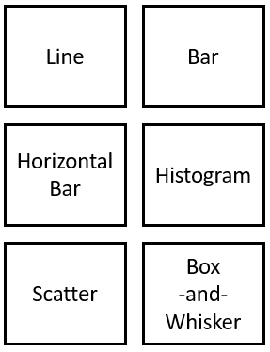

Figure 5.9. Layout for subplots.

***Note***

Once we have generated our figure of 6 subplots, we access each subplot using ‘row, column’ indexing (see Figure 5.10).

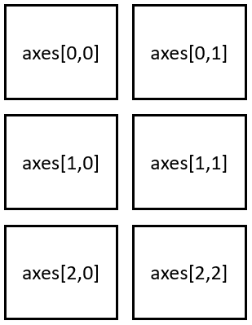

Figure 5.10. Axes index referencing in a figure object with 3 rows and 2 columns.

Thus, to access the Line plot (I.e., top left) use axes[0, 0]. To access the histogram (I.e., middle right) use axes[1, 1]. We will be using this in the following exercise.

1. Import the ‘Items_Sold_by_Week.csv’ file and save it as the data frame object Items_by_Week.
2. Create 1 normally distributed array of numbers and save it as y to use for the histogram and box-and-whisker plots.
3. Import the ‘Weight_by_Height.csv’ file and save it as the data frame object Weight_by_Height.
4. Generate a figure with 6 subplots using 3 rows and 2 columns.
5. Make sure the plots do not overlap.
6. Set the plot titles so they match with Figure 5.9.
7. In the ‘Line’ axis, plot items sold by week from the Items_Sold_by_Week data frame.
8. In the ‘Bar’ axis, plot items sold by week from the Items_Sold_by_Week data frame.
9. In the ‘Horizontal Bar’ axis, plot items sold by week from the Items_Sold_by_Week data frame.
10. In the ‘Histogram’ axis, plot the distribution of y.
11. In the ‘Scatter’ axis, plot weight by height from the Weight_by_Height data frame.
12. In the ‘Box-and-Whisker' axis, plot y.
13. Label the x- and y-axis in each subplot.
14. Increase the size of the figure.
15. Save the figure.

**Solution:**

1. Import pandas and alias it as pd using import pandas as pd. Import the ‘Items_Sold_by_Week.csv’ file and save it as the data frame object Items_by_Week using Items_by_Week = pd.read_csv('Items_Sold_by_Week.csv').

import pandas as pd

Items_by_Week = pd.read_csv('Items_Sold_by_Week.csv')

1. Generate an array of 100 normally distributed numbers to use as the data for the histogram and box-and-whisker plots and save it as y using y = np.random.normal(loc=0, scale=0.1, size=100).

import numpy as np

y = np.random.normal(loc=0, scale=0.1, size=100)

1. Import pandas and alias it as pd using import pandas as pd. Import the Weight_by_Height.csv’ file and save it as the data frame object Weight_by_Height using Weight_by_Height = pd.read_csv('Weight_by_Height.csv').

import pandas as pd

Weight_by_Height = pd.read_csv('Weight_by_Height.csv')

1. To generate a figure with 6 subplots organized in 3 rows and 2 columns we must first import matplotlib using import matplotlib.pyplot as plt. Then generate the fig object using fig, axes = plt.subplots(nrows=3, ncols=2).

import matplotlib.pyplot as plt

fig, axes = plt.subplots(nrows=3, ncols=2)

plt.show()

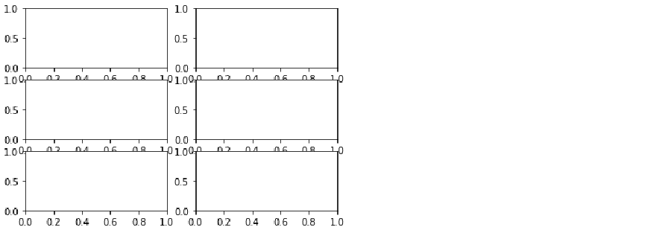

1. To make sure the plots do not overlap use plt.tight_layout().

import matplotlib.pyplot as plt

fig, axes = plt.subplots(nrows=3, ncols=2)

plt.tight_layout() # prevent plot overlap

plt.show()

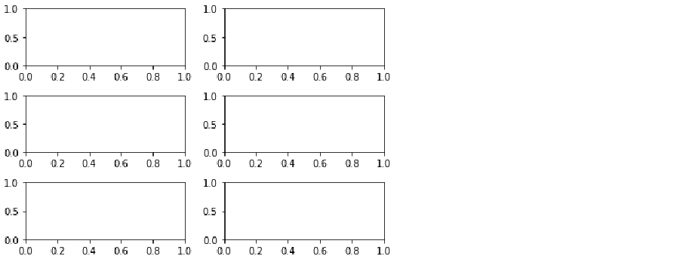

1. Set the respective axes titles to match those in Figure 5.9 using:
   1. axes[0,0].set_title('Line') for the line plot
   2. axes[0,1].set_title('Bar') for the bar plot
   3. axes[1,0].set_title('Horizontal Bar') for the horizontal bar plot
   4. axes[1,1].set_title('Histogram') for the histogram
   5. axes[2,0].set_title('Scatter') for the scatterplot
   6. axes[2,1].set_title('Box-and-Whisker') for the box-and-whisker plot

import matplotlib.pyplot as plt

fig, axes = plt.subplots(nrows=3, ncols=2)

# line plot (top left)

axes[0,0].set_title('Line')

# Bar plot (top right)

axes[0,1].set_title('Bar')

# Horizontal bar plot (middle left)

axes[1,0].set_title('Horizontal Bar')

# Histogram (middle right)

axes[1,1].set_title('Histogram')

# Scatterplot (bottom left)

axes[2,0].set_title('Scatter')

# Box-and-Whisker

axes[2,1].set_title('Box-and-Whisker')

plt.tight_layout() # prevent plot overlap

plt.show()

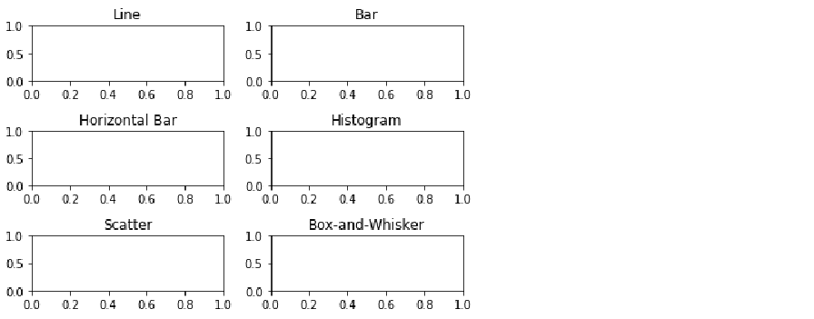

1. Plot ‘Items_Sold’ by ‘Week’ from the ‘Items_by_Week’ data frame in the ‘Line’ axes using axes[0,0].plot(Items_by_Week['Week'], Items_by_Week['Items_Sold']).

import matplotlib.pyplot as plt

fig, axes = plt.subplots(nrows=3, ncols=2)

# line plot (top left)

axes[0,0].plot(Items_by_Week['Week'], Items_by_Week['Items_Sold']) # for line plot

axes[0,0].set_title('Line')

# Bar plot (top right)

axes[0,1].set_title('Bar')

# Horizontal bar plot (middle left)

axes[1,0].set_title('Horizontal Bar')

# Histogram (middle right)

axes[1,1].set_title('Histogram')

# Scatterplot (bottom left)

axes[2,0].set_title('Scatter')

# Box-and-Whisker

axes[2,1].set_title('Box-and-Whisker')

plt.tight_layout() # prevent plot overlap

plt.show()

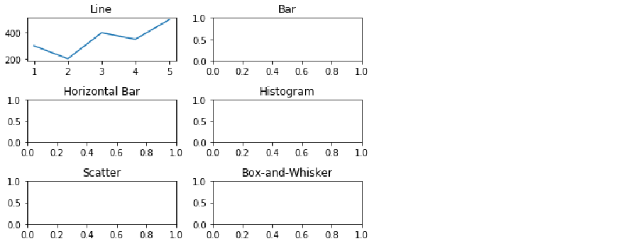

1. Plot ‘Items_Sold’ by ‘Week’ from the ‘Items_by_Week’ data frame in the 'Bar’ axes using axes[0,1].bar(Items_by_Week['Week'], Items_by_Week['Items_Sold']).

import matplotlib.pyplot as plt

fig, axes = plt.subplots(nrows=3, ncols=2)

# line plot (top left)

axes[0,0].plot(Items_by_Week['Week'], Items_by_Week['Items_Sold']) # for line plot

axes[0,0].set_title('Line')

# Bar plot (top right)

axes[0,1].bar(Items_by_Week['Week'], Items_by_Week['Items_Sold']) # for bar plot

axes[0,1].set_title('Bar')

# Horizontal bar plot (middle left)

axes[1,0].set_title('Horizontal Bar')

# Histogram (middle right)

axes[1,1].set_title('Histogram')

# Scatterplot (bottom left)

axes[2,0].set_title('Scatter')

# Box-and-Whisker

axes[2,1].set_title('Box-and-Whisker')

plt.tight_layout() # prevent plot overlap

plt.show()

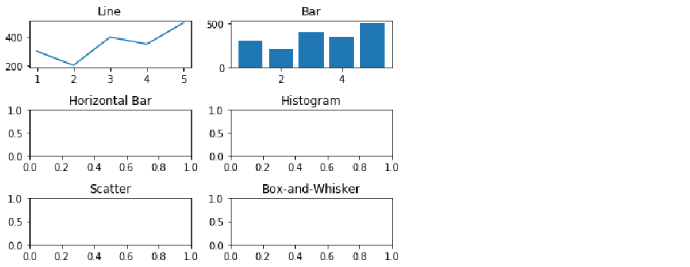

1. Plot ‘Items_Sold’ by ‘Week’ from the ‘Items_by_Week’ data frame in the 'Horizontal Bar’ axes using axes[1,0].barh(Items_by_Week['Week'], Items_by_Week['Items_Sold']).

import matplotlib.pyplot as plt

fig, axes = plt.subplots(nrows=3, ncols=2)

# line plot (top left)

axes[0,0].plot(Items_by_Week['Week'], Items_by_Week['Items_Sold']) # for line plot

axes[0,0].set_title('Line')

# Bar plot (top right)

axes[0,1].bar(Items_by_Week['Week'], Items_by_Week['Items_Sold']) # for bar plot

axes[0,1].set_title('Bar')

# Horizontal bar plot (middle left)

axes[1,0].barh(Items_by_Week['Week'], Items_by_Week['Items_Sold']) # for horizontal bar plot

axes[1,0].set_title('Horizontal Bar')

# Histogram (middle right)

axes[1,1].set_title('Histogram')

# Scatterplot (bottom left)

axes[2,0].set_title('Scatter')

# Box-and-Whisker

axes[2,1].set_title('Box-and-Whisker')

plt.tight_layout() # prevent plot overlap

plt.show()

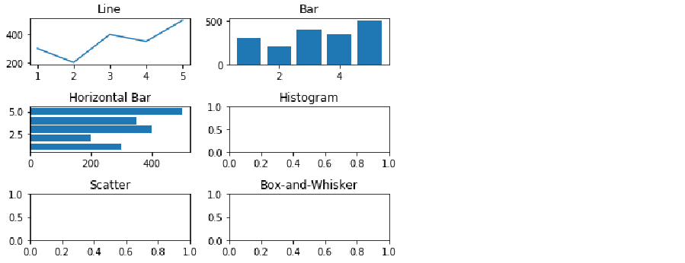

1. Plot the distribution of y using axes[1,1].hist(y, bins=20).

import matplotlib.pyplot as plt

fig, axes = plt.subplots(nrows=3, ncols=2)

# line plot (top left)

axes[0,0].plot(Items_by_Week['Week'], Items_by_Week['Items_Sold']) # for line plot

axes[0,0].set_title('Line')

# Bar plot (top right)

axes[0,1].bar(Items_by_Week['Week'], Items_by_Week['Items_Sold']) # for bar plot

axes[0,1].set_title('Bar')

# Horizontal bar plot (middle left)

axes[1,0].barh(Items_by_Week['Week'], Items_by_Week['Items_Sold']) # for horizontal bar plot

axes[1,0].set_title('Horizontal Bar')

# Histogram (middle right)

axes[1,1].hist(y, bins=20)

axes[1,1].set_title('Histogram') # for histogram

# Scatterplot (bottom left)

axes[2,0].set_title('Scatter')

# Box-and-Whisker

axes[2,1].set_title('Box-and-Whisker')

plt.tight_layout() # prevent plot overlap

plt.show()

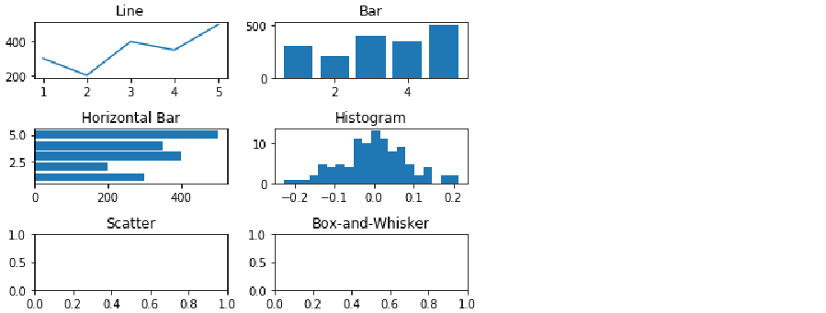

1. Plot Weight by Height in the ‘Scatterplot’ axes from the ‘Weight_by_Height’ data frame using axes[2,0].scatter(Weight_by_Height['Height'], Weight_by_Height['Weight']).

import matplotlib.pyplot as plt

fig, axes = plt.subplots(nrows=3, ncols=2)

# line plot (top left)

axes[0,0].plot(Items_by_Week['Week'], Items_by_Week['Items_Sold']) # for line plot

axes[0,0].set_title('Line')

# Bar plot (top right)

axes[0,1].bar(Items_by_Week['Week'], Items_by_Week['Items_Sold']) # for bar plot

axes[0,1].set_title('Bar')

# Horizontal bar plot (middle left)

axes[1,0].barh(Items_by_Week['Week'], Items_by_Week['Items_Sold']) # for horizontal bar plot

axes[1,0].set_title('Horizontal Bar')

# Histogram (middle right)

axes[1,1].hist(y, bins=20)

axes[1,1].set_title('Histogram') # for histogram

# Scatterplot (bottom left)

axes[2,0].scatter(Weight_by_Height['Height'], Weight_by_Height['Weight']) # for scatterplot

axes[2,0].set_title('Scatter')

# Box-and-Whisker

axes[2,1].set_title('Box-and-Whisker')

plt.tight_layout() # prevent plot overlap

plt.show()

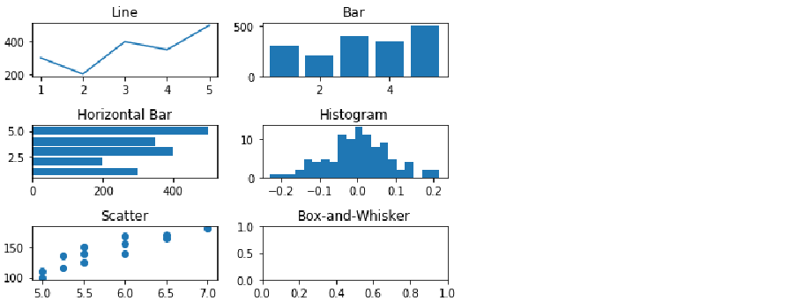

1. Check for outliers in the array y in the ‘Box-and-Whisker' axes using axes[2,1].boxplot(y).

import matplotlib.pyplot as plt

fig, axes = plt.subplots(nrows=3, ncols=2)

# line plot (top left)

axes[0,0].plot(Items_by_Week['Week'], Items_by_Week['Items_Sold']) # for line plot

axes[0,0].set_title('Line')

# Bar plot (top right)

axes[0,1].bar(Items_by_Week['Week'], Items_by_Week['Items_Sold']) # for bar plot

axes[0,1].set_title('Bar')

# Horizontal bar plot (middle left)

axes[1,0].barh(Items_by_Week['Week'], Items_by_Week['Items_Sold']) # for horizontal bar plot

axes[1,0].set_title('Horizontal Bar')

# Histogram (middle right)

axes[1,1].hist(y, bins=20) # for histogram

axes[1,1].set_title('Histogram')

# Scatterplot (bottom left)

axes[2,0].scatter(Weight_by_Height['Height'], Weight_by_Height['Weight']) # for scatterplot

axes[2,0].set_title('Scatter')

# Box-and-Whisker

axes[2,1].boxplot(y) # for Box-and-Whisker

axes[2,1].set_title('Box-and-Whisker')

plt.tight_layout() # prevent plot overlap

plt.show()

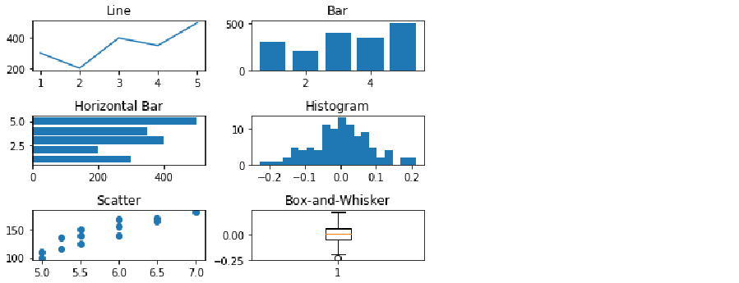

1. Label the x- and y-axis for each subplot using axes[*row, column*].set_xlabel(‘*X-Axis Label*’) and axes[*row, column*].set_ylabel(‘*Y-Axis Label’*), respectively.

import matplotlib.pyplot as plt

fig, axes = plt.subplots(nrows=3, ncols=2)

# line plot (top left)

axes[0,0].plot(Items_by_Week['Week'], Items_by_Week['Items_Sold']) # for line plot

axes[0,0].set_xlabel('Week')

axes[0,0].set_ylabel('Items Sold')

axes[0,0].set_title('Line')

# Bar plot (top right)

axes[0,1].bar(Items_by_Week['Week'], Items_by_Week['Items_Sold']) # for bar plot

axes[0,1].set_xlabel('Week')

axes[0,1].set_ylabel('Items Sold')

axes[0,1].set_title('Bar')

# Horizontal bar plot (middle left)

axes[1,0].barh(Items_by_Week['Week'], Items_by_Week['Items_Sold']) # for horizontal bar plot

axes[1,0].set_xlabel('Items Sold')

axes[1,0].set_ylabel('Week')

axes[1,0].set_title('Horizontal Bar')

# Histogram (middle right)

axes[1,1].hist(y, bins=20) # for histogram

axes[1,1].set_xlabel('y')

axes[1,1].set_ylabel('Frequency')

axes[1,1].set_title('Histogram')

# Scatterplot (bottom left)

axes[2,0].scatter(Weight_by_Height['Height'], Weight_by_Height['Weight']) # for scatterplot

axes[2,0].set_xlabel('Height')

axes[2,0].set_ylabel('Weight')

axes[2,0].set_title('Scatter')

# Box-and-Whisker

axes[2,1].boxplot(y) # for Box-and-Whisker

axes[2,1].set_title('Box-and-Whisker')

plt.tight_layout() # prevent plot overlap

plt.show()

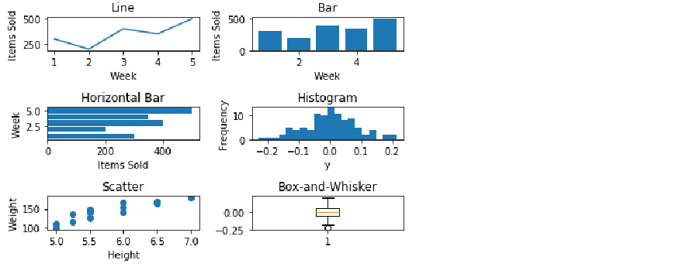

1. Increase the size of the figure with the figsize argument in the subplots function using fig, axes = plt.subplots(nrows=3, ncols=2, figsize=(8,8)).

import matplotlib.pyplot as plt

fig, axes = plt.subplots(nrows=3, ncols=2, figsize=(8,8)) # for figure size

# line plot (top left)

axes[0,0].plot(Items_by_Week['Week'], Items_by_Week['Items_Sold']) # for line plot

axes[0,0].set_xlabel('Week')

axes[0,0].set_ylabel('Items Sold')

axes[0,0].set_title('Line')

# Bar plot (top right)

axes[0,1].bar(Items_by_Week['Week'], Items_by_Week['Items_Sold']) # for bar plot

axes[0,1].set_xlabel('Week')

axes[0,1].set_ylabel('Items Sold')

axes[0,1].set_title('Bar')

# Horizontal bar plot (middle left)

axes[1,0].barh(Items_by_Week['Week'], Items_by_Week['Items_Sold']) # for horizontal bar plot

axes[1,0].set_xlabel('Items Sold')

axes[1,0].set_ylabel('Week')

axes[1,0].set_title('Horizontal Bar')

# Histogram (middle right)

axes[1,1].hist(y, bins=20) # for histogram

axes[1,1].set_xlabel('y')

axes[1,1].set_ylabel('Frequency')

axes[1,1].set_title('Histogram')

# Scatterplot (bottom left)

axes[2,0].scatter(Weight_by_Height['Height'], Weight_by_Height['Weight']) # for scatterplot

axes[2,0].set_xlabel('Height')

axes[2,0].set_ylabel('Weight')

axes[2,0].set_title('Scatter')

# Box-and-Whisker

axes[2,1].boxplot(y) # for Box-and-Whisker

axes[2,1].set_title('Box-and-Whisker')

plt.tight_layout() # prevent plot overlap

plt.show()

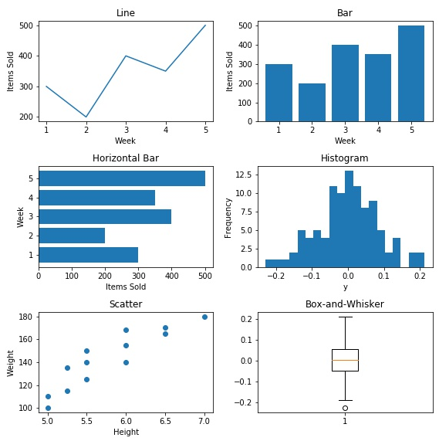

1. Save the figure to the current working directory as ‘Six_Subplots.jpeg’ using fig.savefig('Six_Subplots.jpeg').

import matplotlib.pyplot as plt

fig, axes = plt.subplots(nrows=3, ncols=2, figsize=(8,8)) # for figure size

# line plot (top left)

axes[0,0].plot(Items_by_Week['Week'], Items_by_Week['Items_Sold']) # for line plot

axes[0,0].set_xlabel('Week')

axes[0,0].set_ylabel('Items Sold')

axes[0,0].set_title('Line')

# Bar plot (top right)

axes[0,1].bar(Items_by_Week['Week'], Items_by_Week['Items_Sold']) # for bar plot

axes[0,1].set_xlabel('Week')

axes[0,1].set_ylabel('Items Sold')

axes[0,1].set_title('Bar')

# Horizontal bar plot (middle left)

axes[1,0].barh(Items_by_Week['Week'], Items_by_Week['Items_Sold']) # for horizontal bar plot

axes[1,0].set_xlabel('Items Sold')

axes[1,0].set_ylabel('Week')

axes[1,0].set_title('Horizontal Bar')

# Histogram (middle right)

axes[1,1].hist(y, bins=20) # for histogram

axes[1,1].set_xlabel('y')

axes[1,1].set_ylabel('Frequency')

axes[1,1].set_title('Histogram')

# Scatterplot (bottom left)

axes[2,0].scatter(Weight_by_Height['Height'], Weight_by_Height['Weight']) # for scatterplot

axes[2,0].set_xlabel('Height')

axes[2,0].set_ylabel('Weight')

axes[2,0].set_title('Scatter')

# Box-and-Whisker

axes[2,1].boxplot(y) # for Box-and-Whisker

axes[2,1].set_title('Box-and-Whisker')

plt.tight_layout() # prevent plot overlap

fig.savefig('Six_Subplots.jpeg') # save figure

plt.show()

***Note***

Remember, this figure with 6 subplots is now stored in the object fig.

Conclusion

In this chapter, we used the python plotting library matplotlib to create, customize, and save plots using the functional method. We then covered the importance of a descriptive title and created our own descriptive, programmatic titles. However, the functional method does not create a callable figure object and it does not return subplots. Thus, to create a callable figure object with the potential of numerous subplots we created, customized, and saved plots using the object-oriented method. Plotting needs can vary analysis to analysis, so covering every possible plot in this chapter is not practical. Rather, we learned to access, interpret, and leverage the matplotlib documentation and gallery to create plots which meet the need of each analysis.