Personal Finance Tracker
Project implementation
Name: ____________________ Roll no.: __________ Class: __________
Java 17 console app. One in-memory list. No database, no external library. JDK only.

1. Layout
Path | Role
src/com/financetracker/Main.java | Menu. Calls services. No totals here.
model/Transaction.java | One entry. Fields are final. Serializable.
service/TransactionService.java | Add, delete, month queries, save/load.
service/CategoryAggregator.java | Category totals and percentages.
service/BudgetGoalTracker.java | Category limits and overspend check.
export/CsvExportEngine.java | Monthly CSV.
exception/*.java | InvalidTransactionException, BudgetExceededException.
util/DateUtils.java | Parse dd-MM-yyyy. Test a date against a month.
data/transactions.dat | Saved ledger (ObjectOutputStream).
exports/Financial_Summary_YYYY-MM.csv | Report written for one YearMonth.

2. Run
javac -encoding UTF-8 -d out $(find src -name "*.java")
java -cp out com.financetracker.Main

3. Record
Field | Rule
id | 8 characters, set once. equals/hashCode use only this.
date | LocalDate. Blank input in the menu means today.
type | INCOME or EXPENSE. This is the only sign.
amount | Stored > 0. getSignedAmount() negates an expense.
category, description | Trimmed. Empty text is rejected.
Rejected in TransactionService.validate, thrown as InvalidTransactionException: blank text, amount ≤ 0, date more than 7 days ahead.

4. Formulas (all on one list, via streams)
Result | Call | How
Month rows | getTransactionsForMonth | filter DateUtils.isInMonth, sort by date
Income | getTotalIncome | filter INCOME, mapToDouble, sum
Expense | getTotalExpense | filter EXPENSE, mapToDouble, sum
Saved / net | getNetBalance | income − expense
By category | getExpenseByCategory | groupingBy(category, summingDouble)
Share % | getCategoryPercentages | category ÷ month expense × 100
Top n | getTopSpendingCategories | sort by value desc, limit(n)
Search | searchByDescription | description lower-case contains keyword
Check: 72,000 − 41,250 = 30,750 saved (42.7%). Rent 18,000 / 41,250 = 43.6%. Figures are illustrative.

5. Add → save → warn
Step | Where
Read the five fields | Main.addTransaction
Build and append | TransactionService.addTransaction
Write the whole list | saveToDisk → data/transactions.dat
Reload next launch | loadFromDisk in the constructor
Budget warning, save kept | BudgetGoalTracker.checkBudgets → BudgetExceededException
Limits for this run only | setBudget / removeBudget. Not written to disk.

6. CSV — CsvExportEngine.exportMonthlySummary
Section | Columns
Snapshot | Total income, total expense, net balance
Categories | Category, amount, percentage. Largest first.
Transactions | ID, date, type, category, amount, description (quoted)

7. Code
Transaction.getSignedAmount
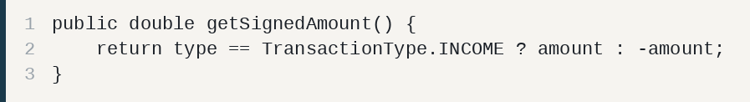
TransactionService.getTransactionsForMonth
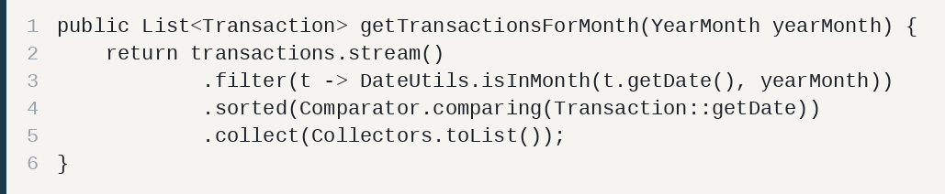
TransactionService.getTotalIncome
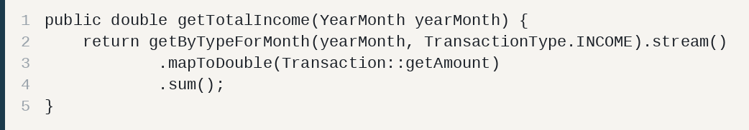
TransactionService.getTotalExpense
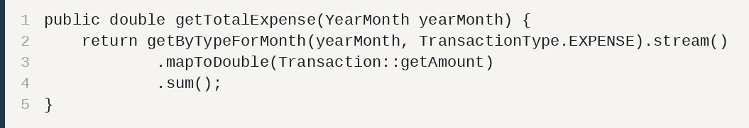
TransactionService.getNetBalance
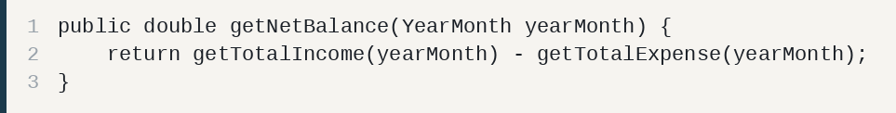
TransactionService.getExpenseByCategory
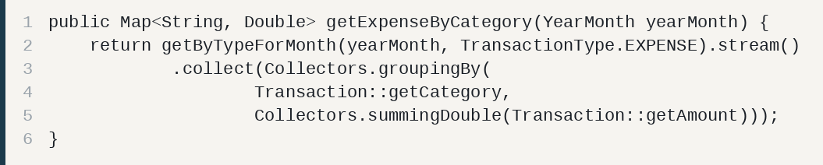
TransactionService.getTopSpendingCategories
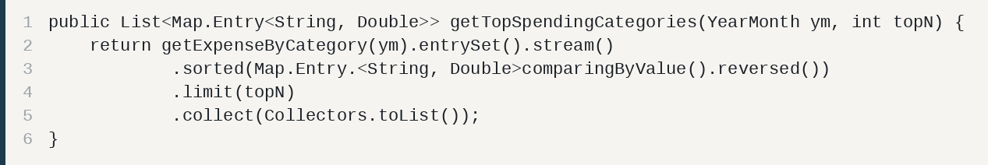
TransactionService.searchByDescription
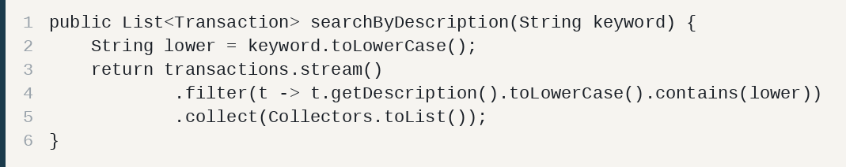
CategoryAggregator.getCategoryPercentages
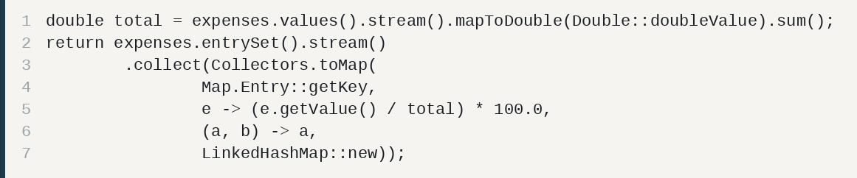
BudgetGoalTracker.checkBudgets
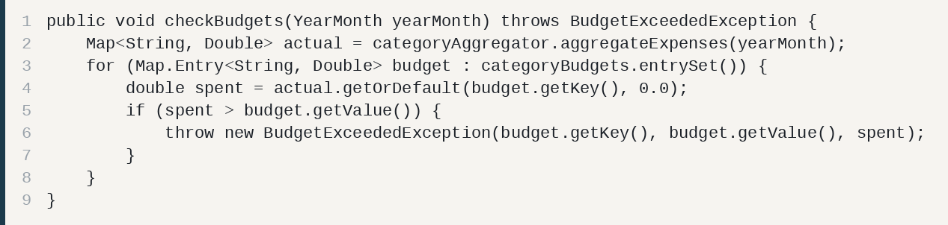
TransactionService.validate
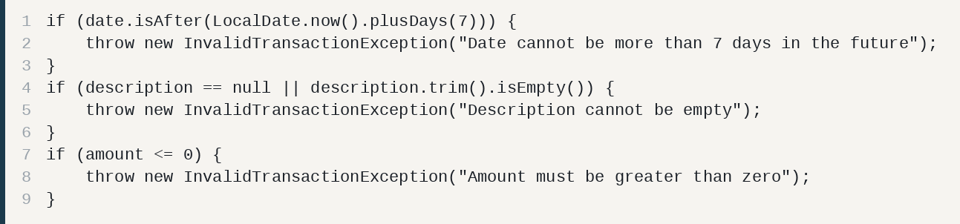
CsvExportEngine.exportMonthlySummary
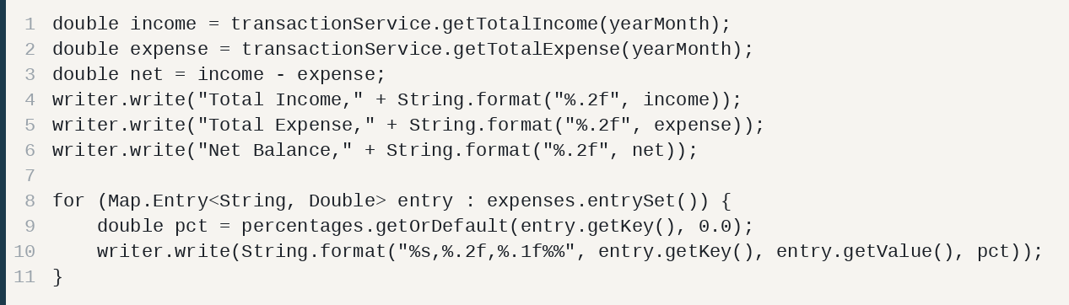

8. Say this if asked
Point | Answer
Why streams | Same filter feeds totals, the category map, and the CSV.
Why amount > 0 | Type already marks income or expense. A stored minus would double the sign.
Why no database | Brief is File I/O + CSV. Serialization stays inside the JDK.
Not production | Budgets not saved. Category case-sensitive. File not locked or encrypted. Single user.
Screenshots to paste in the report: menu, one added row, monthly summary, category table, a budget over the limit, the CSV open in a spreadsheet.

