**Add a Git artifact repository to your DevTest Lab**

By default, a **DevTest Lab** includes artifacts from the official Azure DevTest Lab artifact repository. You can add a Git artifact repository (repo) to your lab to include the artifacts that your team creates. The repository can be hosted on [Github](https://github.com/) or on [Visual Studio Online (VSO)](https://visualstudio.com/).

* To learn how to create a Github repository, see [Github Bootcamp](https://help.github.com/categories/bootcamp/).
* To learn how to create a VSO project with a Git Repository, see [Set up Visual Studio](https://www.visualstudio.com/get-started/setup/set-up-vs).

The repository must contain a top level folder with subfolders corresponding to each Artifacts. Each Artifact subfolder must contain an artifact definition file (Artifactfile.json) and any other optional script files related to the Artifact.

Here's how a repo might look in Github:  
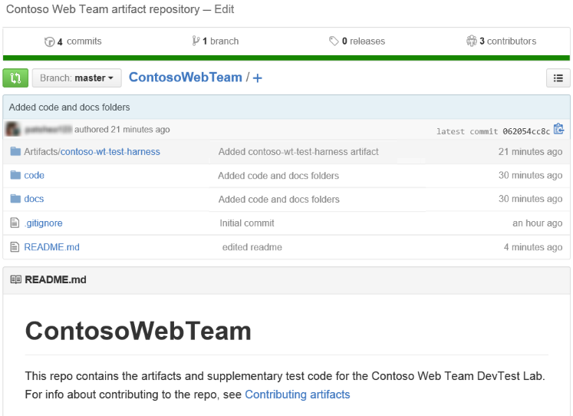

**Adding a Github artifacts repository to your lab**

To add a Github artifacts repository to your lab, you first get the HTTPS clone url and Personal Access Token from the artifacts repo, then you enter that information in your lab

**In the Github artifacts repository**

1. On the home page of the Github repo that contains the team artifacts, copy and then save the **HTTPS** clone url. For example, you can save the url to a temporary Notepad file

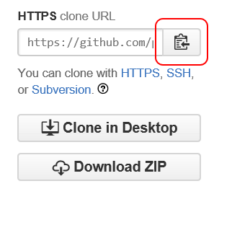

1. On the home page of the Github repo:
2. Open the user menu in the upper-right corner.
3. Choose the **Settings** item.

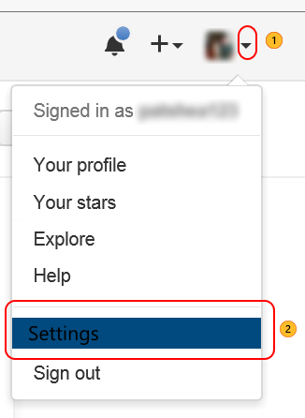

1. In the **Personal Settings** list on the **Your Profile** page, choose **Personal access tokens**.
2. On the **Personal access tokens** page, choose **Generate new token**.
3. On the **New personal access token** page, enter a **Token description**, accept the default items in the **Select scopes**, and then choose **Generate Token**.
4. On the **Personal access tokens** page, copy and then save the generated token:  
   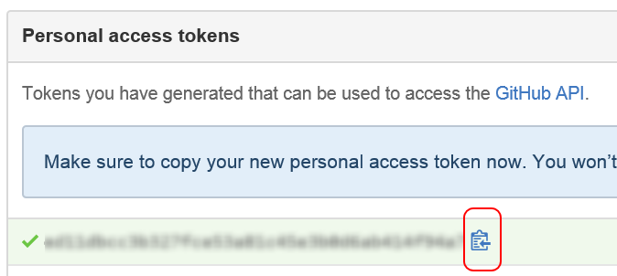

**In the DevTest Lab**

1. On the home blade of your lab, choose **Settings**

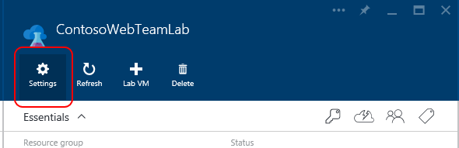

1. On the **Settings** blade, choose **Artifacts Repository**

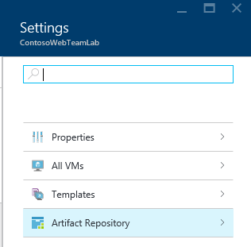

1. On the **Artifacts Repository** blade
2. Enter a display **Name** for the repo.
3. Enter the saved **Git Clone Url**.
4. Enter the relative **Folder Path** of the top level folder that contains the artifacts.
5. Enter the saved **Personal Access Token** to the artifacts repo.
6. Choose **Save**.

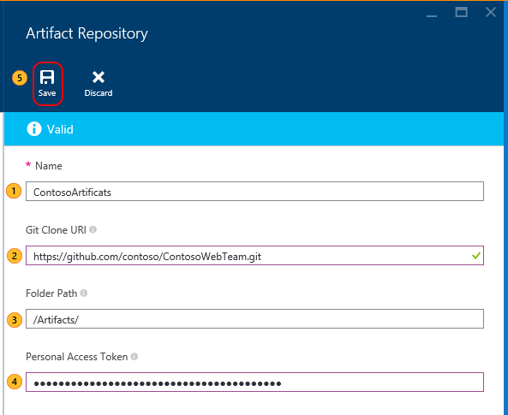

The artifacts in your repository are now listed on the **Add Artifacts** blade.

**Adding a Visual Studio Git artifact repository to your lab**

To add a Visual Studio Git artifact repository to your lab, you first get the HTTPS clone url and Personal Access Token from the artifacts repo, then you enter that information in your lab.

**On the Visual Studio web page of your artifact project**

1. Open the home page of your team collection (for example, https://contoso-web-team.visualstudio.com), and then choose the artifact project.

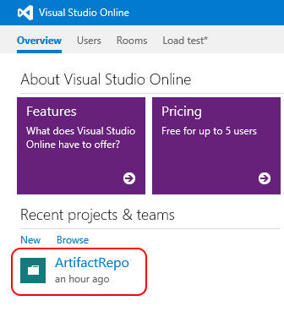

1. On the project home page, choose the **Code** link.

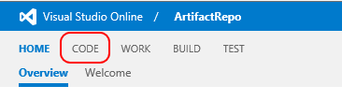

1. To view the clone url, on the project **Code** page, choose the **Clone** link.

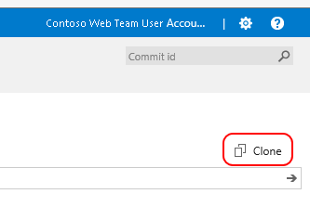

1. Copy and save the url that's displayed. For example, save it to a temporary Notepad file.

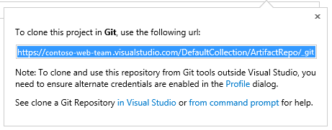

1. To create a Personal Access Token, choose **My profile** from the user account drop-down menu.

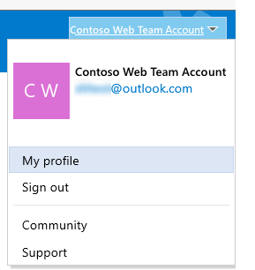

1. On the profile information page choose the **Security** tab.

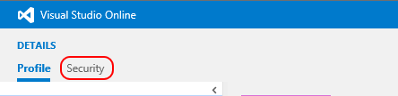

1. On the **Security** tab, choose the **Add** link.

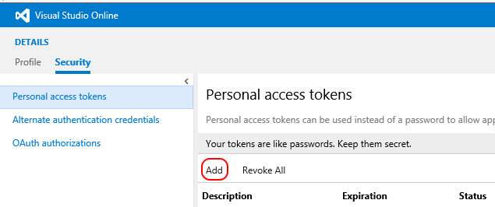

1. In **Create a personal access token**
2. Enter a **Description** for the token.
3. Select **180 days** from the **Expires In** list.
4. Choose **All accessible accounts** from the **Accounts** list.
5. Choose the **All scopes** option.
6. Choose **Create Token**

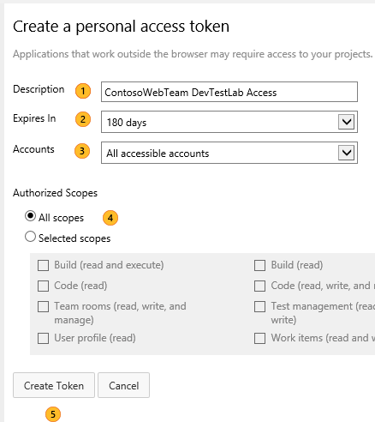

1. The new token appears in the **Personal Access Tokens** list.  
   Choose the **Copy Token** and then save the token value.

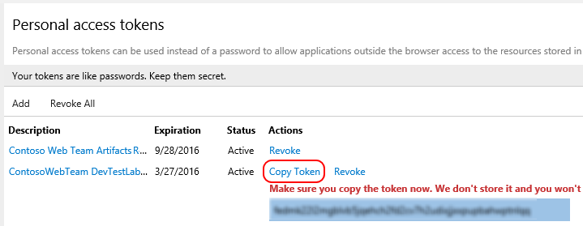

**In the DevTest Lab**

1. On the home blade of your lab, choose **Settings**



1. On the **Settings** blade, choose **Artifacts Repository**



1. On the **Artifacts Repository** blade
2. Enter a display **Name** for the repo.
3. Enter the saved **Git Clone Url**.
4. Enter the **Folder Path** in the artifacts repo that contains the artifacts.
5. Enter the saved **Personal Access Token** to the artifacts repo.
6. Choose **Save**.

