Securely add a user to your Azure DevTest Lab.

Access to a **DevTest Lab** is controlled by Azure Role-Based Access Control (RBAC). Search for [Role-Based-Access-Control (RBAC)](https://azure.microsoft.com/searchresults?query=Role%20Based%20Access%20Control%20%28RBAC%29) in the Azure portal to learn more.

You grant access to your **DevTest-Lab** through two roles:

* **Owner**: Principals assigned to the **owner** role at the Azure subscription level have complete access to the lab, including management and monitoring functions. To add an **owner** role to your subscription, see [Role-based access control in the Microsoft Azure portal](http://go.microsoft.com/fwlink/?LinkId=624812).

**Note: Owner** roles that are assigned at RBAC levels other than the subscription level are not supported in **DevTest Lab**. Assigning a principal to the **Owner** roles in the **DevTest Lab** is not supported.

* **DevTest Lab User**: Principals assigned to the **DevTest Lab User** role can create VMs, read, update and delete virtual machines in the specified lab. Users can be either *internal* (a member of the Azure Active Directory for the subscription), or *external* (a user who is not a member of the Azure AD, such as a member of a partner organization).
* A **DevTest Lab User** role must be assigned through the **Add Users** tiles of the lab.
* Principals in the **DevTest Lab User** role can perform these operations only inside in the lab that they are assigned to.  
  For example, a **DevTest Lab User** cannot create a virtual machine using the Virtual Machine service of the subscription. Creating a virtual machine is only allowed from the DevTest Lab account.
* *External* users must have an account in one of the Microsoft account domains (i.e. @hotmail.com, @live.com, @msn.com, @passport.com, @outlook.com, or any variant for a specific country).

[AZURE.NOTE]

# **Add a DevTest Lab User to your lab**

1. Open the lab home blade in the Azure portal.
2. Choose th**e Access** link.  
     
   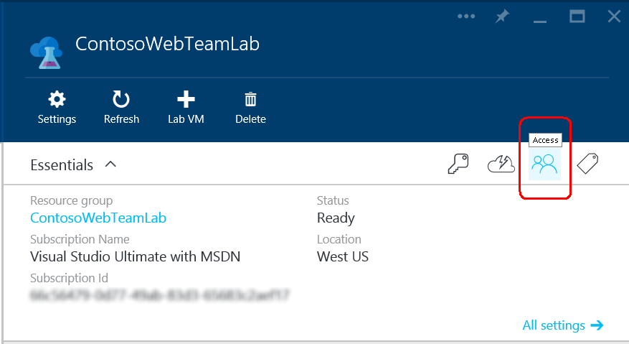
3. On the **Users** blade, choose **Add** to display the **Add access** blade.   
     
   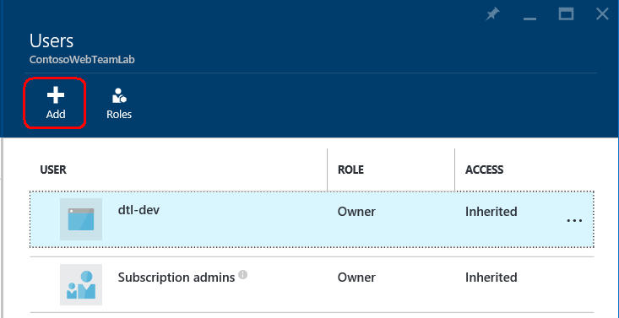
4. In step **1**, choose **DevTest Lab User** on the **Select a role** blade.  
     
   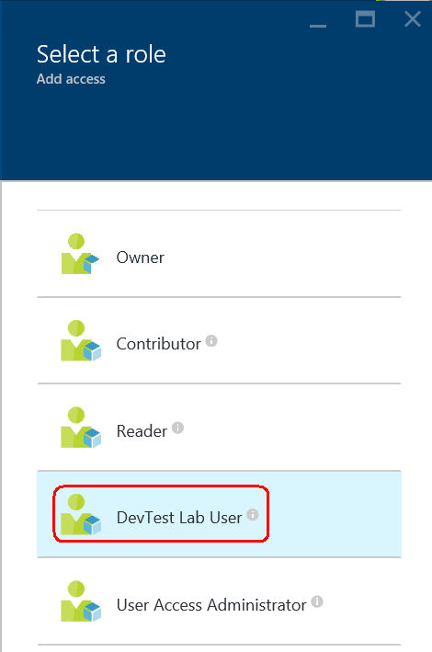
5. In step **2** on the **Add access** blade:  
     
   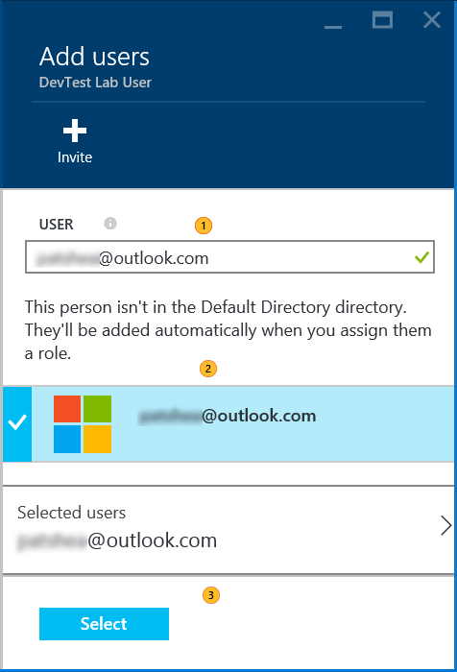
   1. Enter the email account in the **Users** box and press **Enter**. An error message is displayed if the account does not exist.
   2. Select the verified account.
   3. Choose **Select**.