YABEE How To
Features 1
Installation 1
Exporting 1
Options 2
Materials and textures 2
Tags and Collisions 3

Features
YABEE r12.2
Exports:
- Meshes
- UV layers
- Materials and textures (partially)
- Vertex colors
- Armature (skeleton) animation
- ShapeKeys (morph) animation
- <Tag> and collision options export through Blender's "Game logic" -> "properties"
- Non-cyclic NURBS Curves

Installation
You can install YABEE in two ways.
The first way: unpack io_scene_egg into <blender_dir>/<blender_version>/scripts/addons. Run Blender.
The second way: Run Blender, then press Ctrl+Alt+U -> select “Addons” -> press “Install from File” -> select the downloaded *.zip file with YABEE -> “Install from File”. In this case YABEE will be installed in the user's home directory.
After installation you can find “Import-Export: Panda3d EGG format” in “Addons”. You must check the box to use it. In order that you don't have to check the box every time you start Blender press the “Save as default” button. Note: pressing this button will also save the current scene as the default scene.

Exporting
To export a simple model, in the 3d view select the objects to be exported, then press “File” -> “Export” -> “Panda3D (.egg)”. In the window that opens you can select a directory and name for your file and set advanced export options. To export an animated model you should select a mesh that has the “Armature” modifier (but don't select the armature itself) or that has shape keys.

Options
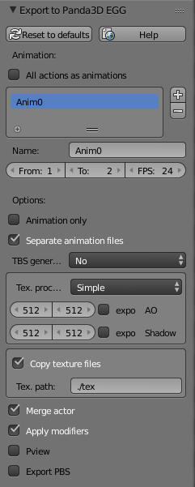
All actions as animations: All actions related to the animated model, which can be set in the action editor will be exported as separate animations.
Animation: Each item in the list can be exported as a separate file with animation data. YABEE uses the main Blender timline to export animation – you should make a series of animations, than add entries into the Animation list. For each you can specify the start and end frame on the timeline. The FPS option is written directly into the animation egg file, and can be used to change the animation speed.
TBS generation (No; Blender; Panda): Generates tangent space vectors for use in shaders like normal- or parallax- mapping. You should have egg-trans from Panda3D SDK installed to use this feature with the “Panda” option. YABEE uses the PATH variable to find egg-trans. If “Blender” is selected, YABEE tries to use blenders tangent space vector creation.
Tex. Processing (Simple; Bake; Raw): This option affects how your materials and textures will be exported.
In “Simple” mode YABEE tries to export most textures and materials as-is and can create special textures for Ambient Occlusion (AO) and Shadow maps. Note: at time of writing the implementation is very much partial, so most textures will be exported in “modulate” mode.
In “Bake” mode YABEE tries to use Blender's bake render to merge all materials and textures into 1-4 (depending on which boxes are checked) final textures – diffuse, normal, gloss and glow.
In “Raw” mode YABEE tries to export all textures and materials as-is.
Copy texture files: YABEE tries to copy all exported textures to the given path, defined relative to the exported egg file.
Merge actor: If your rigged actor contains several parts, then YABEE merges it into a single model before exporting; otherwise the exported file will contain several actors. It is possible that this behaviour will be changed in the future.
Pview: YABEE tries to open the exported egg file with Pview after the export was successful.
Export PBS: YABEE tries to export physically based shading related data which can be used for the Physically based shading panel of the Panda3D BAM Exporter.

Materials and textures
Note: this section deals with the YABEE “Simple” texture processing mode.
From Blender's material tab YABEE exports the Diffuse (rgb), Specular (rgb, hardness), Shading (Emit) and Transparency (Alpha, Specular) settings to the egg file as diff[rgba], spec[rgba], shininess and emit[rgb] respectively. Additionally, if you select “Blender Game” instead of “Blender render” (from the top panel in the default Blender interface), you can uncheck “Backface culling” in “Game Settings” to make YABEE export polygons associated with the selected material as double-sided via the <BFace> tag in Panda's egg format.
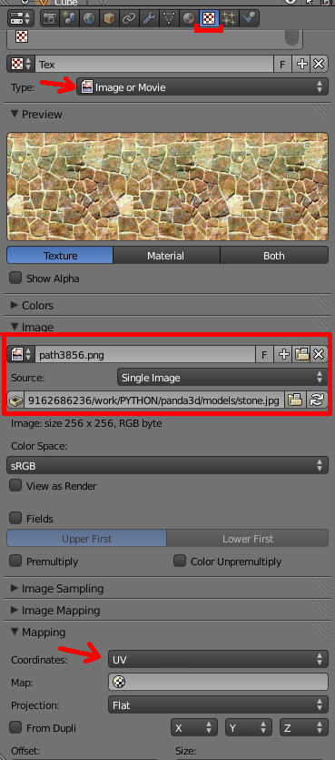
Textures to be exported must have the following parameters in the texture tab:
- Type: Image or Movie
- Image source: As appropriate
- Mapping -> Coordinates: UV.

You can specify a UV name if you have multiple UV layers, otherwise will be used an active layer.

To use a texture as a normal-, glow- or gloss- map, you should check the appropriate box:
- Normal map: Under Geometry, check Normal
- Glow map: Under Shading, check Emit
- Gloss map: Under Specular, check Intensity
A single texture may have only one of these types selected.

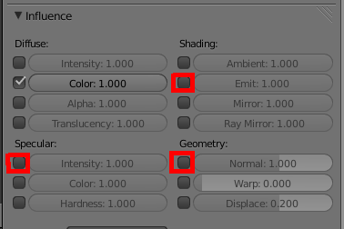

Tags and Collisions
YABEE can export Blender Custom Game Properties as <Tag>, <Collide>, <File> or <ObjectType> attributes. To do this, go to the the Logic Editor, either by selecting it in one of your workspace areas or by selecting the Game Logic screen layout from the drop-down at the top of the screen. In the Logic Editor press “Add Game Property” and enter the desired name and value. If the name is not “Collide”, “File” or “ObjectType”, then the attribute will be exported as: <Tag> option_name { option_value }. If the option name is “Collide”, “File” or “ObjectType” it will be exported as <Collide> {option_value} or <File> {option_value} or <ObjectType> {option_value} respectively.
For more information on the Collide, File and ObjectType attributes, please see the Panda3D manual.

