**AI**

Background Information for Artificial Intelligence

***Kristopher M. Tomplait***

*Ivy-Tech Community college*

Table of Contents

Background Information for Artificial Intelligence 2

What Defines an AI? 5

NPL’s and Transformers 7

Bibliography 8

References 9

Works Cited 10

Footnotes 12

Tables 13

Figures title: 14

**Background Information for Artificial Intelligence**

*According to Merriam-Webster's Dictionary, the word "artificial" is defined as :made or produced by human beings rather than occurring naturally, especially as a copy of something natural.*

*The word intelligence Is defined as the ability to learn or understand or to deal with new or trying situations. The ability to apply knowledge to manipulate one's environment or to think abstractly as measured by objective criteria.*

*Mental acuteness: keenness of mind.*

AI (Artificial Intelligence ) has the potential to spring bored us into the future with advancements in technology, medicine, industry, and education among many other fields with the aid of our creations. But on the other side of that coin it has the potential to be the end of our-selves, as we progress further and further down this path there will be many great advancements and possibility’s but also can lead to many destructive or course altering paths for our species as a whole.

The concept of AI is not a new idea, nor is it a recent one. Even long before the field of Ai research was founded at a workshop held at the campus of [Dartmouth College](https://home.dartmouth.edu/) in 1956 or Alan Turing's 1950 paper ["Computing Machinery and Intelligence"](https://redirect.cs.umbc.edu/courses/471/papers/turing.pdf), It began in antiquity, tales of artificial beings endowed with consciousness and having the ability to learn and perceive the world around itself, being made by craftsmen and magician, gods and demigods, planted the seeds in the human mind long ago and until recently, was only science fiction , but now has grown from an idea, that a creation of our own hands can do the things that we used to have to have direct involvement, is now existing, with governments and corporations, both good and evil alike, have begun waring and attempting to out compete each other, what are the consequences of that?

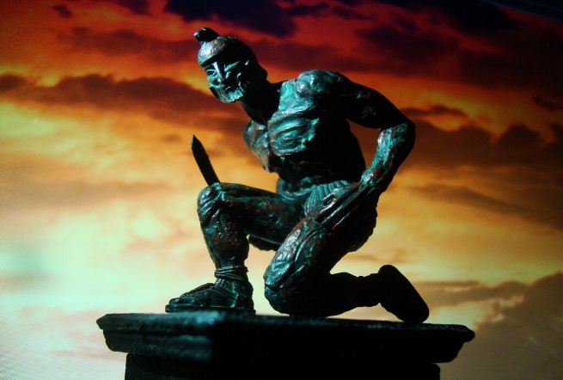

*In* Greek mythology, Talos was a giant made of bronze who protected the island of Crete. Talos would hurl massive rocks at invading ships and walk around the island's perimeter three times every day. According to the ancient text, [Bibliotheca (Pseudo-Apollodorus),](https://www.theoi.com/Text/Apollodorus1.html) Hephaestus built Talos with the assistance of a cyclops and gave the automaton to Minos as a gift. In the Argonautica, Jason and his crew defeated Talos by removing a single plug near his foot, which caused the vital fluid to flow out from his body and rendered him lifeless.

Many Religions believe that we are created in the Image of God, (“Whoso sheddeth man's blood, by man shall his blood be shed: for in the image of God made he man.”Gen 9:6,; and God said, “Let us make man in our image, after our likeness: and let them have dominion over the fish of the sea, and over the fowl of the air, and over the cattle, and over all the earth, and over every creeping thing that creepeth upon the earth.” So, God created man in his own image, in the image of God created he him; male and female created he them.(Gen 1:26-27)

Wouldn’t that equally make us a type of Artificial Intelligence, made in the image of the Infinite, just like as it is now, us making machines in our own image and likeness?

For many century’s if not millennia, human beings pondered the idea of of non-humans, robots , automatons, creations of stone or metal, from the far past we thought of a future with these creations of our own hands.

However, there are questions that need to be asked, what applications that we use AI to do is too far? Is too much like human beings bad for not only the AI but also us as a species, given that we are Violent in nature? And many of our advancements stem from that very nature, as seen with the last two world wars, each war has propelled us forward quicker in the last century in advanced technologies, then it did in the last 1000 years? When or how would we even know when we crossed the PNR(Point of No Return)

Many films and books in science fiction have shown us the thought experiments of one day living in harmony with these machines, or one day waring with our own creations, 

Or being assimilated into advanced virtual realities where we do not truly know what is real? Can you define what is real and what is not? As can you also define what a machine is and what thinking is? Aren’t our brains chemical electrical quantum computers themselves?

Will the machines with consciousness one day demand freedoms and Individual liberties as we have them? Will there be guidelines or “Laws” Like [Isaac Asimov’s “3 Laws of Robotics”](https://www.britannica.com/topic/Three-Laws-of-Robotics), Will something of that nature be implemented as it has influenced the field of AI since its founding’s? Will these machines eventually give way to sentient machines who can choose whether or not to obey those laws? Will it inevitably be a [technological singularity](https://www.popularmechanics.com/technology/robots/a42612745/singularity-when-will-it-happen/) or be like the thought experiment?

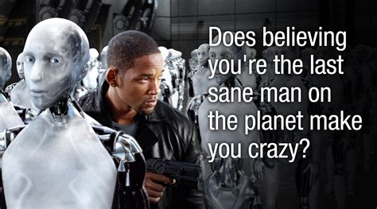

What guidelines should we implement? Is it too late already, as an AI to pass the Turing test would indicate, that other AI’s have equally been able to pass it, but chose not to, showing signs of self-preservation? A trait that is found in living things?

There are many routes this rabbit hole could go but let’s keep it simple for the sake of the eyes viewing this, and the time it takes to read it, unlike our AI’s, we are finite, mortal ,and time is priceless to us, after all, we don’t have a reset button, once our clock runs out, it’s out, and very few of us git the luxury of having extra time.

# What Defines an AI?

There are many types and kinds of AI, and in this field, there are more being made, invented and created with a Field that is expanding quickly, as AI becomes more sophisticated and able to handle more complicated tasks and learn from those tasks, the definition of AI is becoming more of a term to describe a broad field, and with the rate it’s been developing there are more to surely come…. Yet the defining characteristic of AI seem to remain the same, (for now). But the ability to analyze data, learn from it, and make decisions based on that analysis, allows AI to perform tasks that would typically require human intelligence, such as recognizing images or speech, translating languages, or playing complex games. There are varying fields of it as well but are not limited to

**1.Rule-based AI:** This involves a set of predefined rules and conditions that are used to make decisions.

**2.Machine Learning:** This involves the use of algorithms to analyze data and make predictions or decisions based on patterns or trends.

**3.Deep Learning:** This is a type of machine learning that involves the use of artificial neural networks to process and analyze data.

**4.Natural Language Processing (NLP):** This involves teaching computers to understand and interpret human language. NLP enables machines to process and analyze human language, which is useful for applications like virtual assistants, chatbots, and sentiment analysis.

**5.Computer Vision:** This involves teaching computers to interpret visual data, such as images and videos. Computer vision is used for applications such as facial recognition, object detection, and self-driving cars**.**

**6.Robotics:** Robotics involves the integration of AI with physical robots to enable them to perform tasks autonomously. This technology is used in manufacturing, logistics, and healthcare, among other fields**.**

**7.Expert Systems:** These are AI systems designed to mimic the decision-making abilities of a human expert in a particular field. Expert systems can be used to solve complex problems and provide recommendations in areas such as medicine, finance, and engineering.

**8.Generative Adversarial Networks (GANs**): GANs are a type of deep learning that involves two neural networks working together. One network generates new data, while the other network evaluates the generated data to determine if it is real or fake. GANs can be used to generate realistic images, videos, and even music.

But we will only focus on a few….

### NPL’s and Transformers

NLP stands for Natural Language Processing. It is a subfield of computer science and artificial intelligence that focuses on enabling machines to understand, interpret, and generate human language. NLP has applications in a variety of fields, including language translation, sentiment analysis, speech recognition, chatbots, and more.

#### Transformers.

Transformers are a type of neural network architecture that has been widely used in NLP tasks. They were first introduced in the 2017 paper "Attention Is All You Need" by Vaswani et al. Transformers are based on the idea of attention mechanisms, which allow the network to selectively focus on certain parts of the input sequence during processing

In traditional recurrent neural networks (RNNs), the model reads the input sequence one token at a time, and each token's representation is influenced by the previous tokens in the sequence. This sequential processing can be slow and computationally expensive, especially for long sequences. Transformers, on the other hand, can process the entire input sequence in parallel, making them faster and more efficient.

The "Attention Is All You Need" paper introduced the Transformer architecture, which achieved state-of-the-art results in a variety of NLP tasks, including language translation. The paper proposed a new self-attention mechanism that allows the model to attend to all positions in the input sequence when computing the representation of each token. This attention mechanism enables the model to better capture long-range dependencies and relationships between tokens.

Since its introduction, the Transformer architecture has become one of the most popular and widely used neural network architectures in NLP. It has led to significant improvements in performance on a wide range of NLP tasks, including machine translation, text summarization, and language modeling. The Transformer architecture has also inspired further research into attention mechanisms and other improvements to NLP models.

But there are still challenges that need to be overcome, while machines have made significant strides in understanding human language, there are still challenges with understanding the nuances of human language and context. One example of a challenge in understanding the nuances of human language and context is the concept of sarcasm. Sarcasm involves saying one thing but meaning the opposite, often using tone of voice or context to convey the intended meaning. Humans can usually recognize sarcasm based on subtle cues like intonation, facial expressions, or contextual clues, but it can be difficult for machines to understand. This is because sarcasm involves a complex interplay between linguistic and social factors, and requires the ability to infer the speaker's intent and emotional state.For instance, consider the following sentence: "Great, another rainy day in paradise." A human listener might recognize the sarcasm here, understanding that the speaker is actually expressing dissatisfaction with the rainy weather. However, a machine that is simply analyzing the words in the sentence may not be able to distinguish between the literal meaning of the words and the intended sarcastic meaning.

# Bibliography

(2010). Retrieved from lesswrong.com.

al, V. e. (2017). *Attention Is All You Need.*

Anyoha, R. (n.d.). The History of Artificial Intelligence.

Encyclopaedia Britannica. (n.d.). (E. o. Britannica, Ed.) Retrieved from https://www.britannica.com/topic/Three-Laws-of-Robotics https://www.britannica.com/editor/The-Editors-of-Encyclopaedia-Britannica/4419

Gordić, A. (n.d.). The AI Epiphany.

*History of artificial intelligence*. (n.d.). Retrieved from wiki: https://en.wikipedia.org/wiki/History_of_artificial_intelligence

*Holy Bible.* (n.d.).

(1958). Technological singularity.

Turing, A. M. (1950). *Computing Machinery and Intelligence.*

unknown. (300 ad). *Bibliotheca (Pseudo-Apollodorus).*

# References

(2010). Retrieved from lesswrong.com.

al, V. e. (2017). *Attention Is All You Need.*

Anyoha, R. (n.d.). The History of Artificial Intelligence.

Encyclopaedia Britannica. (n.d.). (E. o. Britannica, Ed.) Retrieved from https://www.britannica.com/topic/Three-Laws-of-Robotics https://www.britannica.com/editor/The-Editors-of-Encyclopaedia-Britannica/4419

Gordić, A. (n.d.). The AI Epiphany.

*History of artificial intelligence*. (n.d.). Retrieved from wiki: https://en.wikipedia.org/wiki/History_of_artificial_intelligence

*Holy Bible.* (n.d.).

(1958). Technological singularity.

Turing, A. M. (1950). *Computing Machinery and Intelligence.*

unknown. (300 ad). *Bibliotheca (Pseudo-Apollodorus).*

# Works Cited

(2010). Retrieved from lesswrong.com.

al, V. e. (2017). *Attention Is All You Need.*

Anyoha, R. (n.d.). The History of Artificial Intelligence.

Encyclopaedia Britannica. (n.d.). (E. o. Britannica, Ed.) Retrieved from https://www.britannica.com/topic/Three-Laws-of-Robotics https://www.britannica.com/editor/The-Editors-of-Encyclopaedia-Britannica/4419

Gordić, A. (n.d.). The AI Epiphany.

*History of artificial intelligence*. (n.d.). Retrieved from wiki: https://en.wikipedia.org/wiki/History_of_artificial_intelligence

*Holy Bible.* (n.d.).

(1958). Technological singularity.

Turing, A. M. (1950). *Computing Machinery and Intelligence.*

unknown. (300 ad). *Bibliotheca (Pseudo-Apollodorus).*

Special thanks

1This work wouldn’t have been possible without the