PROJECT PLAN

VIP Coursework
Midterm Submission

DATE PREPARED
27 / 04 / 2026

Team: The Last Set

Team leader name (ID number)Kholmirzaev Temurjon (12235652)
Teammate name (ID number) Tillaev Islombek (12235642)
Teammate name (ID number) Tagaev Rashid (12235611)
Teammate name (ID number) Abdusattorov Otabek (12235640)
Teammate name (ID number) Umurzakov Ozodbek (12235639)
Teammate name (ID number) Erkinova Zahro (12244980)

CONTACT
Email Address: (use INHA e-mail) temurjon@inha.edu

TABLE OF CONTENTS

1. PROJECT OVERVIEW ................................................... 3
2. TECHNOLOGY OVERVIEW AND TASK BREAKDOWN ........... 5
3. TIMELINE & MILESTONES ........................................... 9

1. Project Overview

The fitness industry is valued at over $96 billion globally, yet gym beginners continue to face the same critical problems: poor exercise form, lack of guidance, and high personal trainer costs ($50–150 per session). Studies show that 35% of gym-related injuries stem from incorrect technique, and over 50% of new gym members quit within the first six months due to feeling lost or unsupervised.

While wearable devices and mobile applications have made progress in fitness tracking, they remain limited to counting steps or heart rate — none provide real-time, in-gym form correction. Existing AI coaching apps require users to prop up their phone at specific angles, which is impractical in a busy gym environment. There is a clear gap in the market for an intelligent, always-available physical presence that can guide beginners through their workouts safely and effectively.

Our project addresses this gap by building a gym-deployed robot that acts as an AI-powered personal trainer and gym buddy for beginners.

OUR PRODUCT

GymBot is a TurtleBot-based mobile robot built for gym environments. Equipped with LIDAR for navigation, an RGB-D camera for pose tracking, a front-facing display screen, and a speaker for voice coaching, the robot autonomously moves across the gym floor and follows individual users from station to station — acting as their personal AI gym buddy.

When a user begins exercising, the robot positions itself at an optimal viewing angle, tracks 33 body keypoints in real-time using MediaPipe BlazePose, and displays a live skeletal overlay on its screen showing exactly where the user's form needs correction. It counts reps, detects the exercise type automatically, and provides spoken advice like 'Go lower on your squat' or 'Keep your back straight'. Every session is recorded and synced to a companion web application where users can review their workout history, replay annotated video clips of their form, and track their improvement over time.

The current midterm prototype focuses on the core AI perception pipeline (computer vision, exercise detection, form analysis) and the companion web dashboard, which have been fully implemented and tested as a browser-based proof of concept. The next phase will port this software onto the TurtleBot hardware with ROS 2 integration for autonomous navigation and person-following.

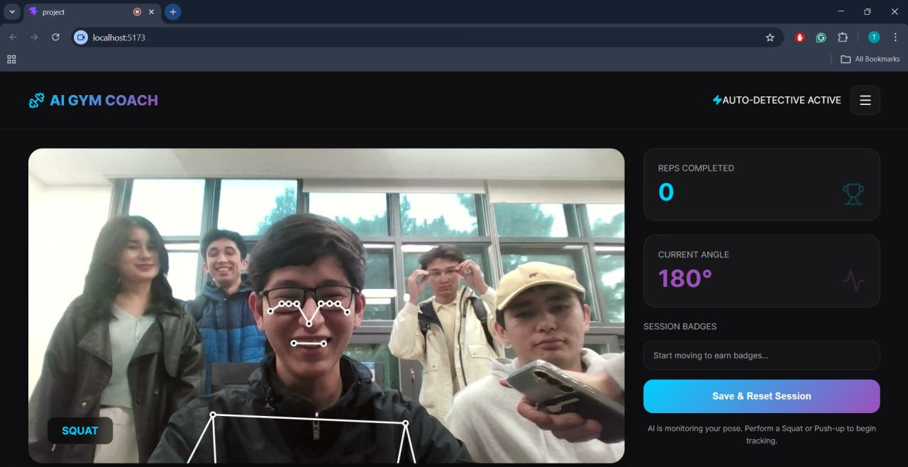
Figure 1: Web application prototype showing real-time pose tracking with skeletal overlay, auto-detection label (SQUAT), rep counter, angle measurement, and session badge system.
THE PROBLEM

1. Beginners exercise with poor form, leading to injuries and ineffective workouts. Without real-time correction, bad habits become ingrained.
2. Personal trainers are expensive and unavailable for every session. Most beginners cannot afford consistent one-on-one coaching.
3. Existing fitness apps require manual logging or only track basic metrics (steps, calories). None provide spatial form analysis in a gym setting.
4. There is no persistent record of form quality over time — users cannot see whether their technique is actually improving.

OUR SOLUTION

We propose a two-part system — a physical gym robot and a companion web platform — that together solve all four problems:

• The robot uses cameras and MediaPipe BlazePose to track 33 body keypoints in real-time, detecting exercises automatically and counting reps via angle-based state machines.
• A live video feed on the robot's screen overlays the user's skeleton with color-coded form indicators (green = correct, red = needs adjustment), along with specific corrective instructions (e.g., 'Drive knees outward', 'Go lower').
• All session data — exercises performed, rep counts, form scores — are stored and synced to the companion web application, where users can review their workout history grouped by date.
• The web app features a gamified badge system that rewards consistency and form improvement, encouraging beginners to keep training.
• An on-device One-Euro filter ensures the skeletal tracking is smooth and professional, not jittery — critical for a product deployed in a real gym environment.

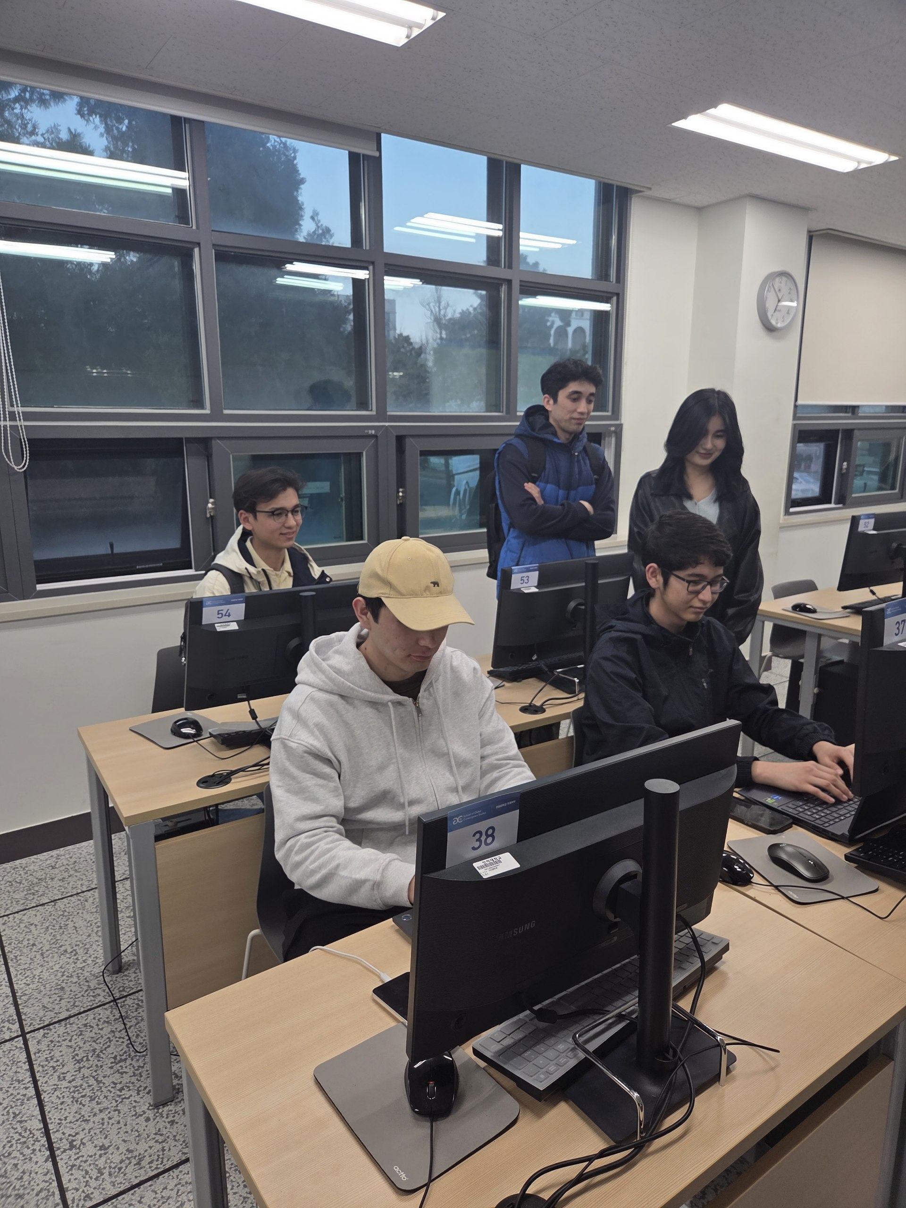

2. Technology Overview and Task Breakdown

The GymBot system is composed of three major subsystems: the Mobile Robot (TurtleBot platform + sensors + embedded AI), the Cloud Backend (database + session storage), and the Companion Web Application (user dashboard). The midterm prototype demonstrates the full AI perception pipeline and web interface running in a browser environment, which will be ported to the TurtleBot hardware with ROS 2 in the next phase.

Primary Technologies

Component |  | Technology | Purpose
Robot Platform | TurtleBot 3 / 4 | Mobile base with differential drive, capable of autonomous indoor navigation
Robot OS | ROS 2 (Humble) | Middleware for sensor fusion, navigation stack, and inter-module communication
Navigation | LIDAR + Nav2 Stack | SLAM-based mapping and obstacle avoidance for safe gym-floor movement
Person Following | Depth Camera + Tracker | Detects and follows the assigned user between workout stations
Pose Estimation | MediaPipe BlazePose | Real-time 33-point skeletal tracking, GPU-accelerated for sub-100ms latency
Signal Processing | One-Euro Filter | Adaptive low-pass filter to eliminate landmark jitter while preserving fast movements
Exercise Classifier | Heuristic Pose Analyzer | Determines exercise type (Squat/Push-up/Plank) from body orientation with 10-frame temporal smoothing
Rep Counter | Angle-Based State Machine | Tracks joint angles through UP→DOWN→UP cycles with configurable thresholds per exercise
Display + Audio | Touchscreen + Speaker | Shows live skeleton overlay with form corrections; delivers voice coaching
Web Frontend | React 18 + Vite | Companion dashboard with real-time stats, badges, and workout history
Cloud Backend | Database + API | Stores workout sessions, syncs between robot and web app, hosts video replays

Task Breakdown

The project is divided into 9 core engineering tasks:

Task 1 — Robot Navigation & Gym Mapping (Planned)
Use the TurtleBot's LIDAR sensor with the ROS 2 Nav2 stack to build a SLAM map of the gym floor. The robot will autonomously navigate between workout zones while avoiding obstacles such as other gym-goers, equipment racks, and benches.

Task 2 — Person Following & Tracking (Planned)
Implement a person-following module using the depth camera. Once a user starts a session, the robot locks onto them and follows them between workout stations, maintaining an optimal distance and viewing angle for pose estimation.

Task 3 — Camera Integration & Video Pipeline (Done ✅)
Initialize the camera stream, handle permissions, and manage the video pipeline at 30 FPS. Currently implemented as a browser-based webcam feed; will be ported to the robot's onboard RGB-D camera module.

Task 4 — Real-Time Pose Estimation (Done ✅)
Load the MediaPipe BlazePose model with GPU delegate, process each video frame to extract 33 normalized landmark coordinates (x, y, z, visibility). Runs entirely on-device for zero-latency inference.

Task 5 — Skeletal Overlay on Robot Display (Done ✅)
Draw joint connections and landmark points on a canvas overlay synchronized with the video feed. Mirrored to match the user's perspective, creating a mirror-like coaching experience shown on the robot's front-facing display.

Task 6 — Landmark Smoothing via One-Euro Filter (Done ✅)
Apply an adaptive One-Euro filter to all 33 landmarks across x, y, z axes (99 filter instances). Parameters: freq=30Hz, minCutoff=0.5, beta=0.007. Eliminates sensor noise while preserving fast movement responsiveness.

Task 7 — Automatic Exercise Detection (Done ✅)
Classify body orientation by comparing shoulder, hip, and ankle positions. Vertical = Squats; horizontal = Push-ups/Planks (distinguished by elbow angle). A 10-frame voting buffer prevents classification flickering.

Task 8 — Rep Counting & Form Feedback (Done ✅)
Track joint angles through a two-state machine (UP/DOWN). A rep is counted on the UP→DOWN transition. Form feedback generated in real-time: 'Go Lower!', 'Good Depth!', 'Great Push-up!'. On the robot, feedback will also be spoken via the onboard speaker.

Task 9 — Session Badges & Workout History (Done ✅)
Track exercise sets as collectable badges during each session. Badges persist to a workout history accessible via a sliding sidebar. Currently uses local Storage; will migrate to a cloud database for cross-device sync between robot and web app.

Task 10 — Voice Coaching & Audio Feedback (Planned)
Integrate text-to-speech on the robot to deliver spoken coaching cues hands-free: 'Drive your knees out', 'One more rep!', 'Great set — take a 60-second rest'. This allows users to focus on their workout without looking at the screen.

Task 11 — Session Recording & Video Replay (Planned)
Record workout sessions as video clips with embedded AI annotations (skeleton overlay, rep markers, form scores). Users can replay these on the companion web app to study their technique.

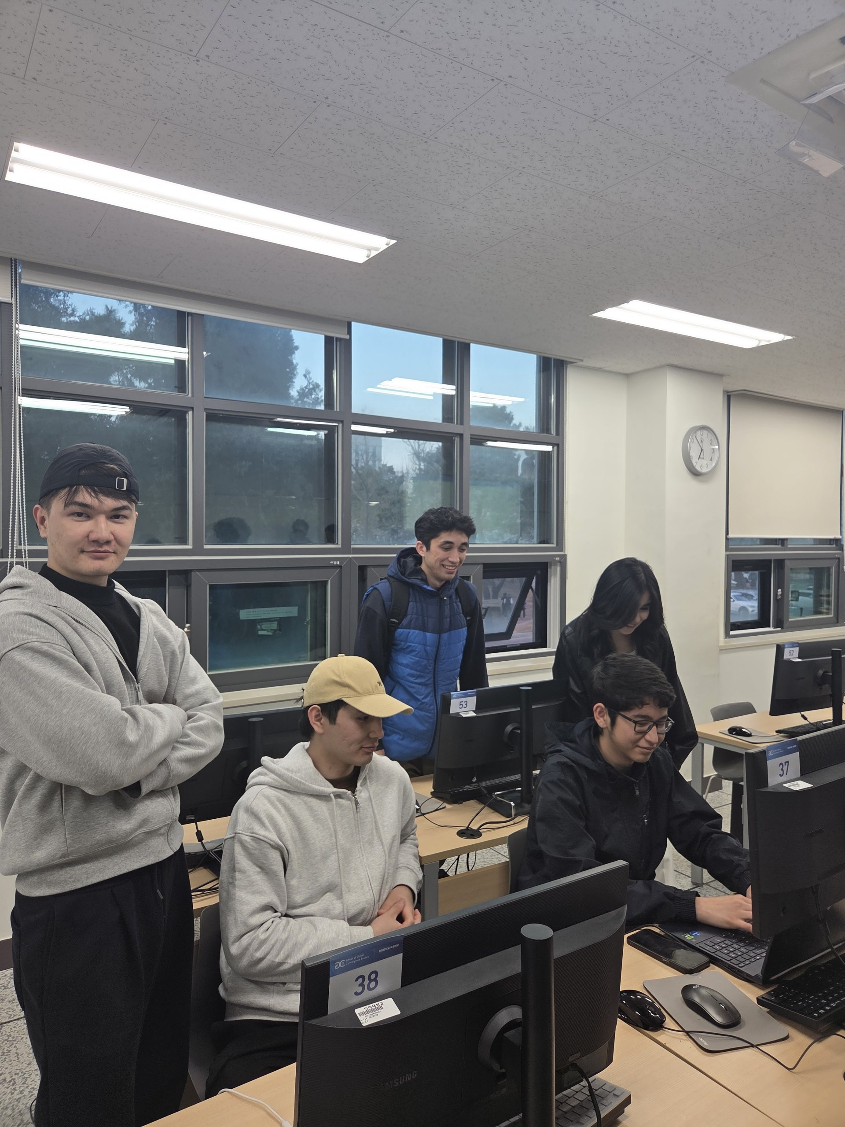
Pseudocode and Algorithms

Algorithm 1: Joint Angle Calculation
FUNCTION calculateAngle(pointA, pointB, pointC):
// B is the vertex (e.g., knee joint)
radians = atan2(C.y - B.y, C.x - B.x) - atan2(A.y - B.y, A.x - B.x)
angle = abs(radians × 180 / π)
IF angle > 180 THEN angle = 360 - angle
RETURN angle

Algorithm 2: One-Euro Adaptive Filter
CLASS OneEuroFilter(frequency, minCutoff, beta, dCutoff):
FUNCTION alpha(cutoff):
tau = 1 / (2π × cutoff)
te = 1 / frequency
RETURN 1 / (1 + tau / te)

FUNCTION filter(rawValue):
IF first_sample: RETURN rawValue
dx = (rawValue - prevValue) × frequency
dxSmoothed = alpha(dCutoff) × dx + (1 - alpha(dCutoff)) × prevDx
adaptiveCutoff = minCutoff + beta × |dxSmoothed|
result = alpha(adaptiveCutoff) × rawValue + (1-alpha(adaptiveCutoff)) × prevValue
RETURN result

Algorithm 3: Automatic Exercise Classification
FUNCTION detectExercise(smoothedLandmarks):
shoulder = landmarks[12]
hip = landmarks[24]
ankle = landmarks[28]
elbow = landmarks[14]

isHorizontal = |shoulder.y - hip.y| < 0.2 AND |hip.y - ankle.y| < 0.2
isVertical = |shoulder.x - hip.x| < 0.2 AND |hip.x - ankle.x| < 0.2

IF isHorizontal:
elbowAngle = calculateAngle(shoulder, elbow, wrist)
IF elbowAngle < 120: prediction = PUSH-UP
ELSE: prediction = PLANK
ELSE IF isVertical:
prediction = SQUAT

predictionBuffer.append(prediction) // keep last 10 frames
stablePrediction = mostFrequent(predictionBuffer)
IF stablePrediction ≠ currentExercise:
currentExercise = stablePrediction
resetRepCounter()
RETURN stablePrediction

Algorithm 4: Squat Rep Counter (State Machine)
FUNCTION processSquat(landmarks):
kneeAngle = calculateAngle(hip[24], knee[26], ankle[28])

IF kneeAngle > 165°: stage = UP, feedback = ''
IF kneeAngle < 95° AND stage == UP:
stage = DOWN
repCount += 1
feedback = 'Good Depth!'
ELSE IF 95° < kneeAngle < 130° AND stage == UP:
feedback = 'Go Lower!'

RETURN {count: repCount, angle: kneeAngle, feedback}

Hardware/Software Flowcharts

Robot Operation Flow:

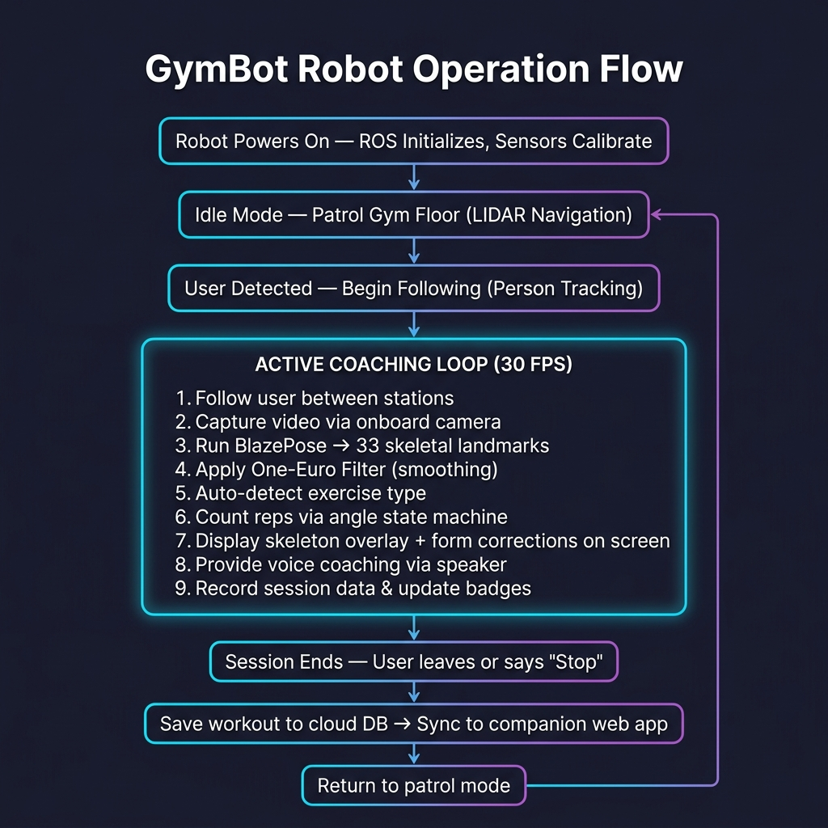

Architecture Diagrams

Full System Architecture:

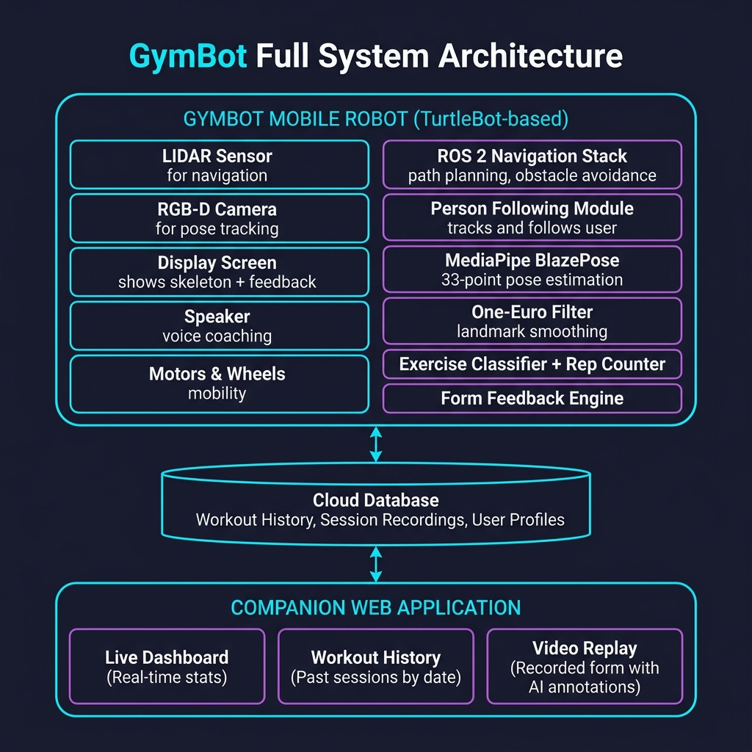
Figure 6: GymBot Full System Architecture — Robot Unit communicates with Cloud Database, which syncs to the Companion Web Application.

3. Timeline & Metrics

TIMELINE

ACTIVITY | DESCRIPTION | COMPLETION DATE
Research & Planning | Surveyed existing fitness AI solutions, selected MediaPipe BlazePose as the CV engine, defined MVP scope (3 exercises) | March 26, 2026
Web Prototype: Foundation | Set up Vite + React project, designed premium dark-mode UI with glassmorphism, implemented camera integration | March 26, 2026
CV Pipeline Implementation | Integrated BlazePose (33 landmarks), implemented skeletal canvas overlay, built angle calculation utilities | March 26, 2026
Exercise Intelligence | Built auto-detection classifier, One-Euro smoothing filter, and rep counting state machines for Squats, Push-ups, Planks | March 26, 2026
Persistence & History | Implemented session badge system, localStorage workout history, sliding sidebar UI | March 27, 2026
Documentation & GitHub | Created README.md, PROJECT_OVERVIEW.md, prepared repository for submission | April 10, 2026
TurtleBot Setup & ROS 2 | Assemble TurtleBot platform, install ROS 2 Humble, configure LIDAR and RGB-D camera drivers | May 2026 (Planned)
SLAM & Navigation | Build gym floor map using LIDAR SLAM, configure Nav2 stack for autonomous navigation and obstacle avoidance | May 2026 (Planned)
Person Following Module | Implement depth-camera-based person tracker, integrate with navigation stack for autonomous user following | May 2026 (Planned)
AI Pipeline Port to Robot | Port MediaPipe + One-Euro + Classifier from browser to TurtleBot's onboard compute (Jetson Nano) | May 2026 (Planned)
Display & Voice Integration | Mount touchscreen display, integrate speaker for TTS voice coaching, wire to ROS 2 topics | May 2026 (Planned)
Cloud Backend & Sync | Migrate from localStorage to cloud DB, enable real-time sync between robot sessions and web dashboard | May 2026 (Planned)

MILESTONES

MILESTONE | DESCRIPTION | COMPLETION DATE
M1: AI Perception Proven ✅ | MediaPipe BlazePose runs at 30fps with One-Euro smoothing, accurately tracking 33 body points in real-time | March 26, 2026
M2: Auto-Detection Working ✅ | System automatically classifies Squats, Push-ups, and Planks from body orientation without manual selection | March 26, 2026
M3: Web Dashboard Live ✅ | Companion web app with real-time stats, session badges, workout history sidebar fully functional | March 27, 2026
M4: TurtleBot Mobile | Robot autonomously navigates gym floor using LIDAR SLAM and follows users between stations | May 2026 (Planned)
M5: Full Robot Integration | AI pipeline running on TurtleBot with display, speaker, and cloud sync fully operational | May 2026 (Planned)
M6: Gym Deployment & Testing | GymBot deployed at INHA University gym, collecting real user feedback and accuracy metrics | May 2026 (Planned)

