**WeakAuras 2**

**COORDS:**

!TJvBVTTnq4)lbOaod2U69xgq)qCMDAksCYcvAAgcKnTeLT6uK8OKsTYh8V9DKuYwXYAZTOROODOP0uhjpE84DppNKRSRJlcdnzUOuxKsFzJ(YUOhDr(S)GbNH9(tFAYYttIsOGGXY8)u4TQ8wn3Xs91zQywc1NqhuUex0GOWNFgt9xp1jjjkleeHZZwKqVAzwysCQyJfRYDwvVH(ZjUi0FLJPK1thLhfTE6DlcZaHuYCyDoflH(ZPj5lRwdk8zcZQkFSU1kXTwjU1kXTwz(X1dhry9ryVkJbLMHPzcRkimomDHOp0vif6NrdNpNqtfA3zJaExUHHZPyqv5ZiprIZq5bbHRCrto9eKZeKZj3atKpIl6TeCu2ITZ9AkHpx01dV4cq8ssu05(LUjFYmqvIZ(BhEX1JUfMsoZYqlJWfGfGIXpsQCQWCrls(0vXGE4)EcCmFIWglpERnZpty(qocHxM4tk9rfxfeKsYy(TshBLanyrXEWn51jHStYPdh7m8gyRirbLIgCLJZvxEXWrW5necNonb0qALIopMRhW9hqbRg8I4mS46GR3rmPIdl60BgoCSlAvnRXljoiCE1TtgHgJJEpCRaxKW1TbCvK49u1ZYYQsQWXMzf0XHxo8(BYdpgZ1IFyTiXOempOpmweCbDFmhIB34NyxLCp8lLNbHsXzne7fHtBoz4w1B)tDco2FYEhwSbknKNNsMi2fi7HMab07FLQnKV8PLTy1bI8HgYPyVMQ3peCjEGKIMNtwk5ocz(W4WhXvBqv(gYhYzycNisHsjSRM0QmQ4KyEG7J4W4dF2BYGpS5lUh2KwNKNffcdGU6wNloF8qw0Y)eeipHXlpnl5rhYkO)63T(Db5XCNzNJHNMk(xucG8SE6QUfV50jxIx2)ms218ey4HRts5bKD2m0asAg0Duc9wixVZrIC9JoU7ME)kmRpC)E2cpEg36PVz90Gek417C0R6Re0D9u2ph1D1Vilj1TG1wBXuswonUJyXGCsS)wKGr9SunKS0KLun0uLv1mCd6Pz3cAWw3XTl9Xma88YFbAGewyG3DH(meWtGNBdjEd6BDm5dcjguswEQinbh9jCrAgnN4o4FbDUkCXfjVbQ(0TqfhgCnBp5OZdyaULAbZpM1GPFj(9(G4pq86EYsTIf(j4M8okgilVBtVGeM9mIg(86P)Eo2Nb)c00o8t3nCA2DafBh36qt9z7PGOww5LC5z8mMgKhUOpcrqHbfUibpYEq13qTqIX(402ayQLQ3gCqnaMdB2BbyoO5N9zW1vNFZpmLfGiqvELhBFxr8fjoJvKK2Brv7sTXj)0E77p7(rbY3D(9BPthPPBBPkllBQOPjjzyXYOvH1mMZ3SpD)dpkNUITIMPQMUKMTUTTkZLy1ci3)dADyGwqy8h5bkpXW)Jl(SHX2FInNv(gE20wxaWrjjvo2j8X4DpJ3v4MfbXLdmGpaVAkojpC8XrlxG51A2w1df8rxXBzlv8gfZkF1IITB7i4ydXbvzjlPjZPK0uicLkdnZznZynywdvHjJ1mJ1GvQf1(nn)QxVv8SkWPVOFqeKP0HNlD8RHMMwsyltwr3O5Kd4tUdSb9AzdoM1J9)xQGE9kvbuMkuMoxnZjzItHq2EWiGOCIpFUWPK5bqmbBDdRN(61tnL2fEGDQ6YS2ULQORCjsbnjJvhd7QNFBVA7TTt9WRVbCk(KuaWGYmNzLggpLrQjv(cs48fm4nDtvBfdBDfvtja3NbVzU5qn7RjN)JHuAc)L73LVpNcDMbVcIpp1hn4IHJ)TAdDoddaUrjpCIV)vXPpChb)NNah00hUK4hIFWrmZ0heFQGjLFJGAvrubr3szdR4GsEWDnzYl8B7st)jox7iDtBdzdtlltdzljDPs3wDUAon7ZKXDqF4p6CwYG99wd8pfXiDvdlBBtfjflfdjz2DGU223KyZl7QzB1hUIS0L1nu0BsS3AjeLaymTnwDds5NVL8taBVSfeuOOlBcL)OQ9fW2)L)XI((HTVLpK0oLb89hB)U0YhcPFJkfAH6)f06157BI0)ZjRFaUIvvygJkzGFTrFflvLgZVOrvcfTxLqrzvcf7wLqXx5QeQy7lyS9fmWKa8Hq1pOeI8)4Vl1xefVMHIPIUTUMSKTgqt9Jef)U8ZTWVxSL52WsZ2WWYYwfk9rUI5Edfz7SOCc9uNau2frYlF)7EjD)EE54TVwTPPMHMMIjGWOyjBiET6g837PCL9wuc3v)eySAkSyo3)(

**HEALTH BARS:**

!TR16YPnYs43L9xz3Y2rJUtv7MQaBW2zXGpi51jNYfGanaATSeRKWb7FWZ(2Zfjn6gGRtso7wvkBRmAU190tpF9xpkJrJThB5apsgBfp2s(mK(zOXwpn2YL8l04mN5p6gfU(8q)WiOIbi6VY0Nk0NQJhiDMgzkMfg5IJ6WhYyRo(EV(QtK7UP2HH(jEqvXZD8XKHX784zPL66Uep2Y6V24eH3nT3gF)DtVFLxcuzeEPxyG9lRHYlJc3SoDmwEVIjkd)vrLuIQKsuLuIQKiIkUD4IfX4KX9u1uLuLmuBzi1Yqwwz8ItvnaJX8equXKLECItucZ2SWlWlEfRmuKvluojYB5sCumtM2zvqlsvxNnroWuTzg(zCqI1Mfl82o2AY5TTSNyz3Ee0rAlJTUc74NSkVV3gHP9162U97dvVg77FTBmtjCXZGPIzrUQB)B7Dh0LnenZATVZlGgyf48eM3BsFTwf(LHbW8q)32WY8zmPTnb56mDn5qBYMv5nHUyUL7Lul3PGftXOfsrwvXqULHjX01IyysWrbo()byqaBiy)1Hzly(QWOBd9ilXZ7oWU7iW0eo)50oHqkskWGDtTa7M2XbSO8T0RdiYK4VSicwqGb2jXH(oBM7rQLzhSoFu3UdiM8eOHHRt3ibbppmyH3sUXGoV8fd4xatK3toKolUPB5cBCKkNW2hJXWCawF(2Aqya169KJxWX37m3OJR)KDhID5JO7671xF4LjBOlfxpHLMFOd9GAcCUkirMu8PnWzTSTtIhh1rOy9S(xP65(oXv7m48nVsLUEWuphQ5LknTGDmQs9BIXtysao2h5mh3GAPuP(1pVUbnok0V604fWWjQD5nXjWDsTlPycEsPkjvJ9xWDH7m02E4n972J5xLDWFBMdLKYzA6AQYT0nn0eo2O3Yq3SLHIQElDKksICQPPdiFTrHGjjzt8bWHiBo0wPJPtJirP(UJTqzGxNN7vALphw32V9N7oAYOUx2DWKlU2QDN(DVGG5WhgCunKj4z4vop7fsJhueQJ0kfzRtzeoslo(eCSofG7QdCSes3HvYMWcpf25sAeSRoKK5KOsJOywmboFtCs4tIgsfDjjPMrfOZqh6mqJF(cda0F9khsWnw72fM7xYBOnT30IxslUnVTEBcMdowWtICF36OWLr444t2nncbpwsEmJ8WH8isMuh5XmYdh5FE3h3nL9JFiOz7MUjfe)32n9oy3I967(j2E2p14aUXzBPXa1SVHDB4xWrzdH(2b7UOqsRypd68WNM5KKxn)DYmiLxR3c2e2EXcmyfdwY6MW8onzfoOWWr7MIdCZNdrRww53x04a)K3)8vFAX3lUiZ6yEPiCYMOGSP8K0UFsQIDcrTegiOGeWva5at9xOEEBPoquyCkxRoFpcc6IJb4RiIImJRs0JCsuiQruYH8J(RWElxbGTMsAitnulDzfnKoYKZUJVC6Kh2S2WaneeS(Gdp5ffXWTePPMG3cQmuyge0YLcDyb4kdUqOPRjyiqOs8dTDDhge)W9yNhBdl04hUb7658GnRNXpWyfpHthwiC0byuzXX95qf1WI6lEUaPZEgqujulzcLyjZw66C7LiVjkve)FE4f3p4U)s9YuiL9KtGbnPG6PJvGdtJu5C9INdoU4jIB6jerzxu8scIxGTFwWxtnzKPPj4mOyAOROrwFAVPGVzbCfdd)nm4Ry8SdeWTyeYIHwleWSyG1dhNUbcafI7wo49)Wc(wmIRqO4MaFeX2QlWQamyEaywevHyUDkhZTCKywGxaV9JvbzFPGcMYoqaOvaGSP1rbG2JQ))aOTcqBTWpnH1EDCB6zIMrZEByVu8wLRsA)AYnAgpAvenUgu1SR2WqwrwsZqsRLKAlvtezcvRb1nlOq1akjeKu6UMt0J3t1Zbij(7m58jMNF(9POO0cezljfn5ws00BalJJ7FchCWUaReQOYqKna9dgGcOSA6iK6(qKPsDub3rXAyB6TVZE43UmNiWcRy3qZSAtGjfaUoW60R2ratFVbdwJJMdTXLNLIszO7MaMRKEuXzAwPPEsi8QtcCOY6xpkKBEE)X)jnHbMZ(l7fPgC6MSFEcOVgi69ahDneXVtwxs20KCistRMuSeGV3wgXTucvm06IG6svb1TRQp)7lRQ3AciCXeHDRuhSuHSDkx7m)n4I5mLjMpaPtDMUwAAsc5GW)HnJS8MQ0irfin9o0P8z8N)f07LotrlVVfY1QGS)1cYUXjhTpL6D8z7uqOqYE)c09djF(G)antq2YwCrshW09PYk)pPXsnOAvZweMUt4J8eXChr08dj0xkrGPa9PM5M8ToLXzorv(If9mvaqaiARKkKeGbeJfWiukNYqroqcX7(CvEq8ygzx0pi1jWFzzOqiGmjELJB4x(u69dMDlqWmrAN3lwX0af0QocytA)wesIX0lY71Dt)pBCCj8l2n1UO8pIpnIqV)CQ2EkkT(CkcSaTzIMH)nGsUKw5ZEXEazmI5J(EHq6xpyaHU)1xELDAW(mHjXhaHXG3IxeYUnvwSV3dsoDOFsyOmNqBQDCWWbDzocP8u1aMAAMY6TaohMQgQCswhh70yVGLWcY6(2J6p88FpVBz10z)3FmXlQto)02xCb9KsBo5ig9OoSV2g5IRdC3)(f)7TvCkGtuL4gZ9jRLTijYmP)0i0XEe1IVRq1wklhcd0lThceSm)9BLc4nDfZKoqrsGITvOpP3K)ULgDz30SpOfzq2v5IFUtm56Y64e9WDxFA(BNArvag3Qo1Y3MPhEUUyqPg09pOPT343dkJNlNWnHOGIKSSHQmczQK6luMEUiDBVaIkq9PFneIZtC4cJ8aMuC6fxnC01)3HdSB3Vkr7AUVg6c48dEaN(bQogA41Sb3iZBDzjvKbKBGIcQfCK4ReZ73OV7(OEdjF90ayZqiIcWcTc7AgDxGx4sCtFs09rIFVuWfOQxInU0X(fBjslBLu9QzA(RCWwTwO6OW3Pzk8F434dTyDLV8LcwT)jqO)au4lY3Va)cbU7cm2RW5)i(qjBRLAFN)p8HsyBmVzk9vh2pO0)dk9VDk9fiZ3eB78KO)oCPKLOY3a51FqB)4OTxHL8EiY)DI4EPKg(xiT932xm6OzTN9)PenK2zQQAMssgMizTJM(4bj3)82zRE8Xh1NV04ii3xhR7VbK7jIYMgolphI9ZCpNH)rF37F1i3NMhvD3Hou(zqAGYcfh)3p

**WoW Macros:**

**AVQ Target Battlemaster:**

/tar Glordrum Steelbeard

/tar Thelman Slatefist

/tar Brogun Stoneshield

**OpenCloseWeakAuras**

/wa

**KeyBindings WoW**

Turn Left - Num Pad 1

Turn Right - Num Pad 3

Interact With - Num Pad 9

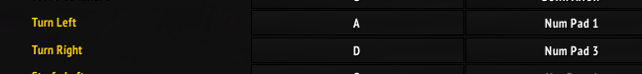



**AVQ Addon**

Check Newest option every time you start the game

Settings:

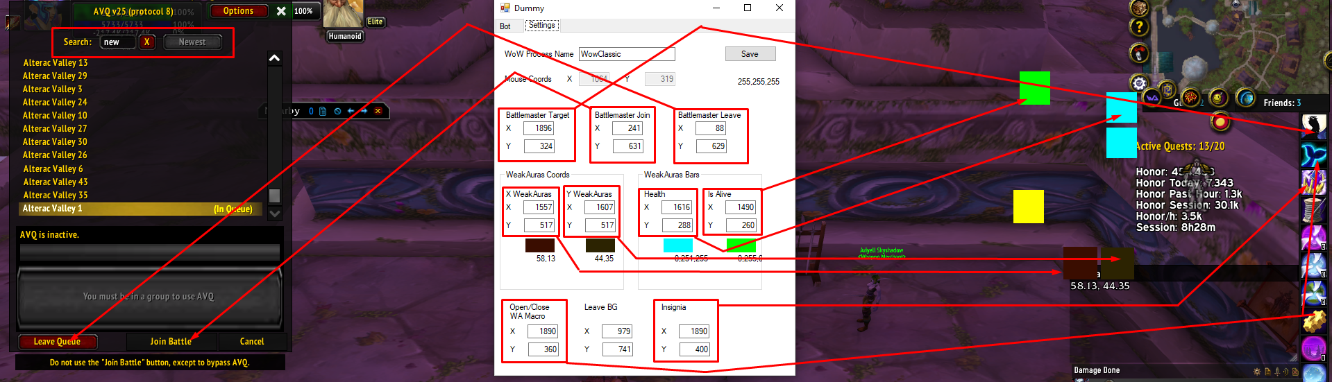

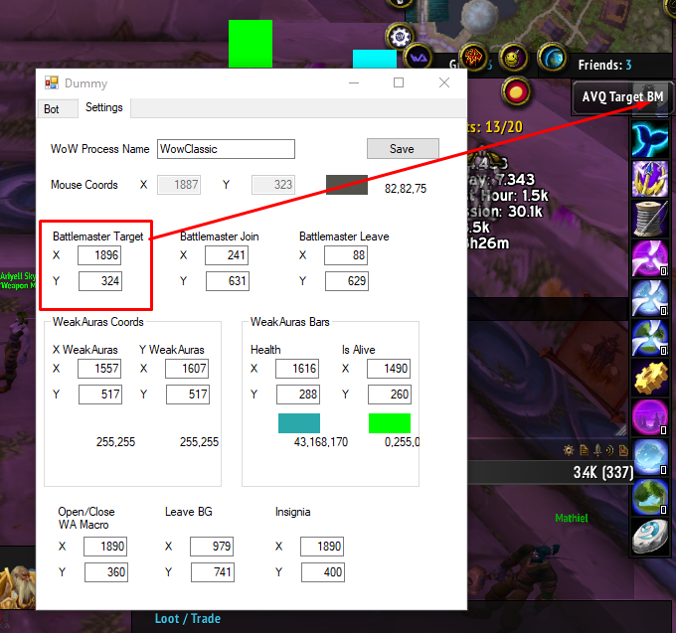

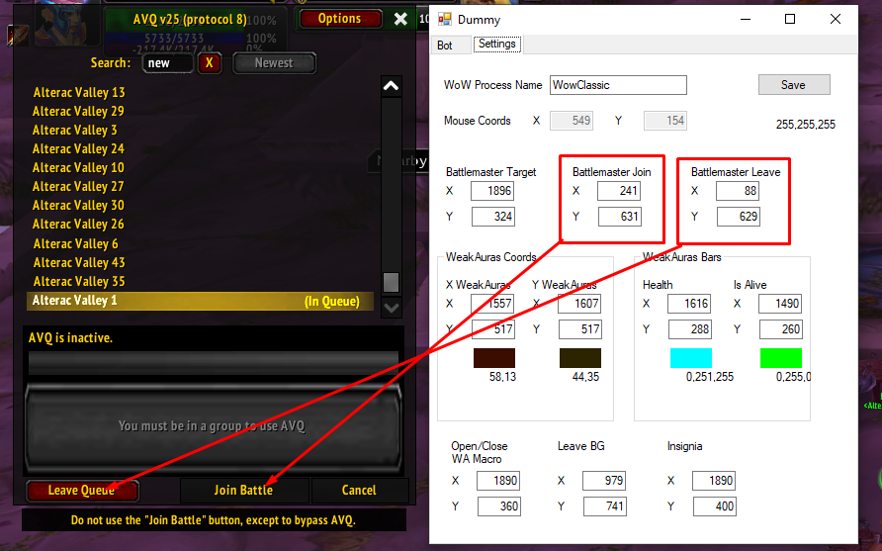

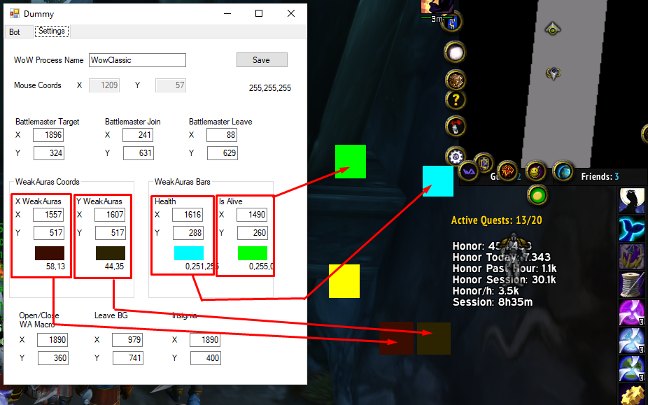

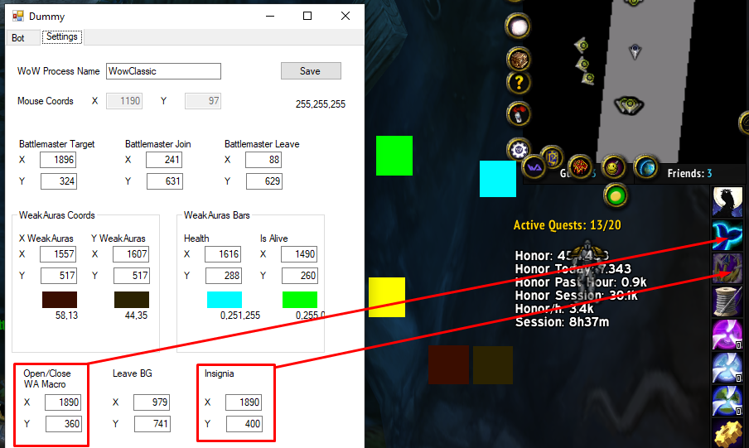

Note: Leave BG is the leave BG button

