
本科实验报告说明书

学 院：数学与大数据学院
课程名称： Web编程技术
学 期： 2026-2027-1
专业班级： 信计24-1
学生学号： 2024306169
学生姓名： 吕家谦
指导教师： 卢可

实验名称 | Web编程技术（6/8）：SpringBootWeb案例2-员工 | 实验时间 | 2026/10/19
实验内容 | 完成删除员工、新增员工、修改员工。选做员工分页查询，若完成请联系班长记录加分。
实验步骤或代码 | package com.demo.controller;  import org.springframework.web.bind.annotation.DeleteMapping;  import org.springframework.web.bind.annotation.GetMapping;  import org.springframework.web.bind.annotation.PostMapping;  import org.springframework.web.bind.annotation.PutMapping;  import org.springframework.web.bind.annotation.RequestBody;  import org.springframework.web.bind.annotation.RequestMapping;  import org.springframework.web.bind.annotation.RequestParam;  import org.springframework.web.bind.annotation.RestController;  import com.demo.api.ApiResponse;  import com.demo.dto.PageEmp;  import com.demo.dto.PageResult;  import com.demo.entity.Emp;  import com.demo.service.EmpService;  import lombok.RequiredArgsConstructor;  @RestController  @RequestMapping("/emps")  @RequiredArgsConstructor  public class EmpController {  private final EmpService empService;  @GetMapping  public ApiResponse<PageResult<Emp>> page(  PageEmp pageEmp) {  return ApiResponse.success(  empService.list(pageEmp));  }  @PostMapping  public ApiResponse<Void> save(@RequestBody Emp emp) {  empService.save(emp);  return ApiResponse.success();  }  @PutMapping  public ApiResponse<Void> update(@RequestBody Emp emp) {  empService.update(emp);  return ApiResponse.success();  }  @DeleteMapping  public ApiResponse<Void> delete(@RequestParam Integer id) {  empService.deleteById(id);  return ApiResponse.success();  }  }  package com.demo.service;  import java.time.LocalDateTime;  import java.util.List;  import org.springframework.beans.BeanUtils;  import org.springframework.stereotype.Service;  import com.demo.dto.PageEmp;  import com.demo.dto.PageResult;  import com.demo.entity.Emp;  import com.demo.mapper.EmpMapper;  import com.github.pagehelper.PageHelper;  import com.github.pagehelper.PageInfo;  import lombok.RequiredArgsConstructor;  @Service  @RequiredArgsConstructor  public class EmpService {  private final EmpMapper empMapper;  public void save(Emp emp) {  emp.setCreateTime(LocalDateTime.now());  emp.setUpdateTime(LocalDateTime.now());  empMapper.insert(emp);  }  public void update(Emp emp) {  Emp newEmp = new Emp();  BeanUtils.copyProperties(emp, newEmp);  newEmp.setUpdateTime(LocalDateTime.now());  empMapper.update(newEmp);  }  public void deleteById(Integer id) {  empMapper.deleteById(id);  }  public PageResult<Emp> list(  PageEmp pageEmp) {  PageHelper.startPage(pageEmp.getPageNum(), pageEmp.getPageSize());  List<Emp> empList = empMapper.list(  pageEmp.getName(),  pageEmp.getGender(),  pageEmp.getBegin(),  pageEmp.getEnd());  PageInfo<Emp> info = new PageInfo<>(empList);  long total = info.getTotal();  List<Emp> rows = info.getList();  return new PageResult<>(total, rows);  }  }  <?xml version="1.0" encoding="UTF-8"?>  <!DOCTYPE mapper  PUBLIC "-//mybatis.org//DTD Mapper 3.0//EN"  "http://mybatis.org/dtd/mybatis-3-mapper.dtd">  <mapper namespace="com.demo.mapper.EmpMapper">  <insert id="insert" useGeneratedKeys="true" keyProperty="id" parameterType="com.demo.entity.Emp">  INSERT INTO tb_emp (username, password, name, gender, image, job, entrydate, dept_id, create_time, update_time)  VALUES (#{username}, #{password}, #{name}, #{gender}, #{image}, #{job}, #{entrydate}, #{deptId}, #{createTime}, #{updateTime})  </insert>  <update id="update">  update tb_emp  <set>  <if test="username != null and username != ''">  username = #{username},  </if>  <if test="password != null and password != ''">  password = #{password},  </if>  <if test="name != null and name != ''">  name = #{name},  </if>  <if test="gender != null">  gender = #{gender},  </if>  <if test="image != null and image != ''">  image = #{image},  </if>  <if test="job != null">  job = #{job},  </if>  <if test="entrydate != null">  entrydate = #{entrydate},  </if>  <if test="deptId != null">  dept_id = #{deptId},  </if>  <if test="updateTime != null">  update_time = #{updateTime},  </if>  </set>  where id = #{id}  </update>  <select id="list" resultType="com.demo.entity.Emp">  SELECT * FROM tb_emp  <where>  <if test="name != null and name != ''">  name like concat('%', #{name}, '%')  </if>  <if test="gender != null">  and gender = #{gender}  </if>  <if test="begin != null">  and entrydate &gt;= #{begin}  </if>  <if test="end != null">  and entrydate &lt;= #{end}  </if>  </where>  ORDER BY update_time DESC  </select>  </mapper>
运行结果及分析 | 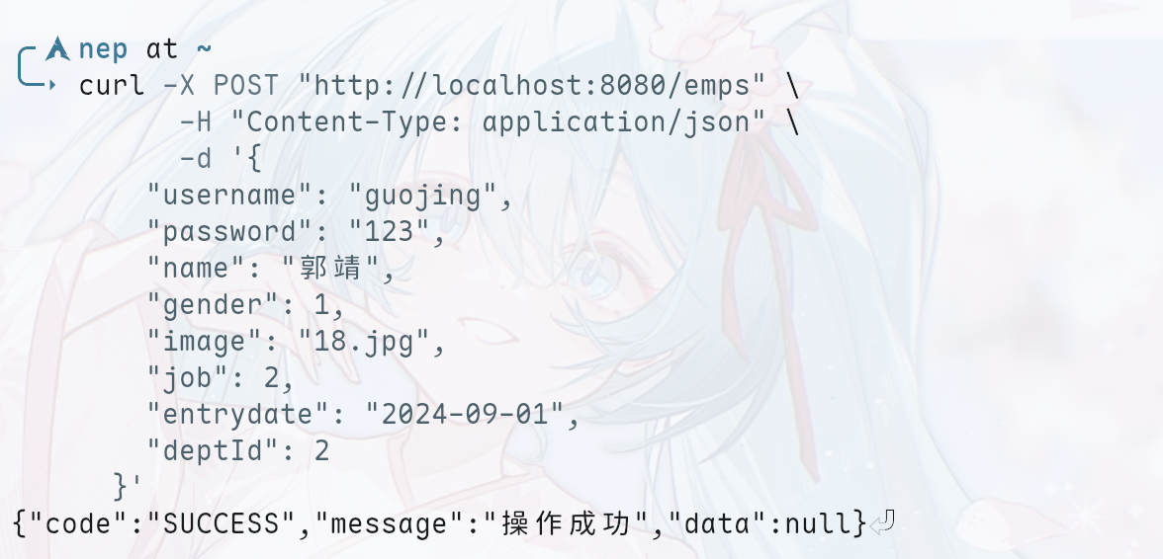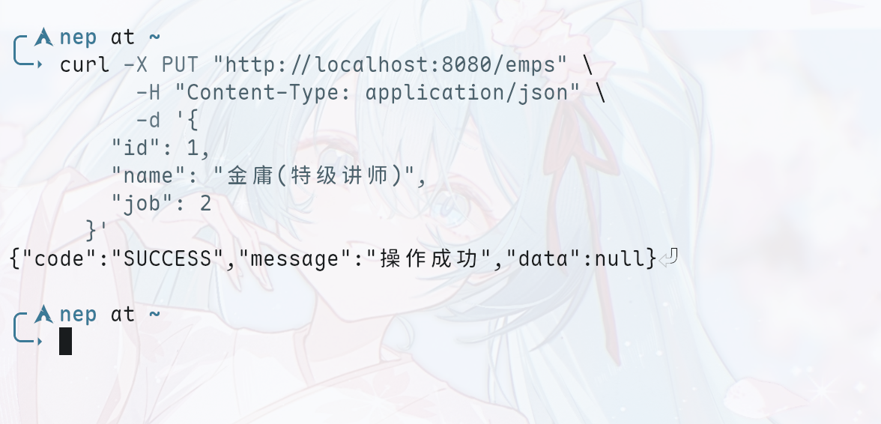  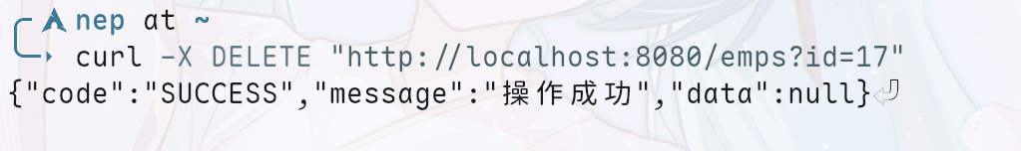  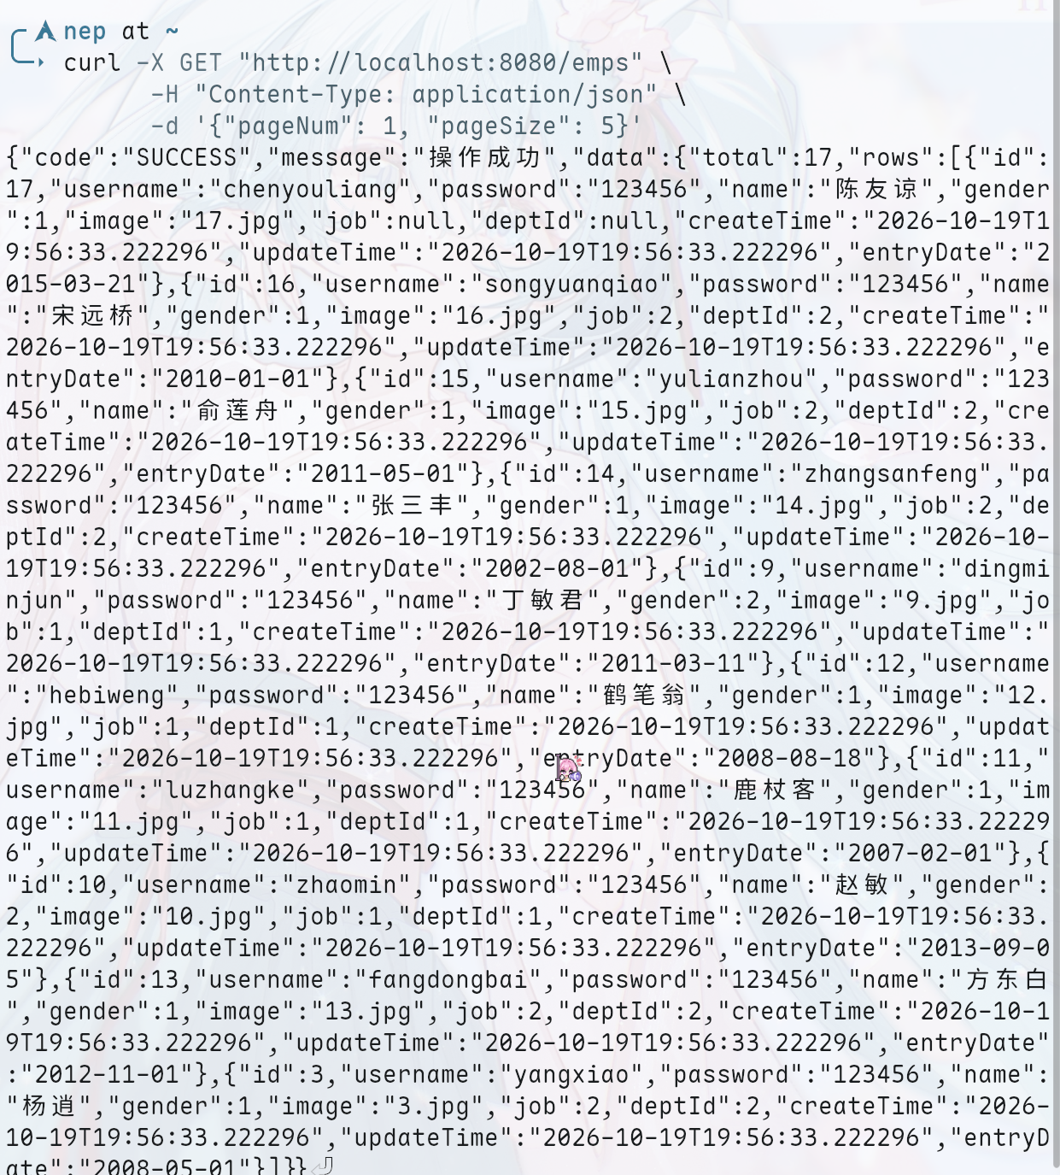
实验总结 | 本次实验围绕Web后端的核心数据管理展开，完成了基于分层架构的完整CRUD功能设计与开发。实验遵循RESTful规范，实现了员工信息的增、删、改、查等接口，借助前后端数据交互完成入参接收与统一结果响应；持久层结合SQL映射技术实现了数据的精准增删改与多条件动态筛选，并引入物理分页机制提升了列表数据的查询效率。通过本次实践，进一步加深了对Controller、Service与Mapper三层架构协同运行的理解，熟练掌握了数据库持久化与业务数据流转的完整处理流程，提升了后端综合开发能力。
教师评语

