
本科实验报告说明书

学 院：数学与大数据学院
课程名称： Web编程技术
学 期： 2026-2027-1
专业班级： 信计24-1
学生学号： 2024306169
学生姓名： 吕家谦
指导教师： 卢可

实验名称 | Web编程技术实验（2/8） | 实验时间 | 2026/9/14
实验内容 | 请完成HTML+CSS+JS综合案例，内容不限。
实验步骤或代码 | <!DOCTYPE html>  <html lang="zh-CN">  <head>  <meta charset="UTF-8">  <meta name="viewport" content="width=device-width, initial-scale=1.0">  <title>Galgame - 涅普姬雅</title>  <!-- 优先本地离线库，失败时自动回退至 CDN -->  <script src="lib/live2d.min.js" onerror="this.src='https://cdn.jsdelivr.net/gh/dylanNew/live2d/webgl/Live2D/lib/live2d.min.js'"></script>  <script src="lib/pixi.min.js" onerror="this.src='https://cdn.jsdelivr.net/npm/pixi.js@6.5.8/dist/browser/pixi.min.js'"></script>  <script src="lib/cubism2.min.js" onerror="this.src='https://cdn.jsdelivr.net/npm/pixi-live2d-display@0.4.0/dist/cubism2.min.js'"></script>  <!-- 本地模型数据包 -->  <script src="live2d/Nepgear/model_data.js"></script>  <style>  * {  margin: 0;  padding: 0;  box-sizing: border-box;  user-select: none;  }  body, html {  width: 100%;  height: 100%;  overflow: hidden;  background: radial-gradient(circle at 50% 35%, #2a144e 0%, #150d2a 60%, #080512 100%);  transition: background 0.6s ease;  font-family: -apple-system, BlinkMacSystemFont, "Segoe UI", "PingFang SC", "Microsoft YaHei", sans-serif;  color: #fff;  cursor: pointer;  }  /* ---------------- 顶部背景效果轻量 UI 控制栏 ---------------- */  #bg-ui-bar {  position: absolute;  top: 18px;  left: 24px;  right: 24px;  display: flex;  justify-content: space-between;  align-items: center;  z-index: 20;  pointer-events: auto;  }  /* 场景地标标签 */  .scene-stamp {  display: flex;  align-items: center;  gap: 8px;  background: rgba(18, 14, 38, 0.65);  border: 1px solid rgba(168, 85, 247, 0.35);  padding: 5px 14px;  border-radius: 20px;  font-size: 0.82rem;  color: #d8b4fe;  backdrop-filter: blur(8px);  letter-spacing: 0.5px;  }  .stamp-dot {  width: 7px;  height: 7px;  border-radius: 50%;  background: #a855f7;  box-shadow: 0 0 8px #a855f7;  }  /* 背景氛围与动效切换组 */  .bg-controls {  display: flex;  align-items: center;  gap: 8px;  background: rgba(18, 14, 38, 0.65);  border: 1px solid rgba(168, 85, 247, 0.35);  padding: 4px 10px;  border-radius: 22px;  backdrop-filter: blur(8px);  }  .bg-label {  font-size: 0.78rem;  color: #94a3b8;  margin-right: 2px;  margin-left: 4px;  }  .theme-btn {  background: rgba(255, 255, 255, 0.08);  border: 1px solid rgba(255, 255, 255, 0.15);  color: #cbd5e1;  padding: 4px 10px;  border-radius: 14px;  font-size: 0.78rem;  cursor: pointer;  transition: all 0.2s ease;  }  .theme-btn:hover {  background: rgba(168, 85, 247, 0.3);  border-color: #c084fc;  color: #fff;  }  .theme-btn.active {  background: #a855f7;  border-color: #e9d5ff;  color: #ffffff;  box-shadow: 0 0 10px rgba(168, 85, 247, 0.6);  }  /* ---------------- 背景微粒层 ---------------- */  #particles-canvas {  position: absolute;  top: 0;  left: 0;  width: 100%;  height: 100%;  z-index: 0;  pointer-events: none;  transition: opacity 0.4s ease;  }  /* ---------------- Live2D 立绘画布 ---------------- */  #live2d-canvas {  position: absolute;  top: 0;  left: 0;  width: 100%;  height: 100%;  z-index: 2;  }  /* ---------------- 纯净 Galgame 对话框 ---------------- */  #dialogue-box {  position: absolute;  bottom: 28px;  left: 50%;  transform: translateX(-50%);  width: calc(100% - 60px);  max-width: 880px;  min-height: 135px;  background: rgba(16, 11, 34, 0.85);  border: 1.5px solid rgba(168, 85, 247, 0.55);  border-radius: 16px;  box-shadow: 0 10px 40px rgba(0, 0, 0, 0.7), inset 0 1px 0 rgba(255, 255, 255, 0.1);  backdrop-filter: blur(14px);  -webkit-backdrop-filter: blur(14px);  padding: 24px 32px 18px;  z-index: 10;  display: flex;  flex-direction: column;  justify-content: space-between;  transition: border-color 0.25s;  }  #dialogue-box:hover {  border-color: rgba(192, 132, 252, 0.85);  }  /* 角色姓名牌 */  #speaker-name {  position: absolute;  top: -16px;  left: 28px;  background: linear-gradient(135deg, #a855f7, #6366f1);  color: #ffffff;  font-weight: bold;  font-size: 1.05rem;  padding: 5px 20px;  border-radius: 8px;  border: 1px solid rgba(255, 255, 255, 0.35);  box-shadow: 0 4px 14px rgba(168, 85, 247, 0.45);  }  /* 对话正文与打字机光标 */  #dialogue-text {  font-size: 1.25rem;  line-height: 1.75;  color: #f8fafc;  margin-top: 6px;  text-shadow: 0 2px 5px rgba(0, 0, 0, 0.85);  min-height: 2.2em;  }  .typing-cursor {  display: inline-block;  width: 2.5px;  height: 1.15em;  background: #38bdf8;  margin-left: 4px;  vertical-align: text-bottom;  animation: blink 0.7s infinite;  }  @keyframes blink {  0%, 50% { opacity: 1; }  51%, 100% { opacity: 0; }  }  /* 推进提示指示器 */  .indicator {  align-self: flex-end;  font-size: 0.85rem;  color: #c084fc;  animation: pulse 1.2s infinite ease-in-out;  opacity: 0.85;  }  @keyframes pulse {  0%, 100% { opacity: 0.35; transform: translateY(0); }  50% { opacity: 1; transform: translateY(-2px); }  }  </style>  </head>  <body>  <!-- 顶部背景氛围与效果轻量控制栏 -->  <div id="bg-ui-bar">  <!-- 场景地标标签 -->  <div class="scene-stamp">  <span class="stamp-dot"></span>  <span id="stamp-text">Planeptune · 姬雅的实验室</span>  </div>  <!-- 背景效果调节按钮组（不繁复，仅3个氛围色调+1个粒子开关） -->  <div class="bg-controls">  <span class="bg-label">背景效果:</span>  <button class="theme-btn active" data-theme="night">🌙 幽夜</button>  <button class="theme-btn" data-theme="sunset">🌆 霞光</button>  <button class="theme-btn" data-theme="sakura">🌸 樱粉</button>  <button id="btn-toggle-particles" class="theme-btn active" title="开启/关闭背景飘动粒子">✨ 粒子 [开]</button>  </div>  </div>  <!-- 动态背景光斑微粒层 -->  <canvas id="particles-canvas"></canvas>  <!-- Live2D 立绘画布 -->  <canvas id="live2d-canvas"></canvas>  <!-- 干净简练的 Galgame 对话框 -->  <div id="dialogue-box">  <div id="speaker-name">涅普姬雅</div>  <div id="dialogue-text"></div>  <div class="indicator">▼ 点击推进</div>  </div>  <script>  // 1. 背景效果配置与主题切换系统  const themes = {  night: {  bg: 'radial-gradient(circle at 50% 35%, #2a144e 0%, #150d2a 60%, #080512 100%)',  stamp: 'Planeptune · 姬雅的实验室 (夜间)',  colors: ['192, 132, 252', '56, 189, 248']  },  sunset: {  bg: 'radial-gradient(circle at 50% 35%, #561c36 0%, #2e0e22 60%, #11050d 100%)',  stamp: 'Planeptune · 姬雅的实验室 (傍晚)',  colors: ['251, 146, 60', '244, 114, 182']  },  sakura: {  bg: 'radial-gradient(circle at 50% 35%, #3e193e 0%, #220c26 60%, #0c0412 100%)',  stamp: 'Planeptune · 姬雅的花园阳台 (春樱)',  colors: ['244, 114, 182', '255, 255, 255']  }  };  let currentTheme = 'night';  let showParticles = true;  const stampText = document.getElementById('stamp-text');  const themeBtns = document.querySelectorAll('.theme-btn[data-theme]');  const btnToggleParticles = document.getElementById('btn-toggle-particles');  const particlesCanvas = document.getElementById('particles-canvas');  // 切换背景主题  themeBtns.forEach(btn => {  btn.addEventListener('click', (e) => {  e.stopPropagation(); // 避免触发对话推进  const themeKey = btn.dataset.theme;  if (!themes[themeKey]) return;  currentTheme = themeKey;  themeBtns.forEach(b => b.classList.remove('active'));  btn.classList.add('active');  // 渐变更新背景色彩与地标文字  document.body.style.background = themes[themeKey].bg;  stampText.textContent = themes[themeKey].stamp;  });  });  // 切换粒子动效  btnToggleParticles.addEventListener('click', (e) => {  e.stopPropagation();  showParticles = !showParticles;  if (showParticles) {  btnToggleParticles.classList.add('active');  btnToggleParticles.textContent = '✨ 粒子 [开]';  particlesCanvas.style.opacity = '1';  } else {  btnToggleParticles.classList.remove('active');  btnToggleParticles.textContent = '✨ 粒子 [关]';  particlesCanvas.style.opacity = '0';  }  });  // 2. 动态光斑粒子逻辑  (function initParticles() {  const ctx = particlesCanvas.getContext('2d');  let width, height;  const particles = [];  const count = 35;  function resize() {  width = particlesCanvas.width = window.innerWidth;  height = particlesCanvas.height = window.innerHeight;  }  window.addEventListener('resize', resize);  resize();  for (let i = 0; i < count; i++) {  particles.push({  x: Math.random() * width,  y: Math.random() * height,  r: Math.random() * 2.5 + 1.2,  vx: (Math.random() - 0.5) * 0.35,  vy: -(Math.random() * 0.5 + 0.25),  alpha: Math.random() * 0.5 + 0.2  });  }  function animate() {  if (showParticles) {  ctx.clearRect(0, 0, width, height);  const colorPool = themes[currentTheme].colors;  for (let i = 0; i < particles.length; i++) {  const p = particles[i];  p.x += p.vx;  p.y += p.vy;  if (p.y < -10) {  p.y = height + 10;  p.x = Math.random() * width;  }  const color = colorPool[i % colorPool.length];  ctx.beginPath();  ctx.arc(p.x, p.y, p.r, 0, Math.PI * 2);  ctx.fillStyle = `rgba(${color}, ${p.alpha})`;  ctx.shadowBlur = 8;  ctx.shadowColor = `rgba(${color}, 0.8)`;  ctx.fill();  }  }  requestAnimationFrame(animate);  }  animate();  })();  // 3. 剧情台词列表  const script = [  { name: "涅普姬雅", text: "你好！我是涅普姬雅（Nepgear）。", motion: "start" },  { name: "涅普姬雅", text: "你可以点击右上角的背景效果按钮，切换房间的光影氛围哦！", motion: "idle" },  { name: "涅普姬雅", text: "无论是【幽夜】、【霞光】还是【樱粉】，背景都会呈现不同的光斑与色调呢~", motion: "tap_D_REF.PT_HEAD" },  { name: "涅普姬雅", text: "只要鼠标单击屏幕或者对话框，就能继续推进下一句台词。", motion: "idle" },  { name: "涅普姬雅", text: "平时我最喜欢做机械研究和写程序了，很高兴能在这里陪着你！", motion: "tap_D_REF.PT_HEAD" },  { name: "涅普姬雅", text: "对话全部结束啦，再次点击就会重新从第一句开始循环循环哦~", motion: "start" }  ];  let currentIndex = 0;  let live2dModel = null;  let isTyping = false;  let typingTimer = null;  const nameEl = document.getElementById('speaker-name');  const textEl = document.getElementById('dialogue-text');  // 打字机更新台词  function showDialogue(index) {  clearTimeout(typingTimer);  const item = script[index];  nameEl.textContent = item.name;  const fullText = item.text;  let charIndex = 0;  isTyping = true;  textEl.innerHTML = '';  // 触发模型动作  if (live2dModel && item.motion) {  try { live2dModel.motion(item.motion); } catch (e) {}  }  function typeNext() {  if (charIndex < fullText.length) {  charIndex++;  textEl.innerHTML = fullText.slice(0, charIndex) + '<span class="typing-cursor"></span>';  typingTimer = setTimeout(typeNext, 25);  } else {  textEl.textContent = fullText;  isTyping = false;  }  }  typeNext();  }  // 推进台词  function nextDialogue() {  if (isTyping) {  clearTimeout(typingTimer);  textEl.textContent = script[currentIndex].text;  isTyping = false;  return;  }  currentIndex = (currentIndex + 1) % script.length;  showDialogue(currentIndex);  }  // 点击推进  document.addEventListener('click', nextDialogue);  // 键盘按键推进  window.addEventListener('keydown', (e) => {  if (e.code === 'Space' || e.code === 'Enter') {  nextDialogue();  }  });  // 初始显示第一句  showDialogue(0);  // 4. 初始化 Pixi.js 和 Live2D 模型  async function initLive2D() {  try {  const canvas = document.getElementById('live2d-canvas');  const app = new PIXI.Application({  view: canvas,  autoStart: true,  resizeTo: window,  backgroundAlpha: 0  });  // 优先使用本地内嵌数据渲染  if (window.NEPGEAR_MODEL_DATA) {  const settings = new PIXI.live2d.Cubism2ModelSettings(window.NEPGEAR_MODEL_DATA);  live2dModel = await PIXI.live2d.Live2DModel.from(settings);  } else {  live2dModel = await PIXI.live2d.Live2DModel.from('live2d/Nepgear/model.json');  }  app.stage.addChild(live2dModel);  // 自适应屏幕大小并居中展示立绘（保持放大与下移合适高度）  function resizeModel() {  if (!live2dModel) return;  const baseHeight = live2dModel.height / (live2dModel.scale.y || 1);  const scale = (window.innerHeight * 1.18) / baseHeight;  live2dModel.scale.set(scale);  live2dModel.x = (window.innerWidth - live2dModel.width) / 2;  live2dModel.y = window.innerHeight * 0.08;  }  resizeModel();  window.addEventListener('resize', resizeModel);  // 点击立绘触发摸头动作  live2dModel.on('hit', () => {  try { live2dModel.motion('tap_D_REF.PT_HEAD'); } catch (e) {}  });  } catch (err) {  console.error("Live2D 加载异常:", err);  }  }  initLive2D();  </script>  </body>  </html>
运行结果及分析 | 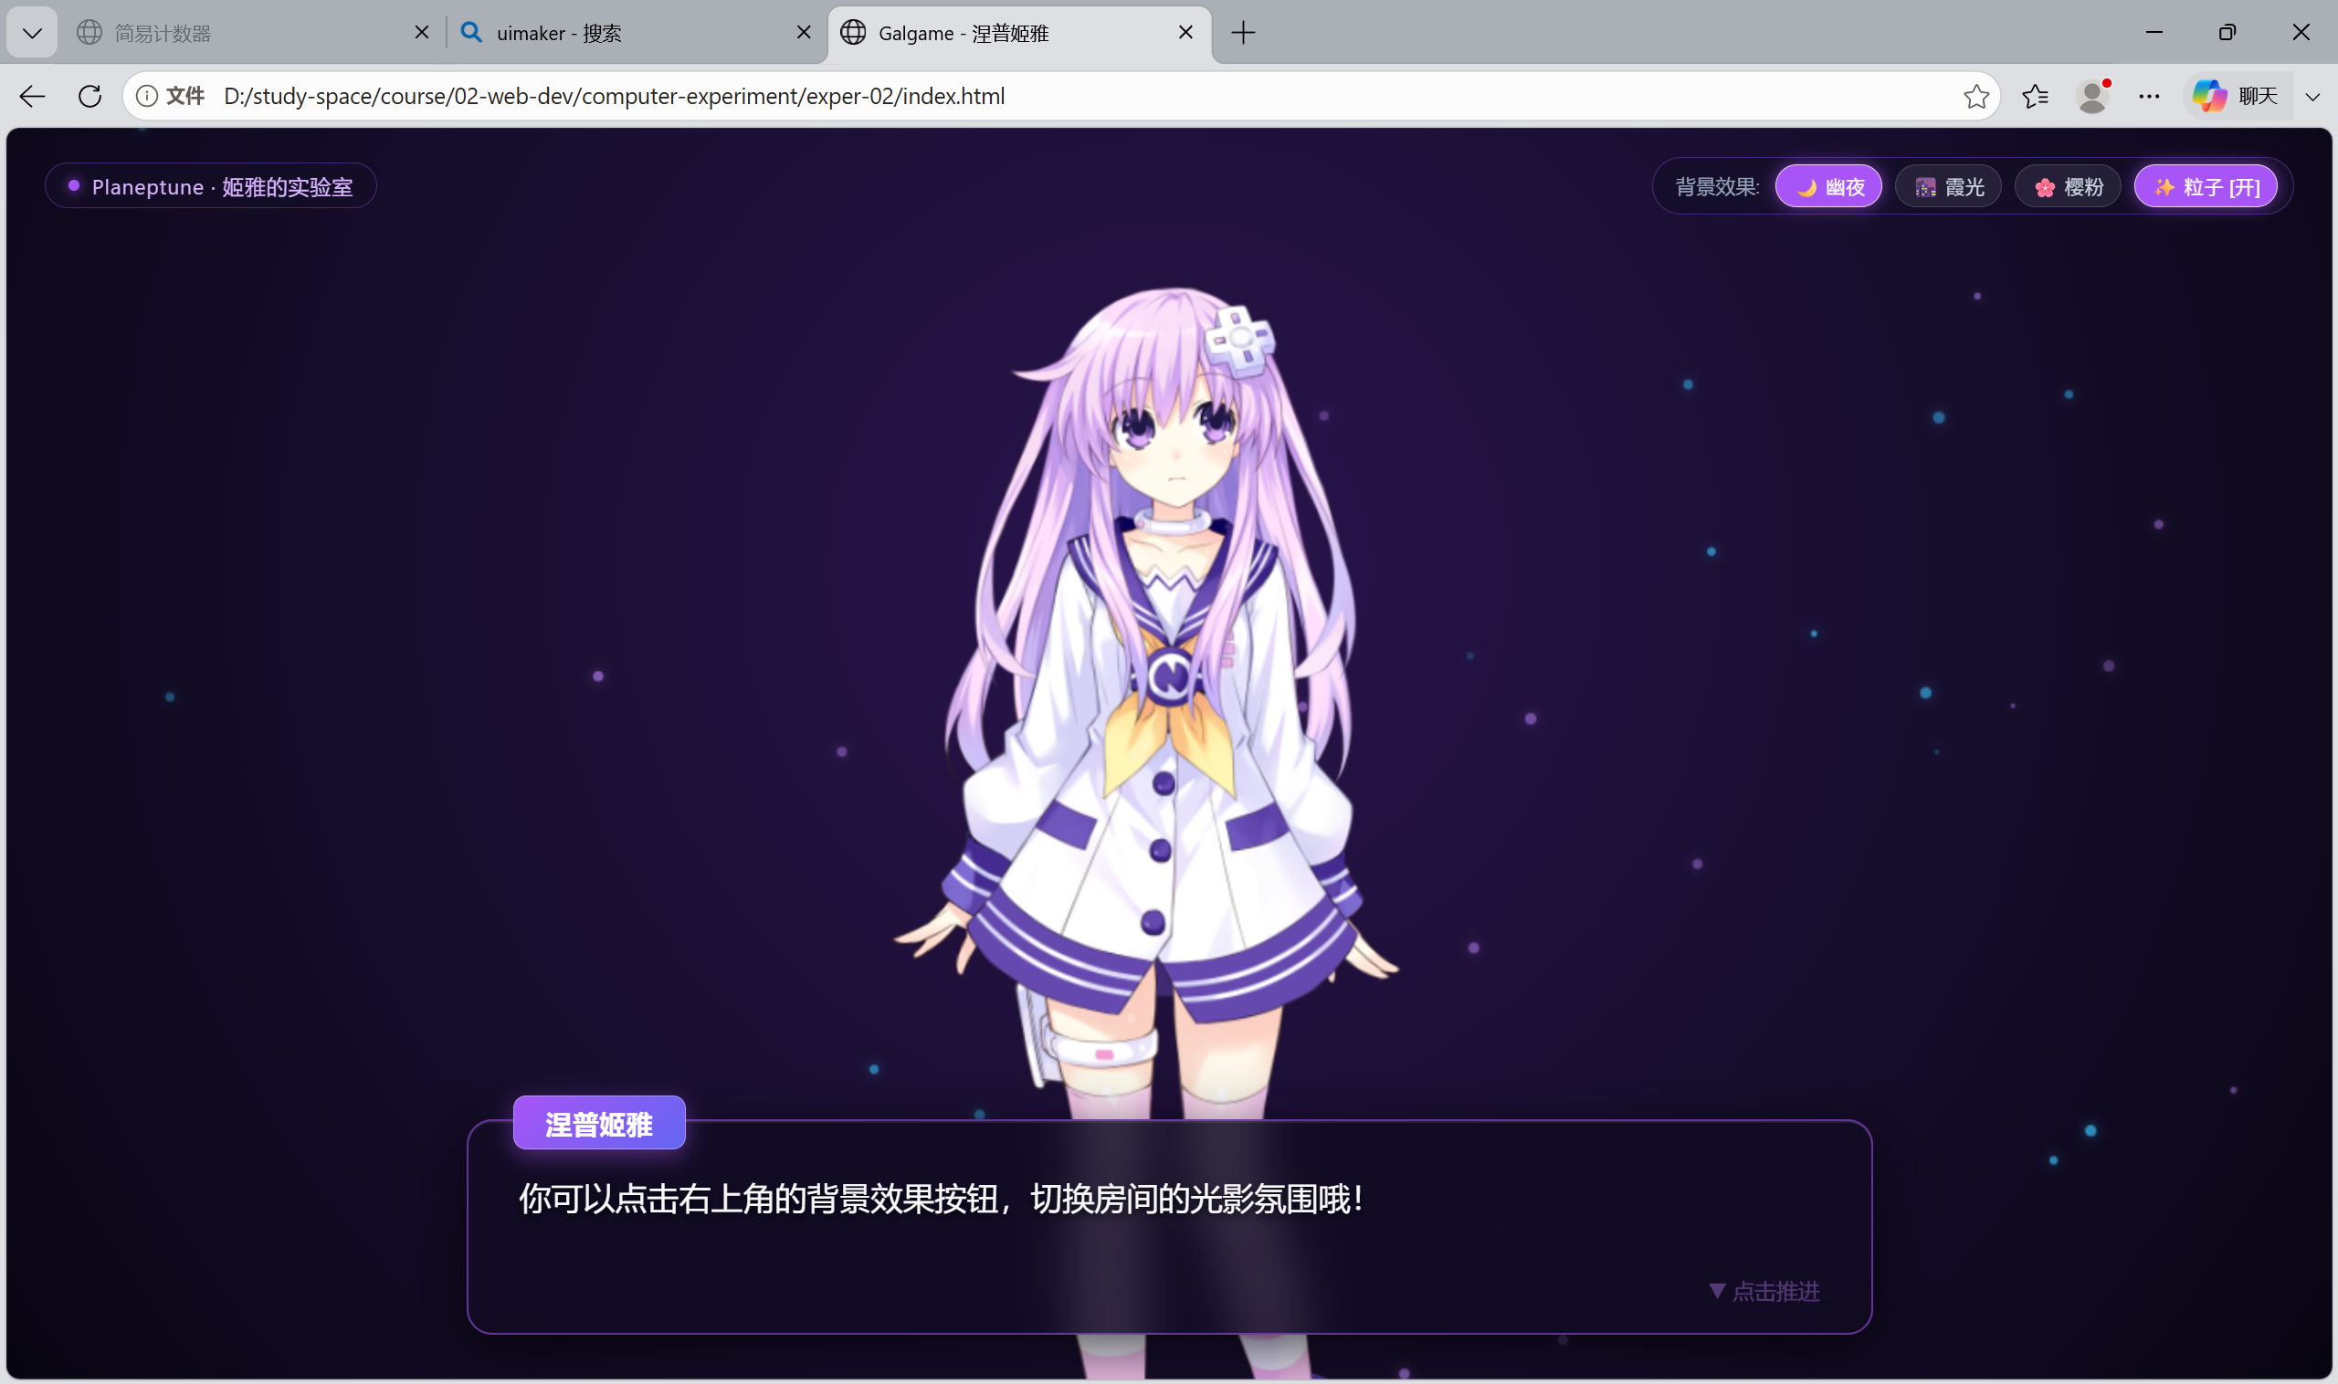  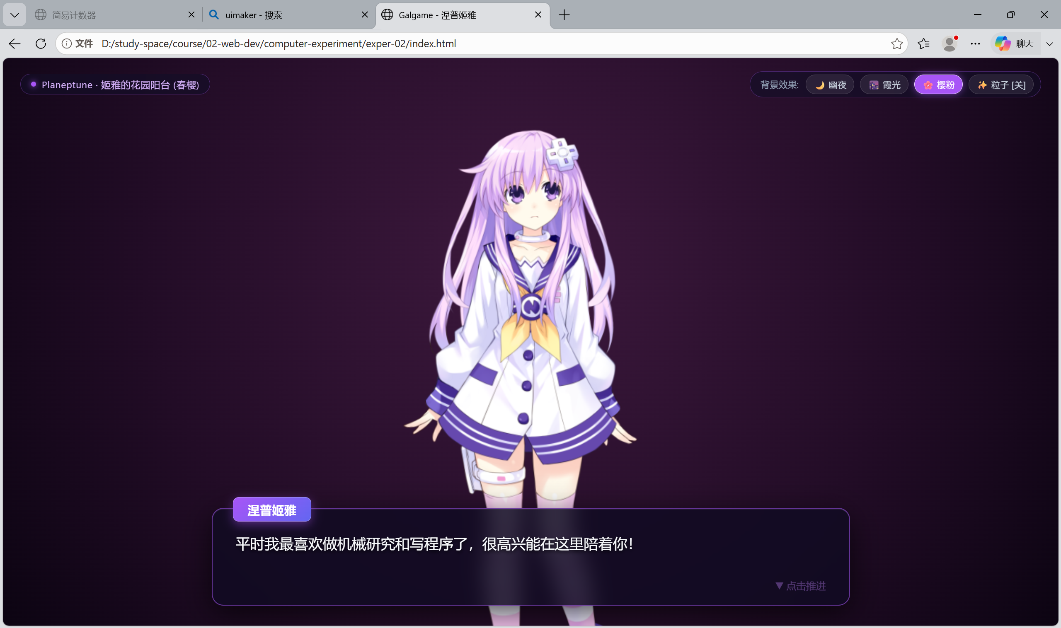
实验总结 | 本次实验顺利完成了HTML、CSS与JavaScript的综合案例开发。实验通过语义化标签搭建了清晰的页面结构，利用CSS完成了页面布局、色彩搭配与视觉样式的美化，并借助JavaScript实现了基础的DOM操作与动态用户交互。整个开发流程规范顺畅，有效巩固了前端三件套的基础理论知识，强化了页面结构、表现与行为的分离理念，全面提升了代码编写、综合实践以及排错调试的能力，达到了预期的实验目标。
教师评语

