Map to EMR Project Documentation
Understanding JoPACC’s public payment data ahead of the EMR requirements

Item | Details
Project | Map to EMR: preparatory data study
Team | Intern team: Emam, Karmah and Naser
Data scope | JoPACC public PDF reports covering the last 24 months (yearly, quarterly and monthly)
Audience | The data analysis team
Deliverables | Clean structured tables, a data dictionary, a category hierarchy, validated data, trend and growth analysis, and proposed new KPIs

1. Project Summary
The goal of the project was to understand JoPACC’s public data before starting on the EMR requirements.

Objectives
- Gather the PDF reports from the last 24 months and extract their content into Excel sheets.
- List the proper metrics and build a data dictionary.
- Transform the extracted data into a clean, easily understandable table.
- Explore chart trends and month-over-month (MoM) and year-over-year (YoY) growth to understand major movements.
- Tag and re-analyze the metrics so the insights can be presented to the data analysis team.

Project stages
The first three objectives formed the preparation stage. The remaining work formed the analysis stage, which ended with the team’s insights and KPI ideas.

2. Team and Responsibilities
The team downloaded the PDFs and split them by report type. Each member owned one type end to end.
Member | Report type | Responsibility
Emam | Yearly | Owned the yearly reports; also led the shared extraction standard
Karmah | Quarterly | Owned the quarterly reports; built the reference extraction
Naser | Monthly | Owned the monthly reports, the largest set (most PDFs and most detail)

Each member studied their report type thoroughly, to the point of being able to discuss it without the PDFs open. This gave the team a shared understanding of how the reports differ in structure and detail.

3. Timeline and Workflow
Step | Phase | What the team did
1 | Collect | Downloaded the PDFs and split them into yearly, quarterly and monthly reports.
2 | Extract | Extracted the PDFs into Excel using Claude AI. Many files needed OCR, so this took longer than expected.
3 | Standardize | Created one standard structure that suits all report types while allowing for a few differences. Built the data dictionary and mapped a hierarchy that groups related metrics and categories under each system.
4 | Transform | Split the data by system, since most systems share similar metrics but have key differences. A well-written prompt produced clear columns and rows suited to data analytics.
5 | Validate | Checked the data both manually and automatically to confirm the extracted figures match the original reports.
6 | Explore | Used the hierarchy to review trends and gaps, and discussed ideas for new KPIs.

How the team moved
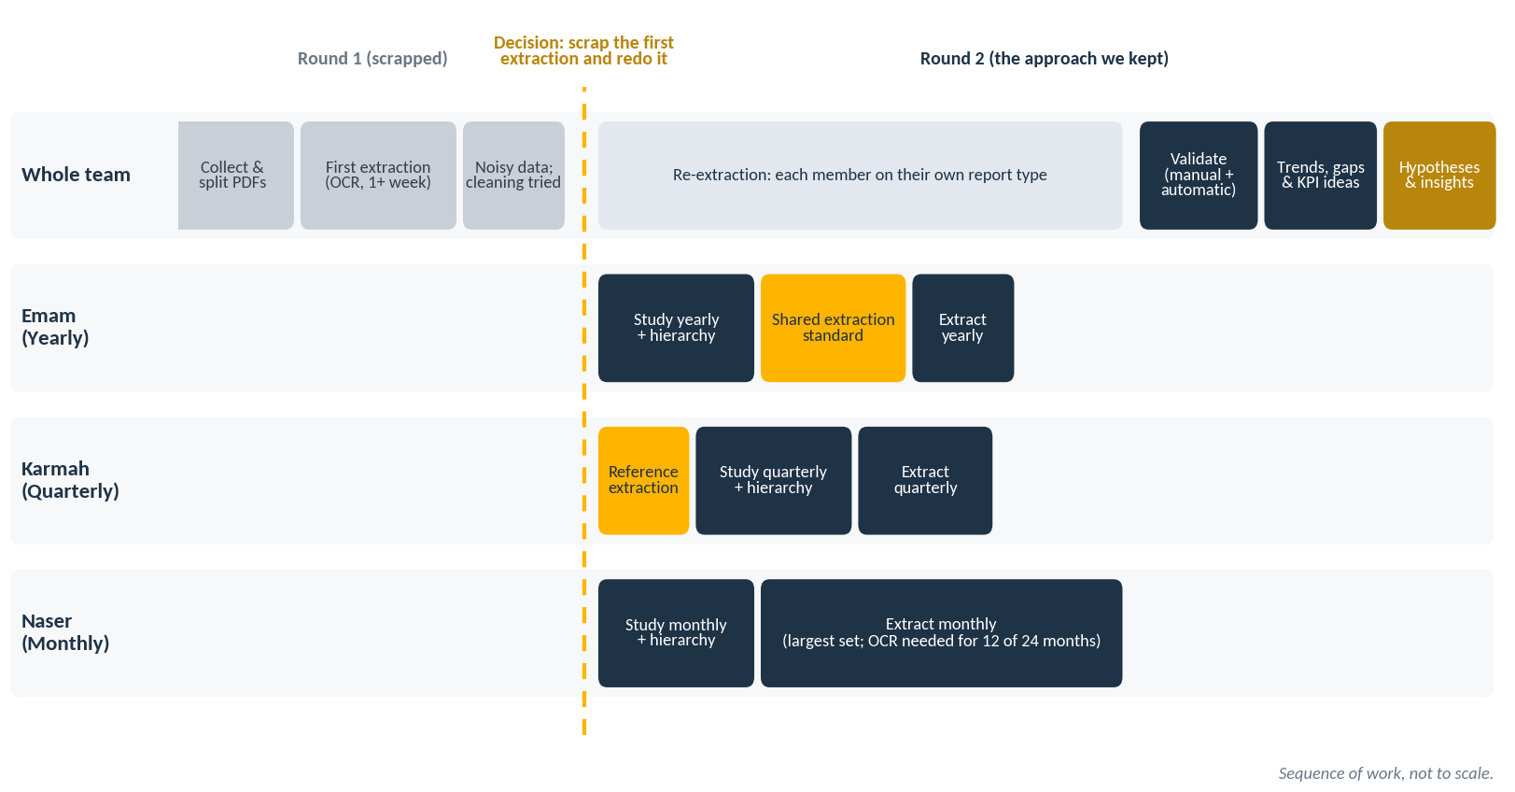
Figure 1. Team progress across both extraction rounds. Gold marks the reference extraction and the shared standard that guided the redo.
Ideas for new KPIs came up throughout the project and became clearer once the data was transformed. Every idea raised by a team member was communicated and discussed with the team.
Note on data quality. The source PDFs were already clean, so no cleaning was needed once extraction was done correctly. The noise seen in the first extraction came from the extraction process itself (OCR), not from the reports.
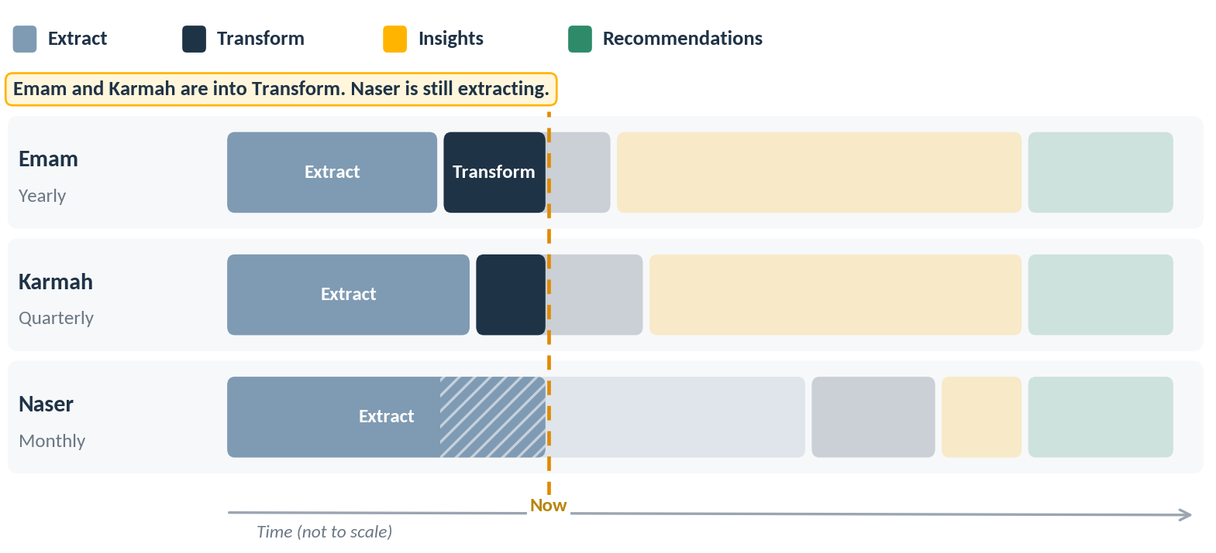
Progress tracker 1 of 4. Extraction. Emam and Karmah finish extraction and move into transformation, while Naser is still extracting because many of his files need OCR.

4. Challenges and Decisions
The team faced several challenges, each of which led to a meaningful discussion and a decision.
Challenge | What happened | Decision and result
1. First extraction failed | Each member downloaded one report type and the team extracted everything at once with Claude. Many PDFs needed OCR, so the first run took over a week. The resulting sheet was noisy and inconsistent, with some values completely unintelligible. | Cleaning was attempted by filtering by system and reference page and correcting values. It became clear that accurate cleaning would mean manually checking every number in every report type, system and page against its metric. The team scrapped the first extraction and redid the process. Karmah built a simple extraction as a reference for what the ETL output should look like.
2. Uneven extraction effort | Emam and Karmah finished quickly. Naser’s monthly set was the largest, and 12 of the 24 months were images that required OCR. Validation also took longer. | Resolved with time. No change of approach was needed. Naser caught up, and the whole team finished together.
3. False-positive insight | Karmah suspected a gender gap among IPS users. Further analysis showed the gap was reasonable and existed only on CliQ. | The team began asking what other insights would be valuable. This led to a proper category hierarchy, built for the IPS system and applicable to other systems, especially eFAWATEERcom.

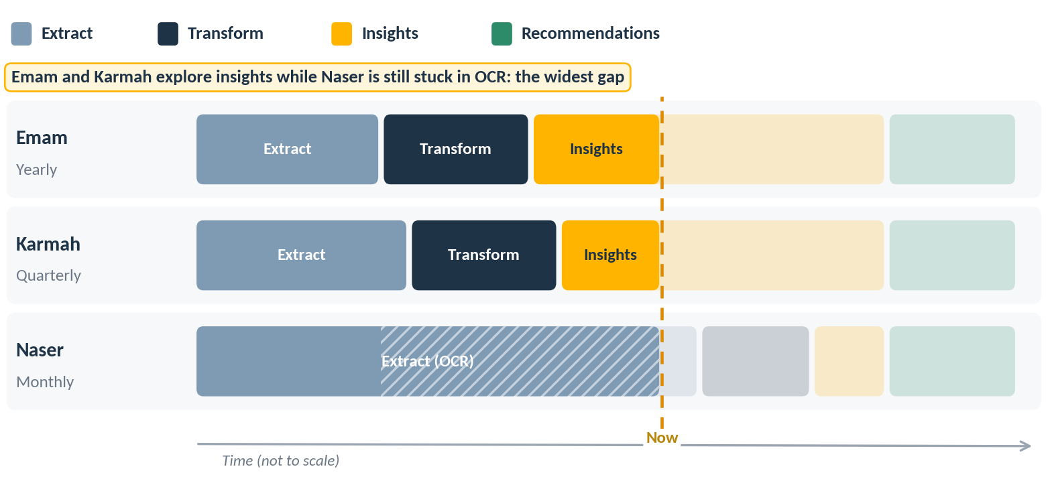
Progress tracker 2 of 4. Exploring insights. Emam and Karmah move on to trends and insights, while Naser is still stuck in OCR. This is the widest gap between team members.

Key decisions
- Redo the extraction rather than patch noisy data. This cost time but gave the team a reliable reference and a shared standard.
- Study first, then standardize. Each member wrote a hierarchy of categories and subcategories for their report type. Emam then built a shared extraction standard from those studies, finding the best middle ground, with changes by report type where needed.
- Split the data by system to keep key differences between systems visible.
- Validate both manually and automatically before moving on to analysis.

5. Outcome
Every team member analyzed the final sheets and looked for gaps. The reports do not contain enough user information to support useful insights on their own.
To work around this, the team formed hypotheses and tested them using only data already available in the reports. This proved the most useful method. It produced real insights and allowed the team to offer constructive criticism of the reports’ content and presentation.
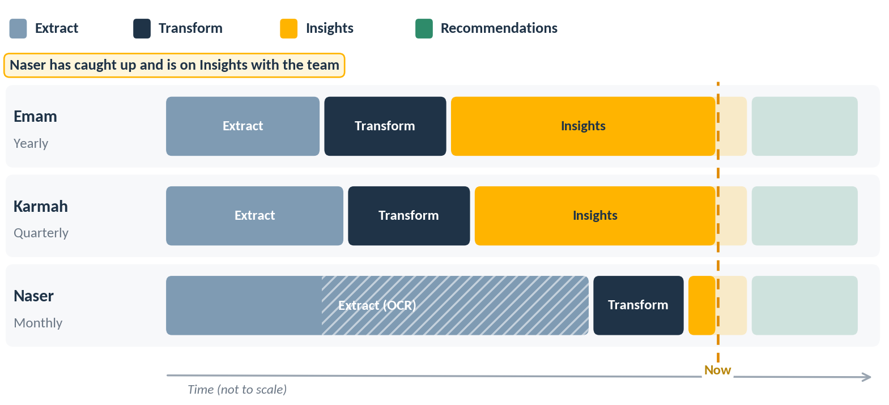
Progress tracker 3 of 4. Catching up. Naser finishes extraction and transformation and reaches insights, while Emam and Karmah work on recommendations.

What the team produced
- New charts built by combining information already in the reports, useful to researchers, investors and anyone who uses the data.
- Ideas for new KPIs that rely only on available, non-confidential data in the JoPACC data warehouse.
- A standard extraction structure, data dictionary and category hierarchy that can be reused across report types and systems.
- Validated, system-level tables ready for the data analysis team.
Details are covered in each team member’s individual report.

6. Insights and Top Recommendations
Each team member picked the insights they consider most valuable for the data analysis team.
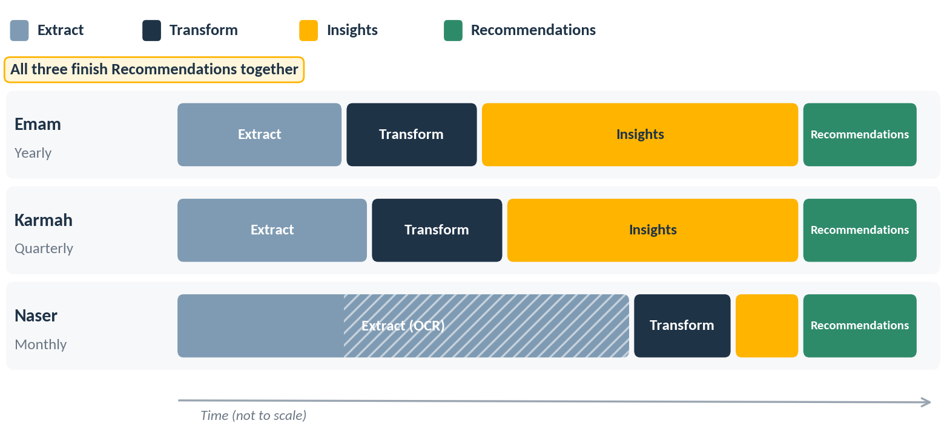
Progress tracker 4 of 4. Finishing together. The whole team reaches recommendations at the same time.

Emam: Yearly reports
Insight | What the visual shows | Why it matters
Insight 1  GDP comparison with three-year average value | JoPACC transaction value was 1.91× Jordan’s GDP in 2023, 1.92× in 2024 and 2.14× in 2025. Over the same three years, the average transaction value fell from JOD 546.5 to JOD 256.3 (-53%). | The whole data team agreed this combined view is clearer than how the same information appears in the reports. It shows the scale of payment activity and the shift to smaller payments in one place.
Insight 2  IPS user distribution | Infographic that splits IPS users into three groups: wallet only (45.5%), bank account only (27.0%), and both wallet and bank account (27.1%). | The whole data team agreed the infographic is much easier to understand than the reports’ current presentation. It also shows that about 7 in 10 users use a wallet in some form.

Recommendation: present these two views in place of the current presentation in the reports, because the data team found them clearer.

Insight 1: Payment activity in the Jordanian economic context
Metric | 2023 | 2024 | 2025
Jordan GDP (JOD billion) | 36.23 | 41.58 | 43.68
JoPACC transaction value (JOD billion) | 69.34 | 79.95 | 93.26
JoPACC value / GDP | 1.91× | 1.92× | 2.14×

How to read this. GDP is used here as a scale reference. It is not a measure of Jordan’s cash flow, the share of GDP processed through JoPACC, or JoPACC’s contribution to GDP. Transaction values can include multiple movements involving the same underlying funds.
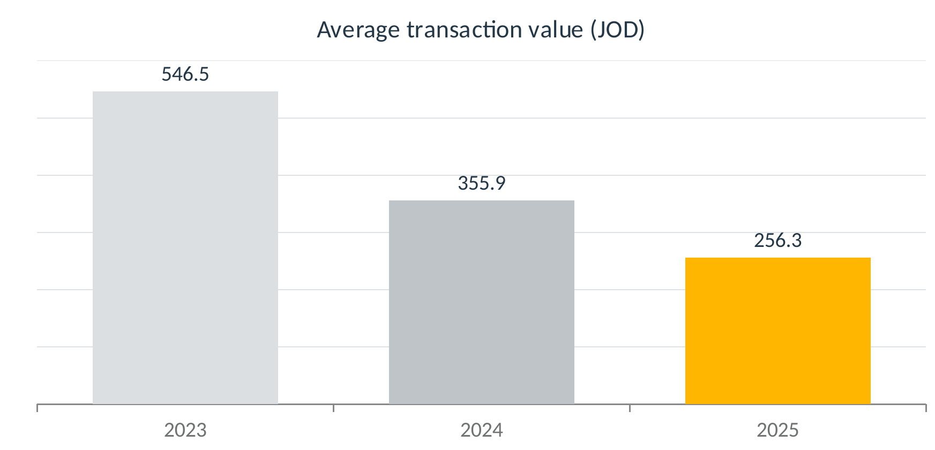
Figure 2. Average transaction value (JOD), 2023 to 2025. The 53% fall over two years is derived from the reported values.

Insight 2: IPS user distribution
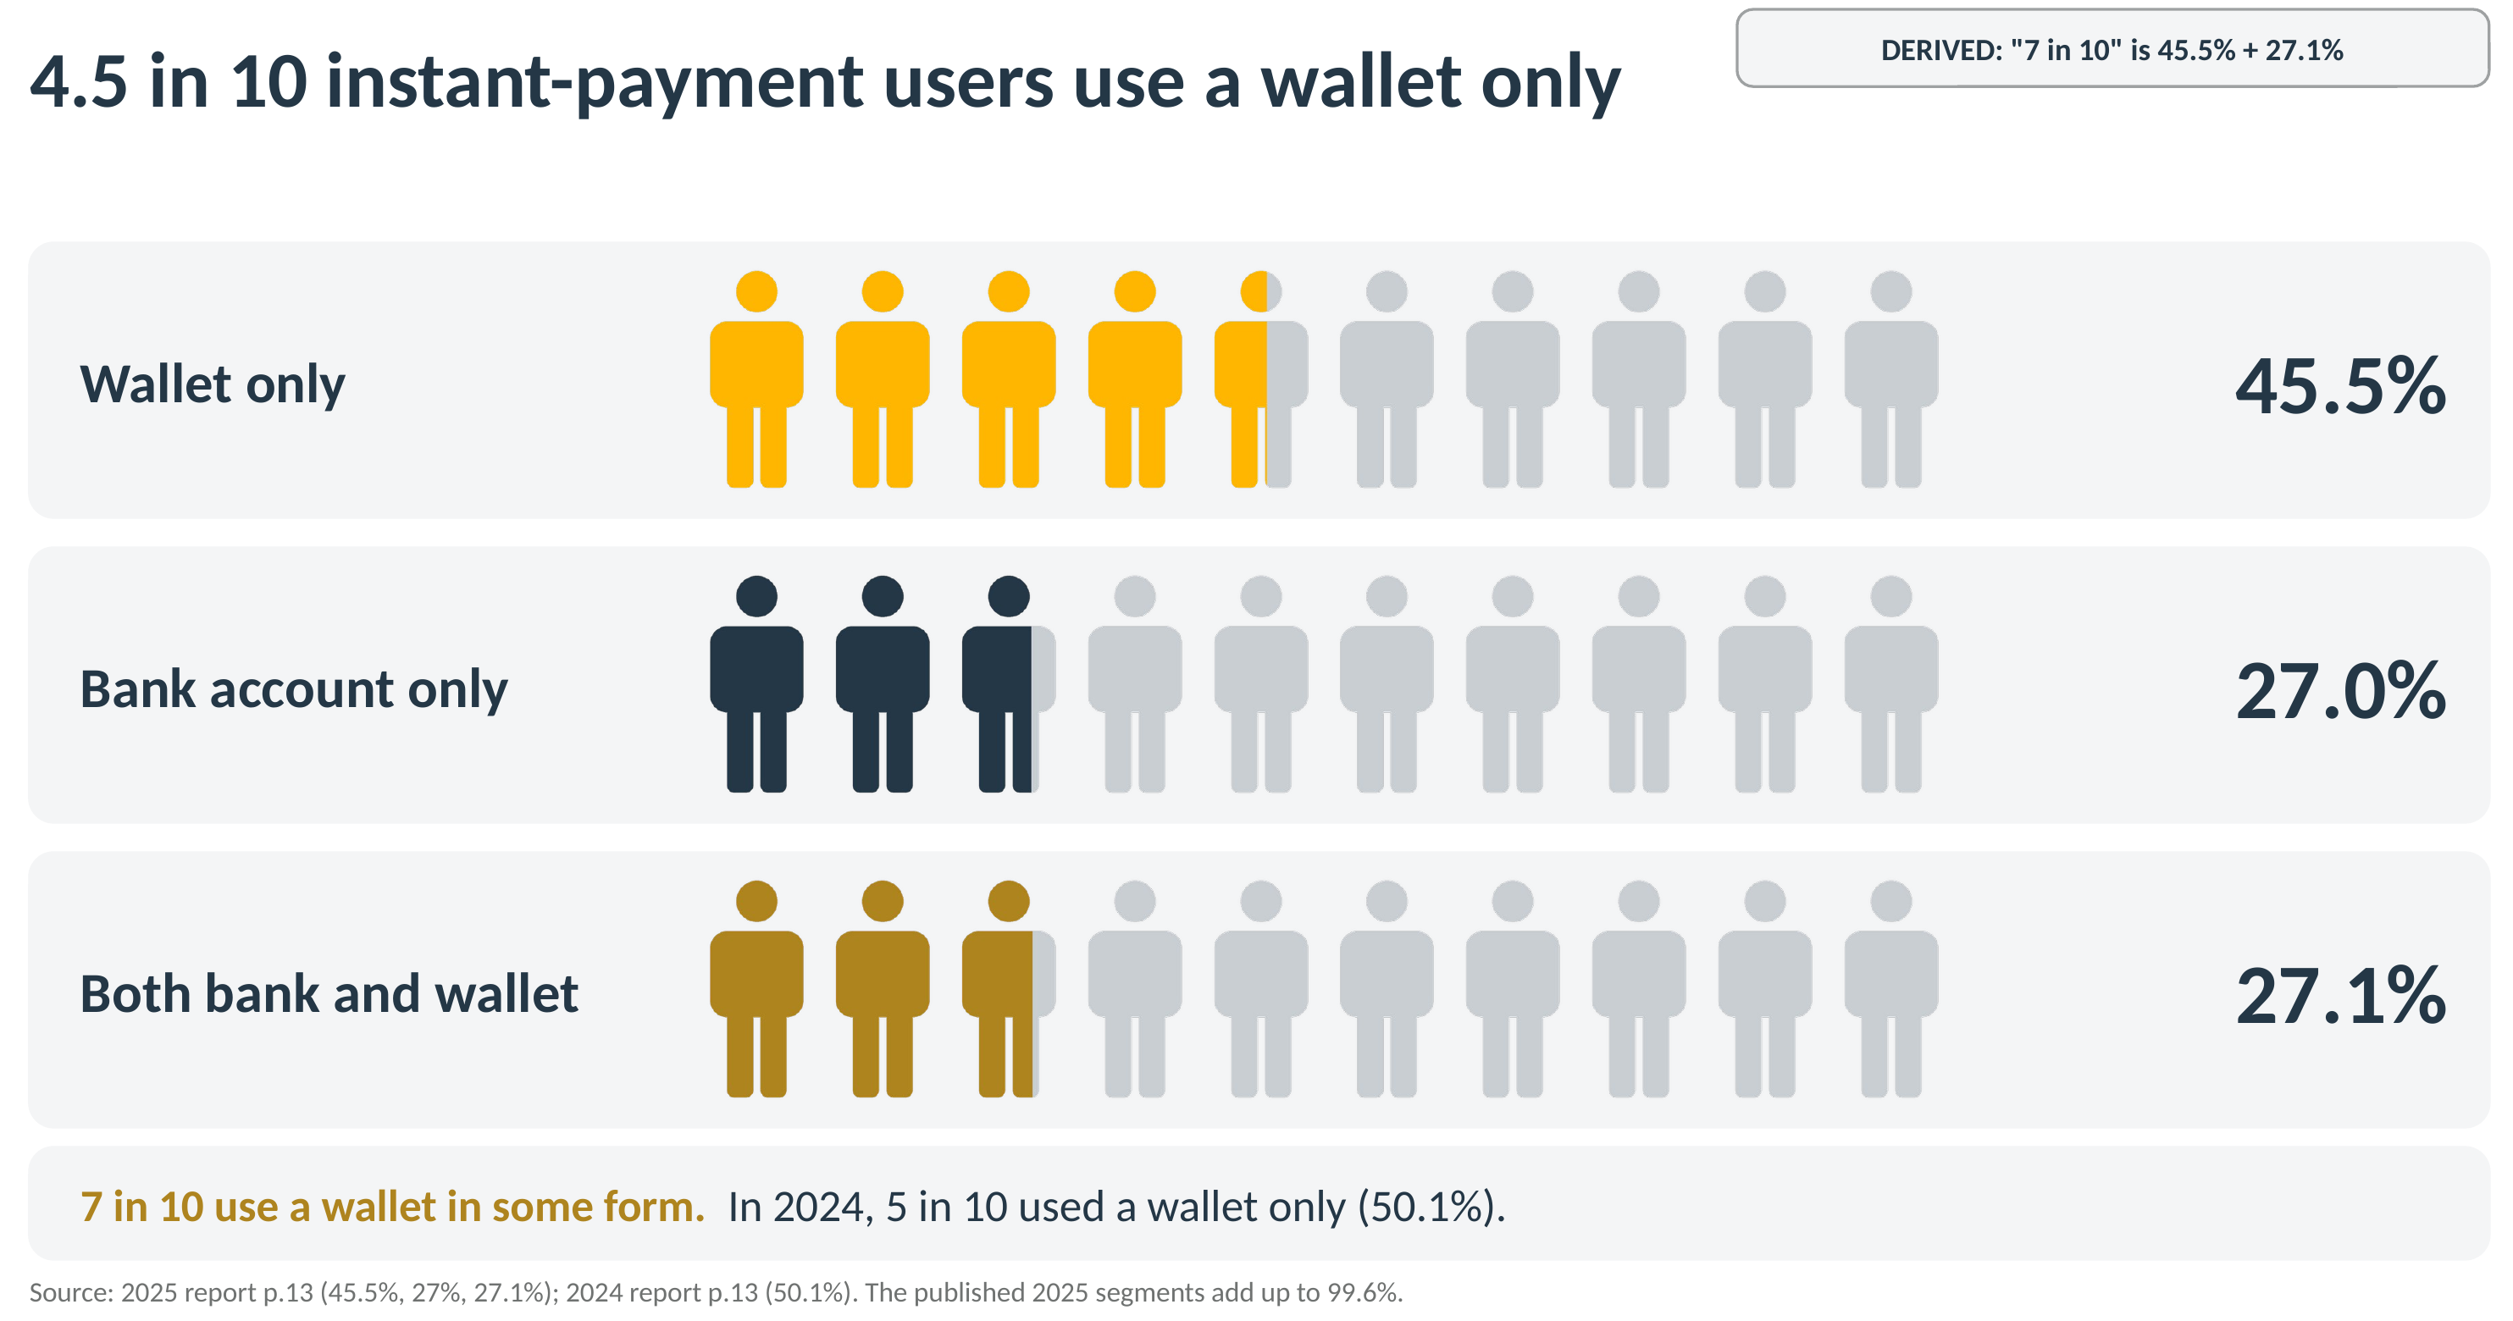
Figure 3. IPS users by account type. Source: 2025 report p.13 and 2024 report p.13. The published 2025 segments add up to 99.6%.

Karmah: Quarterly reports
Insight | What the visual shows | Why it matters
Insight 1 | To be added by Karmah | To be added
Insight 2 | To be added by Karmah | To be added

Recommendation: to be added by Karmah.

Naser: Monthly reports

Recommendation: restructure the monthly report to open with a one-page all-systems overview, report IPS as one consolidated section with CliQ, JoMoPay and interoperability as subsections, and show only the top 5 eFAWATEERcom categories in a chart with the rest in a table.
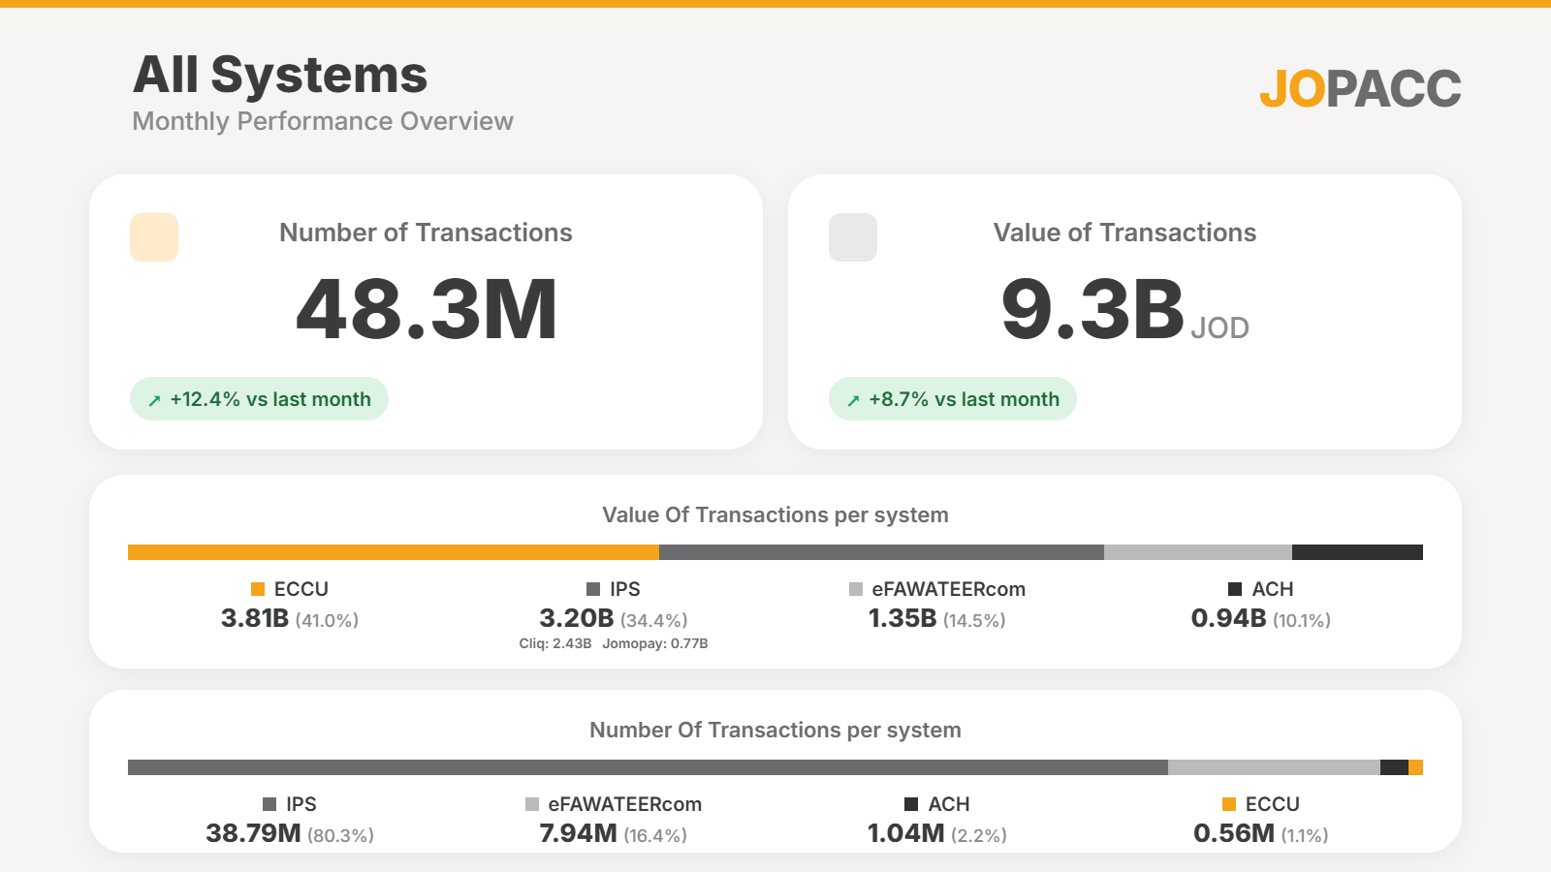
Figure 4. All-systems monthly overview: transaction count and value, with each system’s share.
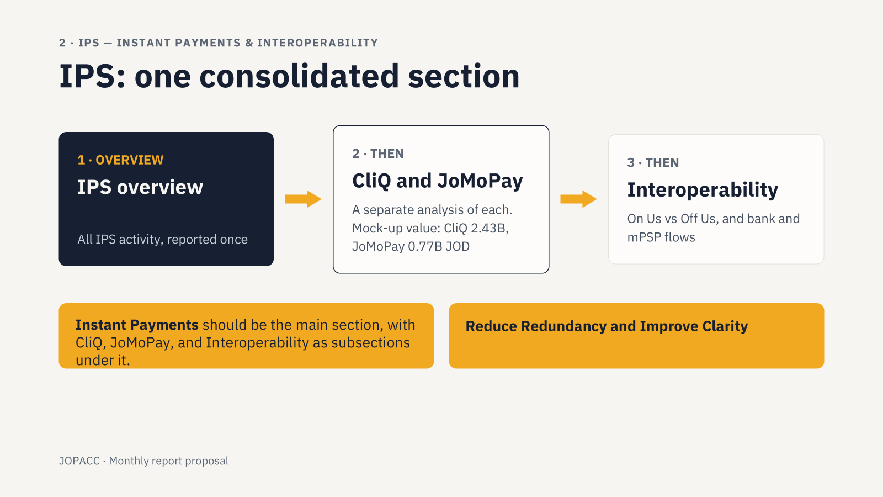
Figure 5. IPS as one consolidated section, with CliQ, JoMoPay and interoperability as subsections. Mock-up figures.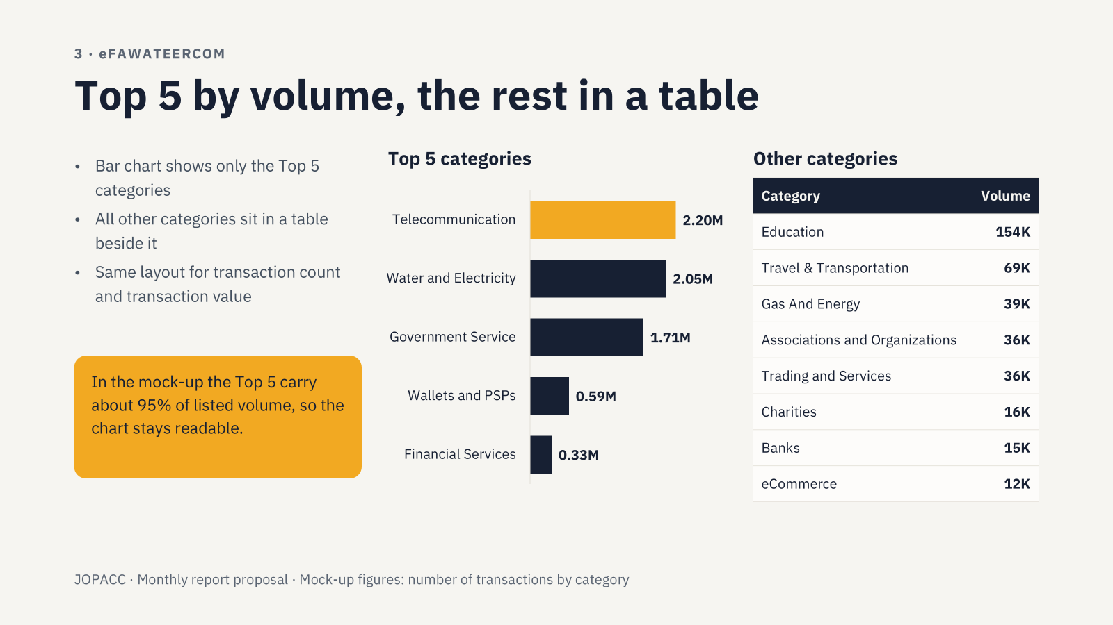
Figure 6. eFAWATEERcom: top 5 categories by volume in a chart, the rest in a table. Mock-up figures.

7. Lessons Learned
- Agree on a reference output before bulk extraction. A small reference extraction up front would have exposed the OCR problems earlier.
- Test extraction on a sample of each report type, especially image-based PDFs, before running the full set.
- Validate early and often. Checking figures against the original reports catches errors before they spread into the analysis.
- Test hypotheses before sharing them. The gender-gap finding showed that a surprising result may be an artifact of how the data is split.

Glossary
Term | Meaning
ETL | Extract, transform, load: the process of pulling data from source files and shaping it into clean tables.
OCR | Optical character recognition: converting scanned or image-based PDF pages into text.
MoM / YoY | Month-over-month and year-over-year growth.
KPI | Key performance indicator.
IPS | JoPACC’s instant payment system, which includes the CliQ service.
CliQ, eFAWATEERcom | Payment systems covered by the JoPACC reports.
JoMoPay | Mobile wallet service within IPS, reported alongside CliQ.
ACH | JoPACC system used for salary clearing.
ECCU | JoPACC cheque clearing system.

