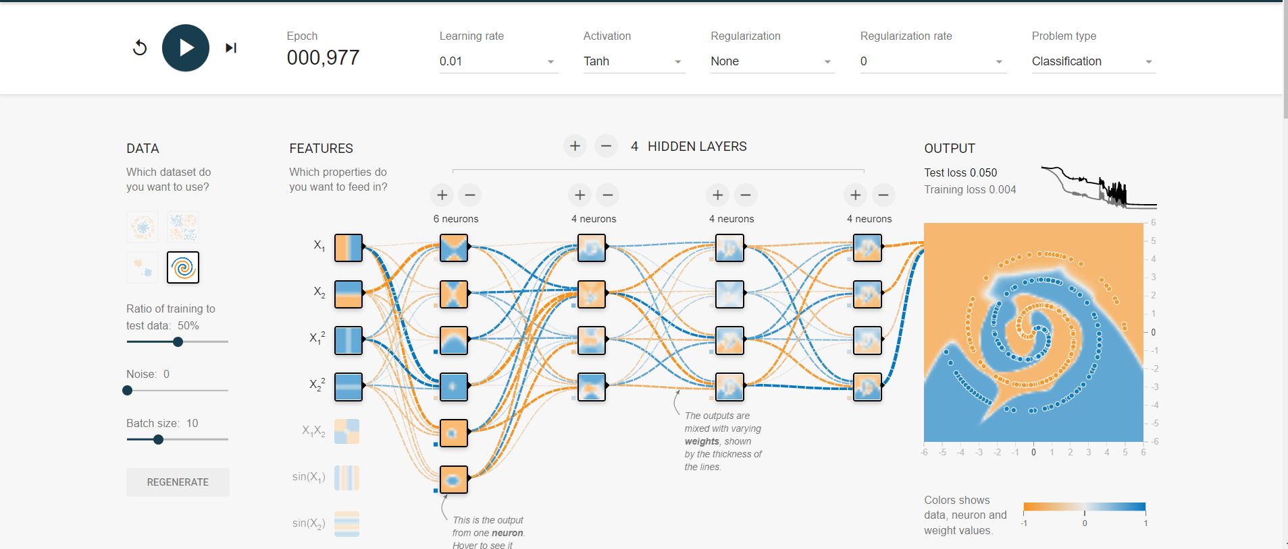

Learning Rate = 0.01

Activation = Tanh

Features = x1, x2, x1^2, x2^2

**Epoch = 000,997**

metin, harita, iç mekan içeren bir resim

Açıklama otomatik olarak oluşturuldu

Learning Rate = 0.01

Activation = Tanh

Features = x1, x2, x1^2, x2^2

**Epoch = 000,438**

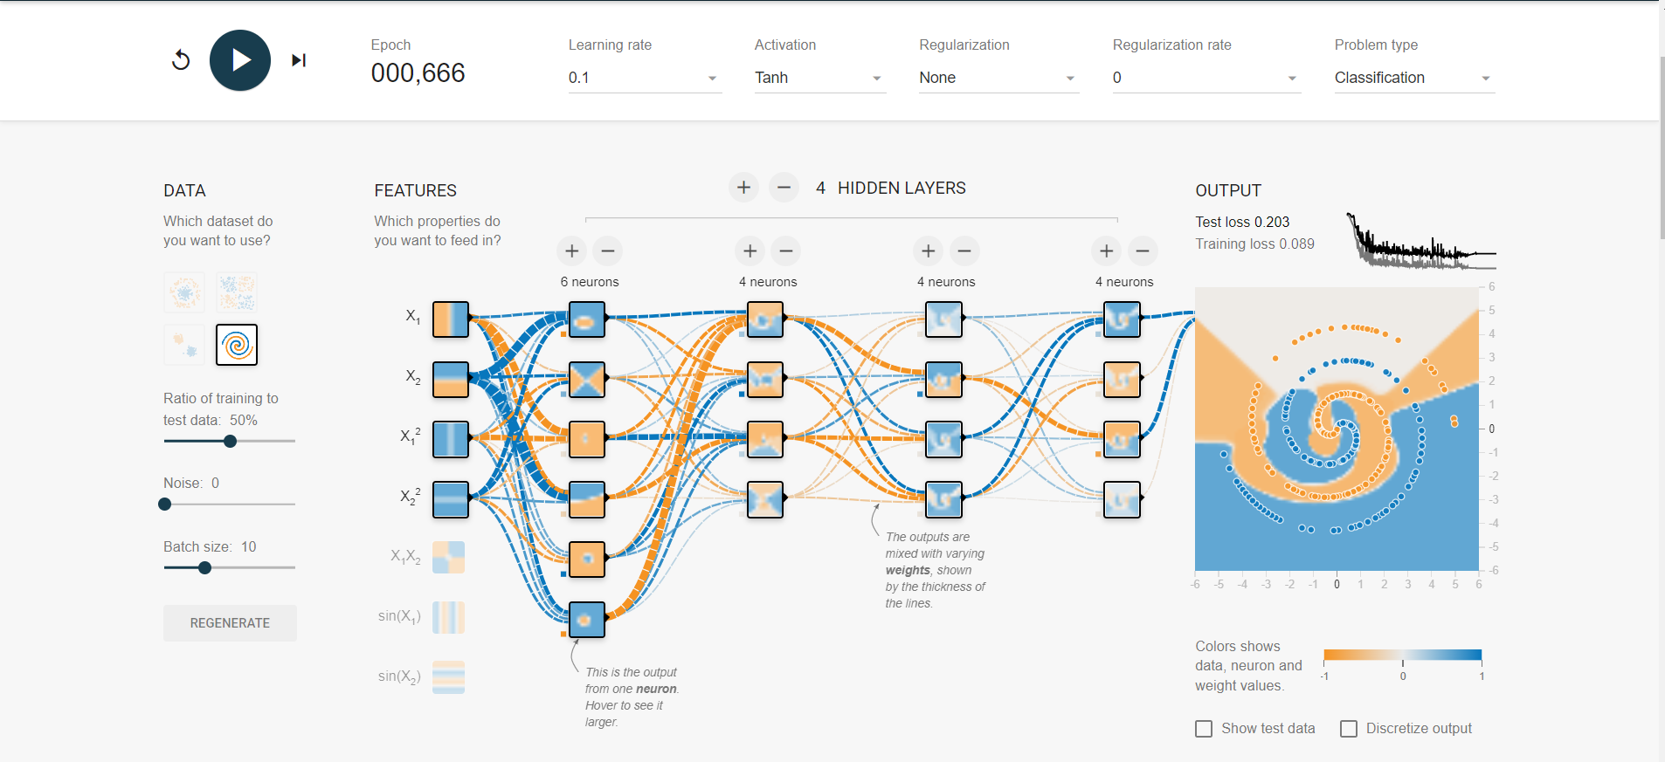

Learning Rate = 0.1

Activation = Tanh

Features = x1, x2, x1^2, x2^2

**Epoch = 000,666**

**I will chage the feature and it’s go wrong**

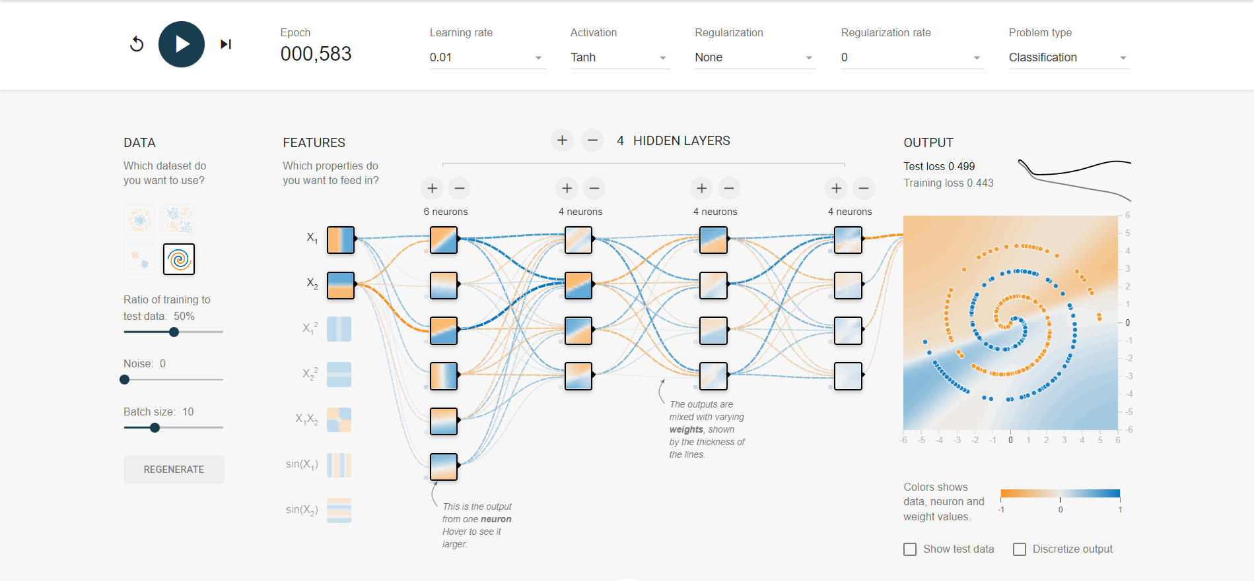

Learning Rate = 0.01

Activation = Tanh

Features = x1, x2

**Epoch = 000,583 🡪 And wrong**

**After that I add back the features and increase the learning rate:**

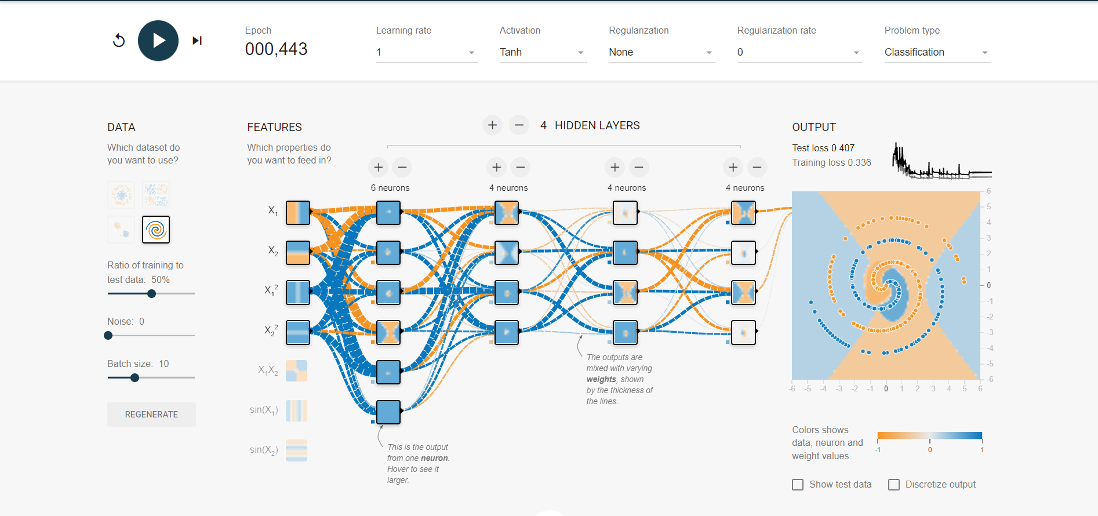

Learning Rate = 1

Activation = Tanh

Features = x1, x2, x1^2, x2^2

**Epoch = 000,443**

**And it’s also went wrong**

**My assumption is the first example is the best fit.**

Learning Rate = 0.01

Activation = Tanh

Features = x1, x2, x1^2, x2^2

**Epoch = 000,997**

**This is the most accurate result.**