Test

哈哈哈哈哈

|  |  |  |  |
| --- | --- | --- | --- |
| 111 | 222 | 333 | 444 |
| 1111111 | 111111 | 111111 | 111111 |

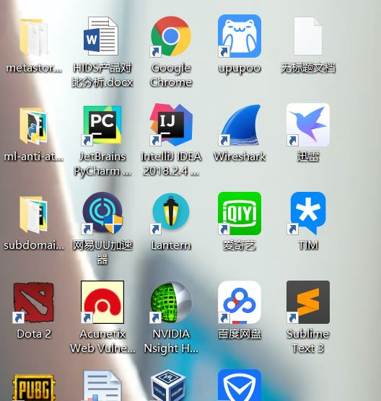

哈哈哈哈哈哈

黑黑黑黑黑黑