**1.Introduction**

An automated teller machine (ATM) or cash machine (in British English) is an electronic telecommunications device that enables customers of financial institutions to perform financial transactions, such as cash withdrawals, deposits, funds transfers, balance inquiries or account information inquiries, at any time and without the need for direct interaction with bank staff.

Atms are known by a variety of names, including automatic teller machine in the United States (sometimes redundantly as "ATM machine"). In Canada, the term automated banking machine (ABM) is also used, although ATM is also very commonly used in Canada, with many Canadian organizations using ATM over ABM.

Atm program in python will give us practice on how to use classes and objects, functions, while loops, modules, and conditional statements in general. It’s a good question to pick as a practice question since it covers almost all the concepts you need to know as a beginner in programming.

This program simulates how the ATM (Automatic Teller Machine) of a Bank Therefore, the program does the following basic ATM requirements:

1 == balance

2 == withdraw balance

3 == deposit balance

4 == exit

**2.Problem statement**

A ATM Software In Python is a simple console based ATM simulator provides the simple account balance management of a respective account.

It contains all the essential features. There is no database connection or neither any external text or other files used in this mini project to save user’s data. Everything is set inside the source code whether its pin code or the amount.

**3.Implementation**

**3.1code:**

from tkinter import *

import time

from tkinter import messagebox

password = "1234"

balance = 5000

root = Tk()

root.title("ATM")

root.resizable(False, False)

def onButtonClick(value):

current = pdisplay.get()

pdisplay.delete(0, END)

pdisplay.insert(0, str(current) + str(value))

def widamt(amt):

global balance

withdraw_amount=int(pdisplay.get())

pdisplay.delete(0, END)

balance = amt - withdraw_amount

messagebox.showwarning(title="Withdraw", message="Ammount WithDraw "+str(withdraw_amount))

messagebox.showinfo(title="Balance", message="Your Balance is "+str(balance))

label.config(text="1 == balance \n2 == withdraw balance \n3 == deposit balance \n4 == exit")

buttn_dep.grid_remove()

buttn_wid.grid_remove()

buttn_ok.grid_remove()

buttn_sub.grid(row=3, column=3)

def depamt(amt):

global balance

deposit_amount=int(pdisplay.get())

pdisplay.delete(0, END)

balance = amt + deposit_amount

messagebox.showinfo(title="Deposite", message="Ammount Deposite "+str(deposit_amount))

messagebox.showinfo(title="Balance", message="Your Balance is "+str(balance))

label.config(text="1 == balance \n2 == withdraw balance \n3 == deposit balance \n4 == exit")

buttn_dep.grid_remove()

buttn_wid.grid_remove()

buttn_ok.grid_remove()

buttn_sub.grid(row=3, column=3)

def func():

option = int(pdisplay.get())

if option == 1:

pdisplay.delete(0, END)

messagebox.showinfo(title="Balance", message="Your Balance is "+str(balance))

elif option == 2:

pdisplay.delete(0, END)

label.config(text="Please Enter Withdraw_amount")

buttn_sub.grid_remove()

buttn_dep.grid_remove()

buttn_wid.grid(row=3, column=3)

elif option == 3:

pdisplay.delete(0, END)

label.config(text="Please Enter Deposite_amount")

buttn_wid.grid_remove()

buttn_sub.grid_remove()

buttn_dep.grid(row=3, column=3)

elif option == 4:

pdisplay.delete(0, END)

label.config(text="Please insert Your CARD")

pdisplay.grid_remove()

buttn_dep.grid_remove()

buttn_wid.grid_remove()

buttn_sub.grid_remove()

buttn_ok.grid(row=3, column=3)

def Del():

data = pdisplay.get()

data = data[:-1]

pdisplay.delete(0, END)

pdisplay.insert(0, str(data))

def Clear():

pdisplay.delete(0,END)

def insert():

time.sleep(2)

label.config(text="Enter your ATM Pin")

pdisplay.grid(row=1, column=0, columnspan=4, pady=10)

def pin():

cpin = pdisplay.get()

pdisplay.delete(0, END)

if password == cpin:

label.config(text="1 == balance \n2 == withdraw balance \n3 == deposit balance \n4 == exit")

buttn_ok.grid_remove()

buttn_sub.grid(row=3, column=3)

else:

messagebox.showerror(title="Error", message="Wrong Pin")

time.sleep(2)

label.config(text="Enter your ATM Pin")

myframe=Frame(root,width=40)

myframe.grid(row=0, column=0, columnspan=4, padx=10, pady=10)

label = Label(myframe, text="Please insert Your CARD",font=("Helvetica",15))

label.grid(row=0,column=0,columnspan=4)

pdisplay = Entry(myframe, width=40, borderwidth=1, font=("Arial", 16))

buttn_1 = Button(root, width= 9, text="1", font=("Arial", 12),command=lambda:onButtonClick(1))

buttn_1.grid(row=1, column=0)

buttn_2 = Button(root, width= 9, text="2", font=("Arial", 12),command=lambda:onButtonClick(2))

buttn_2.grid(row=1, column=1)

buttn_3 = Button(root, width= 9, text="3", font=("Arial", 12),command=lambda:onButtonClick(3))

buttn_3.grid(row=1, column=2)

buttn_c = Button(root, width= 9, text="Clear", font=("Arial", 12), foreground="red",command=lambda:Clear())

buttn_c.grid(row=1, column=3)

buttn_4 = Button(root, width= 9, text="4", font=("Arial", 12),command=lambda:onButtonClick(4))

buttn_4.grid(row=2, column=0)

buttn_5 = Button(root, width= 9, text="5", font=("Arial", 12),command=lambda:onButtonClick(5))

buttn_5.grid(row=2, column=1)

buttn_6 = Button(root, width= 9, text="6", font=("Arial", 12),command=lambda:onButtonClick(6))

buttn_6.grid(row=2, column=2)

buttn_del = Button(root, width= 9, text="Del", font=("Arial", 12), foreground="green",command=lambda:Del())

buttn_del.grid(row=2, column=3)

buttn_7 = Button(root, width= 9, text="7", font=("Arial", 12),command=lambda:onButtonClick(7))

buttn_7.grid(row=3, column=0)

buttn_8 = Button(root, width= 9, text="8", font=("Arial", 12),command=lambda:onButtonClick(8))

buttn_8.grid(row=3, column=1)

buttn_9 = Button(root, width= 9, text="9", font=("Arial", 12),command=lambda:onButtonClick(9))

buttn_9.grid(row=3, column=2)

buttn_ok = Button(root, width= 9, text="Ok", font=("Arial", 12), foreground="green",command=lambda:pin())

buttn_ok.grid(row=3, column=3)

buttn_sub = Button(root, width= 9, text="Ok", font=("Arial", 12), foreground="green",command=lambda:func())

buttn_wid = Button(root, width= 9, text="Ok", font=("Arial", 12), foreground="green",command=lambda:widamt(balance))

buttn_dep = Button(root, width= 9, text="Ok", font=("Arial", 12), foreground="green",command=lambda:depamt(balance))

buttn_0= Button(root, width= 9, text="0", font=("Arial", 12),command=lambda:onButtonClick(0))

buttn_0.grid(row=4, column=1)

buttn_in= Button(root, width= 9, text="Insert Card", font=("Arial", 12),foreground="green",command=lambda:insert())

buttn_in.grid(row=4, column=3)

root.mainloop()

**4.output**

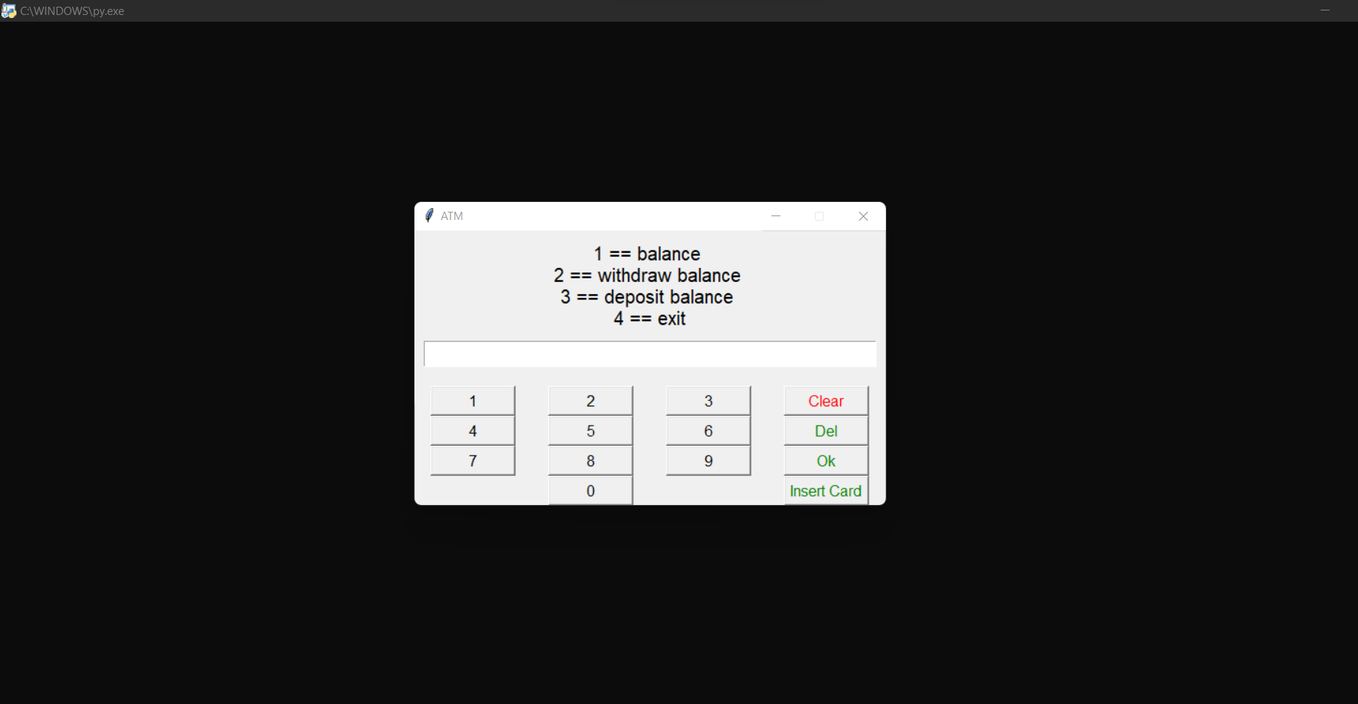

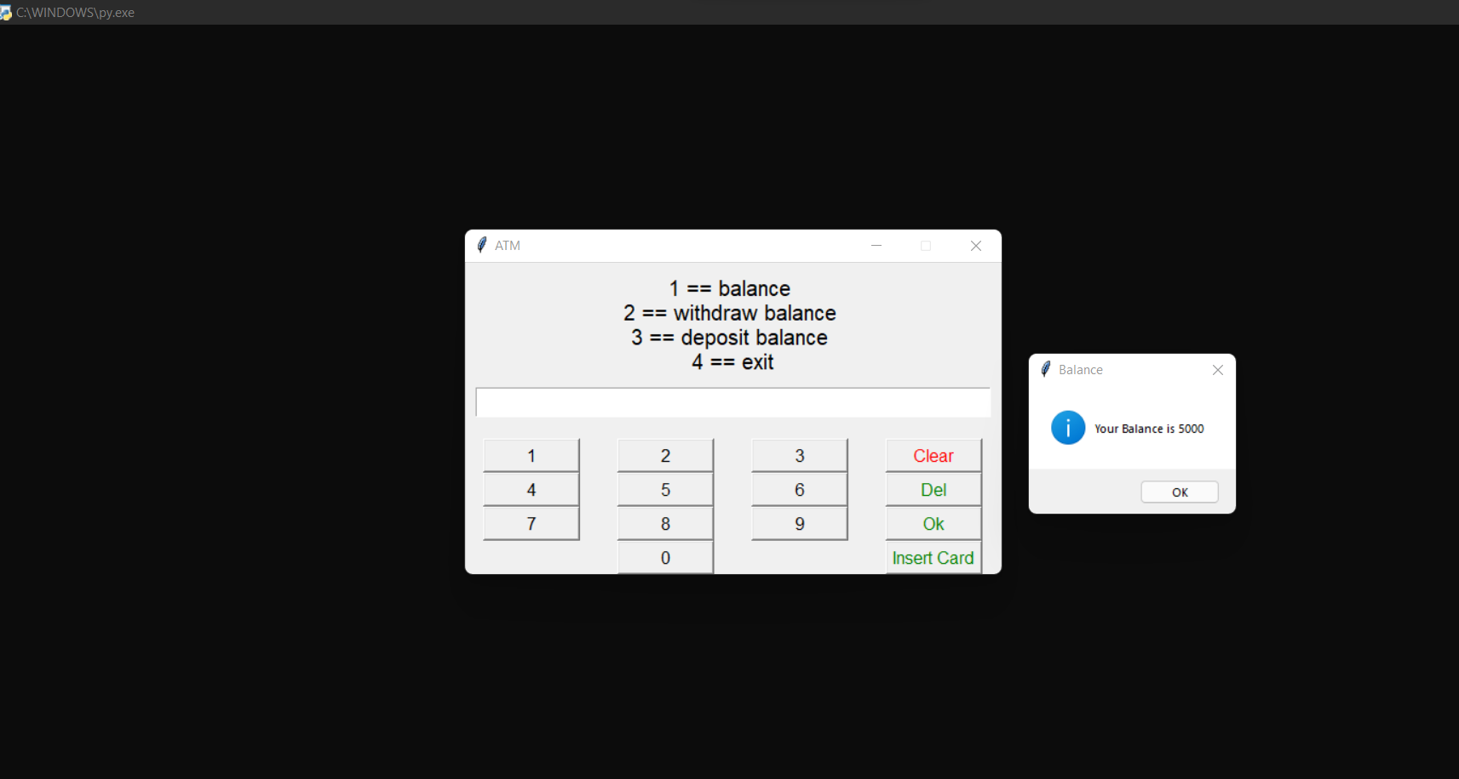

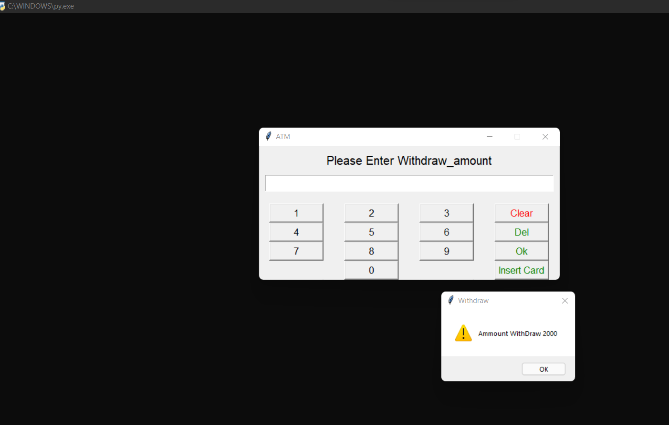

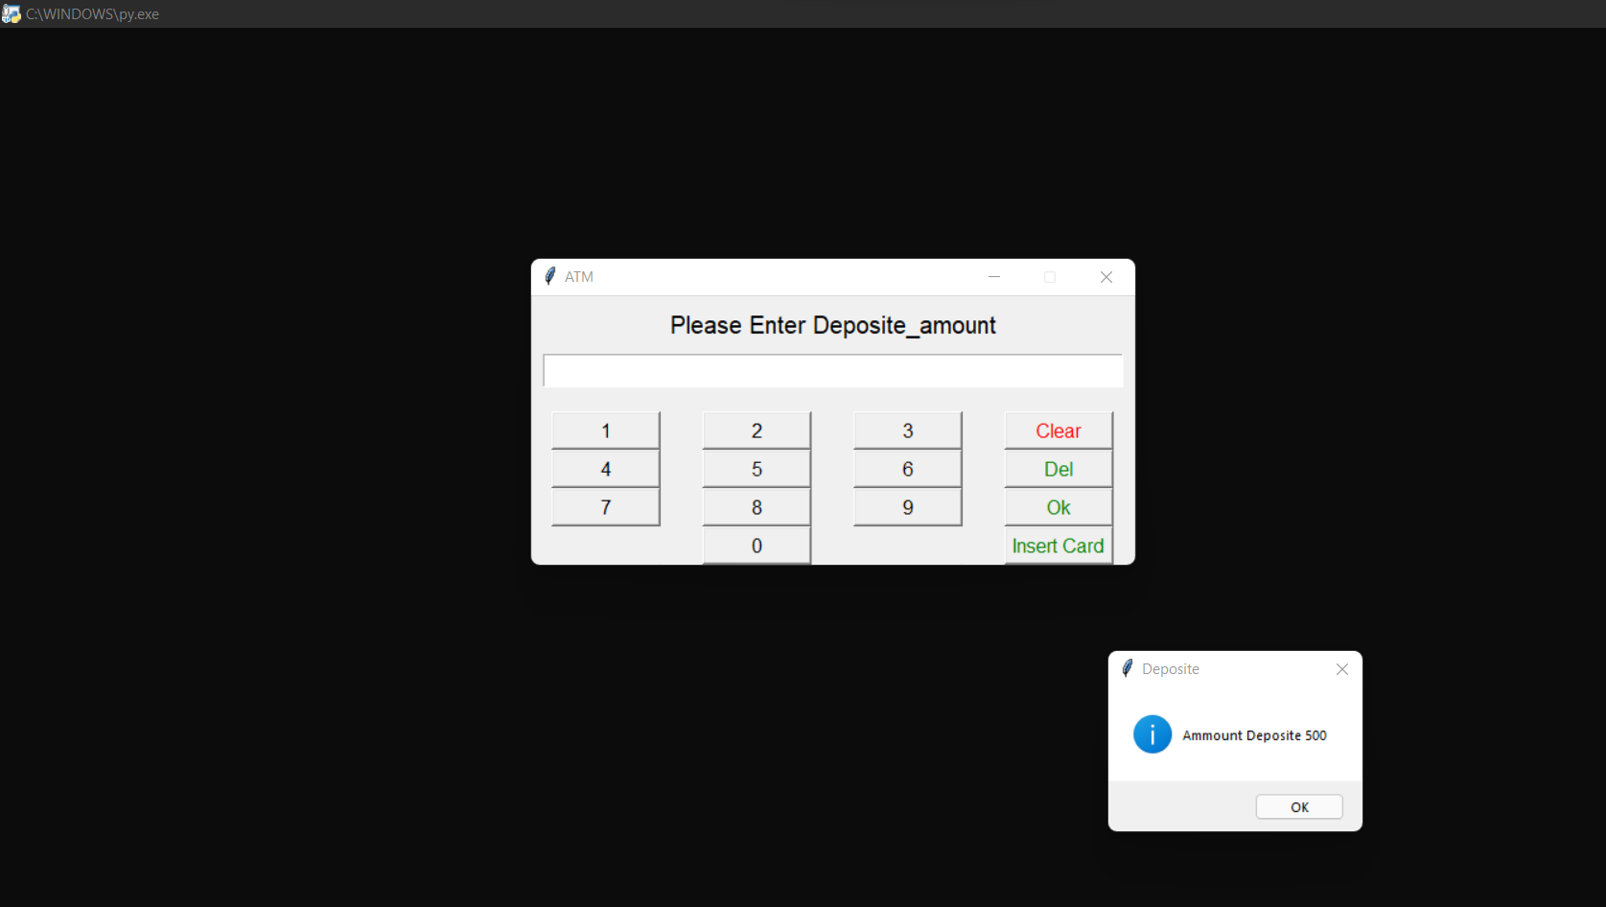

**5.Conclusion**

In this project we learnt the use of python for creating for atm machine simulator