2021-2022-2网络工程技术与运用实验报告
学号 | 202021130302 | 姓名 | 李雨 | 课堂号 | 0 |  | 实验日期 | 2022
同组人 | 李籽漫、朱怡然、曹倩、张惠迪、梁温华、朱颖 |  |  |  |  |  | 指导教师 | 刘琪
实验一、基础综合实验
一、实验目的和要求
(1) 掌握MSTP和SVI的原理和完成配置；
（2）掌握三层多功能交换机和路由器连接的原理和完成配置；
（3）熟练掌握路由器的工作原理，掌握动态路由协议的配置方法；
（4）掌握全网规划与设计的基本思路

二、实验规划
1. 实验要求
在交换部分实现MSTP的负载均衡；
做到全网的互连互通。
2. 实验设备
装有WINDOS XP的电脑一台、锐捷设备配置实验台
路由器2台、交换机1台、 直连线1根

- 实验拓扑
S2 R2 R1
- IP地址规划
设备名 | 接口 | IP地址
R1 | S2/0 | 202.101.1.1/24
R2 | S2/0 | 202.101.1.2/24
R2 | GI0/0 | 192.168.20.10/24
S2 | GI0/1 | 192.168.20.100/24

三、实验内容与实验结果
实验内容：
R1:
R1(config)#int loopback 1
R1(config-if-Loopback 2)#ip add 1.1.1.1 255.255.255.0
R1(config-if-Loopback 2)#exit
R1(config)#interface s2/0
R1(config-if-Serial 2/0)#ip add 202.101.1.1 255.255.255.0
R1(config-if-Serial 2/0)#encapsulation PPP
R1(config-if-Serial 2/0)#*May 19 14:18:15: %LINEPROTO-5-UPDOWN: Line protocol on Interface Serial 2/0, changed state to down.
R1(config-if-Serial 2/0)#no shut
R1(config-if-Serial 2/0)#exit
R1(config)#router ospf 100
R1(config-router)#net 1.1.1.1 0.0.0.255 area 0
R1(config-router)#net 202.101.1.0 0.0.0.255 area 0
R1(config-router)#exit
R2(config)#interface s2/0
R2(config-if-Serial 2/0)#no shut
R2(config-if-Serial 2/0)#exit

R2:
R2(config)#int loopback 2
R2(config-if-Loopback 2)#ip add 2.2.2.2 255.255.255.0
R2(config-if-Loopback 2)#exit
R2(config)#interface s2/0
R2(config-if-Serial 2/0)#ip add 202.101.1.2 255.255.255.0
R2(config-if-Serial 2/0)#encapsulation PPP
R2(config-if-Serial 2/0)#*May 19 14:18:15: %LINEPROTO-5-UPDOWN: Line protocol on Interface Serial 2/0, changed state to down.
R2(config-if-Serial 2/0)#no shut
R2(config-if-Serial 2/0)#exit
R2(config)#interface gi0/0
R2(config-if-GigabitEthernet 0/0)#ip add 192.168.20.10 255.255.255.0
R2(config-if-GigabitEthernet 0/0)#no shut
R2(config-if-GigabitEthernet 0/0)#exit
R2(config)#router ospf 100
R2(config-router)#net 2.2.2.2 0.0.0.255 area 0
R2(config-router)#net 202.101.1.0 0.0.0.255 area 0
R2(config-router)#net 192.168.20.0 0.0.0.255 area 0
R2(config-router)#exit
R2(config)#interface s2/0
R2(config-if-Serial 2/0)#no shut
R2(config-if-Serial 2/0)#exit
S2:
S2(config) int range Gi 0/1-10
S2(config-if) switchport access vlan 20
int range Gi 0/11-20
S2(config-if) switchport access vlan 30
S2(config) int Gi0/21
S2(config-if) switchport access vlan 40
S2(config) int Gi0/23
S2(config-if) switchport mode trunk
S2# conf t
S2(config) int Gi0/24
S2(config-if) switchport mode trunk
S2# conf t
spanning-tree
spanning-tree mode rstp
spanning-tree priority 4096

实验结果：
R1:
R1(config)#show ip int b
Interface IP-Address(Pri) IP-Address(Sec) Status Protocol
Serial 2/0 202.101.1.1/24 no address up up
Serial 3/0 no address no address up down
GigabitEthernet 0/0 221.98.1.10/24 no address down down
GigabitEthernet 0/1 no address no address down down
Loopback 1 1.1.1.1/24 no address up up

R1(config)#show ip route
Codes: C - connected, S - static, R - RIP, B - BGP
O - OSPF, IA - OSPF inter area
N1 - OSPF NSSA external type 1, N2 - OSPF NSSA external type 2
E1 - OSPF external type 1, E2 - OSPF external type 2
i - IS-IS, su - IS-IS summary, L1 - IS-IS level-1, L2 - IS-IS level-2
ia - IS-IS inter area, * - candidate default
Gateway of last resort is no set
C 1.1.1.0/24 is directly connected, Loopback 1
C 1.1.1.1/32 is local host.
C 202.101.1.0/24 is directly connected, Serial 2/0
C 202.101.1.1/32 is local host.
C 202.101.1.2/32 is directly connected, Serial 2/0

R1(config)#sh running-conf
interface Serial 2/0
encapsulation PPP
ip address 202.101.1.1 255.255.255.0

router ospf 100
network 1.1.1.0 0.0.0.255 area 1
network 202.101.1.0 0.0.0.255 area 1
network 221.98.1.0 0.0.0.255 area 1

R2:
R2(config)#sh ip int b
Interface IP-Address(Pri) IP-Address(Sec) Status Protocol
Serial 2/0 202.101.1.2/24 no address up up
Serial 3/0 no address no address up down
GigabitEthernet 0/0 192.168.20.10/24 no address up up
GigabitEthernet 0/1 no address no address down down
Loopback 2 2.2.2.2/24 no address up up

R2(config)#sh ip route
Codes: C - connected, S - static, R - RIP, B - BGP
O - OSPF, IA - OSPF inter area
N1 - OSPF NSSA external type 1, N2 - OSPF NSSA external type 2
E1 - OSPF external type 1, E2 - OSPF external type 2
i - IS-IS, su - IS-IS summary, L1 - IS-IS level-1, L2 - IS-IS level-2
ia - IS-IS inter area, * - candidate default
Gateway of last resort is no set
O IA 1.1.1.1/32 [110/50] via 202.101.1.1, 00:06:21, Serial 2/0
C 2.2.2.0/24 is directly connected, Loopback 2
C 2.2.2.2/32 is local host.
C 192.168.20.0/24 is directly connected, GigabitEthernet 0/0
C 192.168.20.10/32 is local host.
C 202.101.1.0/24 is directly connected, Serial 2/0
C 202.101.1.1/32 is directly connected, Serial 2/0
C 202.101.1.2/32 is local host.
O IA 221.98.1.0/24 [110/51] via 202.101.1.1, 00:06:21, Serial 2/0

R2(config)#sh running-conf
interface Serial 2/0
encapsulation PPP
ip address 202.101.1.2 255.255.255.0
clock rate 64000
interface GigabitEthernet 0/0
ip address 192.168.20.10 255.255.255.0
duplex auto
speed auto
!
interface GigabitEthernet 0/1
duplex auto
speed auto
!
interface Loopback 2
ip address 2.2.2.2 255.255.255.0
router ospf 100
network 2.2.2.0 0.0.0.255 area 0
network 192.168.20.0 0.0.0.255 area 0
network 202.101.1.0 0.0.0.255 area 0

S2:
S2(config)#sh vlan
VLAN Name Status Ports
---- -------------------------------- --------- -----------------------------------
1 VLAN0001 STATIC Gi0/22, Gi0/23, Gi0/24, Te0/25
Te0/26, Te0/27, Te0/28
20 VLAN0020 STATIC Gi0/1, Gi0/2, Gi0/3, Gi0/4
Gi0/5, Gi0/6, Gi0/7, Gi0/8
Gi0/9, Gi0/10, Gi0/23, Gi0/24
30 VLAN0030 STATIC Gi0/11, Gi0/12, Gi0/13, Gi0/14
Gi0/15, Gi0/16, Gi0/17, Gi0/18
Gi0/19, Gi0/20, Gi0/23, Gi0/24
40 VLAN0040 STATIC Gi0/21, Gi0/23, Gi0/24

四、回答问题
1、为什么推荐使用VLAN接口实现三层多功能交换机和路由器的连接？
便利、简单。
2、什么是SVI？它解决了什么问题？
SVI是指交换虚拟接口。
它为交换机中的VLAN创建虚拟接口，并且配置IP地址。

实验二、MSTP+VRRP
一、实验目的和要求
(1) 在接入层和汇聚层交换机上配置MSTP并进行验证。
（2）掌握MSTP和VRRP的配置；
（3）掌握MSTP和VRRP的工作原理；
（4）熟练掌握MSTP和VRRP的配置命令；
（5）能够用MSTP实现负载分担，同时解决STP/RSTP中不同vlan必须运行在同一棵生成树上的问题,并用VRRP解决局域网中配置静态网关出现单点失效现象的路由协议。

二、实验规划
1. 实验要求
传统的生成树协议是基于整个交换网络产生一个树形拓扑结构，所有的VLAN都共享一个生成树，这种结构不能进行网络流量的负载均衡，是的有些交换设备比较繁忙，而另一些设备又很空闲。为了克服这个问题，决定采用基于VLAN的多生成树协议MSTP。现在要在交换机上做适当配置来完成这一任务。
2. 实验设备
装有WINDOS XP的电脑一台、锐捷设备配置实验台
路由器0台、交换机3台、直连线3根
- 实验拓扑

S7

S5
S6

- IP地址规划
网段 | IP地址 | Master
VLAN10 | 192.168.10.0/24 | S5
VLAN20 | 192.168.20.0/24 | S5
VLAN30 | 192.168.30.0/24 | S6
VLAN40 | 192.168.40.0/24 | S6

- 实验内容与实验结果
实验内容：
S5/S6/S7相似：（以S5为例）
Ruijie>en
Ruijie#con ter
Enter configuration commands, one per line. End with CNTL/Z.
Ruijie(config)#hostname S5
S5(config)#vlan 10
S5(config-vlan)#exit
S5(config)#vlan 20
S5(config-vlan)#exit
S5(config)#vlan 30
S5(config-vlan)#exit
S5(config)#vlan 40
S5(config-vlan)#exit
S5(config)#int vlan 10
S5(config-if-VLAN 10)#ip address 192.168.10.1 255.255.255.0
S5(config-if-VLAN 10)#vrrp 10 ip 192.168.10.1
S5(config-if-VLAN 10)#exit
S5(config)#int vlan 20
S5(config-if-VLAN 20)#ip address 192.168.20.1 255.255.255.0
S5(config-if-VLAN 20)#vrrp 20 ip 192.168.20.1
S5(config-if-VLAN 20)#exit
S5(config)#int vlan 30
S5(config-if-VLAN 30)#ip address 192.168.30.1 255.255.255.0
S5(config-if-VLAN 30)#vrrp 30 ip 192.168.30.2
S5(config-if-VLAN 30)#exit
S5(config)#int vlan 40
S5(config-if-VLAN 40)#ip address 192.168.40.1
S5(config-if-VLAN 40)#ip address 192.168.40.1 255.255.255.0
S5(config-if-VLAN 40)#vrrp 40 ip 192.168.40.2
S5(config-if-VLAN 40)#exit
S5(config)#interface range gi 0/1-5
S5(config-if-range)#switchport mode access
S5(config-if-range)#switchport access vlan 10
S5(config-if-range)#exit
S5(config)#int range gi 0/6-10
S5(config-if-range)#switchport mode access
S5(config-if-range)#switchport access vlan 20
S5(config-if-range)#exit
S5(config)#int range gi 0/11-15
S5(config-if-range)#switchport mode access
S5(config-if-range)#switchport access vlan 30
S5(config-if-range)#exit
S5(config)#int range gi 0/20
S5(config-if-range)#switchport mode access
S5(config-if-range)#switchport access vlan 40
S5(config-if-range)#exit
S5(config)#int gi 0/21
S5(config-if-GigabitEthernet 0/21)#switchport mode trunk
S5(config-if-GigabitEthernet 0/21)#exit
S5(config)#router rip
S5(config-router)#version 2
S5(config-router)#network 172.1.1.0
S5(config-router)#network 192.168.1.0
S5(config-router)#
S5(config-if-VLAN 40)#exit
S5(config)#int gi 0/22
S5(config-if-GigabitEthernet 0/22)#switchport mode trunk
S5(config-if-GigabitEthernet 0/22)#int gi 0/23
S5(config-if-GigabitEthernet 0/23)#switchport mode trunk
S5(config-if-GigabitEthernet 0/23)#exit

S5(config)#spanning-tree
S5(config)#spanning-tree mode mstp
S5(config)#spanning-tree mst configuration
S5(config-mst)#instance 1 vlan 10,20
S5(config-mst)#instance 2 vlan 30
S5(config-mst)#instance 3 vlan 40
S5(config)#spanning-tree mst 3 priority 4096
S5(config)#end

实验结果：
S5/S6/S7结果相似：（以S5为例）
S5(config)#show vrrp brief
Interface Grp Pri timer Own Pre State Master addr Group addr
VLAN 10 10 255 3.00 O P Master 192.168.10.1 192.168.10.1
VLAN 20 20 255 3.00 O P Master 192.168.20.1 192.168.20.1
VLAN 30 30 100 3.60 - P Backup 192.168.30.2 192.168.30.2
VLAN 40 40 100 3.60 - P Backup 192.168.40.2 192.168.40.2

S5#show spanning-tree
HelloTime : 2
ForwardDelay : 15
BridgeMaxAge : 20
BridgeHelloTime : 2
BridgeForwardDelay : 15
MaxHops: 20
TxHoldCount : 3
PathCostMethod : Long
BPDUGuard : Disabled
BPDUFilter : Disabled
LoopGuardDef : Disabled

###### mst 0 vlans map : 1-9, 11-19, 21-29, 31-39, 41-4094
BridgeAddr : 8005.88e6.c2d2
Priority: 32768
TimeSinceTopologyChange : 0d:0h:18m:43s
TopologyChanges : 7
DesignatedRoot : 32768.8005.88e6.c190
RootCost : 0
RootPort : GigabitEthernet 0/23
CistRegionRoot : 32768.8005.88e6.c190
CistPathCost : 20000

S5#show spanning-tree mst 1
###### MST 1 vlans mapped : 10, 20
BridgeAddr : 8005.88e6.c2d2
Priority: 32768
TimeSinceTopologyChange : 0d:0h:21m:19s
TopologyChanges : 6
DesignatedRoot : 4097.8005.88e6.c190
RootCost : 20000
RootPort : GigabitEthernet 0/23

S5#show spanning-tree mst 2
###### MST 2 vlans mapped : 30
BridgeAddr : 8005.88e6.c2d2
Priority: 32768
TimeSinceTopologyChange : 0d:0h:21m:34s
TopologyChanges : 5
DesignatedRoot : 32770.8005.88e6.c190
RootCost : 20000
RootPort : GigabitEthernet 0/22

S5#show spanning-tree mst 3
###### MST 3 vlans mapped : 40
BridgeAddr : 8005.88e6.c2d2
Priority: 4096
TimeSinceTopologyChange : 0d:0h:22m:13s
TopologyChanges : 4
DesignatedRoot : 4099.8005.88e6.c2d2
RootCost : 0
RootPort : 0

四、回答问题
1、MSTP是为了解决什么问题提出的？
为了解决RSTP中不同VLAN必须运行在同一棵生成树上。
2、VRRP的主要作用是什么？
提供了局域网上的设备备份机制。
实验三、OSPF虚链路综合实验
一、实验目的和要求
实现OSPF+虚拟链路

二、实验规划
1. 实验设备
装有WINDOS XP的电脑一台、锐捷设备配置实验台
路由器4台、交换机2台、 直连线2根
2、实验拓扑
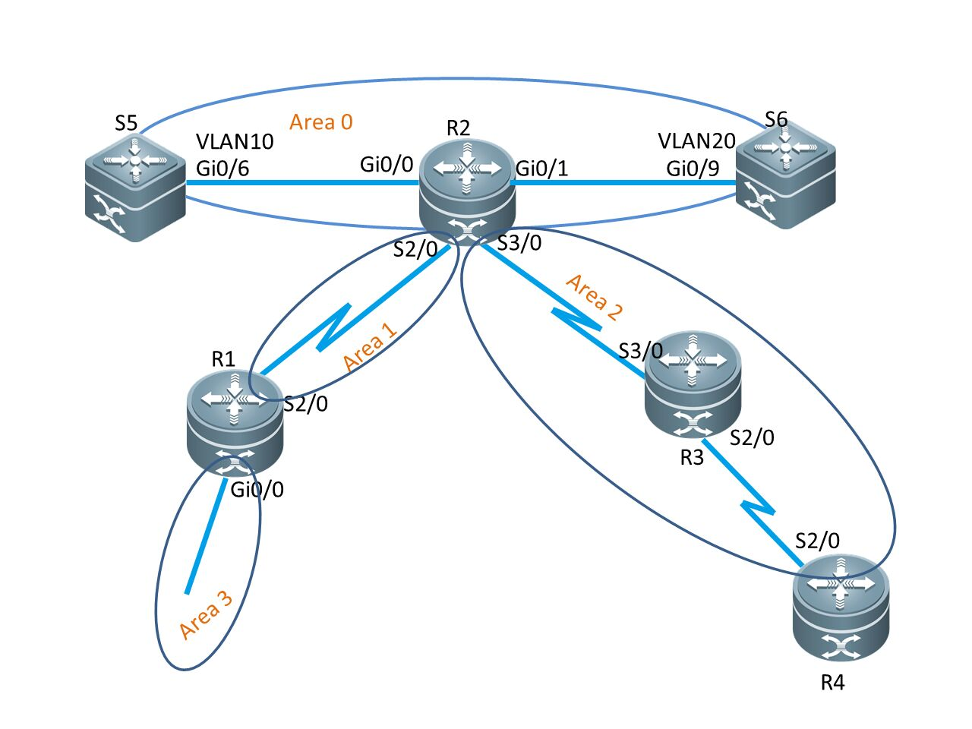
- IP地址规划
设备名 | 接口 | LOOPBACK | IP地址 | 所属区域
R1 | S2/0 | 1.1.1.1/24 | 201.1.1.1/24 | Area1
R2 | 2/0 | 2.2.2.2/24 | 201.1.1.2/24 | Area0
R2 | S3/0 | 2.2.2.2/24 | 203.1.1.2/24 | Area0
R2 | GI0/0 | 2.2.2.2/24 | 192.168.50.10/24 | Area0
R2 | GI0/1 | 2.2.2.2/24 | 192.168.60.10/24 | Area0
R3 | S2/0 | 3.3.3.3/24 | 204.1.1.3/24 | Area4
R3 | S3/0 | 3.3.3.3/24 | 203.1.1.3/24 | Area4
R4 | S2/0 | 4.4.4.4/24 | 204.1.1.4/24 | Area2
S5 | GI0/6 | 5.5.5.5/24 | 192.268.50.105/24 | Area0
S6 | GI0/9 | 6.6.6.6/24 | 192.268.6.106/24 | Area0

- 实验内容与实验结果
实验内容：
R4:
R4#conf
R4(config)# host R4
R4(config)# int loopback 4
R4(config-if)# ip add 4.4.4.4 255.255.255.0
R4(config-if)# exit
R4(config)# int S2/0
R4(config-if)# ip add 204.1.1.4 255.255.255.0
R4(config-if)# no shut
R4(config-if)# exit
R4(config)# int Gi0/0
R4(config-if)# ip add 192.168.40.10 255.255.255.0
R4(config-if)# no shut
R4(config-if)# exit
R4(config)# router ospf 100
R4(config-router)# network 4.4.4.0 0.0.0.255 area 2
R4(config-router)# network 204.1.1.0 0.0.0.255 area 2
R4(config-router)# network 192.168.40.0 0.0.0.255 area 2
R4(config-router)# exit

实验结果：
R4:
R4(config)#show run
interface Serial 2/0
encapsulation HDLC
ip address 192.168.4.2 255.255.255.0
!
interface Serial 2/0
encapsulation HDLC
ip address 192.168.4.2 255.255.255.0
!
router ospf 100
network 4.4.4.0 0.0.0.255 area 4
network 192.168.4.0 0.0.0.255 area 4
network 192.168.7.0 0.0.0.255 area 4
!

R4(config)#show ip rout
Codes: C - connected, S - static, R - RIP, B - BGP
O - OSPF, IA - OSPF inter area
N1 - OSPF NSSA external type 1, N2 - OSPF NSSA external type 2
E1 - OSPF external type 1, E2 - OSPF external type 2
i - IS-IS, su - IS-IS summary, L1 - IS-IS level-1, L2 - IS-IS level-2
ia - IS-IS inter area, * - candidate default
Gateway of last resort is no set
O IA 2.2.2.2/32 [110/100] via 192.168.4.1, 00:12:06, Serial 2/0
O IA 3.3.3.3/32 [110/50] via 192.168.4.1, 00:12:06, Serial 2/0
C 4.4.4.0/24 is directly connected, Loopback 4
C 4.4.4.4/32 is local host.
O IA 192.168.1.0/24 [110/150] via 192.168.4.1, 00:12:06, Serial 2/0
O IA 192.168.2.0/24 [110/100] via 192.168.4.1, 00:12:06, Serial 2/0
C 192.168.4.0/24 is directly connected, Serial 2/0
C 192.168.4.2/32 is local host.
O IA 192.168.5.0/24 [110/51] via 192.168.4.1, 00:03:35, Serial 2/0
O IA 192.168.6.0/24 [110/51] via 192.168.4.1, 00:03:26, Serial 2/0

R4(config)#show ip ospf neighbor
OSPF process 100, 1 Neighbors, 1 is Full:
Neighbor ID Pri State BFD State Dead Time Address Interface
192.168.4.1 1 Full/ - - 00:00:39 192.168.4.1 Serial 2/0
Matching network config: 192.168.7.0/24
Process ID 100, Router ID 4.4.4.4, Network Type BROADCAST, Cost: 1
Transmit Delay is 1 sec, State Down, Priority 1
No designated router on this network
No backup designated router on this network
Timer intervals configured, Hello 10, Dead 40, Wait 40, Retransmit 5
Loopback 4 is up, line protocol is up
Internet Address 4.4.4.4/24, Ifindex 16385, Area 0.0.0.4, MTU 1500
Matching network config: 4.4.4.0/24
Process ID 100, Router ID 4.4.4.4, Network Type LOOPBACK, Cost: 0
Transmit Delay is 1 sec, State Loopback
Timer intervals configured, Hello 10, Dead 40, Wait 40, Retransmit 5

R4(config)#show ip ospf neighbor
OSPF process 100, 1 Neighbors, 1 is Full:
Neighbor ID Pri State BFD State Dead Time Address Interface
192.168.4.1 1 Full/ - - 00:00:40 192.168.4.1 Serial 2/0

五、回答问题：
1、什么是OSPF虚链路？
虚链路是一个逻辑通道,数据包可以通过选择最优的路径从一端到达另一端。
2、OSPF协议的优势在哪里？
(1) 快速收敛；
(2) 支持可变长子网掩码；
(3) 无跳数的限制；
(4) 提供最佳路由的选择。

实验四、网络出口规划与设计
一、实验目的和要求
综合运用路由重分布、NAT和策略路由设计网络出口，并进行验证。
二、实验规划
1. 实验背景
用NAT节省公共地址，并使私有网络向公网转化时，无需重新进行编址；
通过使用基于策略的路由选择，能够根据数据包的源地址、目的地址、源端口、目的端口和协议类型让报文选择不同的路径。
路由重分发是指连接到不同路由选择域的边界路由器，在不同路由选择域（自主系统）之间交换和通告路由选择信息的能力。
2. 实验设备
装有WINDOS XP的电脑一台、锐捷设备配置实验台
路由器3台、 PC2台、直连线3根
3、实验拓扑
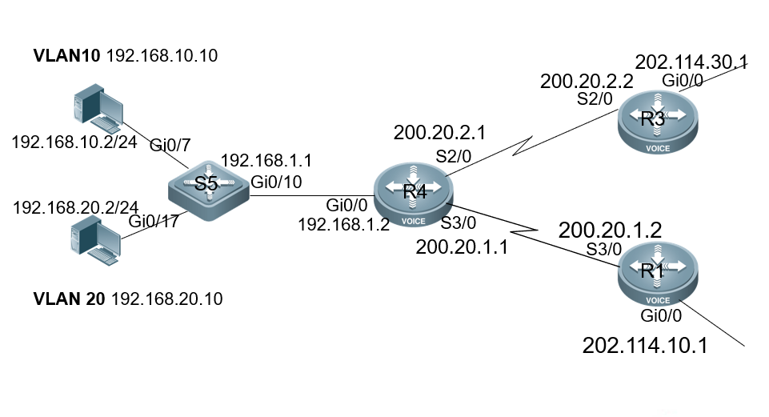

- IP地址规划
设备名 | 接口 | IP地址 | 子网掩码
R1 | S3/0 | 200.20.1.2 | 255.255.255.0
R3 | S2/0 | 200.20.2.2 | 255.255.255.0
R4 | S2/0 | 200.20.2.1 | 255.255.255.0
R4 | S3/0 | 200.20.1.1 | 255.255.255.0
R4 | GI0/10 | 192.168.1.2 | 255.255.255.0
S5 | GI0/10 | 192.168.1.1 | 255.255.255.0

- 实验内容与实验结果

实验内容：
- NAT策略路由
R2:
Ruijie>en
Ruijie#con ter
Enter configuration commands, one per line. End with CNTL/Z.
Ruijie(config)#host R2
R2(config)#int loopback 2
R2(config-if-Loopback 2)#ip add 2.2.2.2 255.255.255.0
R2(config-if-Loopback 2)#exit
R2(config)#int s2/0
R2(config-if-Serial 2/0)#ip add 200.20.2.2 255.255.255.0
R2(config-if-Serial 2/0)#no shut
R2(config-if-Serial 2/0)#exit
R2(config)#int gi0/0
R2(config-if-GigabitEthernet 0/0)#ip add 202.1*May 19 15:46:45: %LINEPROTO-5-UPDOWN: Line protocol on Interface Serial 2/0, changed state to up.
14.30.*May 19 15:46:47: %LINK-3-UPDOWN: Interface FastEthernet 1/21, changed state to up.
*May 19 15:46:47: %LINEPROTO-5-UPDOWN: Line protocol on Interface FastEthernet 1/21, changed state to up.
1 255.255.255.0
R2(config-if-GigabitEthernet 0/0)#no shut
R2(config-if-GigabitEthernet 0/0)#exit
R2(config)#router ospf 100
R2(config-router)#net 2.2.2.0 0.0.0.255 area 0
R2(config-router)#net 200.20.2.0 0.0.0.255 area 0
R2(config-router)#net 202.114.30.0 0.0.0.255 area 0
R2(config-router)#exit
R2(config)#*May 19 15:49:54: %OSPF-5-ADJCHG: Process 100, Nbr 1.1.1.1-Serial 2/0 from Down to Init, HelloReceived.
*May 19 15:50:04: %OSPF-5-ADJCHG: Process 100, Nbr 1.1.1.1-Serial 2/0 from Loading to Full, LoadingDone.
- 路由重分布
R1:
Ruijie>en
Ruijie#con ter
Enter configuration commands, one per line. End with CNTL/Z.
Ruijie(config)#host R1
R1(config)#int loopback 1
R1(config-if-Loopback 1)#ip add 1.1.1.1 255.255.255.0
R1(config-if-Loopback 1)#exit
R1(config)#int s2/0
R1(config-if-Serial 2/0)#ip add 200.20.2.1 255.255.255.0
R1(config-if-Serial 2/0)#no shut
R1(config-if-Serial 2/0)#exit
R1(config)#int s3/0
R1(config-if-Serial 3/0)#ip add 200.20.1.1 255.255.255.0
R1(config-if-Serial 3/0)#no shut
R1(config-if-Serial 3/0)#exit
R1(config)#int gi 0/0
R1(config-if-GigabitEthernet 0/0)#ip add 192.168.1.2 255.255.255.0
R1(config-if-GigabitEthernet 0/0)#no shut
R1(config-if-GigabitEthernet 0/0)#exit
R1(config)#router ospf 100
R1(config-router)#net 200.20.1.0 0.0.0.255 area 0
R1(config-router)#exit
R1(config)#router rip
R1(config-router)#version 2
R1(config-router)#net 192.168.1.0
R1(config-router)#no auto-summary
R1(config-router)#exit

实验结果：
- NAT策略路由
R2:
R2(config)#sh ip int b
Interface IP-Address(Pri) IP-Address(Sec) Status Protocol
Serial 2/0 200.20.2.2/24 no address up up
Serial 3/0 no address no address up down
GigabitEthernet 0/0 202.114.30.1/24 no address up up
GigabitEthernet 0/1 no address no address down down
Loopback 2

R2(config)#sh ip route
Codes: C - connected, S - static, R - RIP, B - BGP
O - OSPF, IA - OSPF inter area
N1 - OSPF NSSA external type 1, N2 - OSPF NSSA external type 2
E1 - OSPF external type 1, E2 - OSPF external type 2
i - IS-IS, su - IS-IS summary, L1 - IS-IS level-1, L2 - IS-IS level-2
ia - IS-IS inter area, * - candidate default
Gateway of last resort is no set
O 1.1.1.1/32 [110/50] via 200.20.2.1, 00:33:02, Serial 2/0
C 2.2.2.0/24 is directly connected, Loopback 2
C 2.2.2.2/32 is local host.
O 5.5.5.5/32 [110/51] via 200.20.2.1, 00:27:07, Serial 2/0
O 192.168.1.0/24 [110/51] via 200.20.2.1, 00:28:06, Serial 2/0
C 200.20.2.0/24 is directly connected, Serial 2/0
C 200.20.2.2/32 is local host.

R2(config)#sh run
Building configuration...
Current configuration : 2059 bytes
!
version RGOS 10.4(3b34)p4 Release(208710)(Mon Oct 24 17:11:09 CST 2016 -ngcf70)
hostname R2
webmaster level 0 username admin password 7 13041647042f
interface Serial 2/0
encapsulation HDLC
ip address 200.20.2.2 255.255.255.0
clock rate 64000
!
interface Serial 3/0
encapsulation HDLC
clock rate 64000
interface GigabitEthernet 0/0
ip address 202.114.30.1 255.255.255.0
duplex auto
speed auto
!
interface GigabitEthernet 0/1
duplex auto
speed auto
!
interface Loopback 2
ip address 2.2.2.2 255.255.255.0
!
router ospf 100
network 2.2.2.0 0.0.0.255 area 0
network 200.20.2.0 0.0.0.255 area 0
network 202.114.30.0 0.0.0.255 area 0
!
!
!
ref parameter 75 140
line con 0
line aux 0
line vty 0 4
login
!

- 路由重分布
R1:
R1(config)#sh ip int b
Serial 2/0 200.20.2.1/24 no address up up
Serial 3/0 200.20.1.1/24 no address up up
GigabitEthernet 0/0 192.168.1.2/24 no address down down
GigabitEthernet 0/1 no address no address down down
Loopback 1 1.1.1.1/24 no address up up
R1(config)sh ip route
Codes: C - connected, S - static, R - RIP, B - BGP
O - OSPF, IA - OSPF inter area
N1 - OSPF NSSA external type 1, N2 - OSPF NSSA external type 2
E1 - OSPF external type 1, E2 - OSPF external type 2
i - IS-IS, su - IS-IS summary, L1 - IS-IS level-1, L2 - IS-IS level-2
ia - IS-IS inter area, * - candidate default
Gateway of last resort is no set
C 1.1.1.0/24 is directly connected, Loopback 1
C 1.1.1.1/32 is local host.
O 2.2.2.2/32 [110/50] via 200.20.2.2, 00:07:29, Serial 2/0
C 200.20.1.0/24 is directly connected, Serial 3/0
C 200.20.1.1/32 is local host.
C 200.20.2.0/24 is directly connected, Serial 2/0
C 200.20.2.1/32 is local host.
R1(config)#show ip ospf
Routing Process "ospf 100" with ID 1.1.1.1
Process uptime is 2 minutes
Process bound to VRF default
Memory Overflow is enabled.
Router is not in overflow state now.
Conforms to RFC2328, and RFC1583Compatibility flag is enabled
Supports only single TOS(TOS0) routes
Supports opaque LSA
Enable two-way-maintain
Initial SPF schedule delay 1000 msecs
Minimum hold time between two consecutive SPFs 5000 msecs
Maximum wait time between two consecutive SPFs 10000 msecs
Initial LSA throttle delay 0 msecs
Minimum hold time for LSA throttle 5000 msecs
Maximum wait time for LSA throttle 5000 msecs
Lsa Transmit Pacing timer 40 msecs, 1 LS-Upd
Minimum LSA arrival 1000 msecs
Pacing lsa-group: 30 secs
Number of incomming current DD exchange neighbors 0/5
Number of outgoing current DD exchange neighbors 0/5
Number of external LSA 0. Checksum 0x000000
Number of opaque AS LSA 0. Checksum 0x000000
Number of non-default external LSA 0
External LSA database is unlimited.

ping命令：
R1#ping 2.2.2.2
Sending 5, 100-byte ICMP Echoes to 2.2.2.2, timeout is 2 seconds:
< press Ctrl+C to break >
!!!!!
Success rate is 100 percent (5/5), round-trip min/avg/max = 50/50/50 ms

R1#ping 5.5.5.5
Sending 5, 100-byte ICMP Echoes to 5.5.5.5, timeout is 2 seconds:
< press Ctrl+C to break >
!!!!!
Success rate is 100 percent (5/5), round-trip min/avg/max = 1/2/10 ms
R1(config)#show ip nat trans
Pro Inside global Inside local Outside local Outside global
icmp200.20.2.1:1 192.168.20.2:1 202.114.30.2 202.114.30.2

S5:
S5(config)#show ip ospf
Routing Process "ospf 100" with ID 5.5.5.5
Process uptime is 3 minutes
Process bound to VRF default
Memory Overflow is enabled.
Router is not in overflow state now.
Conforms to RFC2328, and RFC1583Compatibility flag is enabled
Supports only single TOS(TOS0) routes
Supports opaque LSA
Enable two-way-maintain
Initial SPF schedule delay 1000 msecs
Minimum hold time between two consecutive SPFs 5000 msecs
Maximum wait time between two consecutive SPFs 10000 msecs
Initial LSA throttle delay 0 msecs
Minimum hold time for LSA throttle 5000 msecs
Maximum wait time for LSA throttle 5000 msecs
Lsa Transmit Pacing timer 40 msecs, 1 LS-Upd
Minimum LSA arrival 1000 msecs
Pacing lsa-group: 30 secs
Number of incomming current DD exchange neighbors 0/5
Number of outgoing current DD exchange neighbors 0/5
Number of external LSA 0. Checksum 0x000000
Number of opaque AS LSA 0. Checksum 0x000000
Number of non-default external LSA 0
External LSA database is unlimited.

五、回答问题

1、网络出口规划与设计包含哪几部分的内容？
NAT、策略路由、路由协议。
2、NAT中涉及到的四种地址是什么？各自的含义是什么？
内部本地IP地址：分配个内部网络中的主机的IP地址，通常这种地址来自RFC 1918指定的私有地址空间；
内部全局IP地址：对外代表一个或多个内部本地IP地址，通常这种地址来自全网唯一的地址空间；
外部全局IP地址：外部网络中的主机IP地址，通常来自全局可路由的地址空间；
外部本地IP地址：在外部网络中看到的外部主机的IP地址，通常来自RFC 1918定义的私有地址空间。
3、请给出路由寻址时，路由器的遵循顺序：策略路由、静态路由协议、动态路由协议和默认路由。
教师评语：  实验拓扑清晰；  实验内容完整；  实验结果经过验证，结果正确；  实验结论分析清楚；  实验过程完善。  刘琪 |  |  |  |  |  | 评分：

