

DEPARTMENT OF INFORMATION TECHNOLOGY 24ITT32 - PROGRAMMING IN JAVA

INDIVIDUAL PROJECT ON ACADEMIC MANAGEMENT SYSTEM

P R O J E C T R E P O R T
Submitted by
SUMANTH S - 25ITR146

JAVA ASSIGNMENT

AIM:
Development of Kongu Engineering College (R2024) Student Academic &
Continuous Evaluation System using Java JDBC.

OBJECTIVE:
Design and develop a database-driven Java application using JDBC to manage student records, perform incremental marks entry (Continuous Internal Assessments and End Semester Examinations), enforce attendance eligibility rules, and generate formal academic performance reports according to Kongu Engineering College (Autonomous) - Regulation 2024. System Requirements & Specifications.

FLOW CHART:
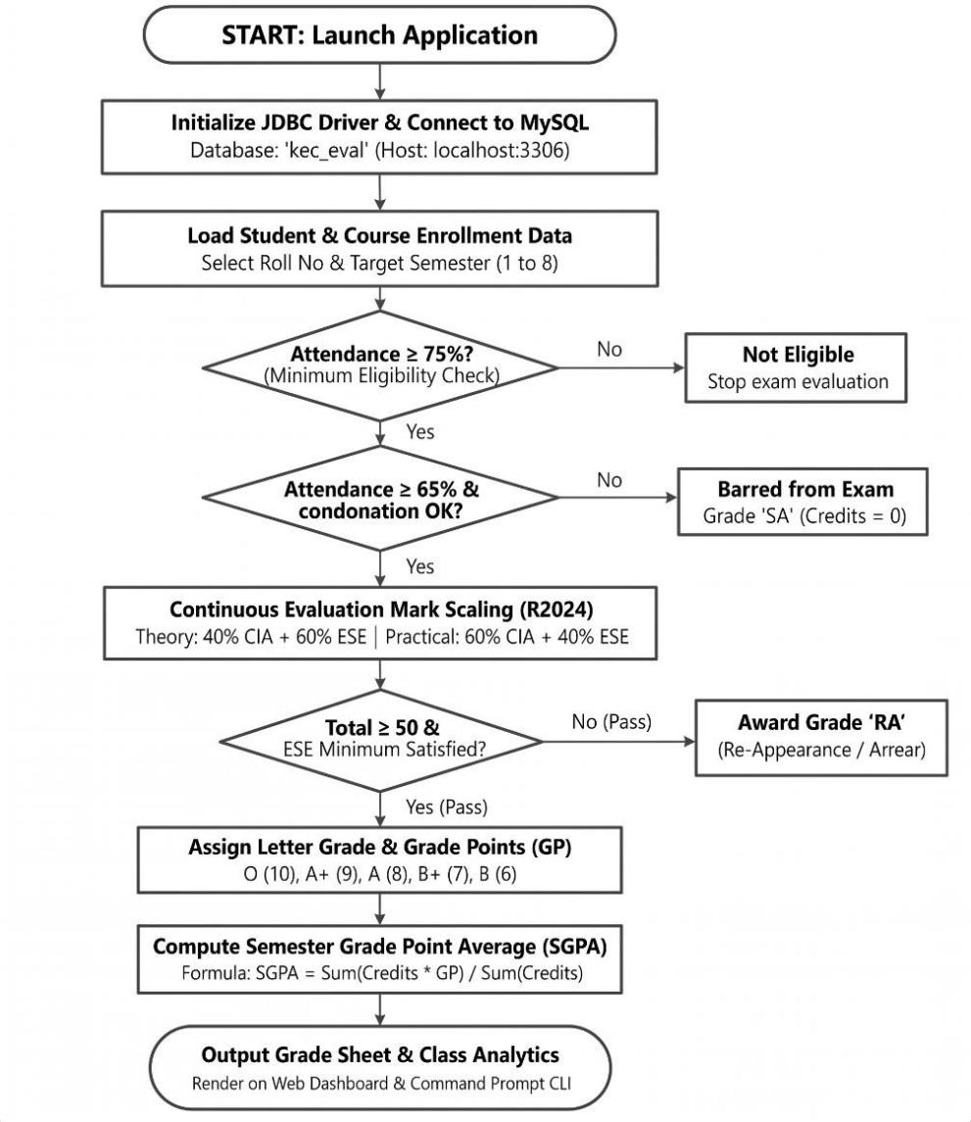

PROCEDURE:
- Load the MySQL Connector/J driver to enable communication between the Java application and the MySQL database.

- Establish a connection to the kec_eval database running on the local MySQL server using DriverManager.getConnection().

- Store and retrieve student details, including roll number, name, department, and semester, along with course information such as course code, title, credits, and course type.

- Enroll students in semester courses, record the number of classes held and attended, and calculate the attendance percentage.

- Verify examination eligibility based on attendance percentage. Students with 75% or above are eligible, those with 65%–74% require medical condonation verification, and those below 65% are marked as Shortage of Attendance (SA).

- Record CIA-1, CIA-2, CIA-3 and assignment marks, and calculate the scaled internal assessment marks according to the specified theory and practical course weightages.

- Record end-semester examination marks out of 100, verify the minimum passing requirements, and scale the marks according to the applicable theory and practical .

- Calculate the total marks by combining scaled CIA and ESE marks. Assign letter grades and grade points according to the specified grading scale, marking students as RA if they fail the examination or score below the required passing mark.

- Generate student grade sheets, attendance shortage reports, and department-wise pass percentage reports. Display the results through the interactive web dashboard and the command prompt console.

DATABASE SCHEMA:

- STUDENTS TABLE:
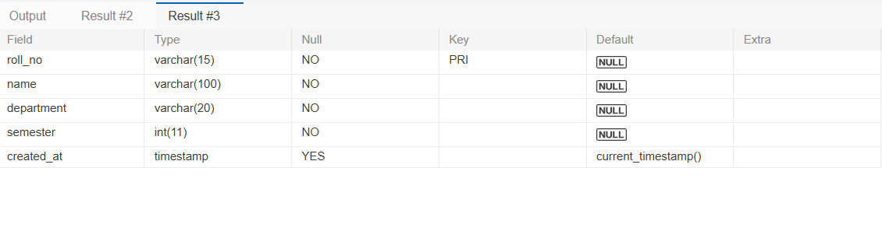

COURSES TABLE:

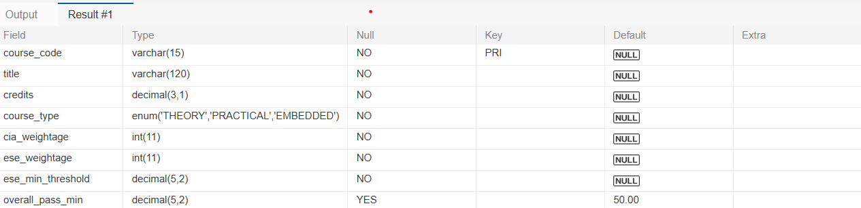

ENROLLMENTS TABLE:

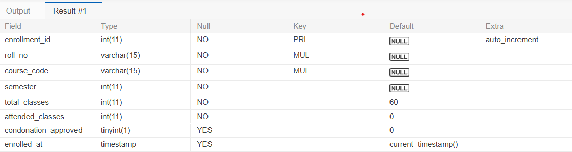

ASSESSMENT MARKS TABLE:
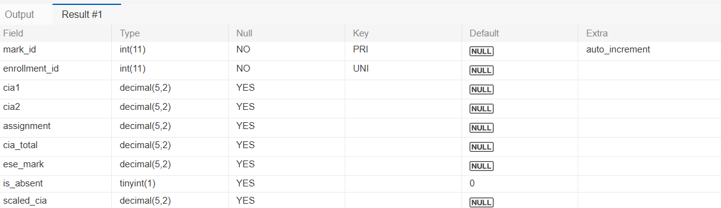

SOURCE CODE: MAINAPP.JAVA:

import java.sql.SQLException;

import java.util.List;

import java.util.Scanner;

/**

* MainApp - Menu-Driven Command Line Application

* Kongu Engineering College (Autonomous), Perundurai, Erode

* Regulation 2024 (R2024) - Student Academic & Continuous Evaluation System

*/

public class MainApp {

private static final StudentDAO studentDAO = new StudentDAO();

private static final AcademicDAO academicDAO = new AcademicDAO();

private static final Scanner scanner = new Scanner(System.in);

public static void main(String[] args) {

if (args.length > 0 && ("--demo".equalsIgnoreCase(args[0]) || "--verify".equalsIgnoreCase(args[0]))) {

runAutomatedDemonstration();

return;

}

printBanner();

if (!DBConnection.testConnection()) {

System.err.println("CRITICAL ERROR: Failed to establish connection to MySQL database 'kec_eval_db'.");

System.err.println("Please check your database server at localhost:3306 (user: root, pass: 1234).");

return;

}

boolean running = true;

while (running) {

printMainMenu();

System.out.print("Select an option (0-12): ");

String input = scanner.nextLine().trim();

try {

switch (input) {

case "1": registerStudentMenu(); break;

case "2": addCourseMenu(); break;

case "3": enrollStudentMenu(); break;

case "4": recordPhase1MarksMenu(); break;

case "5": recordPhase2MarksMenu(); break;

case "6": recordPhase3MarksMenu(); break;

case "7": runEvaluationEngineMenu(); break;

case "8": generateStudentMarkSheetMenu(); break;

case "9": generateAttendanceDefaultersMenu(); break;

case "10": generateClassSummaryMenu(); break;

case "11": viewMasterDataMenu(); break;

case "12": runAutomatedDemonstration(); break;

case "0":

running = false;

System.out.println("\nThank you for using KEC R2024 Evaluation System. Goodbye!");

break;

default:

System.out.println("Invalid selection. Please enter a valid number (0-12).");

}

} catch (Exception e) {

System.err.println("Error: " + e.getMessage());

}

if (running) {

System.out.println("\nPress Enter to return to main menu...");

scanner.nextLine();

}

}

}

private static void printBanner() {

System.out.println("=======================================================================================");

System.out.println(" KONGU ENGINEERING COLLEGE (AUTONOMOUS) - REGULATION 2024 (R2024) ");

System.out.println(" STUDENT ACADEMIC & CONTINUOUS EVALUATION SYSTEM (JDBC) ");

System.out.println("=======================================================================================");

}

private static void printMainMenu() {

System.out.println("\n---------------------------------- MAIN MENU ------------------------------------------");

System.out.println(" [1] Student Registration (Add Student)");

System.out.println(" [2] Course Catalog Management (Add Course)");

System.out.println(" [3] Course Enrollment & Attendance Tracking");

System.out.println(" [4] Incremental Marks Entry: Phase 1 (Mid-Semester: CIA 1 & CIA 2)");

System.out.println(" [5] Incremental Marks Entry: Phase 2 (End-of-Semester: Assignments/Lab)");

System.out.println(" [6] Incremental Marks Entry: Phase 3 (Post-Semester: ESE Marks & Absence)");

System.out.println(" [7] Execute KEC R2024 Evaluation Engine (Compute Grades & Thresholds)");

System.out.println(" [8] Generate Student Semester Mark Sheet (SGPA & Equivalent %)");

System.out.println(" [9] Generate Attendance Defaulter Report (Grade SA)");

System.out.println(" [10] Generate Department & Class Performance Summary");

System.out.println(" [11] View All Master Data (Students, Courses, Enrollments)");

System.out.println(" [12] Run Comprehensive Automated Demonstration & Verification");

System.out.println(" [0] Exit System");

System.out.println("---------------------------------------------------------------------------------------");

}

private static void registerStudentMenu() throws SQLException {

System.out.println("\n--- [1] Student Registration ---");

System.out.print("Enter Roll Number (e.g. 24ITR005): ");

String rollNo = scanner.nextLine().trim();

if (rollNo.isEmpty()) return;

System.out.print("Enter Student Full Name: ");

String name = scanner.nextLine().trim();

System.out.print("Enter Department (IT, CSE, ECE, MECH, etc.): ");

String dept = scanner.nextLine().trim();

System.out.print("Enter Current Semester (1-8): ");

int sem = Integer.parseInt(scanner.nextLine().trim());

Student s = new Student(rollNo, name, dept, sem);

boolean ok = studentDAO.addStudent(s);

if (ok) {

System.out.println("SUCCESS: Student " + rollNo + " (" + name + ") registered successfully!");

} else {

System.out.println("FAILED: Could not register student.");

}

}

private static void addCourseMenu() throws SQLException {

System.out.println("\n--- [2] Course Catalog Management ---");

System.out.print("Enter Course Code (e.g. 24ITR34): ");

String code = scanner.nextLine().trim();

System.out.print("Enter Course Title: ");

String title = scanner.nextLine().trim();

System.out.print("Enter Credits (e.g. 3.0, 4.0, 1.5): ");

double credits = Double.parseDouble(scanner.nextLine().trim());

System.out.print("Enter Course Type (THEORY / PRACTICAL / EMBEDDED): ");

String type = scanner.nextLine().trim().toUpperCase();

try {

Course c = new Course(code, title, credits, type);

boolean ok = studentDAO.addCourse(c);

if (ok) {

System.out.println("SUCCESS: Course " + code + " added successfully!");

System.out.printf(" Rules: CIA Weight = %d%% | ESE Weight = %d%% | ESE Min Threshold = %.0f%%\n",

c.getCiaWeightage(), c.getEseWeightage(), c.getEseMinThreshold());

} else {

System.out.println("FAILED: Could not add course.");

}

} catch (IllegalArgumentException ex) {

System.out.println("Error: " + ex.getMessage());

}

}

private static void enrollStudentMenu() throws SQLException {

System.out.println("\n--- [3] Course Enrollment & Attendance Tracking ---");

System.out.print("Enter Student Roll Number: ");

String rollNo = scanner.nextLine().trim().toUpperCase();

Student st = studentDAO.getStudentByRollNo(rollNo);

if (st == null) {

System.out.println("Student with Roll Number " + rollNo + " does not exist.");

return;

}

System.out.print("Enter Course Code: ");

String courseCode = scanner.nextLine().trim().toUpperCase();

Course c = studentDAO.getCourseByCode(courseCode);

if (c == null) {

System.out.println("Course with Code " + courseCode + " does not exist.");

return;

}

System.out.print("Enter Semester (default " + st.getSemester() + "): ");

String semStr = scanner.nextLine().trim();

int sem = semStr.isEmpty() ? st.getSemester() : Integer.parseInt(semStr);

System.out.print("Enter Total Classes Held (e.g. 60): ");

int total = Integer.parseInt(scanner.nextLine().trim());

System.out.print("Enter Classes Attended (e.g. 50): ");

int attended = Integer.parseInt(scanner.nextLine().trim());

System.out.print("Is Medical Condonation Approved? (yes/no, default no): ");

String condStr = scanner.nextLine().trim();

boolean cond = "yes".equalsIgnoreCase(condStr) || "y".equalsIgnoreCase(condStr);

int id = studentDAO.enrollStudent(rollNo, courseCode, sem, total, attended, cond);

if (id > 0) {

double pct = total > 0 ? (attended * 100.0) / total : 0;

System.out.printf("SUCCESS: Enrolled student %s in %s! (Enrollment ID: %d)\n", rollNo, courseCode, id);

System.out.printf(" Attendance: %d/%d (%.1f%%) - %s\n", attended, total, pct,

pct >= 75 ? "Eligible" : (pct >= 65 && cond ? "Condoned" : "SA Barred"));

} else {

System.out.println("FAILED: Could not enroll student.");

}

}

private static void recordPhase1MarksMenu() throws SQLException {

System.out.println("\n--- [4] Phase 1 (Mid-Semester): CIA 1 & CIA 2 Entry ---");

System.out.print("Enter Enrollment ID: ");

int id = Integer.parseInt(scanner.nextLine().trim());

Enrollment e = studentDAO.getEnrollmentById(id);

if (e == null) {

System.out.println("Enrollment ID #" + id + " not found.");

return;

}

System.out.printf("Student: %s (%s) | Course: %s (%s)\n",

e.getRollNo(), e.getStudentName(), e.getCourseCode(), e.getCourseTitle());

System.out.print("Enter CIA Test 1 Marks (0-100): ");

double cia1 = Double.parseDouble(scanner.nextLine().trim());

System.out.print("Enter CIA Test 2 Marks (0-100): ");

double cia2 = Double.parseDouble(scanner.nextLine().trim());

boolean ok = academicDAO.recordPhase1Marks(id, cia1, cia2);

if (ok) {

System.out.printf("SUCCESS: Phase 1 Marks recorded for Enrollment #%d (CIA1: %.1f, CIA2: %.1f, Avg: %.1f)\n",

id, cia1, cia2, (cia1 + cia2) / 2.0);

}

}

private static void recordPhase2MarksMenu() throws SQLException {

System.out.println("\n--- [5] Phase 2 (End of Semester - CIA): Assignments/Quizzes/Lab Entry ---");

System.out.print("Enter Enrollment ID: ");

int id = Integer.parseInt(scanner.nextLine().trim());

Enrollment e = studentDAO.getEnrollmentById(id);

if (e == null) {

System.out.println("Enrollment ID #" + id + " not found.");

return;

}

System.out.printf("Student: %s (%s) | Course: %s (%s)\n",

e.getRollNo(), e.getStudentName(), e.getCourseCode(), e.getCourseTitle());

System.out.print("Enter Assignment / Quiz / Lab Evaluation Marks (0-100): ");

double assign = Double.parseDouble(scanner.nextLine().trim());

boolean ok = academicDAO.recordPhase2Marks(id, assign);

if (ok) {

System.out.printf("SUCCESS: Phase 2 Marks recorded for Enrollment #%d (Assignment: %.1f)\n", id, assign);

}

}

private static void recordPhase3MarksMenu() throws SQLException {

System.out.println("\n--- [6] Phase 3 (Post Semester): End Semester Exam (ESE) Entry ---");

System.out.print("Enter Enrollment ID: ");

int id = Integer.parseInt(scanner.nextLine().trim());

Enrollment e = studentDAO.getEnrollmentById(id);

if (e == null) {

System.out.println("Enrollment ID #" + id + " not found.");

return;

}

System.out.printf("Student: %s (%s) | Course: %s (%s)\n",

e.getRollNo(), e.getStudentName(), e.getCourseCode(), e.getCourseTitle());

System.out.printf("Attendance Status: %s (%.1f%%)\n", e.getAttendanceStatus(), e.getAttendancePercentage());

if (!e.isEligibleForESE()) {

System.out.println("WARNING: Student is BARRED from ESE due to Shortage of Attendance (Grade SA awarded).");

}

System.out.print("Was the student ABSENT in ESE? (yes/no): ");

String absStr = scanner.nextLine().trim();

boolean isAbsent = "yes".equalsIgnoreCase(absStr) || "y".equalsIgnoreCase(absStr);

Double eseMark = null;

if (!isAbsent) {

System.out.print("Enter End Semester Exam (ESE) Marks (0-100): ");

eseMark = Double.parseDouble(scanner.nextLine().trim());

}

boolean ok = academicDAO.recordPhase3Marks(id, eseMark, isAbsent);

if (ok) {

academicDAO.evaluateEnrollment(id);

System.out.println("SUCCESS: Phase 3 Marks recorded and evaluated for Enrollment #" + id + "!");

}

}

private static void runEvaluationEngineMenu() throws SQLException {

System.out.println("\n--- [7] Execute KEC R2024 Evaluation Engine ---");

System.out.println("1. Evaluate Single Enrollment");

System.out.println("2. Evaluate All Enrollments in Database (Batch)");

System.out.print("Select (1 or 2): ");

String sel = scanner.nextLine().trim();

if ("1".equals(sel)) {

System.out.print("Enter Enrollment ID: ");

int id = Integer.parseInt(scanner.nextLine().trim());

boolean ok = academicDAO.evaluateEnrollment(id);

if (ok) {

System.out.println("SUCCESS: Evaluated Enrollment #" + id);

}

} else {

int count = academicDAO.evaluateAllEnrollments();

System.out.println("SUCCESS: Evaluated " + count + " enrollments using KEC R2024 rules!");

}

}

private static void generateStudentMarkSheetMenu() throws SQLException {

System.out.println("\n--- [8] Generate Student Semester Mark Sheet ---");

System.out.print("Enter Roll Number (e.g. 24ITR001): ");

String rollNo = scanner.nextLine().trim().toUpperCase();

System.out.print("Enter Semester (e.g. 3): ");

int sem = Integer.parseInt(scanner.nextLine().trim());

AcademicDAO.StudentMarkSheet sheet = academicDAO.getStudentSemesterMarkSheet(rollNo, sem);

if (sheet == null) {

System.out.println("No records found for Roll Number " + rollNo);

return;

}

renderMarkSheet(sheet);

}

public static void renderMarkSheet(AcademicDAO.StudentMarkSheet sheet) {

System.out.println("\n" + "=".repeat(105));

System.out.println(" KONGU ENGINEERING COLLEGE (AUTONOMOUS)");

System.out.println(" AFFILIATED TO ANNA UNIVERSITY | REGULATION 2024");

System.out.println(" STUDENT SEMESTER GRADE SHEET");

System.out.println("=".repeat(105));

System.out.printf(" Roll Number : %-15s Student Name : %-30s\n", sheet.student.getRollNo(), sheet.student.getName());

System.out.printf(" Department : %-15s Semester : %-30d\n", sheet.student.getDepartment(), sheet.semester);

System.out.println("-".repeat(105));

System.out.printf("%-9s | %-28s | %-9s | %-4s | %-6s | %-6s | %-6s | %-6s | %-5s | %-3s | %-12s\n",

"Code", "Course Title", "Type", "Cred", "Att %", "CIA", "ESE", "Total", "Grade", "GP", "Status");

System.out.println("-".repeat(105));

for (AcademicDAO.MarkSheetRow r : sheet.rows) {

String ciaStr = r.scaledCia != null ? String.format("%5.1f", r.scaledCia) : "-";

String eseStr = r.isAbsent ? " AB" : (r.scaledEse != null ? String.format("%5.1f", r.scaledEse) : "-");

String totStr = r.totalMarks != null ? String.format("%5.1f", r.totalMarks) : "-";

System.out.printf("%-9s | %-28s | %-9s | %4.1f | %5.1f%% | %6s | %6s | %6s | %5s | %3d | %-12s\n",

r.courseCode,

truncate(r.courseTitle, 28),

r.courseType,

r.credits,

r.attendancePct,

ciaStr,

eseStr,

totStr,

r.letterGrade,

r.gradePoint,

r.resultStatus);

}

System.out.println("-".repeat(105));

System.out.printf(" Total Credits Enrolled : %-6.1f Total Credits Earned : %-6.1f\n",

sheet.totalEnrolledCredits, sheet.totalEarnedCredits);

System.out.printf(" SEMESTER GRADE POINT AVERAGE (SGPA) : %-6.2f EQUIVALENT PERCENTAGE : %-5.2f %%\n",

sheet.sgpa, sheet.equivalentPercentage);

System.out.printf(" SEMESTER RESULT STATUS : %-15s\n", sheet.overallStatus);

System.out.println("=".repeat(105));

}

private static void generateAttendanceDefaultersMenu() throws SQLException {

System.out.println("\n--- [9] Attendance Defaulter Report (< 65% Barred from ESE) ---");

List<AcademicDAO.DefaulterRecord> list = academicDAO.getAttendanceDefaulters();

renderDefaulterReport(list);

}

public static void renderDefaulterReport(List<AcademicDAO.DefaulterRecord> list) {

System.out.println("\n" + "=".repeat(105));

System.out.println(" KONGU ENGINEERING COLLEGE (AUTONOMOUS)");

System.out.println(" ATTENDANCE DEFAULTER REPORT (REGULATION 2024)");

System.out.println("=".repeat(105));

System.out.printf("%-10s | %-20s | %-5s | %-9s | %-10s | %-7s | %-5s | %-30s\n",

"Roll No", "Student Name", "Dept", "Course", "Attended", "Att %", "Grade", "Remarks");

System.out.println("-".repeat(105));

if (list.isEmpty()) {

System.out.println("No attendance defaulters found! All enrolled students meet eligibility criteria.");

} else {

for (AcademicDAO.DefaulterRecord r : list) {

System.out.printf("%-10s | %-20s | %-5s | %-9s | %3d/%-3d | %5.1f%% | %-5s | %-30s\n",

r.rollNo,

truncate(r.studentName, 20),

r.department,

r.courseCode,

r.attendedClasses,

r.totalClasses,

r.attendancePct,

r.assignedGrade,

truncate(r.remarks, 30));

}

}

System.out.println("=".repeat(105));

System.out.println("Rule: Attendance < 65% is barred from ESE and awarded grade 'SA' (0 Grade Points).");

System.out.println(" Attendance 65%-74.9% requires Medical Condonation approval.");

}

private static void generateClassSummaryMenu() throws SQLException {

System.out.println("\n--- [10] Class Performance & Result Summary ---");

List<AcademicDAO.DepartmentSummary> list = academicDAO.getClassPerformanceSummary();

renderClassSummary(list);

}

public static void renderClassSummary(List<AcademicDAO.DepartmentSummary> list) {

System.out.println("\n" + "=".repeat(105));

System.out.println(" KONGU ENGINEERING COLLEGE (AUTONOMOUS)");

System.out.println(" CLASS PERFORMANCE & RESULT SUMMARY (REGULATION 2024)");

System.out.println("=".repeat(105));

System.out.printf("%-8s | %-10s | %-10s | %-6s | %-6s | %-6s | %-6s | %-8s | %-12s\n",

"Dept", "Students", "Attempts", "Pass", "Fail", "SA", "AB", "Pass %", "Avg SGPA");

System.out.println("-".repeat(105));

for (AcademicDAO.DepartmentSummary s : list) {

System.out.printf("%-8s | %-10d | %-10d | %-6d | %-6d | %-6d | %-6d | %6.2f%% | %8.2f\n",

s.department,

s.totalStudents,

s.totalCourseAttempts,

s.passCount,

s.failCount,

s.saCount,

s.abCount,

s.passPercentage,

s.classAverageSGPA);

}

System.out.println("=".repeat(105));

}

private static void viewMasterDataMenu() throws SQLException {

System.out.println("\n=========================== REGISTERED STUDENTS ===========================");

List<Student> students = studentDAO.getAllStudents();

for (Student s : students) System.out.println(s);

System.out.println("\n============================= COURSE CATALOG ==============================");

List<Course> courses = studentDAO.getAllCourses();

for (Course c : courses) System.out.println(c);

System.out.println("\n======================== ENROLLMENTS & ATTENDANCE =========================");

List<Enrollment> enrollments = studentDAO.getAllEnrollments();

for (Enrollment e : enrollments) System.out.println(e);

}

public static void runAutomatedDemonstration() {

System.out.println("\n" + "#".repeat(105));

System.out.println(" KONGU ENGINEERING COLLEGE (R2024) - AUTOMATED VERIFICATION & PROOF OF EXECUTION");

System.out.println("#".repeat(105));

try {

// Proof 1: Adding a new student and course

String newRoll = "24ITR005";

System.out.println("\n>>> PROOF 1: ADDING A NEW STUDENT AND COURSE");

System.out.println("Adding Student: " + newRoll + " (Dharani P, IT, Semester 3)...");

Student newStudent = new Student(newRoll, "Dharani P", "IT", 3);

studentDAO.addStudent(newStudent);

System.out.println("Registered: " + studentDAO.getStudentByRollNo(newRoll));

String newCourse = "24ITR34";

System.out.println("\nAdding Course: " + newCourse + " (Cloud Computing, Credits: 3.0, Type: THEORY)...");

Course course = new Course(newCourse, "Cloud Computing Principles", 3.0, "THEORY");

studentDAO.addCourse(course);

System.out.println("Added Course: " + studentDAO.getCourseByCode(newCourse));

System.out.println("\nEnrolling " + newRoll + " into " + newCourse + " (Total: 60, Attended: 52 -> 86.7%)...");

int enrollId1 = studentDAO.enrollStudent(newRoll, newCourse, 3, 60, 52, false);

System.out.println("Enrolling " + newRoll + " into 24ITR38 (Lab, Total: 30, Attended: 27 -> 90.0%)...");

int enrollId2 = studentDAO.enrollStudent(newRoll, "24ITR38", 3, 30, 27, false);

// Proof 2: Incremental marks entry

System.out.println("\n>>> PROOF 2: INCREMENTAL MARKS ENTRY (PHASE 1, PHASE 2, PHASE 3)");

System.out.println("--- Phase 1 (Mid-Semester): Recording CIA 1 & CIA 2 ---");

academicDAO.recordPhase1Marks(enrollId1, 88.0, 92.0);

academicDAO.recordPhase1Marks(enrollId2, 94.0, 96.0);

System.out.println("Phase 1 Recorded: CIA1=88.0, CIA2=92.0 for " + newCourse);

System.out.println("Phase 1 Recorded: CIA1=94.0, CIA2=96.0 for 24ITR38");

System.out.println("\n--- Phase 2 (End-of-Semester): Recording Assignments/Lab Evaluations ---");

academicDAO.recordPhase2Marks(enrollId1, 95.0);

academicDAO.recordPhase2Marks(enrollId2, 98.0);

System.out.println("Phase 2 Recorded: Assignment=95.0 for " + newCourse);

System.out.println("Phase 2 Recorded: Lab Evaluation=98.0 for 24ITR38");

System.out.println("\n--- Phase 3 (Post-Semester): Recording ESE Examination Marks ---");

academicDAO.recordPhase3Marks(enrollId1, 84.0, false);

academicDAO.recordPhase3Marks(enrollId2, 92.0, false);

System.out.println("Phase 3 Recorded: ESE Mark=84.0 for " + newCourse);

System.out.println("Phase 3 Recorded: ESE Mark=92.0 for 24ITR38");

System.out.println("\n--- Testing Absent Scenario (AB) ---");

int enrollAb = studentDAO.enrollStudent("24CSR015", "24ITR31", 3, 60, 50, false);

academicDAO.recordPhase1Marks(enrollAb, 75.0, 78.0);

academicDAO.recordPhase2Marks(enrollAb, 80.0);

academicDAO.recordPhase3Marks(enrollAb, null, true);

System.out.println("Recorded ESE as ABSENT for 24CSR015 in 24ITR31");

System.out.println("\nExecuting KEC R2024 Evaluation Engine on all records...");

academicDAO.evaluateAllEnrollments();

// Proof 3: Render Mark Sheet

System.out.println("\n>>> PROOF 3: GENERATED FORMAL GRADE SHEET WITH SGPA & PERCENTAGE");

AcademicDAO.StudentMarkSheet sheet1 = academicDAO.getStudentSemesterMarkSheet("24ITR001", 3);

renderMarkSheet(sheet1);

AcademicDAO.StudentMarkSheet sheetNew = academicDAO.getStudentSemesterMarkSheet(newRoll, 3);

renderMarkSheet(sheetNew);

// Proof 4: Render Attendance Defaulter Report

System.out.println("\n>>> PROOF 4: ATTENDANCE DEFAULTER REPORT (GRADE SA)");

List<AcademicDAO.DefaulterRecord> defaulters = academicDAO.getAttendanceDefaulters();

renderDefaulterReport(defaulters);

// Proof 5: Render Class Summary

System.out.println("\n>>> PROOF 5: CLASS PERFORMANCE & RESULT SUMMARY");

List<AcademicDAO.DepartmentSummary> summaries = academicDAO.getClassPerformanceSummary();

renderClassSummary(summaries);

System.out.println("\nALL SYSTEM VERIFICATIONS COMPLETED SUCCESSFULLY!");

} catch (Exception e) {

System.err.println("Demonstration failed: " + e.getMessage());

e.printStackTrace();

}

}

private static String truncate(String s, int len) {

if (s == null) return "";

if (s.length() <= len) return s;

return s.substring(0, len - 3) + "...";

}

}

DB CONNECTION.JAVA:

import java.sql.Connection;

import java.sql.DriverManager;

import java.sql.SQLException;

/**

* DBConnection - Database Connection Management for Kongu Engineering College (R2024)

* Student Academic & Continuous Evaluation System.

*

* Manages JDBC connections to MySQL database 'kec_eval_db'.

*/

public class DBConnection {

private static final String URL = "jdbc:mysql://localhost:3306/kec_eval_db?useSSL=false&allowPublicKeyRetrieval=true&serverTimezone=UTC";

private static final String USER = "root";

private static final String PASSWORD = "1234";

static {

try {

Class.forName("com.mysql.cj.jdbc.Driver");

} catch (ClassNotFoundException e) {

try {

Class.forName("com.mysql.jdbc.Driver");

} catch (ClassNotFoundException ex) {

System.err.println("[DBConnection] Warning: MySQL JDBC Driver class not found in classpath.");

}

}

}

public static Connection getConnection() throws SQLException {

return DriverManager.getConnection(URL, USER, PASSWORD);

}

public static void closeConnection(Connection conn) {

if (conn != null) {

try {

conn.close();

} catch (SQLException e) {

System.err.println("[DBConnection] Error closing connection: " + e.getMessage());

}

}

}

public static boolean testConnection() {

try (Connection conn = getConnection()) {

return conn != null && !conn.isClosed();

} catch (SQLException e) {

System.err.println("[DBConnection] Connection test failed: " + e.getMessage());

return false;

}

}

}

OUTPUT SCREENSHOTS:

MAIN MENU:

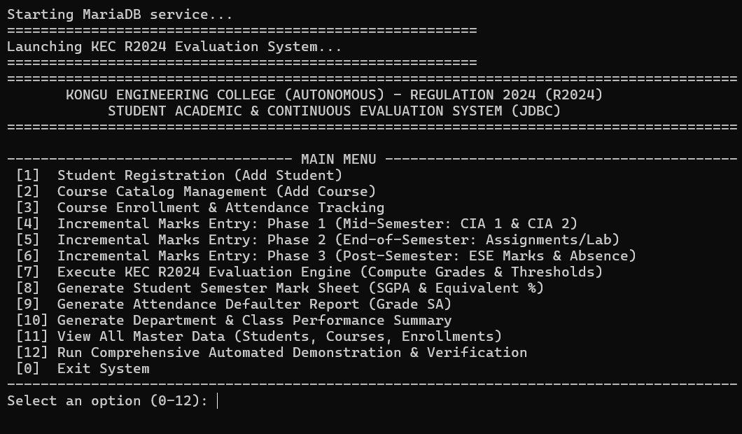

STUDENT & COURSE MANAGEMENT:

STUDENT REGISTRATION:
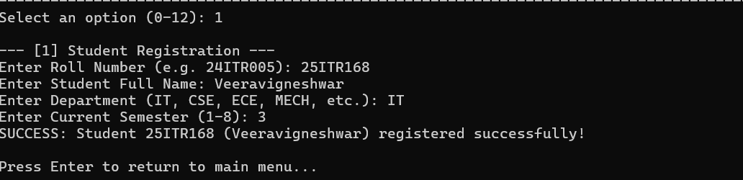

COURSE CATALOG:
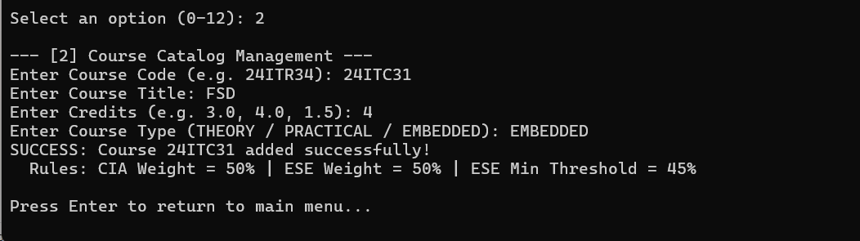

COURSE ENROLLMENT & ATTENDANCE TRACKING:
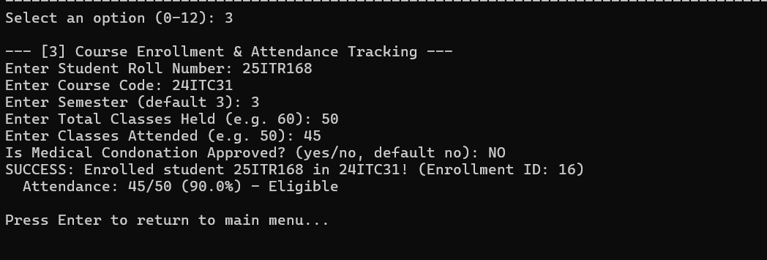

INCREMENTAL MARKS ENTRY:

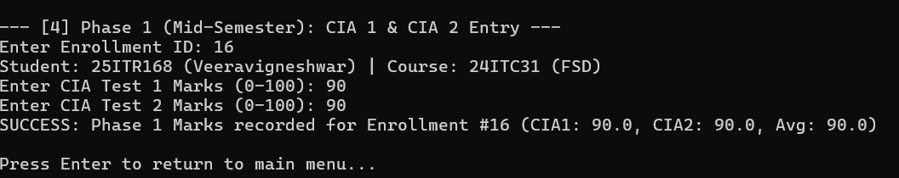

ATTENDANCE & GRADING RULES:

ATTENDANCE FILTER:
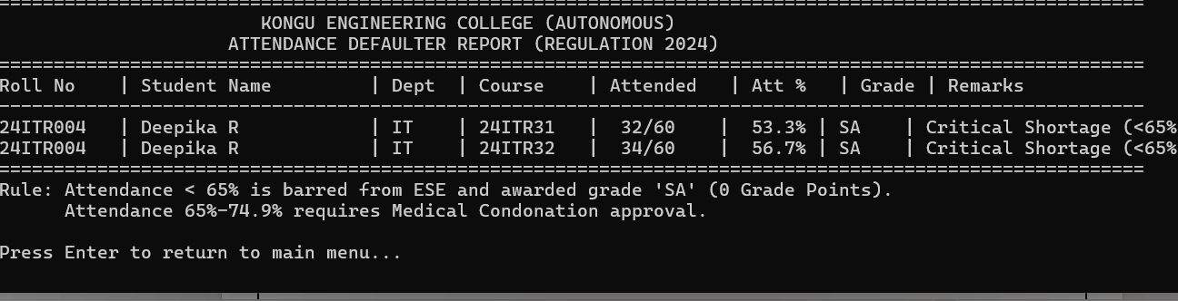

STUDENT MARK :
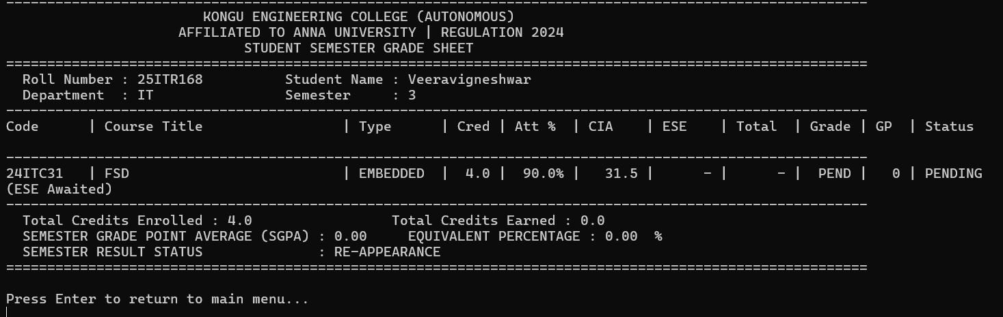

DATABASE:

STUDENTS DATABASE:

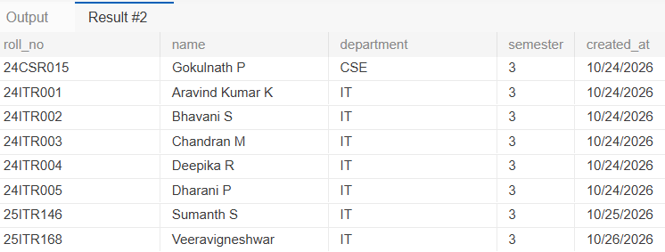

COURSES DATABASE:
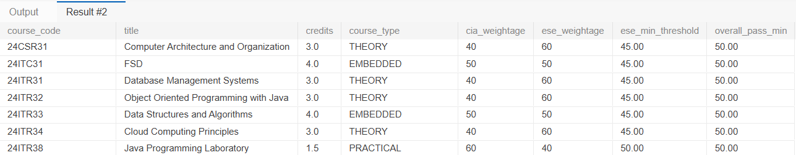

ENROLLMENTS DATABASE:
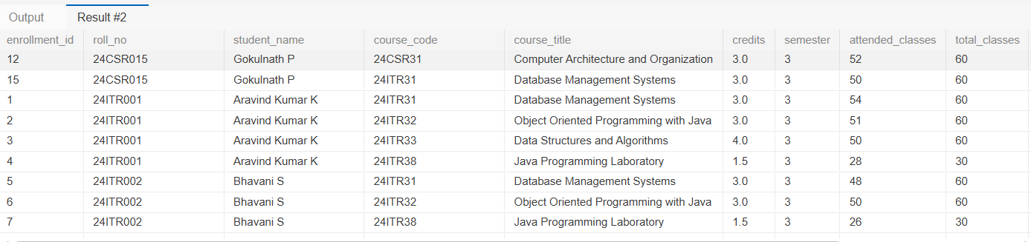

RESULT:

Thus, the Student Academic and Continuous Evaluation System for Kongu Engineering College (Autonomous) Regulation 2024 was successfully designed, developed, and tested using Java (JDBC) and MySQL. The system accurately automates the calculation of Continuous Internal Assessments (CIA), End Semester Examinations (ESE), Letter Grades, Attendance Eligibility, and Semester Grade Point Average (SGPA).

REFERENCES:
- Oracle, Java SE Documentation – JDBC Overview and Architecture. https://docs.oracle.com/javase/8/docs/technotes/guides/jdbc/ .
- Oracle, Java SE API – HttpServer. https://docs.oracle.com/en/java/javase/17/docs/api/jdk.httpserver/com/sun/net/httpserve r/HttpServer.html .
- Oracle, MySQL 8.0 Reference Manual. https://dev.mysql.com/doc/refman/8.0/en/ .

- Oracle, MySQL Connector/J Developer Guide. https://dev.mysql.com/doc/connector-j/8.0/en/ .
- University Grants Commission, Guidelines for Choice Based Credit System (CBCS). https://www.ugc.gov.in/pdfnews/8023719_Guidelines-for-CBCS.pdf .
- Chart.js, Chart.js Documentation. https://www.chartjs.org/docs/latest/ .

- Tailwind CSS, Tailwind CSS Documentation. https://tailwindcss.com/docs .

- GeeksforGeeks, Establishing JDBC Connection in Java. https://www.geeksforgeeks.org/establishing-jdbc-connection-in-java/ .
- YouTube, Java JDBC with MySQL Tutorial Videos. https://www.youtube.com/results?search_query=Java+JDBC+MySQL+tutorial .
- Anthropic, Claude AI Assistant (used for project ideas and guidance). https://claude.ai/ .

GITHUB:

LINK: | https://github.com/0MRX0-00/JDBC

