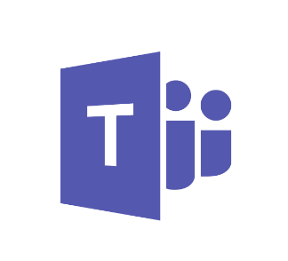

Practical Guidance for Microsoft Teams

Pre-Workshop Questionnaire

© 2017 Microsoft Corporation. All rights reserved. This document is provided "as-is." Information and views expressed in this document, including URL and other Internet Web site references, may change without notice.

This document does not provide you with any legal rights to any intellectual property in any Microsoft product. Microsoft Teams customers and partners may copy, use and share these materials for planning, deployment and operation of Microsoft Teams.

|  |  |  |
| --- | --- | --- |
| Version | Changes | Date |
| 1.0 | Initial Release | 14-Mar-2017 |
|  |  |  |

Please answer the following questionnaire to provide an overview of your existing Microsoft Office 365 environment. The results of this questionnaire will be used to customize the Microsoft Teams Plan, Deliver, Operate Workshop specifically for your organization.

|  |  |
| --- | --- |
| Question | Answer |
| Has your organization already deployed other Office 365 workloads? (Exchange Online, SharePoint Online, Skype for Business Online, etc.) |  |
| Has your organization configured a verified domain for Office 365?  If yes, please include the verified domain(s) in your answer. |  |
| Does your organization synchronize identities to Azure Active Directory? |  |
| How is Exchange deployed in your organization? | Exchange Online  Exchange Hybrid  Exchange On-premises  Not deployed |
| How is SharePoint deployed in your organization? | SharePoint Online  SharePoint Hybrid  SharePoint On-premises  Not deployed |
| How is Skype for Business deployed in your organization? | Skype for Business Online  Skype for Business Hybrid  Skype for Business On-premises  Not deployed |
| What Office 365 subscriptions does your organization currently use? | E5  E4  E3  E1  Other |