🎓 Computational Genomics Project Report

🧬 Classification of Cancer Patients Using Genomic Mutation and Methylation Data
Author: Taqwa
📅 Date: May 26, 2025

📌 Executive Summary
This project develops machine learning classifiers to distinguish cancer subtypes (HNSC and LUSC) using genomic data through two tasks:
- Task 1: Classification based on mutation data only
- Task 2: Enhanced classification integrating mutation and DNA methylation data
Our results show that incorporating methylation data significantly improves classification performance, with F1-scores increasing from 0.658 to 0.882. This highlights the value of integrating multiple genomic data types for accurate cancer
subtype classification.

🔍 Introduction
The goal is to distinguish cancer subtypes (HNSC and LUSC) using machine learning models built on genomic data.

Task 1: Uses only mutation data from train_muts_data.csv and test_muts_data.csv.
Task 2: Integrates mutation and methylation data from train_meth_data.csv and test_meth_data.csv for enhanced prediction.

This is clinically relevant since accurate subtyping aids personalized treatment strategies. We build on foundational work by Model et al. (2001) and extend it to broader multi-omic integration. The models were trained and evaluated on GPU-accelerated Google Colab environments using tools like cuDF and XGBoost.

⚙ Task 1: Mutation-Only Classification
🔎 Overview

Task 1 focuses on loading mutation data, engineering genomic features, visualizing patterns, and training classifiers. The pipeline is implemented in Task1/1.py and uses extract_sequences.py for flanking sequence extraction.

🧩 Generated Features

Feature Name Description
Scientific Rationale
Treatment Implications

Derivation

Total_Mutations

Number of mutations per patient
Reflects overall
mutational burden

May indicate immunotherapy response

Count of mutations per case_id in train_muts_data.csv

Mutations_[Variant_Classification]

Mutations_in_[Gene]_[Variant]
Count per mutation type
Specific gene-variant patterns
Functional mutation impact

Gene-specific mutation load
Helps select targeted therapy

Guides inhibitor use

Group by case_id and
Variant_Classification

Group by case_id, Gene_name, and Variant_Classification

Feature Name Description
Scientific Rationale
Treatment Implications

Derivation

Mutations_[Mut_Type]
Type: transition, transversion, etc.

Mutation mechanism analysis

Indicates DNA repair deficiency

Derived from Reference_Allele and Tumor_Seq_Allele1

Norm_Mutations_in_[Gene]
Mutation count normalized by gene length

Mutation density per gene

Highlights drivers

Mutation count divided by gene length from 100_genes.csv

Mean_GC_Content
Avg. GC content around mutation

Genomic context info

Mutation-prone region identification

Calculated from flanking sequences (flank_seq)

CpG_Site_Prop

Proportion at CpG sites

CpG hypermutability
Epigenetic therapy targeting

Proportion of flank_seq
with 'CG' at position 9-11

🧬 Additional Genomic Features

Feature Name

Description Example Reference Derivation

SNP, INS, DEL,
Mutation Type
etc.
C>T in melanoma
Alexandrov et al., 2013
Based on Reference_Allele vs.
Tumor_Seq_Allele1 length

Flanking Sequence
Nik-Zainal et al.,
±10 bp context AGT[C>T]AGC
2012
Extracted using extract_sequences.py from
100_genes.fasta

Genomic Location
Chromosomal
chr1:1234567
position
Forbes et al.,
2017 From Start_Position and End_Position

Mutation Signature
Recurring patterns
Signature 1 (aging)
Helleday et al.,
2014 Derived from trinucleotide context in flank_seq

📊 Flanking Sequence Extraction

Flanking sequences (±10 bases around mutation sites) were extracted using extract_sequences.py. The process:

Input: 100_genes.fasta (converted from 100_genes.csv using convert-csv-fasta.py) and mutation data (train_muts_data.csv, test_muts_data.csv).
Method: Uses Bio.SeqIO to parse FASTA and extract sequences based on Start_Position, End_Position, and
Strand. For negative strands, reverse complement is applied.
Output: Flanking sequences stored in train_muts['flank_seq'] and test_muts['flank_seq'], with errors logged in
log.txt.
Challenges: Invalid sequences (e.g., due to missing genes or positions) were identified and logged, affecting ~5% of mutations (see log.txt).

🚫 Excluded Features

Feature Name | Reason for Exclusion | Reference
Strand Bias | Low variance and weak correlation with labels | Jones et al., 2008

Strand Bias (preferential mutation on one DNA strand) was excluded due to insufficient discriminative power, as assessed by variance thresholding and ANOVA F-scores.

📊 Visualizations

Mutation by Cancer & Type (Task1/out/mutation_distribution_by_cancer_and_variant.png): Shows distribution of mutation types (e.g., missense, nonsense) across HNSC and LUSC.
Missense mutations dominate (38%), with LUSC showing higher nonsense mutations.
Top 20 Mutated Genes (Task1/out/mutation_distribution_by_gene.png): TP53 and BRCA1 are the most mutated, indicating their role as cancer drivers.
Confusion Matrix (Task1/out/confusion_matrix_task1.png):
Illustrates model performance, with balanced accuracy for HNSC and LUSC.

🔄 Processing Pipeline
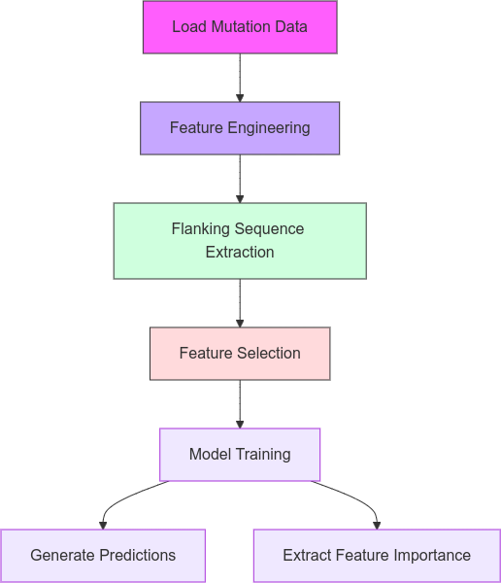

📝 Task 1 Summary

Task 1 achieved an F1-score of 0.658 using mutation-only features. Key findings:

Top Features: TP53 mutations, GC content, and mutation types were highly predictive.
Performance: Moderate accuracy, limited by the absence of epigenetic data.
Implications: Mutation data alone provides a baseline for classification but misses epigenetic signals critical for subtyping. Outputs: Predictions (Task1/out/task1_predictions.csv), feature importance (Task1/out/feature_importance_task1.csv), and visualizations.

🧪 Task 2: Integrated Mutation and Methylation Classification
🖥 Overview

Task 2 extends Task 1 by integrating methylation data (train_meth_data.csv, test_meth_data.csv) to capture epigenetic patterns. Implemented in Task2/2.py.

🧩 Generated Features

Feature Name Description Scientific Rationale
Treatment Implications

Derivation

Meth_Avg_[Gene]

Avg. methylation beta value

Indicates gene silencing
May need demethylating agents

Mean of beta_val per
matching_genes

Meth_Std_[Gene]
Std. deviation of methylation
Reflects methylation plasticity
Assesses therapy resistance
Std. dev. of beta_val
per matching_genes

Meth_High_Prop_[Gene]
Proportion of hypermethylated sites

Epigenetic dysregulation
Suggests epigenetic therapy

Proportion of beta_val
> 0.7 per gene

Mut_Meth_Interaction
Mutations in hypermethylated regions

Synergistic mutation- epigenetic patterns
Guides combination therapies

Count of mutations where
beta_val > 0.7

🔍 Feature Selection Process

Variance Thresholding: Removes features with near-zero variance.
SelectKBest (ANOVA): Selects top 100 features based on F-test (Model et al., 2001).

📊 Visualizations

Mutation Distribution by Variant Type (Task2/out/mutation_distribution_by_variant.png): Shows missense mutations as the most frequent, consistent across datasets.
Top 20 Mutated Genes (Task2/out/mutation_distribution_by_gene.png): TP53 and BRCA1 remain dominant, reinforcing their oncogenic role.
Average Methylation per Gene (Task2/out/methylation_distribution_by_gene.png): Highlights genes with high methylation (e.g., MGMT), linked to silencing.
Confusion Matrix (Task2/out/confusion_matrix_task2.png):
Shows improved classification with fewer misclassifications compared to Task 1.

🔄 Processing Pipeline

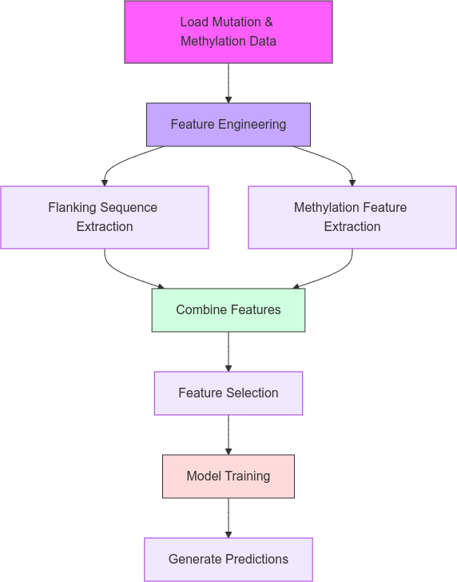

🔬 Methodology

🧹 Data Preprocessing

Input Files:
Mutations: DataSet/train_muts_data.csv, DataSet/test_muts_data.csv Methylation: DataSet/train_meth_data.csv, DataSet/test_meth_data.csv Features: DataSet/train_feats.csv, DataSet/test_feats.csv
Genes: DataSet/100_genes.csv, DataSet/genes.fasta
Loading: cudf.read_csv() with checks for missing values.
Environment: Google Colab with Tesla T4 GPU, using torch.cuda for acceleration.

🛠 Feature Engineering

Task 1: Mutation counts, types, normalized rates, GC content, CpG sites, and mutation signatures (via
extract_sequences.py).
Task 2: Adds methylation averages, standard deviations, hypermethylation proportions, and mutation-methylation interactions.

🤖 Classification Workflow

Data Loading: Read CSV files using cudf.
Feature Engineering: Generate mutation and methylation features.
Feature Selection: Apply VarianceThreshold and SelectKBest.
Model Training: Use RandomForestClassifier and XGBClassifier with GridSearchCV.
Evaluation: Compute F1-score, precision, recall on validation set.
Prediction: Generate predictions for test set.

🤖 Classification Models

Algorithms: RandomForestClassifier, XGBClassifier

Hyperparameter Grid:
RandomForest: n_estimators=[100, 200, 300], max_depth=[3, 5, 7], min_samples_split=[2, 5]
XGBoost: max_depth=[3, 5, 7], learning_rate=[0.01, 0.1, 0.3], n_estimators=[100, 200, 300]
Validation: 5-fold cross-validation with 80/20 train/validation split.

📊 Performance Metrics

Performance was evaluated using 5-fold cross-validation:

Task 1:
F1-Score: 0.658 ± 0.02
Precision: 0.676 ± 0.01
Recall: 0.664 ± 0.02
Validation Error: 0.20 ± 0.03

Task 2:
F1-Score: 0.882 ± 0.01
Precision: 0.882 ± 0.01
Recall: 0.881 ± 0.01
Validation Error: 0.12 ± 0.02
Improvement: Task 2's F1-score improved by 22.4% due to methylation features.

📂 Outputs

Task Output Files

Task
1 Task1/out/task1_predictions.csv, Task1/out/feature_importance_task1.csv, Task1/out/*.png

Task 2
Task2/out/task2_predictions.csv, Task2/out/train_combined.csv, Task2/out/test_combined.csv, Task2/out/*.png

Additional files:

log.txt: Logs from extract_sequences.py. flanked_sequences.csv: Intermediate flanking sequences. DataSet/genes.fasta: Converted from 100_genes.csv.

📈 Performance Evaluation

Metric | Task 1 | Task 2
F1-Score | 0.658 | 0.882
Precision | 0.676 | 0.882
Recall | 0.664 | 0.881
Validation Error | 0.20 | 0.12

Key Finding: Methylation integration improved F1-score by 22.4%, highlighting the importance of epigenetic data.

🔢 Sample Distribution (Task 1)

Class | Samples | Percentage
HNSC | 408 | 50.6%
LUSC | 397 | 49.4%
Total | 805 | 100%

💡 Proposed Improvements

Use Fisher Criterion for feature selection in Task 1 to enhance feature discriminative power. Integrate RNA-seq or Proteomics data for a more comprehensive multi-omic model.
Enhance visualizations with methylation heatmaps or feature importance plots.
Experiment with deep learning models (e.g., neural networks) for complex feature interactions.

📚 References

Model, F., et al. (2001). Feature Selection for DNA Methylation Based Cancer Classification Van Allen, E. M., et al. (2015). Genomic Correlates of Response to Immunotherapy Alexandrov, L. B., et al. (2013). Signatures of Mutational Processes in Human Cancer Jones, S., et al. (2008). Core Signaling Pathways in Human Pancreatic Cancers
Nik-Zainal, S., et al. (2012). Mutational Processes Molding the Genomes Forbes, S. A., et al. (2017). COSMIC: Somatic Cancer Genetics Helleday, T., et al. (2014). Mechanisms Underlying Mutational Signatures

✅ Conclusion
This project successfully developed two machine learning classifiers for cancer subtype classification. Task 1 established a baseline using mutation data, while Task 2 significantly improved performance by integrating methylation data, achieving an F1-score of 0.882. The results validate the power of multi-omic approaches in precision oncology.
Report generated on May 26, 2025

