REPORT

I used python when I was doing task-4 of this assignment. First, I installed Pillow 9.4.0 in Visual Studio Code and applied operations to the pictures without any difficulty. But I had a little trouble doing Task-3. There was no problem installing GNU Octave, but I had difficulty running it, so I removed it and installed matlab. Matlab was easier to use. First of all, the trouble I experienced, the transactions I did came separately, so I could not see all 4 transactions at the same time but I solved this problem by doing research. Then I had trouble with the histogram, the chart was coming up but not as desired. Then I realized that it was my fault and that what was being asked of us was a histogram of the grayscale.

During this assignment, I experienced making operations on pictures. I implemented the functions for each given picture, but found that the same commands were not applied for every picture. The reason for this is that the characteristics of each picture are different.

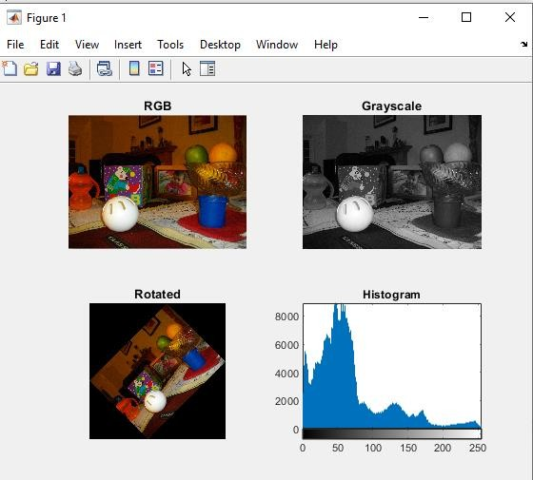

**Figure 1:**

**RGB**(imread,imshow)-**Grayscale**- **Rotated**(imrotate)- **Histogram**(imhist)

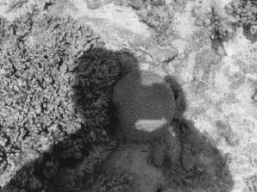 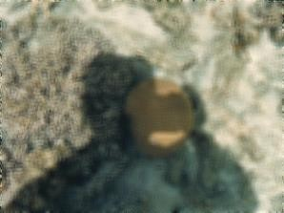

**Figure 2.1:** Convert RGB to Grayscale **Figure 2.2:** Filter - Blur