|  |  |
| --- | --- |
| ***Programming Language*** |  |
| ***Programming Environment*** | *MATLAB R2021a* |
| ***Your filter (3x3)*** | *k=1*  *3x3*  *h =* |
| ***Reflections*** | *We learned how to add and activate buttons via Matlab app designer. We had a hard time learning because there were not enough resources.* |

***Discussion***

1. *Discuss the behavior of your filter for different* ***k*** *values (especially k < -1, k = -1, k = 0, k = 1, k > 1), with screenshots.*

***k<-1:*** The clarity of the picture decreases, so blur occurs.

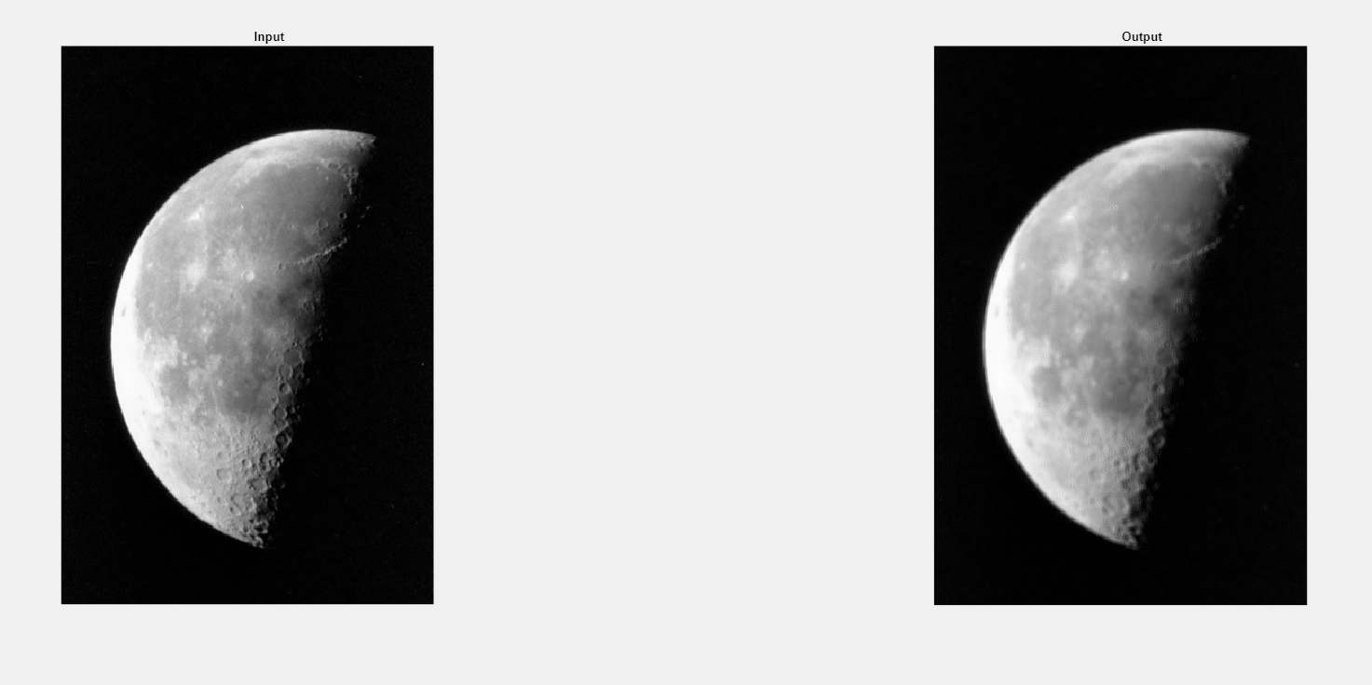

***1.1 Figure: k<-1***

***k=-1:***  Less blur is generated than the k<-1 operation. As the Filter Size increases, the clarity of the picture decreases.

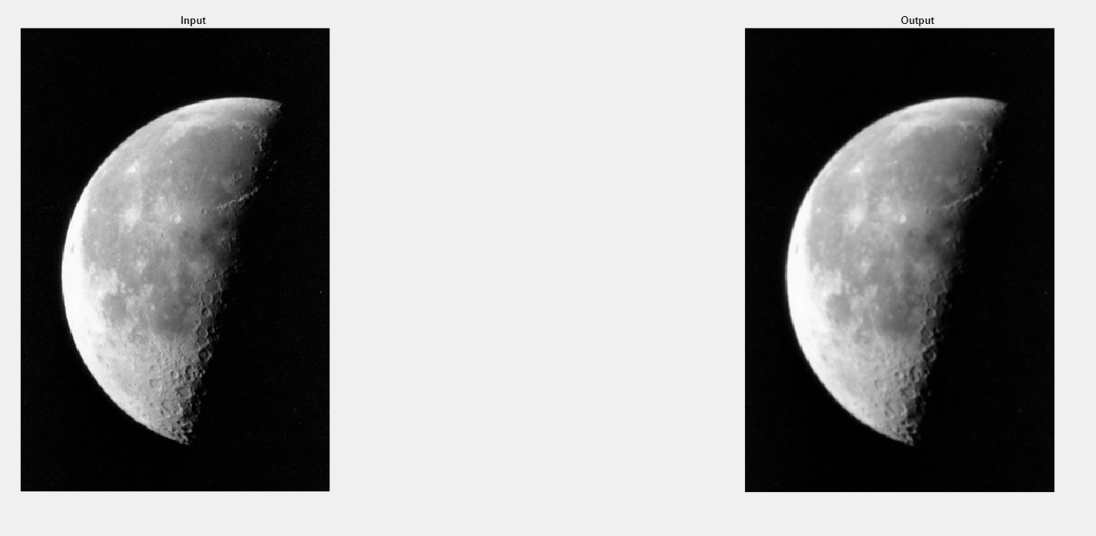

***1.2 Figure: k=-1***

***k=0:*** There is no change in the picture.

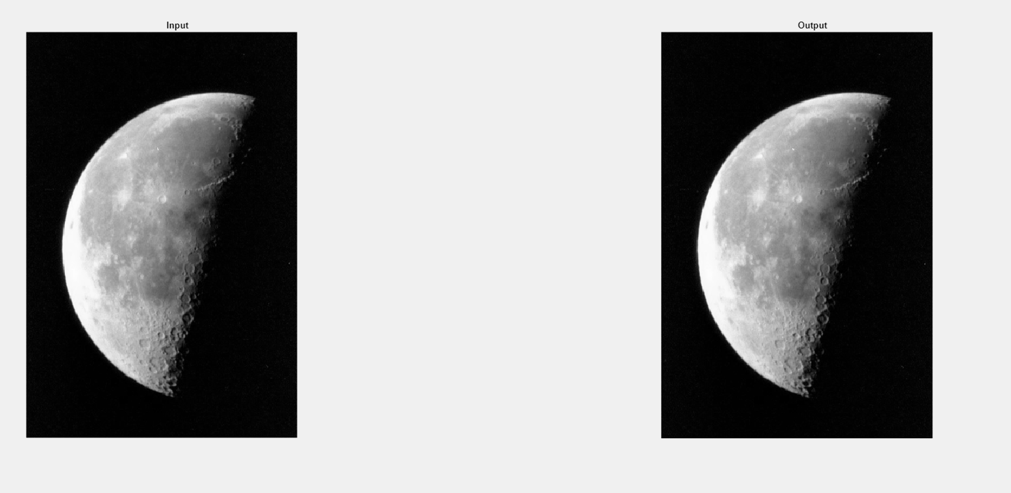

***1.3 Figure: k=0***

***k=1:***  The sharpening process is applied, the clarity of the picture increases and we can see the details more clearly.

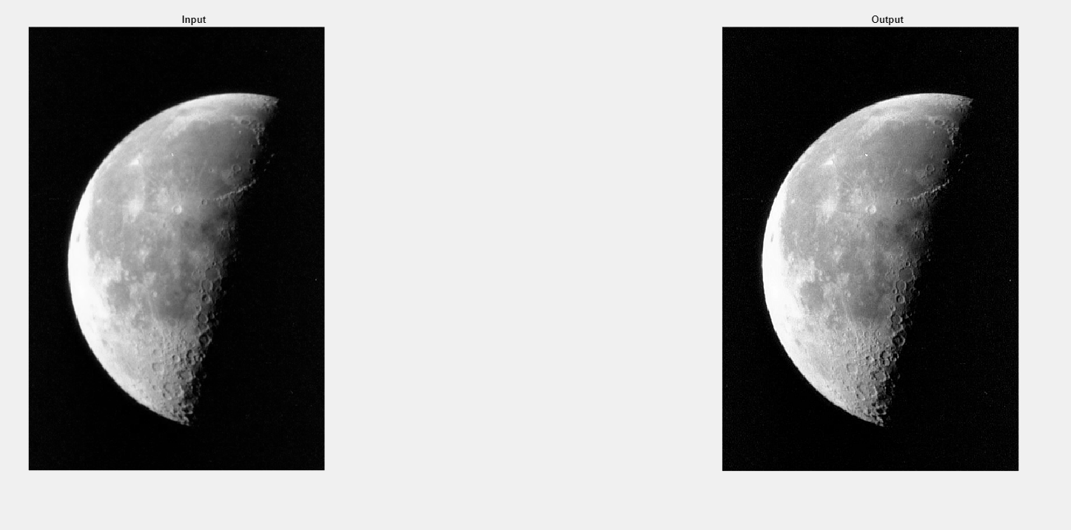

* 1. ***Figure: k=1***

***k>1:*** Compared to the k=1 operation, more sharpening is seen, the clarity of the picture increases, we see more details, and the higher the filter Size, the more details.

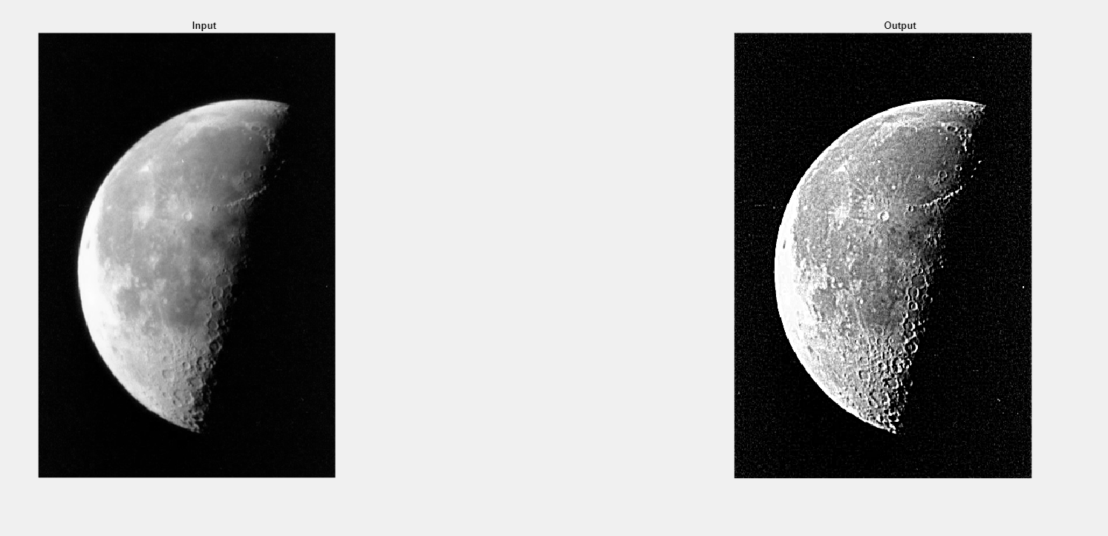

* 1. ***Figure: k>1***

1. *What is the effect of filter size* ***s****?*

As you increase the number size of square filter effects in the image, the image becomes sharper. However, as the number size of square filter effects decreases, the image becomes softer and the details of the image will be decreased.

***Source Code***

***Matlab code:***

% Prompt user to enter filter size and k value

s = input("Enter filter size (odd number): ");

k = input("Enter k value: ");

% Create filter for averaging

filter = ones(s, s) / (s * s);

% Load input image and convert to double

f = im2double(imread("moon.tif"));

% Perform convolution with filter

f_bar = conv2(f, filter, 'same');

% Calculate unsharp mask

g_mask = f - f_bar;

% Calculate sharpened image using highboost filtering

g = (k + 1) * f - k * f_bar;

% Display input and output images side by side

figure;

subplot(1,2,1);

imshow(f);

title("Input Image");

subplot(1,2,2);

imshow(g);

title("Sharpened Image (k=" + k + ")");

***Matlab App Designer Code:***

classdef moon < matlab.apps.AppBase

% Properties that correspond to app components

properties (Access = public)

UIFigure matlab.ui.Figure

ControlsPanel matlab.ui.container.Panel

FilterSizeSpinner matlab.ui.control.Spinner

FilterSizeSpinnerLabel matlab.ui.control.Label

kSpinner matlab.ui.control.Spinner

kSpinnerLabel matlab.ui.control.Label

FilterSizeEditField matlab.ui.control.NumericEditField

FilterSizeEditFieldLabel matlab.ui.control.Label

kEditField matlab.ui.control.NumericEditField

kEditFieldLabel matlab.ui.control.Label

SelectImageButton matlab.ui.control.Button

UIAxes2 matlab.ui.control.UIAxes

UIAxes matlab.ui.control.UIAxes

end

properties (Access = private)

a % Description

end

% Callbacks that handle component events

methods (Access = private)

% Button pushed function: SelectImageButton

function SelectImageButtonPushed(app, event)

% Button pushed function: TakeanImageButton

[filename, pathname] = uigetfile('*.*', 'Select Image');

filename=strcat(pathname,filename);

a=imread(filename);

imshow(a,'Parent',app.UIAxes);

filter = ones(app.FilterSizeEditField.Value, app.FilterSizeEditField.Value) / (app.FilterSizeEditField.Value * app.FilterSizeEditField.Value);

% Load input image and convert to double

f = im2double(a);

% Perform convolution with filter

f_bar = conv2(f, filter, 'same');

% Calculate unsharp mask

g_mask = f - f_bar;

% Calculate sharpened image using highboost filtering

g = (app.kEditField.Value + 1) * f - app.kEditField.Value * f_bar;

imshow(g,'Parent',app.UIAxes2);

app.FilterSizeEditField.Editable=false;

app.kEditField.Editable=false;

end

% Value changing function: kSpinner

function kSpinnerValueChanging(app, event)

% Get the changing value from the spinner

changingValue = event.Value;

% Update the spinner value to the new value

app.kSpinner.Value = changingValue;

% Get the current image data from the UIAxes

a = app.UIAxes.Children.CData;

% Get the filter size from the FilterSizeSpinner

filterSize = app.FilterSizeSpinner.Value;

% Create a filter with the specified size

filter = ones(filterSize) / (filterSize^2);

% Convert the image to double precision

f = im2double(a);

% Convolve the image with the filter

f_bar = conv2(f, filter, 'same');

% Calculate the sharpened image using high-boost filtering

k = changingValue;

g = (k+1)*f - k*f_bar;

% Display the sharpened image

imshow(g, 'Parent', app.UIAxes2);

end

% Value changing function: FilterSizeSpinner

function FilterSizeSpinnerValueChanging(app, event)

% Get the changing value from the spinner

changingValue = event.Value;

% Update the spinner value to the new value

app.FilterSizeSpinner.Value = changingValue;

% Get the current image data from the UIAxes

a = app.UIAxes.Children.CData;

% Get the filter size from the spinner

filterSize = changingValue;

% Create a filter with the specified size

filter = ones(filterSize) / (filterSize^2);

% Convert the image to double precision

f = im2double(a);

% Convolve the image with the filter

f_bar = conv2(f, filter, 'same');

% Calculate the sharpened image using high-boost filtering

k = app.kSpinner.Value;

g = (k+1)*f - k*f_bar;

% Display the sharpened image

imshow(g, 'Parent', app.UIAxes2);

end

end

% Component initialization

methods (Access = private)

% Create UIFigure and components

function createComponents(app)

% Create UIFigure and hide until all components are created

app.UIFigure = uifigure('Visible', 'off');

app.UIFigure.Position = [100 100 640 480];

app.UIFigure.Name = 'MATLAB App';

% Create UIAxes

app.UIAxes = uiaxes(app.UIFigure);

title(app.UIAxes, 'Input')

app.UIAxes.XTick = [0 0.2 0.4 0.6 0.8 1];

app.UIAxes.XTickLabel = {'0'; '0.2'; '0.4'; '0.6'; '0.8'; '1'};

app.UIAxes.YTick = [0 0.2 0.4 0.6 0.8 1];

app.UIAxes.Position = [34 269 267 178];

% Create UIAxes2

app.UIAxes2 = uiaxes(app.UIFigure);

title(app.UIAxes2, 'Output')

app.UIAxes2.YTick = [0 0.2 0.4 0.6 0.8 1];

app.UIAxes2.Position = [321 268 288 179];

% Create ControlsPanel

app.ControlsPanel = uipanel(app.UIFigure);

app.ControlsPanel.Title = 'Controls';

app.ControlsPanel.BackgroundColor = [1 1 0.0667];

app.ControlsPanel.Position = [52 24 557 217];

% Create SelectImageButton

app.SelectImageButton = uibutton(app.ControlsPanel, 'push');

app.SelectImageButton.ButtonPushedFcn = createCallbackFcn(app, @SelectImageButtonPushed, true);

app.SelectImageButton.BackgroundColor = [0 1 1];

app.SelectImageButton.Position = [193 150 184 34];

app.SelectImageButton.Text = 'Select Image';

% Create kEditFieldLabel

app.kEditFieldLabel = uilabel(app.ControlsPanel);

app.kEditFieldLabel.BackgroundColor = [1 1 0];

app.kEditFieldLabel.HorizontalAlignment = 'right';

app.kEditFieldLabel.Position = [34 90 55 22];

app.kEditFieldLabel.Text = 'k';

% Create kEditField

app.kEditField = uieditfield(app.ControlsPanel, 'numeric');

app.kEditField.Position = [104 82 90 37];

% Create FilterSizeEditFieldLabel

app.FilterSizeEditFieldLabel = uilabel(app.ControlsPanel);

app.FilterSizeEditFieldLabel.HorizontalAlignment = 'right';

app.FilterSizeEditFieldLabel.Position = [373 89 59 22];

app.FilterSizeEditFieldLabel.Text = 'Filter Size';

% Create FilterSizeEditField

app.FilterSizeEditField = uieditfield(app.ControlsPanel, 'numeric');

app.FilterSizeEditField.Position = [447 82 90 36];

% Create kSpinnerLabel

app.kSpinnerLabel = uilabel(app.ControlsPanel);

app.kSpinnerLabel.HorizontalAlignment = 'right';

app.kSpinnerLabel.Position = [44 35 46 22];

app.kSpinnerLabel.Text = 'k';

% Create kSpinner

app.kSpinner = uispinner(app.ControlsPanel);

app.kSpinner.ValueChangingFcn = createCallbackFcn(app, @kSpinnerValueChanging, true);

app.kSpinner.Limits = [-5 10];

app.kSpinner.Position = [105 25 45 42];

% Create FilterSizeSpinnerLabel

app.FilterSizeSpinnerLabel = uilabel(app.ControlsPanel);

app.FilterSizeSpinnerLabel.HorizontalAlignment = 'right';

app.FilterSizeSpinnerLabel.Position = [374 35 59 22];

app.FilterSizeSpinnerLabel.Text = 'Filter Size';

% Create FilterSizeSpinner

app.FilterSizeSpinner = uispinner(app.ControlsPanel);

app.FilterSizeSpinner.ValueChangingFcn = createCallbackFcn(app, @FilterSizeSpinnerValueChanging, true);

app.FilterSizeSpinner.Limits = [3 15];

app.FilterSizeSpinner.Position = [448 25 89 41];

app.FilterSizeSpinner.Value = 3;

% Show the figure after all components are created

app.UIFigure.Visible = 'on';

end

end

% App creation and deletion

methods (Access = public)

% Construct app

function app = moon

% Create UIFigure and components

createComponents(app)

% Register the app with App Designer

registerApp(app, app.UIFigure)

if nargout == 0

clear app

end

end

% Code that executes before app deletion

function delete(app)

% Delete UIFigure when app is deleted

delete(app.UIFigure)

end

end

end