Technical Project Report: Enterprise Cloud-Native ITSM Infrastructure
Author: MD IBNA SAIM SAZIN
Date: May 31, 2026
Environment: AWS / Ubuntu / Windows Server 2025 / Zammad
1. Executive Summary
This project details the engineering of a scalable, cloud-native IT Service Management (ITSM) infrastructure. The solution integrates secure Windows Active Directory identity services with a containerized Zammad help desk platform, ensuring high availability, centralized governance, and ITIL-compliant operational workflows.
2. Infrastructure Architecture & Deployment
The deployment utilizes a modular AWS EC2 architecture designed for performance and isolation, separating the identity management layer from the application layer.
- Compute Architecture: Deployed three dedicated instances to optimize service reliability:
  - Corp-DC01: Dedicated Windows Domain Controller for core identity services.
  - Corp-Linux01: Host for secure identity bridging and cross-platform authentication.
  - Corp-App-Zammad: Dedicated instance (c7i-flex.large) for application hosting.
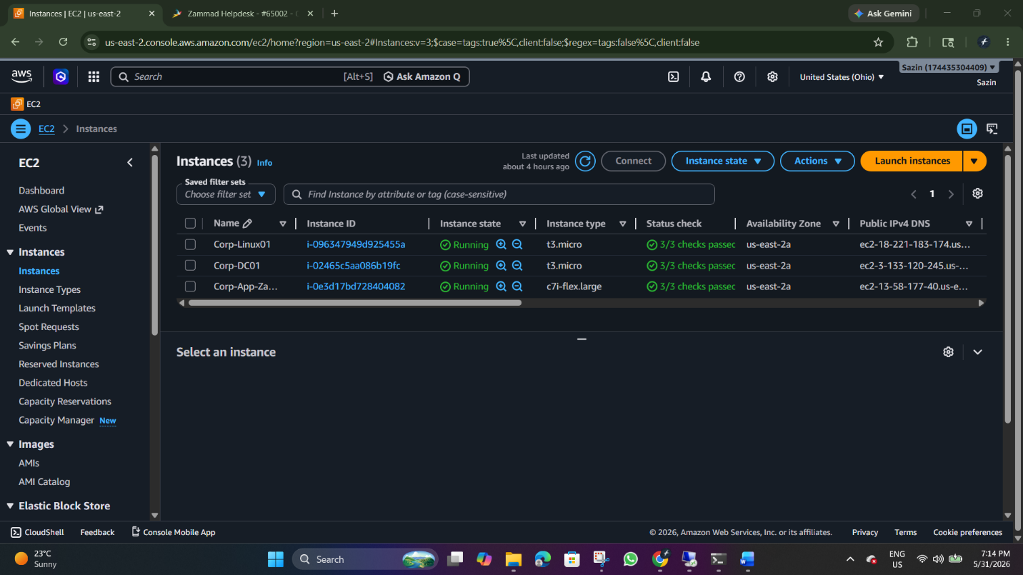
Caption: Figure 1 - AWS EC2 instance overview showing the three-tier architectural separation.
3. Identity & Access Management (IAM)
To ensure enterprise-grade security, a cross-platform identity bridge was engineered alongside an automated user provisioning system.
3.1 Linux Domain Integration
The Linux application host was securely joined to the internal Windows domain (crop.local) using realm and sssd for centralized authentication.
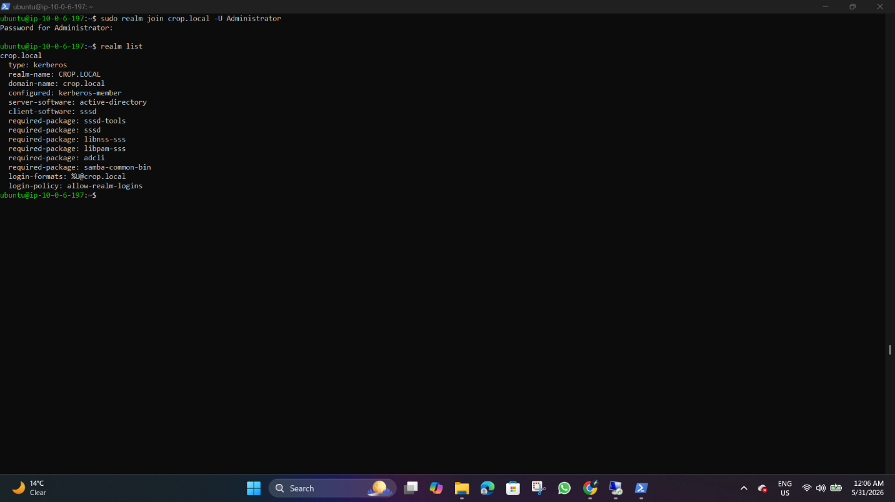
Caption: Figure 2 - Verification of successful Linux host integration to the Active Directory domain.
To support seamless cross-platform user access, PAM modules were configured (pam-auth-update) to automatically generate home directories upon initial Active Directory user login.
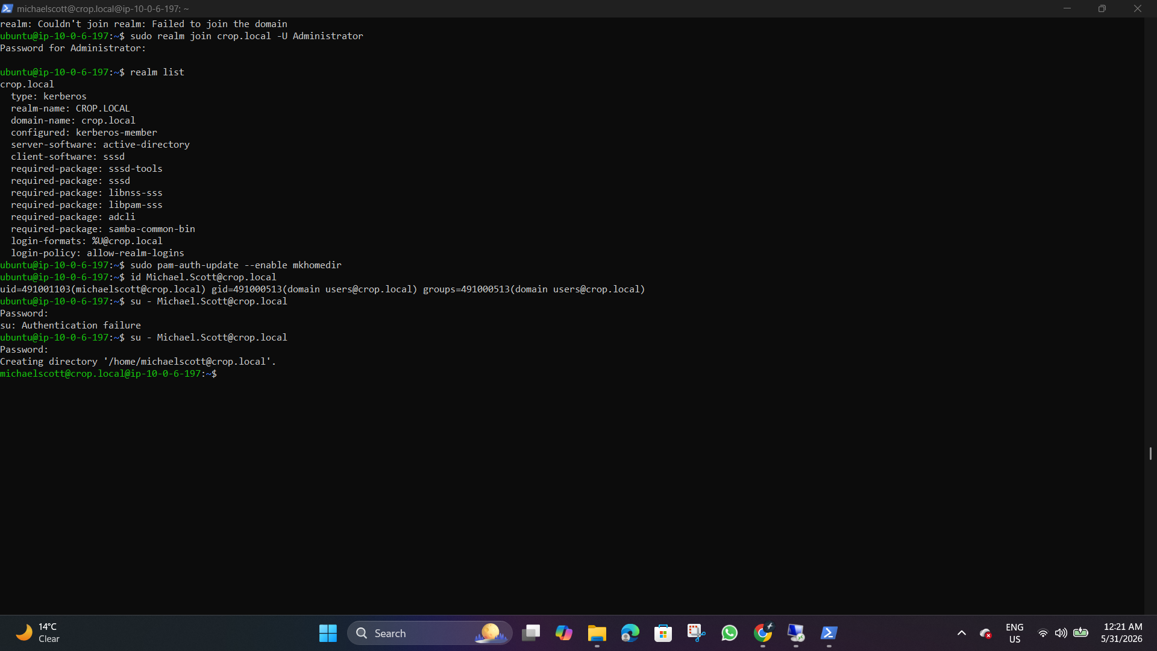
Caption: Figure 3 - Validation of cross-platform authentication and automated home directory creation for an Active Directory user.
3.2 Directory Automation
A custom PowerShell automation suite was developed to streamline user onboarding by dynamically creating Organizational Units (OUs) and provisioning accounts.
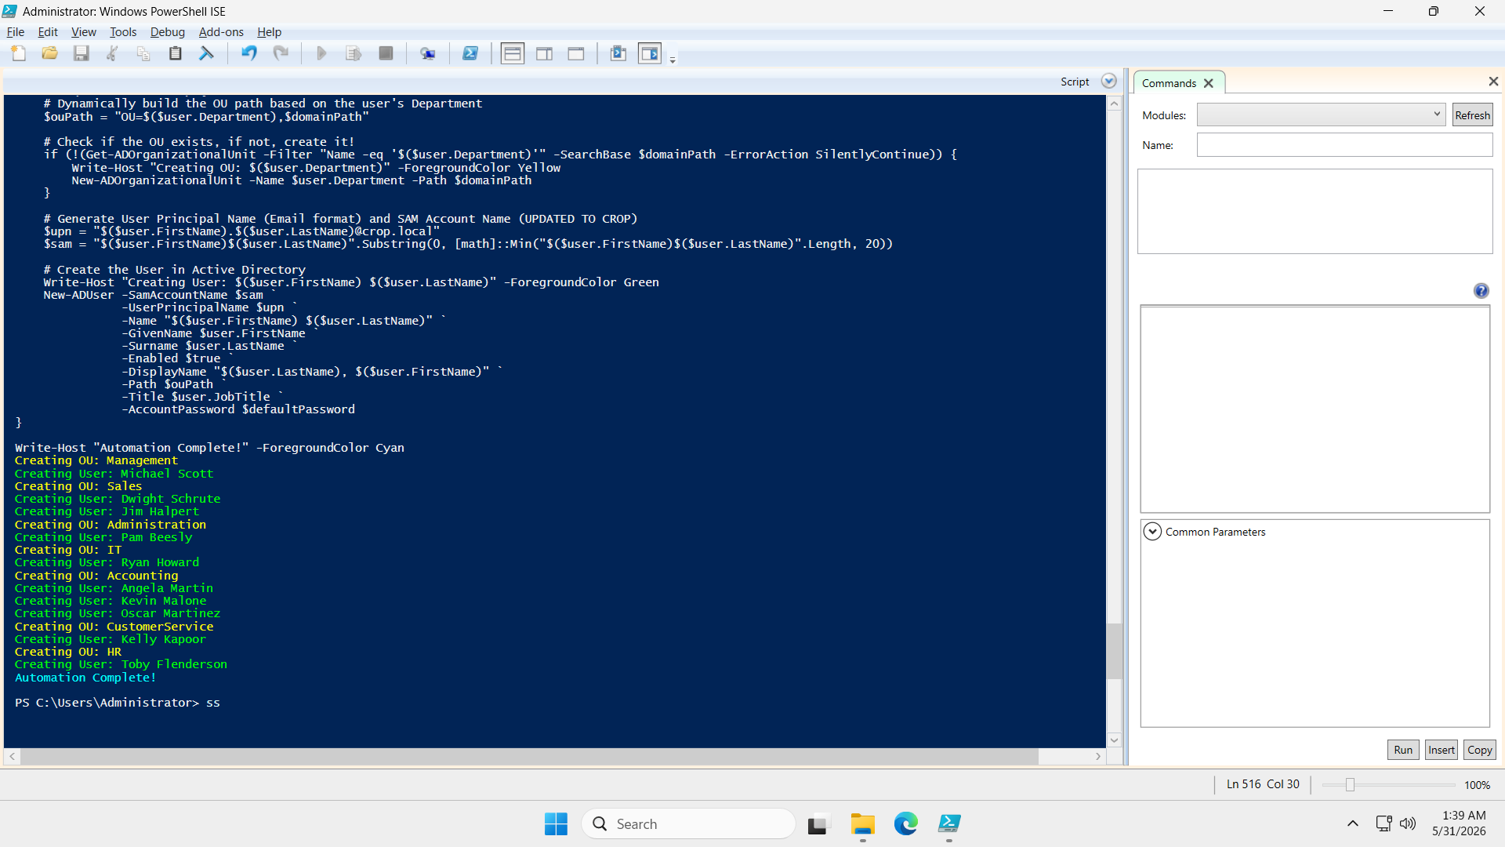
Caption: Figure 4 - PowerShell automation logic for dynamic Active Directory provisioning.
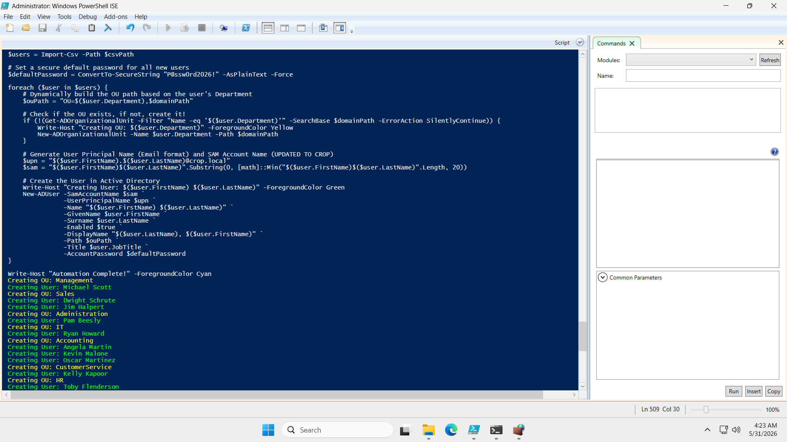
Caption: Figure 5 - Execution confirmation of user account provisioning automation.
4. ITSM Platform Configuration
The service layer was initialized using Zammad, configured to meet specific organizational support parameters.
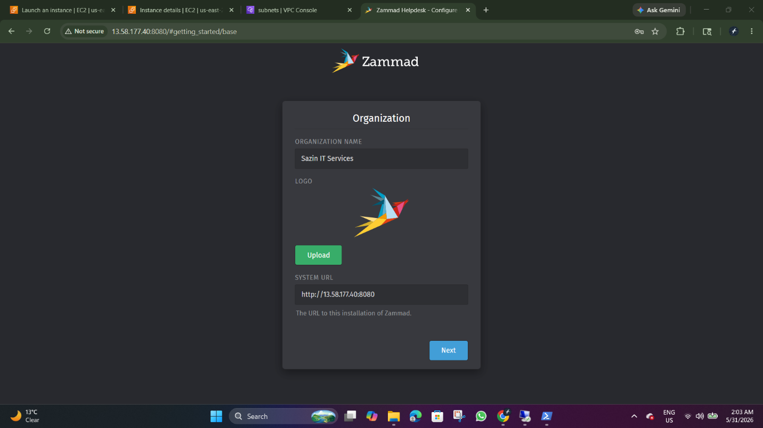
Caption: Figure 6 - Zammad organization and base URL configuration.
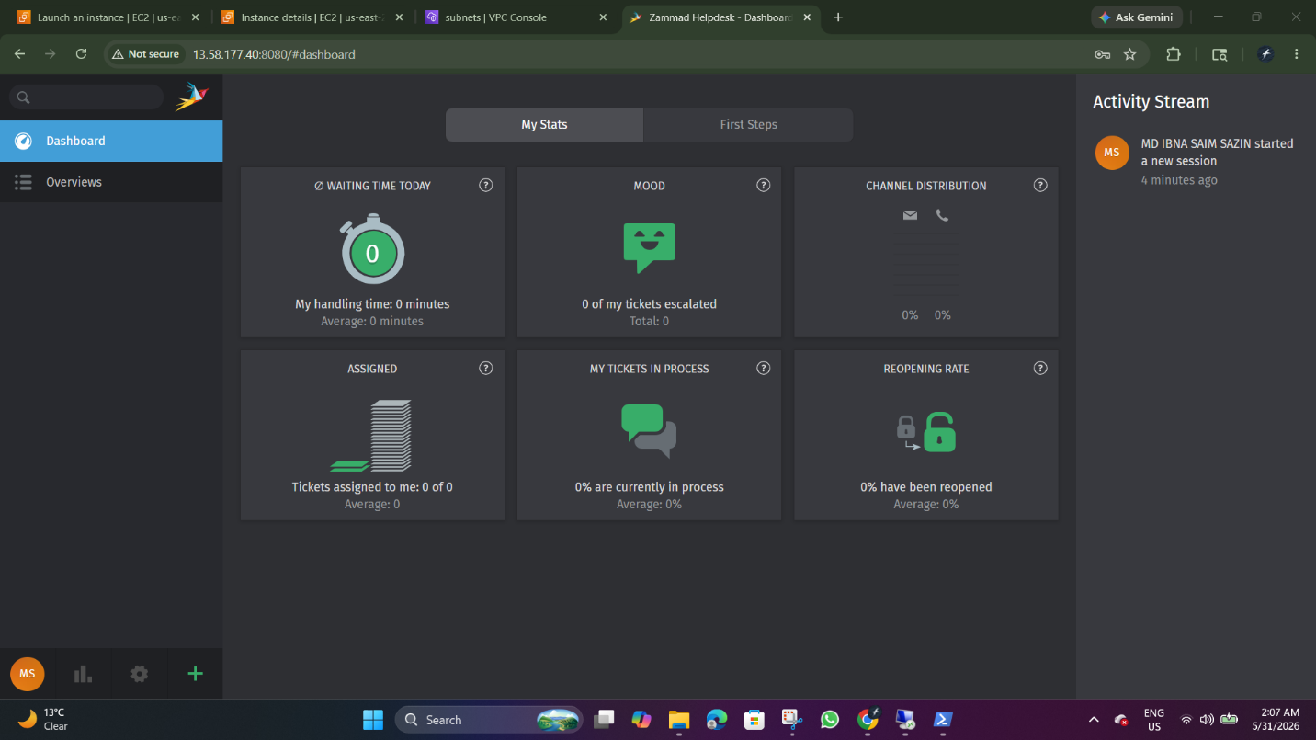
Caption: Figure 7 - Zammad system dashboard after successful initialization and environment setup.
5. Operational Governance & Service Delivery
The system is governed by strict ITIL-aligned policies to ensure measurable and secure service delivery.
5.1 Role-Based Access Control (RBAC)
Granular permissions were configured to restrict access based on technical roles, strictly adhering to the principle of least privilege.
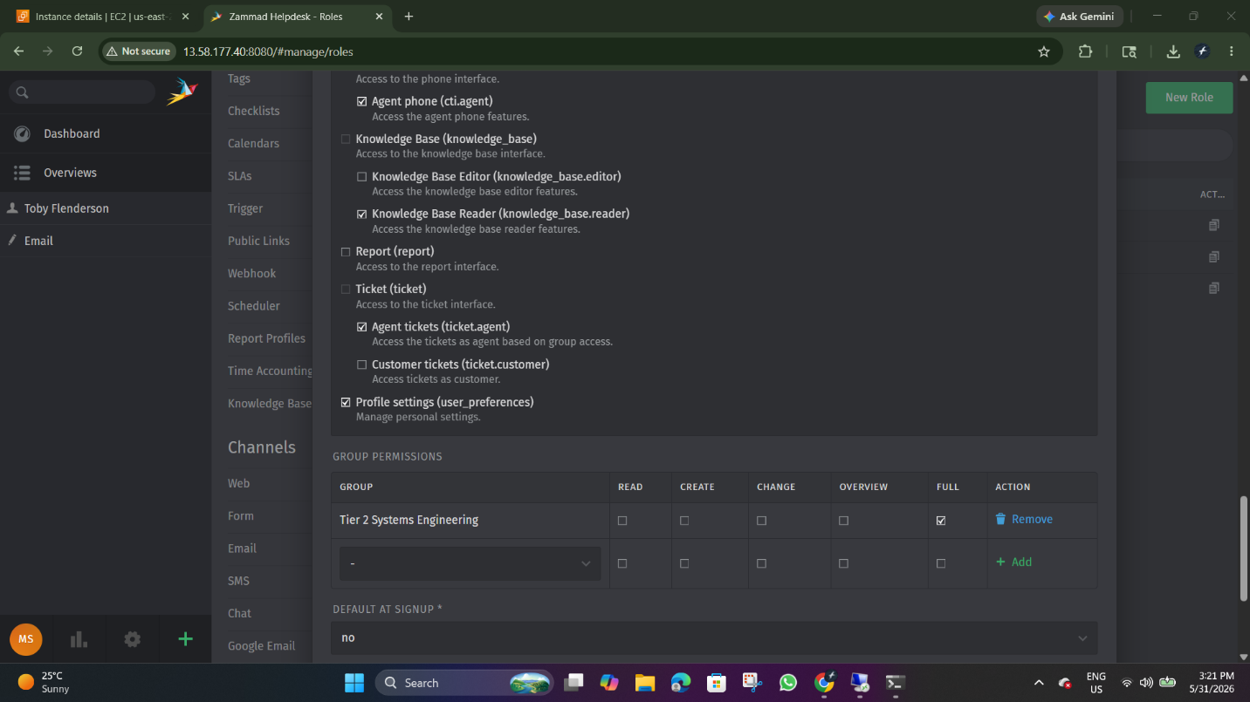
Caption: Figure 8 - RBAC configuration for technical agent groups, ensuring strict access boundaries for the Tier 2 Systems Engineering team.
5.2 SLA Enforcement & Validation
Automated escalation logic was programmed to track and manage critical infrastructure incidents.
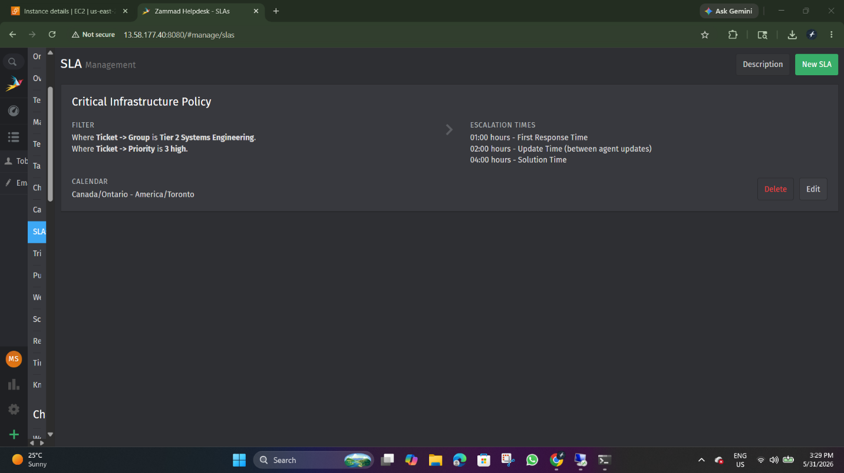
Caption: Figure 9 - SLA management interface defining critical escalation timers (1-hour response, 4-hour solution).
Operational compliance was confirmed by simulating a high-priority network incident, successfully triggering the automated governance logic.
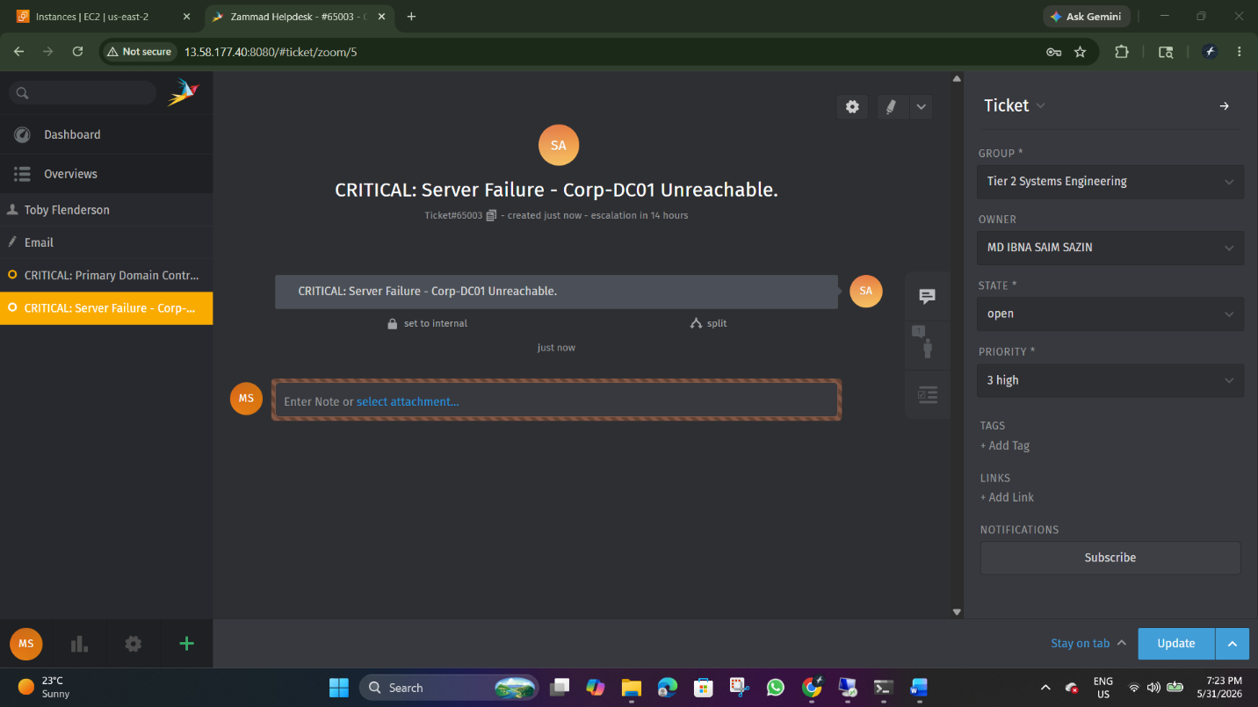
Caption: Figure 10 - Validated SLA timer activation for a critical infrastructure incident (Ticket #65003).
6. Conclusion
This project demonstrates the end-to-end engineering of a professional-grade ITSM environment. By bridging hybrid-identity services with cloud-native application hosting and automating administrative tasks, the infrastructure provides a stable, secure, and measurable framework for enterprise technical support.

