BOOK STORE-APP

Supervisor : | Sir Umer
Batch : | 2303e
Group : | Book Store-App
Serial No. | Enrollment No. | Student Name.
1. | 1430955 | Sheraz Hussain.
2. | 1423239 | Mavia
3.  4.  5. | 14  14  14 | Eazaz Mir  Alishan  Fahad Khan

Acknowledgement

The first, we would like to express my special thanks of gratitude to my teacher SIR UMER who helped a lot in finalizing this project within the limited time frame, valuable counseling and assistance for the accomplishment of this project.
Secondly, we would also like to thanks the e-project team at Aptech Head Office, who gave as the opportunity to do this interesting and wonderful project about BookStore-App.
Thirdly, we also thank the e-project team for giving this task to us. Following are the benefits of this Project:
- Re-enforcement of skills happens in the experimental learning process.
- A mentor, ensuring that we do not get drifted, constantly guide us.
- It gives us a lot of confidence to face an interview as we have worked on a project. We can explain virtually everything on the subject we have learnt.

Problems Definition

Mr. “Jazib Shaikh” is the owner of Book Store-App.Our bookstore app is a haven for book lovers, designed to bring the joy of reading right to your fingertips. With a sleek, intuitive interface, it offers an extensive library of titles across all genres, from timeless classics to the latest bestsellers. Whether you're searching for your next great read, tracking your reading progress, or discovering new authors, our app makes the experience seamless and enjoyable. Personalized recommendations, user reviews, and easy-to-navigate categories ensure that every book you find is perfectly suited to your taste. Dive into a world of stories and let our bookstore app be your gateway to countless literary adventures.

Task Sheet
Project Ref.No:  Ep/Advertisement  Portal Management  System /01 |  | Project  Title | Date Of preparation Of Activity Plan
No. | Task | B  O  O  K  S  T  O  R  E  -  A  P  P | Actual  Start Date | Actual Days | Team-Mate  Name | Status
01. | Home page |  | 2  -  J  A  N  -  2  0  2  5 | 3  0  -  D  A  Y  S  - | Fahad Khan  Alishan
02. | BOOKS  VIEWS |  |  |  | Mavia,  Eazaz
03. | MANAGE  CART  /  MANAGE  USER |  |  |  | Sheraz, Mavia, Alishan
04. | Login  /  Register |  |  |  | Sheraz,  Eazaz
05. | Student  Feedback  Form |  |  |  | Sheraz,  Mavia
06. | Documentation |  |  |  | Alishan

SCREENSHOTS

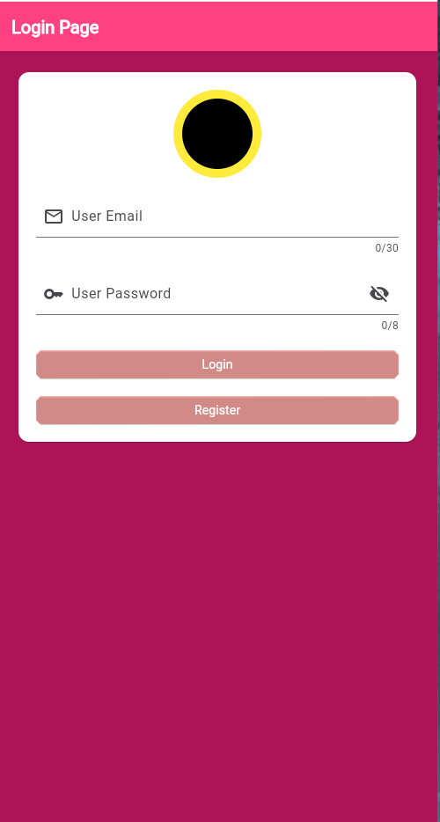
Login: Register User:
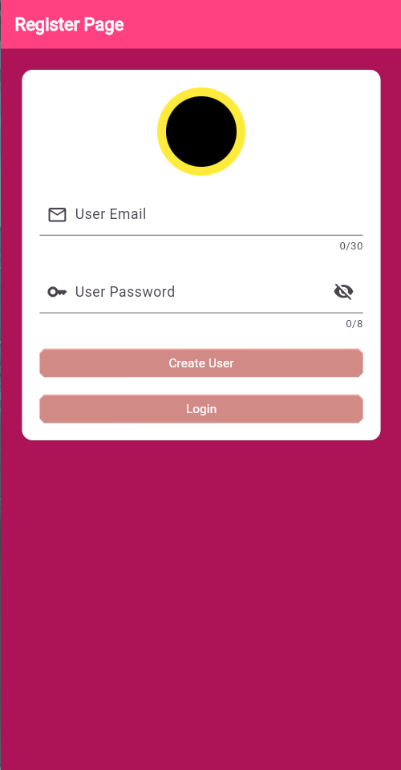

Home Page: Cart Page:
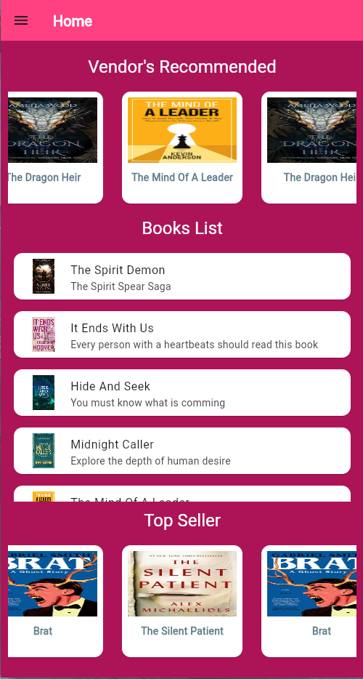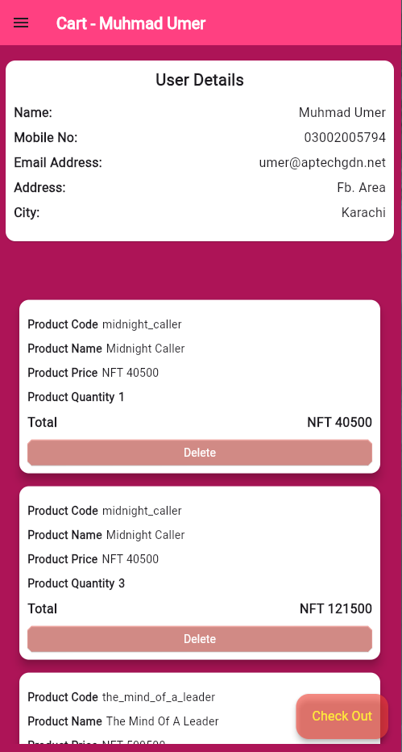

Books View:
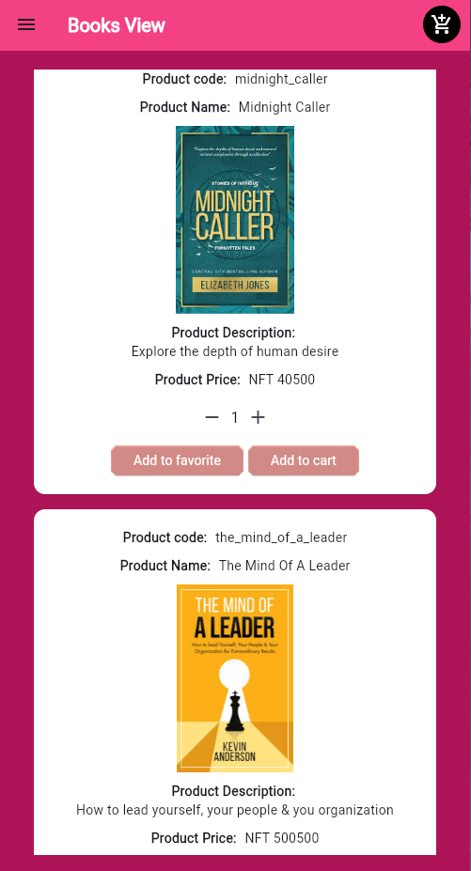

Splash Page: Drawer Page: