Table of Contents
(Press F9 after opening, or print, to populate the table of contents.)

1. Executive Summary
The structured workflow is worth adopting at the intake desk. Across the same 42 notes the structured workflow cut the median from 28.0 to 20.0 minutes per note, rework from 7.5% to 4.1%, and raised reviewer satisfaction from 71% to 84%. Adoption costs a one-off USD 4,800 for template work and two onboarding sessions, and takes about six weeks to pay back in speed. The evidence is one desk over one week, so the recommendation is to adopt at this desk and re-measure before extending.

2. Key Findings
The comparison was designed so that the workflow was the only thing that differed. The same 42 client notes were processed twice, by the same two reviewers in the same week, with no change to the intake form. Across the same 42 notes the structured workflow cut the median from 28.0 to 20.0 minutes per note, rework from 7.5% to 4.1%, and raised reviewer satisfaction from 71% to 84%. The time saving and the rework drop point the same way, which is what makes the result usable for a scheduling decision rather than merely encouraging.
Table 1 sets the two conditions side by side, with the note counts the medians rest on.
Table 1. Intake desk pilot, manual baseline versus structured workflow
Condition | Notes processed | Median minutes per note | Rework rate (%) | Reviewer satisfaction (%)
Manual baseline | 42 | 28.0 | 7.5 | 71
Structured workflow | 42 | 20.0 | 4.1 | 84
Figure 1 traces the monthly median through the phase-in, which is where the six-week ramp is visible.
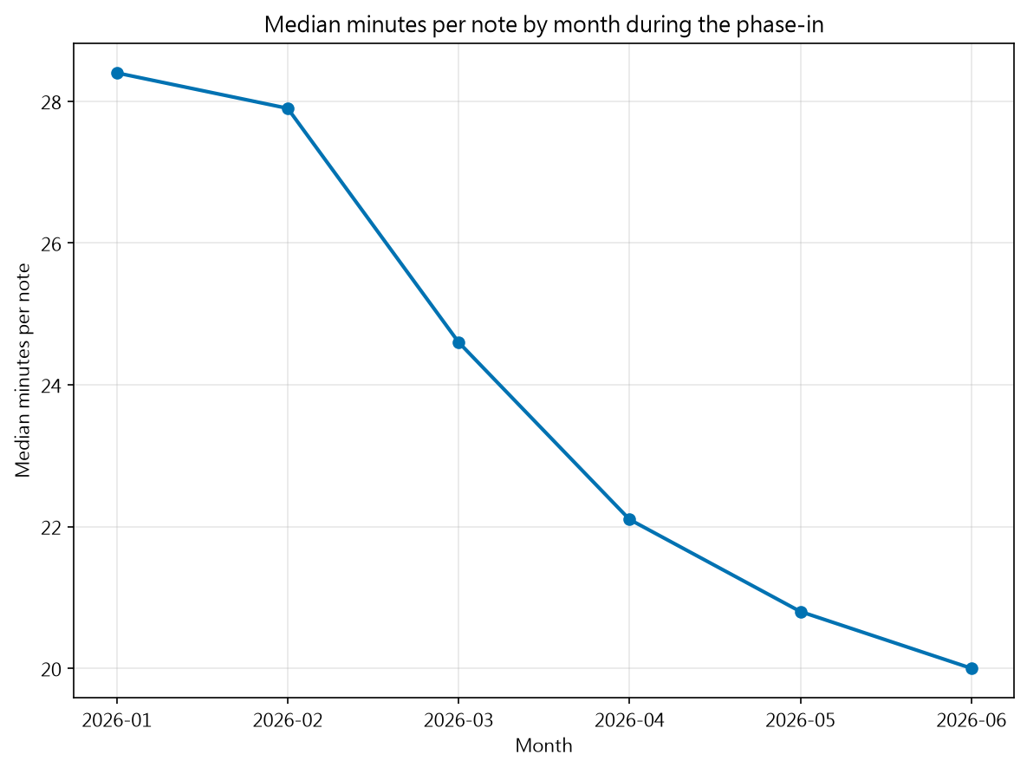
Figure 1. Median minutes per note by month during the phase-in

3. Recommendations
Adopt the structured workflow at this desk and budget for the ramp. Adoption costs a one-off USD 4,800 for template work and two onboarding sessions, and takes about six weeks to pay back in speed. Hold the decision to this desk for now: satisfaction came from the two reviewers who ran the pilot, so it supports the finding rather than carrying it. Re-measure after the first full quarter before extending to a desk with a different note format.

