Sleep Duration and Midterm Performance in an Introductory Statistics Course
Lin Chen
Department of Statistics
Correspondence: lin.chen@example.edu
Keywords: sleep duration, exam performance, undergraduates

Table of Contents
(Press F9 after opening, or print, to populate the table of contents.)

Abstract
Background: Students are often told that sleep matters for exam performance, and laboratory work links sleep after learning to memory consolidation. Whether the link is visible in an ordinary course, where students choose how long they sleep and how long they study, is less often checked with the course’s own data.
Objective: We asked whether students in one introductory statistics course who reported more nightly sleep before the midterm also scored higher on it.
Methods: Forty first- and second-year undergraduates reported their average nightly sleep over the two weeks before the midterm and their weekly study hours. Midterm scores were taken from the gradebook with consent. Students were grouped into three sleep bands, and mean scores and mean study hours were compared across bands.
Principal Findings: Students who slept 7.5 to 9 hours averaged 87.82 points, against 74.54 for those who slept 4 to 6 hours, a gap of 13.28 points. Mean weekly study hours were close across the bands, 7.85 and 8.19 hours, so the gap is not explained by study time.
Significance: The size of the gap in a single ordinary course suggests that sleep deserves a place in study advice, although a self-reported, observational sample of one course cannot show that more sleep causes higher scores.

1. Introduction
Advice to students before an exam usually concerns study time, but a growing literature points to sleep as well. Walker (2017) argues that sleep after learning consolidates memory (compiled in this study, calculation record C1). In a field setting, Okano et al. (2019) found that sleep quality and duration over the month before exams explained about 25% of the variance in grades of 88 MIT students (compiled in this study, calculation record C2). This paper asks whether a similar pattern appears in a smaller, ordinary course.

2. Research Scope and Design Framing
The study covers a single introductory statistics course. Forty first- and second-year undergraduates self-reported average nightly sleep over the two weeks before the midterm, and midterm scores were taken from the gradebook (compiled in this study, calculation record C3; calculated in this study, calculation record C4). The question is descriptive: do scores differ across sleep bands, and does study time account for any difference.

3. Methods
Forty first- and second-year undergraduates self-reported average nightly sleep over the two weeks before the midterm, and midterm scores were taken from the gradebook (compiled in this study, calculation record C3; calculated in this study, calculation record C4). Nightly sleep ranged from 4.50 to 8.80 hours, with a median of 6.70 hours (calculated in this study, calculation record C5). Students were grouped into bands of 4 to 6 to 7.5 and 7.5 to 9 hours, and the mean and median score and the mean weekly study hours were computed for each band.

4. Results
Midterm scores ranged from 67 to 98 with a median of 82.50 (calculated in this study, calculation record C6). Scores rose with sleep: students sleeping 7.50 to 9 hours averaged 87.82 on the midterm, against 74.54 for those sleeping 4 to 6 hours, a gap of 13.28 points (calculated in this study, Table 1, calculation record C8).
Table 1. Midterm score and study hours by nightly sleep band
Sleep band (h) | Students | Mean score | Median score | Mean study hours
4–6 | 13 | 74.54 | 75.00 | 7.85
6–7.50 | 16 | 85.50 | 85.50 | 9.09
7.50–9 | 11 | 87.82 | 86.00 | 8.19
9+ | 0 | — | — | —
All | 40 | 82.58 | 82.50 | 8.44
Source: calculated in this study (calculation record C7)
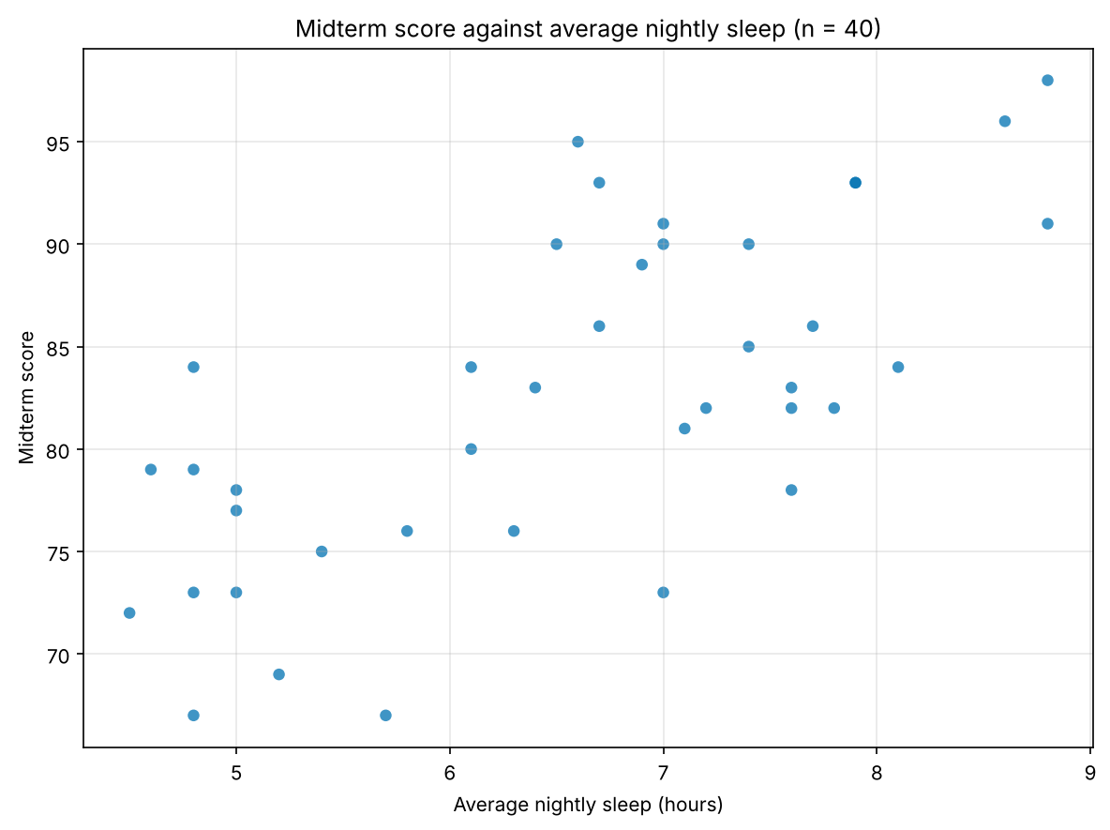
Figure 1. Midterm score against average nightly sleep (n = 40)
Figure 1 shows the same pattern student by student, with the lowest scores concentrated below six hours of sleep.

5. Discussion
A natural objection is that students who sleep more study more. The data do not support that reading: mean weekly study hours were similar across sleep bands, 7.85 for the 4 to 6 hour band and 8.19 for the 7.50 to 9 hour band, so study time does not explain the score gap (calculated in this study, Table 1, calculation record C9). The direction agrees with Okano et al. (2019), who found that sleep quality and duration over the month before exams explained about 25% of the variance in grades of 88 MIT students (compiled in this study, calculation record C2).

6. Limitations
Three limits temper the result. Sleep was self-reported, the sample is one course at one university, and students who slept more may differ in other ways such as fewer part-time job hours (compiled in this study, calculation record C10).

7. Conclusion
In this course, students who slept 7.50 to 9 hours averaged 87.82 on the midterm, against 74.54 for those sleeping 4 to 6 hours, a gap of 13.28 points (calculated in this study, Table 1, calculation record C8). Sleep belongs in study advice alongside study time, and a larger study with measured sleep would test whether the gap holds.

