Does the 20-Day Momentum Signal Predict Next-Week Basket Returns?
Quant Research Desk

Table of Contents
(Press F9 after opening, or print, to populate the table of contents.)

1. Summary
Weeks with a signal of 1 or more returned 1.59% on average the following week, against -0.46% for weeks below 0, a gap of 2.05 percentage points; all 7 high-signal weeks were up weeks (calculated in this study, Table 1, calculation record C2). The sample is short, so the result supports a paper-trading period rather than capital.

2. Question and Data
The question is whether the desk’s 20-day momentum signal says anything about the following week. The signal applies the cross-sectional momentum idea of Jegadeesh and Titman (1993) in time series to a single basket (compiled in this study, calculation record C3). Each Friday from week 1 to week 36 of 2026 the 20-day momentum signal was computed for an equal-weight basket of 11 sector ETFs and standardized to a z-score against its trailing 52-week history; the outcome is the basket’s return over the following week, with no transaction costs (compiled in this study, calculation record C4). The signal ranged from -2.77 to 3.42 over 36 weekly observations, and next-week returns from -2.56% to 2.92% (calculated in this study, calculation record C5, C6; compiled in this study, calculation record C7).

3. Method
A week is labelled bull when the basket closed above its 200-day moving average on the signal date and bear otherwise (compiled in this study, calculation record C8). The relation is measured as mean returns across signal bands cut at 0 and 1, and the regime breakdown is compared.

4. Results
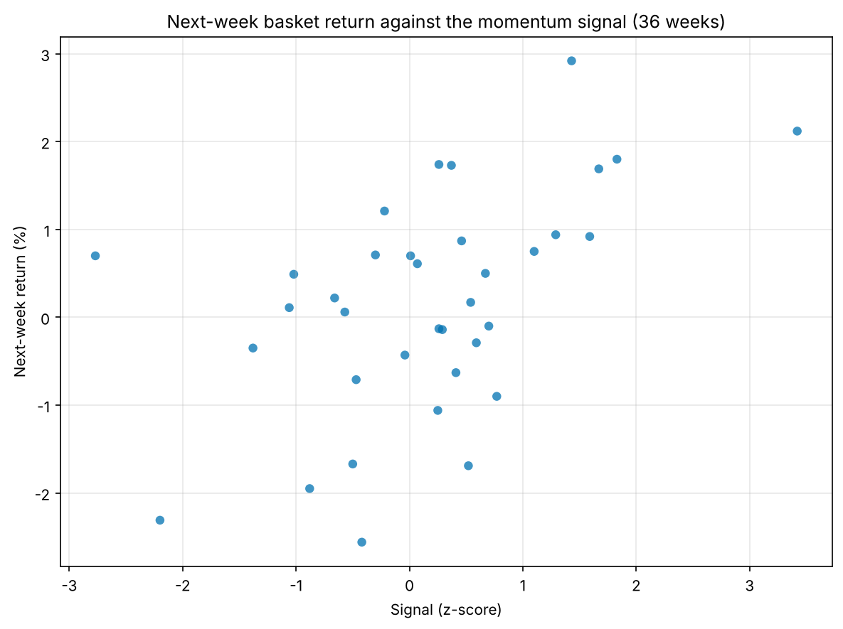
Figure 1. Next-week basket return against the momentum signal (36 weeks)
Weeks with a signal of 1 or more returned 1.59% on average the following week, against -0.46% for weeks below 0, a gap of 2.05 percentage points; all 7 high-signal weeks were up weeks (calculated in this study, Table 1, calculation record C2).
Table 1. Next-week return by signal band
Signal z band | Weeks | Mean next-week return (%) | Share of up weeks
-3–0 | 14 | -0.46 | 50.00%
0–1 | 15 | 0.09 | 46.67%
1–3.50 | 7 | 1.59 | 100.00%
3.50+ | 0 | — | —
All | 36 | 0.17 | 58.33%
Source: calculated in this study (calculation record C1)

5. Robustness
By regime, the mean next-week return was 0.30% in bull weeks and -0.02% in bear weeks, and the mean signal was -0.22 and 0.71 (calculated in this study, calculation record C9). So the signal is not picking out the bull regime.

6. Limitations
36 weekly observations is a short sample, the weeks overlap with one rate-hiking cycle, and the regime label was assigned after the fact (compiled in this study, calculation record C7). A correlation of this size over 36 points is not a forecast of live returns after costs.

