Transport Validation

## Warning: package 'magclass' was built under R version 4.1.2

## Warning: package 'lusweave' was built under R version 4.1.2

## Warning: package 'mip' was built under R version 4.1.2

## Loading required package: quitte

## Warning: package 'quitte' was built under R version 4.1.2

## Warning: package 'data.table' was built under R version 4.1.2

## Warning: package 'remind2' was built under R version 4.1.2

## Registered S3 method overwritten by 'quantmod':  
## method from  
## as.zoo.data.frame zoo

## Warning: package 'madrat' was built under R version 4.1.2

## Warning: package 'devtools' was built under R version 4.1.2

## Loading required package: usethis

## Warning: package 'usethis' was built under R version 4.1.2

## i Loading edgeTransport

## FE Transport

mainReg <- "GLO"  
  
vars <- c(  
 "FE|Transport (EJ/yr)",  
 "FE|Transport|Pass (EJ/yr)",  
 "FE|Transport|Pass|Rail (EJ/yr)",  
 "FE|Transport|Pass|Road|Bus (EJ/yr)",  
 "FE|Transport|Pass|Road|LDV (EJ/yr)",  
 "FE|Transport|Freight (EJ/yr)",  
 "FE|Transport|Freight|Navigation (EJ/yr)",  
 "FE|Transport|Freight|Rail (EJ/yr)",  
 "FE|Transport|Freight|Road (EJ/yr)")  
  
for (var0 in vars) {  
 if (sub(" (.*)", "",var0) %in% unique(data$LinePlot_data$variable)) {  
 p1 <- mipLineHistorical(  
 data$LinePlot_data[region==mainReg & variable==sub(" (.*)", "",var0)],  
 x_hist = historical[mainReg, , var0],  
 ylab = var0,  
 scales = "free_y",  
 xlim = c(1990, 2050)  
 )  
 print(p1)  
 p2 <- mipLineHistorical(data$LinePlot_data[!region==mainReg & variable==sub(" (.*)", "",var0)],  
 x_hist = historical[, , var0][mainReg, , , invert = TRUE],  
 ylab = var0, scales = "free_y", plot.priority = c("x_hist", "x", "x_proj"), facet.ncol = 3,  
 xlim = c(1990, 2050)  
 )  
 print(p2)  
 } else {  
 print(paste0(var0, " not in runs"))  
 }  
}

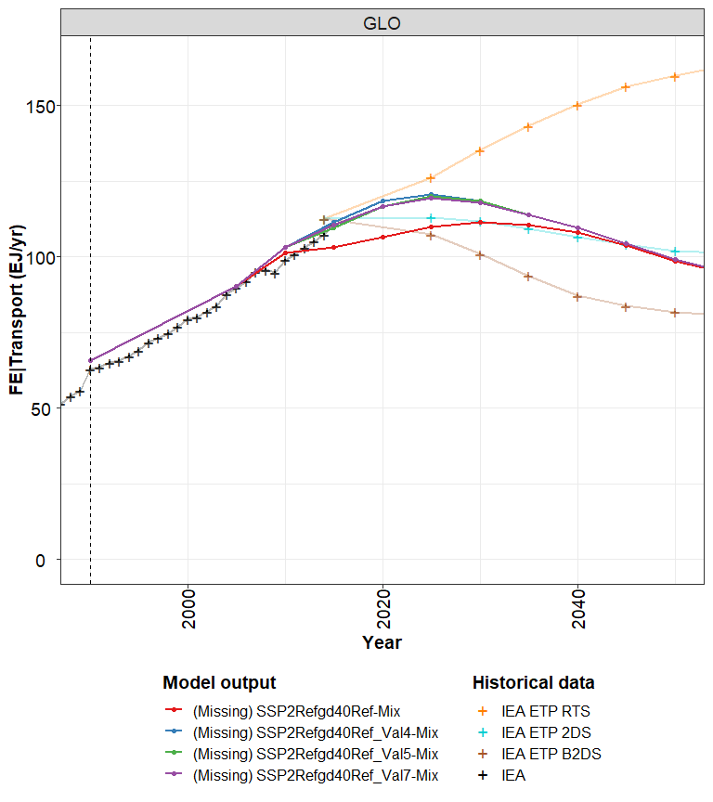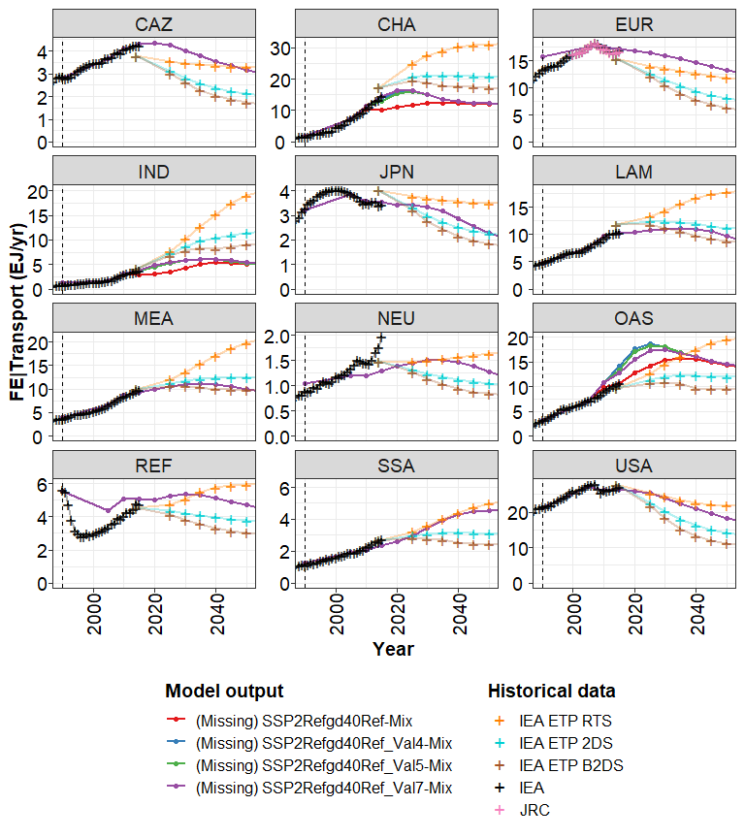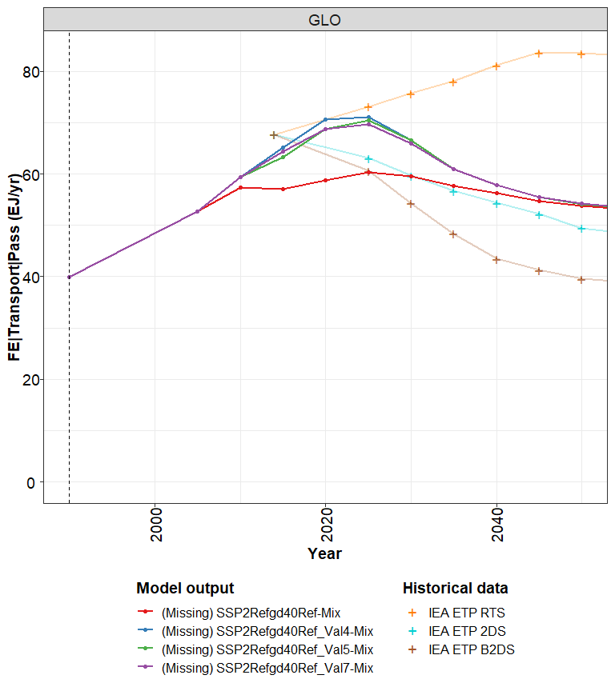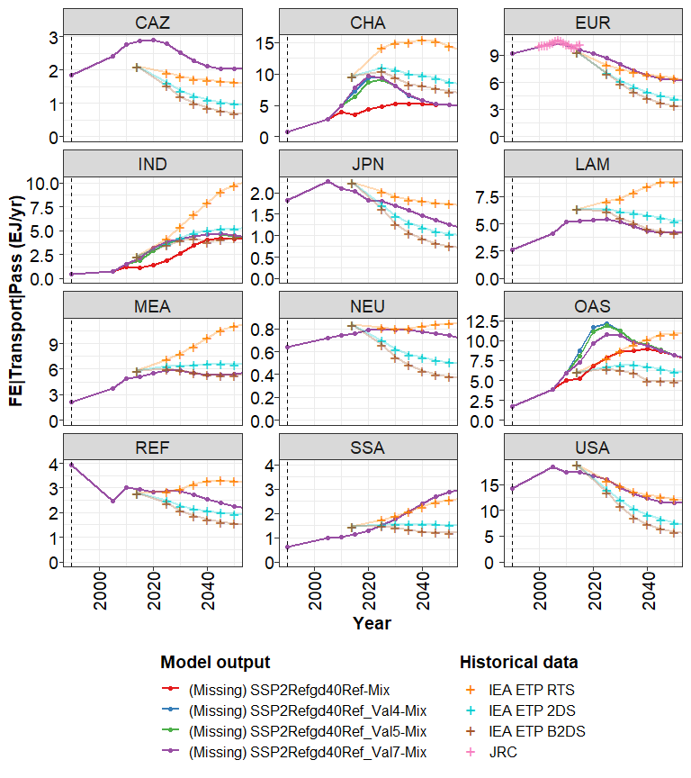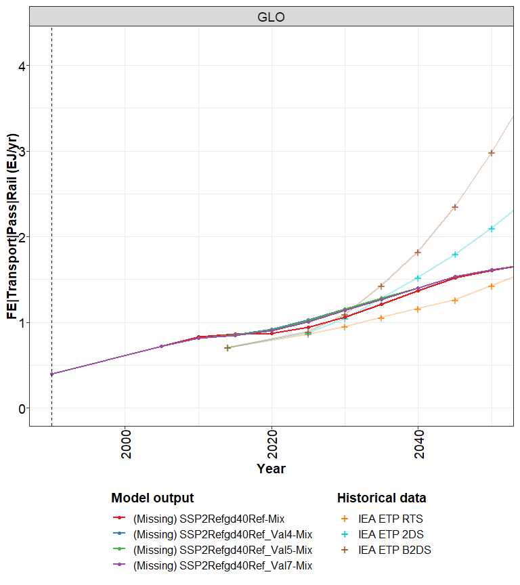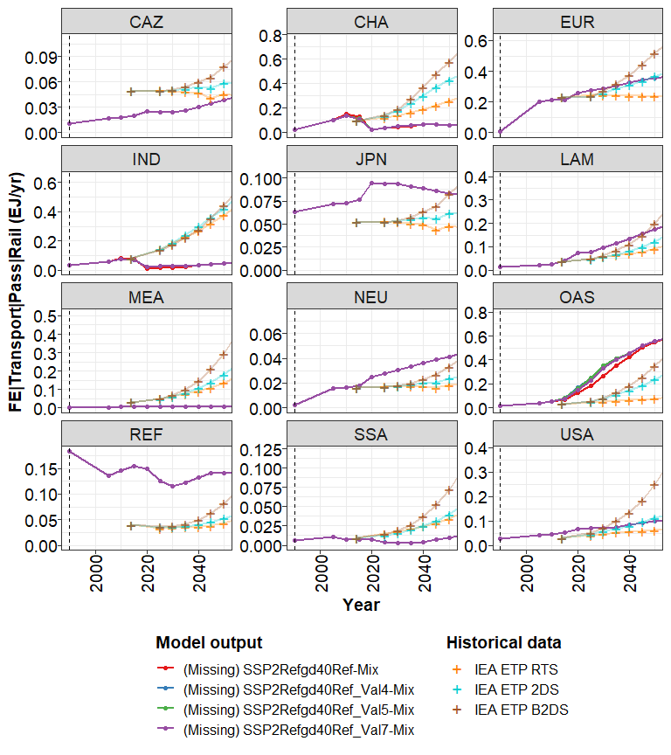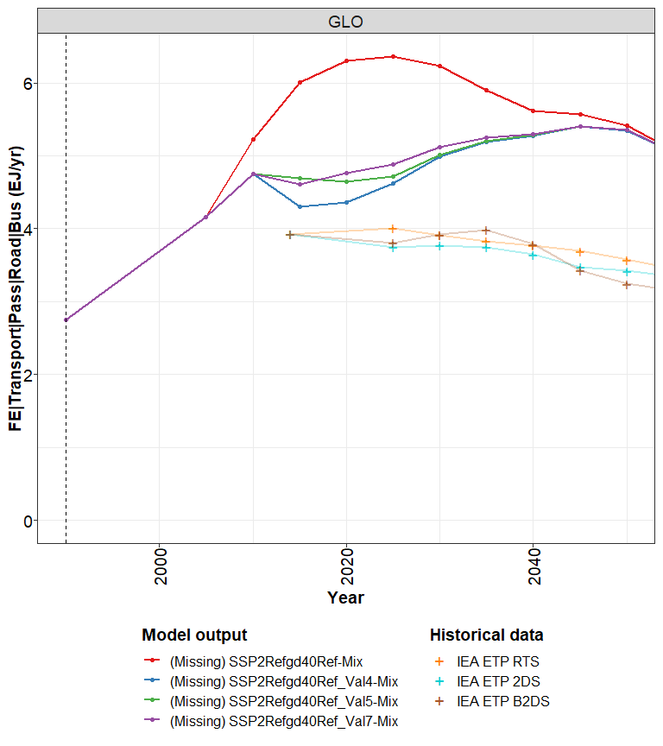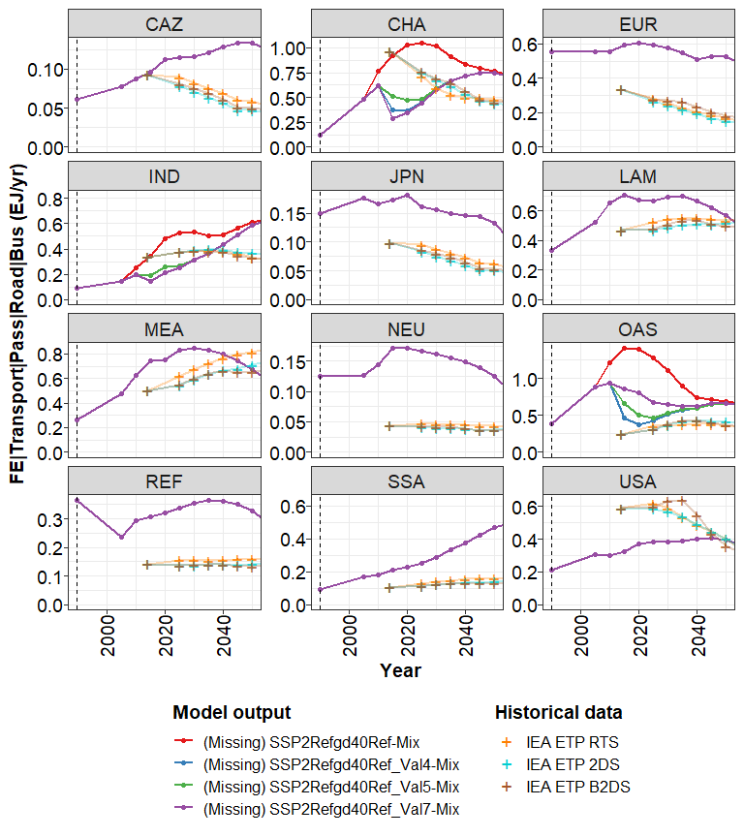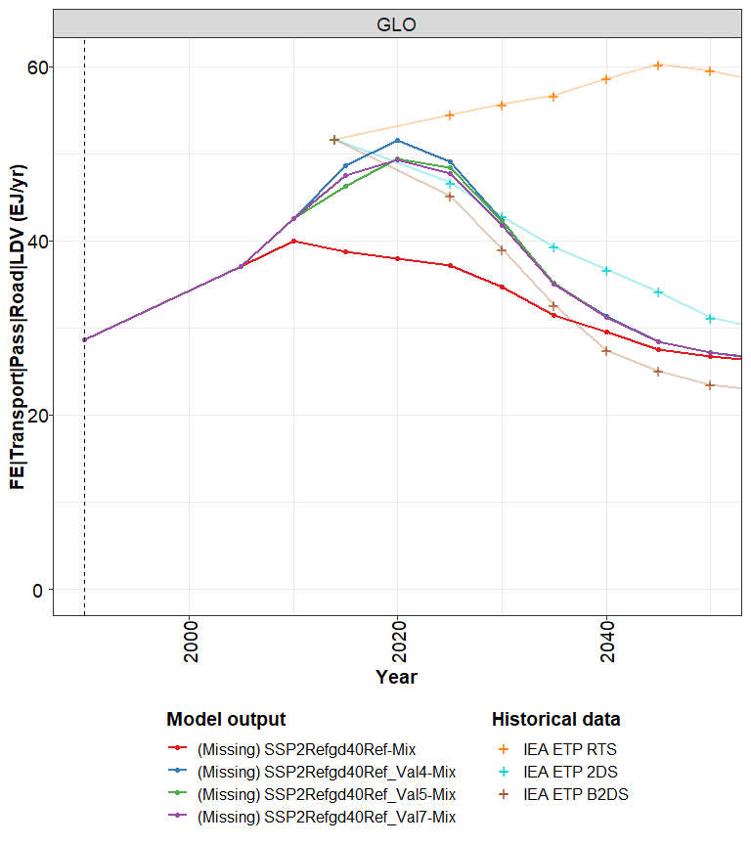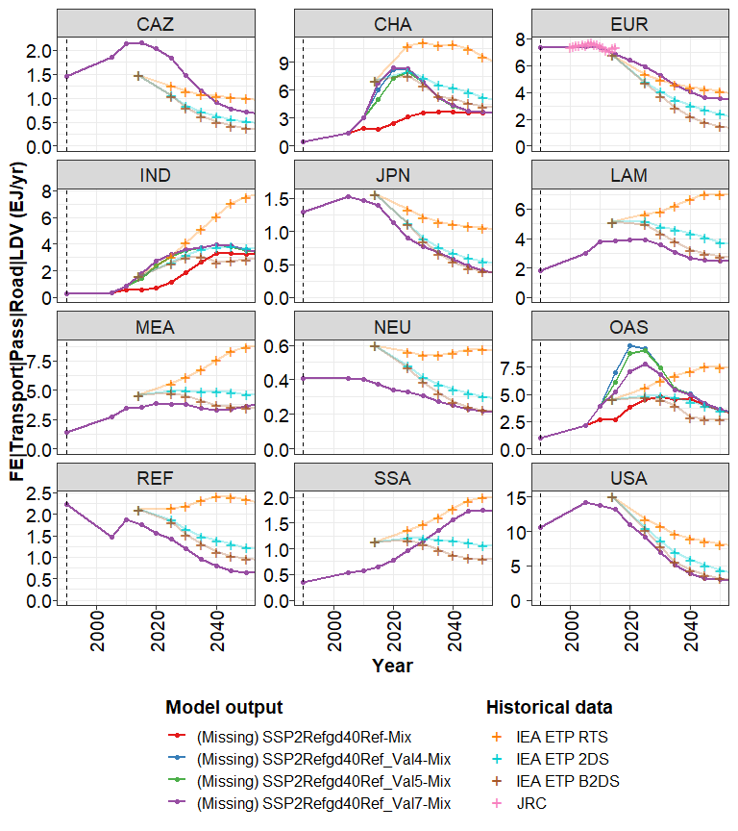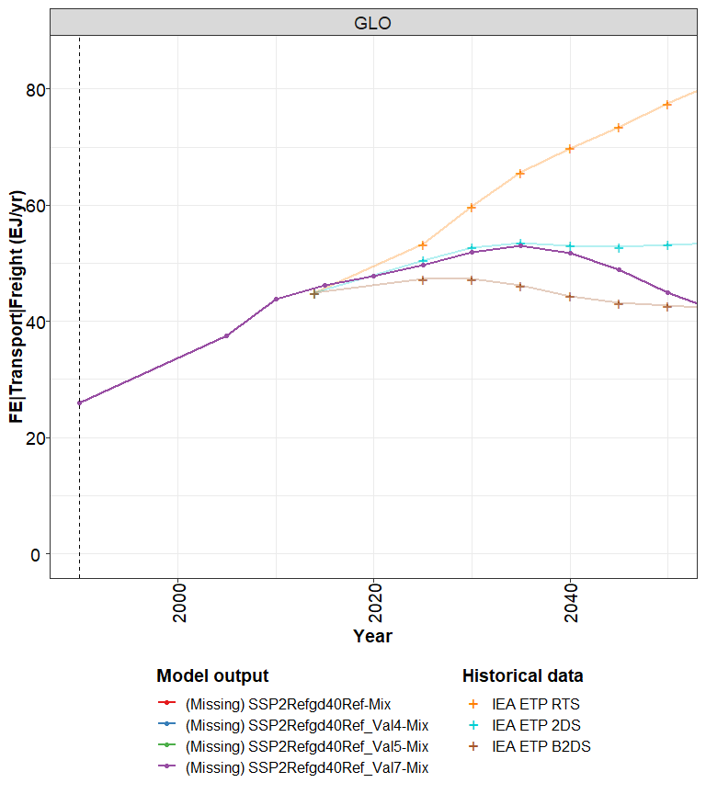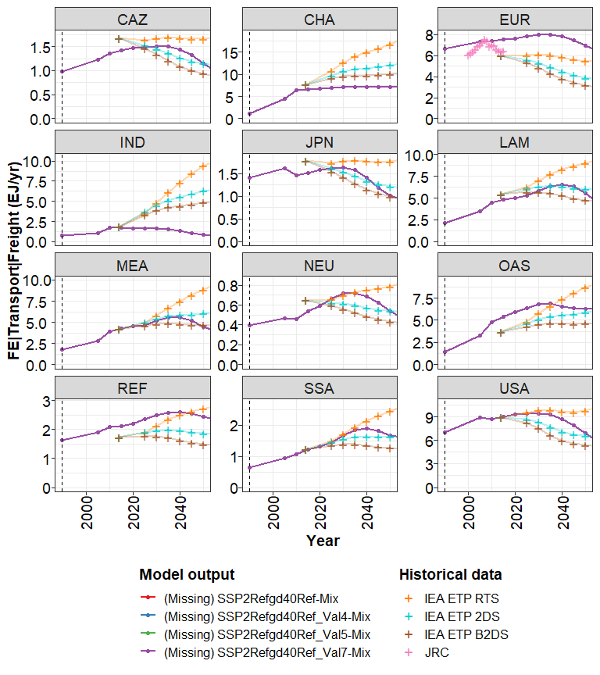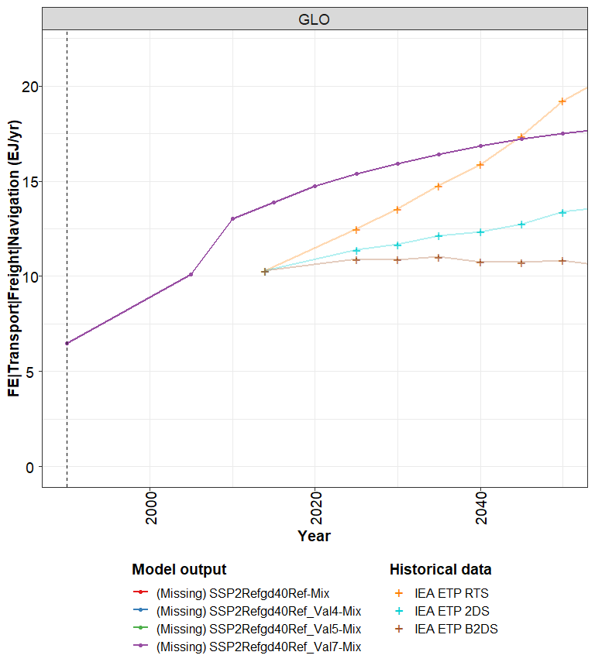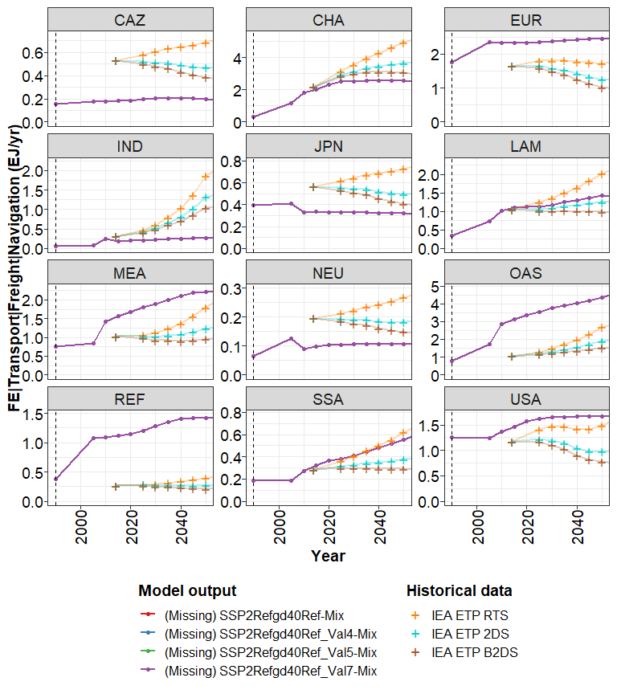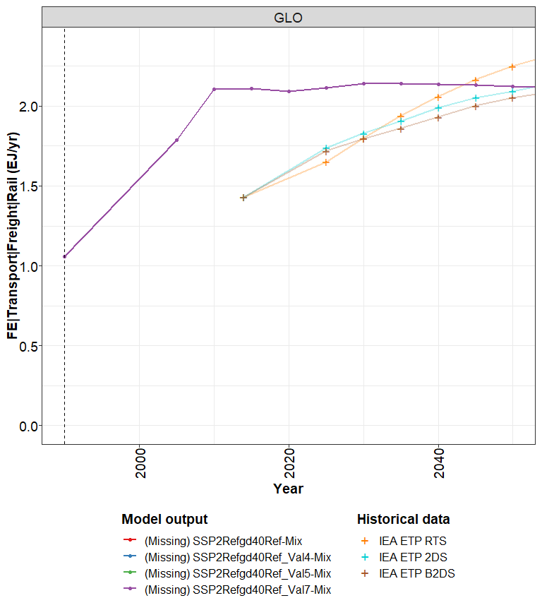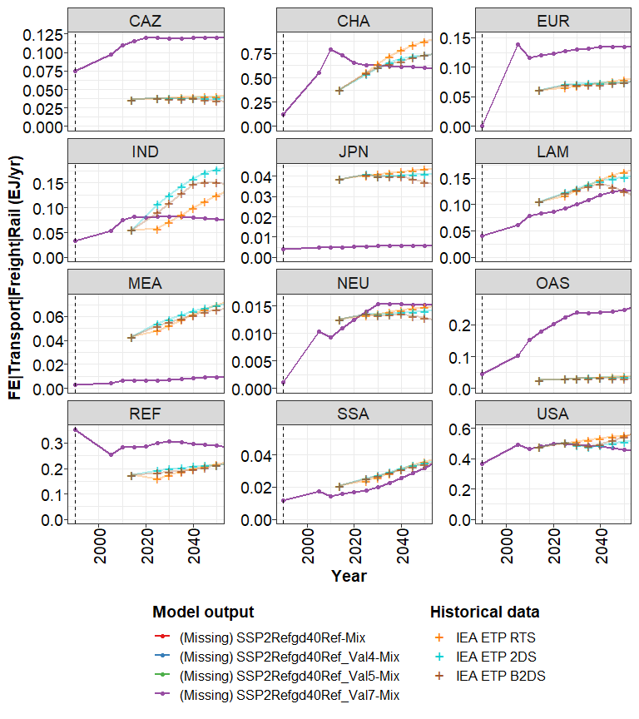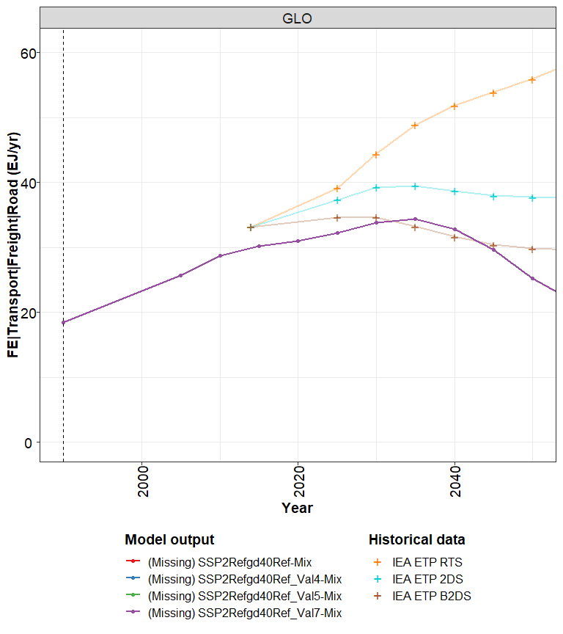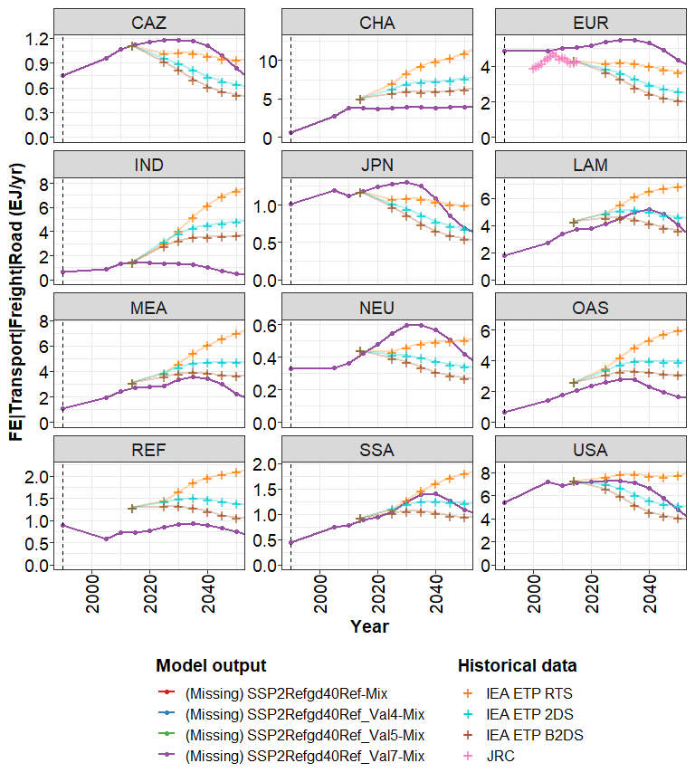

## ES Transport

mainReg <- "GLO"  
  
vars <- c(  
   
 "ES|Transport|Pass (bn pkm/yr)",  
 "ES|Transport|Pass|Rail (bn pkm/yr)",  
 "ES|Transport|Pass|Road|Bus (bn pkm/yr)",  
 "ES|Transport|Pass|Road|LDV (bn pkm/yr)",  
 "ES|Transport|Freight|Rail (bn tkm/yr)",  
 "ES|Transport|Freight|Road (bn tkm/yr)"  
)  
  
for (var0 in vars) {  
 if (sub(" (.*)", "",var0) %in% unique(data$LinePlot_data$variable)) {  
 p1 <- mipLineHistorical(  
 data$LinePlot_data[region==mainReg & variable==sub(" (.*)", "",var0)],  
 x_hist = historical[mainReg, , var0],  
 ylab = var0,  
 scales = "free_y",  
 xlim = c(1990, 2050)  
 )  
 print(p1)  
 p2 <- mipLineHistorical(data$LinePlot_data[!region==mainReg & variable==sub(" (.*)", "",var0)],  
 x_hist = historical[, , var0][mainReg, , , invert = TRUE],  
 ylab = var0, scales = "free_y", plot.priority = c("x_hist", "x", "x_proj"), facet.ncol = 3,  
 xlim = c(1990, 2050)  
 )  
 print(p2)  
 } else {  
 print(paste0(var0, " not in runs"))  
 }  
}

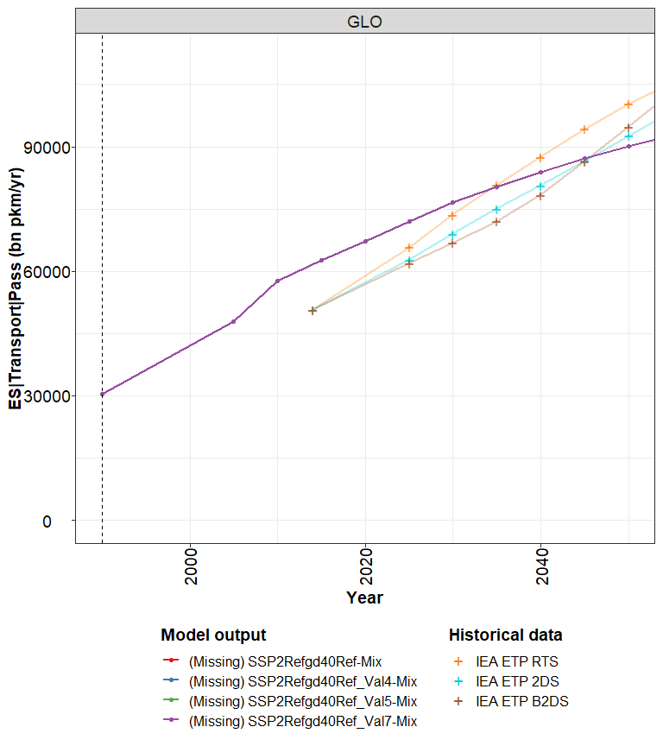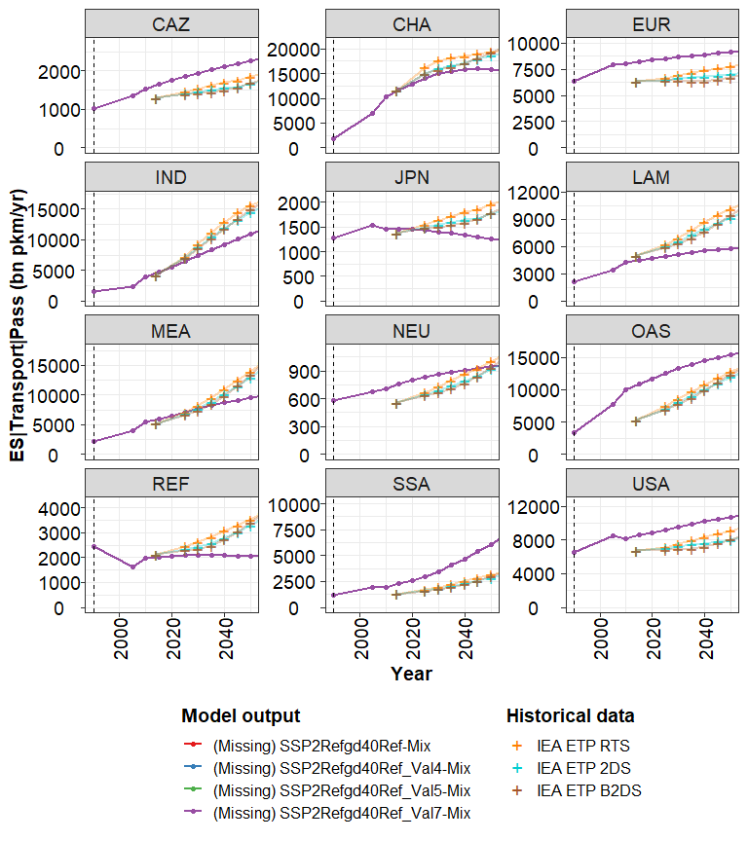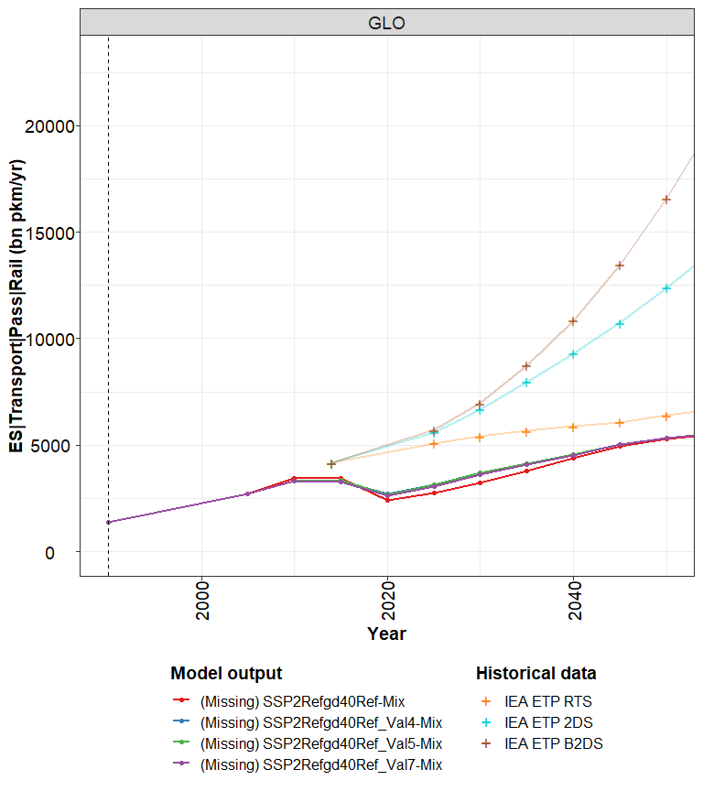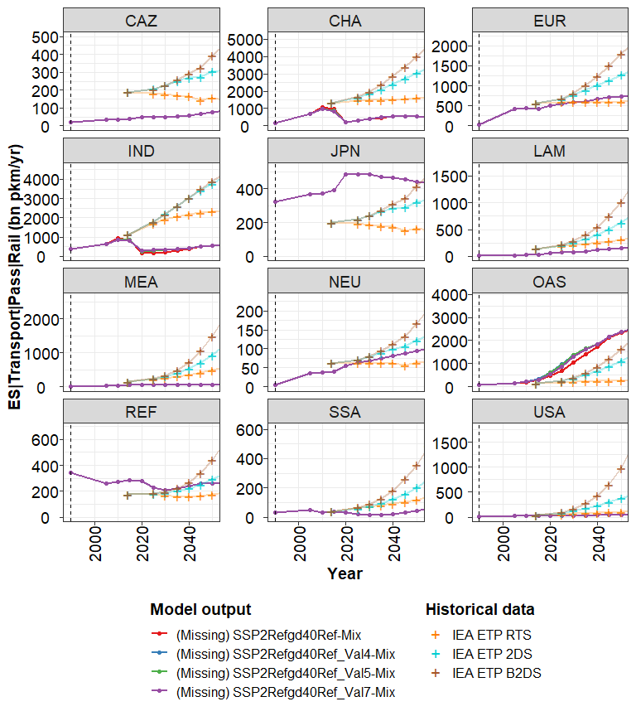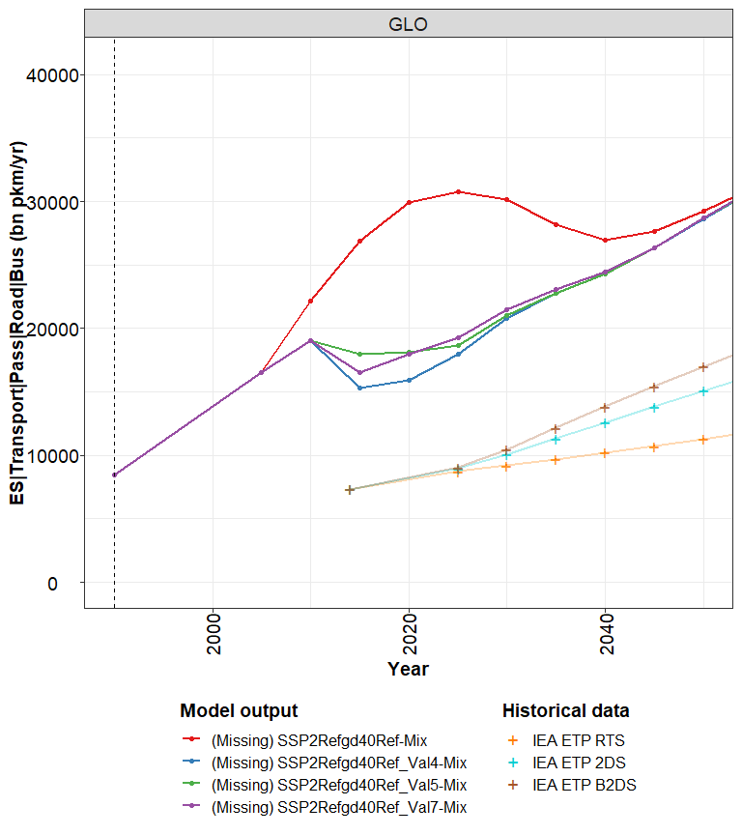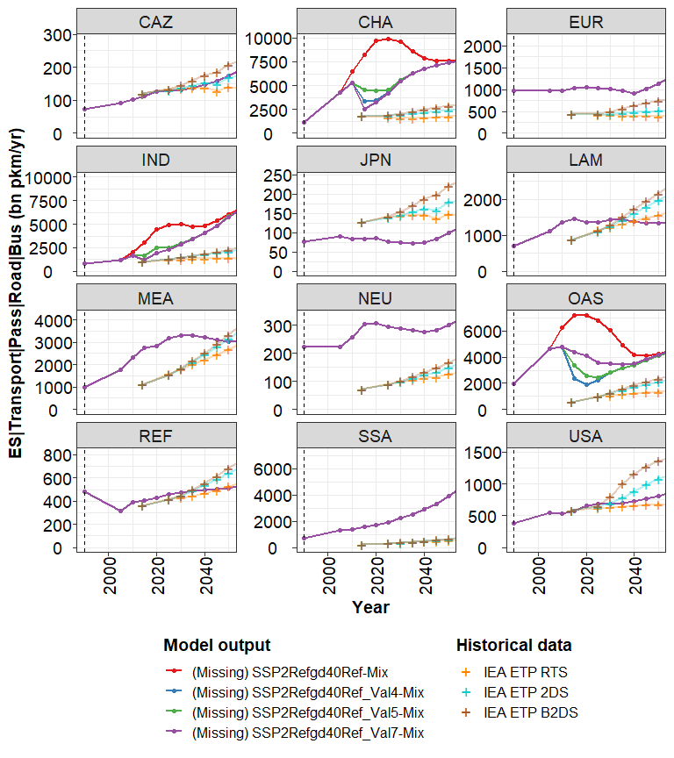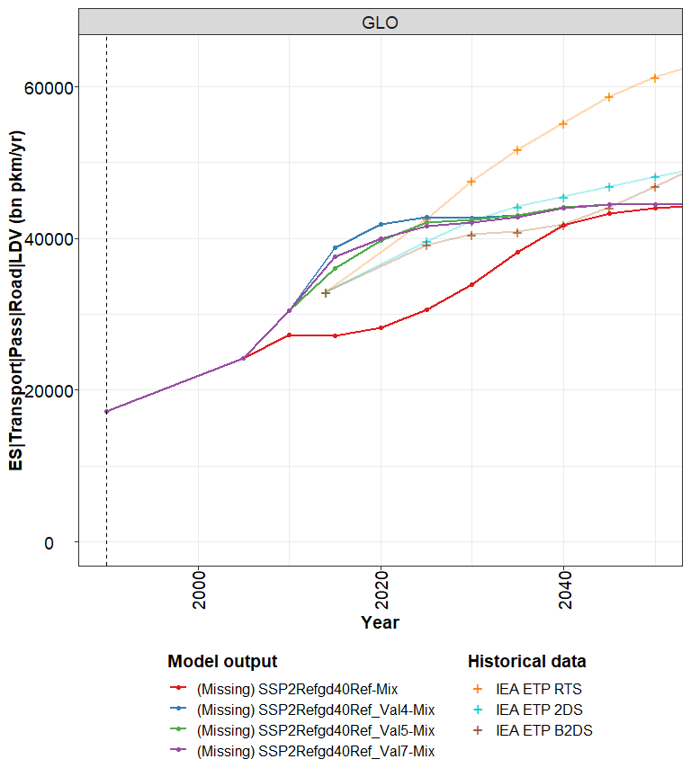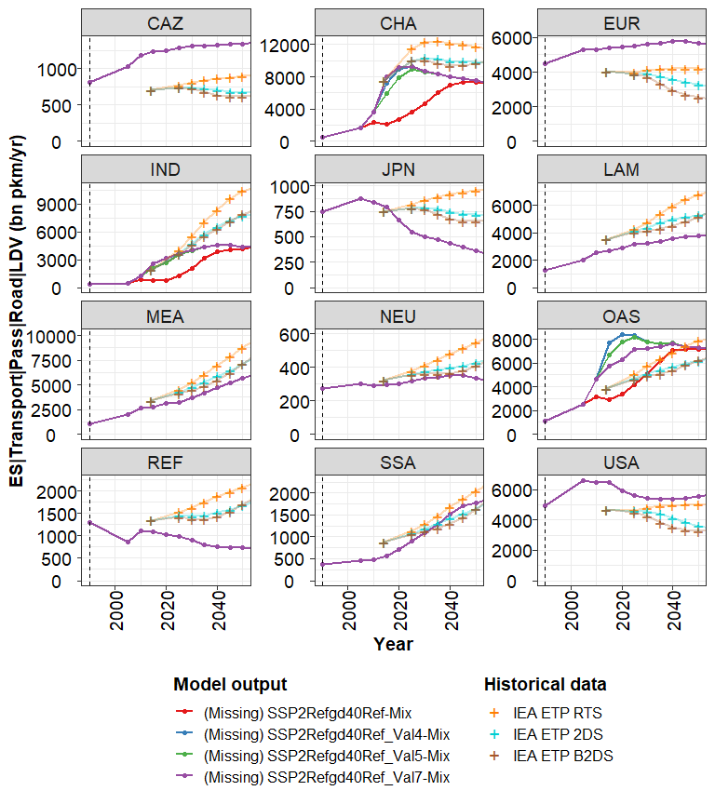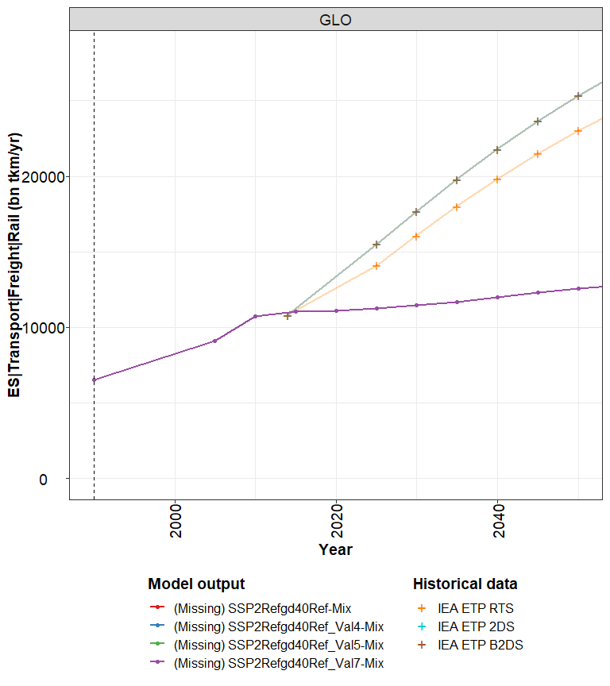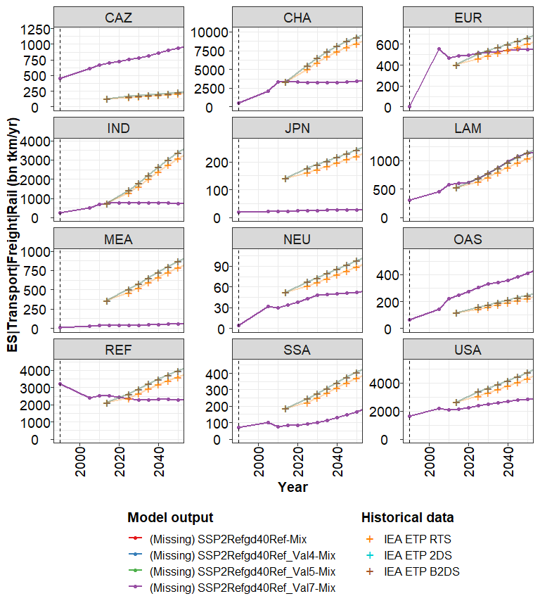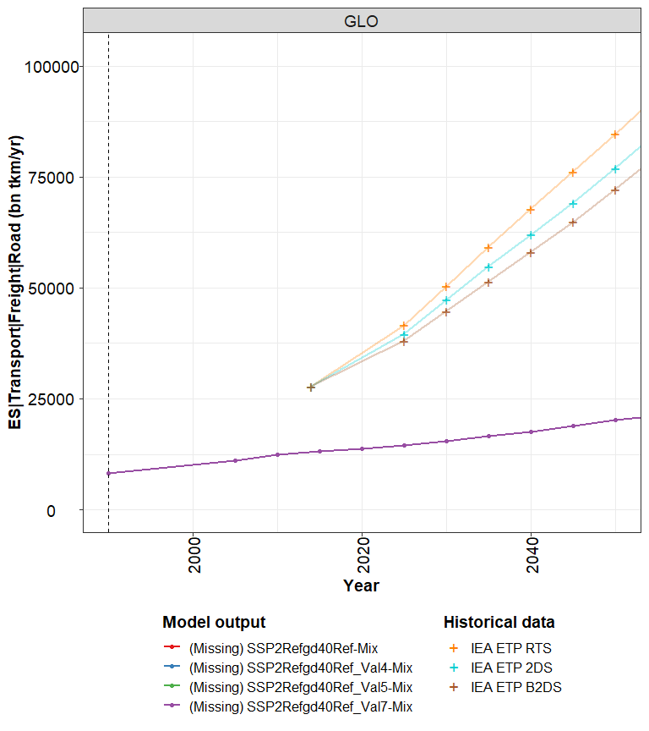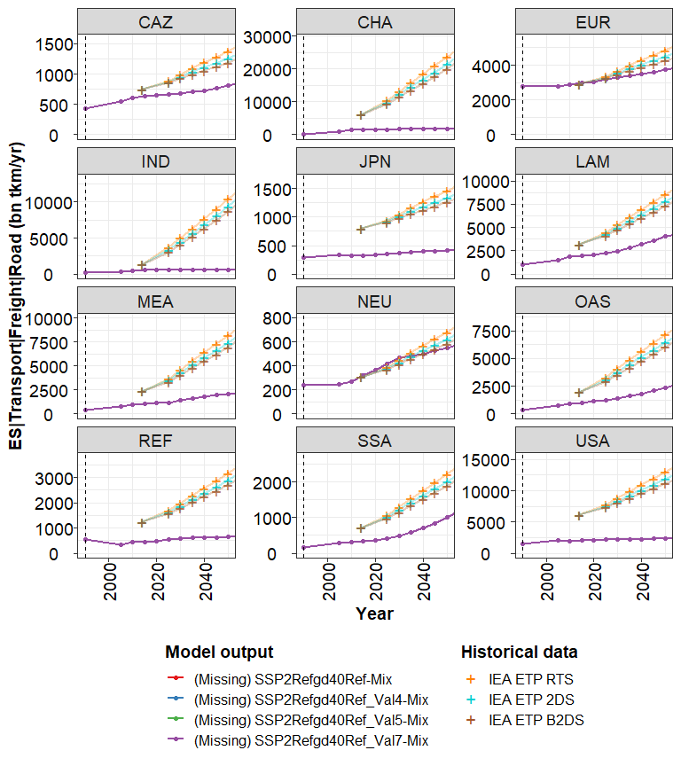

## EInt Transport

mainReg <- "GLO"  
  
vars <- c(  
   
 "EInt|Transport (MJ/km)",  
 "EInt|Transport|Pass (MJ/km)",  
 "EInt|Transport|Pass|Rail (MJ/km)",  
 "EInt|Transport|Pass|Road|Bus (MJ/km)",  
 "EInt|Transport|Pass|Road|LDV (MJ/km)",  
 "EInt|Transport|Freight (MJ/km)",  
 "EInt|Transport|Freight|Navigation (MJ/km)",  
 "EInt|Transport|Freight|Rail (MJ/km)",  
 "EInt|Transport|Freight|Road (MJ/km)"  
)  
  
for (var0 in vars) {  
 if (sub(" (.*)", "",var0) %in% unique(data$LinePlot_data$variable)) {  
 p1 <- mipLineHistorical(  
 data$LinePlot_data[region==mainReg & variable==sub(" (.*)", "",var0)],  
 #x_hist = historical[mainReg, , var0],  
 ylab = var0,  
 scales = "free_y",  
 xlim = c(1990, 2050)  
 )  
 print(p1)  
 p2 <- mipLineHistorical(data$LinePlot_data[!region==mainReg & variable==sub(" (.*)", "",var0)],  
 #x_hist = historical[, , var0][mainReg, , , invert = TRUE],  
 ylab = var0, scales = "free_y", plot.priority = c("x_hist", "x", "x_proj"), facet.ncol = 3,  
 xlim = c(1990, 2050)  
 )  
 print(p2)  
 } else {  
 print(paste0(var0, " not in runs"))  
 }  
}

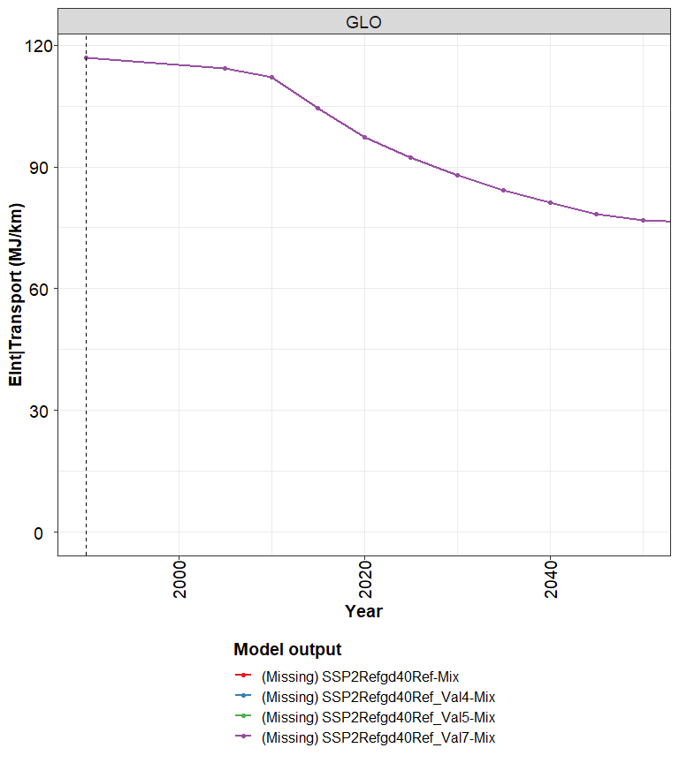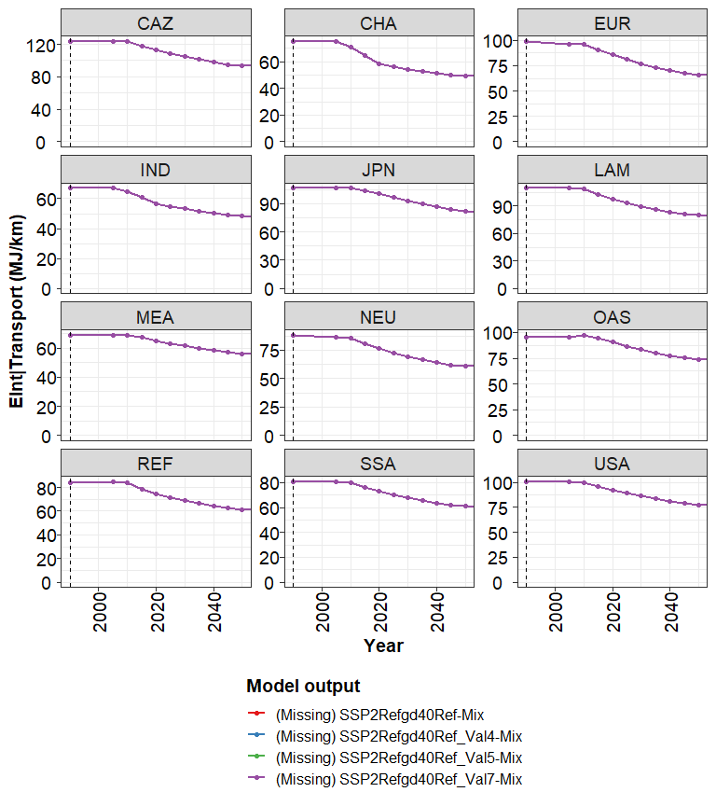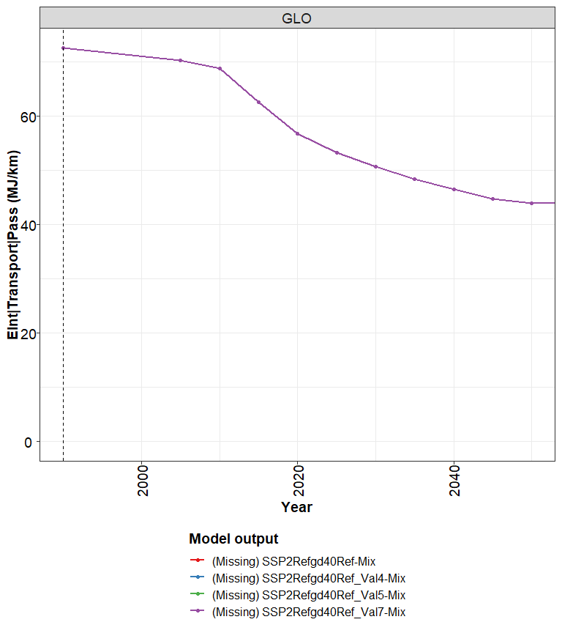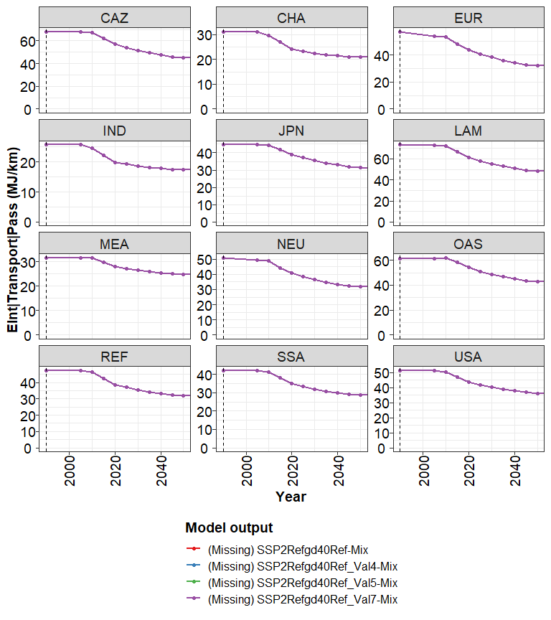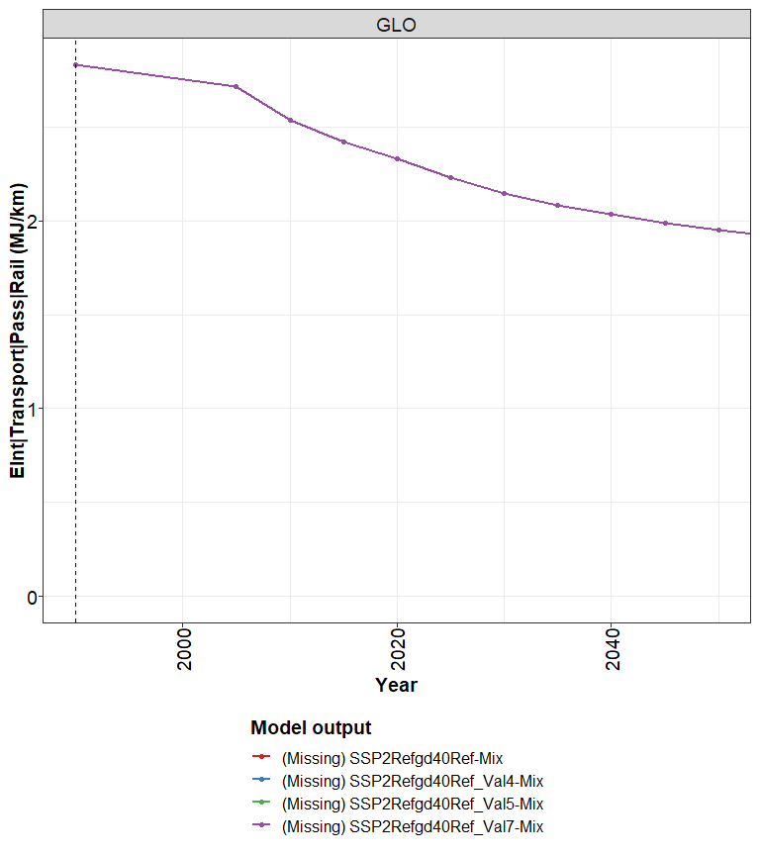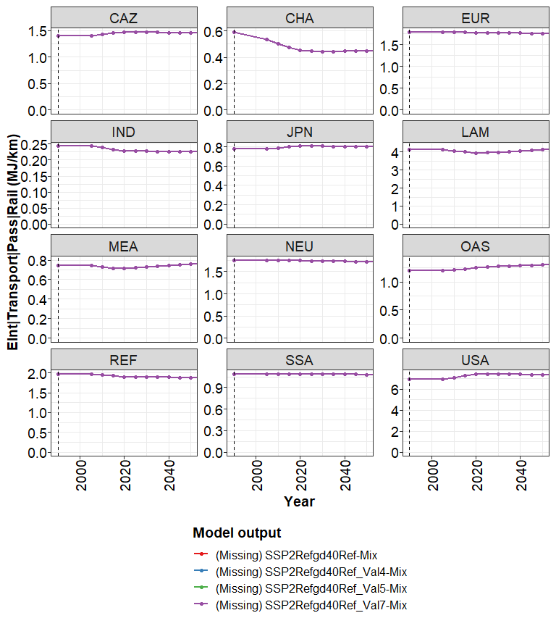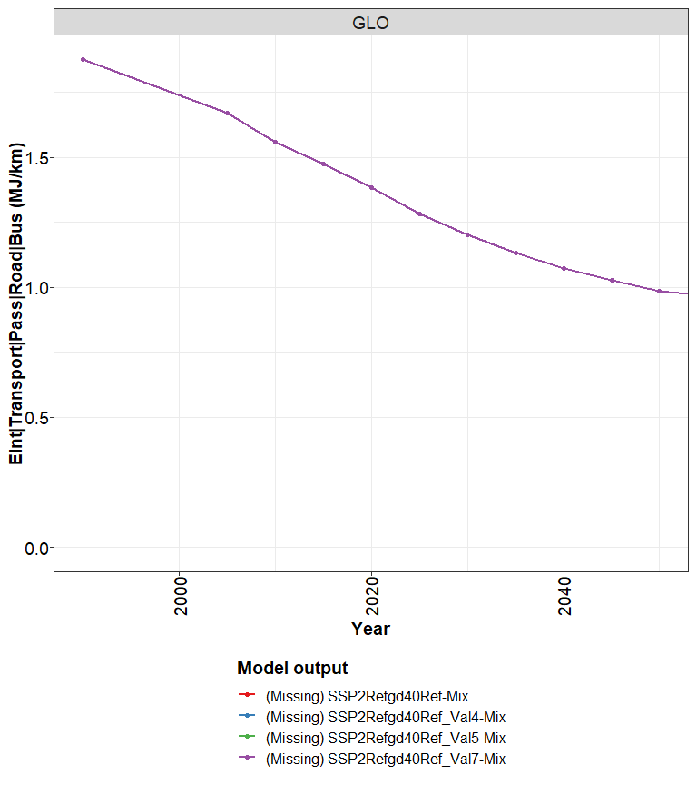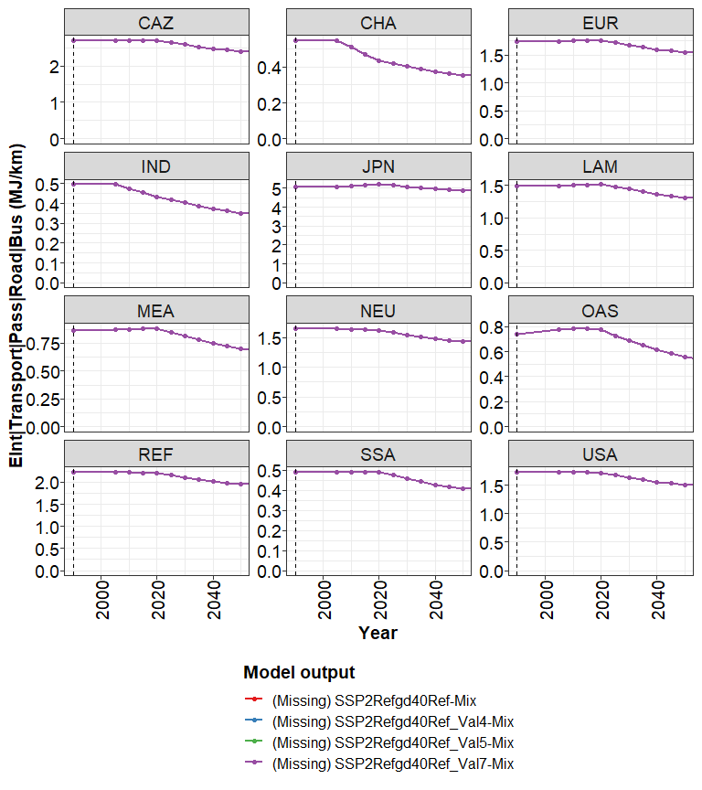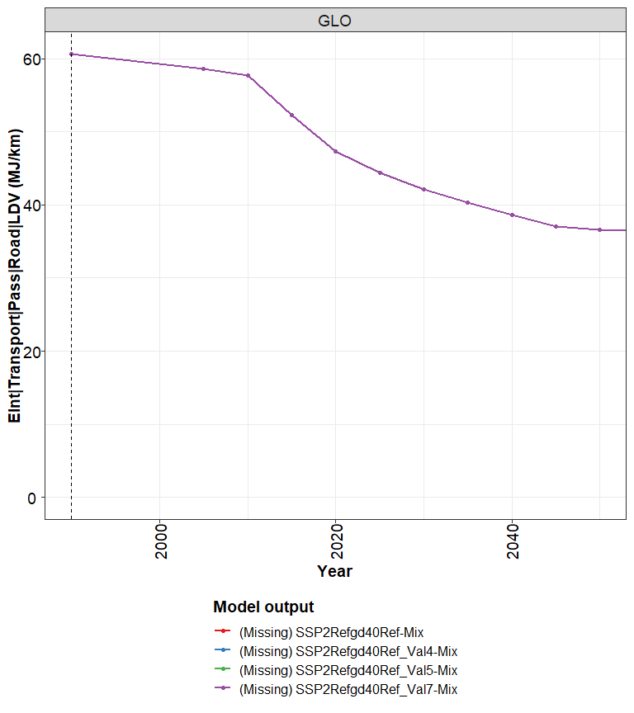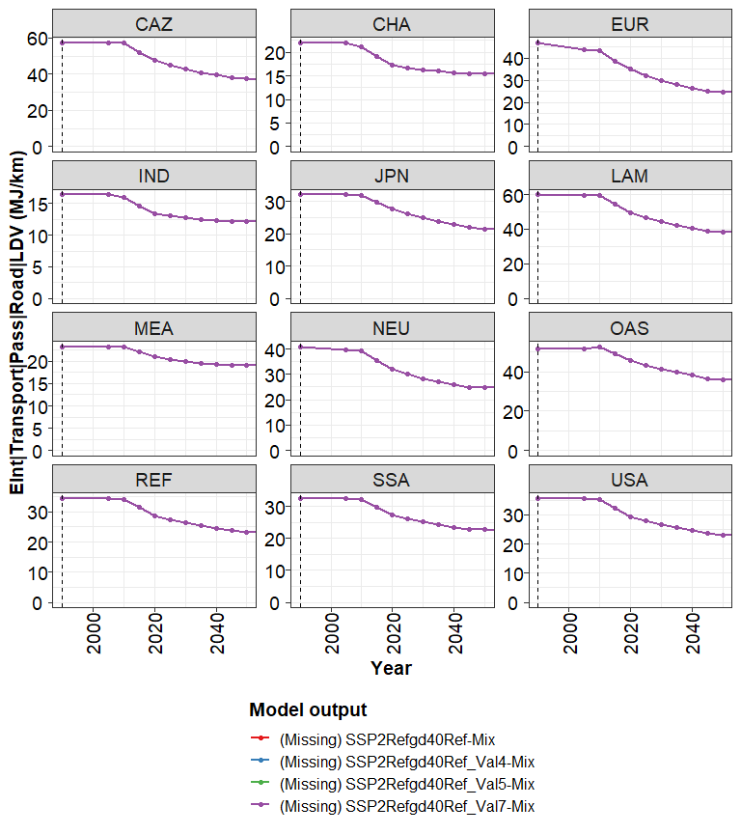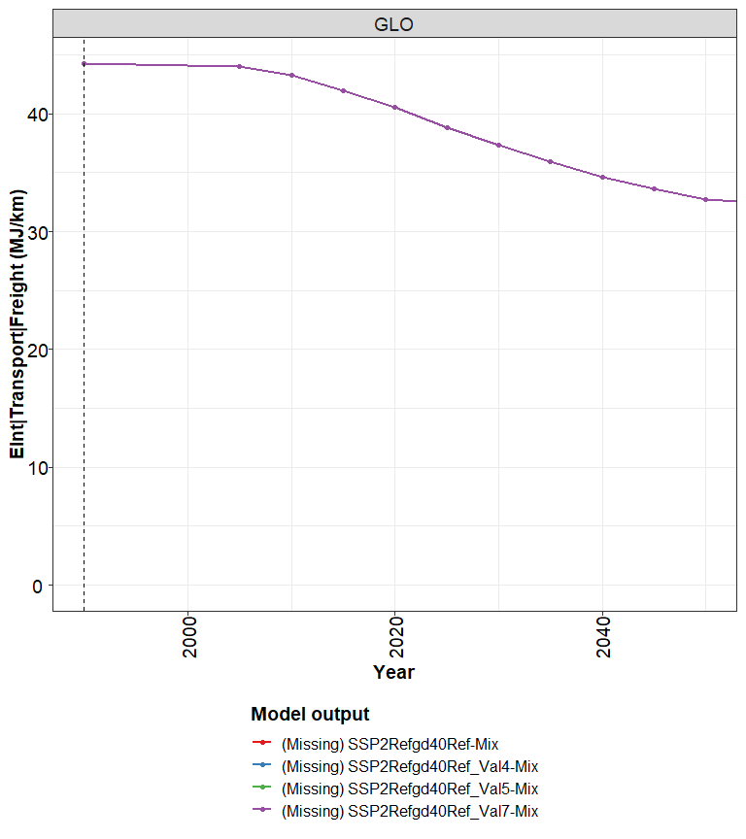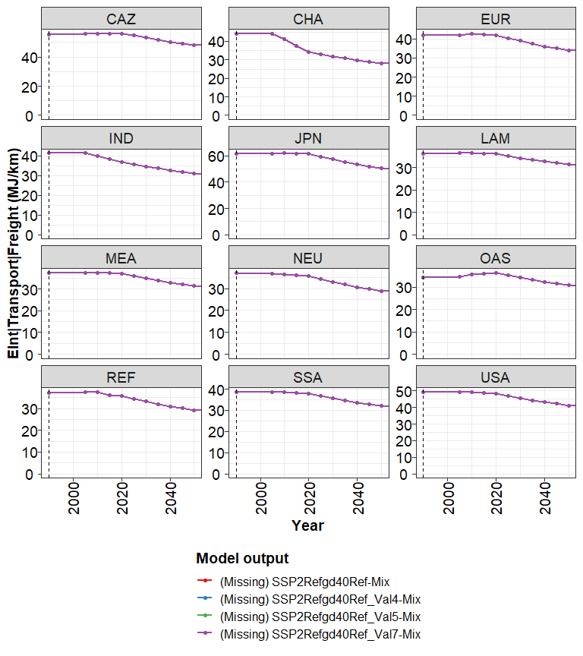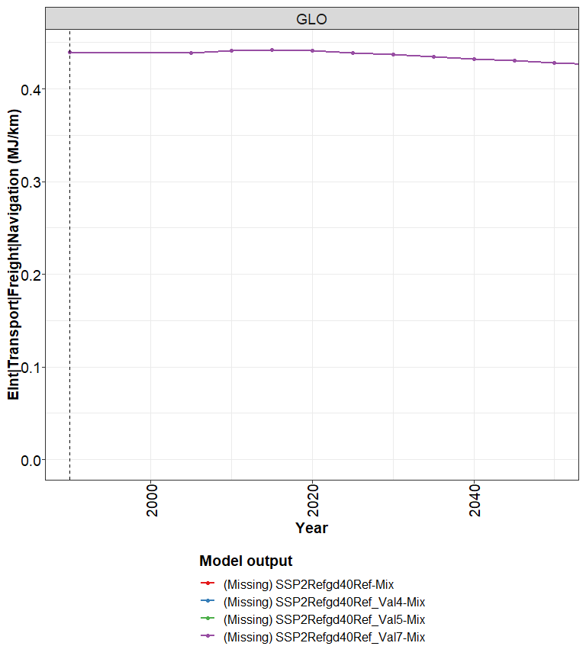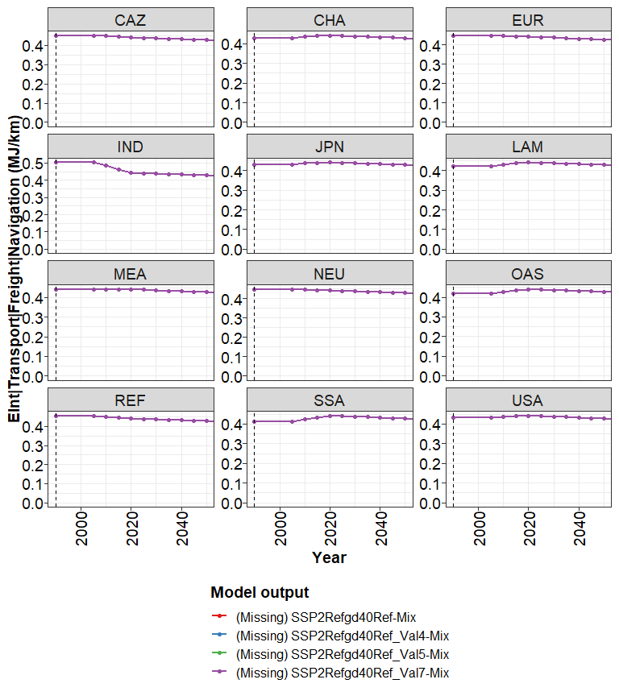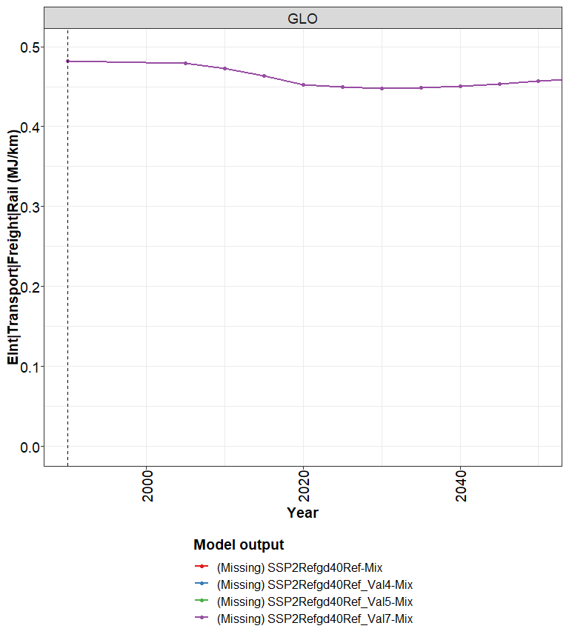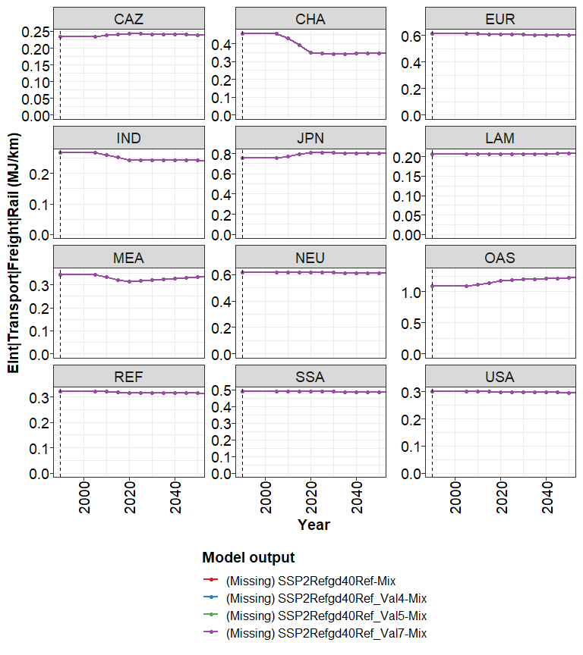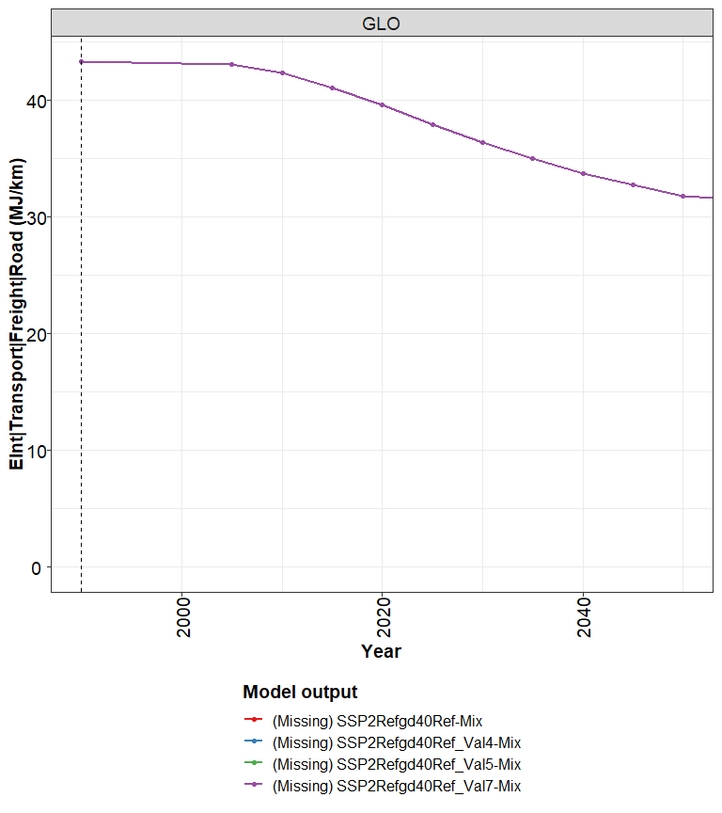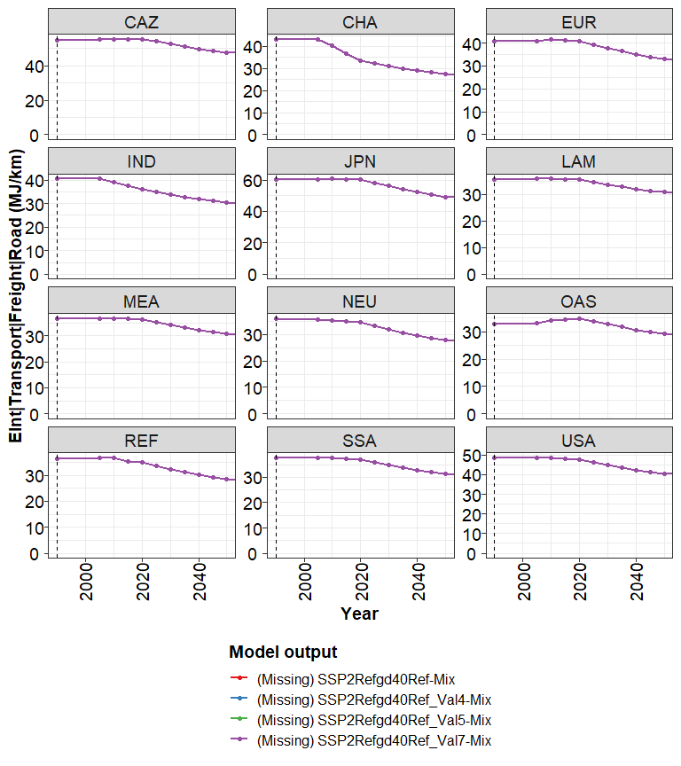

## Prices S2S3

p1 <- mipBarYearData(data$Prices_S2S3_Plot_data_LDV[period %in% c(2010,2020, 2030, 2050)],ylab="Prices logit_S2S3 LDV [USD2005/pkm]")  
 print(p1)

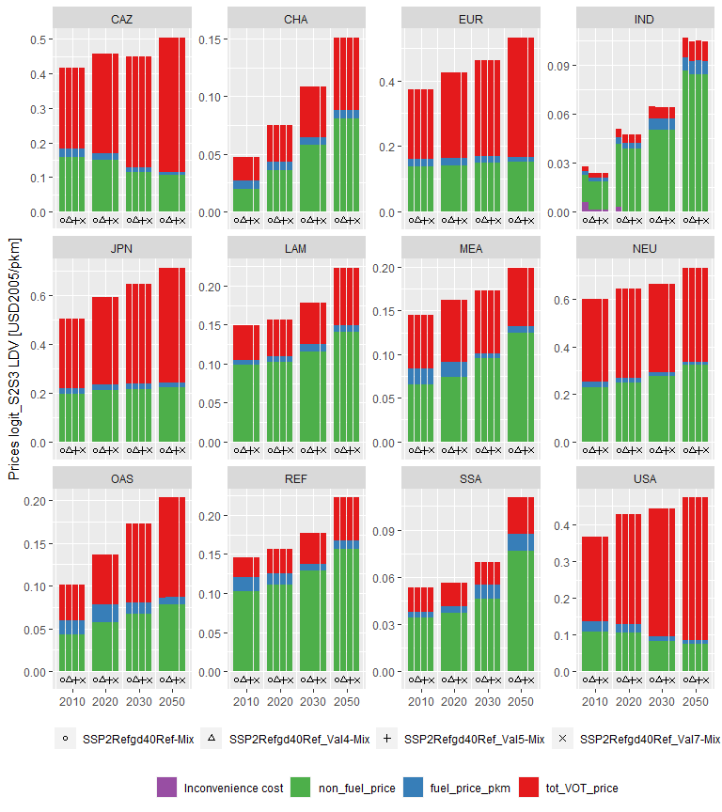

p2 <- mipBarYearData(data$Prices_S2S3_Plot_data_Bus[period %in% c(2010,2020, 2030, 2050)],ylab="Prices logit_S2S3 Bus [USD2005/pkm]")  
 print(p2)

