Readme

# Abstract

This paper introduces the basic information of software development and operation environment, source code language, development purpose, functional characteristics, environmental configuration, software compilation and other operation steps, as well as the main functions and usage methods of software inspection and configuration, seismic phase confirmation, seismic phase discarding, seismic phase revocation, seismic phase fine-tuning and so on. The folder Check _ Example under the current path is an example, which can be referred to in this manual for further understanding.

# 1. Software overview

**Software name :**

Seismic Phase Inspection Visualization PlatformBased On Automatic Pickup of Seismic Phase (Abbreviation : Seismic Phase Inspection Visualization Platform)

**The hardware environment of the development :**

CPU : 2.9GHz, Memory : 128GB, Hard disk : 49TB

**The running hardware environment :**

2.9GHz or more CPU, 32GB or more memory, 60GB or more hard disk

**The operating system for developing the software :**

Ubuntu 22.04.1 LTS

**Software development environment / development tools :**

Visual Studio Code 1.73.1

**Software operating platform / operating system :**

Linux system

**Software Run Support Environment / Support Software :**

JDK 11

**Programming language :**

Java

**Source program quantity :**

1,091 row

**Purpose of development :**

In order to better serve the automatic phase picking work, it is used by personnel in the corresponding field.

**Area / industry oriented :**

seismological researches

**The main functions of the software :**

The visualization platform of seismic phase inspection is to use advanced GUI technology to innovate the seismic phase pickup inspection mode, implement the visualization of seismic phase inspection, realize the parametric control of the whole process of seismic phase reproduction, fine adjustment, screening, free inspection and sorting, so as to build a more scientific, efficient and convenient seismic phase inspection system. Through the innovative application model, the seismic phase picking work mode of seismic science and technology personnel is innovated, so that the seismic phase picking truly feels the convenience, effectiveness and economy of computer technology, and realizes the burden reduction of scientific research.

**The technical characteristics of the software :**

By checking the practice of visualization, the artificial phase picking is gradually replaced by the man-machine cooperative phase picking, and the parameter standard of phase picking is standardized in practice. At the same time, the time cost of seismic phase picking is reduced, and the efficiency of picking and inspection is improved. From application to promotion, the intelligent and visualization of picking up seismic phases is steadily realized.

# **2. Operation steps**

## Step 1 Environment configuration and compilation

**Operating environment :**

Java / JDK 11、JavaFX 19

**Javafx configuration :**

1. Download the 'Javafx' package from the Javafx official website ;

2. Decompress 'openjfx-19_linux-x64_bin-sdk.zip' ;

3. Move the 'javafx-sdk-19' folder to '/home/xiangjh/opt/' ;

4. Terminal runs 'gedit ~/.bashrc' ;

5. At the end of the text, add :'export PATH_TO_FX=/home/xiangjh/opt/javafx-sdk-19/lib' .

It is recommended that the javafx-sdk-19 path is located in the root directory so that it can be set permanently at one time.

**Compiling command :**

javac --module-path $PATH_TO_FX --add-modules javafx.controls Check.java

## Step 2 Configuration file settings

**Configuration file path :**

./configs/config.properties

**Note :**

The selection of epicentral distance and time mode, the epicentral distance mode must be selected after automatic picking.

**Key check items :**

Screening level (level), Minimum epicentral distance (minGcarc), Input and output file path (rawFile&outFile), Check the historical file path (historyFile), Inspection-free file path (exemptionFile), Picture file path (imagedir), Whether to open the epicentral distance mode (epiModel), Whether to turn on the order recovery function (recoverSort), Does load check history (historyLoad), Whether to turn on the inspection-free function (exemptionLoad).

## Step 3 Start the inspection

**Note :**

The original -Checking/firmtemp.txt and -Checking/rawsorttemp.txt (epicentral distance mode) must be deleted in advance, except that the firmtemp.txt is retained if you need to continue the previous check, and the rawsorttemp.txt (epicentral distance mode) is retained if you need to continue using the previous sort.

**Commands to run :**

java --module-path $PATH_TO_FX --add-modules javafx.controls Check ./configs/config.properties

**Operation results :**

- Checking/Pn_picknet_manu.txt

# 3. Methods of use

## 3.1 Home

The user opens the program to enter the home page and sees 'configuration' and 'start' healthy, as shown in the figure :

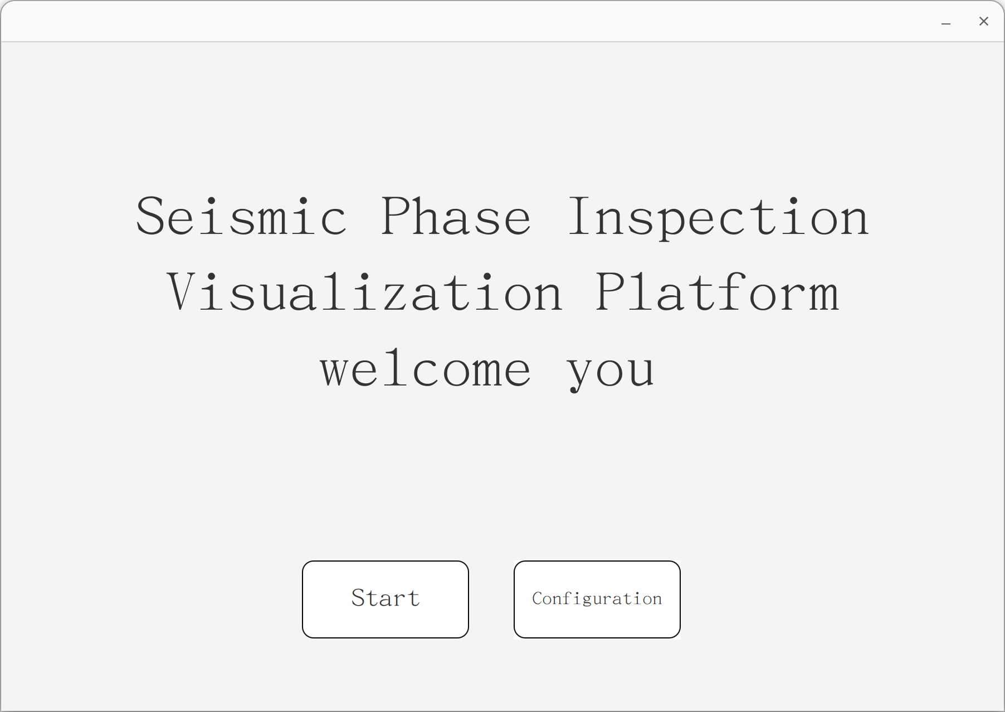

## 3.2 Check configuration

Users click on the page 'configuration' button, pop up the configuration file, the user can modify the parameters are as follows :

### 3.2.1 Configuration parameters

|  |  |  |
| --- | --- | --- |
| **configuration** | **option** | **content** |
| phaseType | “1”、“2” | Select the target seismic phase type, there are Pn, Sn two types of seismic phases. |
| level | “A”、“AB”、“ABC”、“ABCD” | Select the screening level, there are A, B, C, D four levels |
| minGcarc  maxGcarc | “>0” | The minimum and maximum epicentral distances are selected in the unit of the earth 's large circular arc. |
| epiModel | “True”、“False” | Two modes of time mode and epicentral distance model are provided. The time mode refers to checking the order of seismic phases to sort the occurrence time, and the epicentral distance mode refers to checking the order of seismic phases to sort the epicentral distance. |
| historyLoad | “True”、“False” | The user has the need for multiple inspections, and the software can provide corresponding functions to reproduce and visualize the previous inspection results. |
| exemptionLoad | “True”、“False” | The software provides users with the function of checking whitelists, which will not be checked in the list. |
| other parameters |  | path information |

### 3.2.2 Save configuration

The user saves and closes the configuration file, returns to the home page, and clicks the 'Start' button on the page.

## 3.3 seismic phase examination

Next, pop up the check sub-interface, as shown in Figure :

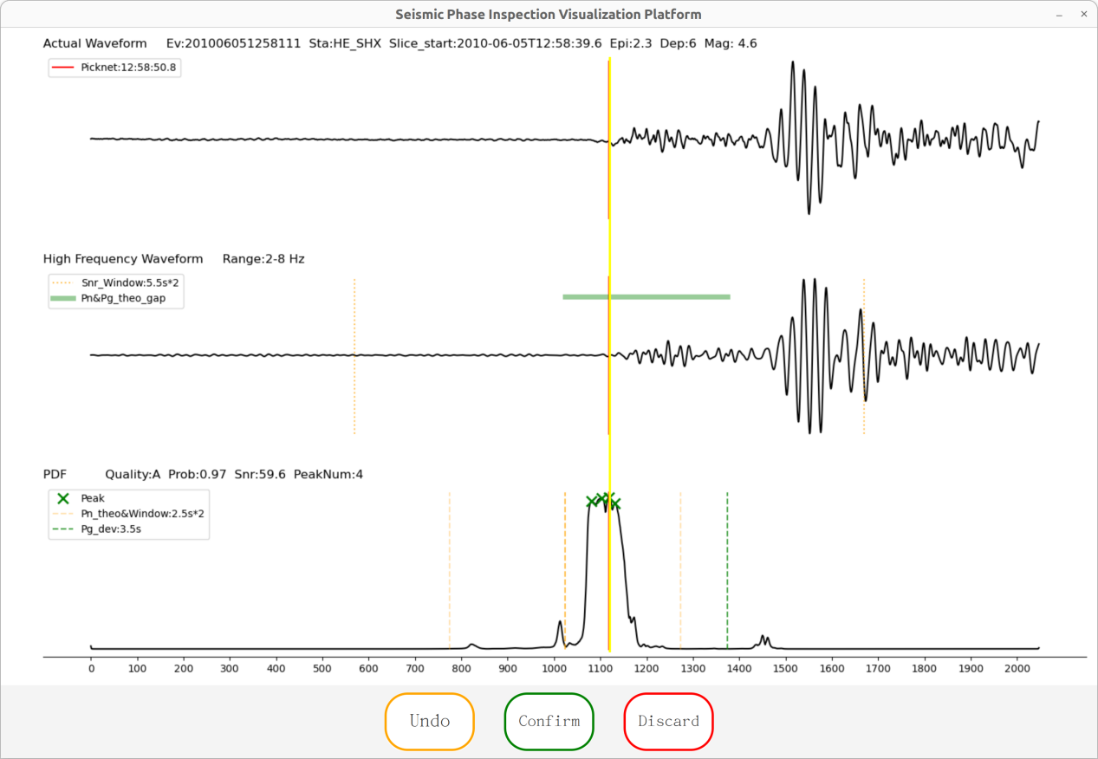

Users can view the original seismic waveform, 2-8 Hz filtered seismic waveform, seismic phase analysis and other information on the check sub-interface, and 'confirm', 'revoke', 'discard' three function buttons, where the red line represents the arrival time of the seismic phase recommended by the machine, and the yellow line represents the arrival time of the seismic phase selected by the user.

### 3.3.1 Seismic phase confirmation

The user clicks the 'Confirm' button on the page to save the current phase and switch the next phase, as shown in Figure :

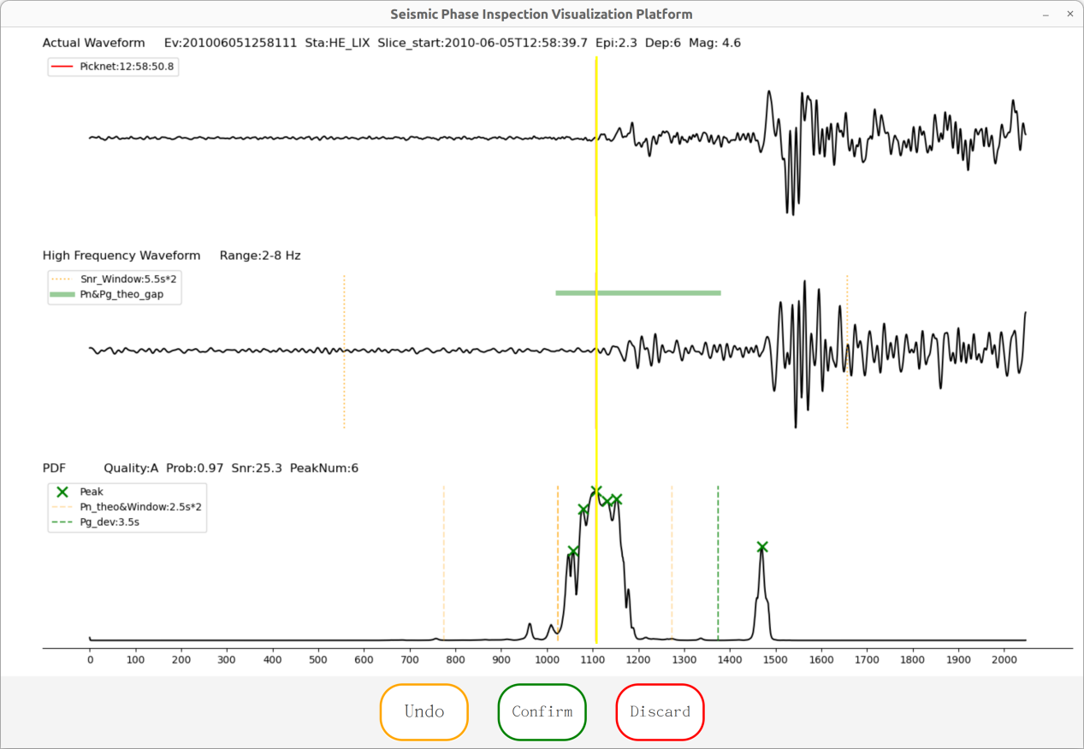

### 3.3.2 Phase discarding

The user clicks the 'discard' button on the page, that is, discard the current phase and switch the next phase, as shown in the figure :

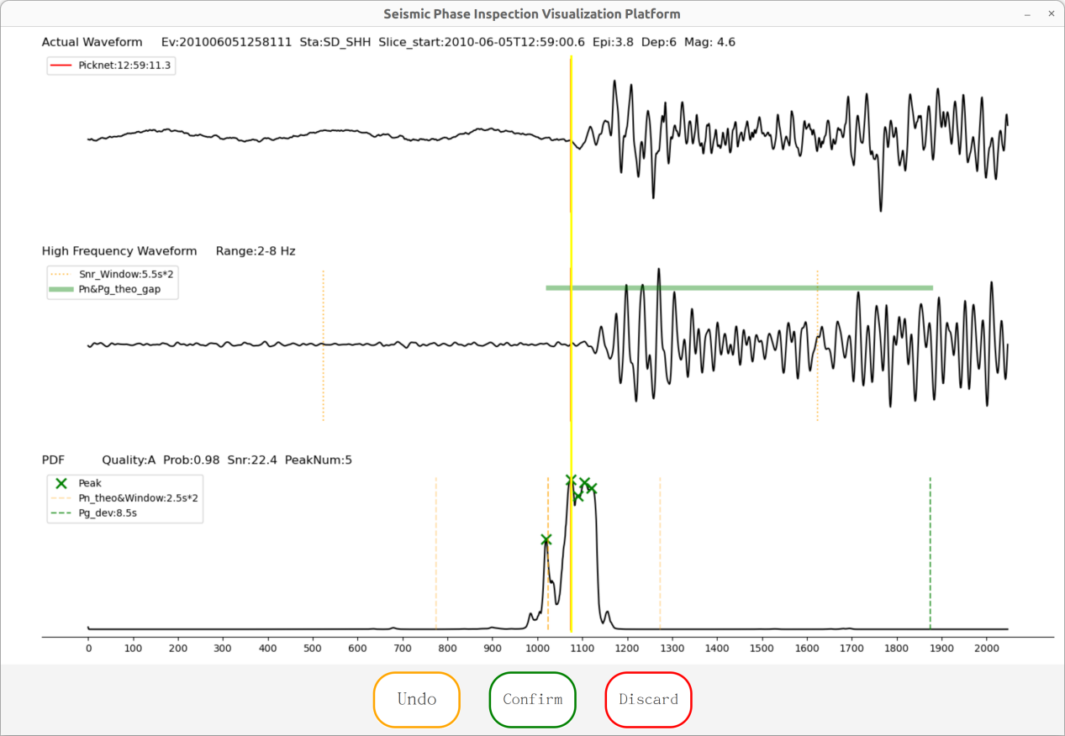

### 3.3.3 Phase cancellation

The user clicks the 'Undo' button on the page, that is, revokes the previous operation and returns the previous phase, as shown in the figure :

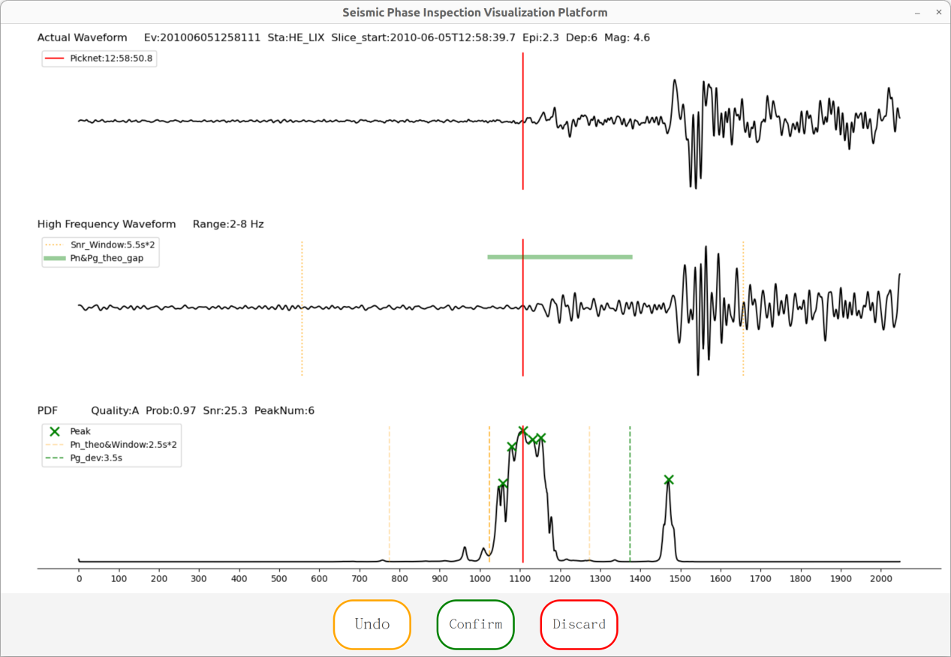

### 3.3.4 Seismic phase fine-tuning

The user slides the mouse 'roller', that is, fine-tuning the arrival time of the seismic phase, as shown in the yellow line. Scroll down to reduce the time, on the contrary, the time increases, as shown in the figure :

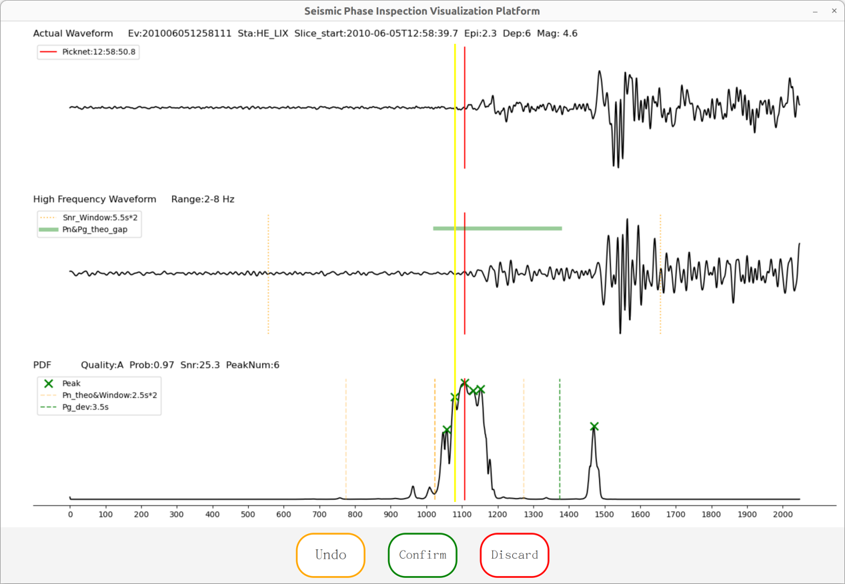

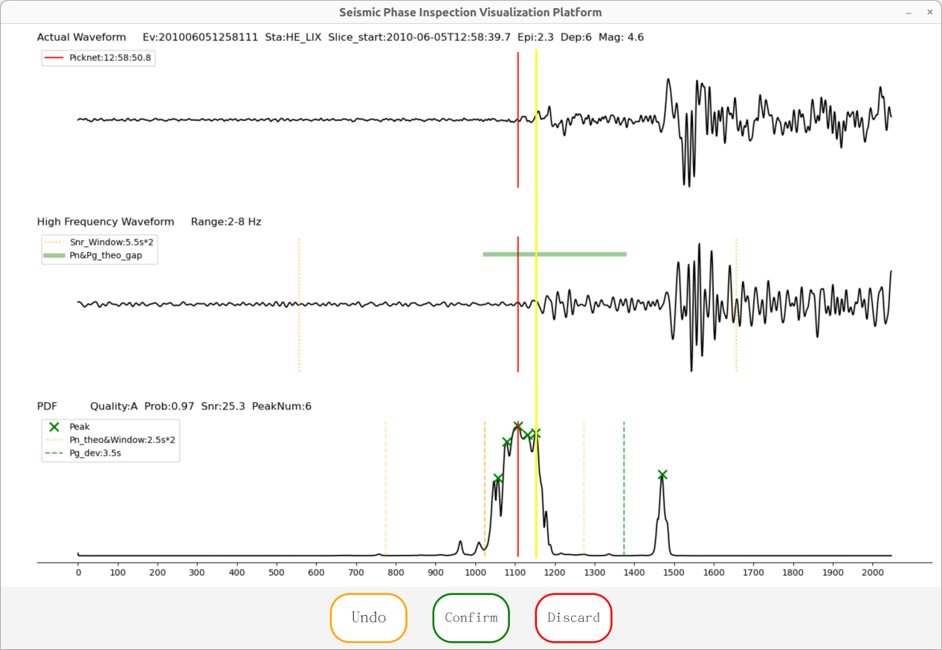

## 3.4 Withdrawal procedure

Without changing the configuration, the exit will record the current process.

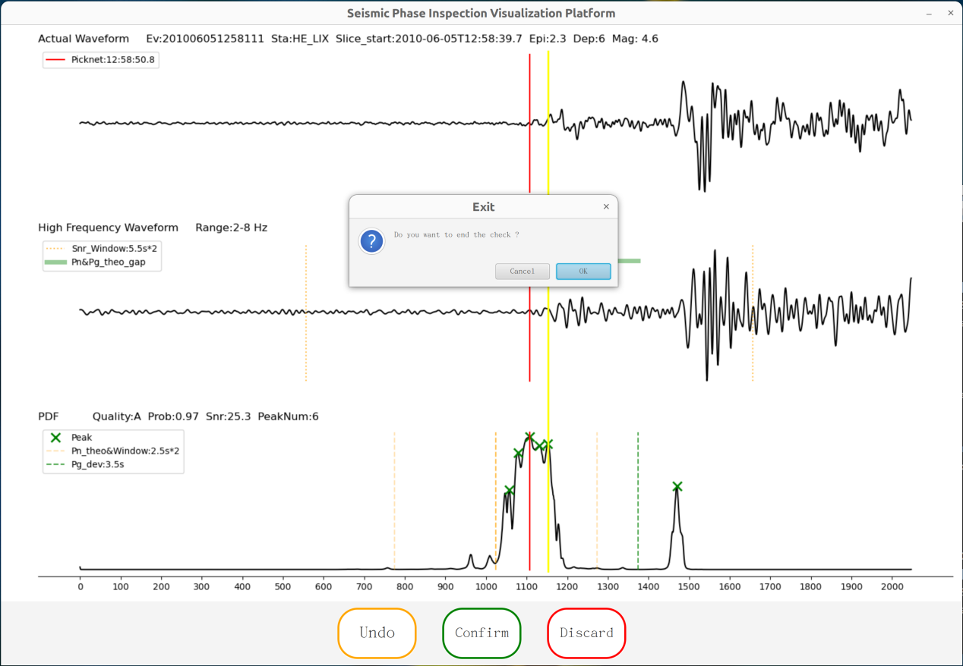

## 3.5 Back-end processing

Users can configure the path of input and output in the configuration file. The following is the input and output data format and data back-end processing :

### 3.5.1 Input and output

Enter the '.txt' file, as shown in Figure :

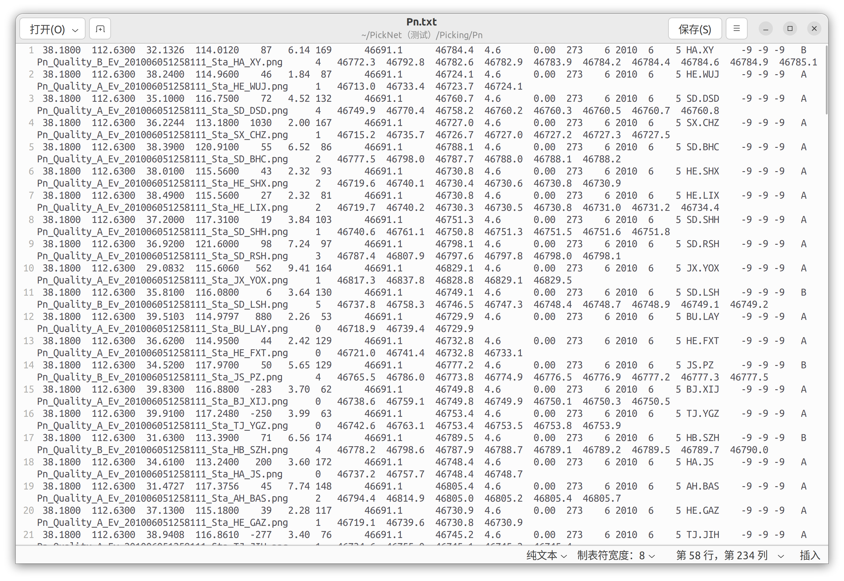

Data format : event latitude ( space ) event longitude ( space ) station latitude ( space ) station longitude ( space ) station elevation ( space ) epicenter distance ( space ) azimuth ( space ) earthquake time ( space ) pick up time ( space ) magnitude ( space ) residual ( space ) station number ( space ) focal depth ( space ) year ( space ) month ( space ) day ( space ) station network. Station name ( space ) -9-9-9 ( space ) pickup quality ( space ) picture name ( space ) pickup point number ( space ) start anchor point ( space ) end anchor point ( space ) pickup point 1 ( space ) pickup point 2, etc.

Enter the '.png' file, as shown in Figure :

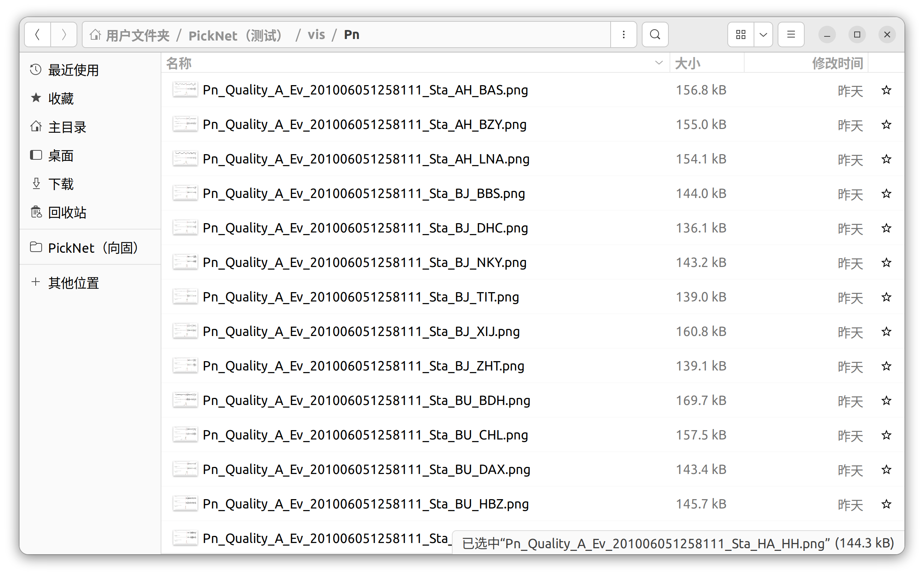

Image size : width 1500 pixels, height 900 pixels

Naming : Pn/Sn_Quality_A/B/C/D_Ev_event number_Sta_station name_station name.png

Output '.txt' file, as shown in Figure :

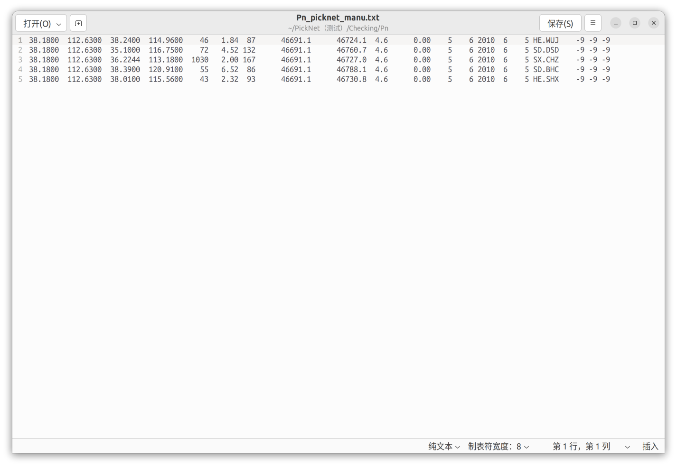

Data format : event latitude ( space ) event longitude ( space ) station latitude ( space ) station longitude ( space ) station elevation ( space ) epicenter distance ( space ) azimuth ( space ) earthquake time ( space ) pick up time ( space ) magnitude ( space ) residual ( space ) station number ( space ) focal depth ( space ) year ( space ) month ( space ) day ( space ) station network. Station name ( space ) -9-9-9

### 3.5.2 Process flow

**Pretreatment :**

1. Inspect the record, continue the last inspection progress ;

2. Statistics of seismic phase picking quality ;

3. According to the configuration, the picking quality and epicentral distance of the seismic phase are preliminarily screened.

4. (epicentral distance mode), sort the seismic phase data according to the epicentral distance ;

5. (Open the history of loading check) Click to find the history of the last check to reproduce ;

6. Screen out the phases in the white list in advance (under the function of free detection).

**Post-processing :**

1. Delete the revoked temporary data ;

2. According to the fine-tuning results, modify the seismic phase arrival time ;

3. Update the number of stations from the latest seismic phase data.