**People’s Democratic Republic Of Algeria**

**Ministry Of Higher Education And Scientific Research**

**AHMED GHOUL**

**BY:**

**AHMED GHOUL AND ABDOU ABDESSAMED**

NWT2

**Project Report:**

**ALGCourses**

**Table of Contents**

1. Project Overview
2. Platform’s Design
   * Platform’s Architecture
3. Technologies Used
4. Challenges and Solutions
5. Future Improvements
6. Conclusion

# Project Overview

The project is focused on creating an educational platform where teachers can create and manage courses. The primary goal of the platform is to provide a seamless experience for both instructors and students. The platform allows teachers to list their courses, set prices (if applicable), and manage course content easily through an intuitive interface , and also create quizzes. By leveraging a modern database system, we ensure that all course details are efficiently stored, and students can easily access and enroll in their desired courses.

Platform’s Design

## Platform’s Architecture:

The platform follows a modular and scalable architecture that ensures flexibility for future enhancements.

At the heart of the design is a well-structured relational database managed through MySQL, accessed via phpMyAdmin for ease of management. The user interface is designed to be responsive and user-friendly.Enabling both teachers and students to navigate the platform effortlessly.

The platform consists of several key modules:

**Course Management Module:** Enables teachers to create and manage courses, including defining course content, setting prices, and also create quizzes.

**Student Portal:** Provides students with an easy way to browse available courses and quizzes, check course details, and save or start the selected courses.

# Technologies Used

The platform utilizes a combination of reliable and modern technologies to ensure high performance, scalability, and ease of use:

* **XAMPP:** Used as the local development environment, combining Apache, MySQL, and PHP, enabling the smooth development and testing of the platform in a controlled environment before deployment.

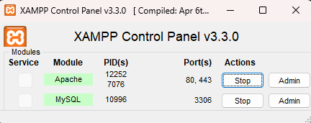

* **MySQL Database:** Used to manage all course-related data, including teacher profiles, course details, and student enrollments.
* **phpMyAdmin:** Provides an easy-to-use interface for managing and maintaining the MySQL database, allowing for quick administration and manipulation of data.

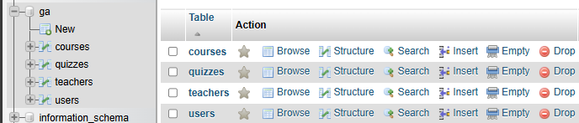

* **Node.js:** Powers the server-side functionality, ensuring that all operations on the platform are processed efficiently, particularly for handling real-time interactions and APIs.
* **HTML/CSS/JavaScript:** Powers the front-end user interface, ensuring an interactive experience for users.
* **Bootstrap Framework:** Used for quick and consistent front-end design, allowing the platform to be mobile-friendly and providing a cohesive visual layout.

# Challenges and Solutions

During the development of the platform, several challenges were encountered, which were addressed with practical solutions:

**Database Management:** One challenge was ensuring that courses with null prices are considered free without needing an additional is_free column. This was resolved by updating the price column to 0 when the price is not specified, allowing for efficient handling of free courses.

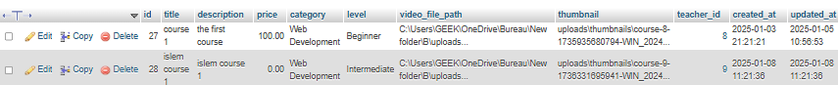

**Scalability:** As the platform grows and more courses are added, it was important to ensure the database can scale. This was addressed by optimizing queries, implementing indexing, and ensuring that the architecture can handle increasing user data.

**User Experience:** Designing an intuitive interface for both teachers and students while managing multiple features posed a challenge. This was resolved by focusing on simple and consistent UI components, ensuring that each user type could easily perform their tasks.

**Authentication and Auth State:** A key challenge was implementing a secure and reliable authentication system for users (teachers, students). To solve this, we integrated a robust authentication mechanism, allowing users to securely log in and access their profiles and courses. Additionally, the platform maintains an **auth state** to track user sessions, ensuring that users remain logged in across different pages, providing a seamless and secure experience.

# Future Improvements

While the platform is fully functional, there are several areas for future improvement:

**Advanced Search Functionality:** Enabling students to filter and search for courses based on multiple criteria such as subject, difficulty level, and instructor ratings, making it easier for them to find courses that suit their needs.

**Instructor Analytics:** Providing teachers with detailed analytics on course performance, student engagement, and financial reports, helping them understand their audience and improve their teaching methods.

**PDF Lessons:** Expanding course content to include **PDF lessons** in addition to traditional video and written content. This allows instructors to provide downloadable study materials, enhancing the learning experience and giving students more flexibility in how they consume course content.

**Tracking User Course Progress:** Introducing a feature to **track user course progress**. This will allow students to see their advancement within courses, and teachers to monitor student progress. It also provides a way to motivate students to complete their courses.

**Adding Logo to the Website:** Integrating a **custom logo** into the website to enhance the branding and user recognition of the platform. This small but important change will make the platform feel more cohesive and professional.

**Do More Testing:** Conducting **extensive testing** to ensure that all platform features work seamlessly, identify and fix bugs, and optimize performance. This will help ensure a smooth user experience and increase the platform's reliability before launching new features or updates.

# 

# Conclusion

This project is a simple, ongoing effort to build an educational platform, and it is still in the early stages of development. The platform has laid the groundwork for core functionalities such as course creation, management, and student enrollment. While the current version is basic and lacks some advanced features, it serves as a foundation for future enhancements and improvements.

Since I worked on this project alone, the focus was on delivering a functional prototype that could be expanded over time. The simplicity of the project allows for a clear, manageable structure that can be built upon as more features and capabilities are added. Although not yet complete, this platform has potential for growth and can be developed into a more comprehensive tool with additional resources and time.

.