
Ministry of Higher Education and Scientific Research
University of 8 may 1945 Guelma

Intership Report

The Central Directorate of Research and Development -DCRD SONATRACH

From 27 april to 3 june 2025

Supervisor's name : hakim soussi Student's name : ghoul ahmed

Table of Content
Introduction: 3
Company Presentation: 3
Central Directorate of Research and Development 4
Internship Mission: 5
Mission Execution: 6
Internship Contributions: 12
Conclusion: 14

Table of Figures
Figure 1.1:SONATRACH logo 3
Figure 2 DCRD map 5
Figure 3:Use Case Diagram showing roles (User, Agent) and core system actions. 6
Figure 4:Data Flow Diagram showing JSON transmission from devices to backend and frontend. 7
Figure 5:Front end & Back end Server 7
Figure 6: Sequence Diagram of data exchange between agents, backend, and frontend. 8
Figure 7: Agent Script Workflow (Continuous Loop) 9
Figure 8:Front end Design (Homepage) 10
Figure 9:Front end Design (Device Dashboard) 11

Introduction:
This report aims to present my internship experience as an IT specialist in a company. The internship took place from 27 april 2025 to 3 june2025 at DCRD - Sonatrach . The main objective of this internship was to gain professional experience in the field of IT and to put into practice the theoretical knowledge acquired during my training.

Company Presentation:
SONATRACH, founded in 1963 by the State, is the national company responsible for developing Algeria's hydrocarbon reserves. Today, it is the leading hydrocarbon group in Africa and ranks among the world's top exporters of gas and oil.
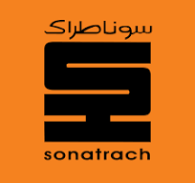
Figure 1.1:SONATRACH logo
- Size: Very large company (African leader and global player)
- Industry sector: Hydrocarbons (oil and gas), renewable energies
- Market positioning: Leader in Africa, among the world’s top gas and oil exporters
- Number of employees : around 200,000 employees
- Founded: 1963
- Ownership: Public company (founded by the Algerian state)

Central Directorate of Research and Development
The Central Directorate of Research and Development (DCRD) is a branch of SONATRACH, the organization hosting my internship.
The directorate is responsible for promoting and implementing the policy of applied research and technology development in the core sectors of the company. Its objectives are:
• To address the company's concerns regarding the petroleum chain by researching issues that could be developed into projects.
• To initiate, develop, and manage scientific and technical problems faced by operational structures.
• To carry out studies, syntheses, analytical services, and experiments, particularly related to the needs of operations, transportation, production, and the upgrading of hydrocarbons.
• To introduce and develop new techniques, analysis methods, and interpretation methods.
• To provide support and assistance to SONATRACH's operational structures and subsidiaries by handling the resolution of scientific and technical issues encountered.
• To promote expertise in the field of upstream oil.
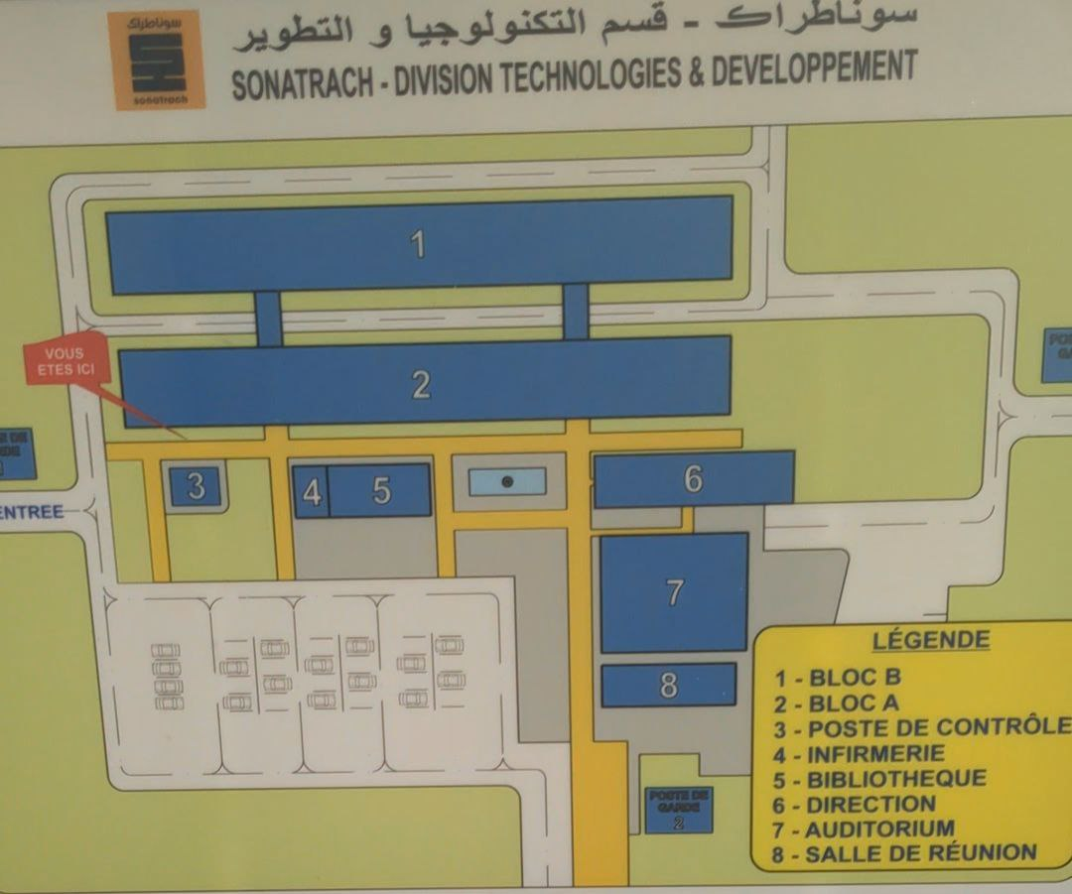
Figure 2 DCRD map

Internship Mission:
During my internship in Central Research and Development Directorate of SONATRACH, I was tasked with developing a web application whose main objective is to display installed software and other system information on devices connected within a local area network (LAN).
This mission involved several technical aspects:
- Analyzing the organization’s needs in terms of IT equipment supervision and inventory.
- Developing the web application, including both frontend and backend parts.
- Exploring methods for detecting devices on a LAN and retrieving information such as:
- List of installed software
- Device name
- IP address
- Operating system
- Hardware resources (CPU, RAM, etc.)
- Deploying in a local environment for testing and demonstration.
The final objective was to provide a simple, intuitive, and efficient tool for the IT team to monitor the software status of connected machines, aiming at better management and optimization of digital resources.
The Use Case Diagram (Figure 3) summarizes key functionalities.
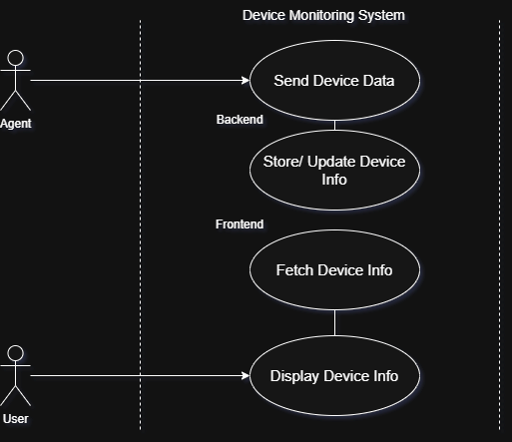
Figure 3:Use Case Diagram showing roles (User, Agent) and core system actions.

Mission Execution:
I developed a web application to display installed software and other technical information on devices connected to a local area network (LAN).

Work Done:
The project was carried out in several key stages:

Application Architecture Design:
  - Set up a central server capable of receiving and storing data sent by network machines.
  - Created a frontend for administrators to view the collected information.
  - The system follows a client-server model where target devices send JSON data to the backend, which is then displayed on the frontend dashboard. The Data Flow Diagram (Figure 4) illustrates this process.
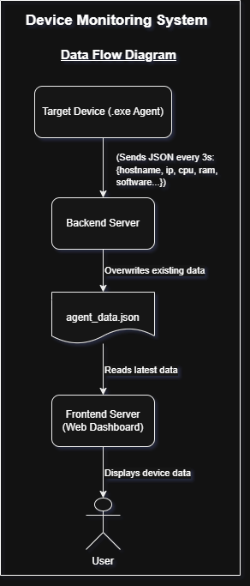
Figure 4:Data Flow Diagram showing JSON transmission from devices to backend and frontend.

Backend Development:
  - Used JavaScript and Node.js framework to build the REST API.
  - The backend receives JSON-formatted data sent by various devices through Python scripts,(Figure 5 shows that).
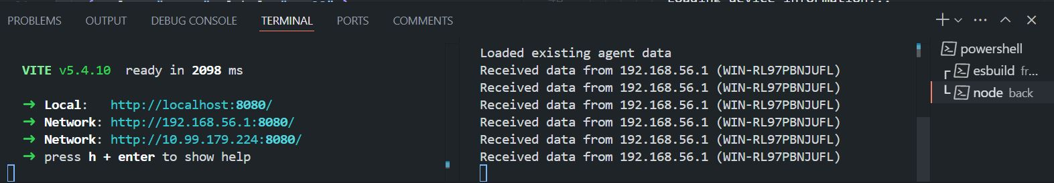
Figure 5:Front end & Back end Server

  - The sequence diagram (Figure 6) outlines the automated data flow: Agents send JSON every 3 seconds, the backend stores it, and the frontend fetches/renders it for the user.
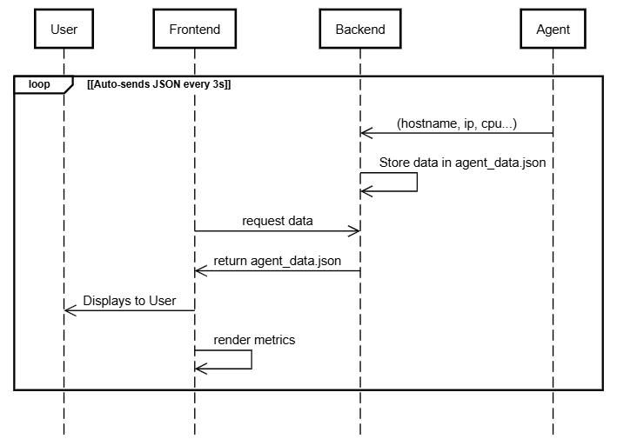
Figure 6: Sequence Diagram of data exchange between agents, backend, and frontend.
Data Collection Scripts Deployment:
  - Wrote Python scripts to gather system information, including:
    - Installed software list & Device IP address and name
    - Operating system details & Hardware resources (CPU, RAM, etc.)
  - Initially attempted to use WinRM (Windows Remote Management) and SSH (for Linux) for remote execution, but due to security restrictions, remote execution was not feasible on all target machines.
  - Solution:
    - Converted the Python script into a Windows Service to ensure continuous execution on each target machine.
    - Configured the service to start automatically at system boot, ensuring persistent data collection.
    - The script sends collected data to the backend server every second via HTTP requests.
    - Logs all transmitted data locally in a device_data.logs file for debugging and verification.
    - The Python agent (Figure 7) runs indefinitely, collecting system/software data every 3 seconds and transmitting it to the backend via HTTP POST.
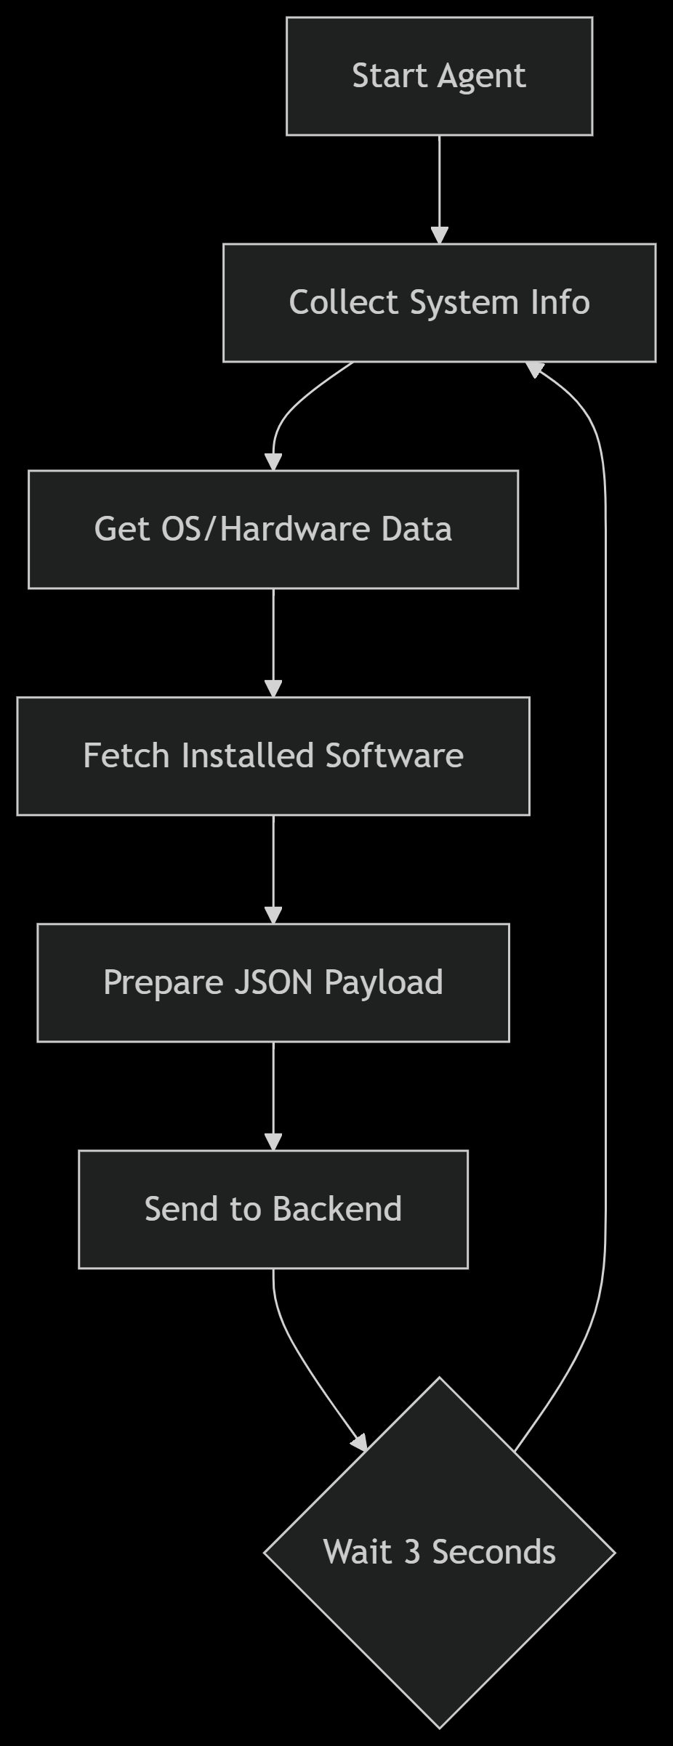
Figure 7: Agent Script Workflow (Continuous Loop)

Testing Environment:
- Used Oracle Vmware to simulate multiple machines (Windows & Linux) in an isolated network.
- Verified script functionality, service persistence, and backend data reception before deploying to real devices
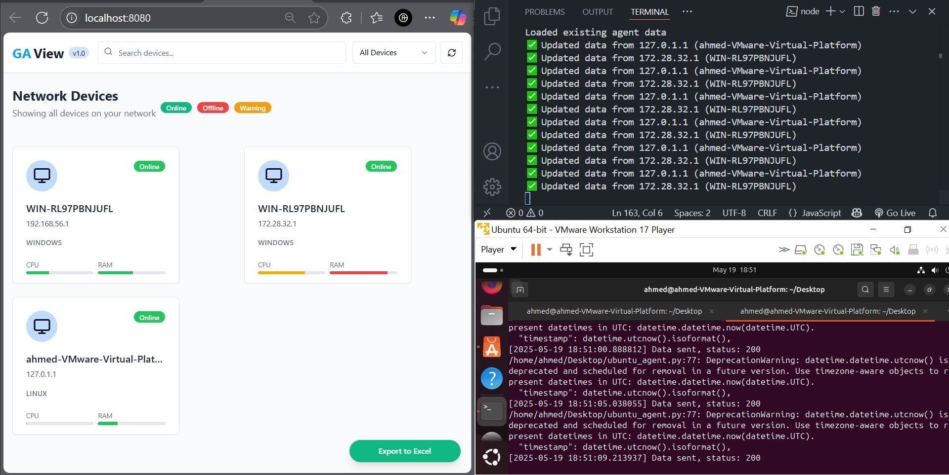
Figure 8: Receiving Data from Both my Machine and my Virtual Machine
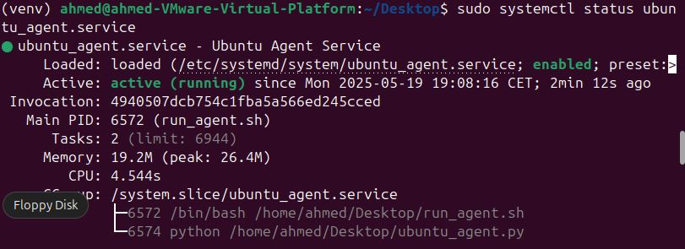
Figure 9: The Agent Script Works as a Service in The Vertual Machine (ubuntu)

Frontend Development:
  - Used React with Vite as a bundler to build a modern, fast, and responsive interface.
  - Integrated HTML and CSS for a clear and readable data presentation.
  - Retrieved the data using fetch() to dynamically display it on the administrator dashboard.
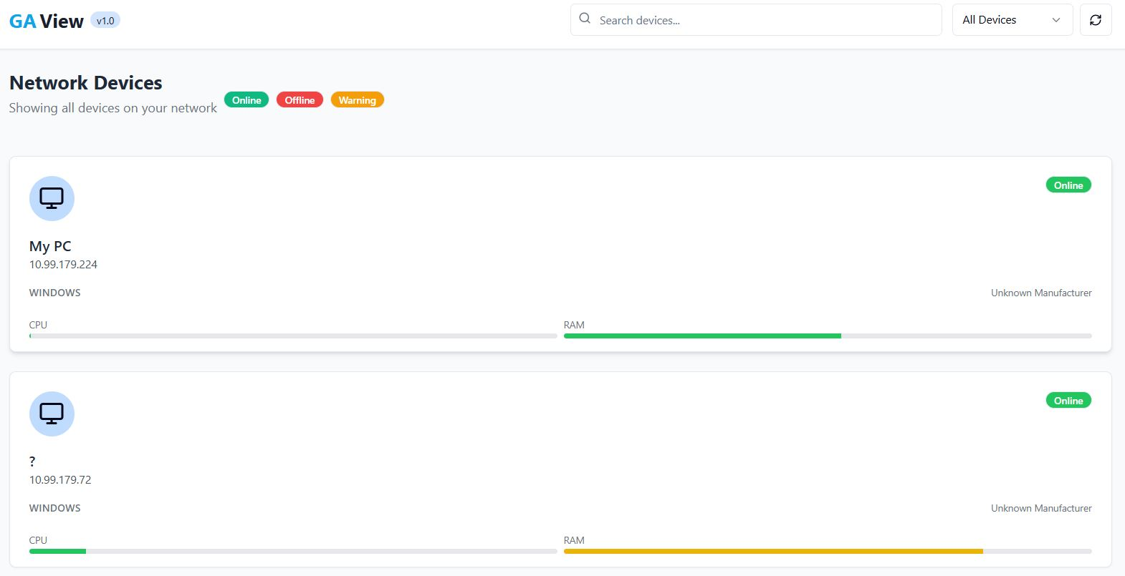
Figure 10:Front end Design (Homepage)
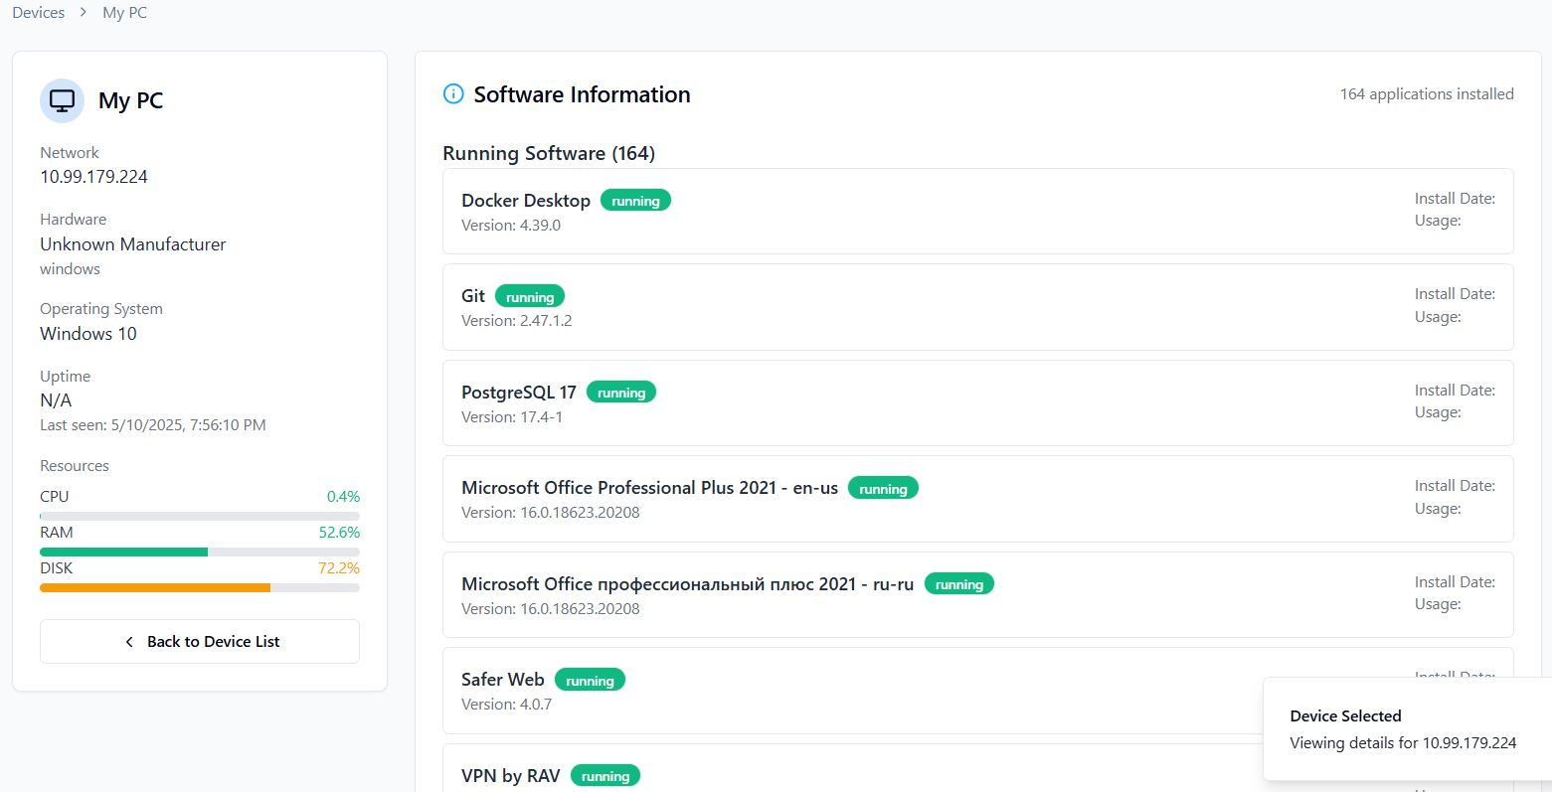
Figure 11:Front end Design (Device Dashboard)

Tools and Technologies Used:
- Frontend: React, Vite, HTML, CSS
- Backend: JavaScript, Node.js
- Data Collection Scripts: Python (deployed as a Windows Service on client machines)
- Remote Access Attempts: WinRM (Windows), SSH (Linux)
- Network Communication: HTTP requests (REST API)
- Central Server: Hosting the Node.js API and receiving client data
- Testing: Oracle VirtualBox (for multi-machine simulation)

Challenges Encountered:
- Remote execution via WinRM/SSH was blocked due to security policies, requiring an alternative deployment method.
- Accessing system information on restricted machines required administrator rights.
- Securing communication between clients and the server.
- Ensuring compatibility across different operating systems (Windows/Linux).

Solutions Provided:
- Deployed Python scripts as Windows Services to bypass remote execution restrictions.
- Configured services to auto-start on boot for continuous operation.
- Tested extensively in VirtualBox before real-world deployment.
- Developed cross-platform scripts with automatic OS detection.
- Used standard Python modules (platform, psutil, subprocess) for reliable data collection.
- Implemented token-based authentication to secure backend communications.

Internship Contributions:
This internship provided a valuable opportunity to strengthen both technical expertise and professional skills through hands-on project development and problem-solving.

Technical Skills Acquired:
- Virtualization & Testing:
  - Gained proficiency in configuring and managing virtual machines (Oracle VirtualBox) to simulate real-world network environments.
  - Used VMs to rigorously test script functionality, service deployment, and cross-platform compatibility before production rollout.
- Operating System Expertise:
  - Linux:
    - Mastered system commands, filesystem hierarchy, and service/process management (systemd, cron).
    - Automated deployments via SSH for remote script execution and log monitoring.
  - Windows:
    - Implemented WinRM (Windows Remote Management) for remote script execution (where policies permitted).
    - Developed and deployed Windows Services to ensure persistent, automated data collection on restricted systems.
- Network Protocols & Security:
  - Applied SSH for secure remote access and HTTP/REST APIs for client-server communication.
  - Configured firewall rules and token-based authentication to secure data transmissions.

Practical Achievements:
- Full-Stack Development:
  - Built a client-server application from scratch, integrating:
    - A Node.js backend to process and store device data.
    - A React-based frontend for real-time monitoring.
- Automation & Systems Engineering:
  - Designed cross-platform Python scripts to collect hardware/software metrics (CPU, RAM, installed apps, OS details).
  - Solved deployment challenges by packaging scripts as Windows Services with auto-start capabilities.
- Infrastructure & Debugging:
  - Established centralized logging (device_data.logs) for troubleshooting.
  - Validated network communication between virtualized and physical machines.

Soft Skills Developed:
- Independent Problem-Solving:
  - Resolved technical blockers (e.g., remote execution restrictions) through iterative testing and alternative solutions (Windows Services).
- Collaboration & Documentation:
  - Worked within technical teams while taking ownership of key deliverables.
  - Maintained clear documentation for scripts, APIs, and deployment processes.
- Analytical Mindset:
  - Diagnosed compatibility issues across Windows/Linux environments and optimized scripts for reliability.

Theoretical Knowledge Applied:
- Networking Concepts:
  - LAN topologies, TCP/IP protocols, and port management.
  - Secured data in transit using encryption (SSH, HTTPS).
- System Administration:
  - Practical exposure to user/service management (Windows SC Manager, Linux systemd).

Source Code:
0ahmed0ghoul/LAN-Monitoring-System: gatheres data from devices withtin a LAN

Conclusion:
This internship provided me with hands-on experience in independently developing and deploying an IT monitoring solution. Working autonomously, I designed scripts, built a full-stack application, and implemented secure data collection across networked devices - significantly strengthening my technical and problem-solving abilities.
The successful completion of this project demonstrates my capability to take ownership of complex technical tasks from conception to implementation. I appreciate DCRD - Sonatrach for this valuable opportunity to grow as a professional.

