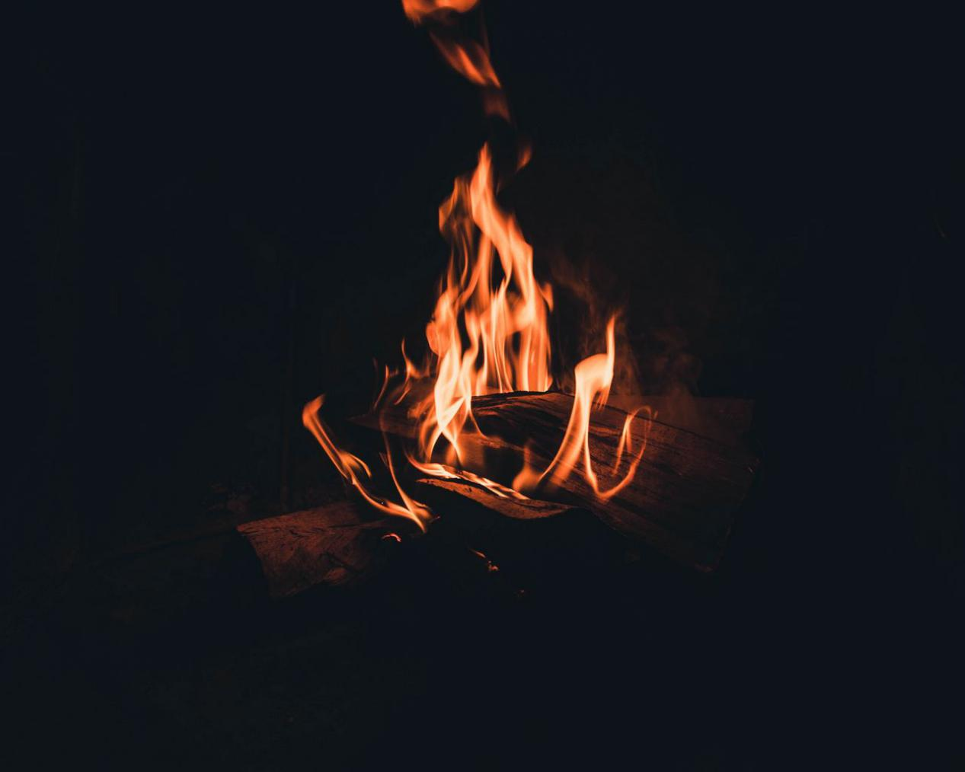

donnuCTF{c2c6f47ab48305d2dc70eccc8560eb8a}