Chapter 1 : Linear Regression
We will start with Linear regression with one variable : which also called “Univariant Linear Regression”
The formula :
$$f_{w,b}\left(x^{\left(i\right)}\right)=wx^{\left(i\right)}+b$$where :
x : represent the input “features”
y : represent the output ”target” $f_{w,b}\left(x^{\left(i\right)}\right)$
m : # of training examples (rows sin the table)
n : # of features (x)
(x, y) : one training example (sample)
($x^{\left(i\right)},y^{\left(i\right)}$) : i^{th} training example
$$f_{w,b} means that f depend of both w and b$$
What is the difference between Residual , Loss , Cost ?

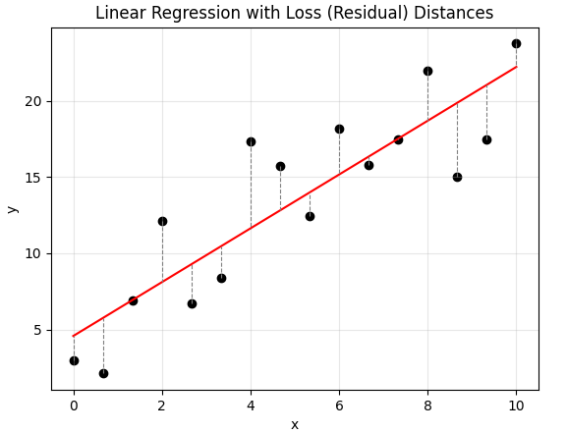

Residual distance :
The residual distance is the vertical difference between the true value y^{(i)} of a sample and the predicted value $\hat{y^{\left(i\right)}}$ given by the fitted line.
can be positive or negative (for only one sample)
$$r^{\left(i\right)}=( y^{\left(i\right)}-\hat{y^{\left(i\right)}} )$$
Loss :
The loss function converts the residual into a non-negative value in order to measure the error magnitude of a single prediction.
$$L^{\left(i\right)}={\left(y^{\left(i\right)}-\hat{y^{\left(i\right)}}\right)}^{2}$$
Cost :
The cost function measures the average loss over all training samples and represents the overall error of the model.
For a dataset with mmm samples, the cost function is defined as:
$$J\left(w,b\right)=\frac{1}{2m}\sum_{i=1}^{m}{{\left(y^{\left(i\right)}-\left(wx^{\left(i\right)}+b\right)\right)}^{2}}$$
Note : in the cost function we put 1/2m instead 1/m to simplify the derivation later.

Main Goal :
The main Goal is to find the optimal `w` and `b` that minimize the cost function $J\left(w,b\right)$
The Goal : $min J\left(w,b\right)$

Understanding Cost Function :
Let’s assume that $b=0$ so the linear function : $f_{w}\left(x^{\left(i\right)}\right)=wx^{\left(i\right)}$lets compute $J(w)$ for different $w$ values
Let’s have the samples (1, 1) , (2, 2) , (3, 3)
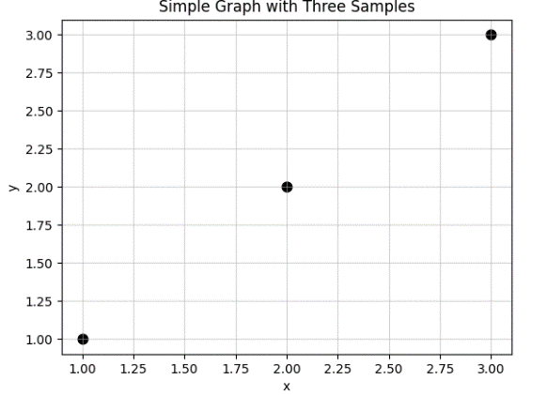

- $w =1$so : $f_{w}\left(x\right)= x$
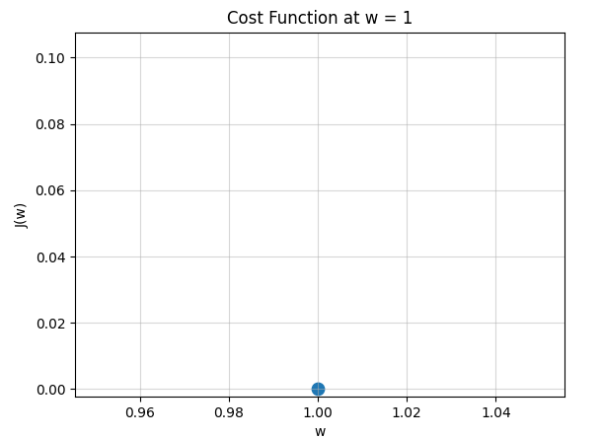
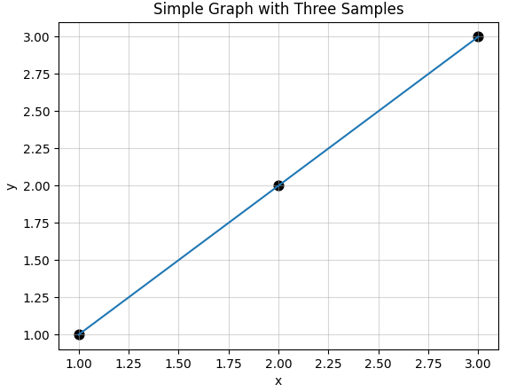

$$J\left(w\right)=\frac{1}{2m}\sum_{i=1}^{m}{{\left(y^{\left(i\right)}-\left(wx^{\left(i\right)}\right)\right)}^{2}}=1/2m \left[0^{2}+0^{2}+0^{2}\right]= 0$$
$$So J\left(w\right)=0 when w =1$$
- $w =1$so : $f_{w}\left(x\right)= 0.5x$ and for $J\left(w\right)=0.58$
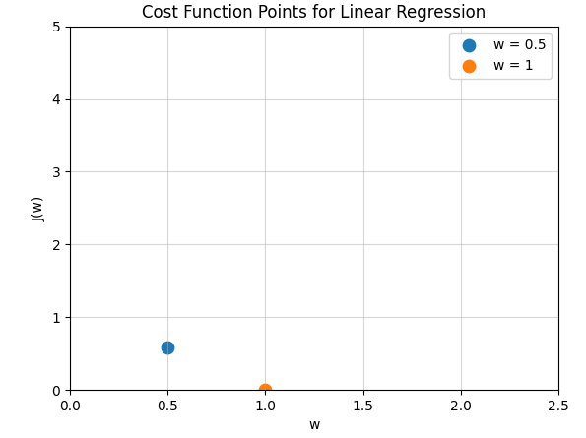
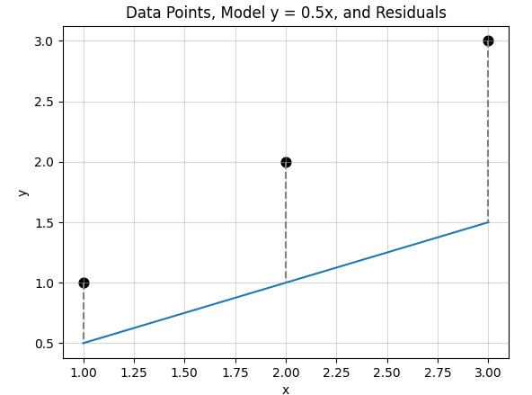

- $w =0$so : $f_{w}\left(x\right)= 0$ and for $J\left(w\right)=$ 2.3
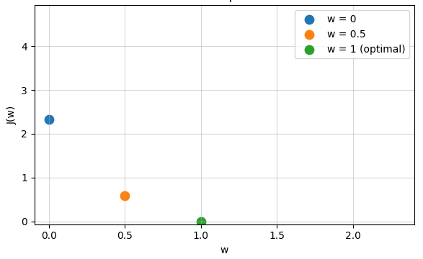
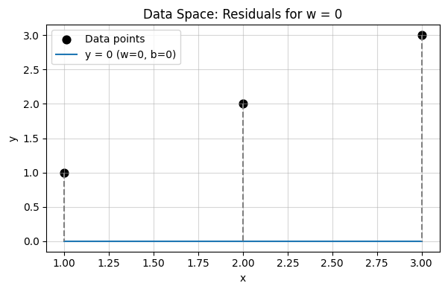

After trying many w values and plot every value we will get the following :
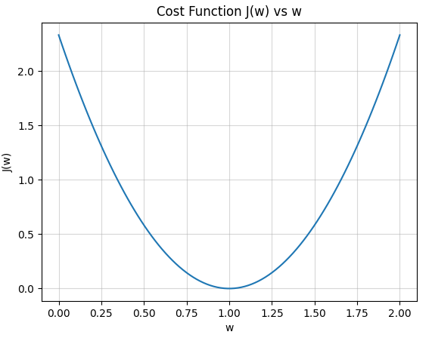

We clearly see that the point $J(w)$ was al the lowest at $w=1$
So, when $w=1$ we get the minimum cost .
So, $w=1$ is the optimal parameter for these samples
To find $min J(w)$ we must find optimal $w$
$$in general min J\left(w,b\right)$$

Gradient Descent Algorithm :
we will use gradient descent algorithm to find optimal $w , b$

Outline :
- Start with some $w,b$ (set w=0 , b=0)
- Keep changing $w,b$ to reduce $J(w,b)$
- Until settle at or near a minimum
Notes :
Gradient Descent can be applied to linear regression as well as to many other models and functions.
If the cost function $J(w,b)$is not convex (not bowl-shaped), it may contain multiple local minima and one global minimum.
When using the squared error cost function$, J(w,b)$ is convex, which guarantees the existence of only one global minimum.
The final solution obtained by Gradient Descent depends on the starting values of the parameters, but for convex cost functions, any starting point will converge to the global minimum

Repeat until convergence {
$$// simulaneously update w,b$$
$$w= w - α\frac{∂}{∂w} J(w,b)$$
$$b= b - α\frac{∂}{∂b} J(w,b)$$
}
$α :$ learning rate (usually = 0.001) “determine the size of the step”
$\frac{∂}{∂w} J(w,b)$ : means “which direction you want to take your baby step”

What simultaneous update mean ?
Repeat until convergence {
$$w_temp= w - α\frac{∂}{∂w} J(w,b)$$
$$b_temp= b - α\frac{∂}{∂b} J(w,b)$$
$$w= w_temp$$
$$b= b_temp$$
}

Lets simplify : assume that we have $J\left(w\right)$
$$w= w - α\frac{∂}{∂w} J(w)$$


Learning rate $α$always positive
$when \frac{∂}{∂w} J(w)$> 0 $this mean$ $w = w- α . (positive number ) so w will move to the left$
$when \frac{∂}{∂w} J(w)$< 0 $this mean$ $w = w- α . (negaitve ) so w will move to the right$
1
1
-2
2

