Howard University
College of Engineering and Architecture
Department of Electrical Engineering & Computer Science

Large Scale Programming
Fall 2024

Midterm Exam – Part I
October 17, 2024

Part I: 50 pts. (essay questions)

Instructions:
- Submit completed exam to your github repository under package org.howard.edu.lsp.midterm

Verify that the commit(s) completed successfully

- OPEN BOOK, OPEN NOTES. THERE IS NO COLLABORATION ON THIS EXAM
- Site any and ALL references for anything obtained off the internet.

Question 1. (10 pts.)

You are reviewing the following class in a Fitness Tracking System. The class is intended to manage various aspects of a user’s fitness activities.

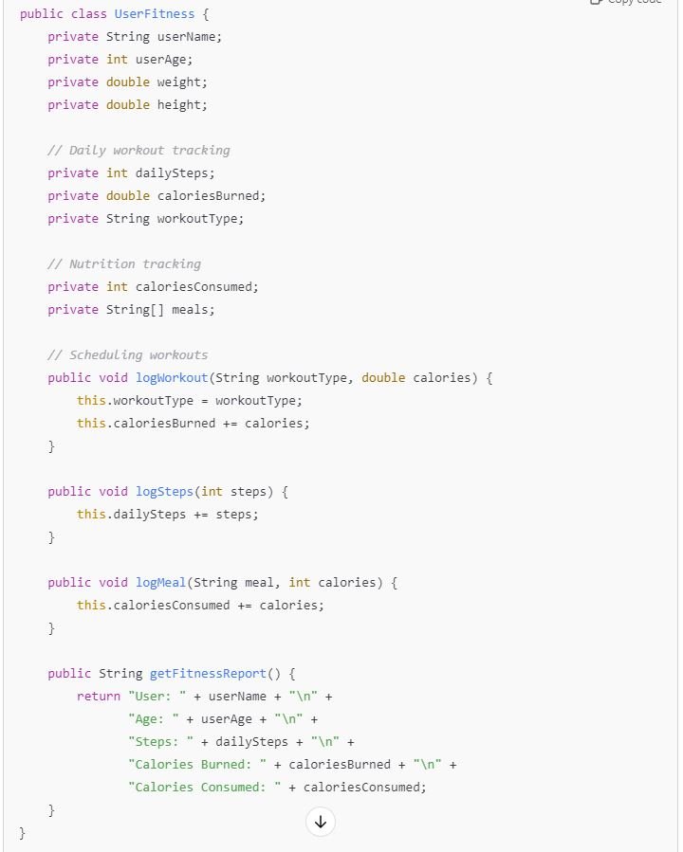

Tasks:
- Analyze the UserFitness class. Explain why this class has low cohesion. (5 pts.)

The classes low cohesion stems from the fact that it tries to handle too many functions that are not related to one another. The code snippet above has it handling user details, daily workout tracking, nutrition tracking, and generating fitness reports

- Describe, in general, how you would split the UserFitness class into more cohesive classes. Your answer should not be a complete design. (5 pts.)

Personally I would split into smaller classes for example a
WorkoutTracker would track daily workout data like workoutType, caloriesBurned, dailySteps and have methods like logWorkout() and logSteps().
NutritionTracker would track nutrition data like caloriesConsumed , meals and have methods like logMeal()

And Finally a Report class that combines the data from this other classes.

Question 2. (5 pts.)
Given the following, answer the below questions.

A university manages its students using a program that has a class Student with subclasses FirstYear, SecondYear, and ThirdYear for year-specific state and behaviors. The program has a List that contains all Students.

Should Student be a class, an abstract class or an interface? Explain your answer

Student should be an abstract class since all students share the same attributes like name, studentID … and this will also allow us to make sure that nobody can create a generic Student object without specifying the year

- At the end of each year, the third-year students graduate and must be removed. This is done by passing the list to the following method:

void removeThirdYears(List<Students> students) {
for (Student student : students) {
try {
ThirdYear = (ThirdYear) student;
students.remove(thirdyear);
}
}
}

Why is the above method flawed? Hint: Another Arthur Riel heuristic (5 pts.)

The Above Method Is Flawed because it uses a try-catch to attempt casting each Student to ThirdYear, catching a ClassCastException if it fails. This approach violates Arthur Riel's heuristic that exceptions should not be used to control program flow.

Question 3. (5 pts.)
Given the following, answer the below questions.

public class BankAccount {
public String accountHolderName;
public String accountNumber;
public double balance;
public double interestRate;

public BankAccount(
String accountHolderName,
String accountNumber,
double initialDeposit,
double interestRate) {
this.accountHolderName = accountHolderName;
this.accountNumber = accountNumber;
this.balance = initialDeposit;
this.interestRate = interestRate;
}

// Exposed implementation for adding interest
public void addInterest() {
double interest = balance * (interestRate / 100);
balance += interest;
}

// Exposed implementation for deposits
public void deposit(double amount) {
balance += amount;
}

// Exposed implementation for withdrawals
public void withdraw(double amount) {
balance -= amount;
}
}

- Is BankAccount well-encapsulated? Why or why not? If so, describe what changes you would make to the class. Otherwise, state nothing. (5 pts.)

BankAccount is NOT well-encapsulated because it declares all its fields as public to allowing outside code to access these fields and make changes to them. In order to fix this I would first make all the public fields private

Question 4. (10 pts.)
Given the following, answer the below questions.

Given:
A car manufacturer uses Java software to track current vehicles being built. The UML diagram below shows an excerpt of the current software structure. You should assume the presence of other appropriate fields and methods

Car
getTrimLevel()
Engine
accelerate()
getFuelLevel()
Base
Sports
Luxury
Electric
Petrol

Each car can be built to one of three trim levels: Base, Luxury or Sport. They can also be configured with an electric or petrol engine. At various points in the manufacturing process the customer can choose to change the trim level.

Task:
- Explain in detail why the current structure does not support this. (5 pts.)

The current structure does not support this because The trim levels (Base, Luxury, Sport) are subclasses of the Car class, using inheritance so each trim level is a specific type of Car, and the trim level is determined by the class of the Car object so since it uses inheritance to define trim levels, binding the trim to the object's class it is impossible to change the trim level of an existing Car instance during the manufacturing process.

- Describe how to refactor the structure to allow trim-level change for a car to dynamically change. Hint: How would you modify Car to use composition to solve the problem? (5 pts.)
By changing the Car class to include a TrimLevel component through composition for example a TrimLvl field, allowing the car's trim level to be changed dynamically by assigning different TrimLevel instances at runtime.

Question 5. (5 pts.)
Suppose you are about to code a particular class and find that you have written another class with nearly the functionality that you now are developing. This means that the two classes in large parts contain the same code, but in smaller parts have different code. Explain in detail why this may be a problem and how to solve it. Give your answer in terms of Arthur Riel’s design heuristics.
Having two classes with largely the same code leads to code duplication, violating Arthur Riel's heuristic that duplication indicates a missing abstraction. To solve this, extract the common code into a shared superclass or use composition to encapsulate the shared functionality, reducing duplication and improving maintainability.

Question 6. (5 pts.)
Suppose we need to store instances of the classes Car and BankAccount in a database. To obtain low coupling it may seem as if the functionality to save an instance should be in precisely those classes, since they have the information that shall be saved. Why is it unwise to place the database calls there?

Placing database calls inside the Car and BankAccount classes increases coupling between the business logic and data access layers, violating the Single Responsibility Principle. It's unwise because it makes the classes less flexible and harder to maintain; instead, using a separate data access objects or repositories would be better

Question 7. (5 pts.)
Given a set of requirements, what conditions must be met to make it appropriate to create a new class hierarchy using inheritance? Neither superclass nor subclass exist before, the question is about designing a new class hierarchy.

Creating a new class hierarchy using inheritance is appropriate when there's a clear "is-a" relationship, shared attributes and behaviors among classes, and a need for polymorphism.

Question 8. (2.5 pts.)
Describe the difference between inheritance and composition why would you choose one over the other.
Inheritance is an "is-a" relationship where a class derives from another, inheriting its attributes and methods, suitable for hierarchical relationships and polymorphism. Composition is a "has-a" relationship where a class contains other classes as members; it's chosen over inheritance when you need flexibility and lower coupling, as it allows you to change behavior at runtime by composing different objects.

Question 9. (2.5 pts.)
Explain the meaning of cohesion and describe whether low or high cohesion is better.
Cohesion refers to how closely related the functions of a class are. High cohesion is better because it means the class has a well-defined purpose and is easier to maintain and understand, while low cohesion can lead to complex, error-prone code that's difficult to manage as seen in question 1.

