**TASLIMA TANIA**

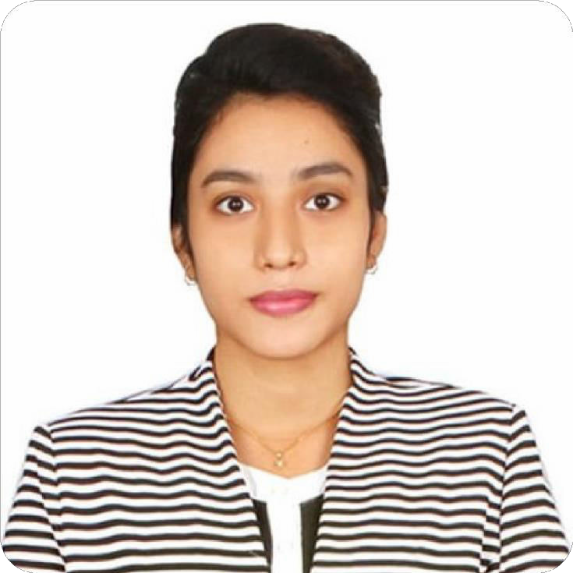STRENGTHS .

* Comprehensive Communication Skills
* Strong sense of accountability
* Project Management
* Responsibility
* Strong work ethic
* Critical Thinking
* Teamwork and Collaboration Target driven
* Self-motivated

ACHIEVEMENTS.

* Girls Guide
* Handball Champian
* BNCC
* Dean Award

SKILLS .

* Microsoft office
* Softwer and Hardwar
* Bangla 20ps
* English 30ps

LANGUAGES .

* English Fluent
* Bangla

PASSIONS .

* Handball
* Drawing
* Singing
* Dancing

 01771820403 chowdhurytania23@gmail.

Uttara Sector#4,Dhaka

SUMMARY .

I am an energetic, ambitious person who has developed a mature and responsible approach to any task that I undertake, or situation that I am presented with. As a graduate with four years’ experience in English Department with many cultural activities, I am excellent in working with others to achieve a certain objective on time and with excellence.

EXPERIENCE .

Institute Name : Sristy center School and Collage

Designation : Assistant English teacher

Duration : March-2022-23(Still Now)

Institute Name : Wide Vision School & Collage

Designation : Assistant English teacher

Duration : Four Month.

Institute Name : Soft it Link

Designation : Telemarketing Executive

Duration : One Year

EDUCATION .

Master of Human Resource and Industrial Relations **3.18** 2022-2023

Jahangirnagar university Jahangirnagar,Dhaka

Bacholor of English Language & Literature **3.71** 2018-2021

Uttara University Uttara,Dhaka

Higher Secondary School Certificate **4.00**  2017

Uttara High school Uttara,Dhaka

Secondary school Certificate **4.44** 2015

Mollartake Udyan School and Collage Uttara,Dhaka

**Referance: .**

* Monir Hossain

CCN Science and technolgy university department of English

 01733-873084

* Aminul Haque

Associate professor at Uttara University department of English

01712331031