Mst Taslima Tania

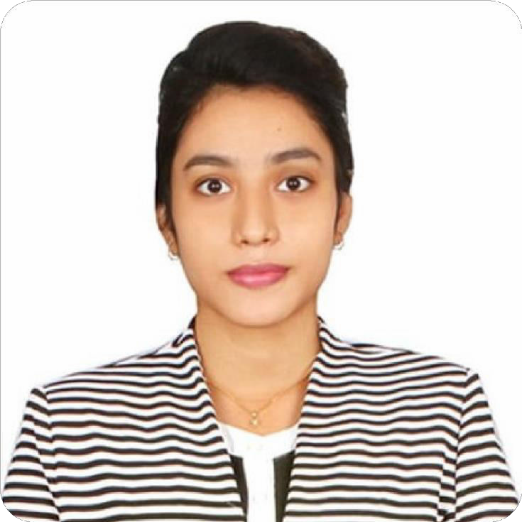

Sector-4, road-19,Uttara, Dhaka-1230.



*­*

chowdhurytania23@gmail.com



***Career Objective:***

I am an energetic, ambitious person who has developed a mature and responsible approach to any task that I undertake, or situation that I am presented with. As a graduate with four years’ experience in English Department with many cultural activities, I am excellent in working with others to achieve a certain objective on time and with excellence.

***Academic Achievements:***

|  |  |  |  |  |  |
| --- | --- | --- | --- | --- | --- |
| Exam Title | Group | College/University | Board | Result | Passing Year |
| MA | Human Resource and Industrial Relation Development | Jahangirnagar University | Dhaka | 3.18 | 2023 |
| BSC | English Language & Literature | Uttara University | Dhaka (Private) | 3.71 | 2022 |
| HSC | Business Study | Uttara High School and College | Dhaka | 4.00 | 2017 |
| SSC | Business Study | Udyan School and College | Dhaka | 4.44 | 2015 |

***Computer Skills:***

* Basic Operation of Windows, Good knowledge about Microsoft Office 2010 (Word, Excel, Power point), Using of different application software e.g. Nero, Avro, Skype, Yahoo, Messenger, Application of html. Good experience in net browsing & e-mail handling etc.

***Language Proficiency:***

* Fluent in Bangla and English

# ***Personal Achievement:***

***:***

* Girls Guide | 2010-2012
* Handball Champion | 2012
* BNCC |2018
* Dean Award, Uttara University | 2019 & 2020

***Personal Proficiency:***

* Comprehensive Communication Skills
* Strong sense of accountability
* Project Management
* Responsibility
* Strong work ethic
* Critical Thinking
* Teamwork and Collaboration Target driven
* Self-motivated

***Extra-curricular Activities:***

* General member of English Department Cultural Club, Uttara University | 2018-2021
* Former volunteer of Language Club at Uttara University | 2019-2021
* Former Debater of English Department debate club, Uttara University | 2019-2021

***Hobby:***

* Handball
* Drawing
* Singing
* Dancing

***Personal Details:***

Father’s Name : Md. Barek Chowdhury

Mother’s : Mst Deluara Chowdury

Date of Birth : 09/02/2000

Gender : Female

Marital Status : Unmarried

Nationality : Bangladeshi

Religion : Islam

***Declaration:***

To the best of my knowledge the above mentioned information is true and I am aware about the fact that my any misrepresentation of information might be treated as disqualification for me.

***Job Experience:***

* Soft it link

Telemarketing Executive

Duration 1 year.

* Wide Vision School & College

Assistant English Teacher

Duration 6 month.

* Sristy Central School & College

English Teacher

Duration March-2022 to still now.

***Reference:***

* Monir Hossain

CCN Science and Technolgy University Department of English

01733-873084

* Mustafizur Rahman

Principal of Amin Model college

880 1712-809160

* Aminul Haque

Associate professor at Uttara University Department of English

01712331031

**Mst Taslima Tania**

## Date: