**BlockPy**

**Block/Text Python with Guided Practice and Data Science**

Austin Cory Bart, Javier Tibau, Eli Tilevich, Clifford A. Shaffer, Dennis Kafura  
Software Innovations Lab in Computer Science at Virginia Tech

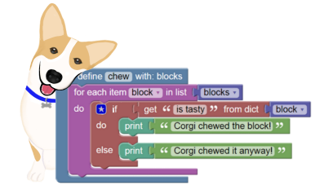

BlockPy is a web-based Python environment that lets you switch freely between blocks and text. The goal of BlockPy is to empower students to solve real-world Data Science problems with scientific plotting and access to real-world data, such as weather forecasts, stock trading information and more. The environment also supports scaffolded practice problems that give interactive feedback as students develop their programs. The platform is free, open-source, and works without connecting to a server.

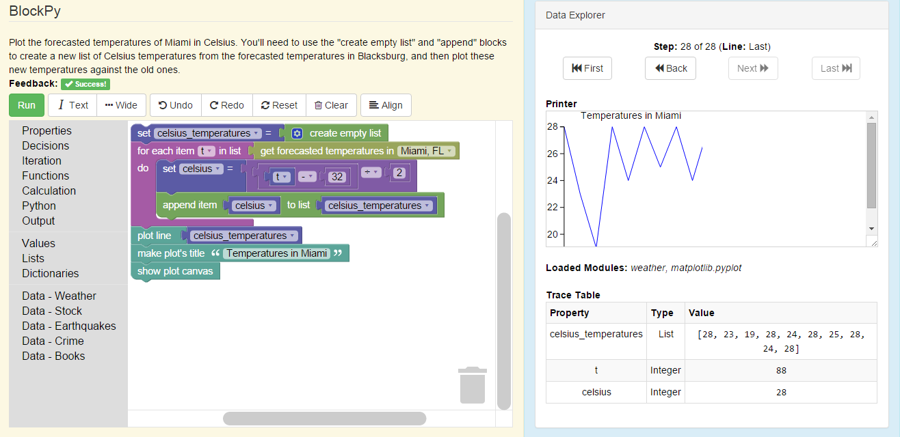

**Instructor?**  
Contact us about using BlockPy in your course!

**Developer?**  
Join our open-source development!

Try it now at **www.blockpy.com**