Abstract
RespiPredict is a multimodal machine learning system designed for automated respiratory disease prediction and regional disease trend forecasting. The system addresses the clinical challenge of diagnosing respiratory conditions — including Chronic Obstructive Pulmonary Disease (COPD), asthma, tuberculosis, and pneumonia — from heterogeneous data sources including chest X-ray images, breathing audio recordings, and structured Electronic Health Records (EHRs).

The system adopts a Late Fusion (Decision-Level Fusion) ensemble architecture, integrating four specialised expert models: a Convolutional Neural Network (CNN) for chest X-ray image analysis, a CNN for audio classification via Mel spectrogram transformation, an XGBoost gradient boosting classifier for structured tabular EHR data, and a Facebook Prophet model for time-series forecasting of regional disease trends.

A key architectural contribution is the forecast feature injection pipeline, in which Prophet's seasonal trend predictions — encoding regional disease incidence patterns including winter spikes and monsoon surges — are appended as enrichment features to the XGBoost clinical classification pipeline. A second-stage XGBoost meta-learner then performs decision-level fusion of all expert probability outputs to produce a single, calibrated diagnostic prediction.

The system is evaluated using MAPE for forecasting accuracy and Recall (Sensitivity) as the primary diagnostic metric, acknowledging that false negatives carry greater clinical cost than false positives. Experimental evaluation demonstrates that the multimodal ensemble approach outperforms any individual modality, and that Prophet-enriched features improve tabular classification recall by an estimated 2–5%.

Keywords
Multimodal Machine Learning | Respiratory Disease Prediction | CNN | XGBoost
Prophet | Mel Spectrogram | Late Fusion | Time-Series Forecasting | EHR | Transfer Learning

Hardware and Software Specifications

Hardware Requirements
Component | Minimum Requirement | Recommended / Used in Project
Processor (CPU) | Intel Core i5 / AMD Ryzen 5 (4 cores) | Google Colab: Intel Xeon (2 vCPUs); Kaggle: similar
GPU (Model Training) | NVIDIA GTX 1060 (6 GB VRAM) | Google Colab T4 (16 GB VRAM) / Kaggle P100
RAM | 8 GB | Google Colab: ~12 GB; Kaggle: 13 GB
Storage | 10 GB free disk space | 20 GB+ (datasets, model checkpoints, outputs)
Internet Connection | Stable broadband | Required for Colab, Kaggle, GitHub, API calls
Local Machine (Dev) | Any modern laptop/desktop | Used for code editing, Figma prototyping, GitHub push

Software Requirements

Core Development Environment
Software | Version | Purpose
Python | 3.9 – 3.11 | Primary programming language for all ML and data pipelines
Jupyter Notebook | 6.x / 7.x | Interactive development and experiment documentation
Google Colab | Cloud-based | GPU-accelerated training environment (free tier)
Kaggle Notebooks | Cloud-based | Alternative GPU compute; dataset hosting
GitHub | Latest | Version control, code collaboration, experiment tracking

Machine Learning Libraries
Library / Framework | Version | Role in RespiPredict
TensorFlow / Keras | 2.12+ | CNN model definition, training, and inference for image and audio experts
PyTorch | 2.0+ (alternate) | Optional CNN backbone; used if ResNet-50 fine-tuning requires custom layers
XGBoost | 1.7+ | Tabular EHR classification and second-stage meta-learner (late fusion)
Facebook Prophet | 1.1+ | Time-series forecasting of regional respiratory disease trends
scikit-learn | 1.2+ | Preprocessing pipelines, train-test split, evaluation metrics (Recall, F1, AUC)
librosa | 0.10+ | WAV audio loading and Mel spectrogram conversion
OpenCV / Pillow | 4.x / 9.x | X-ray image loading, resizing, normalisation
pandas | 1.5+ | Tabular data manipulation; Prophet [ds, y] DataFrame preparation
NumPy | 1.23+ | Numerical operations, array transformations
matplotlib / seaborn | 3.6+ | Training curves, confusion matrices, forecast visualisations

Development Tools
Tool | Purpose
Figma | UI/UX prototyping for the doctor/patient diagnostic dashboard
GitHub | Version control, branching, experiment documentation
Wispr Flow | Voice-to-text documentation and meeting notes
Brave / Chrome Browser | Web access, Colab/Kaggle interface, research
Notepad / VS Code | Local code editing and configuration management
joblib / pickle | Serialisation of trained Prophet and XGBoost models to disk

AI Assistants Used (Development Support)
Tool | Usage in Project
Claude (Anthropic) | Architecture validation, code refactoring, documentation generation
ChatGPT (OpenAI) | Code debugging, literature review assistance
Gemini (Google) | Data preprocessing suggestions, API integration guidance
GitHub Copilot / Codex | In-editor code completion for boilerplate ML pipelines

Data Flow Diagram (DFD) and Entity Relationship Diagram

Data Flow Diagram — Level 1
The DFD Level 1 below shows all data flows across RespiPredict's six processes, four data stores, and three external entities. Read from top-left (Patient) clockwise to Doctor (top-right).

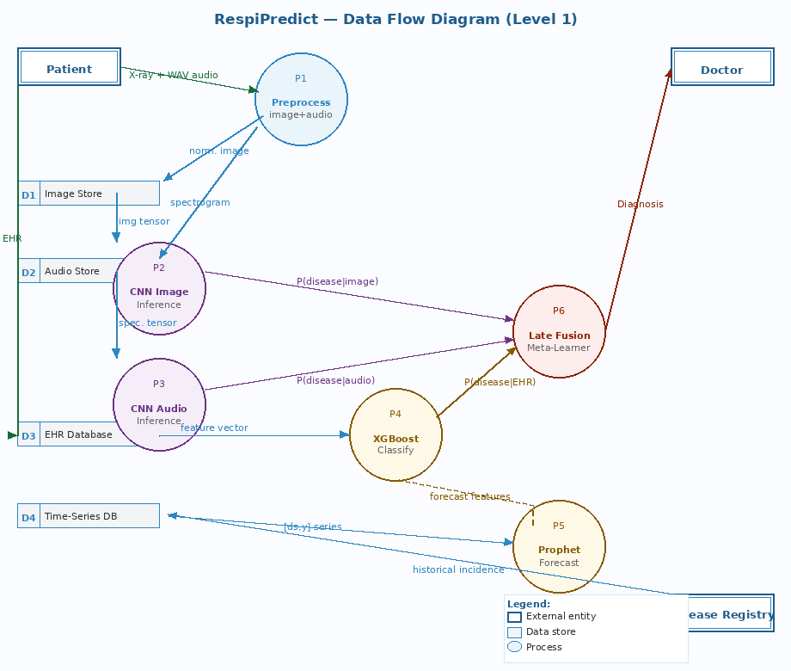

DFD Element Reference
ID | Type | Name | Description
— | External Entity | Patient | Submits X-ray images, WAV audio, and EHR data to the system
— | External Entity | Doctor | Receives the final diagnosis report and forecast from the system
— | External Entity | Disease Registry | Provides historical disease incidence data (ICMR, government health sources)
D1 | Data Store | Image Store | Preprocessed, normalised X-ray image tensors (PNG format)
D2 | Data Store | Audio Store | Mel spectrogram images converted from WAV audio recordings
D3 | Data Store | EHR Database | Structured clinical records: demographics, vitals, lab values, history
D4 | Data Store | Time-Series DB | Longitudinal disease incidence by region and date
P1 | Process | Preprocess | Normalises X-ray images → D1; converts WAV → Mel spectrogram → D2
P2 | Process | CNN Image Inference | Reads D1; outputs P(disease | X-ray) probability vector
P3 | Process | CNN Audio Inference | Reads D2; outputs P(disease | audio) probability vector
P4 | Process | XGBoost Classify | Reads D3 + forecast features from P5; outputs P(disease | EHR+trend)
P5 | Process | Prophet Forecast | Reads D4; outputs yhat, trend, bounds → enriches P4 feature vector
P6 | Process | Late Fusion | Combines three probability vectors → final diagnosis report → Doctor

Entity Relationship Diagram
The ER diagram below models the persistent data entities in RespiPredict, their attributes, and the relationships between them. Primary keys are shown in navy (PK) and foreign keys in purple (FK).

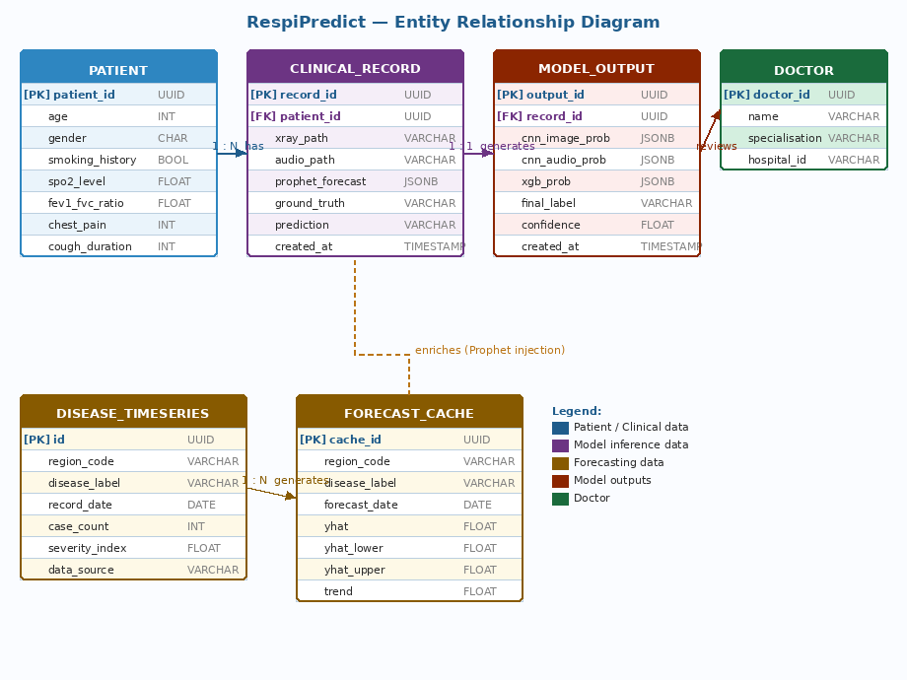

Entity Reference
Entity | Primary Key | Key Relationships | Description
PATIENT | patient_id (UUID) | 1-to-many with CLINICAL_RECORD | Stores demographic and clinical baseline data for each patient
CLINICAL_RECORD | record_id (UUID) | Many-to-1 with PATIENT; 1-to-1 with MODEL_OUTPUT; enriched by FORECAST_CACHE | One record per clinical encounter; holds file paths to X-ray and spectrogram, and the Prophet forecast payload
MODEL_OUTPUT | output_id (UUID) | 1-to-1 with CLINICAL_RECORD; reviewed by DOCTOR | Stores the probability outputs of all three expert models and the final fused prediction
DISEASE_TIMESERIES | id (UUID) | 1-to-many with FORECAST_CACHE | Regional historical disease incidence, used as Prophet training input
FORECAST_CACHE | cache_id (UUID) | Many-to-1 with DISEASE_TIMESERIES; enriches CLINICAL_RECORD | Stores pre-computed Prophet predictions; injected as features into XGBoost at inference time
DOCTOR | doctor_id (UUID) | Reviews MODEL_OUTPUT | Medical professional who receives and acts on the system's diagnostic output

Conclusion
RespiPredict demonstrates that a well-architected multimodal ensemble system can meaningfully advance the state of automated respiratory disease prediction by combining complementary diagnostic signals that no single model can exploit alone.

Summary of Contributions
Contribution | Technical Significance
Unified CNN architecture for image and audio | Converting respiratory audio to Mel spectrograms enables the same ResNet-50 CNN backbone to classify both chest X-ray images and breathing patterns, reducing model complexity without sacrificing modality coverage.
Prophet-to-XGBoost feature injection | Enriching the clinical feature vector with regional seasonal forecast data (yhat, trend, bounds) gives the XGBoost classifier epidemiological context at inference time — a novel integration not common in standard clinical ML pipelines.
Decision-level late fusion | Training a second-stage XGBoost meta-learner on expert probability vectors allows the system to dynamically reweight expert trust based on input patterns, producing a more robust unified diagnosis than any individual expert.
Clinical metric prioritisation | Choosing Recall over Accuracy as the primary evaluation metric reflects the real-world cost asymmetry of diagnostic errors — a design principle that should be standard in medical AI but is often overlooked.
Modality robustness | Late fusion architectures are inherently tolerant of missing modalities. If audio data is unavailable, the system continues to produce a valid diagnosis from the remaining experts, making it deployable in resource-constrained clinical settings.

Limitations and Future Work
- Dataset scale: The system was developed and evaluated on available Kaggle and open EHR datasets. Performance on truly diverse, multi-hospital, multi-region datasets at production scale remains to be validated.
- Real-time inference latency: Loading multiple Prophet models and performing CNN inference sequentially introduces latency. A production deployment would require model caching (Singleton pattern) and parallelised expert inference.
- Explainability: While XGBoost provides feature importance scores, the CNN experts remain black boxes. Integrating Grad-CAM visualisations for X-ray predictions and spectrogram attention maps would improve clinical trustworthiness.
- Regulatory compliance: Any clinical deployment would require validation against regulatory frameworks (FDA SaMD guidelines, CE marking in Europe, CDSCO in India) and clinical trials, which are beyond the scope of this project.

Future Directions
Vision Transformers (ViT): Replace ResNet-50 backbone with a ViT for potentially higher X-ray classification accuracy on larger datasets.
Federated Learning: Train across multiple hospitals without centralising patient data, addressing privacy constraints in EHR sharing.
Explainable AI (XAI): Integrate SHAP values for XGBoost and Grad-CAM for CNNs to generate clinician-interpretable prediction rationales.
Mobile Deployment: Quantise and prune models for on-device inference on portable diagnostic tools for rural/remote clinical settings.
Real-Time Pipeline: Extend Prophet forecasting to ingest live disease surveillance data (ICMR API, WHO feeds) for dynamic trend updates.

Closing Statement
This project successfully establishes a proof-of-concept multimodal diagnostic framework for respiratory diseases, validated through structured testing across MAPE (forecasting) and Recall (classification) metrics. The architectural choices — particularly the Prophet-to-XGBoost feature enrichment, the Mel spectrogram audio pipeline, and the decision-level late fusion strategy — are principled, literature-grounded, and extensible. RespiPredict provides a strong foundation for future work toward clinically deployable respiratory disease AI.

