# Bootstrap

**Objective**: To develop a working understanding of bootstrap and use it to develop simple front end pages.

Main Resources:

* What is Bootstrap: <https://www.youtube.com/watch?v=wesUO81YX0U>
* Installation by CDN: <https://www.youtube.com/watch?v=R52AsglN0DE>
* Bootstrap Classes: <https://www.w3schools.com/bootstrap/>
* Bootstrap Forms: <https://www.youtube.com/watch?v=gl5rIDno7Ps>

Bootstrap Grids:

* <https://www.youtube.com/watch?v=g3LRU3JF-rQ> (explanation on grids)
* <https://www.youtube.com/watch?v=e5VQampkqdg> (explanation on how to use them)
* <https://www.youtube.com/watch?v=x6uafDNy-F4> (explanation on how to nest them)

Helpful sites

* <https://www.w3schools.com/bootstrap/>
* <http://getbootstrap.com/>

Advantages of learning Bootstrap:

* Easier designing website phase; increase development speed.
* Help to implement responsive website in much easier and faster ways

Challenge:

* Install and use LESS CSS framework for the following deliverables

Deliverables:

* Install bootstrap into your personal repository
* Build a bootstrap page that resembles the following photo:

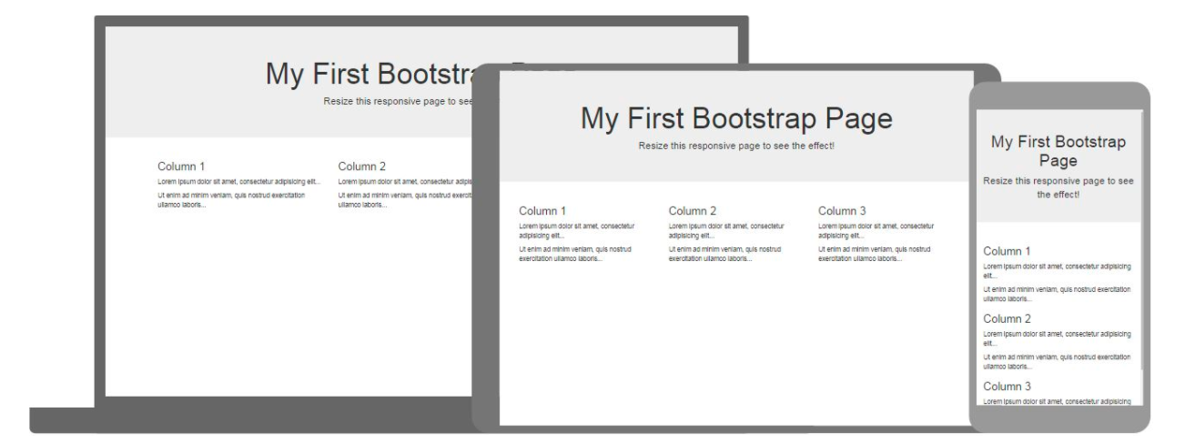

* Re-build the keep.edu.hk homepage using bootstrap